**Monthly Assessment Sheet: Python Django**

**Student Name: Ajeeba MV____________________**

**Month: Jan - Feb____________________**

**Instructor: Rahul RP____________________**

**Date of Assessment: 22/02/2025____________________**

**1. Django Fundamentals**

**a. Django Basics**

* **Understanding of Django’s MVC architecture and core concepts**
* **Ability to create and manage Django projects, apps, and models**
* **Rating: ☐ Excellent ☐ Good ☐ Average ☐ Needs Improvement**
* **Comments:**

**b. Django ORM**

* **Proficiency in using Django’s ORM for database interactions**
* **Ability to create and manage models, relationships, and queries**
* **Rating: ☐ Excellent ☐ Good ☐ Average ☐ Needs Improvement**
* **Comments:**

**c. Views and Templates**

* **Implementation of Django views and templates**
* **Ability to create and manage templates for rendering HTML**
* **Rating: ☐ Excellent ☐ Good ☐ Average ☐ Needs Improvement**
* **Comments:**

**2. Forms and User Authentication**

**a. Forms Handling**

* **Ability to create and handle Django forms**
* **Understanding of form validation and error handling**
* **Rating: ☐ Excellent ☐ Good ☐ Average ☐ Needs Improvement**
* **Comments:**

**b. User Authentication**

* **Implementation of Django’s authentication system (login, registration)**
* **Management of user sessions and permissions**
* **Rating: ☐ Excellent ☐ Good ☐ Average ☐ Needs Improvement**
* **Comments:**

**3. API Development**

**a. RESTful APIs**

* **Ability to create RESTful APIs using Django REST Framework**
* **Handling of API views, serializers, and routing**
* **Rating: ☐ Excellent ☐ Good ☐ Average ☐ Needs Improvement**
* **Comments: Not started**

**b. API Authentication**

* **Implementation of API authentication mechanisms (e.g., JWT, OAuth)**
* **Secure handling of API requests and responses**
* **Rating: ☐ Excellent ☐ Good ☐ Average ☐ Needs Improvement**
* **Comments:Not started**

**4. Testing and Debugging**

**a. Unit and Integration Testing**

* **Ability to write and execute unit and integration tests for Django applications**
* **Understanding of Django’s testing framework and best practices**
* **Rating: ☐ Excellent ☐ Good ☐ Average ☐ Needs Improvement**
* **Comments:Not started**

**b. Debugging Skills**

* **Proficiency in debugging Django applications**
* **Use of Django’s debugging tools and techniques**
* **Rating: ☐ Excellent ☐ Good ☐ Average ☐ Needs Improvement**
* **Comments:**

**5. Deployment and Maintenance**

**a. Deployment**

* **Knowledge and skills in deploying Django applications to production (e.g., using Docker, Heroku, or AWS)**
* **Configuration of deployment settings and environments**
* **Rating: ☐ Excellent ☐ Good ☐ Average ☐ Needs Improvement**
* **Comments:Not started**

**b. Maintenance**

* **Ability to manage and maintain Django applications post-deployment**
* **Handling updates, bug fixes, and performance optimizations**
* **Rating: ☐ Excellent ☐ Good ☐ Average ☐ Needs Improvement**
* **Comments:Not started**

**6. Project Development and Delivery**

**a. Project Progress**

* **Progress on assigned project tasks and milestones**
* **Quality and functionality of delivered project components**
* **Rating: ☐ Excellent ☐ Good ☐ Average ☐ Needs Improvement**
* **Comments: Not started**

**b. Adherence to Deadlines**

* **Timeliness in completing assignments and meeting deadlines**
* **Ability to manage project timelines effectively**
* **Rating: ☐ Excellent ☐ Good ☐ Average ☐ Needs Improvement**
* **Comments: Not started**

**Instructor’s Summary:**

**Strengths:  
Shows willingness to learn and adapt  
Understands basic concepts but needs more practical application**

**Areas for Improvement:**

**Struggles with task completion within the expected timeframe.  
Requires better focus and attention to detail.  
Needs to improve self-initiative and problem-solving skills.**

**Action Plan:**

**Provide challenging tasks to help her enhance problem-solving skills.  
Assign time-sensitive tasks to improve his ability to meet deadlines**

**Overall Grade: Average Performance_______________**

**Pass/Fail: Pass _______________**

**Instructor’s Signature: ___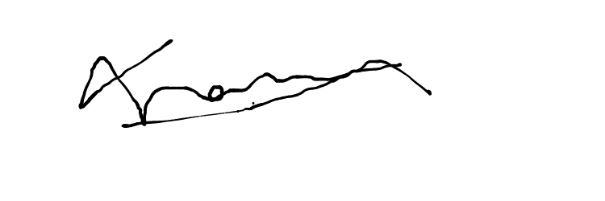_________________**

**Student’s Signature: ____________________**