# ABSTRACT

This report gives details of my first industrial training experience attained from 17th of July 2023 to 17th September 2023 at the TANZANIA COMMERCIAL BANK. Shows and gives more details on the achievement I got on my industrial training, I learned and test things more practically and I got an experience on how to support a user and solving their problem due to main tasks l was performed during my industrial training.

It will mainly comprise of four chapters.

Chapter one explains about the historical background, location, name of the organization, the organization’s mission and vision, the organization’s function and brief provide description of assigned tasks and describe whether assigned task fall under the role of IT department.

Chapter two explains all about the assigned tasks such as computer hardware maintenance and troubleshooting, network troubleshooting, printer configuration and maintenance, operating system installation, antivirus installation and activation for data security and some short class about server room, system administrator, systems that are operating in the organization and linux commands for system administrator.

Chapter three explain all about the overall programme challenges the psychological challenges, physical challenges and technical challenges and measures used to control those challenges.

Chapter four explain all about the recommendation and suggestion.

# ACKNOWLEDGEMENT

Firstly, I would like to thank God for having been with me from the start until the end and having me passed all times throughout the industrial training period. I also thank the TANZANIA COMMENRCIAL BANK for giving me the opportunity to do my industrial training and being hand in hand with me and my fellow colleagues.

I would also like to thank our main supervisor Mr. Arthur and other supervisors Mr. Daudi, and Mr. Eliatosha for their endless support throughout the industrial training period.

Lastly, I would like to thank my fellow colleagues for their cooperation and support throughout the industrial training period.

# TABLE OF CONTENTS

ABSTRACT 1

ACKNOWLEDGEMENT 2

TABLE OF CONTENTS 3

CHAPTER ONE 4

1.1 INTRODUCTION 4

1.1.1 Name, Nature and Environment 4

1.1.2 Historical background of the organization 4

1.1.3 Organization Mission and Vision 4

1.1.4 Functions of the organization 5

1.1.5 Activity performed by Information Communication and Technology (ICT) department 6

1.1.6 Organization Structure 7

CHAPTER TWO 8

2.1 ASSIGNED TASKS 8

2.1.1 Application support 8

2.1.2 Install the operating system 10

2.1.3 Web development task 12

2.1.4 Computer Hardware maintenance and troubleshooting 15

2.1.5 Networking connectivity 17

2.2 Simple application developments 18

CHAPTER THREE 20

3.1 OVERALL CHALLENGES AND SUGGESTED SOLUTIONS 20

3.1.1 CHALLENGES 20

3.1.2 SUGGESTED SOLUTIONS 20

CHAPTER FOUR 22

4.1 RECOMMENDATION AND SUGGESTION 22

4.1.1 To students 22

4.1.2 To university 22

4.1.3 To Organization 22

4.2 CONCLUSION 22

4.3 REFERENCES 23

4.4 APPENDICES 24

# CHAPTER ONE

## 1.1 INTRODUCTION

### 1.1.1 Name, Nature and Environment

Tanzania Commercial Bank is a Commercial bank in Tanzania that has been mandated to administer All Transactions and All bank activities such as financial solutions. Located in Millennium tower makumbusho Dar es salaam.

### 1.1.2 Historical background of the organization

Historically Tanganyika Postal Office Savings Bank (TPOSB) now Tanzania Commercial Bank came into being in 1925 when Tanganyika was under British Rule. It later became a Savings Bank under the then East African Post and Telecommunications which ceased to operate after the collapse of the East African Community. The Tanzania Posts & Telecommunications Corporation (TP&TC) came into being to cater for the Tanzanian market. TPB was formed from the now defunct TP&TC. TPB was established by the Tanzania Postal Bank Act No. 11 of 1991. On Monday the 29th of June 2015, the Parliament of the United Republic of Tanzania repealed the Act and on the 29th of March 2016 the bank was incorporated under the Companies Act (Cap 212) as TPB Bank PLC. On Thursday 19th January 2017, the bank unveiled it’s the name TPB Bank PLC to the public as well as its new logo and tagline (Grow with us). On the 14th July 2021 the bank changed its name to Tanzania Commercial Bank Plc with a tagline ‘Growing stronger together’.

### 1.1.3 Organization Mission and Vision

#### Mission

To provide convenient banking products and services through the deployment of innovative solutions, enhance value to stakeholders and contribute to the socio-economic needs of the Country.

#### Vision

To be the leading bank in the provision of innovative financial solutions and promoting financial inclusion in Tanzania.

### 1.1.4 Functions of the organization

The Tanzania commercial Bank has the following functions;

* To provide convenient banking product
* services through the deployment of innovative solutions
* Registration of land titles and legal documents
* enhance value to stakeholders and contribute to the socio-economic needs of the Country

Information Communication and Technology (ICT)

Objective:

To ensure appropriate ICT systems that enable optimal performance enhancing quality and efficient service delivery

Functions:

* To oversee the implementation of ICT activities
* To develop a coordinated and integrated management information system
* To coordinate data warehouse and data storage
* To develop efficient ICT infrastructure and network security
* To coordinate the purchase of ICT hardware and software
* To develop and implement ICT strategy
* To research on software for system support and applications,

### 1.1.5 Activity performed by Information Communication and Technology (ICT) department

The main activity performed by Information Communication and Technology (ICT) department in the organization is business solutions support. Information communication and technology (ICT) members are there to make sure other department are not getting any trouble in network or bad performance of all web apps and applications.

The assigned tasks such as web apps supports and applications, network troubleshooting and operating system installation, and some short class about server room, system administrator, systems that are operating in the organization and short class about programming skills.

### 1.1.6 Organization Structure

figure 1. 1 organization structure

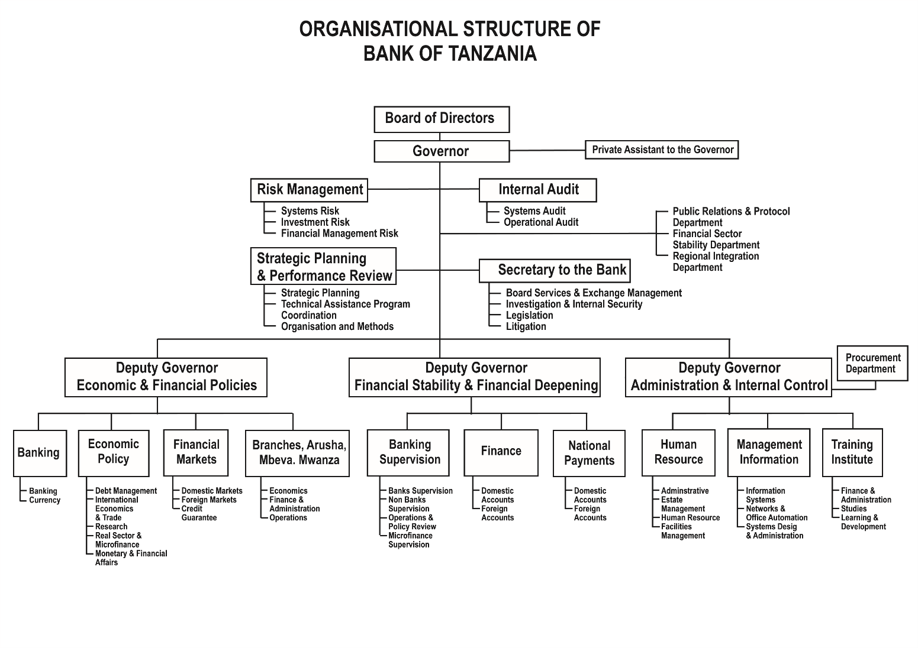

# CHAPTER TWO

## 2.1 ASSIGNED TASKS

The organization has a variety of Information Communication and Technology (ICT) activities, but for security reasons some of the work was limited to us, so the industry training was assigned the following tasks. Below is a clear description of the problem that caused the individual task, as shown below.

### 2.1.1 Printer configuration and maintenance

This is one of the most frequent activities throughout the industrial training as the ministry recently introduced new printers. This activity involved configuring printer to connect to multiple computers so that can print and in maintenance was fixing of printer problems such as RAM disk problem, paper jam and printer driver failure.

Problem

Printer was not connected in a local area network (LAN) so that many computers can print in one computer, failure to print due to jams of commanded document waited to be printed, stacked of paper in a printer, misbehave of printer driver and existence of 404 error.

Proposed solutions on solving the problem

Connect printer in the network and allow printer to share to print in many devices, check if there is jams on the commanded documents that are waited to be printed, install printer driver in the computer and fix the RAM problem

Technical and non-technical approaches to implement proposed solution

In printer configuration there were two main methods used which are,

1. Share a printer that is directly connected to the network. Here computer and printer both should be in the same network
2. Share a printer that is connected to your computer with a USB cable, and your computer should be connected to the network. Here all computer that are needed to share printer should be in the same network

In the printer maintenance we were first check if all cables are connected well for both power and network cables if there is no problem then we check for the network if there is network and the connection then also we check for ink, remove and delete paper jams and installation of the driver to the printer to the computer so that to solve the problem the users.

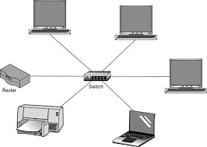

##### figure 2. 1 printer connection

User’s adaptation and satisfaction.

Since the main activity for information communication member at ministry of land, housing and human settlement development was user support so user was satisfied with the problem solution as they were able to print their documents a part from that he or she was trained on how to use printer on printing document for testing if its function good.

### 2.1.2 Install the operating system.

An operating system (OS) is system software that manages computer hardware and software resources and provides general services to computer programs. In my industrial training I install linux operating system (Ubuntu) and windows (window 7 and window 10)

Problems

Windows become unresponsive, monitor display black screen and ask for operating system installation, upgrade the operating system and change computer window operating system to linux operating system.

Proposed solutions on solving the problem

Due to such kind of problems the installation of operating system was required

Technical and non-technical approaches to implement proposed solution

During installation of operating system, I required to have a bootable flash that contain a window setup of a compact disk (CD) that contain a setup of window then put the bootable flash or compact disk (CD) in the computer, follow the steps for installation of operating system.

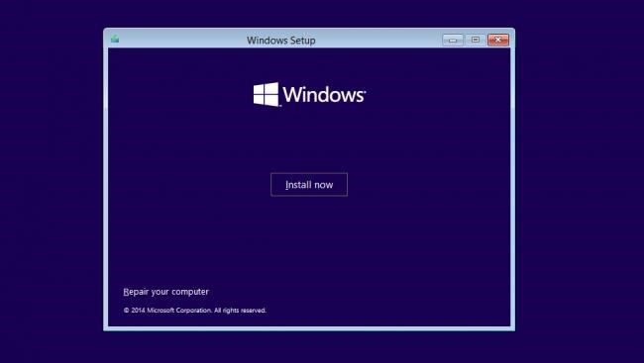

##### figure 2. 2 window installation

For linux operating system (Ubuntu), also you are required to have a flash that contain a setup of Ubuntu and follow the instruction to install operating system.

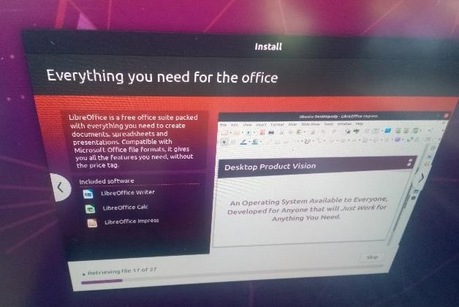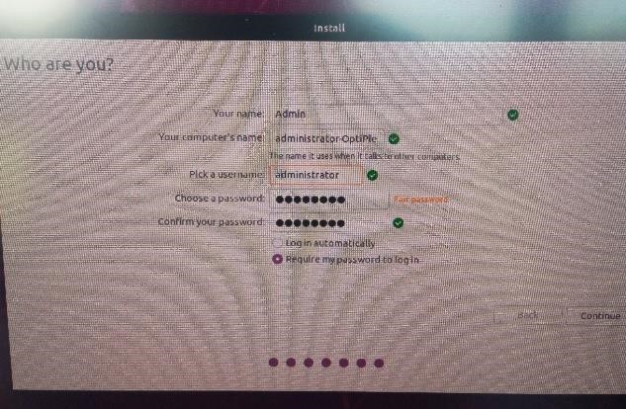

figure 2. 3 ubuntu installation

User’s adaptation and satisfaction.

After I have implemented solution on exist problem on the operating system installation, the satisfaction of my supervisor was good and he said that the proposed solution was nice and well implemented but also, he suggests that next time when l will installing operating system in personal computer (PC) or desktop, first I must look if there is enough space (storage) on hard disk, sometimes installation failed because of physical device’s storage. So, we must be very careful during installations.

### 2.1.3 Network troubleshooting

Network troubleshooting is a combination of measurements and processes used to identify, diagnose, and resolve problems on your computer network. This is a logical process that network engineers use to solve network problems and improve network operations.

Problems

Network cables to fail to provide network access across the network devices but also failure to transmit network data.

Proposed solutions on solving the problem

Trace which cable fail to provide network and failed to transmit network data

Technical and non-technical approaches to implement proposed solution

The activity involved detecting of switch device failure to supply network or cable line problem. Here the type of switch to be worked upon was an access switch (unmanaged switch) that basic needed to be rebooted for it to work properly or in a right way is to replace it with another switch.

Also, it was well explained on detecting cable line problem using tools such as

Tone generator and network cable line tracker tester. They are used to detect the Ethernet cable with a problem and also used to ensure direct communication of the managed switch (configured switch) to the user through the Ethernet cable line.

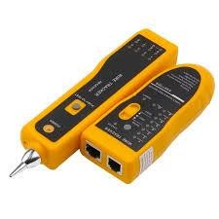

figure 2. 4 A Tone generator detector and a Network cable line tracker tester

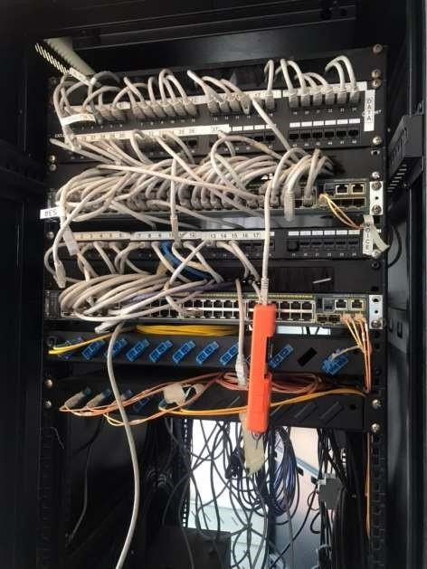

##### figure 2. 5 network troubleshooting

User’s adaptation and satisfaction.

The user was able to get good connection and access the internet but also the user was satisfied in a manner that he or she preferred to use ethernet connection because it helps to transfer large amount of data in a small amount of time.

### 2.1.4 Computer Hardware maintenance and troubleshooting

This includes checking the hardware parts to see if they are working properly.

Problems

The computers are not able to gain power supply due to poor connections but also some hardware devices seem not to be able to perform some tasks such as keyboard buttons are not working, hard disk and RAM failure and existence of dust

Proposed solutions on solving the problem

To make sure all power cable are connected well so that computer could gain power and to be able to turn on, exchange of keyboard and mouse, open the unit case and replace the RAM plot and hard disk and for the dust is blow the computer to remove dust

Technical and non-technical approaches to implement proposed solution

The activity involved cleaning of computer hardware part example, Keyboard, Monitor, and unit case were as with the assistance of my supervisor we opened the unit case (CPU) and blow out dust from the computer fan and the motherboard

Upon troubleshooting, the challenge was fixing computer power supply problem. Under this circumstance, the power supply could either be not functioning hence needs a replacement or it could not start up when given power and change the hard disk and RAM to make computer perform its functionality.

User’s adaptation and satisfaction

Users were happy with the results since their computer returned to perform as it used. The good thing was I thanks my supervisor the way he was training me on how to deal with such kind of the problems to support user

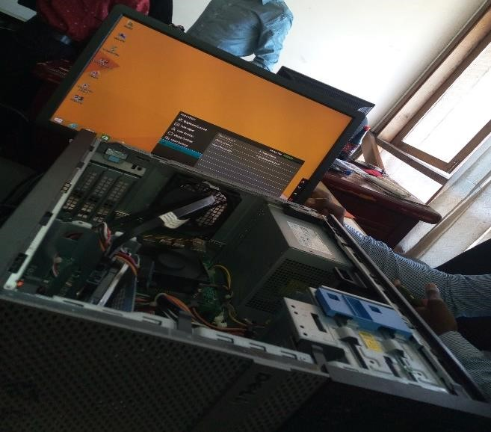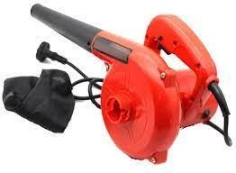

##### figure 2. 6 the opened unit case (CPU) for blowing dust from the computer fun using a blower

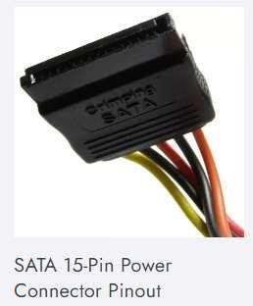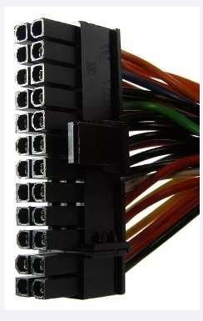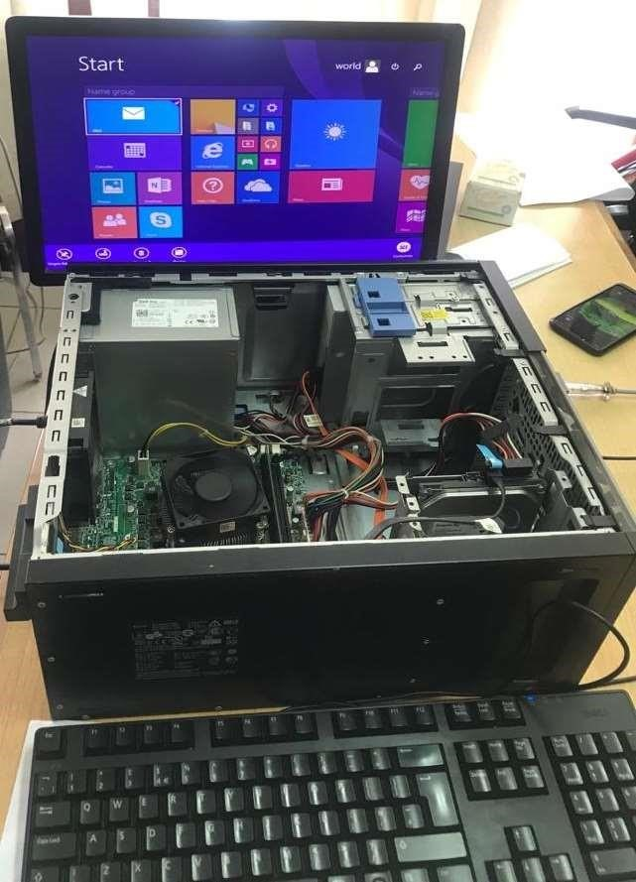

figure 2. 7 The opened unit case (CPU) for fixing power supply and hard disk

The opened unit case (CPU) for fixing power supply and hard disk

### 2.1.5 Antivirus installation and activation for data security

The ministry of land, housing and human settlement development since they have many important documents to avoid virus to destroy, they need security they choose Kaspersky antivirus as their security to protect their documents from virus

Problems

Outdated license of antivirus and existence of new computer that does not have antivirus

Proposed solutions on solving the problem

Installation of antivirus for computer that does not have antivirus and activate the license for computer that is outdated

Technical and non-technical approaches to implement proposed solution

Install antivirus in the computer but your required to have a flash that contain a setup of Kaspersky then for activation of license your required to have a activation key or code so that to activate the license.

User’s adaptation and satisfaction

User were satisfied since they know their computer will be protected from virus. And we install and activate to all member of organization but it was only for the computer of organization since the software is for payment and organization pay for it.

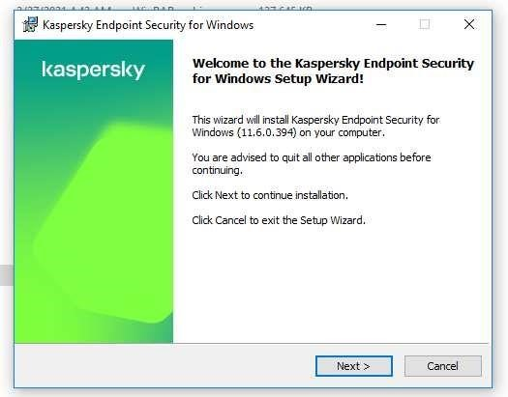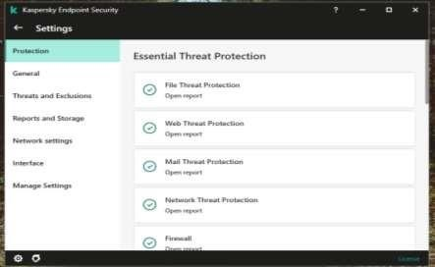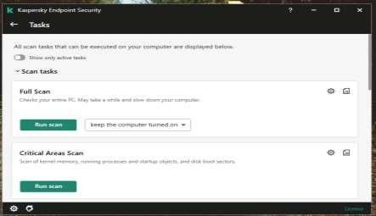

figure 2. 8 Antivirus installation for Kaspersky endpoint security

## 2.2 Simple training during industrial training

This training it was like a short class where we trained on,

1. System administrator

Is a person who is responsible for the upkeep, configuration, and reliable operation of computer systems. Here we were trained on how to operate the system

1. System orientation

Here some of the system that are used by ministry of land we were trained on how they are operate and operated by the user

1. Server orientation
2. With the support from technical experts different guidelines, knowledge and simple basic training was achieved. **Server security**
   * Here we discussed on the use CYBEROAM security technology used to filter out bad traffic attacks to the server, also prevent denial of services to other network traffics.
   * This technology is used to provide protection with the ability to detect and investigate threats across endpoints, servers, firewalls and other data sources. Also due to advance in technology the most recently used technology is SOPHOS

#### CYBEROAM TECHNOLOGY

• Access Control Criteria • Fusion Technology – Firewalls well integrated with VPN,

IPS, Anti-Virus & Anti-Spyware, Web Filtering, Bandwidth Management and Multiple Link Management.

# CHAPTER THREE

## 3.1 OVERALL CHALLENGES AND SUGGESTED SOLUTIONS

The working environment is genuinely friendly and favorable, and duties have been assigned commensurate with the level of supervision. We were encouraged to act as a team and, in many cases, to be precise, through certain duties that have been performed independently as instructed by my supervisor, thus helping me build self-confidence. I have also done several difficult work that requires self-initiation in performance and analytical skills that need creativity. But all the challenges encountered during my participation as a generally trained student were as follows:

### 3.1.1 CHALLENGES

1. The physical location of our office was in the middle of the city of Dar es Salaam in a place called Posta, so I was exposed to traffic almost every day and had many opportunities, so the time I should be in the office Has been shortened I am late for the office. On the other hand, it was expensive because I needed the sum of the two public transports from my place of residence to my office**.**
2. Lack of resources, such as equipment, to support the hardware components maintenance that cause problems for trainers in the organization, and lack of technicians who can assist in preparing the equipment in the event of a problem**.**
3. There are some other things that I didn't learn and I had to deal with during my practical training like troubleshooting printer and creating network cables so it was difficult to cope with and it took me some time to learn

### 3.1.2 SUGGESTED SOLUTIONS

i. In the department, school supervisors need to assign students to workplaces in the field, depending on their physical location, so that they can arrive at the workplace sooner. Also, if you find your own field, find the nearest dormitory so that you can get to work sooner. ii. Government should provide enough devices and increase staffs in the office in the field areas such as ministry of land. So, to increase productivity and for the students like us to get many supervisors who can assist us and give us many works.

iii. ln university, most courses were taught based on theories in order to solve this problem most of courses must be illustrated based on practical in order to be familiar at working places.

# CHAPTER FOUR

## 4.1 RECOMMENDATION AND SUGGESTION

To improve the effectiveness and performance of students during the training, we recommend the following**:**

### 4.1.1 To students

i. To actively and fully attend to their industrial training centers because the dedicated time is too short thus there will be no another time for them to learn more practically than during industrial training.

### 4.1.2 To university

1. Encouraging the teaching of more practical sessions. There should be computer laboratories with enough tools for learning
2. The industrial training period should be increased. The time of eight weeks is short for a student to master the course. Considering the few practical sessions students get, field is the only place where student can learn more practically

### 4.1.3 To Organization

1. Giving more opportunities to students to come for training
2. Giving financial support to the trainees by either giving them allowances or bus fares when they are coming from a distant place
3. To provide strong supervision to the industrial trainees without any discrimination

## 4.2 CONCLUSION

The purpose of this industrial training was to learn and put into practice various ideas that were theoretically conveyed in the classroom. Through this training, I learned a lot, especially from discipline to living with other employees in the company. When it comes to discipline, time management was my most difficult lesson. I had to work on time and complete a given task on time. Respect was also one of the most important lessons I learned while in the organization. Also am grateful with the help of IT experts and their support in explaining to me any technical challenge that I faced during my Industrial Practical Training that helped in brooding my knowledge and work experience in my course of study

# 4.3 REFERENCES

Shotton, M. A. (1989). *Computer addiction? A study of computer dependency*. London, England: Taylor & Francis

# 4.4 APPENDICES

1. System administrator

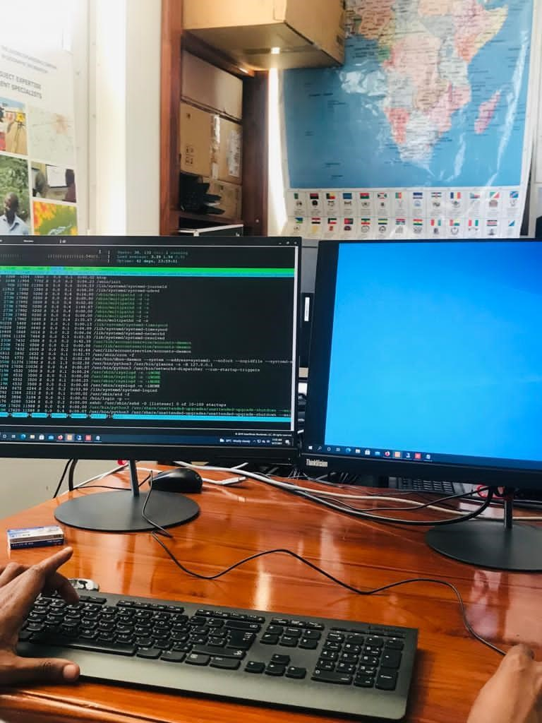 figure 4.1 1 system administrator display

1. Server security

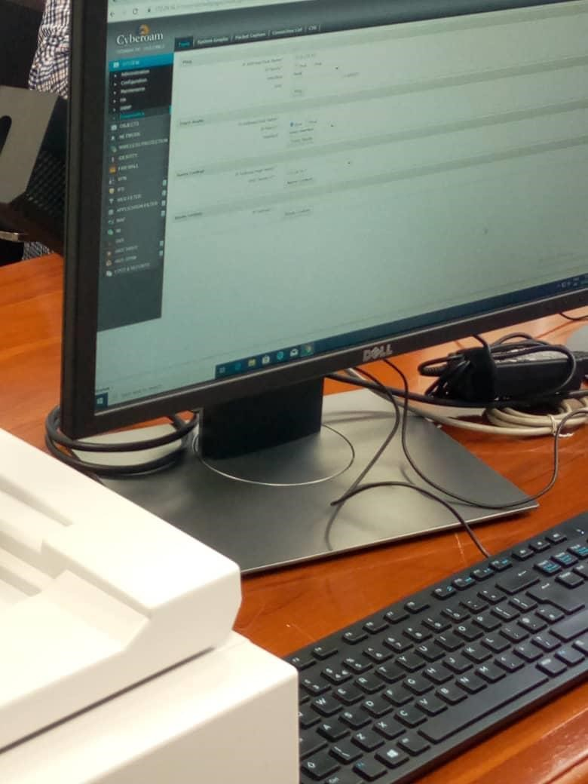 figure 4.2 1 cyberoam technology