1/19/2020

Report

**AMAZING LOCATIONS IN BRASOV**

|  |  |
| --- | --- |
| Module name | Introduction to Web Authoring |
| Assignment title | Final Marked Assignment |
| Student name | Manea Valentin Cornel |
| Student ID number | XXXXXXXXX |
| Tutor name | Macnabb John |
| Assignment due date | 01/20/2020 |

Contents

1 Introduction 2

1.1 Document purpose 2

1.2 Development tools 2

2 Usability and accessibility 2

2.1 Accessibility 2

2.2 Usability 2

3 Structure and content 3

4 Semantic elements 4

5 Website layout and layout techniques 5

5.1 Website layout 5

5.2 Layout techniques used and their implementation. 5

6 Conclusion 6

# Introduction

## Document purpose

The purpose of this document is to provide information on techniques used to create and design the “Amazing Locations in Brasov” travel guide website for a European city.

The aim of this website is to attract tourists and to provide information on travel destinations.

## Development tools

The programming languages used are HTML5 to mark up the content of the website and CSS3 to style the content of the website.

# Usability and accessibility

How usability and accessibility that informed the design and implementation of the website.

## Accessibility

In short, an accessible website is a website that can be easily used and understood by the clients.

* Appropriate usage of the headings in order to avoid any confusion. H1 element is used strictly for the title. Skipping heading levels were avoided.
* Alternative text have been added for the images, to support the screen reader users
* Descriptive and unique names for links to avoid any confusion.
* Red and green colors were avoided, to support people with color deficiency.

## Usability

Website usability refers to how easy a website is for visitor to interact with.

* Visual hierarchy is carefully created through color, size and layout positioning.
* Content of the website is relevant and clear making the people to navigate easily through the website and to find the content they are looking for.
* Color palette picked using the [Paletton](https://paletton.com/) tool in two complementary colors.

# Structure and content

Website hierarchy *Figure 1*

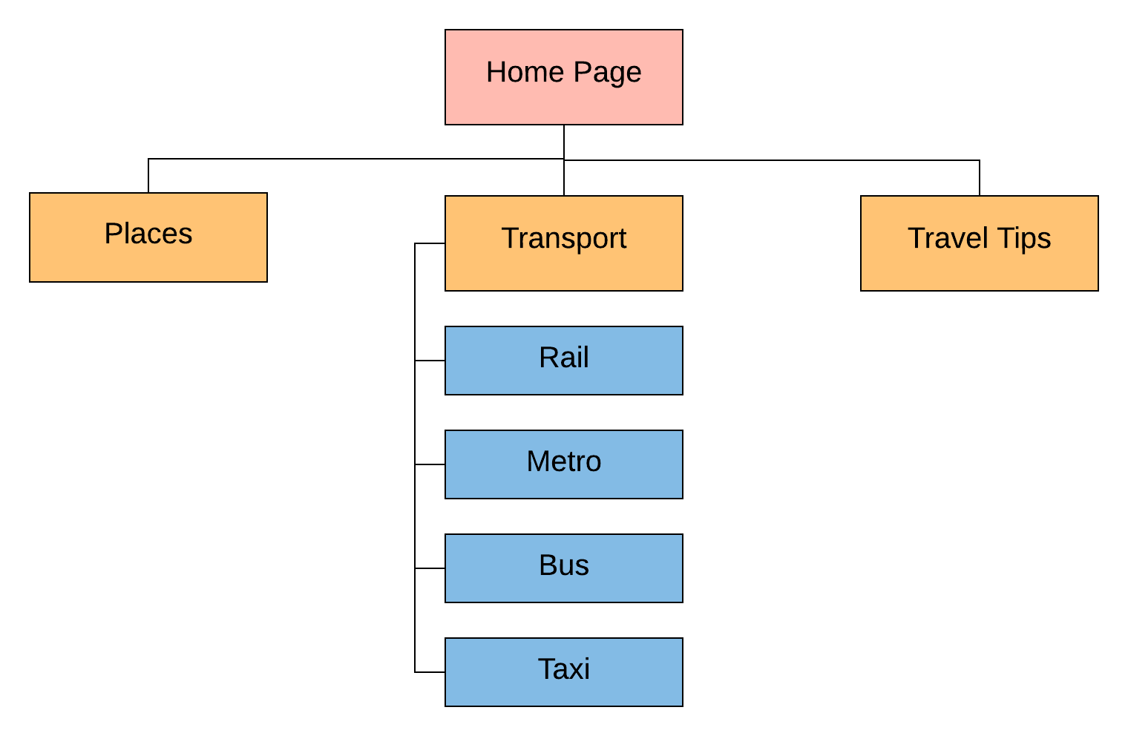

Figure Site Structure

The content of the travel site is split between four main sections, each represents a linked page.

1. The *Home* page includes details about the city and user reviews on their experience.
2. The *Places* page presents six locations to visit in the region.
3. The *Transport* page contains introductory details on transport facilities in the city.
4. The *Travel Tips* page includes five short travel guides for the city.

# Semantic elements

Semantic elements being used in the document:

*Headings* were used to define the hierarchy of the content.

* *<h1>* It is used as a logo within the header element with the name of the city.
* *<h2>* Represents the title of each page.
* *<h3>* Used to highlight important topics within nested articles and sections.

*Paragraph <p></p>* used to group and organize the text content of all the headings.

*Header* *<header><header>* used to represent the title of the website.

*Navigation element*s *<nav></nav>* were used to wrap the primary and secondary navigation menus, registration links and footer links.

*Main Element <menu></menu>* contains the main content of the website that is unique to all pages.

*Footer <footer></footer>* contains copyright information and the footer links.

*Image <img></img>* and *Figure <figure></figure>* were used to present and to format the images.

*Unordered <ul></ul>*, list elements<li></li> and anchor links<a></a> were used to group links together.

# Website layout and layout techniques

## Website layout

The layout structure of the website is almost identical between all the pages, with the exception of the <main> element content, which is different on each page, *Figure 2*

Despite the almost identical structure, the pages look quite different.

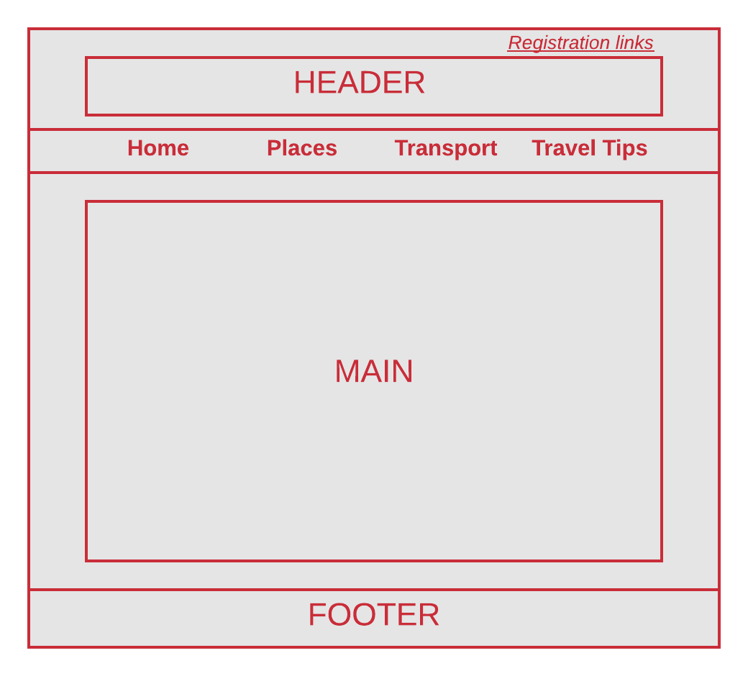

Figure Layout

## Layout techniques used and their implementation.

*Auto-margins are* used to horizontally center the element in its parent container.

*Box model* used for:

* Set border property with diverse border styles for images, articles, sections, and for other elements.
* Used to manipulate the width and height of the elements.
* Set space between elements by using padding and margin properties

*Inline-block property*

* Is used to render horizontally the primary navigation bar, registration links and footer links.
* To set the horizontal alignment of the review stars.
* To create the two-column layout on the transport page.

*Flexbox layout* Is used to horizontally align and wrap the articles of the Places page. Every article flexbox is nested in another flexbox container, in order to push the Footer to the bottom of the article.

*Float property* was used to position appropriately the image on the parent container.

*Position property* used to overlay text on the images.

# Conclusion

HTML and CSS are the barebones of website authoring, more technologically advanced features can be achieved by using a scripting language and a range of developer tools.