

3/27/2020

Computer Networking

Module Name Computer Networking

Assignment title UDP

Student name Manea Valentin Cornel

Student ID number xxxxxxxxxx

Tutor Name Andrea Cali

Assignment due date 25/04/2020

# Explanation of the script

Client

The client initializes the Datagram Socket object that will be used as a channel to send and receive UDP packets. Using the Scanner class the system prompts for three distinct strings that are going to be stored in a list. Immediately after the input is typed in the system, concatenates all strings into one (C) and calculates its overall length (l).

By parsing the list of strings, the client converts each individual string into a list of bytes. These lists of bytes are wrapped by the Datagram Packet object (UDP packet) that will provide extra information on the destination IP address and the required port. The UDP packets are sent to the specified Server by IP address.

The client waits to receive two UDP packets back from the server. After it has successfully received the UDP packets, coverts them into required data type finds out which of them is the string and which is the length. Grabs the string and remove the # symbols out of the string.

Finally checks if the sent message and its length is equal with the received one, computes YES if it is true and No if it is False.

Typing Y or N allows the user to repeat the same process.

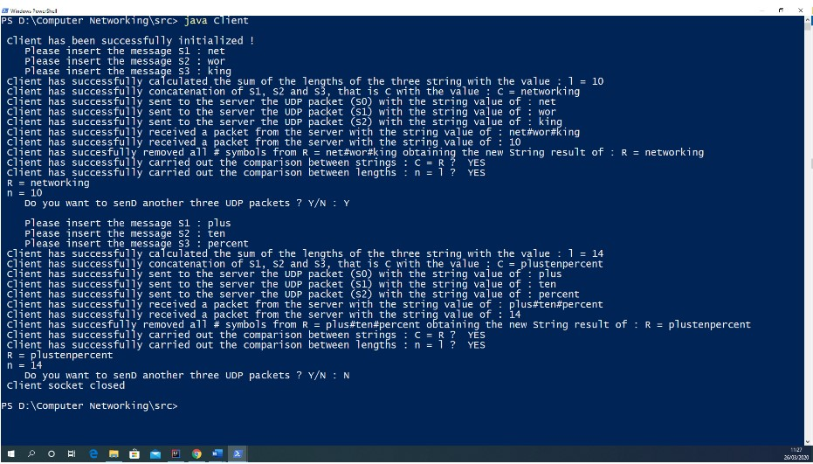

Server

First operation is the server initialization. If the server is successfully initialized it will wait for 3 UDP packets. Each received packet is converted as a string and stored in a list. The acquired list is parsed, and the server computes the sum of the strings length into variable R and concatenates all strings as one with # symbol used as a delimitator between each string obtaining the form of S1#S2#S3#.

Using the received UDP packet the server finds the IP address and the required port and replies with two UDP packets, namely n and R back to the client. The server repeats the operation until it gets shuttled off.

