**TABLE OF CONTENTS**

|  |  |  |
| --- | --- | --- |
| **SL.**  **NO** | **CONTENT** | **PAGE .NO** |
| 1 | PROJECT SYNOPSIS | 2 |
| 2 | MODULES AND METHODS USED | 4 |
| 3 | FLOW DIAGRAM | 7 |
| 4 | DATA STRUCTURES | 9 |
| 5 | PYTHON SOURCE CODE | 13 |
| 6 | PYTHON OUTPUTS | 45 |



**PROJECT SYNOPSIS**

**MEDPLUS** is a **Python-based program** that can be useful to a **seller** as well as a **consumer** to handle his/her medical requirements. The project is designed in such a way that it is user_ friendly. It serves several options to both the seller as well as the customer. The data handling structure that has been used in this project is a **Comma Separated Value file (CSV**). The data of a registered seller and a customer cannot be accessed by anyone else, the account of the legitimate user has been encrypted using the **login credentials**, which are only accessible by the user.

The **consumer section** of the project has various options as follows:-

👉**Register/log in** as a customer by providing valid credentials

👉**Purchase** the medicines as prescribed by a medical practitioner

👉Provides various options for **payment** including Cash on Delivery, Online Payments, and so on.

👉Options to **print** the machine-generated Payment Invoice

👉**Hassle-free** shopping that requires the user that requires the user to make the selection of the medicines only. The program can find the nearest medical store to the user and hence create communication between the consumer as well as the retailer.

The **seller section** of the project has various options as follows:-

👉**Register/ log in** as a customer by providing valid credentials

👉View the **store details** of the seller as well as to edit them after providing valid credentials

👉Enables the user to **introspect his progress** in the sales as well as the number of orders

👉Helps to **compare his progress** with that of other sellers registered with MEDPLUS.

👉**Predict** the sales of the succeeding month with help of the calculations made by the program

**Graphs** are a common method to visually illustrate relationships in the data. The purpose of a graph is to present data that are too numerous or complicated to be described adequately in the text and less space

All the data generated are displayed to the user in the form of Charts that include Bar Plots, Pie Plots.

The project has been made cogent using various modules in Python including **TKinter, Pyautogui, Matplotlib, PIL.**



**MODULES AND METHODS USED**

|  |  |  |  |
| --- | --- | --- | --- |
| SL.NO | NAME OF MODULE | METHODS IN THE MODULE | DESCRIPTION |
| 1. | Tkinter | Tkinter.Label()  Tkinter.RadioButton()  Tkinter. Button()  Tkinter.Window()  Window.destroy() | Tkinter is actually an inbuilt Python module used to create simple GUI apps. It is the most commonly used module for GUI apps in the Python. |
| 2. | PIL | .open()  .resize() | Python Imaging Library (abbreviated as PIL) (in newer versions known as Pillow) is a free and open-source additional library for the Python programming language that adds support for opening, manipulating, and saving many different image file formats |
| 3. | CSV | csv.writerow()  csv.writerows()  csv.read()  csv.next() | CSV files are plain-text files, which makes them easy for the website developer to create. Because the CSV is plain-text it can be imported into any spreadsheet program or database regardless of what's being used. |
| 4. | PyAutoGUI | .screenshot()  .save() | * PyAutoGUI is a cross-platform GUI automation Python module for human beings. Used to programmatically control the mouse & keyboard. |
| 5. | DATE | date.today()  date.today.month() | In Python, date and time are not a data type of its own, but a module named datetime is imported to work with the date as well as time |
| 6. | MATPLOTLIB | .bar()  .xlabel()  .ylabel()  .legend()  .xticks()  .savefig()  .show() | Matplotlib is a python library used to create 2D graphs and plots by using python scripts. It has a module named pyplot which makes things easy for plotting by providing feature to control line styles, font properties, formatting axes etc. |
| 7. | SYS | sys.exit() | Sys module in python is used to access variables & functions used by / related to the interpreter. |
| 8. | OS | os.startfile() | The OS module in Python provides a way of using operating system dependent functionality. The functions that the OS module provides allows you to interface with the underlying operating system that Python is running on |

**FLOW DIAGRAM**

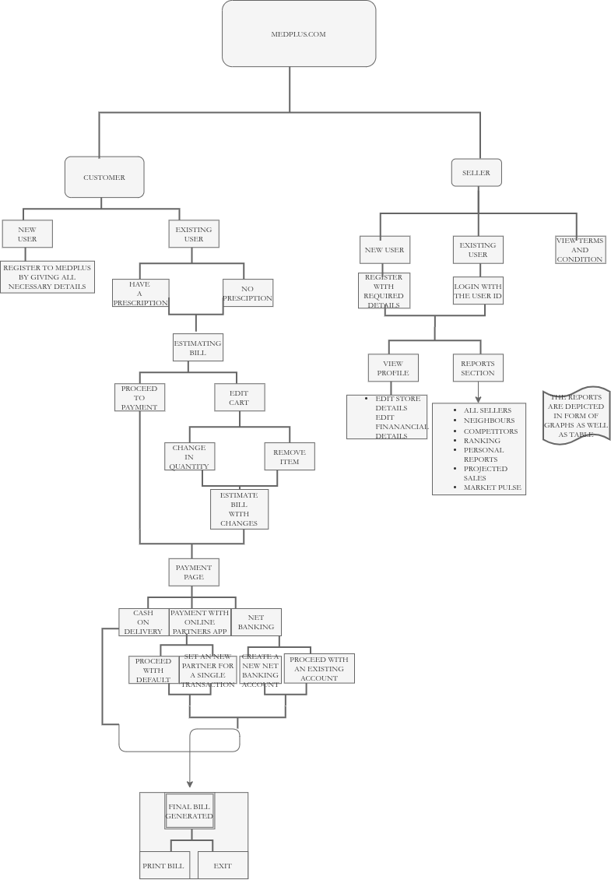

**DATA STRUCTURES**

**FOR A CUSTOMER**

**1.CUSTOMER.csv**

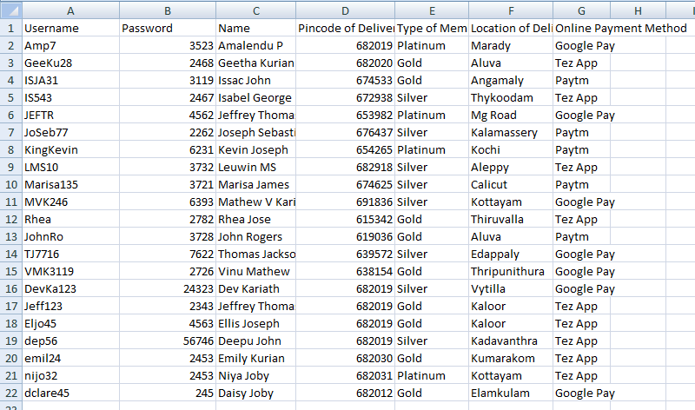**2.MEDSTORE.csv**

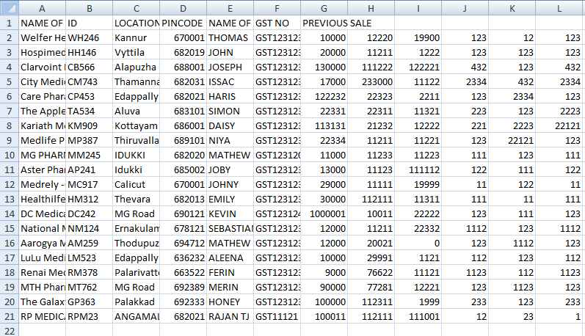

**3.MEDICINES.csv**

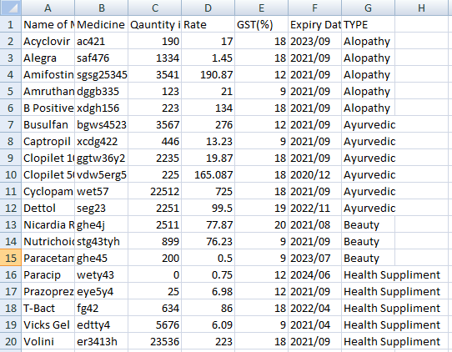

**FOR A SELLER**

**1.MEDSTORE.csv**



# **MAIN PROGRAM**

**PYTHON SOURCE CODE**

**#The program that the user runs in order to access“MEDPLUS”**

def mainprogram():

master.destroy()

import tkinter

**#Tkinter is a module in python that helps us to create a GUI**

root=tkinter.Tk()

root.title("WELCOME")

def ShowChoice():

num=u.get()

root.destroy()

if num==0:

import CUSTOMER

elif num==1:

import SELLER

else:

import sys;sys.exit()

u = tkinter.IntVar()

u.set(0)

users = [("I AM A CUSTOMER",1),("I AM A SELLER",2)]

tkinter.Label(root,

text="""Choose your option""").grid(row=0)

c1=0

for val, user in enumerate(users):

c1+=1

tkinter.Radiobutton(root,

text=user[0],

variable=u,

value=val).grid(row=c1)

bt=tkinter.Button(root,text="PROCEED",command=ShowChoice)

bt.grid(columnspan=3)

import tkinter

from PIL import Image

from PIL import ImageTk

**#PIL is a module in python that is used to display images**

master = tkinter.Tk()

width = 400

height = 400

img1 = Image.open("MEDPLUS.png")

img1 = img1.resize((width,height), Image.ANTIALIAS)

photoImg1 = ImageTk.PhotoImage(img1)

a=tkinter.Button(master,image=photoImg1,width=400,command=mainprogram).grid(row=0,column=1)

master.mainloop()

**MODULES**

**1.CUSTOMER**

**‘’’ The first module :”CUSTOMER” ,which is a program that allows the user to do his / her shopping from “MEDPLUS’’’**

def cartview(finalbill,finalnameretail,finaldetails):

def Payment(finalbill,finalnameretail,finaldetails):

#**CSV File handling is used in order to store and edit data.**

import csv

print()

f1=open("BILL.csv","w",newline='')

writer=csv.writer(f1)

writer.writerow(["MEDPLUS.COM","","","","","","TAX INVOICE"])

writer.writerow(["SOLD BY","","","","","","BILLING LOCATION\PINCODE"])

#**To display the details in a tabular form**

print("+","-"*101,"+")

print("|","MEDPLUS.COM"," "*77,"TAX INVOICE","|")

print("|","SOLD BY:"," "*66,"BILLING LOCATION\PINCODE:","|")

x=str(finalnameretail[2])

y=str(finaldetails[2])

for i in range(2):

print("|",finalnameretail[i]," "*(99-len(finalnameretail[i])-len(finaldetails[i])),finaldetails[i],"|")

writer.writerow([str(finalnameretail[i]),"","","","","",str(finaldetails[i])])

print("|",x," "*(99-len(x)-len(y)),y,"|")

writer.writerow([x,"","","","","",y])

print("+","-"*101,"+")

print()

print(" +","-"*98,"+")

writer.writerow(["SL.NO","DESCRIPTION","UNIT PRICE","TAX","QUANTITY","NET RATE","TOTAL AMOUNT"])

print(" |","SL.NO"," |","DESCRIPTION"," "*14,"|","UNIT PRICE"," |","TAX"," "*1," |","QUANTITY|","NET RATE"," "*3,"|","TOTAL AMOUNT","|")

print(" +","-"*98,"+")

totalbillamnt=0

total1=0

for i in finalbill:

totalbillamnt+=i[6]

total1+=i[5]

a=str(i[0])

b=str(i[1])

c=str(i[2])

d=str(i[3])

e=str(i[4])

f=str(i[5])[:7]

g=str(i[6])[:7]

writer.writerow([a,b,c,d,e,f,g])

print(" |",i[0]," "*(5-len(a)),"|",i[1]," "*(25-len(b)),"|",i[2]," "*(10-len(c)),"|",i[3]," "*(5-len(d)),"|",i[4]," "*(5-len(e)+1),"|",f," "*(10-len(f)+1),"|",g," "*(12-len(g)-1),"|")

print(" +","-"*98,"+")

if finaldetails[4]=="Platinum":

disct=15

elif finaldetails[4]=="Gold":

disct=10

elif finaldetails[4]=="Silver":

disct=5

else:

disct=0

print("+","-"*101,"+")

print("|","TYPE OF MEMBERSHIP"," "*(80-len(finaldetails[4])),finaldetails[4]," |")

print("|","% OF DISCOUNT"," "*(85-len(str(disct))),disct," |")

print("|","NET RATE"," "*(90-len(str(total1))),total1," |")

print("|","TOTAL TAX AMOUNT"," "*(82-len(str((totalbillamnt-total1))[:6])),str(totalbillamnt-total1)[:6]," |")

print("|","TOTAL BILL AMOUNT"," "*75,str(totalbillamnt)[:6]," |")

print("+","-"*101,"+")

print("|","TOTAL AMOUNT PAYABLE"," "*72,str(totalbillamnt*(100-disct)/100)[:6]," |")

print("+","-"*101,"+")

print("NOW IT'S TIME FOR PAYMENT!!!!")

print("a.CASH ON DELIVERY")

print("b.PAYMENT THROUGH OUR ONLINE PARTNER's APP")

print("c.NET BANKING")

writer.writerow(["MEMBERSHIP TYPE","","","","","",finaldetails[4]])

writer.writerow(["% OF DISCOUNT","","","","","",disct])

writer.writerow(["NET RATE","","","","","",total1])

writer.writerow(["TOTAL TAX AMOUNT","","","","","",str(totalbillamnt-total1)[:6]])

writer.writerow(["TOTAL BILL AMOUNT","","","","","",str(totalbillamnt)[:6]])

writer.writerow(["TOTAL AMOUNT PAYABLE","","","","","",str(totalbillamnt*(100-disct)/100)[:6]])

ch=input("ENTER YOUR CHOICE TO PROCEED: ")

if ch in 'Aa':

print("THANK YOU FOR CHOOSING CASH ON DELIVERY OPTION\nPLEASE HAND OVER THE EXACT CHANGE TO OUR SERVICE EXCECUTIVE\nTHANK YOU")

elif ch in 'Bb':

def qr():

#**Enables the user to take a screenshot of the QR CODE GENERATED**

def screenshot():

import pyautogui, time

time.sleep(6)

screenshot = pyautogui.screenshot()

screenshot.save("QRCODE.png")

master.destroy()

import tkinter

from PIL import Image

from PIL import ImageTk

master = tkinter.Tk()

width = 200

height = 200

img1 = Image.open("TEST.png")

img1 = img1.resize((width,height), Image.ANTIALIAS)

photoImg1 = ImageTk.PhotoImage(img1)

a=tkinter.Button(master,image=photoImg1,width=200).grid(row=0,column=1)

b=tkinter.Button(master,text="TAKE SCREENSHOT",command=screenshot).grid(row=0,column=2)

master.mainloop()

print("AS PER THE DETAILS GIVEN AT THE TIME OF REGISTRATION YOU HAVE OPTED FOR",finaldetails[3])

ch2=input("TO CONTINUE WITH THIS PLEASE PRESS THE ENTER KEY,ELSE ENTER ANY OTHER KEY ")

if ch2 =="":

print("THANK YOU FOR CHOOSING",finaldetails[3])

else:

print("NOW YOU CAN CHOOSE OUR PREFERRED PARTNER.THIS IS ONLY A TEMPORARY CHANGE.")

print("1.Google Pay\n2.Tez App\n3.Paytm")

chi=int(input("ENTER YOUR CHOICE: "))

if chi==1:

x="Google Pay"

print("THANK YOU FOR CHOOSING",x)

elif chi==2:

x="Tez App"

print("THANK YOU FOR CHOOSING",x)

elif chi==3:

x="Paytm"

print("THANK YOU FOR CHOOSING",x)

qr()

print("OUR SERVICE EXCECUTIVE WILL HELP YOU TO COMPLETE THE TRANSACTION AT THE TIME OF DELIVERY")

elif ch in "cC":

def otp(cost,end):

import time

c=1

t1=0

import random,math

string="0123456789qwertyuioplkjhgfdsazxcvbnmASDFGHJKLPOIUYTREWQZXCVBNM"

OTP=""

length=len(string)

for i in range(6):

OTP+=string[math.floor(random.random()*length)]

y=OTP

print("YOUR OTP FOR THE TRANSACTION OF",cost,"INR is",y,"\t THIS SHOULD NOT BE REVEALED TO ANY ONE.THIS WILL BE VALID FOR ONLY 3 ATTEMPTS")

print(y)

while c<=3:

to=time.perf_counter()

ot=input("ENTER OTP: ")

if ot==y:

t1+=time.perf_counter()-to

if(t1-to)>30:

print("SORRY YOUR SEESION HAS TIMED OUT.PLEASE TRY AGAIN LATER.")

break

else:

print("SUCCESSFULLY TRANSFERRED")

import tkinter as tk

master = tk.Tk()

msgtext = "AN AMOUNT OF"+cost+"INR HAS BEEN DEBITED FROM YOUR CARD ENDING IN ****"+end+"\nTHANK YOU FOR SHOPPPING WITH MEDPLUS.COM"

msg = tk.Message(master, text = msgtext)

msg.config(font=('times', 24))

msg.pack()

tk.mainloop()

break

else:

t1+=time.perf_counter()-to

c+=1

if c<4:

print("ATTEMPT UNSUCCESSFULL,TRY AGAIN")

else:

print("THREE ATTEMPTS UNSUCCESSFUL TRY AGAIN LATER")

#**Card Details**

import csv

with open("CARD.csv","r") as f:

csv_reader=csv.reader(f,delimiter=",")

next(csv_reader)

x=list(csv_reader)

username=input("ENTER USERNAME: ")

for i in x:

if i[1]=="" and i[0]==username :

name=i[0]

cardnumber=input("ENTER A CARD NUMBER: ")

cvv=input("ENTER CVV OF YOUR CARD: ")

year=input("ENTER YEAR OF EXPIR: ")

month=input("ENTER MONTH OF EXPIRY: ")

x.remove(i)

x.append([name,cardnumber,cvv,year,month])

c=cardnumber[-4:]

otp(c)

with open("carddetails.csv","w",newline='')as f:

heading=["Username","CardNumber","CVV","Yaer of Expiry","Month Of Expiry"]

csv_writer=csv.writer(f)

csv_writer.writerow(heading)

csv_writer.writerows(x)

break

elif i[0]==username and i[1]!="":

card=input("ENTER A CARD NUMBER: ")

cvv=input("ENTER CVV OF YOUR CARD: ")

year=input("ENTER YEAR OF EXPIRY: ")

month=input("ENTER MONTH OF EXPIRY: ")

if int(i[1])==int(card) and int(i[2])==int(cvv) and int(i[3])==int(year) and int(i[4])==int(month):

end=i[1][-4:]

cost=str(totalbillamnt*(100-disct)/100)[:6]

otp(cost,end)

break

else:

print("INVALID CREDENTIALS")

else:

print("OOPS WE WERE UNABLE TO FIND THE CARD IN OUR DATABASE.")

ch=input( "TO REGISTER A NEW CARD PRESS THE ENTER KEY: ")

if ch=="":

name=input("ENTER YOUR NEW USERNAME:")

cardnumber=input("ENTER YOUR CARD NUMBER: ")

cvv=input("ENTER CVV NUMBER: ")

year=input("ENTER YEAR OF EXPIRY: ")

month=input("ENTER MONTH OF EXPIRY: ")

x.remove(i)

x.append([name,cardnumber,cvv,year,month])

end=cardnumber[-4:]

cost=str(totalbillamnt*(100-disct)/100)[:6]

otp(cost,end)

with open("CARD.csv","w",newline='')as f:

heading=["Username","CardNumber","CVV","Yaer of Expiry","Month Of Expiry"]

csv_writer=csv.writer(f)

csv_writer.writerow(heading)

csv_writer.writerows(x)

f1.close()

with open ("BILL.csv","r") as f1:

reader=csv.reader(f1,delimiter=",")

reader=list(reader)

def print1():

import os

os.startfile("BILL.csv","print")

window.destroy()

def exit1():

window.destroy

import tkinter

import csv

window=tkinter.Tk()

window.title("BILL")

for i in range (len(reader)):

tkinter.Label(window,text=str(reader[i][0])).grid(row=i,column=1)

tkinter.Label(window,text=str(reader[i][1])).grid(row=i,column=2)

tkinter.Label(window,text=str(reader[i][2])).grid(row=i,column=3)

tkinter.Label(window,text=str(reader[i][3])).grid(row=i,column=4)

tkinter.Label(window,text=str(reader[i][4])).grid(row=i,column=5)

tkinter.Label(window,text=str(reader[i][5])).grid(row=i,column=6)

tkinter.Label(window,text=str(reader[i][6])).grid(row=i,column=7)

f1.close()

button1=tkinter.Button(window,text="EXIT",command=exit1)

button1.grid(row=len(reader)+3,column=1)

button2=tkinter.Button(window,text="PRINT",command=print1)

button2.grid(row=len(reader)+3,column=4)

print("THANK YOU FOR CHOOSING MEDPLUS.COM")

import tkinter as tk

master = tk.Tk()

msgtext = "DEAR "+finaldetails[0]+" YOUR MEDICINES WILL BE DELIVERED IN 3 DAYS BY OUR DELIVERY AGENT\nFOR AN FURTHER ASSISTANCE PLEASE MAIL US AT\nmedpluscustomer@gmail.com"

msg = tk.Message(master, text = msgtext)

msg.config(font=('times', 12))

msg.pack()

tk.mainloop()

print("+","-"*45,"+")

print("|","SL.NO"," |","DESCRIPTION"," "*14, "|","QUANTITY|")

print("+","-"*45,"+")

for i in finalbill:

a=str(i[0])

b=str(i[1])

c=str(i[4])

print("|",a," "*(5-len(a)),"|",b," "*(25-len(b)),"|",c," "*(6-len(c)),"|")

print("+","-"*45,"+")

print("1.PROCEED TO PAYMENT\n2.EDIT MY CART")

ch=input("ENTER YOUR CHOICE: ")

if ch=="1":

Payment(finalbill,finalnameretail,finaldetails)

elif ch=="2":

opt=input("PLEASE ENTER THE SERIAL NUMBER OF THE ITEM YOU WANT TO MAKE CHANGE TO: ")

if int(opt)<=len(finalbill):

print("1.REMOVE THIS ITEM FROM THE LIST\n2.MAKE A CHANGE IN THE QUANTITY")

ch=input("ENTER YOUR CHOICE: ")

if ch=="1":

for i in finalbill:

if i[0]==int(opt):

finalbill.remove(i)

for i in range(len(finalbill)):

finalbill[i][0]=i+1

print("THE ITEM HAS BEEN REMOVED FROM YOUR CART")

print("+","-"*45,"+")

print("|","SL.NO"," |","DESCRIPTION"," "*14, "|","QUANTITY|")

print("+","-"*45,"+")

for i in finalbill:

a=str(i[0])

b=str(i[1])

c=str(i[4])

print("|",a," "*(5-len(a)),"|",b," "*(25-len(b)),"|",c," "*(6-len(c)),"|")

print("+","-"*45,"+")

elif ch=="2":

for i in finalbill:

if i[0]==int(opt):

newqty=int(input("PLEASE ENTER THE NEW QUANTITY: "))

i[5]+=(i[2]*(newqty-i[4]))

i[6]=i[5]*((100+i[3])/100)

i[4]=newqty

print("THE QUANTITY HAS BEEN CHANGED")

print("+","-"*45,"+")

print("|","SL.NO"," |","DESCRIPTION"," "*14, "|","QUANTITY|")

print("+","-"*45,"+")

for i in finalbill:

a=str(i[0])

b=str(i[1])

c=str(i[4])

print("|",a," "*(5-len(a)),"|",b," "*(25-len(b)),"|",c," "*(6-len(c)),"|")

print("+","-"*45,"+")

ch1=input("TO PROCEED TO PAYMENT PRESS THE ENTER KEY: ")

if ch1=="":

Payment(finalbill,finalnameretail,finaldetails)

else:

import sys;sys.exit()

#**The Function that enables the user to do the shopping**

**‘’’This Functions provides many options to do the shopping’’’**

def shopping(finalnameretail,finaldetails):

print("HAI",finaldetails[0],"WELCOME TO MEDPLUS.COM")

chentry=input("LET'S BEGIN SHOPPING!!!,TO CONTINUE SHOPPING PRESS THE ENTER KEY:")

if chentry=="":

import csv

with open("medicines.csv","r")as x:

reader=csv.reader(x,delimiter=",")

next(reader)

meddet=list(reader)

medname=[]

medrate=[]

meditax=[]

for i in meddet:

medname.append(i[0])

medrate.append(float(i[3]))

meditax.append(i[4])

print("1.HAVE A PRESCRIPTION\n2.NO PRESRIPTION")

ch_1=input("ENTER YOUR CHOICE: ")

medamnt=[]

medtax=[]

billname=[]

billqty=[]

billrate=[]

if ch_1=="1":

nos=int(input("ENTER NUMBER OF MEDICINES: "))

for i in range(nos):

name=input("ENTER THE NAME OF THE MEDICINE: ")

qty=int(input("ENTER THE QUANTITY REQUIRED: "))

c=0

for j in medname:

c+=1

if name==j:

medamnt.append(medrate[c-1])

medtax.append(int(meditax[c-1]))

billname.append(name)

billqty.append(qty)

billrate.append(medrate[c-1]*float(qty))

break

else:

print("OOPS!!!NOT FOUND")

elif ch_1=="2":

import csv

with open("medicines.csv","r") as f:

reader=csv.reader(f,delimiter=",")

next(reader)

reader=list(reader)

group=[]

for i in reader:

group.append([i[0],i[6]])

dic1={}

l=len(group)

for i in range(l):

while group[i][1] not in dic1:

temp=group[i][1]

tup=()

for j in group:

if j[1]==temp:

tup+=(j[0],)

dic1[temp]=tup

grp=["A.","B.","C.","D."]

c1=0

for i in dic1:

print("+","-"*27,"+")

c=1

print("|",grp[c1]," |",i," "*(20-len(i)),"|")

print("+","-"*27,"+")

c1+=1

for j in dic1[i]:

print("|",c,".","|",j," "*(20-len(j)),"|")

c+=1

print("+","-"*27,"+")

n=int(input("ENTER THE NUMBER OF MEDICINES YOU WOULD LIKE TO CHOOSE: "))

for i in range(n):

GRP1=input("ENTER THE TYPE OF MEDICINE A/B/C/D: ")

GRP2=int(input("ENTER THE SERIAL NUMBER OF MEDICINE: "))

if GRP1=="A":

x="Alopathy"

elif GRP1=="B":

x="Ayurvedic"

elif GRP1=="C":

x="Beauty"

else:

x="Health Suppliment"

name=dic1[x][(GRP2-1)]

qty=int(input("ENTER THE QUANTITY YOU WOULD LIKE TO PURCHASE: "))

c=0

for j in medname:

c+=1

if name==j:

medamnt.append(medrate[c-1])

medtax.append(int(meditax[c-1]))

billname.append(name)

billqty.append(qty)

billrate.append(medrate[c-1]*float(qty))

break

else:

print("NOT FOUND")

finalbill=[]

for i in range(len(billname)):

temptax=medtax[i]/100

totalitem=billrate[i]+(billrate[i]*temptax)

tempbill=[i+1,billname[i],medamnt[i],medtax[i],billqty[i],billrate[i],totalitem]

finalbill.append(tempbill)

cartview(finalbill,finalnameretail,finaldetails)

else:

print("THANK YOU FOR VISITING MEDPLUS.COM")

def storelocator(finalname,finaldetails):

import csv

import math

with open("MEDSTORE.csv","r")as x:

y=csv.reader(x,delimiter=",")

next(y)

ylist=list(y)

NAME=[]

ID=[]

LOCATION=[]

PINCODE=[]

for i in ylist:

if len(i)>0:

NAME.append(i[0])

ID.append(i[1])

LOCATION.append(i[2])

PINCODE.append(i[3])

with open("CUSTOMER.csv","r")as y:

reader=csv.reader(y,delimiter=",")

next(reader)

x=list(reader)

PIN=[]

NAMED=[]

for i in x:

NAMED.append(i[2])

PIN.append(i[3])

tempdiff=[]

for i in range (len(NAMED)):

if finalname!="" and finalname==NAMED[i]:

pin=int(PIN[i])

for j in range(len(PINCODE)):

x=int(math.fabs(pin-int(PINCODE[j])))

tempdiff.append(x)

break

if len(tempdiff)>0:

minpin=min(tempdiff)

for i in range(len(tempdiff)):

if tempdiff[i]==minpin:

finalnameretail=[NAME[i],LOCATION[i],PINCODE[i]]

shopping(finalnameretail,finaldetails)

break

else:

print("OOPS!!!ENTRY NOT FOUND")

return x

def registration():

def okay():

import csv

with open("CUSTOMER.csv","r")as x1:

reader=csv.reader(x1,delimiter=",")

result=list(reader)

templist=[y.get(),z.get(),x.get(),int(a.get()),member[u.get()][0],f.get(),payments[v.get()][0]]

result.append(templist)

finalname=x.get()

finaldetails=[x.get(),f.get(),int(a.get()),payments[v.get()][0],member[u.get()][0]]

with open("CUSTOMER.csv","w",newline='')as x2:

csv_records=csv.writer(x2)

csv_records.writerows(result)

storename=storelocator(finalname,finaldetails)

window.destroy()

import tkinter

window=tkinter.Tk()

window.title("REGISTRATION")

tkinter.Label(window,text="ENTER NAME").grid(row=0)

x=tkinter.Entry(window)

x.grid(row=0,column=1)

tkinter.Label(window,text="ENTER USERNAME").grid(row=1)

y=tkinter.Entry(window)

y.grid(row=1,column=1)

tkinter.Label(window,text="ENTER PASSWORD").grid(row=2)

z=tkinter.Entry(window,show="*")

z.grid(row=2,column=1)

tkinter.Label(window,text="ENTER LOCATION OF DELIVERY").grid(row=3)

f=tkinter.Entry(window)

f.grid(row=3,column=1)

tkinter.Label(window,text="ENTER PINCODE").grid(row=4)

a=tkinter.Entry(window)

a.grid(row=4,column=1)

finalname=x.get()

u = tkinter.IntVar()

u.set(0)

member = [("Gold",1),("Platinum",2),("Silver",3),("Not intereted now",4)]

tkinter.Label(window, text="""CHOOSE THE TYPE OF MEMBERSHIP YOU WANT""").grid(row=5)

c1=0

for val, membership in enumerate(member):

c1+=1

tkinter.Radiobutton(window,

text=membership[0],

variable=u,

value=val).grid(row=5,column=c1)

v = tkinter.IntVar()

v.set(0)

payments = [("Paytm",1),("Tez App",2),("Google Pay",3)]

def ShowChoice():

x=v.get()

print(payments[x][0])

tkinter.Label(window,

text="""CHOOSE ANY ONE AF OUR ONLINE PAYMENT PARTNER""").grid(row=6)

c=0

for val, payment in enumerate(payments):

c+=1

tkinter.Radiobutton(window,

text=payment[0],

variable=v,

value=val).grid(row=6,column=c)

bt=tkinter.Button(window,text="SUBMIT",command=okay)

bt.grid(columnspan=8)

window.mainloop()

def nameerror():

import tkinter

error=tkinter.Tk()

error.title("ERROR")

tkinter.Message(error,text="INVALID CREDENTIALS\nPLEASE TRY AGAIN LATER!!!").grid(row=0)

def password():

import csv

with open("CUSTOMER.csv","r")as x3:

reader=csv.reader(x3,delimiter=",")

next(reader)

s=list(reader)

user=[]

password=[]

name=[]

location=[]

mempincode=[]

Type=[]

onlinepay=[]

for i in s:

user.append(i[0])

password.append(int(i[1]))

name.append(i[2])

mempincode.append(i[3])

Type.append(i[4])

location.append(i[5])

onlinepay.append(i[6])

def check():

username=x.get()

passcode=int(y.get())

window.destroy()

for i in range(0,len(user),1):

if user[i]==username and password[i]==passcode:

finalname=name[i]

finalloaction=location[i]

fianlpin=mempincode[i]

finalonlinepay=onlinepay[i]

finaltype=Type[i]

finaldetails=[finalname,finalloaction,fianlpin,finalonlinepay,finaltype]

finalname=name[i]

storename=storelocator(finalname,finaldetails)

break

else:

finalname=""

nameerror()

#**The opening window that enables the user to Register if it is a new user and Login if it is an existing user**

import tkinter

window=tkinter.Tk()

window.title("SIGNIN")

tkinter.Label(window,text="ENTER USERNAME").grid(row=0)

x=tkinter.Entry(window)

x.grid(row=0,column=1)

tkinter.Label(window,text="ENTER PASSWORD").grid(row=1)

y=tkinter.Entry(window,show="*")

y.grid(row=1,column=1)

tkinter.Checkbutton(window,text="Keep Me Logged In").grid(columnspan=2)

bt=tkinter.Button(window,text="SUBMIT",command=check)

bt.grid(columnspan=3)

window.mainloop()

def ShowChoice():

num=u.get()

root.destroy()

if num==0:

password()

else:

registration()

import tkinter

root=tkinter.Tk()

root.title("WELCOME")

u = tkinter.IntVar()

u.set(0)

users = [("EXISTING USER",1),("NEW USER",2)]

tkinter.Label(root,

text="""Choose your option""").grid(row=0)

c1=0

for val, user in enumerate(users):

c1+=1

tkinter.Radiobutton(root,

text=user[0],

variable=u,

value=val).grid(row=c1)

bt=tkinter.Button(root,text="PROCEED",command=ShowChoice)

bt.grid(columnspan=3)

**2.SELLER**

**#The module “SELLER” that enables a seller to view his store details and the market trends as well as his/ her progress**

#**The python module called PIL that enables us to open images from the system.**

def image():

import tkinter

from PIL import Image

from PIL import ImageTk

master = tkinter.Tk()

width = 400

height = 400

img1 = Image.open("ALLSELLERS.png")

img2 = Image.open("COMPETITIONS.png")

img3 = Image.open("PIEPERSONAL.png")

img4 = Image.open("GROWTHPERSONAL.png")

img5 = Image.open("MARKETPULSE.png")

img6 = Image.open("NEIGHBOURS.png")

img1 = img1.resize((width,height), Image.ANTIALIAS)

img2 = img2.resize((width,height), Image.ANTIALIAS)

img3 = img3.resize((width,height), Image.ANTIALIAS)

img4 = img4.resize((width,height), Image.ANTIALIAS)

img5 = img5.resize((width,height), Image.ANTIALIAS)

img6 = img6.resize((width,height), Image.ANTIALIAS)

photoImg1 = ImageTk.PhotoImage(img1)

photoImg2 = ImageTk.PhotoImage(img2)

photoImg3 = ImageTk.PhotoImage(img3)

photoImg4 = ImageTk.PhotoImage(img4)

photoImg5 = ImageTk.PhotoImage(img5)

photoImg6 = ImageTk.PhotoImage(img6)

a= tkinter.Button(master,image=photoImg1,width=400).grid(row=0,column=1)

b=tkinter.Button(master,image=photoImg2,width=400).grid(row=0,column=2)

c=tkinter.Button(master,image=photoImg3,width=400).grid(row=0,column=3)

d=tkinter.Button(master,image=photoImg4,width=400).grid(row=1,column=1)

e=tkinter.Button(master,image=photoImg5,width=400).grid(row=1,column=2)

f=tkinter.Button(master,image=photoImg6,width=400).grid(row=1,column=3)

master.mainloop()

print("THANK YOU FOR CHOOSING MEDPLUS.COM")

import tkinter as tk

master = tk.Tk()

msgtext = "DEAR SELLER THANK YOU FOR CHOOSING MEDPLUS\nFOR AN FURTHER ASSISTANCE PLEASE MAIL US AT\nmedplusseller@gmail.com"

msg = tk.Message(master, text = msgtext)

msg.config(font=('times', 12))

msg.pack()

tk.mainloop()

#**The user defined function that enables the seller to view his/her store details and edit them after providing the valid credentials**

def reportseller(user):

#**The function that enables the user to view the market pulse.**

def marketpulse():

orders=[]

sales=[]

import csv

with open("MEDSTORE.csv","r") as f:

csv_reader=csv.reader(f,delimiter=",")

next(csv_reader)

x=list(csv_reader)

#**Datetime is an inbuilt python function that retrieves the date from the system**

import math

from datetime import date

today=date.today()

p=today.month

listmonth=[("JANUARY",1),("FEBRUARY",2),("MARCH",3),("APRIL",4),("MAY",5),("JUNE",6),("JULY",7),("AUGUST",8),("SEPTEMBER",9),("OCTCOBER",10),("NOVEMBER",11),("DECEMBER",12)]

for i in range(len(listmonth)):

if listmonth[i][1]==p-1:

monthname=[listmonth[i-2][0],listmonth[i-1][0],listmonth[i][0]]

break

salesa=[int(i[6]) for i in x if len(i)>0]

salesb=[int(i[7]) for i in x if len(i)>0]

salesc=[int(i[8]) for i in x if len(i)>0]

ordersa=[int(i[9]) for i in x if len(i)>0]

ordersb=[int(i[10]) for i in x if len(i)>0]

ordersc=[int(i[11]) for i in x if len(i)>0]

avg1=0

avg2=0

avg3=0

avg4=0

avg5=0

avg6=0

for i in salesa:

avg1+=i

for i in salesb:

avg2+=i

for i in salesc:

avg3+=i

for i in ordersa:

avg4+=i

for i in ordersb:

avg5+=i

for i in ordersc:

avg6+=i

sales=[avg1,avg2,avg3]

orders=[avg4,avg5,avg6]

#**Matplotlib is an inbuilt module in python that helps the user to view his data in a diagrammatical form,which is more organised and easily understandable.**

import matplotlib.pyplot as plt

x = monthname

y = sales

a=monthname

b=orders

plt.plot(x, y,label="SALES")

plt.plot(a,b,label="ORDERS")

plt.xlabel('MONTH')

plt.ylabel('SALES')

plt.title('MARKET PULSE')

plt.legend()

plt.savefig("MARKETPULSE.png")

plt.show()

def projected(user):

import math

import csv

l=[]

with open("MEDSTORE.csv","r") as f:

csv_reader=csv.reader(f,delimiter=",")

next(csv_reader)

for i in csv_reader:

if len(i)>0:

if i[1]==user:

l.extend([int(i[6]),int(i[7]),int(i[8])])

name=i[0]

a=sum(l)/len(l)

md=[]

for i in l:

md.append(i-a)

mda=sum(md)/len(md)

projected=l[-1]+mda

print("DEAR ",name,"YOUR PROJECTED SALES FOR THE NEXT MONTH IS",math.ceil(projected))

def personal(user):

import csv

import math

with open("MEDSTORE.csv","r") as f:

csv_reader=csv.reader(f)

next(csv_reader)

x=list(csv_reader)

salespersonal=[]

orderspersonal=[]

for i in x:

if len(i)>0:

if i[1]==user:

salespersonal.extend([int(i[8]),int(i[7]),int(i[6])])

orderspersonal.extend([int(i[11]),int(i[10]),int(i[9])])

from datetime import date

today=date.today()

p=today.month

listmonth=[("JANUARY",1),("FEBRUARY",2),("MARCH",3),("APRIL",4),("MAY",5),("JUNE",6),("JULY",7),("AUGUST",8),("SEPTEMBER",9),("OCTCOBER",10),("NOVEMBER",11),("DECEMBER",12)]

for i in range(len(listmonth)):

if listmonth[i][1]==p-1:

monthname=[listmonth[i-2][0],listmonth[i-1][0],listmonth[i][0]]

break

print("1.SEE MY GROWTH\n2.SEE MY MONTHLY SALES DISTRIBUTION")

while True:

opt=input("ENTER YOUR CHOICE: ")

if opt=="1":

import matplotlib.pyplot as plt

x = monthname

y = salespersonal

a=monthname

b=orderspersonal

plt.plot(x, y,label="SALES")

plt.plot(a,b,label="ORDERS")

plt.xlabel('MONTH')

plt.ylabel('SALES')

plt.title('PERSONAL SALES')

plt.legend()

plt.savefig("GROWTHPERSONAL.png")

plt.show()

elif opt=="2":

total=0

for i in salespersonal:

total+=i

mod=[]

for i in salespersonal:

mod.append(math.ceil((i/total)*100))

#TO GET SALES IN PERCENTAGE

import matplotlib.pyplot as plotter

figureObject, axesObject = plotter.subplots()

axesObject.pie(mod,labels=monthname,autopct='%1.2f',startangle=90,explode=(0,0,0.3))

frame=True

axesObject.axis('equal')

plotter.savefig("PIEPERSONAL.png")

plotter.show()

else:

break

def graphall(user):

import csv

with open("MEDSTORE.csv","r") as f:

csv_reader=csv.reader(f)

next(csv_reader)

x=list(csv_reader)

name=[]

sales=[]

for i in x:

if len(i)>0:

if i[0]!="":

name.append(i[0])

sales.append(int(i[6]))

import matplotlib.pyplot as plt

left=[]

number=[]

c=2

m=1

for i in range(len(sales)):

left.append(c)

c+=2

height = sales

tick_label = name

plt.bar(left, height, tick_label = tick_label, width = 0.8, color = ['red', 'green','blue'],label="SELLERS")

plt.xlabel('SELLERS')

plt.ylabel('SALES')

plt.xticks(rotation=-90)

plt.title('SALES GRAPH OF ALL REGISTERED SELLERS')

plt.legend()

plt.savefig("ALLSELLERS.png")

plt.show()

def neighbours(user):

import csv

import math

with open("MEDSTORE.csv","r") as f:

csv_reader=csv.reader(f)

next(csv_reader)

x=list(csv_reader)

neighbourname=[]

neighboursales=[]

for i in x:

if len(i)>0:

if i[1]==user:

pinsearch=i[3]

for j in x:

if len(j)>0:

if math.fabs(int(j[3])-int(pinsearch))<2000 :

if j[1]==i[1]:

neighbourname.append("YOUR STORE")

neighboursales.append(int(j[6]))

else:

neighbourname.append(j[0])

neighboursales.append(int(j[6]))

print("1.VIEW ALL MY NEIGHBOURS\n2.GRAPHICALLY VIEW MY NEIGHBOURS")

ch=input("ENTER YOUR CHOICE: ")

if len(neighboursales)>1:

if ch=="1":

print("+","-"*25,"+")

print("|","SL.NO"," |","NEIGHBOUR"," "*6,"|")

print("+","-"*25,"+")

c=0

for i in range (len(neighbourname)):

if neighbourname[i]!="YOUR STORE":

print("|",c+1,"."," ","|",neighbourname[i]," "*(14-len(neighbourname[i])),"|")

c+=1

print("+","-"*25,"+")

elif ch=="2":

import matplotlib.pyplot as plt

left=[]

c=2

for i in range(len(neighboursales)):

left.append(c)

c+=2

height = neighboursales

tick_label =neighbourname

plt.bar(left, height, tick_label = tick_label, width = 0.8, color = ['red', 'green','blue'],label="NEIGHBOURS")

plt.xlabel('MY NEIGHBOURS')

plt.ylabel('SALES')

plt.title('SALES GRAPH OF ALL NEIGHBOURING SELLERS')

plt.legend()

plt.xticks(rotation=90)

plt.savefig("NEIGHBOURS.png")

plt.show()

else:

print("Oops!!You have no neighbours")

def competitions(user):

import math

import csv

print("1.SET LIMIT\n2.PROCEED WITH DEFAULT LIMIT")

cha=input("ENTER YOUR CHOICE: ")

if cha=="1":

lim=int(input("ENTER YOUR LIMIT: "))

else:

lim=10000

with open("MEDSTORE.csv","r") as f:

csv_reader=csv.reader(f)

next(csv_reader)

x=list(csv_reader)

compname=[]

compsales=[]

for i in x:

if len(i)>0:

if i[1]==user:

salesearch=i[6]

for j in x:

if len(j)>0:

if math.fabs(int(j[6])-int(salesearch))<lim:

if j[1]==i[1]:

compname.append("YOUR STORE")

compsales.append(int(j[6]))

else:

compname.append(j[0])

compsales.append(int(j[6]))

print("1.VIEW ALL MY NEIGHBOURS\n2.GRAPHICALLY VIEW MY COMPETITIONS")

ch=input("ENTER YOUR CHOICE: ")

if len(compsales)>1:

if ch=="1":

print("+","-"*25,"+")

print("|","SL.NO"," |","COMPETITION"," "*4,"|")

print("+","-"*25,"+")

c=0

for i in range (len(compname)):

if compname[i]!="YOUR STORE":

print("|",c+1,"."," ","|",compname[i]," "*(14-len(compname[i])),"|")

c+=1

print("+","-"*25,"+")

elif ch=="2":

import matplotlib.pyplot as plt

left=[]

c=2

for i in range(len(compsales)):

left.append(c)

c+=2

height = compsales

tick_label =compname

plt.bar(left, height, tick_label = tick_label, width = 0.8, color = ['red', 'green','blue'],label="COMPETITIONS")

plt.xlabel('MY COMPETITIONS')

plt.xticks(rotation=60)

plt.ylabel('SALES')

plt.title('SALES GRAPH OF ALL COMPETITORS')

plt.legend()

plt.savefig("COMPETITIONS.png")

plt.show()

else:

print("CONGRATS!!!YOU HAVE NO COMPETITIONS")

def ranking(user):

import csv

with open("MEDSTORE.csv","r") as f:

csv_reader=csv.reader(f)

next(csv_reader)

x=list(csv_reader)

name=[]

sales=[]

for i in x:

if len(i)>0:

if i[1]==user:

namesearch=i[0]

name.append(i[0])

sales.append(int(i[6]))

list1=sales

list2=name

l=len(list1)

for i in range(0,l):

for j in range(l-i-1):

if list1[j]>list1[j+1]:

list1[j+1],list1[j]=list1[j],list1[j+1]

list2[j+1],list2[j]=list2[j],list2[j+1]

list1.reverse()

list2.reverse()

print("+","-"*60,"+")

print("|","RANK "," |","SELLER"," "*44,"|")

print("+","-"*60,"+")

for i in range(len(list1)):

print("|",i+1," "*(6-len(str(i+1))),"|",list2[i]," "*(50-len(list2[i])),"|")

if list2[i]==namesearch:

position=i+1

print("+","-"*60,"+")

print("CONGRATS YOU ARE IN THE",position,"th","position")

print("WELCOME TO THE REPORT SECTION OF ALL REGISTERD SELLERS")

while True:

print("1.VIEW ALL SELLERS\n2.VIEW MY NEIGHBOURS\n3.VIEW MY COMPETITIONS\n4.SEE RANKING AND VIEW MY RANK\n5.VIEW PERSONAL PROFILE\n6.VIEW PROJECTED SALES FOR THE NEXT MONTH\n7.VIEW MARKET PULSE")

ch=input("ENTER YOUR CHOICE: ")

if ch=="1":

graphall(user)

elif ch=="2":

neighbours(user)

elif ch=="3":

competitions(user)

elif ch=="4":

ranking(user)

elif ch=="5":

personal(user)

elif ch=="6":

projected(user)

elif ch=="7":

marketpulse()

else:

print("INVALID OPTION")

print("DO YOU WANT TO CONTINUE IN REPORTS SECTION")

print("1.YES\n2.NO")

ch=input("ENTER YOUR OPTION: ")

if ch=="1":

continue

elif ch=="2":

break

import sys;sys.exit()

def view(user):

import csv

with open("MEDSTORE.csv","r") as f:

csv_reader=csv.reader(f)

next(csv_reader)

x=list(csv_reader)

for i in range(len(x)):

if len(x[i])>0:

if x[i][1]==user:

print("+","-"*133,"+")

print("|NAME OF MEDICAL STORE"," "*4,"|","SELLER ID"," "*1,"|","LOCATION"," "*2,"|","NAME OF OWNER"," "*1,"|","GST NUMBER","|","PREVIOUS MONTH SALES","|","PREVIOUS MONTH ORDERS","|")

print("+","-"*133,"+")

print("|",x[i][0]," "*(24-len(x[i][0])),"|",x[i][1]," "*(10-len(x[i][1])),"|",x[i][2]," "*(12-len(x[i][2])),"|",x[i][4]," "*(14-len(x[i][4])),"|",x[i][5]," "*(9-len(x[i][5])),"|",x[i][6]," "*(19-len(x[i][6])),"|",x[i][9]," "*(20-len(x[i][9])),"|")

print("+","-"*133,"+")

print("YOU CAN EDIT THE DETAILS")

print("1.EDIT DETAILS\n2.EXIT")

ch=input("PLEASE ENTER YOUR CHOICE: ")

if ch=="1":

print("1.STORE DETAILS\n2.FINANCIAL DETAILS")

ch1=input("ENTER YOUR OPTION: ")

if ch1=="1":

print("1.NAME OF THE RETAIL STORE\n2.NAME OF OWNER\n3.LOCATION AND PINCODE")

ch2=input("ENETER YOUR CHOICE:")

if ch2=="1":

oldname=input("ENETER THE OLD NAME OF THE RETAILS STORE AS PER REGISTERED")

newname=input("ENETER THE NEW NAME OF THE RETAILS STORE TO BE REGISTERED")

if x[i][0]==oldname:

x[i][0]=newname

else:

print("YOUR DETAILS COULD NOT BE VERIFIED")

elif ch2=="2":

oldname=input("ENETER THE OLD NAME OF THE OWNER AS PER REGISTERED")

newname=input("ENETER THE NEW NAME OF THE OWNER STORE TO BE REGISTERED")

if x[i][4]==oldname:

x[i][4]=newname

else:

print("YOUR DETAILS COULD NOT BE VERIFIED")

elif ch2=="3":

oldloc=input("ENETER THE OLD LOCATION STORE AS PER REGISTERED")

newloc=input("ENETER THE NEW LOCATION THE RETAILS STORE TO BE REGISTERED")

newpin=input("ENETER THE NEW PINCODE OF THE AREA")

if x[i][2]==oldloc:

x[i][2]=newloc

x[i][3]=newpin

else:

print("YOUR DETAILS COULD NOT BE VERIFIED")

else:

print("INVALID OPTION")

elif ch1=="2":

print("1.GST NUMBER\n2.SALES")

ch2=input("ENTER YOUR CHOICE: ")

if ch2=="1":

oldgst=input("ENETER THE OLD GST REGISTERED")

newgst=input("ENETER THE NEW GST RETAILS STORE TO BE REGISTERED")

if x[i][5]==oldgst:

x[i][5]=newgst

else:

print("YOUR DETAILS COULD NOT BE VERIFIED")

elif ch2=="2":

newsales=input("ENETER THE NEW SALES OF THE RETAILS STORE TO BE REGISTERED")

x[i][6]=newsales

h=["NAME OF RETAIL STORE","ID","LOCATION","PINCODE","NAME OF OWNER","GST NO","PREVIOUS SALE"]

with open("MEDSTORE.csv","w",newline='' ) as f:

csv_writer=csv.writer(f)

csv_writer.writerow(h)

csv_writer.writerows(x)

import sys;sys.exit()

print("+","-"*133,"+")

print("|NAME OF MEDICAL STORE"," "*4,"|","SELLER ID"," "*1,"|","LOCATION"," "*2,"|","NAME OF OWNER"," "*1,"|","GST NUMBER","|","PREVIOUS MONTH SALES","|","PREVIOUS MONTH ORDERS","|")

print("+","-"*133,"+")

print("|",x[i][0]," "*(24-len(x[i][0])),"|",x[i][1]," "*(10-len(x[i][1])),"|",x[i][2]," "*(12-len(x[i][2])),"|",x[i][4]," "*(14-len(x[i][4])),"|",x[i][5]," "*(9-len(x[i][5])),"|",x[i][6]," "*(19-len(x[i][6])),"|",x[i][9]," "*(20-len(x[i][9])),"|")

print("+","-"*133,"+")

elif ch=="2":

import sys;sys.exit()

else:

print("INVALID DETAILS")

import sys;sys.exit()

def newseller():

import csv

print("HAI SELLER TO VIEW YOUR REPORTS PLEASE REGISTER")

ch=input("PRESS THE ENTER THE ENTER KEY TO REGISTER AS A SELLER: ")

if ch=="":

def okay():

import csv

templist=[a.get(),b.get(),c.get(),int(d.get()),e.get(),f.get(),int(g.get()),int(h.get()),int(i.get()),int(j.get()),int(k.get()),int(l.get())]

if int(g.get()) >10000 and int(h.get())>10000 and int(i.get())>10000:

with open("MEDSTORE.csv","a") as f1:

csv_writer=csv.writer(f1)

csv_writer.writerow(templist)

user=b.get()

else:

print("SORRY YOUR STORE DOES NOT SATISFY ALL THE NECESSARY CONDITIONS TO REGISTER")

print("PLEASE REFER TO THE DISCLAIMER")

import sys;sys.exit()

window.destroy()

print("1.VIEW MY PROFILE\n2.REPORTS")

ch=input("ENTER YOUR OPTION: ")

if ch=="1":

view(user)

elif ch=="2":

reportseller(user)

image()

import tkinter

window=tkinter.Tk()

window.title("REGISTRATION")

tkinter.Label(window,text="ENTER THE NAME OF YOUR RETAIL STORE").grid(row=0)

a=tkinter.Entry(window)

a.grid(row=0,column=1)

tkinter.Label(window,text="ENTER A USER ID FOR YOUR RETAIL SHOP").grid(row=1)

b=tkinter.Entry(window)

b.grid(row=1,column=1)

tkinter.Label(window,text="ENTER THE LOCATION OF YOUR RETAIL STORE").grid(row=2)

c=tkinter.Entry(window)

c.grid(row=2,column=1)

tkinter.Label(window,text="ENTER THE PINCODE OF YOUR STORE").grid(row=3)

d=tkinter.Entry(window)

d.grid(row=3,column=1)

tkinter.Label(window,text="ENTER THE NAME OF THE RETAIL STORE OWNER").grid(row=4)

e=tkinter.Entry(window)

e.grid(row=4,column=1)

tkinter.Label(window,text="ENTER THE GST ID OF YOUR STORE").grid(row=5)

f=tkinter.Entry(window)

f.grid(row=5,column=1)

tkinter.Label(window,text="ENTER THE PREVIOUS MONTH SALES").grid(row=6)

g=tkinter.Entry(window)

g.grid(row=6,column=1)

tkinter.Label(window,text="ENTER THE SECOND PREVIOUS MONTH SALES").grid(row=7)

h=tkinter.Entry(window)

h.grid(row=7,column=1)

tkinter.Label(window,text="ENTER THE THIRD PREVIOUS MONTH SALES").grid(row=8)

i=tkinter.Entry(window)

i.grid(row=8,column=1)

tkinter.Label(window,text="ENTER THE NUMBER OF ORDERS RECEIVED IN THE LAST MONTH").grid(row=9)

j=tkinter.Entry(window)

j.grid(row=9,column=1)

tkinter.Label(window,text="ENTER THE NUMBER OF ORDERS RECEIVED IN THE SECOND LAST MONTH").grid(row=10)

k=tkinter.Entry(window)

k.grid(row=10,column=1)

tkinter.Label(window,text="ENTER THE NUMBER OF ORDERS RECEIVED IN THE THIRD LAST MONTH").grid(row=11)

l=tkinter.Entry(window)

l.grid(row=11,column=1)

bt=tkinter.Button(window,text="SUBMIT",command=okay)

bt.grid(row=12)

u=b.get()

print(u)

return u

def ShowChoice():

num=u.get()

root.destroy()

if num==0:

def close():

user=a.get()

window.destroy()

print("1.VIEW MY PROFILE\n2.REPORTS")

ch=input("ENTER YOUR OPTION")

if ch=="1":

view(user)

elif ch=="2":

reportseller(user)

image()

else:

import sys;sys.exit()

import tkinter

window=tkinter.Tk()

window.title("SIGNIN")

tkinter.Label(window,text="ENTER YOUR USER ID").grid(row=0)

a=tkinter.Entry(window)

a.grid(row=0,column=1)

bt=tkinter.Button(window,text="SUBMIT",command=close)

bt.grid(row=1)

elif num==1:

user=newseller()

elif num==2:

def TERMS():

import os;os.startfile("TERMS AND CONDITIONS.txt")

print("THANK YOU FOR VISITING MEDPLUS")

window.destroy()

import tkinter

import tkinter

window=tkinter.Tk()

window.title("TERMS AND CONDITION")

tkinter.Label(window,text="DEAR SELLER YOU CAN VIEW OUR TERMS AND CONDITIONS BY CLICKING PROCEED").grid(row=0)

bt=tkinter.Button(window,text=">>>PROCEED",command=TERMS)

bt.grid(row=1)

import tkinter

root=tkinter.Tk()

root.title("WELCOME")

u = tkinter.IntVar()

u.set(0)

users = [("EXISTING USER",1),("NEW USER",2),("VIEW THE TERMS AND CONDITIONS",3)]

tkinter.Label(root,

text="""Choose your option""").grid(row=0)

c1=0

for val, user in enumerate(users):

c1+=1

tkinter.Radiobutton(root,

text=user[0],

variable=u,

value=val).grid(row=c1)

bt=tkinter.Button(root,text="PROCEED",command=ShowChoice)

bt.grid(columnspan=3)

**PYTHON OUTPUTS**

**CUSTOMER**

**LOGIN AND REGISTRATION**

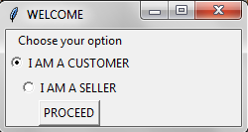

**EXISTING USER-LOGIN**

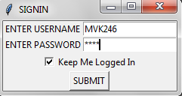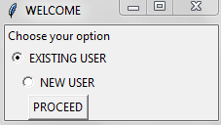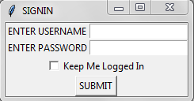

**PASSWORD AND USERNAME NOT MATCHED**

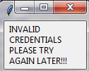

**PASS WORD AND USERNAME MATCHED**

HAI Mathew V.Kariath WELCOME TO MEDPLUS.COM

LET'S BEGIN SHOPPING!!!,TO CONTINUE SHOPPING PRESS THE ENTER KEY:

**1.2 NEW CUSTOMER REGISTRATION**

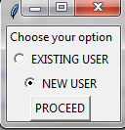

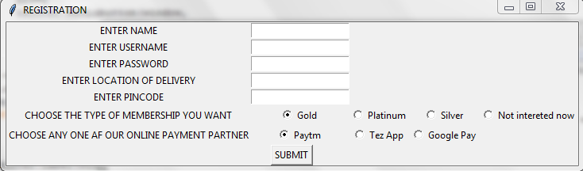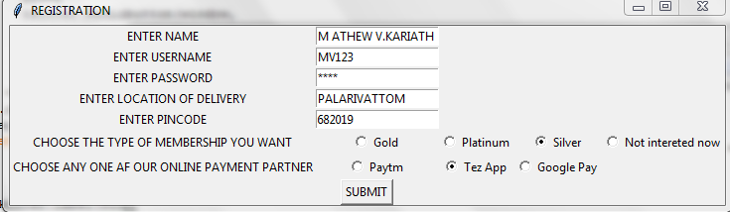

HAI MATHEW V.KARIATH WELCOME TO MEDPLUS.COM

LET'S BEGIN SHOPPING!!!,TO CONTINUE SHOPPING PRESS THE ENTER KEY:

**SHOPPING**

**2.1HAVE A PRESCRIPTION**

NOTE:THE USER WILL NOT HAVE THE LIST OF MEDICINES AVAILABLE IN OUR MEDICINE DIRECTORY.THE USER WILL HAVE TO ENTER THE NAMES OF THE MEDICINES AS PRESCRIBED BY THE MEDICAL PRACTITIONER

**HAVE NO PRESCRIPTION**

NOTE:THE USER CAN CHOOSE THE REQUIRED MEDICINEDS FROM THE LIST OF MEDICINES SEGREGATED BY THEIR TYPE.

**VIEWING THE CART AND MAKE CHANGES IF NECESSARY**

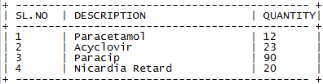

**3.1 REMOVING AN ITEM**

**3.2 MAKE A CHANGE IN THE QUANTITY**

**PAYMENT PAGE**

**MODE OF PAYMENT**

NOW IT'S TIME FOR PAYMENT!!!!

a.CASH ON DELIVERY

b.PAYMENT THROUGH OUR ONLINE PARTNER's APP

c.NET BANKING

ENTER YOUR CHOICE TO PROCEED:

**4.1 CASH ON DELIVERY**

ENTER YOUR CHOICE TO PROCEED: a

THANK YOU FOR CHOOSING CASH ON DELIVERY OPTION

PLEASE HAND OVER THE EXACT CHANGE TO OUR SERVICE EXCECUTIVE

THANK YOU

**4.2 PAYMENT THROUGH OUR ONLINE PARTNER's APP**

**4.2.1 CONTINUE WITH OPTION CHOSEN AT TIME OF REGISTRATION**

ENTER YOUR CHOICE TO PROCEED: b

AS PER THE DETAILS GIVEN AT THE TIME OF REGISTRATION YOU HAVE OPTED FOR Google Pay

TO CONTINUES WITH THIS PLEASE PRESS THE ENTER KEY,ELSE ENTER ANY OTHER KEY

THANK YOU FOR CHOOSING Google Pay

OUR SERVICE EXCECUTIVE WILL HELP YOU TO COMPLETE THE TRANSACTION AT THE TIME OF DELIVERY

**4.2.2CHANGE THE OPTION:**

ENTER YOUR CHOICE TO PROCEED: B

AS PER THE DETAILS GIVEN AT THE TIME OF REGISTRATION YOU HAVE OPTED FOR Google Pay

TO CONTINUES WITH THIS PLEASE PRESS THE ENTER KEY,ELSE ENTER ANY OTHER KEY no

NOW YOU CAN CHOOSE OUR PREFERRED PARTNER.THIS IS ONLY A TEMPORARY CHANGE.

1.Google Pay

2.Tez App

3.Paytm

ENTER YOUR CHOICE: 2

THANK YOU FOR CHOOSING Tez App

OUR SERVICE EXCECUTIVE WILL HELP YOU TO COMPLETE THE TRANSACTION AT THE TIME OF DELIVERY

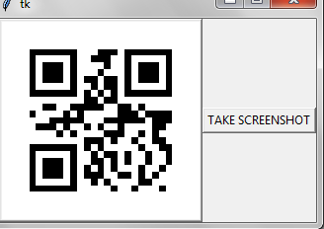**QR CODE GENERATION**

**THE SCREENSHOT TAKEN BY CLICKING “TAKE SCREENSHOT”**

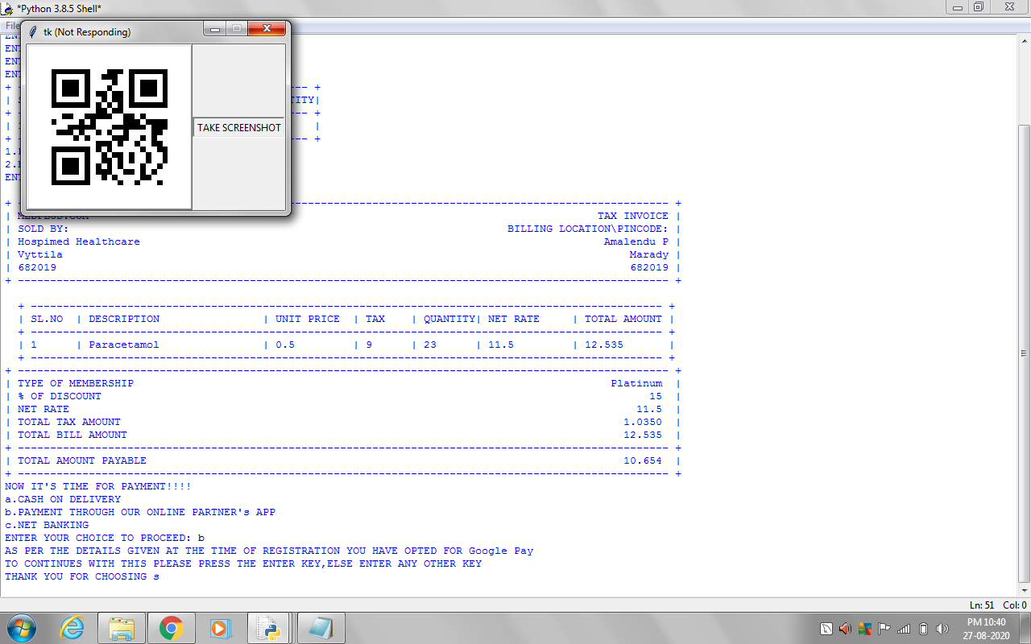

**4.3 ONLINE PAYMENT**

**4.3.1EXISTING USER**:

**4.3.1.1 NO MATCH AND REGISTER NEW CARD:**

ENTER USERNAME: VMK3119

ENTER A CARD NUMBER: 6048631042374130

ENTER CVV OF YOUR CARD: 290

ENTER YEAR OF EXPIRY: 2023

ENTER MONTH OF EXPIRY: 7

INVALID CREDENTIALS

OOPS WE WERE UNABLE TO FIND THE CARD IN OUR DATABASE.

TO REGISTER A NEW CARD PRESS THE ENTER KEY:

ENTER YOUR NEW USERNAME:MVK246

ENTER YOUR CARD NUMBER: 6048631042374135

ENTER CVV NUMBER: 142

ENTER YEAR OF EXPIRY: 2023

ENTER MONTH OF EXPIRY: 09

**4.3.1.2 MATCHED**

ENTER YOUR USERNAME:MVK246

ENTER YOUR CARD NUMBER: 6048631042374135

ENTER CVV NUMBER: 142

ENTER YEAR OF EXPIRY: 2023

ENTER MONTH OF EXPIRY: 09

**4.3.2 NEW USER-REGISTERING A NEW CARD**

ENTER YOUR NEW USERNAME:MVK246

ENTER YOUR CARD NUMBER: 6048631042374135

ENTER CVV NUMBER: 142

ENTER YEAR OF EXPIRY: 2023

ENTER MONTH OF EXPIRY: 09

**4.3.3 OTP GENERATION FOR COMPLETING PAYMENT**

YOUR OTP FOR THE TRANSACTION OF 2291.7 INR is RHYpMH . THIS SHOULD NOT BE REVEALED TO ANY ONE.THIS WILL BE VALID FOR ONLY 3 ATTEMPTS

RHYpMH

ENTER OTP: RHYpMh

ATTEMPT UNSUCCESSFULL,TRY AGAIN

ENTER OTP: RHYpMH

SUCCESSFULLY TRANSFERRED

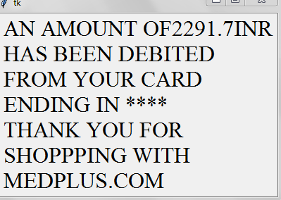

**4.3.4 AFTER SUCCESSFUL PAYMENT**

**BILL GENERATION**

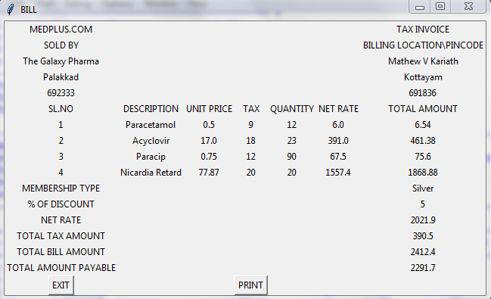

ON CLICKING “PRINT”-THE EXCEL FILE NAMED “BILL ” WILL POP UP AND THE BILL IS PRINTED IF CONNECTED TO A PRINTER

PRINT PREVIEW OF THE EXCEL SHEET

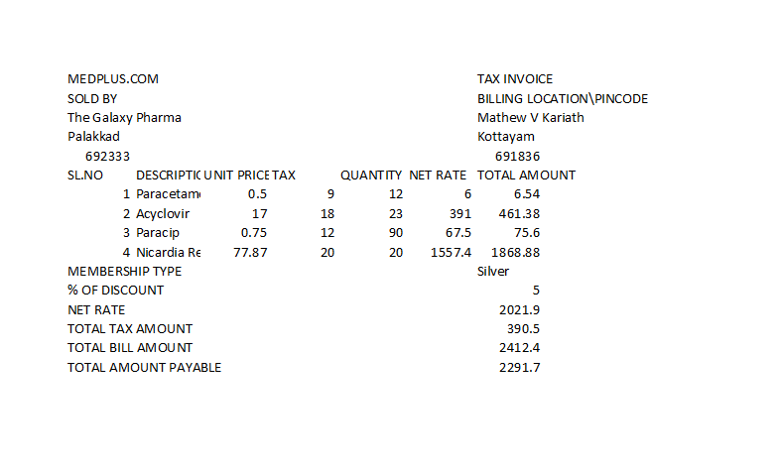



ON CLICKING “OK” THE PRINTER GETS ACTIVE AND PRINTS THE DOCUMENT

**CLOSING**

THANK YOU FOR CHOOSING MEDPLUS.COM

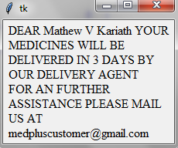

**SELLER**

**1.LOGIN AND REGISTRATION**

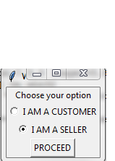

**1.1EXISTING USER-LOGIN**



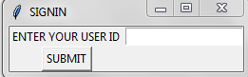

**1.1.1USERNAME NOT FOUND IN DATABASE**



**1.1.2PASS WORD AND USERNAME MATCHED**

HAI MG MEDICALS WELCOME TO MEDPLUS.COM

**1.2 NEW CUSTOMER REGISTRATION**



HAI SELLER TO VIEW YOUR REPORTS PLEASE REGISTER

PRESS THE ENTER THE ENTER KEY TO REGISTER AS A SELLER:

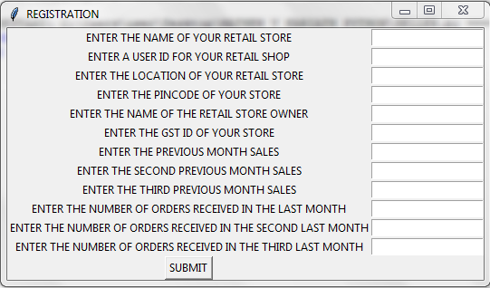

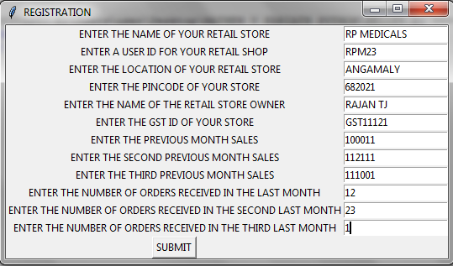

HAI RP MEDICALS WELCOME TO MEDPLUS.COM

1.VIEW MY PROFILE

2.REPORTS

**2.VIEW MY PROFILE**

**2.1EDITING DETAILS**

NOTE:THE USER CAN NOW EDIT THE DETAILS REGARDING HIS RETAIL STORE

PLEASE ENTER YOUR CHOICE: 1

1.STORE DETAILS

2.FINANCIAL DETAILS

ENTER YOUR OPTION:

**2.1.1 STORE DETAILS**

NOTE:THE USER CAN EDIT DETAILS REGARDING THE STORE LIKE NAME OF RETAIL STORE,NAME OF OWNER AND LOCATION

1.NAME OF THE RETAIL STORE

2.NAME OF OWNER

3.LOCATION AND PINCODE

**2.1.1.1 NAME OF RETAIL STORE**

ENTER YOUR CHOICE:1

ENTER THE OLD NAME OF THE RETAILS STORE AS PER REGISTERED: MG MEDICALS

ENTER THE NEW NAME OF THE RETAILS STORE TO BE REGISTERED: MG PHARMACY

**2.1.1.2 NAME OF OWNER**

ENTER YOUR CHOICE:2

ENTER THE OLD NAME OF THE OWNER AS PER REGISTERED: THOMAS

ENTER THE NEW NAME OF THE OWNER STORE TO BE REGISTERED: JOSEPH

**2.1.1.3 LOCATION AND PINCODE**

ENTER YOUR CHOICE:3

ENTER THE OLD LOCATION STORE AS PER REGISTERED: Moonar

ENTER THE NEW LOCATION THE RETAILS STORE TO BE REGISTERED: IDUKKI

ENTER THE NEW PINCODE OF THE AREA: 682020

**2.1.2 FINANCIAL DETAILS**

NOTE:THE USER CAN CHANGE THE DETAILS LIKE HIS SALES OF THE PREVIOUS MONTH AND THE GST NUMBER

1.GST NUMBER

2.SALES

ENTER YOUR CHOICE:

**2.1.2.1 GST NUMBER**

ENTER YOUR CHOICE: 1

ENETER THE OLD GST REGISTERED: GST123123

ENETER THE NEW GST RETAILS STORE TO BE REGISTERED: GST123120

**2.1.2.2 SALES AMOUNT**

ENTER YOUR CHOICE: 2

ENETER THE NEW SALES OF THE RETAILS STORE TO BE REGISTERED11000

**2.2 DETAILS AFTER EDIT**

**3.REPORTS SECTION**

WELCOME TO THE REPORT SECTION OF ALL REGISTERD SELLERS

1.VIEW ALL SELLERS

2.VIEW MY NEIGHBOURS

3.VIEW MY COMPETITIONS

4.SEE RANKING AND VIEW MY RANK

5.VIEW PERSONAL PROFILE

6.VIEW PROJECTED SALES FOR THE NEXT MONTH

7.VIEW MARKET PULSE

ENTER YOUR CHOICE:

**3.1 VIEW ALL SELLERS**

NOTE:VIEW THE BAR GRAPH OF ALL SELLERS REGISTERED WITH MEDPLUS.COM

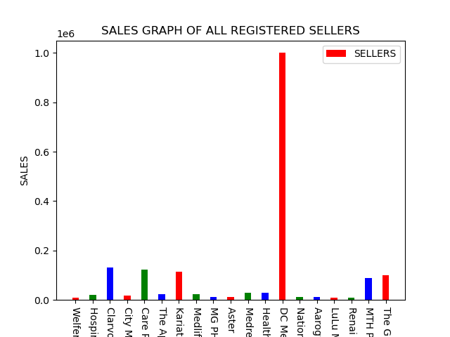

**3.2 VIEW NEIGHBOURS**

NOTE:THE SELLER CAN VIEW ALL HIS NIGHBOURS AS WELL AS THEIR SALES

1.VIEW ALL MY NEIGHBOURS

2.GRAPHICALLY VIEW MY NEIGHBOURS

ENTER YOUR CHOICE:

**3.2.1 VIEW ALL MY NEIGHBOURS**

**3.2.2 GRAPHICALLY VIEW MY NEIGHBOURS**

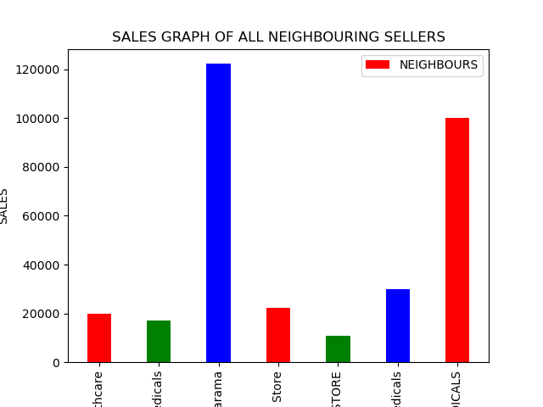

**3.3 VIEW COMPETITORS**

NOTE:THE SELLER CAN VIEW ALL HIS COMPETITINS AS WELL AS THEIR SALES

1.SET LIMIT

2.PROCEED WITH DEFAULT LIMIT

ENTER YOUR CHOICE:

**3.3.1 SETTING A LIMIT OF COMPARISON**

NOTE:NOW THE USER CAN SET A LIMIT IN RUPEES TO COMPARE HIMSELF WITH OTHERS

ENTER YOUR CHOICE: 1

ENTER YOUR LIMIT: 100000

1.VIEW ALL MY COMPETITIONS

2.GRAPHICALLY VIEW MY COMPETITIONS

ENTER YOUR CHOICE:

**3.3.1.1 VIEW ALL COMPETITIONS**

**3.3.1.2 GRAPHICALLY VIEW MY COMPETITIONS**

**3.3.2 PROCEEDING WITH THE DEFAULT VALUE**

**3.3.2.1 VIEW ALL COMPETITIONS**

**3.3.2.2 GRAPHICALLY VIEW MY COMPETITIONS**

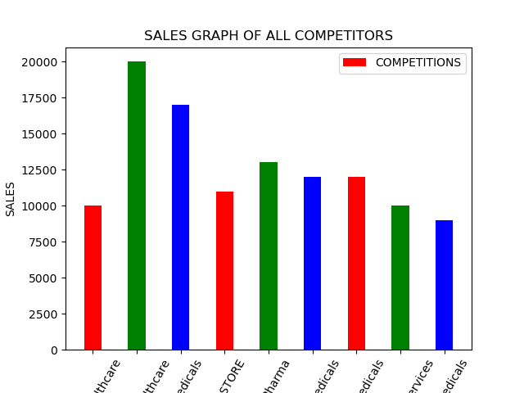

**3.4 VIEW RANKING AND THE SELLER’S POSITION**

**3.5 VIEW PERSONAL PROFILE**

1.SEE MY GROWTH

2.SEE MY MONTHLY SALES DISTRIBUTION

ENTER YOUR CHOICE:

**3.5.1 VIEW THE SELLER’S GROWTH**

NOTE: THE USER CAN NOW VIEW THE LINE GRAPH WITH ORDERS AND SALES

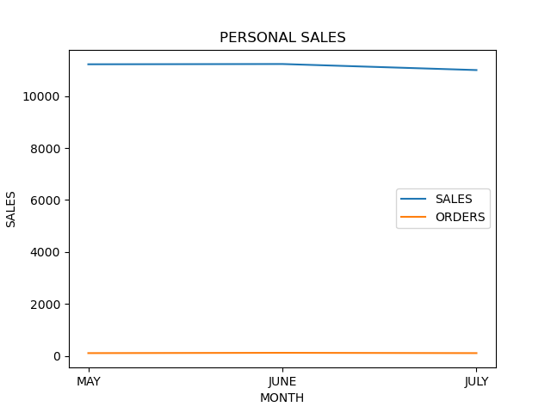

**3.5.2 VIEW MONTHLY SALES DISTRIBUTION FOR THW LAST 3 MONTHS**

NOTE: THE USER CAN NOW VIEW THE PIE PLOT OF THE LAST MONTH’S SALES

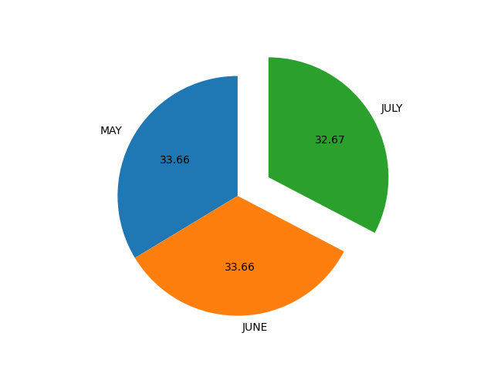

**3.6 VIEW PROJECTED SALES FOR THE NEXT MONTH**

DEAR MG PHARMACY YOUR PROJECTED SALES FOR THE NEXT MONTH IS 11223

**3.7 VIEW MARKET PULSE**

NOTE:GIVES A GENERAL IDEA ABOUT THE SALES AND ORDERS IN THE MARKET FOR THE PAST 3 MONTHS

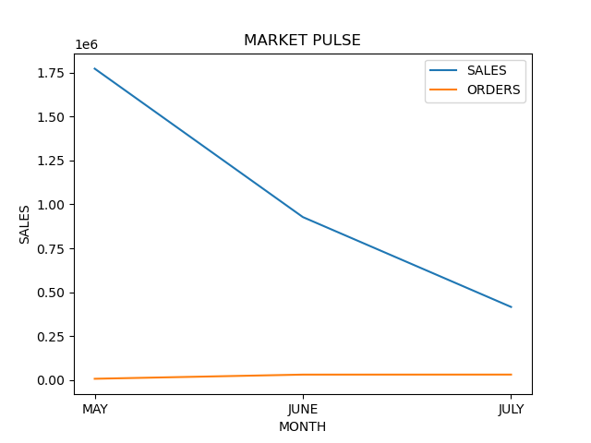

**4.CLOSING**

DISPLAY ALL THE GRAPH GENERATED IN A SINGLE WINDOW

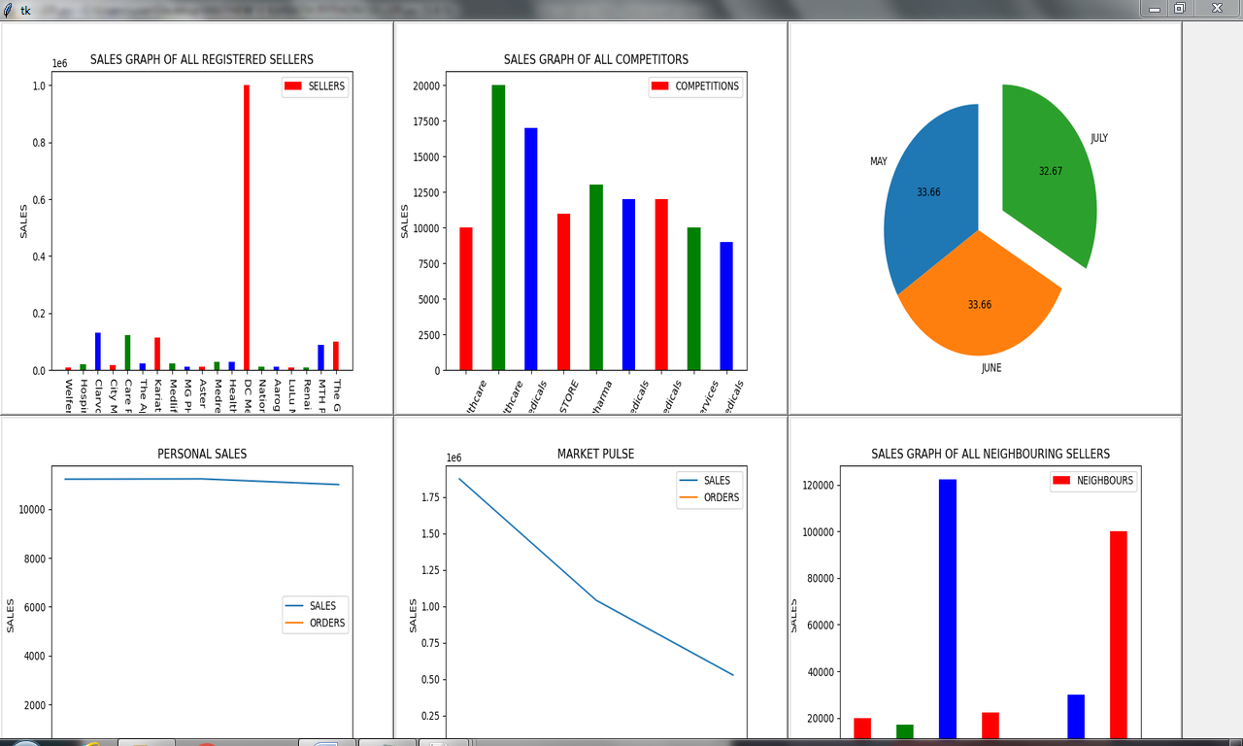

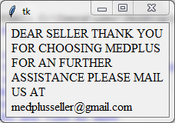

**5.TERMS AND CONDITIONS**

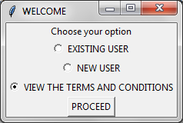

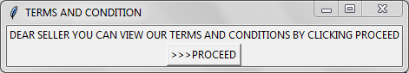

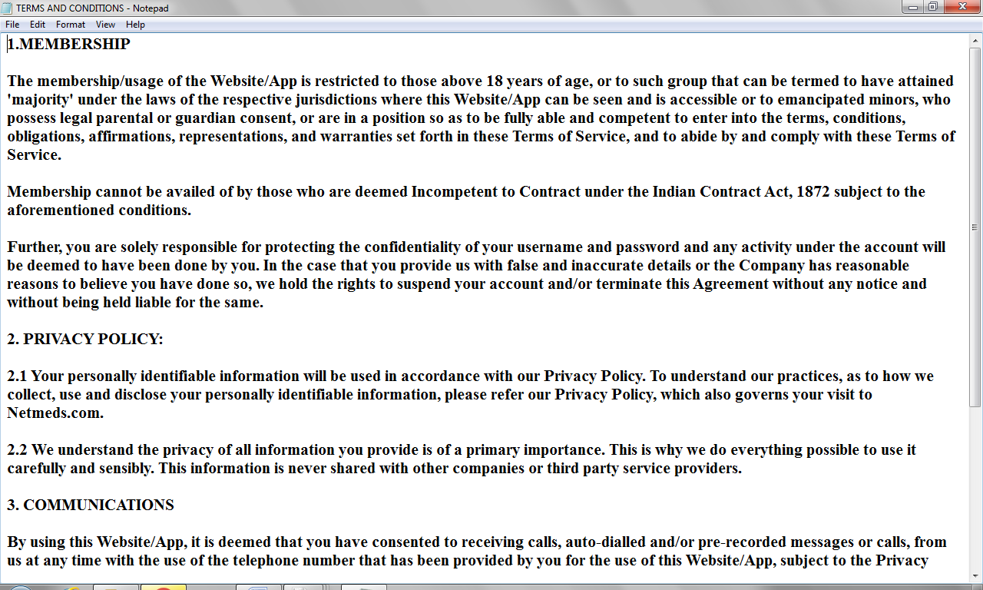

THANK YOU FOR SHOPPING WITH MEDPLUS