**Assignment 1**

**Install Power BI Desktop and share the final screenshot of the report view page which appears when power desktop starts.**

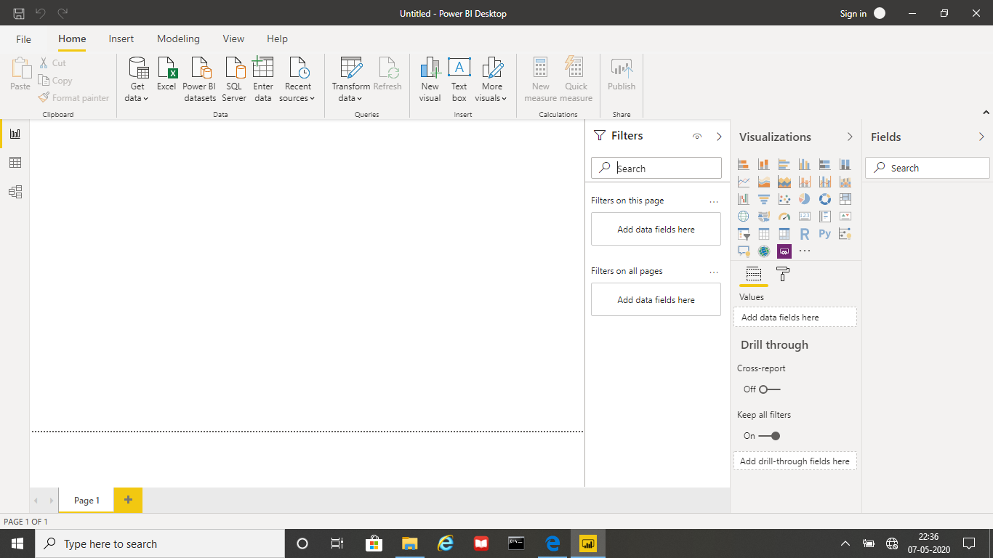

**Prepare a document and with the following screenshot**

Report View



Data View

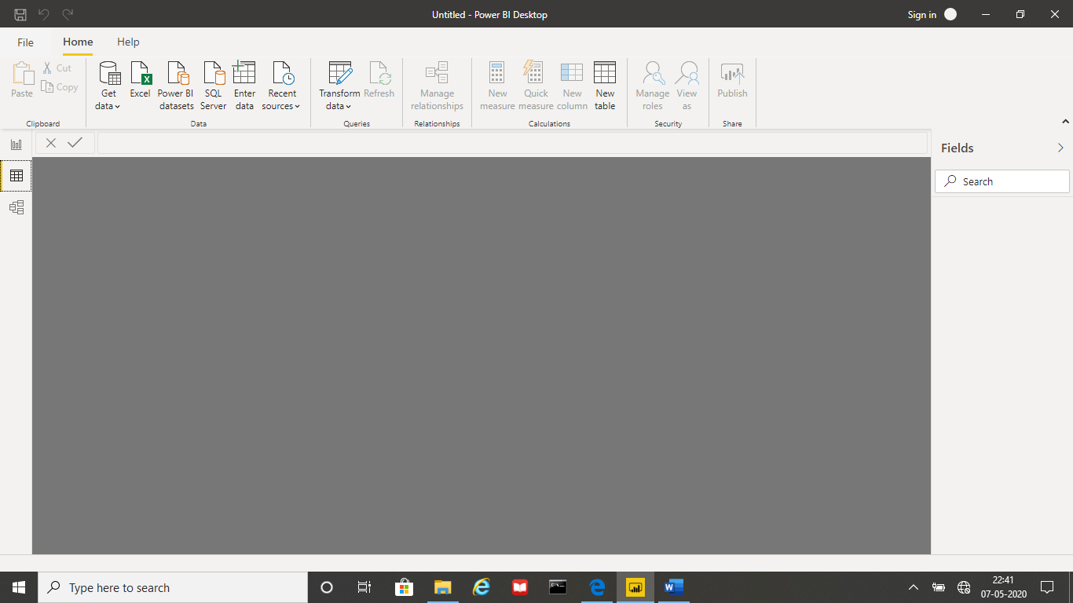

Model View

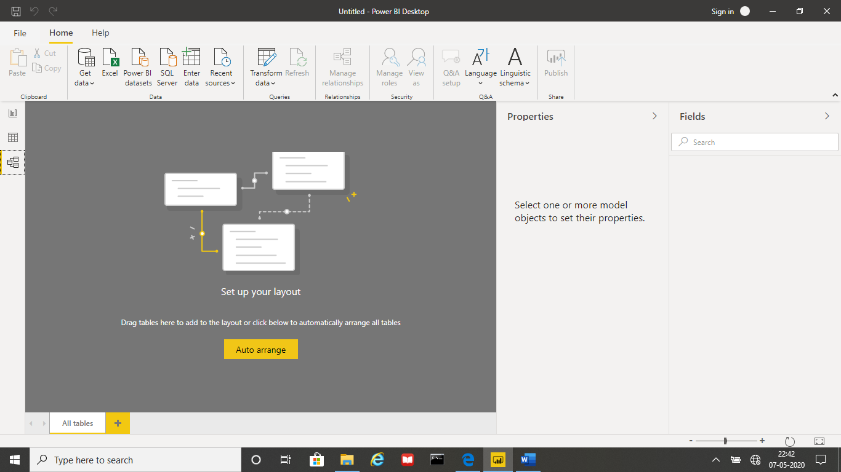

Power Query Editor

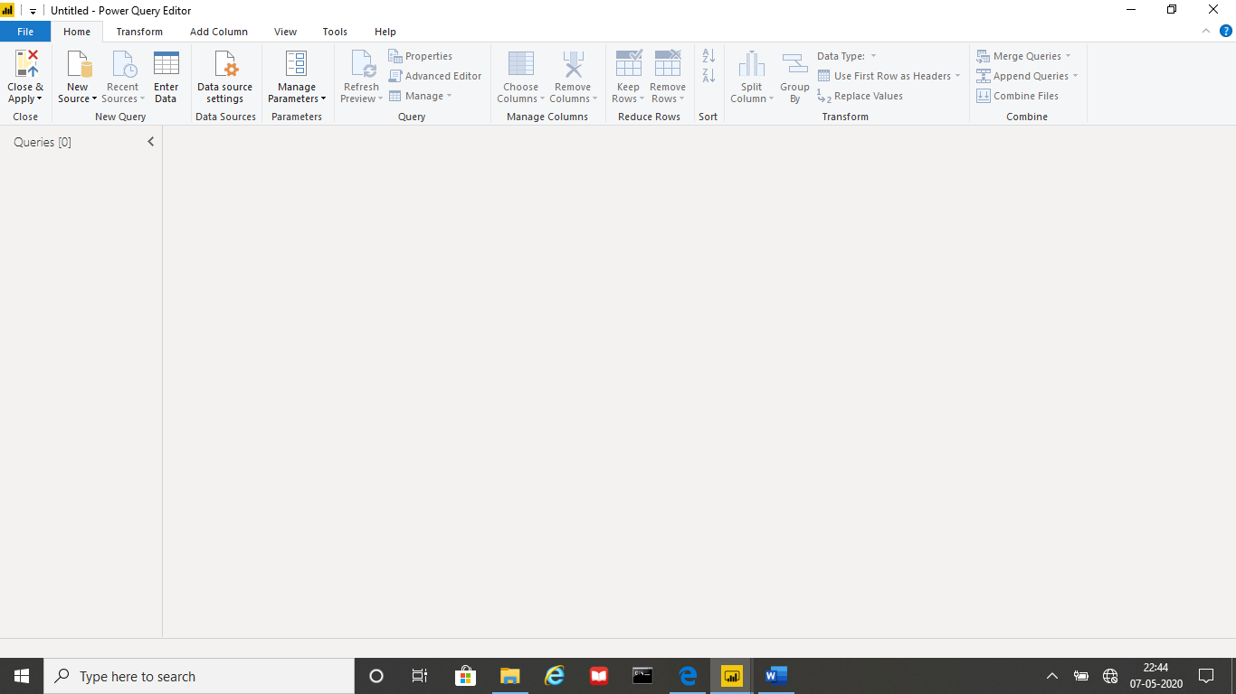

Advance Editor

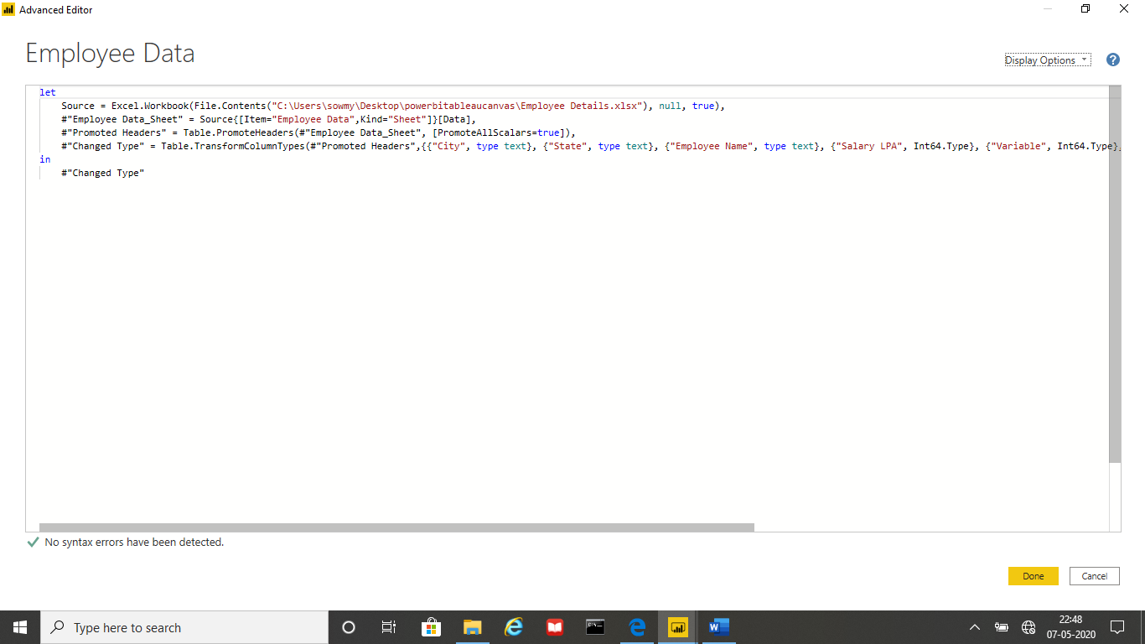

**Prepare a document with details of the following along with their price**

**PowerBI Desktop**

Power BI Desktop is a free application you install on your local computer that lets you connect to, transform, and visualize your data. With Power BI Desktop, you can connect to multiple different sources of data, and combine them (often called modeling) into a data model. This data model lets you build visuals, and collections of visuals you can share as reports, with other people inside your organization. Most users who work on business intelligence projects use Power BI Desktop to create reports, and then use the Power BI service to share their reports with others.

The most common uses for Power BI Desktop are as follows:

* Connect to data
* Transform and clean that data, to create a data model
* Create visuals, such as charts or graphs, that provide visual representations of the data
* Create reports that are collections of visuals, on one or more report pages
* Share reports with others by using the Power BI service

There are three views available in Power BI Desktop, which you select on the left side of the canvas. The views, shown in the order they appear, are as follows:

Report: In this view, you create reports and visuals, where most of your creation time is spent.

Data: In this view, you see the tables, measures, and other data used in the data model associated with your report, and transform the data for best use in the report's model.

Model: In this view, you see and manage the relationships among tables in your data model.

Minimum requirements to run Power BI Desktop:

* Windows 7 / Windows Server 2008 R2, or later
* .NET 4.5
* Internet Explorer 9 or later
* Memory (RAM): At least 1 GB available, 1.5 GB or more recommended.
* Display: At least 1440×900 or 1600×900 (16:9) recommended. Lower resolutions such as 1024×768 or 1280×800 are not recommended, as certain controls (such as closing the startup screen) display beyond those resolutions.
* Windows Display settings: If your display settings are set to change the size of text, apps, and other items to more than 100%, you may not be able to see certain dialogs that must be closed or responded to in order to proceed using Power BI Desktop. If you encounter this issue, check your Display settings by going to Settings > System > Display in Windows, and use the slider to return display settings to 100%.
* CPU: 1 gigahertz (GHz) or faster x86- or x64-bit processor recommended.

Pricing : Free

**PowerBI Pro**

Power BI Pro is the full version of Power BI, which means it comes complete with the ability to use Power BI for both building dashboards, reports and unlimited viewing, sharing and consumption of your created reports (and reports shared by others) which is not possible with Power BI Desktop.

The biggest difference of Power BI Pro vs. Free is the fact that with Pro you have the option and the ability to share the data, reports, and dashboards with a large number of other users that also have a Power BI Pro license while also being able to create an app based workspace.

You use Power BI Pro in your organisations means each individual will receive their won Power BI Pro license and the collaborative use of which will allow every member of the organisation to integrate their workspace and therefore, their efforts.

Pricing: The Pro plan costs $9.99/user/month. It includes data collaboration, data governance, building dashboards with a 360-degree real-time view and the ability to publish reports anywhere. Users can try it a free trial for 60 days before purchasing the subscription.

**PowerBI Premium**

Power BI Premium licence provides a dedicated unit of capacity for all users in the organisation. This dedicated capacity (aka Premium Workspace) can be used to host large datasets up to 50GB while offering a total storage of 100TB in the cloud.

It enables your organization to use your own dedicated capacity and hardware rather than relying on Microsoft’s shared capacity. Although you will in fact need to determine said capacity accurately and ensure that it has the capabilities to handle your reporting and analysis needs. This allows for much larger scale and better performance if you size the capacity properly. Microsoft offers three sizes for Premium capacity and each come with a different number of v-cores and memory size.

Power BI Premium is for use in large organisations with a great number of users that need to collaborate in real time. The application is geared towards addressing the challenges of large enterprise deployments and workloads.

Pricing: The Premium plan starts at $4,995 a month per dedicated cloud compute and storage resource. This does not include the cost of licensing for individual Pro and Free licenses required for each user in your organisation.