**Power BI Dashboard**

**User Management**

**Introduction**

User Management is a dashboard where one can add a user details, edit user details and delete user details from the database. The User Management dashboard mainly three modules, namely:

1. Add User Details

2. Edit User Details

3. Delete User Details

**Home Page**

The home page has three buttons namely Add, Edit and Delete where one clicking on the Add button presents him the form asking for the user details that are to be added to the database and to submit, clicking on the Edit button presents him the form asking for the user details that are to be edited and saved to the database and to submit, clicking on the Delete button presents him the form asking for the user details that are to be deleted from the database and to submit.

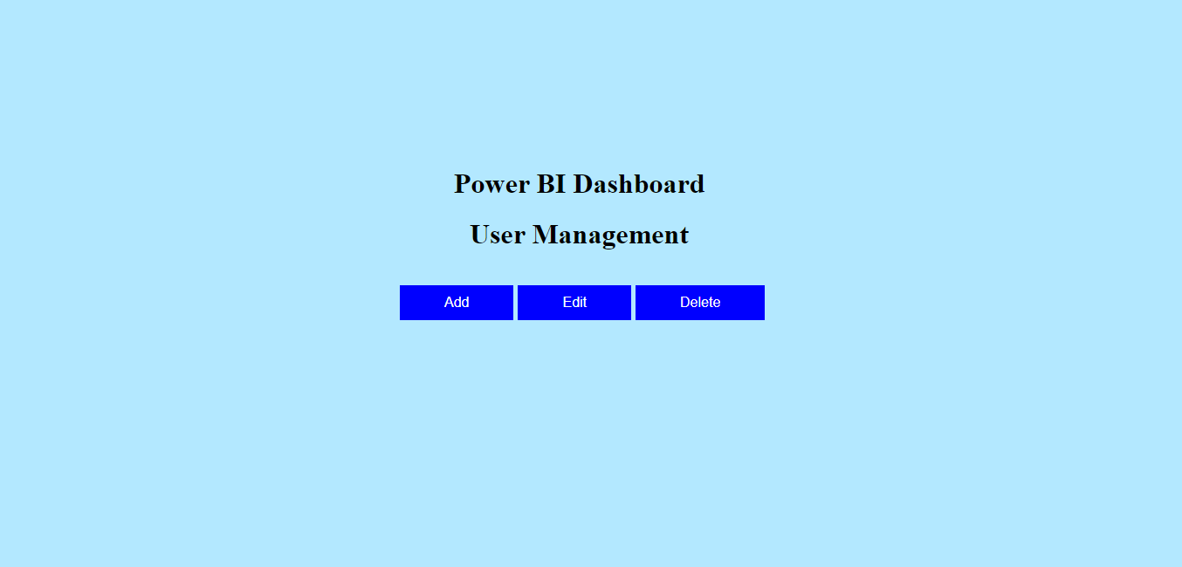

**Modules Description**

**1. Add User Details**

In this module, one can add a user details to the database. By clicking on the Add button in the home page, he will be shown with a form asking for the user details that are to be added to the database and to submit.

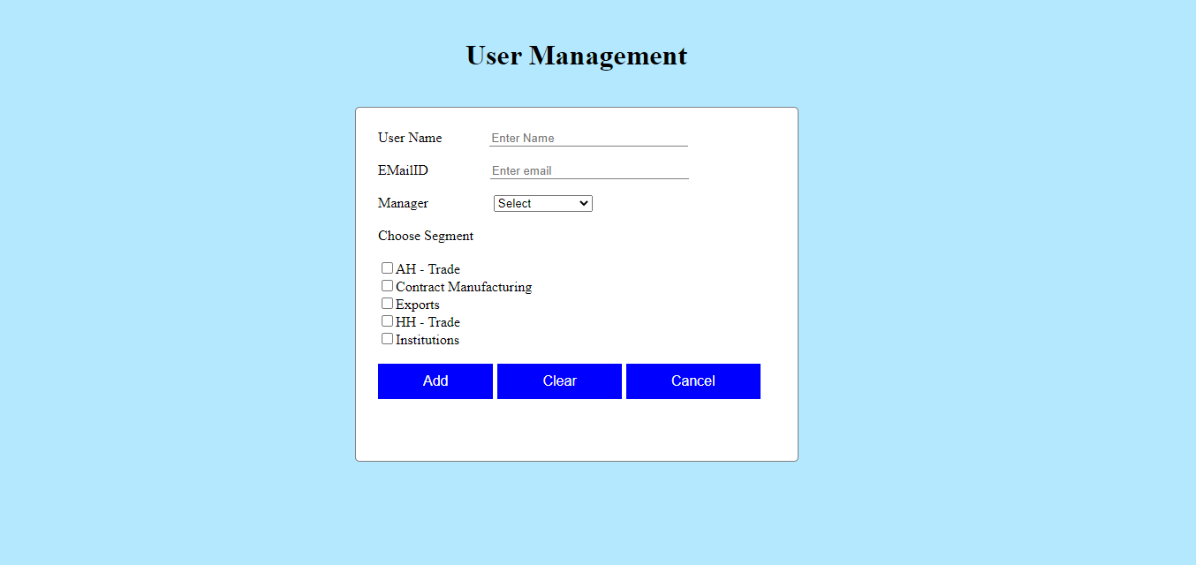

The form asks for the details like Username, EmailID, Manager and Segment. After filling the form, when he clicks on Add button, it validates the email according to the pattern that has been mentioned. If the email is validated, the user details are added to the database and he will be taken to the home page. When the Clear button is clicked, the form gets reset. When the Cancel button is clicked, he will be taken to the home page.

**2. Edit User Details**

In this module, one can edit and save user details to the database. By clicking on the Edit button in the home page, he will be shown with a form asking for the user details that are to be edited and saved to the database and to submit.

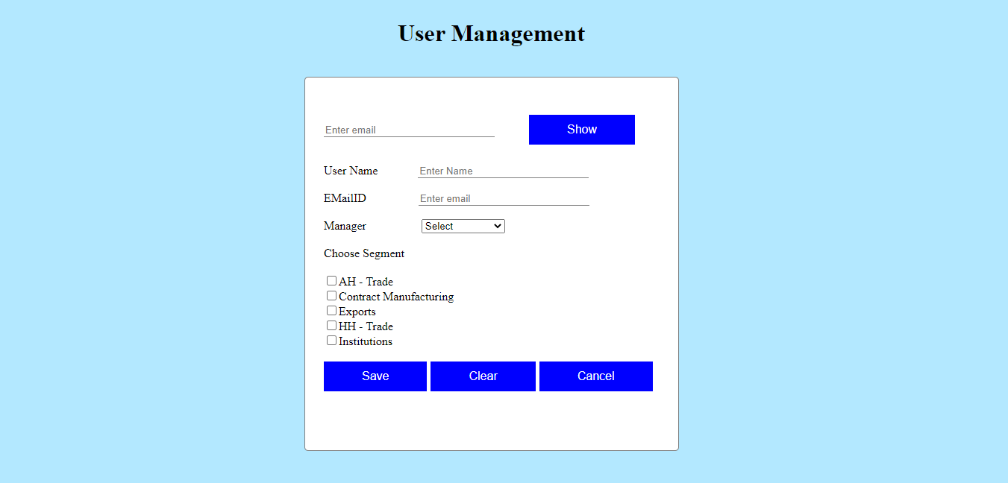

In the form, at first, it asks for the EmailID so that when one clicks the Show button, the user details related to the emailid provided are shown on the screen if it is already present in the database, else it shows an alert that the user is not found. When the displayed on the screen, one can edit the details accordingly. When he clicks the Save button, the user details are saved in the database and he will be taken to the home page. When the Clear button is clicked, the form gets reset. When the Cancel button is clicked, he will be taken to the home page.

**3. Delete User Details**

In this module, one can delete user details from the database. By clicking on the Delete button in the home page, he will be shown with a form asking for the user details that are to be deleted from the database and to submit.

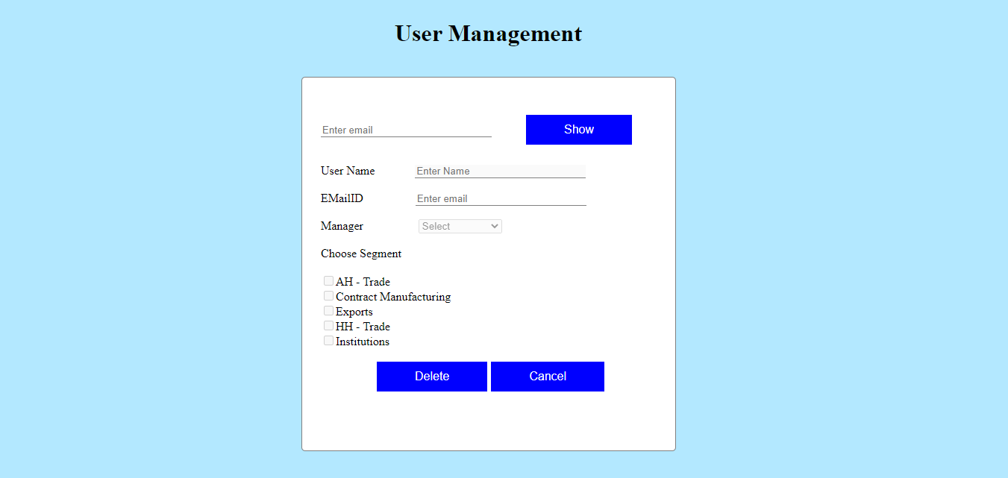

In the form, at first, it asks for the EmailID so that when one clicks the Show button, the user details related to the emailid provided are shown on the screen if it is already present in the database, else it shows an alert that the user is not found. The details are displayed on the screen but are not editable. When one clicks the Delete button, the user details are deleted from the database and he will be taken to the home page. When the Cancel button is clicked, he will be taken to the home page.

**Sample Screenshots**

