Empathy Map for Future Sales Prediction:

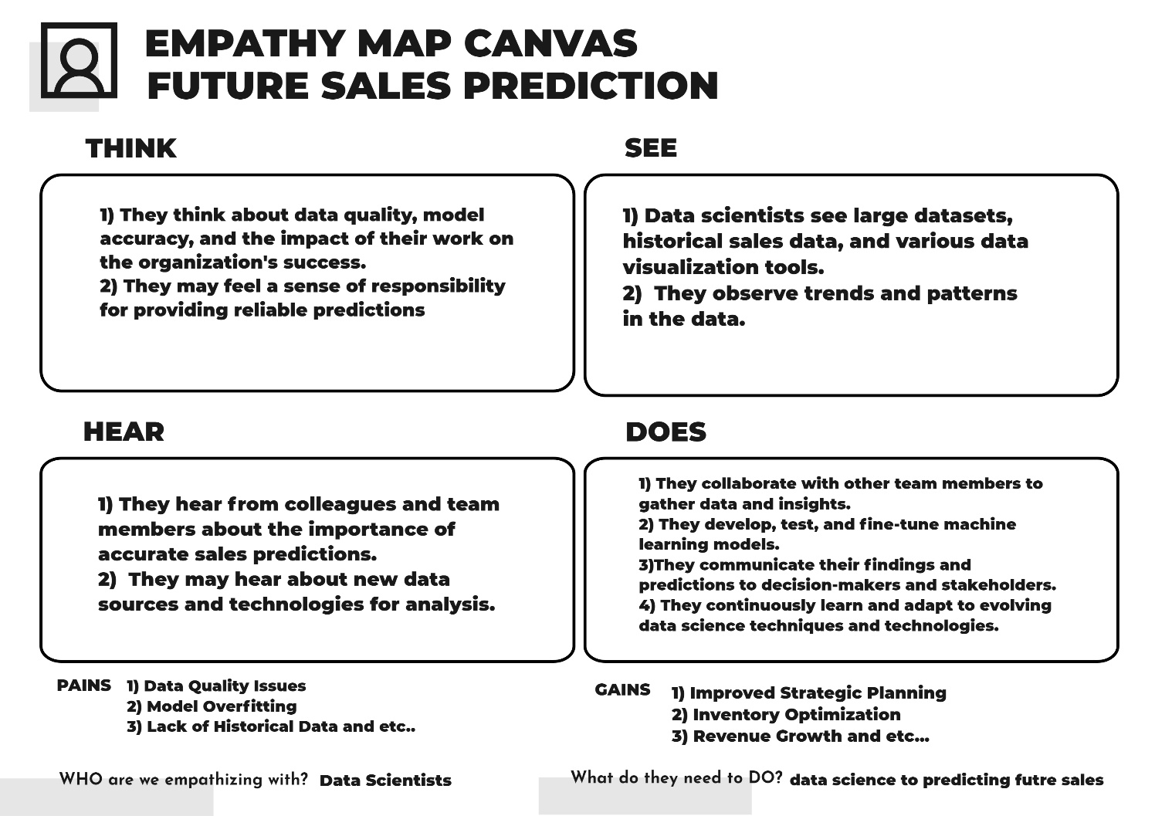

FUTURE SALES PREDICTION:

Problem:

Explain in detail the complete steps that will be taken by you to put your design that you thought of in previous phase into transformation.

Output:

1. Data Collection:

* Gather historical sales data, including date, product/service, location, price, and other relevant factors.
* Collect additional external data that may impact sales, such as economic indicators, seasonality, holidays, and marketing campaigns.

1. Data Preprocessing:

* Clean and preprocess the data to handle missing values, outliers, and inconsistencies.
* Convert categorical variables into numerical format using techniques like one-hot encoding or embeddings.
* Normalize or scale numerical features to bring them to a common scale.

1. Feature Engineering:

* Create new features that might be informative for sales predictions, such as rolling averages, trend indicators, and seasonality features.

1. Splitting the Data:

* Divide the dataset into training, validation, and test sets to assess and validate the model's performance accurately.

1. Model Selection:
   * + Choose an appropriate machine learning model for sales prediction. Common choices include:
     + Time series forecasting models (e.g., ARIMA, Exponential Smoothing).
     + Regression models (e.g., Linear Regression, Random Forest).
     + Neural networks (e.g., LSTM, GRU for sequence data).
2. Model Training:

* Train the selected model using the training data.
* Optimize hyperparameters using techniques like cross-validation and grid search.

1. Model Evaluation:
   * + Evaluate the model's performance using the validation dataset.
     + Use appropriate metrics such as Mean Absolute Error (MAE), Mean Squared Error (MSE), or Root Mean Squared Error (RMSE) to measure accuracy.
2. Hyperparameter Tuning:

* Fine-tune the model by adjusting hyperparameters based on validation results.

1. Model Deployment:

* Deploy the trained model to a production environment, such as a web application or an API.

1. Monitoring and Maintenance:
   * + Continuously monitor the model's performance in a real-world setting.
     + Retrain the model periodically to account for changing trends and patterns.
2. Visualization and Reporting:

* Create interactive dashboards or reports to present sales predictions and insights to stakeholders.