**Work Experience Week 2021 Air Quality Project**

**Intro:**

You’re going to create a device that will measure the air quality in your house or out your window and will send that data to a platform where you can visualise and compare it to others in the group!

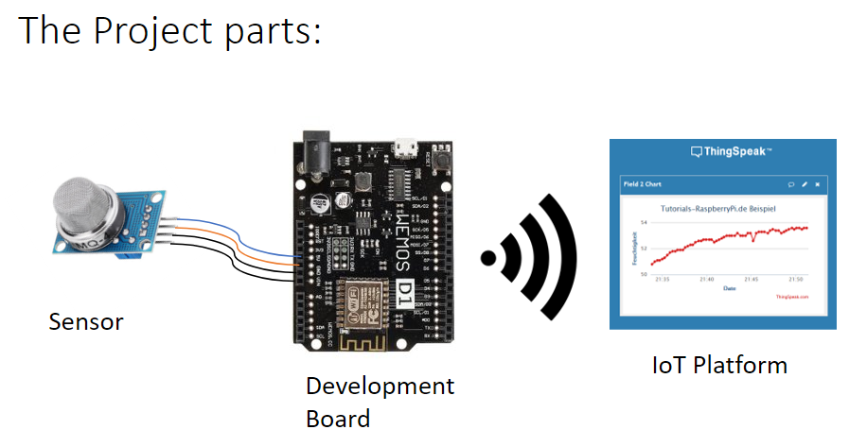

We’ll talk through sensors later. Thingspeak is an IoT (Internet of things) platform where we’ll collect all our data from our sensors and process that data.

**Development Board**

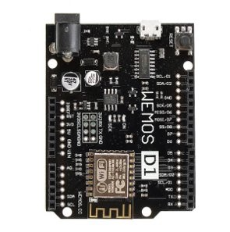This board is called a **wemos** and is a wifi enabled microcontroller – which is great for prototyping internet enabled electronics projects. It runs on the **arduino** platform – which is a great program for writing and uploading C++ code.

**1. Setting up your Wemos to program:**

1. Download and install Arduino from [here](https://www.arduino.cc/en/software) (mac, windows & linux)
2. Open Arduino
3. Click File > Preferences > Additional Board Managers
4. Paste the following into the box:
5. <http://arduino.esp8266.com/stable/package_esp8266com_index.json>
6. Click Tools > Boards > Boards Manager
7. Click Type > Contributed
8. Find **esp8266 by ESP8266 Community** and click install
9. Click Tools > Board > ESP8266 Boards > LOLIN(WEMOS) D1 R2 & mini
10. Click Tools > Upload Speed > 115200
11. Plug in wemos to computer using the USB cable, give your computer a few seconds to recognise the board (windows should make a noise when plugged in)
12. Click Tools > Port > COMx, where x is any number greater than 1. If you can’t see a COM port, check your USB, possibly try a different USB port on your computer.
13. Click File > Examples > ESP8266 > Blink. This will load an example piece of code.
14. Click the  upload button. You should see the sketch compiling at the bottom of the arduino window, and then a writing % in red text. It may take a little while to upload. Once it’s Done uploading you should see a blue LED light blink on for 1 second and off for 2 seconds and repeat over and over.   
    *Note: when you first plug in your wemos the light may already be flashing on and off every second – now it should be off for two seconds, on for one if the upload succeeded.*

Drivers for windows and mac if needed: <https://www.wemos.cc/en/latest/ch340_driver.html>

**2. Blink Code:**

Below is the code you’ve loaded on to the Wemos board. We’re blinking on and off an LED light (Light Emitting Diode) in the loop in the code below.

void setup() {

pinMode(LED_BUILTIN, OUTPUT); // Initialize the LED_BUILTIN pin as an output

}

// the loop function runs over and over again forever

void loop() {

digitalWrite(LED_BUILTIN, LOW); // Turn the LED on (Note that LOW is the voltage level

// but actually the LED is on; this is because

// it is active low on the ESP-01)

delay(1000); // Wait for a second

digitalWrite(LED_BUILTIN, HIGH); // Turn the LED off by making the voltage HIGH

delay(2000); // Wait for two seconds (to demonstrate the active low LED)

}

Let’s talk through the main features of the code:

* **void setup()**  - function called at the start of the program, everything within the { } will run only once. In this case we’re setting up the LED pin as an output
* **void loop()** –everything within the{ } is looped over and over after setup has finished - in this case turning the LED on and then off over and over.
* **//** - means comment, we use this to annotate our code with notes
* **DigitalWrite –** we're telling a digital pin on the wemos to turn on or off – in this case the LED light, but in future our air quality sensors!
* **delay(x)** – pause program for x number of milliseconds, so 1000 = 1 second

**Why don’t you change the delay values to smaller or larger values – what do you think will happen to the LED? Upload the code and see what happens!**

**3. Sensors Research**

We’re using two sensors that we’ll hook up to the wemos:

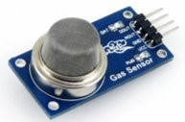**MQ-135** - Measures general air quality [Datasheet](https://www.olimex.com/Products/Components/Sensors/Gas/SNS-MQ135/resources/SNS-MQ135.pdf)

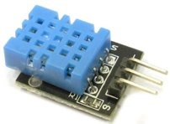**DHT11** - Measures temperature and humidity [Datasheet](https://components101.com/sensors/dht11-temperature-sensor)

**Research time, as a group:**

* **How do the sensors work?**
* **What are you trying to measure?**
* **how will you wire them up?**
* **analog & digital sensors with arduino?**
* **Make a wiring diagram in padlet**
* **how do you think the code will work?**
* **What do you think the data will show?**

After this you will do a Show & Tell with the other groups.