Scratch for Raspberry Pi Setup

1. Mount image of Raspbian onto SD card (SD card size must be at least 4GB)
   1. Go to <http://www.raspberrypi.org/downloads>
   2. Scroll down the page and click on the download link highlighted to download the software (called an image, but doesn't mean the same thing as a picture!)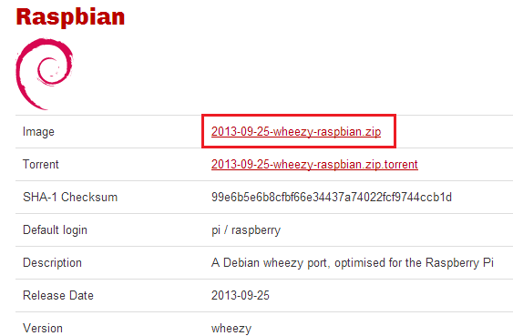
   3. Insert your SD card into your computer (your computer must have a card reader)
   4. Go to <https://www.sdcard.org/downloads/formatter_4/> and click the relevant link shown at the side of the page, depending on your computer's operating system (Windows or Mac)

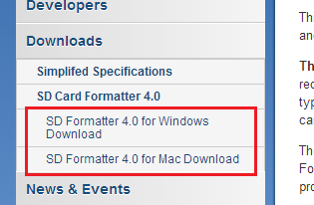

* 1. Accept the terms and conditions and download the SD card formatter setup program
  2. Double-click the downloaded file and install the SD card formatter software
  3. Go to <http://sourceforge.net/projects/win32diskimager/> and click on the green download link. This software will be used to 'mount' the image (Raspbian) onto the SD card. First, we have to format the SD card.
  4. Open up the SD Formatter and format your SD card with the default settings (ensure your SD card is selected!)
  5. Open Win32DiskImager, select the Raspbian image you downloaded earlier and ensure the device selected is your SD card. Click 'Write' to write the Raspbian image to the SD card. This may take a few minutes!

1. Slot SD card into Rasperry Pi and connect HDMI, USB keyboard and mouse and finally the power cable
2. Wait for the Raspberry Pi to start up
3. On the 'Setup Options' screen, select the '1 Expand Filesystem' option and press return on the keyboard. This ensures all of your SD card's space will be available for use
4. Select the '3 Enable Boot to Desktop/Scratch' option by highlighting it using the arrow keys and press return
5. Select the bottom option 'Scratch' and press return
6. Press the right arrow key twice to select the '<Finish>' option, and press return. Select '<Yes>' when asked is you want to reboot now, and press return
7. Wait for the Raspberry Pi to boot up again. It will eventually show the Scratch programming environment