**Hedgehog bot**

# Parts checkt

Check that you have the following parts in your pack.

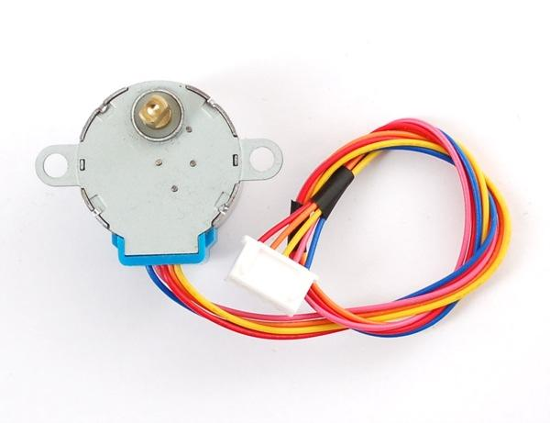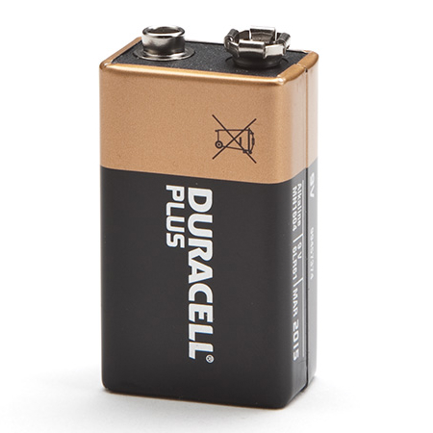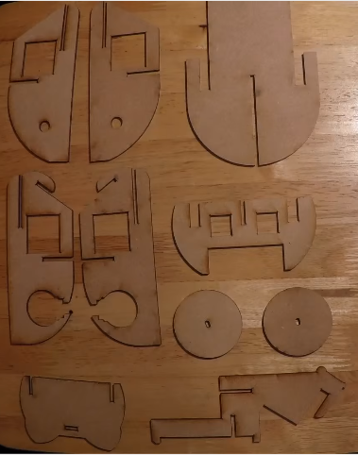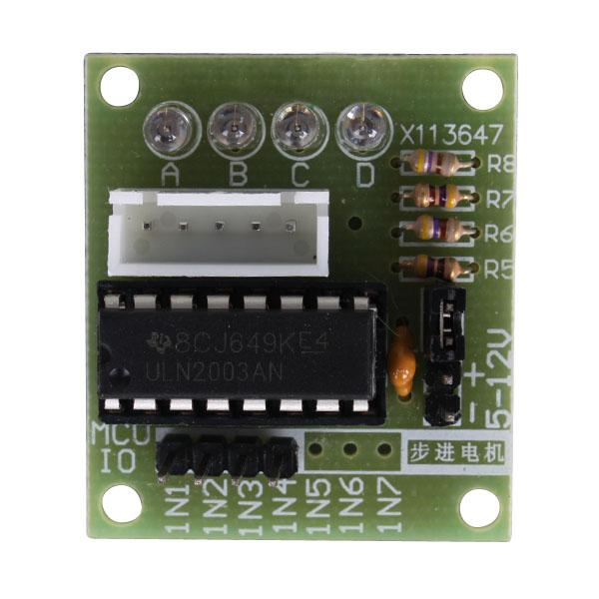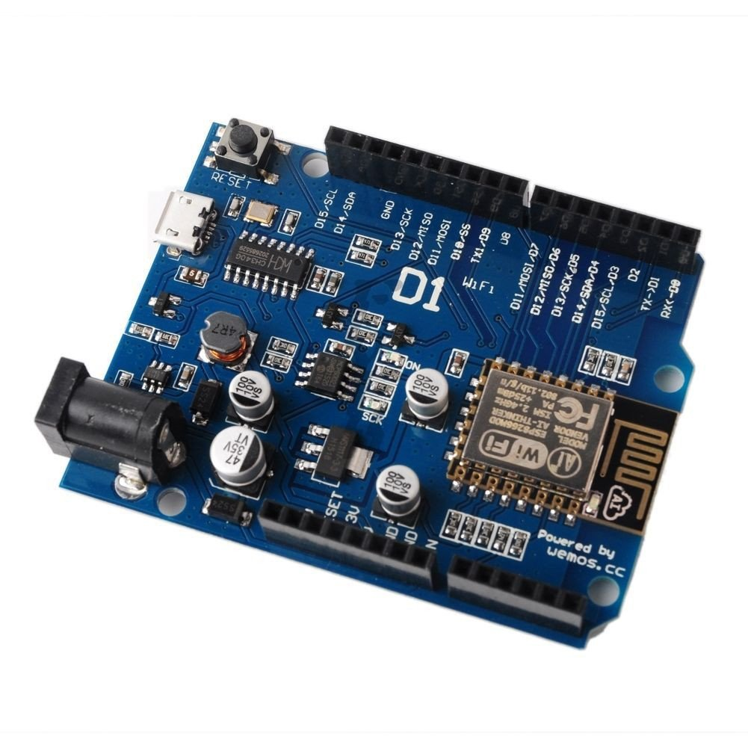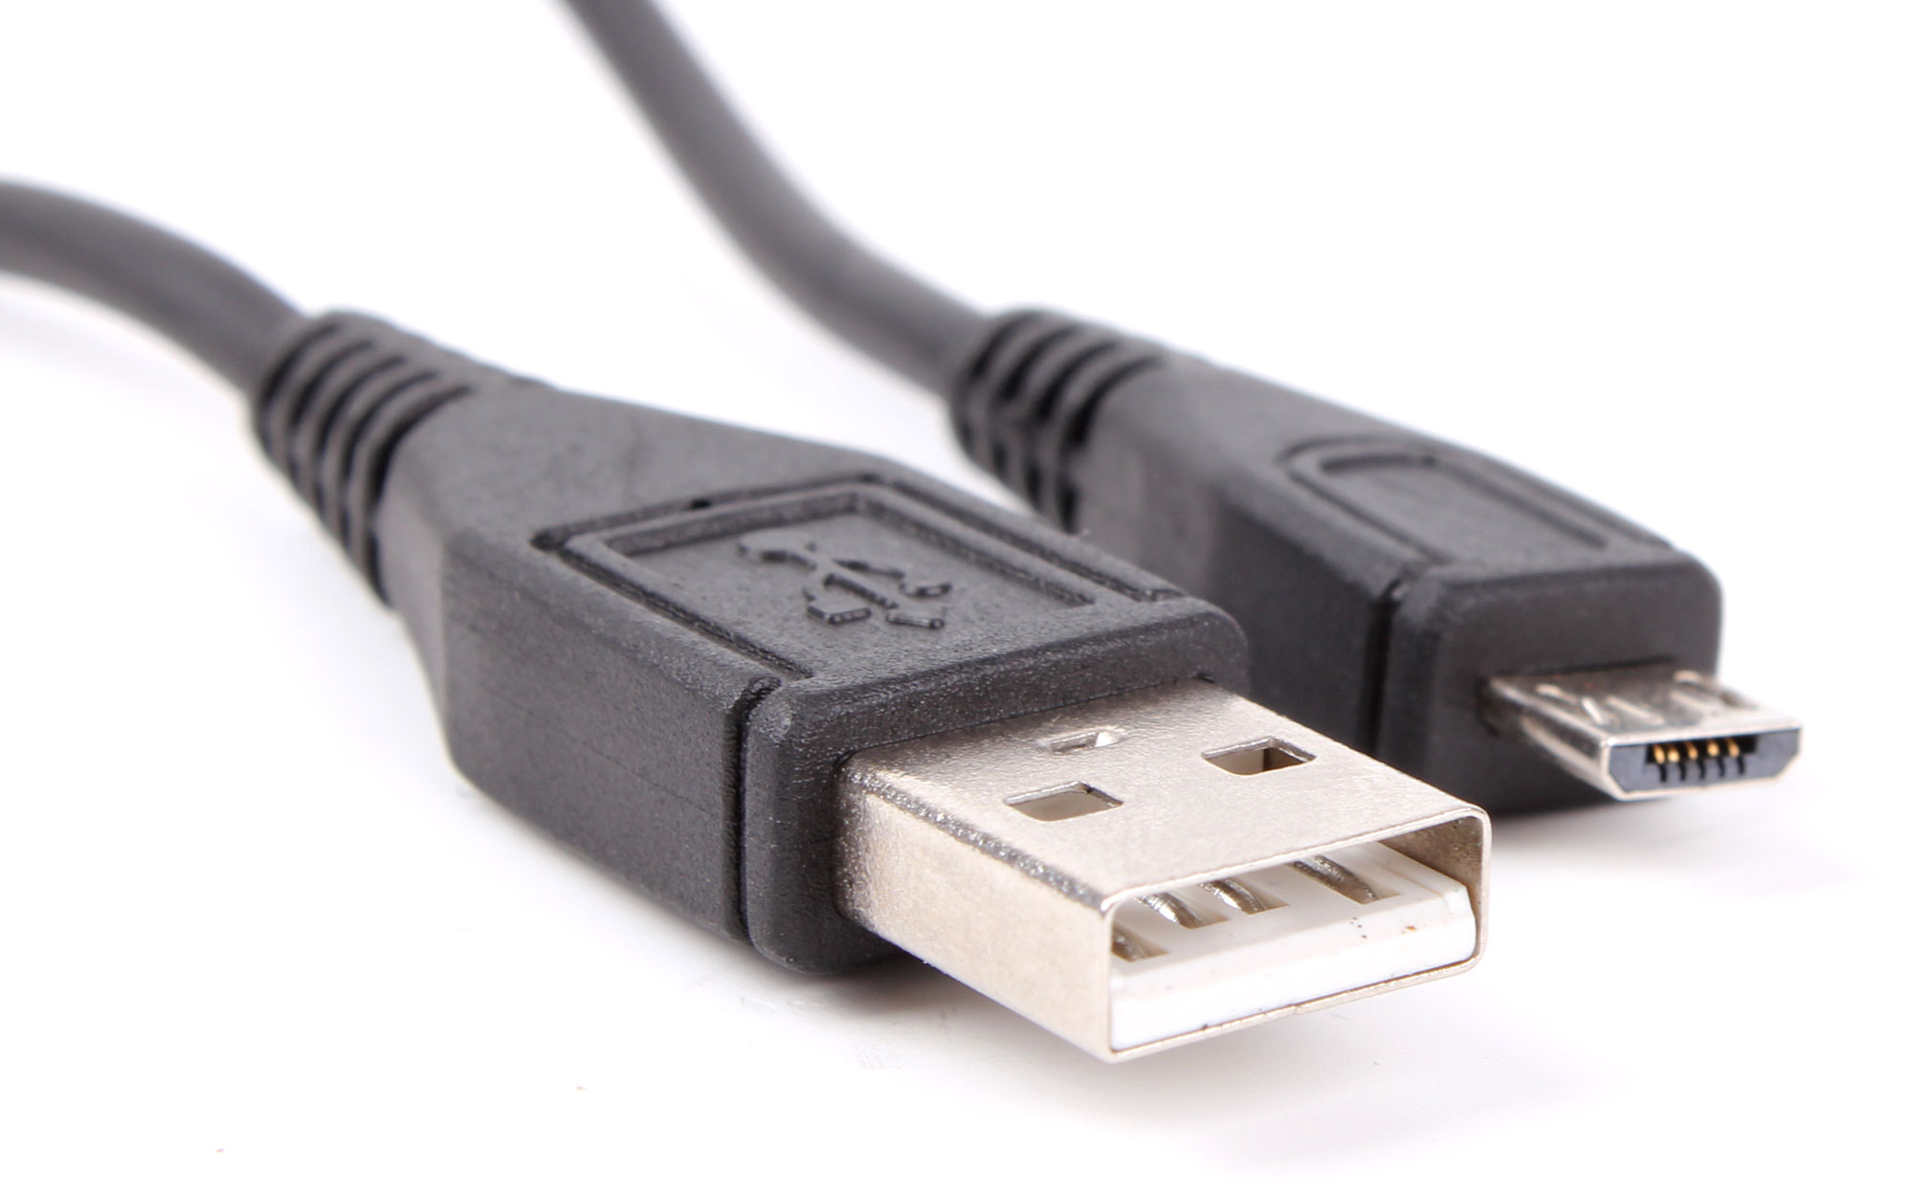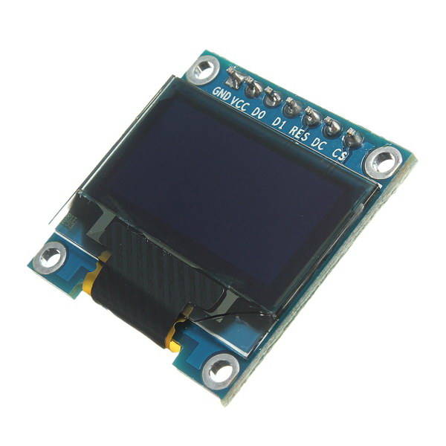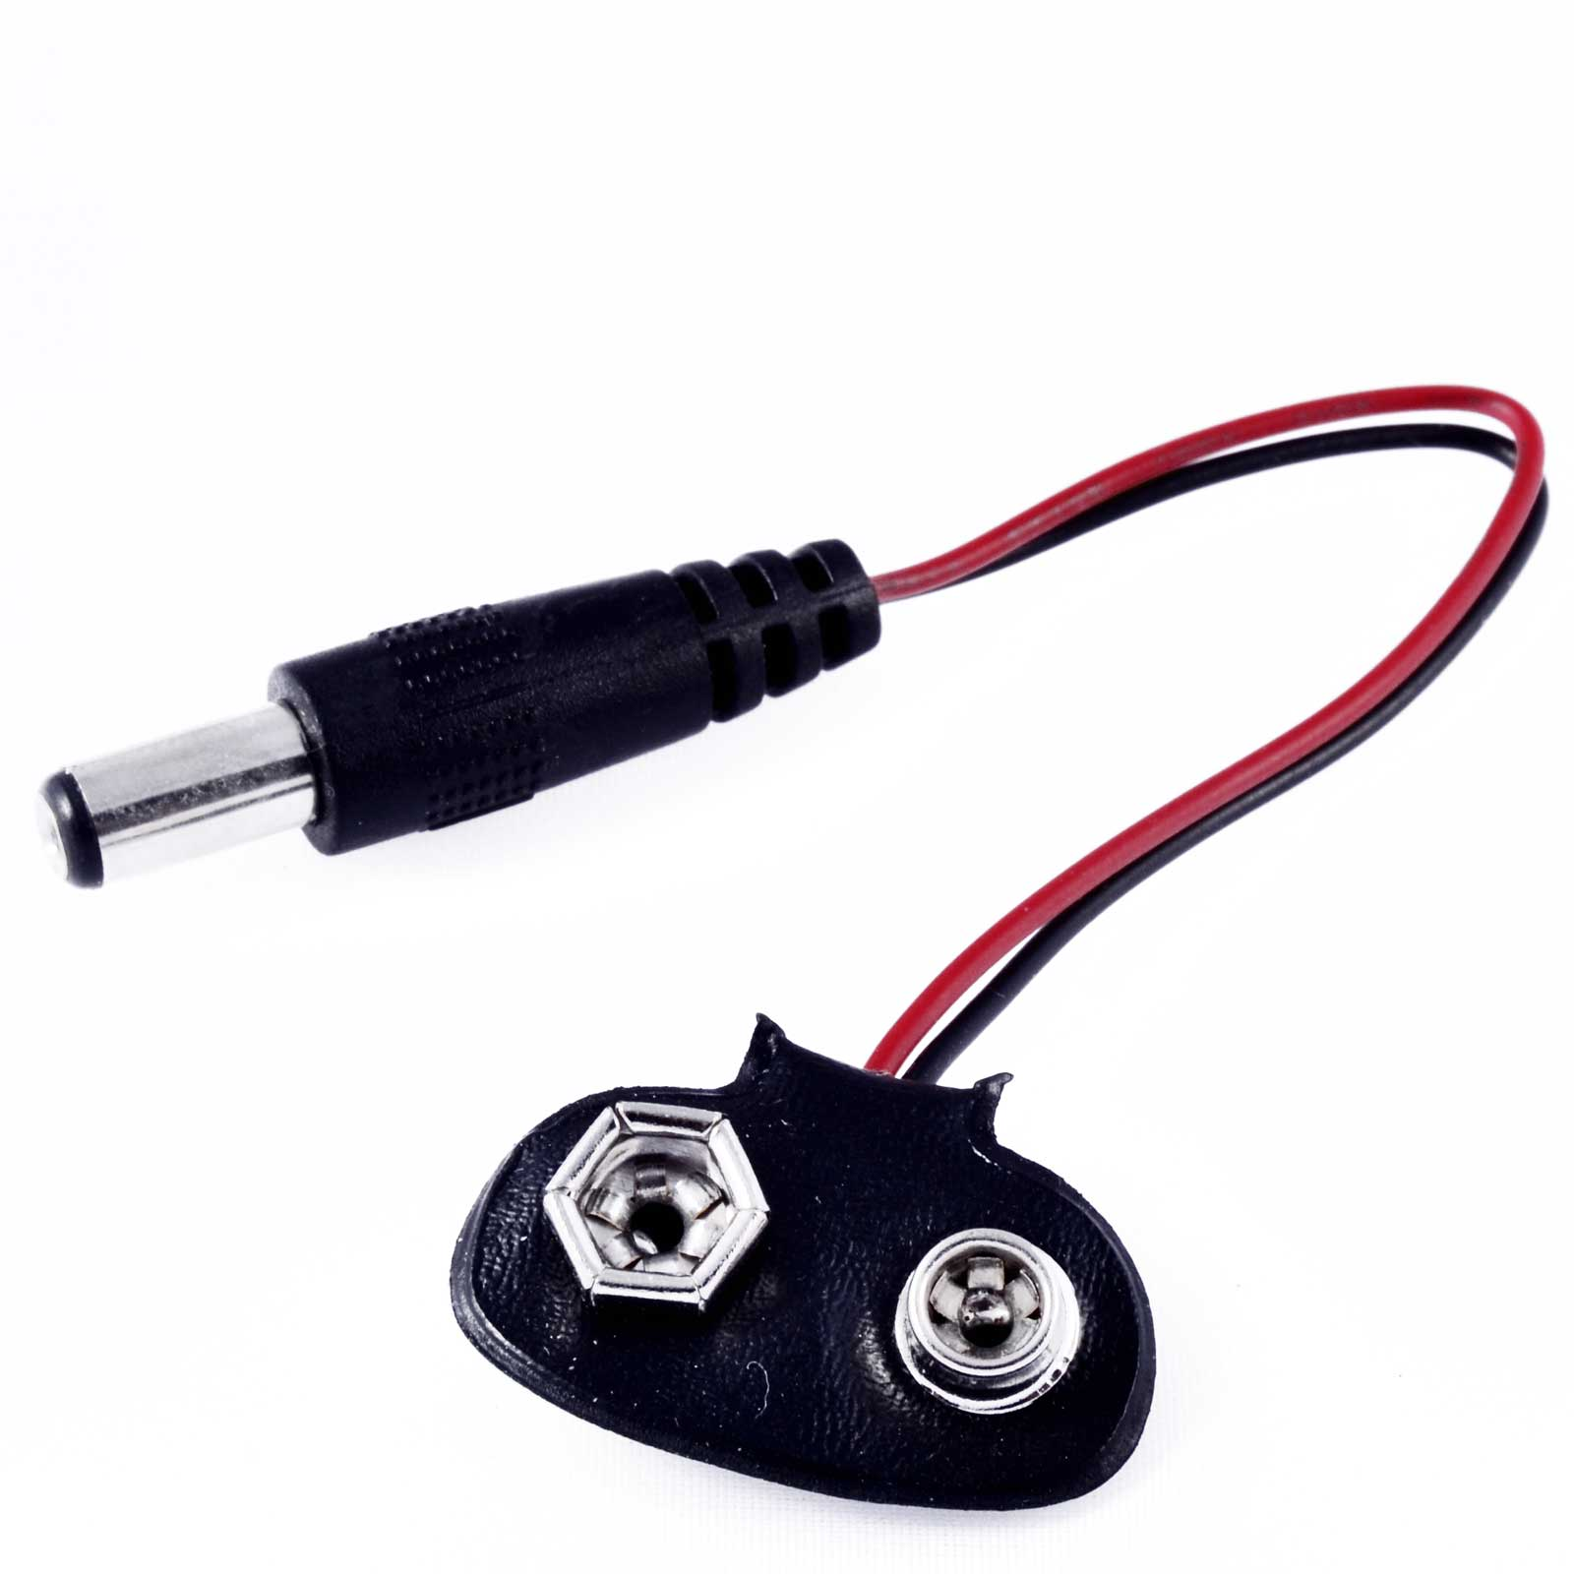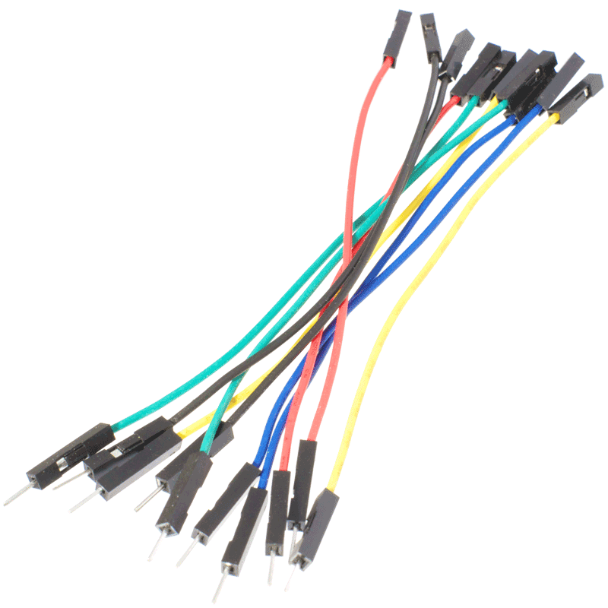

# Computer setup

Open <http://www.hedgehogbot.co.uk/setup.html> to setup your computer with the *Arduino IDE*, *esp8266 board package* for Arduino, and the *hedgehog bot libraries*.

In short:

* Grab a memory stick
* Copy and paste the Arduino setup file and extract/run it
* Open Arduino, select *File > Preferences* and type [*http://arduino.esp8266.com/stable/package_esp8266com_index.json*](http://arduino.esp8266.com/stable/package_esp8266com_index.json) into *Additional Boards Manager URLs*
* Close the Preferences window
* Select *Tools > Boards > Board Manager* and click on *esp8266* and press the *Install* button
* Close the Board manager window
* Copy the contents of the folder *Arduino > All > libraries* to *Documents > Arduino > Libraries*

# Get building!

Open <http://www.hedgehogbot.co.uk/> and select *“Challenge 1: LED”*, or if you’re still **waiting to setup** your computer, **skip ahead** and start building your robot by looking at *“Challenge 2: Bot”*, you can go back to Challenge 1 once your bot is built.

Progress through challenges 1-3.

**We’re here to help**, if you get stuck, please come and ask one of us for help. If you’ve completed all the challenges and want to go further, come and have a chat too!