VICTOR KARAMALIS  MS, PMP | Senior Operations & HPC Infrastructure Leader  📞 347-466-9507 ✉ victor@karamalis.me 🌐 LinkedIn | GitHub | Credly | 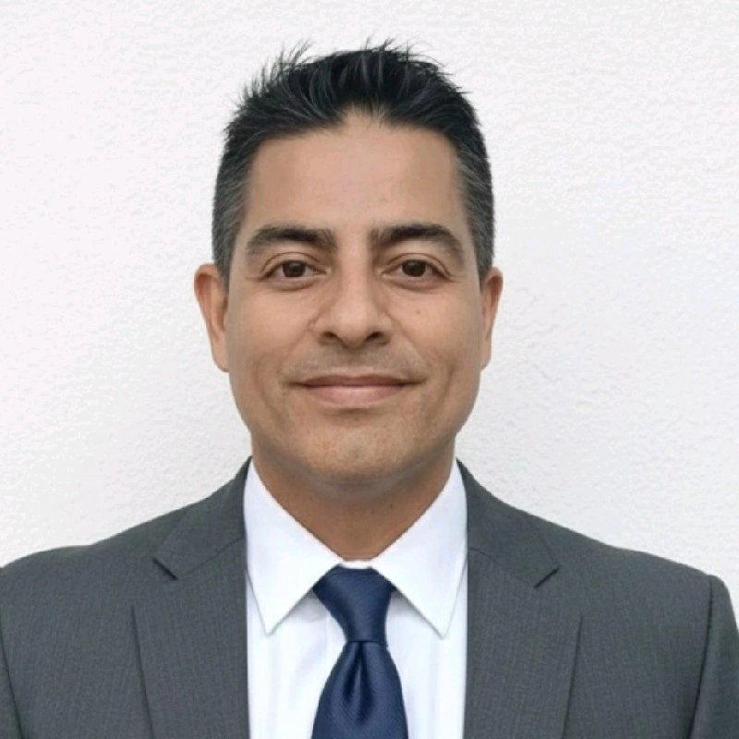

PROFESSIONAL SUMMARY
Research scientist and systems architect bridging computational chemistry, scientific machine learning, and HPC infrastructure to solve complex multi-physics and materials problems. Proven track record designing and deploying predictive neural network pipelines on DOE national laboratory platforms (NERSC / NVIDIA H100), co-architecting FAIR scientific data repositories, and translating research findings into peer-reviewed publications and provisional patents. Deep domain expertise spanning molecular dynamics, lanthanide/actinide ligand systems, nanomaterial property prediction, and ML-driven materials discovery — with a demonstrated ability to lead cross-institutional programs from proof of concept through commercial licensing and regulatory-grade evidence development.

KEY HIGHLIGHTS

Infrastructure Optimization | Delivered 15–20% cost reductions through ML-driven capacity planning, predictive maintenance, and power/cooling optimization across enterprise data centers.
Production ML Systems | Engineered end-to-end ML pipelines from business problem definition, feature engineering, and hyperparameter tuning through production deployment for mission-critical systems.
Strategic Leadership | Managed P&L and led global cross-functional teams of 10–15 engineers; M&A due diligence experience on 8 figure transactions with proven vendor management expertise.
Enterprise Risk & Compliance | Developed NIST CSF 2.0, ISO-27001, and SOX-compliant policies for disaster recovery, SOPs, and DevSecOps workflows across on-premises and cloud environments.

PROFESSIONAL EXPERIENCE
Researcher — AI-Driven Materials Discovery  Lattice Studio Labs, LLC | Miami, FL | Jan 2025 –PRESENT

- AI-Driven Materials R&D: Directed R&D for materials discovery projects using AI-driven workflows for molecular characterization and property prediction, applying scientific ML to accelerate nanomaterial and formulation innovation.
- End-to-End Innovation Lifecycle: Managed the full innovation lifecycle from Proof of Concept (PoC) through modeling, experimental sample testing, and licensing with commercial partners — demonstrating translation of scientific ML insights into measurable business value.
- Multi-Scale Computational Frameworks: Applied hybrid computational-experimental frameworks to nanomaterial design, building expertise in multi-scale property prediction transferable to formulation optimization and device performance modeling.

Visiting Researcher — Theoretical Division (T-1 / CNLS)  Los Alamos National Laboratory | Los Alamos, NM | October 2023

- SAFE Database Infrastructure: Led technical development of the SAFE database (https://safe.lanl.gov/about/) hosted at NERSC, integrating Docker/SPIN containerized architecture for reproducibility and long-term stability across distributed DOE computing systems.
- LLM-Driven Data Generation: Developed pretrained LLM-based data generation pipelines for novel rare-earth molecular candidates, advancing ML-ready datasets for lanthanide/actinide separation chemistry — methodologies directly transferable to biologics and small-molecule ligand modeling.
- Cross-Disciplinary Collaboration: Collaborated with LANL computational physicists to define data schemas, ML model requirements, and validation standards, reinforcing cross-disciplinary scientific rigor applicable to kinetic modeling and molecule development.

Research Scientist  Fordham University | New York, NY | Jan 2023 – Mar 2024

- Production Systems Management: Managed Big Data operations for the largest online AI-ready chemistry dataset repository in collaboration with Los Alamos National Lab and University of Utah, maintaining data integrity and web accessibility for global research community.
- High-Availability HPC Operations: Engineered secure benchmarking environment for mission-critical HPC services, minimizing node crashes and service disruptions.
- Kubernetes & Cloud Infrastructure: Deployed Python-based ML applications on Kubernetes across DCEP-compliant cloud infrastructure, designing scalable data pipelines processing terabytes of simulation data with real-time monitoring via Grafana.
- Cross-Functional ML Engineering: Collaborated with data scientists on full-stack ML systems, bridging research models with production-grade deployment using Docker containers.

Consultant — Data Infrastructure & Cost Strategy  True Technology International Corporation | Miami, FL | Jan 2020 – Jan 2023

- Cloud Migration & Cost Optimization: Led 'lift & shift' migration of data/ML workloads from legacy Linux servers to GCP, delivering 20% reduction in annual infrastructure costs through resource right-sizing and capacity planning.
- Hybrid Architecture & Real-Time Monitoring: Designed resilient hybrid data architectures (Hadoop, Data Lake) supporting ML feature engineering and batch/streaming workflows at scale, implementing Grafana dashboards for compute and storage optimization.
- Capacity Planning & Automation: Executed capacity planning initiatives with multi-national stakeholders, deploying automated alerting for infrastructure health preventing resource bottlenecks and ensuring seamless data flow between on-premises and cloud environments.

Automation Director  Olympus Group, LLC | North America HQ | 2013 – 2019

- Strategic Division Leadership: Established Automation Division and developed enterprise technology roadmap aligning technical initiatives with business continuity and data center modernization; managed P&L for globally dispersed teams of 10–15 engineers.
- Predictive Maintenance & Fleet Optimization: Developed ESMS predictive maintenance software and Economaster system using Industrial IoT devices (PLC, VFD) and anomaly detection algorithms, reducing equipment downtime by 15% across cruise line and cargo shipping fleets.
- Global Systems Deployment: Led delivery of 10,000+ hours of systems development for PLC-based tertiary control systems, ensuring operational reliability in high-stakes maritime engineering environments.
EARLIER CAREER HISTORY

Enterprise Project Lead  Lilgrams Inc. at Kimberly-Clark Corp. | Led AWS cloud integration into on-premises recommendation system for Huggies Brand (2012).
Functional Project Lead  Skillnet Solutions Inc. | Managed Oracle E-Business Suite implementation and AI engine (JGAP) integration across 12 sites (2010–2011).
IT Project Manager  Stanley Black & Decker Inc. | Oversaw demand forecasting initiative on global data migration project spanning 3 regions (2009).
IT Project Specialist  Siemens AG | Implemented Energy Management software with Siemens teams for utility asset monitoring at 10 sites (2008).

EDUCATION  Master of Science (MS) — Management & Systems  New York University  Bachelor of Arts (BA) — Chemistry  New York University  Machine Learning Bootcamp  University of Maryland  Adjunct Professor — Data Warehousing & Big Data Analytics  St. Thomas University | CERTIFICATIONS  Project Management Professional (PMP)  PMI | #253128  AWS Cloud Practitioner (CLF-C01)  AWS | Sustainability in AWS  Machine Learning Specialization — In Progress  NVIDIA  Kubernetes & Container Orchestration  Linux Foundation | DevSecOps & GitOps

TECHNICAL SKILLS

Cloud & Infrastructure | AWS, Azure, GCP, Docker, Kubernetes, Hybrid Cloud, Linux
Data Science & ML | PyTorch, TensorFlow, XGBoost, Spark (Databricks), Time-Series Forecasting, Anomaly Detection
DevOps & Monitoring | CI/CD Pipelines, Git, Jira, Grafana Stack, Real-Time Dashboards
Programming & Tools | Python, Linear Algebra, Calculus, Differential Equations

PUBLICATIONS & PATENTS

[1] | Karamalis, V., et al. (2025). Creation of the SAFE Database. Solvent Extraction and Ion Exchange, 43:7, 847–852. https://doi.org/10.1080/07366299.2025.2564381
[2] | Karamalis, V. (2024). Mantel Material — Radiation Shielding Compound. Provisional U.S. Patent Application No. 63/567538.
[3] | Lee, J., Karamalis, V. (Contributor). (2024). Machine Learning-Aided Chemical Kinetic Modeling. Doctoral Dissertation, University of Texas. https://doi.org/10.26153/TSW/55747
[4] | Karamalis, V. (2007). A Hypothesis Testing Study on the Privacy and Security of ePHI in a Public Entity. M.S. Thesis, New York University.

PROFESSIONAL MEMBERSHIPS

Royal Society of Chemistry (UK)  Member #767030 | Royal Society for Arts, Manufactures & Commerce (UK)  Fellow (RSA) | Project Management Institute  PMP #539366

Victor Karamalis, MS, PMP | 347-466-9507 | victor@karamalis.me

