**COMPILER :**

a compiler is a computer program that translates computer code written in one programming language into another language. The name "compiler" is primarily used for programs that translate source code from a high-level programming language to a lower level language to create an executable program.

For a example, a Java interpreter can be completely written in C, or even Java.

**Process of compiler :**

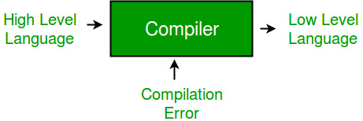

**Compiler Design** 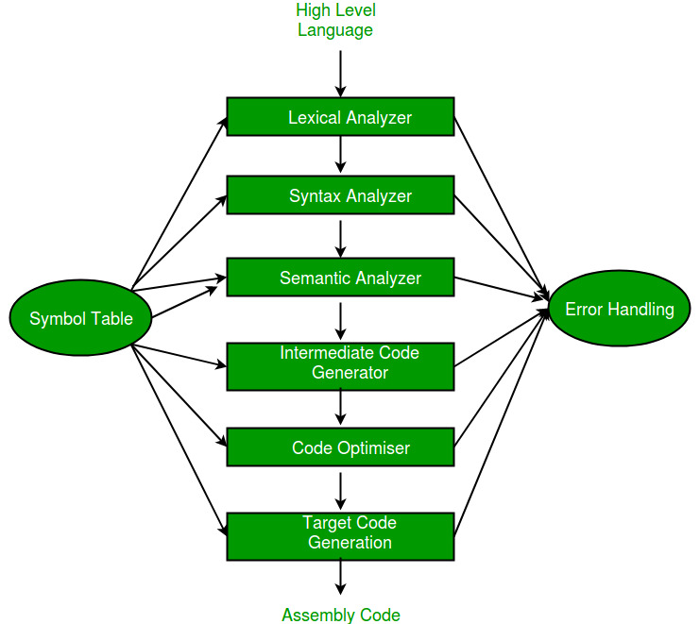

**Four Steps of Compilation:**

**preprocessing, compiling, assembly, linking.**

* Preprocessing: Preprocessing is the first step. ...
* Compiling: Compiling is the second step. ...
* Assembly: Assembly is the third step of compilation. ...
* Linking: Linking is the final step of compilation.

**Function :**

Compilers are very large programs, with **error-checking and other abilities**. Some compilers translate high-level language into an intermediate assembly language, which is then translated (assembled) into machine code by an assembly program or assembler. Other compilers generate machine language directly.

**INTERPRETER :**

In computer science, an interpreter is **a computer program that directly executes instructions written in a programming or scripting language**, without requiring them previously to have been compiled into a machine language program.

Examples of interpreted languages are **Perl, Python and Matlab**. Following are some interesting facts about interpreters and compilers.

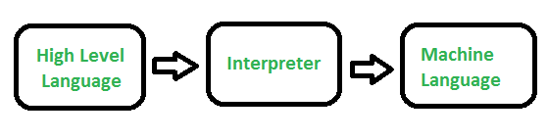

**Difference Between Compiler and Interpreter :**

# Difference Between Compiler and Interpreter.png