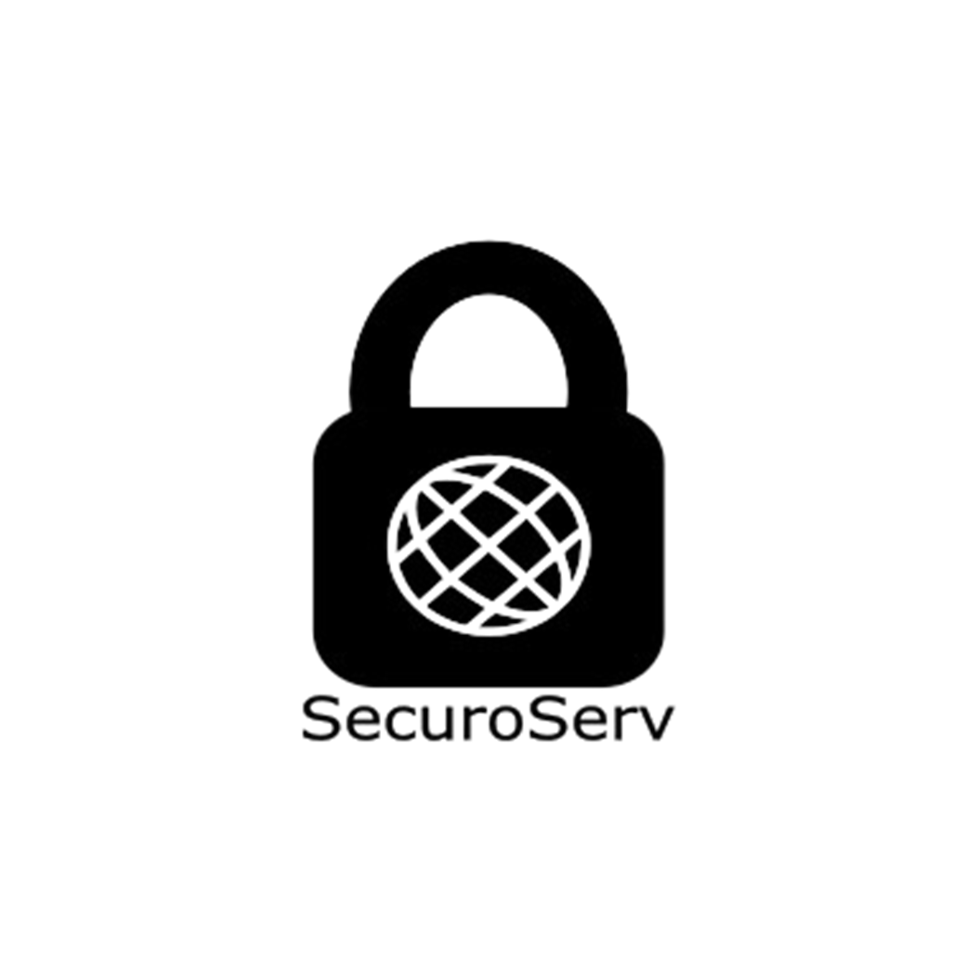Project for a bank

Made by

SecuroServ

TABLE OF CONTENT

Team Members 3

Project Description 3

Completed Tasks 4

Method and manner of implementation……………………………………………………………………………………………5

# Team Members

|  |  |
| --- | --- |
| Name | Roles |
| Stiliyan Mishev | Scrum trainer |
| Martin Stoyanov | Back-end developer |
| Martin Velkov | Back-end developer |
| Nikola Paskov | Designer |

Project description

|  |  |
| --- | --- |
| What is the main task? | The main task is to create site or an app for a bank |
| Where to find our project? | You can find our project in GitHub or you can visit this link: https://github.com/SMMishev21/SecuroServ. |
| How we communicated and worked on the project? | During we make the game we communicated on Discord and Teams. There we used to gather to discuss what everyone was going to do and where we were at. |
| What we are using for make the game? | For make the game we are using a lot of technologies like: Visual Studio and Visual studio code for writing the code, Discord and Teams for communication, Inkscape for the logo, Power Point for creating the presentation, Word for creating the documentation. |

Completed Tasks

|  |  |
| --- | --- |
| Number | Tasks |
| 1 | Consider the idea  The first thing we have to do is consider the idea for our work. |
| 2 | Create the design  We need to know what the game will look like and make it |
| 3 | Make the main part of the site and app  After discussing what the game will look like, we start working on it |
| 4 | Make a readme  In the readme you can get a quick overview of our project |
| 5 | Finish the work  Everything is already done with the website and the app |
| 6 | Make presentation  We have made a little presentation so you can see what we have done. |
| 7 | Make documentation  The documentation provides very useful information in terms of the technical aspect. You can learn pretty much everything by reading it. |

| Acquaintance with the tasks and effective work. | The tasks are defined in a way that everyone is aware of the tasks performed so far to present and answer quickly, clearly, and accurately, and teamwork is more effective. |
| --- | --- |
| Allocation of tasks. | For each person there is a chosen task in which he is good and will be able to perform the task in the most competent way possible. |
| Terms | Meeting the deadlines is reminded by the Scrum Trainer. A team meeting is held every week to discuss the time required to complete the assigned task and whether progress is being made. |

METHOD AND MANNER OF IMPLEMENTATION