Visualizing Housing Market Trends Using Tableau & Flask Integration

1. Project Title
Visualizing Housing Market Trends Using Tableau and Flask Integration

2. Objective
The objective of this project is to analyze housing market data and visualize key trends such as house prices, area, and grading system using Tableau. The project also includes a Flask-based web application to embed and display the Tableau dashboard and story for interactive web access.

3. Dataset Description
The dataset contains housing market information such as Sale Price, Flat Area (sqft), House Age, Overall Grade, Bedrooms and other attributes.

4. Tools & Technologies Used
- Tableau Public
- Python (Flask)
- HTML & CSS
- GitHub
- Render

5. Data Collection
Dataset collected from structured housing dataset (Kaggle / provided dataset).
dataset link

6. Data Loading
Dataset loaded successfully into Tableau for analysis.

7. Data Cleaning
- Removed missing values
- Handled inconsistent data
- Standardized formats
8. Visualizations
- Distribution of House Sale Prices
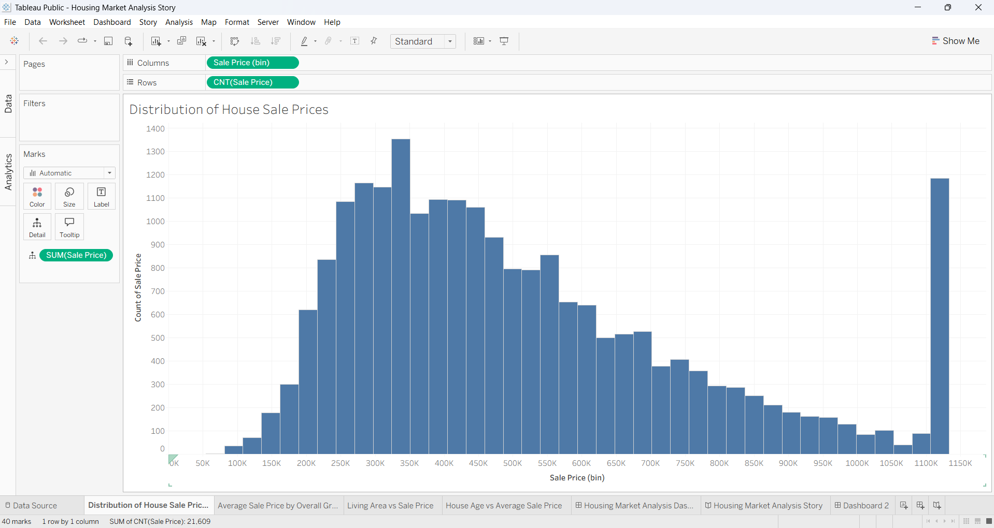
- Average Sale Price by Overall Grade
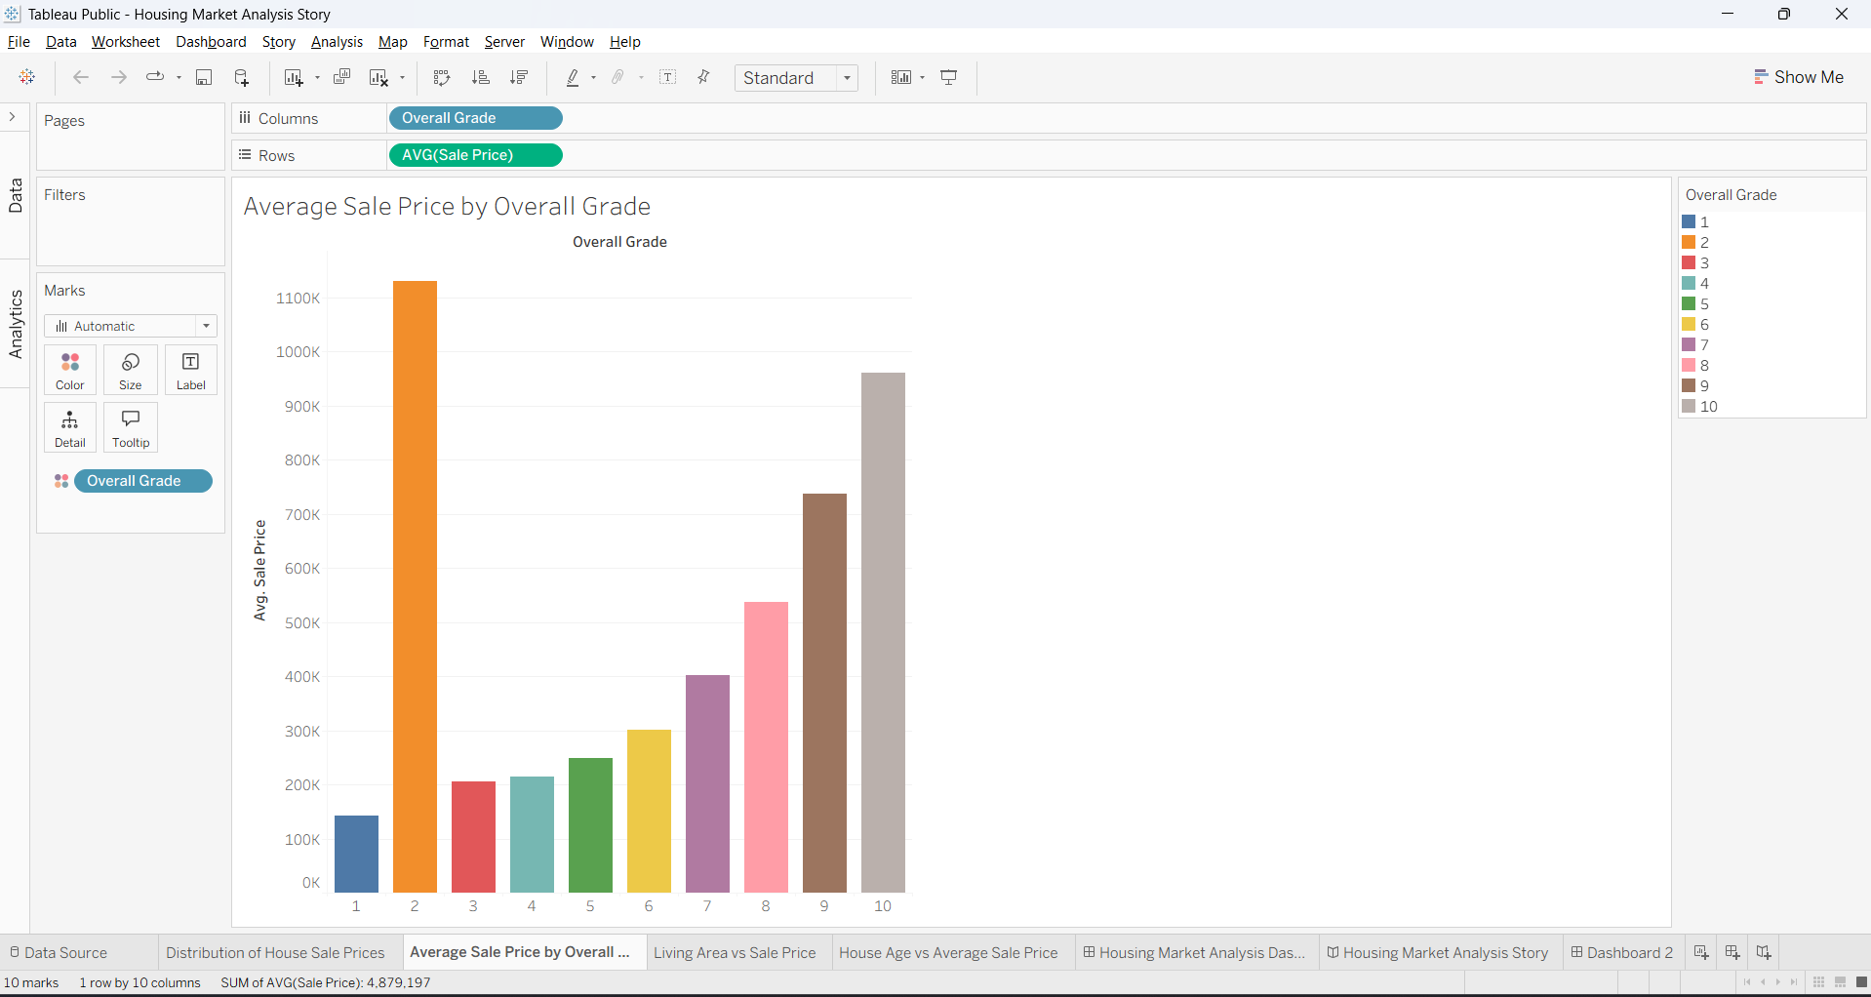

- Living Area vs Sale Price
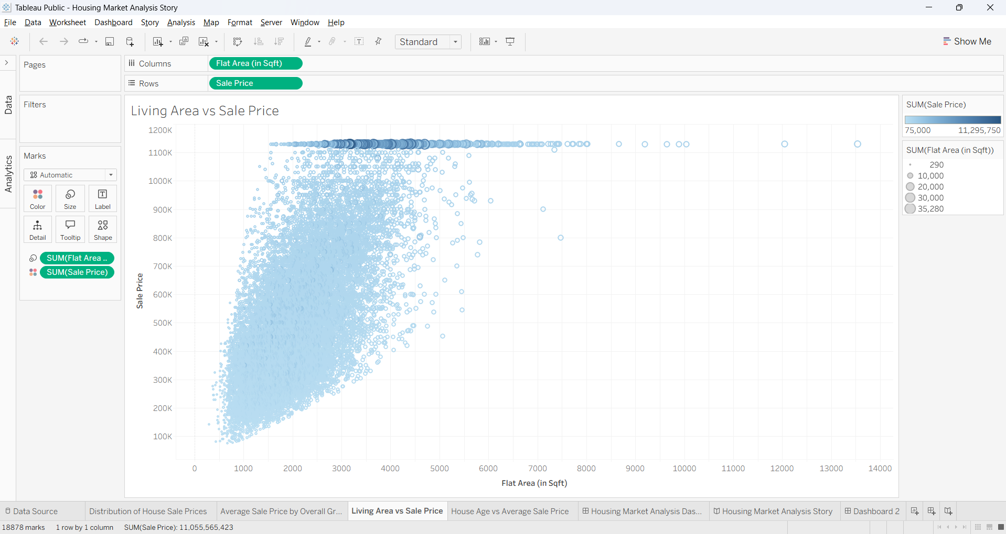
- House Age vs Average Sale Price
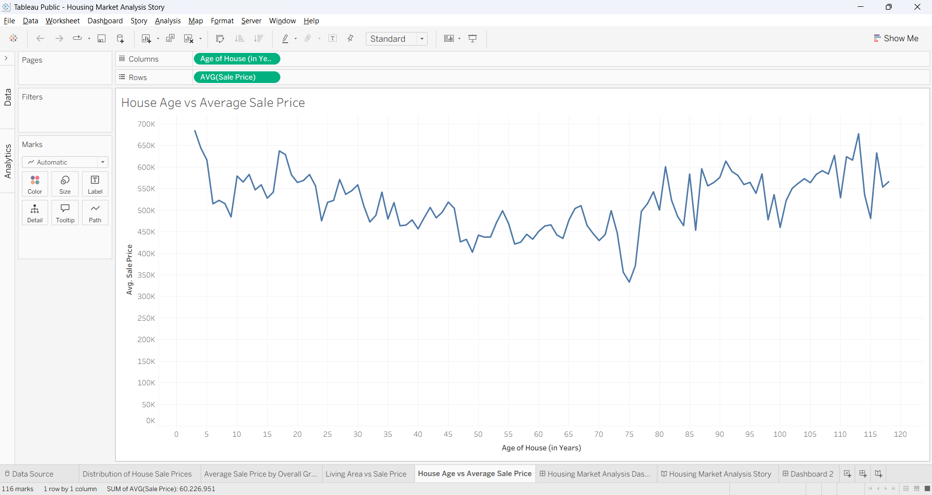

9. Dashboard Design
Interactive Tableau dashboard with filters and actions.
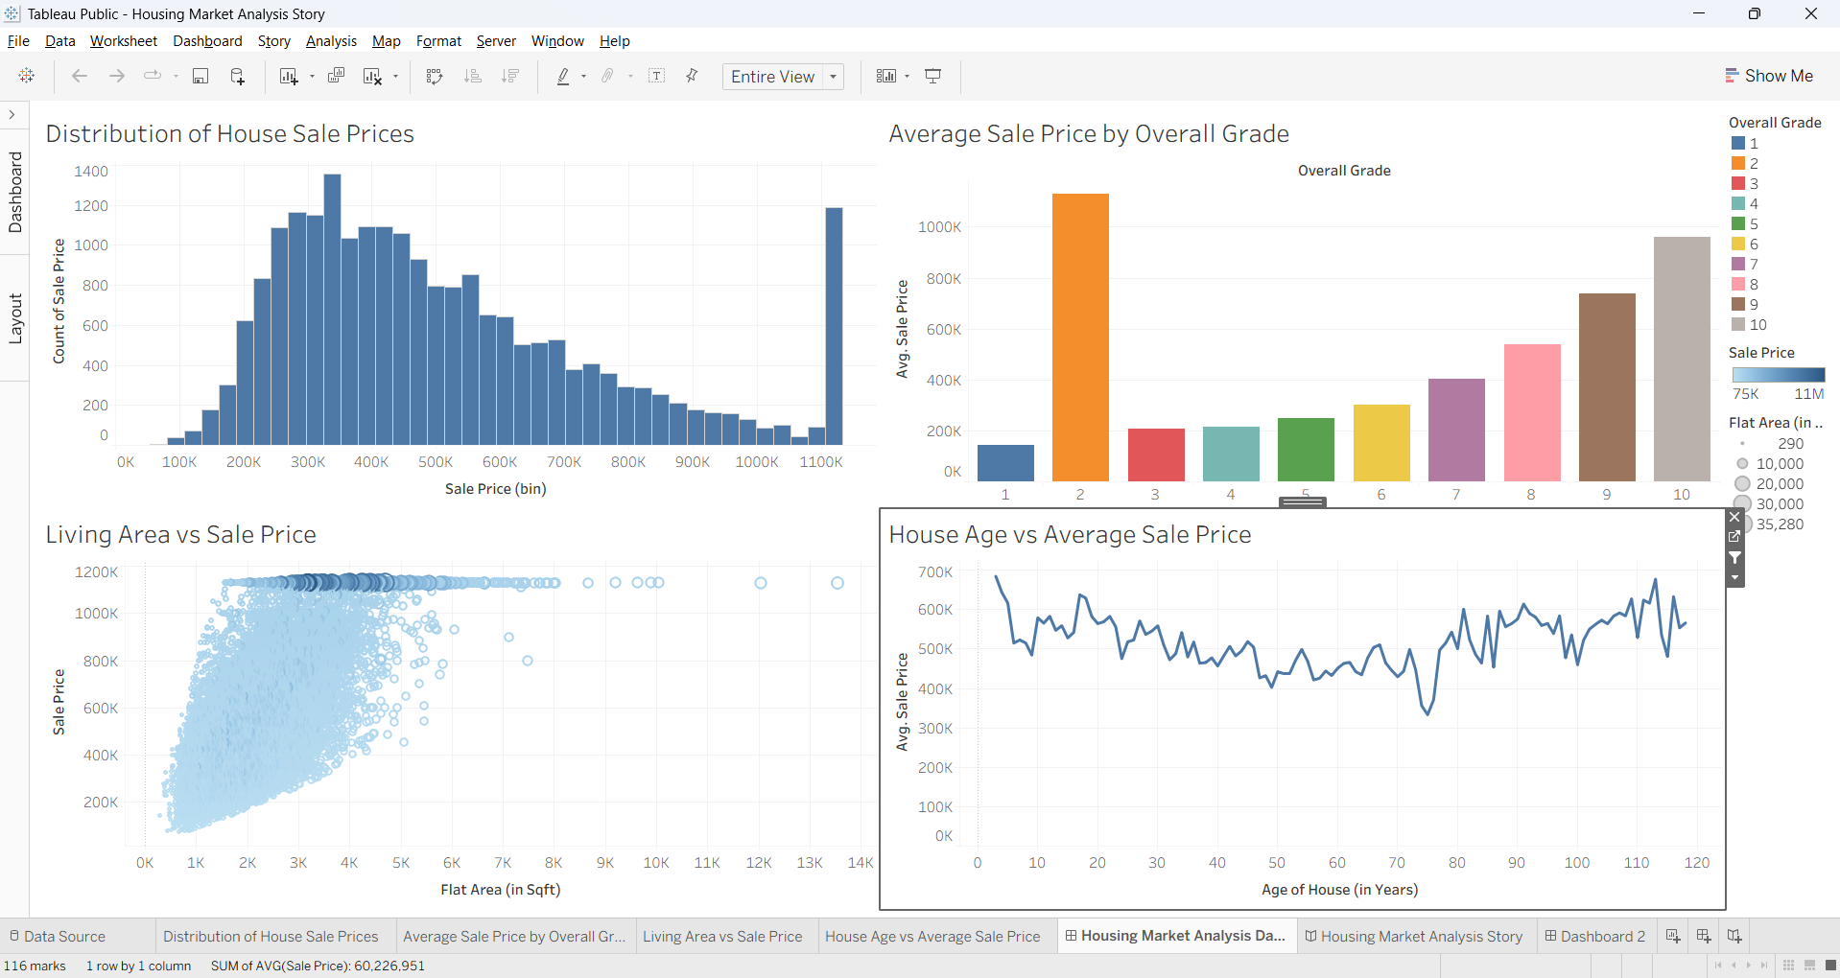

10. Storyboard Design
Step-by-step story showing insights from dashboard.
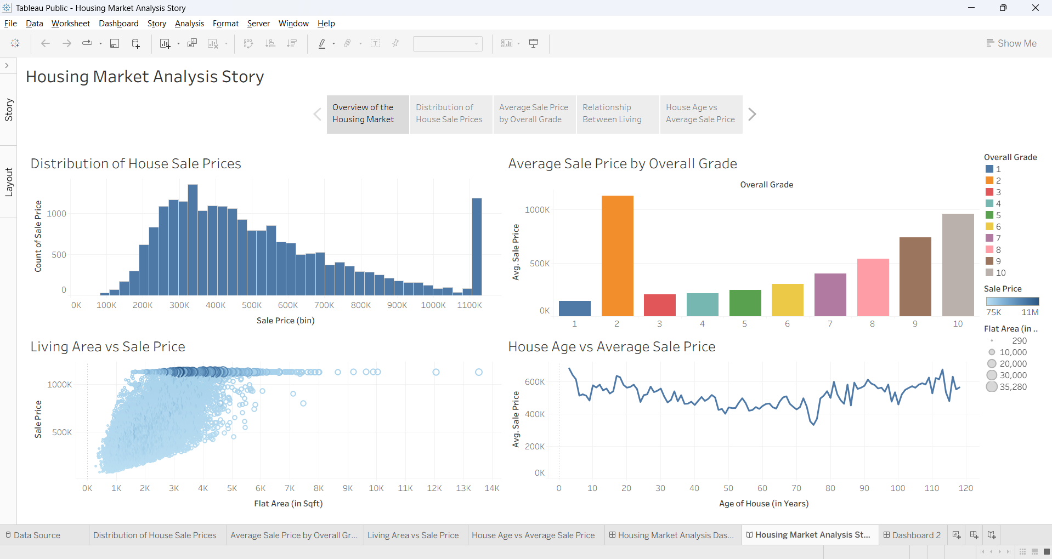

11. Amount of Data Loaded
The dataset was successfully loaded into Tableau without errors. All required fields were properly recognized and used for visualization.
Objective:
To verify that the housing dataset has been loaded successfully into Tableau for analysis.

Dataset Details:
- Dataset Name: Transformed_Housing_Data2.csv
- Total Records (Rows): 21,609
- Total Fields (Columns): 32

Observation:
- The dataset was successfully loaded into Tableau.
- All 21,609 records and 32 fields were imported correctly.
- The data connection is active and working properly.
- Data preview is available in the Data Source tab.
- No loading or connection errors were observed.
- The dataset is ready for visualization and further analysis.

Result:
The dataset has been loaded successfully and is ready for analysis in Tableau.
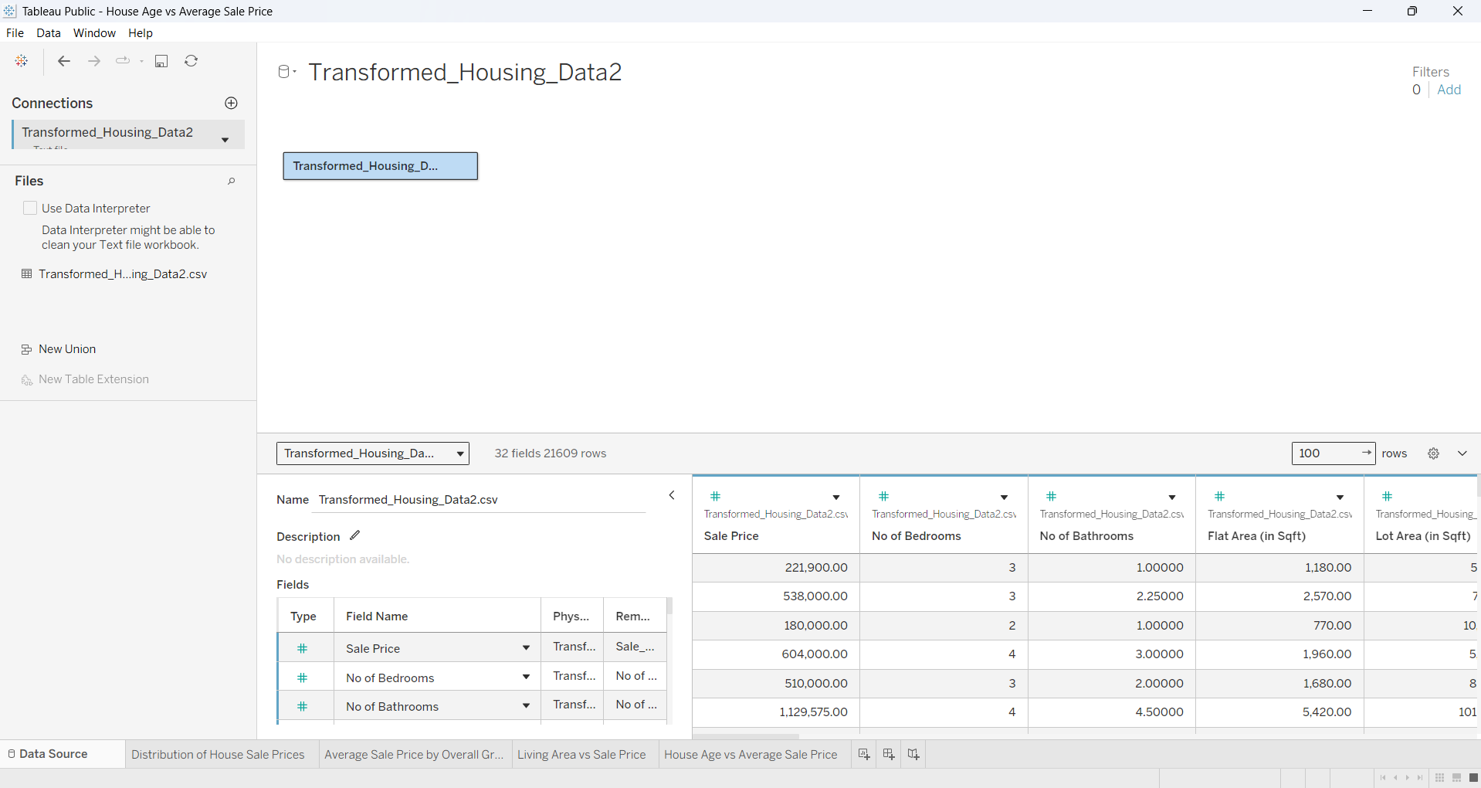

12. Utilization of Filters
Filters used for Sale Price and Flat Area.
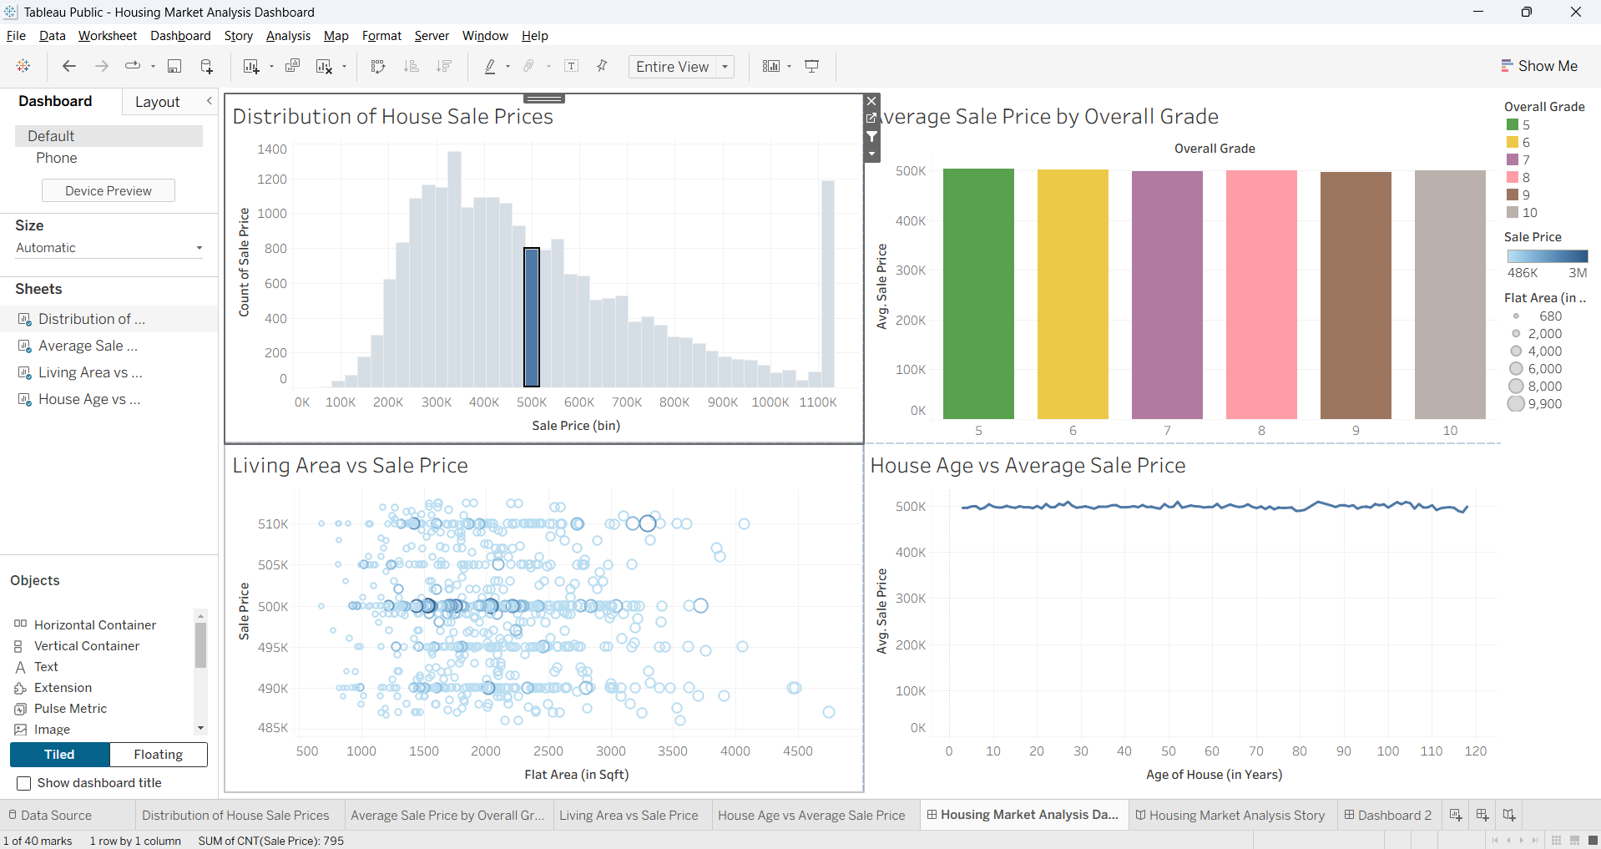
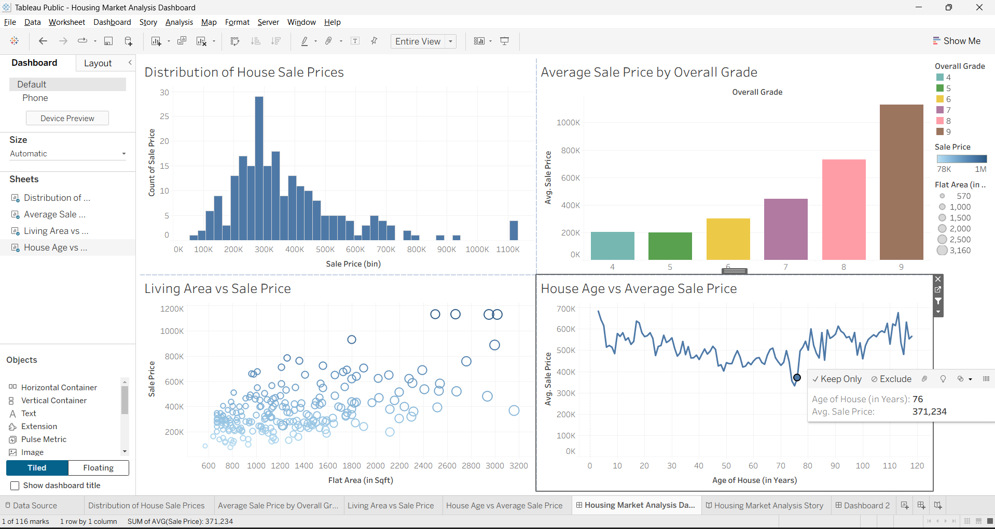

13. Number of Visualizations
Total 4 visualizations created.

14. Publishing
Published on Tableau Public.
https://public.tableau.com/app/profile/vamsi.karthik.mangali/viz/HouseAgevsAverageSalePrice/HousingMarketAnalysisStory?publish=yes

15. Flask Integration
Embedded Tableau Story in Flask web application.

16. Conclusion
Project demonstrates housing market trends using Tableau and Flask integration.

17. Future Enhancements
  - Add ML prediction model
  - Improve UI
  - Deploy full cloud application

