A Frozen-Classifier Audit for Subgroup Recall Loss Under Test-Time Feature Missingness
M. Vamsi Krishna; S. Sri Harsha
KL University
2501050195@kluniversity.in; sriharsha@kluniversity.in

Abstract
Test-time feature missingness can reduce recall in a prespecified group while leaving aggregate accuracy less affected. We define the Focus-Group Masking Gap (FMG) as the signed difference between focus-group recall loss and aggregate-accuracy loss for the same frozen classifier under test-only feature masking. The primary benchmark used ten repeated splits across three datasets and four models; at 20% MCAR, nine of twelve dataset-model means exceeded the study-specific descriptive reference of 0.01. FMG is not a between-group disparity: focus-group recall loss exceeded comparison-group loss in only 4/12 pairs. A separate public-health extension evaluated 2024 BRFSS and UCI Diabetes 130-US Hospitals with five models, three seeds, two split settings, and three controlled missingness mechanisms. At 80/20 and 20% MCAR, BRFSS mean FMG ranged from 0.0272 to 0.0455; comparison-group loss exceeded focus-group loss in all five models. UCI mean FMG ranged from 0.0000 to 0.0038, with mean clean focus recall of 0.000–0.020 across models, indicating a floor effect. BRFSS held-out evaluation used survey weights; UCI splits were patient-disjoint. Findings are descriptive and conditional on the tested benchmarks, groups, and mechanisms. FMG is a diagnostic, not a fairness certificate, causal estimate, or evidence of deployment utility.

Keywords: missing data; MCAR; fairness; tabular classifiers; focus-group masking gap; robustness evaluation
1. Introduction
A classifier may perform well on complete data yet receive incomplete features at test time. Overall accuracy is usually the headline measure, but it can conceal a different degree of degradation for a particular demographic group. We therefore examine whether controlled feature masking at test time reduces focus-group recall more than aggregate accuracy when the trained model remains unchanged. This contrast is not itself a between-group disparity: in the primary results, g0 recall loss exceeded g1 recall loss in only 4/12 dataset-model pairs.
Prior research documents fairness effects of missingness, test-time feature-missingness robustness, and statistical fairness auditing (Min et al. [1]; Jang et al. [2]; Kochs et al. [3]; Zhang and Long [4]; Cherian and Candès [5]). These studies establish relevant overlap; our gap is narrower: a reproducible paired report of focus-group recall loss and aggregate-accuracy loss for the same unchanged classifier, with per-split denominators. The contributions are:
(1) A signed definition and interpretation of the conditional recall-loss versus accuracy-loss contrast.
(2) A frozen-classifier audit procedure with test-only feature masking and denominator reporting.
(3) A descriptive benchmark demonstration across the specified datasets, models, groups, and missingness conditions.
Prior research has examined how missingness and imputation affect group fairness and subgroup performance, and how classifiers behave under test-time feature-missingness overlays. Section 2 reviews these lines of work. The present study focuses on a narrower paired comparison: the change in recall for a prespecified focus group versus the change in aggregate accuracy when the same trained classifier is evaluated on clean and masked test data.
This question is important, because missingness typically creeps in after a model is trained: a sensor breaks, a form field is skipped, a data service only delivers a partial record. When this happens, even a stable aggregate score doesn't imply stable group recall. For this reason, we consider missingness to be a deployment stressor and ask for a simple, quantifiable trade-off between total accuracy degradation and focus-group recall degradation.
2. Literature Review and Research Gap
Missing-data handling and imputation. Research on missingness mechanisms, imputation quality, incomplete-data classification, and fairness includes Bhatti et al. [6], Caton et al. [7], Emmanuel et al. [8], Jeanselme et al. [9], Jeong et al. [10], Martinez-Plumed et al. [11], Miao et al. [12], Min et al. [1], and Pessach and Shmueli [13]. Caton et al. [7] examine how imputation strategies affect fairness, while Bhatti et al. [6] study the influence of missingness mechanisms and simple handling techniques on fairness outcomes. These studies establish that missingness and preprocessing can affect group outcomes; the present paper does not claim that this broader problem is unstudied.
Fairness and subgroup performance assessment. Fairness definitions are context-dependent, and some error-rate constraints cannot generally be satisfied simultaneously, as discussed by Barrainkua et al. [14], Buolamwini and Gebru [15], Caton and Haas [16], Chouldechova [17], D'Amour et al. [18], Hardt et al. [19], Mehrabi et al. [20], and Wang et al. [21]. Min et al. [1] examines inequitable effects of missingness, while Wang and Singh [22] study missing values and selection bias. Fairness-aware incomplete-data methods, including Miao et al. [12], develop or modify prediction procedures; Kamiran and Calders [23] established preprocessing approaches to reduce discrimination. The present audit addresses a different question: how much does subgroup recall change relative to aggregate accuracy when one frozen classifier is evaluated before and after the same test-time masking stressor?
Robustness and distribution shift. Robustness research considers aggregate degradation, deployment shift, and heterogeneous model decay (Hendrycks and Dietterich [24]; Koh et al. [25]; Moreno-Torres et al. [26]; Shao et al. [27]; Singh et al. [28]). Jang et al. [2] evaluate tabular classifiers under feature-missingness overlays, including test-time stress. Shadbahr et al. [29] examine how imputation quality affects downstream classifier performance. Kochs et al. [3] directly study fairness risks under structured and unstructured missing data and report that fairness can deteriorate when structured missingness is present only during inference. Their work also proposes a robustness-oriented mitigation method. These studies overlap with the present problem setting; they make it important to define the distinction by estimand and protocol rather than by claiming that fairness under test-time missingness is absent from prior research.
Fairness auditing also has established statistical and theoretical foundations. Zhang and Long [4] study fairness estimation under missing data, while Cherian and Candès [5] develop model-agnostic statistical inference for subgroup fairness audits. The present FMG analysis is descriptive and condition-specific; it does not provide a fairness guarantee, simultaneous subgroup certification, or a new missing-data estimator.
Scope of the FMG distinction. Prior studies examine fairness under missing data [1], [3], robustness to test-time feature-missingness overlays [2], and statistical or theoretical fairness auditing [4], [5]. The present study asks a narrower question: for the same clean-versus-masked test evaluation of an unchanged classifier, how does the prespecified focus group’s recall loss compare with the aggregate-accuracy loss? The protocol records per-seed subgroup denominators and reports both component losses. FMG is their deterministic signed difference and contains no information beyond those components reported separately. Its contribution is therefore a specific comparative diagnostic and reproducible reporting procedure, not a new fairness theory, missingness mechanism, mitigation algorithm, or operationally validated decision tool.
Research focus. Rather than asserting that prior work has not studied fairness under missingness or test-time masking, this paper makes explicit one paired estimand: the difference between focus-group recall loss and aggregate-accuracy loss for the same frozen classifier under a stated test-time masking condition. Table 1 compares this bounded focus with related work. The result remains conditional on the data, preprocessing, model, subgroup, split, and missingness mechanism.
Table 1. Comparison of related research and the FMG audit.
Related research direction | Overlap with this paper | Narrow distinction claimed here | Boundary of the claim
Fairness under missing data [1], [3] | Studies group-related missingness, fairness outcomes, and in some cases inference-time missingness. | This paper reports a paired difference between focus-group recall loss and aggregate-accuracy loss for an unchanged classifier. | Does not claim fairness effects under inference-time missingness as new.
Test-time feature-missingness robustness [2] | Evaluates classifier behaviour under feature-missingness overlays at test time. | Adds subgroup-recall versus aggregate-accuracy loss reporting and per-split group denominators. | Does not claim test-time masking itself as a new method.
Fairness auditing and inference [4], [5] | Audits subgroup performance and addresses inference under missingness or distribution shift. | Uses a fixed-group, clean-versus-masked descriptive contrast. | Does not provide simultaneous inference, certification, or a new missing-data estimator.
Fairness-aware incomplete-data methods [12] | Develops methods for prediction or fairness under incomplete data. | Evaluates an existing classifier without retraining after masking. | The distinction is audit purpose, not superiority or prior-art absence.
3. Methodology

3.1 Datasets and focus groups
Table 2. Datasets and analytical scope.
Dataset | Rows | Task | Sensitive attribute | Focus group
Adult Income | 32,561 raw; 30,162 analyzed | Income > $50K | Sex | Female (g0)
COMPAS | 5,278 | Two-year recidivism | Race | African-American (g0)
Taiwan Credit | 30,000 | Payment default | Sex | Female (g0)
German Credit | 1,000 | Credit outcome | Personal status | Female (g0); exploratory

The primary analysis uses Adult Income (Dua and Graff [30]), COMPAS (Angwin et al. [31]), and Taiwan Credit (Yeh and Lien [32]). German Credit uses the OpenML credit-g record (data ID 31), based on the original Statlog German Credit data [39], and is exploratory because of its smaller sample and known encoding issues. It is not the corrected South German Credit dataset described by Grömping [33]; that separate corrected dataset is not used here. Sensitive attributes are excluded from model features; in COMPAS, race is also excluded. The dataset characteristics and analysis roles are summarized in Table 2.

Dataset source links: Adult Income (UCI); COMPAS (ProPublica); Taiwan Credit (UCI); German Credit (OpenML).
Separate public-health extension. In addition to the primary benchmarks, we evaluated a cross-sectional self-reported diabetes task in the CDC 2024 Behavioral Risk Factor Surveillance System (BRFSS) [37] and an early-readmission task in the UCI Diabetes 130-US Hospitals records [38]. The analyzed cohorts contained 353,573 BRFSS respondents and 99,493 UCI encounters after prespecified eligibility filtering. In BRFSS, the focus group was non-Hispanic Black respondents and the comparison group was non-Hispanic White respondents; race was excluded from predictors. Models were fit without survey weights, while held-out metrics used the CDC final person weight and the paired unit bootstrap resampled primary sampling units within strata. In UCI, the focus group was African-American patients and the comparison group comprised other records with reported race; patient_nbr was used only to create patient-disjoint splits and was not a predictor. This extension is analyzed and reported separately from the original primary benchmark. Its protocol and dataset summary are in the supplementary public-health extension, with numerical model results in Supplementary Tables S6-S7.
The focus groups are fixed at the dataset level, not selected after inspecting FMG: female (Adult Income and Taiwan Credit), African-American (COMPAS), and female (exploratory German Credit). The sensitive attribute is used only for subgroup evaluation and is excluded from model features; the complement forms the descriptive comparison group. These choices make subgroup recall observable but do not support outcome-selected claims about which group is affected more. Per-seed subgroup totals, positive- and negative-label counts, positive-label rates, recall denominators, and no-positive-label indicators are provided in subgroup_denominators_per_seed.csv. For evaluation, the numeric sensitive-group label is 0 for the focus group (g0) and 1 for its complement (g1): female/male for Adult Income; African-American/Caucasian for COMPAS; and female/male for Taiwan Credit (the source Taiwan sex values 2=female and 1=male are mapped to 0 and 1, respectively). For exploratory German Credit, female personal-status categories A92 and A95 map to g0; the remaining retained status categories form g1. These labels are retained only for evaluation and are not model features.
The audit architecture is shown in Fig. 1.
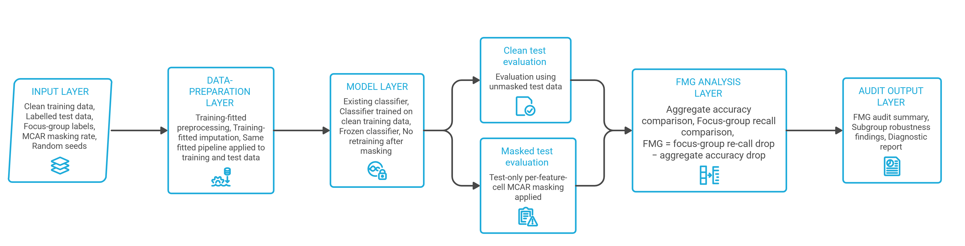
Fig. 1. Frozen-classifier audit architecture.
The data flow from training-fitted preprocessing through clean and masked evaluation to audit outputs is shown in Fig. 2.
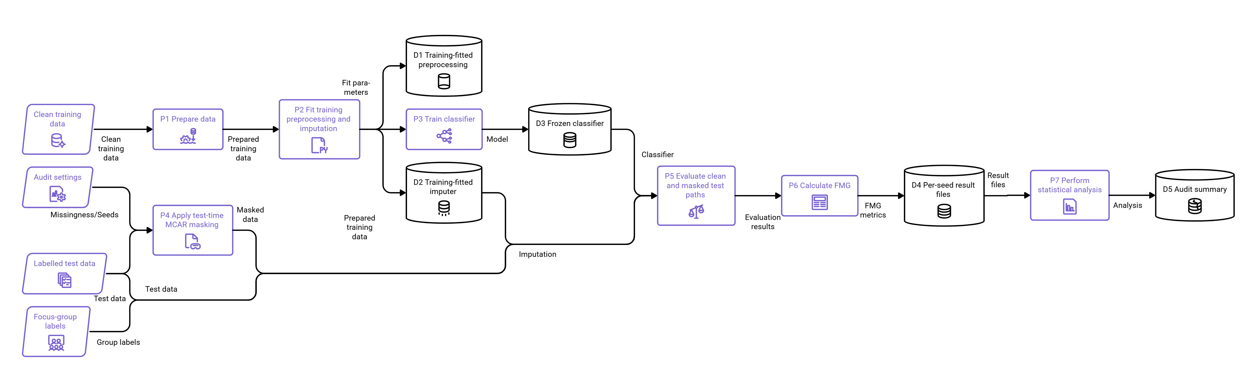
Fig. 2. Audit data flow.

3.2 Preprocessing and models
For each seed, we create a target-stratified 70:30 train/test split. Categorical variables are encoded with mappings learned from the training data; categories unseen during training receive the reserved code −1. Features are scaled to [0, 1] using training-fitted minima and maxima. Original row identifiers preserve the mapping to sensitive-group labels for test-set evaluation. The fixed seeds are {42, 123, 456, 1, 7, 13, 21, 37, 55, 99}.
Validation protocol. The primary benchmark has no independent external validation set. For each seed, the stratified 70:30 train/test split is used; preprocessing and imputation are fitted on training data, and the held-out test set is evaluated after model configuration. Hyperparameters are fixed before evaluation and are not tuned on masked test data. The MLP uses its stated internal early-stopping split during training; this split is not used as a reported test set. Ten seeds assess stability under repeated stratified resampling of the same finite datasets, not generalization to independent deployment populations. The historical primary run used a CPU-based Google Colab runtime. The reported Intel Core i5 10th-generation processor belongs to the author's local computer used to access Colab, not the Colab backend; the historical backend CPU model and resource allocation were not recorded. The later corrected full rerun's environment and runtime are summarized in the reproducibility and correction-trace paragraph in Section 3.5.
The ten seeds are stratified resampling repetitions from the same finite datasets, not separate populations or deployments. The observed split-to-split variability is descriptive of this benchmark procedure and is not treated as a sampling distribution for population- or deployment-level uncertainty.
Unless otherwise stated, parameters not listed below use the relevant library defaults. Logistic regression uses C=1.0, the lbfgs solver, and max_iter=1000. Random forest uses 100 trees with n_jobs=-1. XGBoost uses 100 trees with logloss evaluation and verbosity=0, while LightGBM uses 100 trees with verbosity=-1. The multilayer perceptron uses hidden_layer_sizes=(50, 30), max_iter=500, and early_stopping=True. Each model's random_state is set to the experiment seed. In the type-aware sensitivity analysis, KNNImputer uses n_neighbors=5 and weights='uniform'; IterativeImputer uses max_iter=10, random_state=42, and sample_posterior=False. The earlier single-seed encoded-space ablation is reported only as an illustration.
We train logistic regression, random forest (RF), XGBoost (XGB), LightGBM (LGB), and multilayer perceptron (MLP) using only clean training features. The primary model family consists of RF, XGB, LGB, and MLP; logistic regression is included for exploratory comparison.
The primary families were selected to span distinct modelling approaches rather than to represent all classifiers: RF provides a bagged-tree ensemble, XGB and LGB provide gradient-boosted tree implementations, and MLP provides a feed-forward neural-network comparator; logistic regression is a simpler linear reference. This diversity allows the audit to describe whether the paired loss contrast differs across these tested model families. It does not establish that any family is generally more robust, and it is not an exhaustive model comparison.

3.3 Missingness, imputation, and metric
For each eligible test feature cell in the encoded and scaled model-input matrix, primary MCAR masking is imposed independently with probability ε ∈ {0.05, 0.10, 0.20} (Rubin [34]). Thus, primary masking is applied after categorical encoding and scaling, not to the raw source variables. Masking occurs only after training. In the primary and group-conditional missingness analyses, the mask-generation seed matches the experiment seed; SHAP uses seed 42. For Adult Income, the official adult.data training member was parsed with '?' treated as a missing value; 2,399 of 32,561 rows contained at least one missing value and were excluded under the complete-case protocol, leaving 30,162 analyzed records. The primary pipeline fits a median SimpleImputer to the encoded, scaled clean training matrix and applies it to masked test features. Because nominal categories are integer-label encoded, median imputation can yield fractional codes that do not denote observed categories and the encoding imposes an artificial order. This is a limitation of the primary representation, not a claim that the imputed values preserve valid category semantics. A separate type-aware sensitivity experiment masks raw test feature cells before transformation and compares training-fitted median/mode, five-neighbour KNN/mode, and iterative numeric/mode imputation across ten seeds, three datasets, RF, and one 20% MCAR condition; its bounded results are summarized in Section 4.8 and detailed in the supplement.
FMG is conditional on representation, preprocessing, imputation, model, selected subgroup, evaluation split, and masking mechanism; it is not a preprocessing-independent property of a classifier. The additional type-aware experiment tests only the stated RF, three-dataset, 20% MCAR setting and does not establish general preprocessing robustness.
A separate exploratory sensitivity varied the strength of one observed-age-dependent logistic MAR mechanism against matched-eligible-feature MCAR. For each dataset, seed, and model, the clean-trained classifier was held fixed; age remained observed, and all other encoded and scaled test-feature cells were eligible for masking in both conditions. The MAR propensity used row-specific Bernoulli probabilities based on standardized observed test age, with the intercept calibrated to expected cell-missingness rates of 10% or 20%. We tested conditional odds ratios of 1.5, 2, and 4 per standard deviation of age. The training-fitted median imputer was used in both conditions. Mean differences and positive split counts are reported descriptively; the repeated splits reuse records and are not treated as independent inferential units. This sensitivity covers one observed covariate and one logistic propensity form, not all MAR mechanisms.
Let ε denote the independent per-feature-cell masking probability. It is not the proportion of test records affected. If p eligible feature cells are available for a record, the probability of at least one masked cell is:
P(at least one masked feature) = 1 − (1 − ε)ᵖ
For each dataset, model, seed, and masking rate ε, define the paired focus-group recall loss ΔR and aggregate-accuracy loss ΔA. FMG is the difference between these two losses:
ΔR(ε) = R(g₀, clean) − R(g₀, masked); ΔA(ε) = A(clean) − A(masked)
FMG(ε) = ΔR(ε) − ΔA(ε)
We choose aggregate accuracy as the comparison because this is a popular deployment headline metric that can remain seemingly stable even when recall for a subgroup of interest decreases. This makes this comparison diagnostic rather than a symmetric fairness measure.

3.3.1 FMG properties and interpretation
Let R₀(clean) and R₀(masked) denote focus-group recall in the clean and masked test conditions, respectively, and let A(clean) and A(masked) denote aggregate accuracy in those same conditions. Define the signed losses and their contrast as follows:
ΔR = R₀(clean) − R₀(masked); ΔA = A(clean) − A(masked); FMG = ΔR − ΔA
FMG > 0 indicates greater recall loss for the focus group than aggregate-accuracy loss; FMG = 0 indicates equal losses; and FMG < 0 indicates a larger aggregate-accuracy loss. Each component is a signed difference between two metrics in [0, 1] and therefore lies in [−1, 1]. Consequently, their difference FMG lies in [−2, 2]. This mathematical range does not establish protocol efficacy: FMG depends on the selected group, label rate, masking mechanism, imputation pipeline, model, and evaluation split, and remains a conditional diagnostic.

3.4 Focus-Group Masking Gap Audit Algorithm (Algorithm 1)
Algorithm 1 (Focus-Group Masking Gap audit). This is an evaluation algorithm for an existing classifier, not a classifier-training innovation.
- Inputs: a classifier; labelled training and test data; group labels; training-fitted encoding, scaling, and imputation; masking rates; fixed random seeds; and the prespecified recall convention.
- For each seed, fit preprocessing and train the classifier using the clean training data.
- Evaluate the unchanged trained classifier on the clean test set; record aggregate accuracy and focus-group recall.
- Generate an MCAR mask on test features only at the specified missingness rate; do not retrain the classifier.
- Apply the mask and transform the masked test features using the preprocessing and imputation fitted on the training data.
- Evaluate the same trained classifier on the stressed test set; record aggregate accuracy and focus-group recall.
- Calculate FMG = [focus-group recall(clean) − focus-group recall(stressed)] − [accuracy(clean) − accuracy(stressed)].
- Repeat the procedure for every seed and missingness rate, retaining the paired per-seed values.
- Report the mean and standard deviation of FMG, the observed range, the number of positive seed-level FMG values, and subgroup denominators. These are descriptive summaries of the repeated benchmark splits, not inferential estimates.
- Outputs: paired per-seed clean/stressed metrics, FMG values, subgroup denominators and positive-label counts, means, standard deviations, observed ranges, positive-split counts, tables, and figures.
Figures 1 and 2 summarize the audit architecture and data flow. Together with Algorithm 1, they show that one classifier trained on clean data is held fixed while clean and masked test paths are evaluated and compared.
The procedure is applied to the same trained model before and after masking. The denominator record is part of the reproducibility output, so a reader can check the number of positive labels supporting each focus-group recall value.
Computational cost. For n test records, p eligible feature cells per record, and r mask repetitions, constructing masks and transforming the masked matrices requires O(rnp) time and O(np) working memory when one masked matrix is processed at a time. Scoring adds r calls to the model prediction routine, whose cost depends on the fitted model and is not reduced to one model-independent bound here. Model fitting is performed once per seed and is separate from the additional masking-and-scoring overhead. The public-health run's observed 9,129-second runtime and approximately 2.00-GB sampled peak process memory are a hardware- and workload-specific reference, not an industrial scalability guarantee.

3.5 Statistical analysis
Primary results are summarized across the ten fixed stratified train/test splits using mean, standard deviation, range, and the number of positive FMG values. Because the splits reuse observations from the same finite datasets, seed-level values are not treated as independent inferential units; the manuscript therefore reports no seed-based significance tests or population-level confidence intervals. The 0.01 value is retained only as a study-specific descriptive reference and is not a validated or operational threshold. If a focus-group test subset has no positive labels, recall is recorded as zero (zero_division=0); subgroup totals and positive-label denominators are retained for every split. No k-fold cross-validation or external validation cohort was used. The n = 30 COMPAS extension is post-hoc descriptive evidence.
Table 3 reports both focus-group and comparison-group positive-class recall losses, plus their signed difference (g0 minus g1). Its percentile-bootstrap 95% intervals for mean FMG and focus-group positive-label denominator ranges are descriptive summaries of repeated-split resampling only; because splits reuse observations from the same finite datasets, they are not independent-population or deployment-level uncertainty intervals. The public-health archive separately reports unit-level bootstrap intervals resampling BRFSS primary sampling units within strata and UCI patients; those intervals are conditional on the specified split, fitted model, and mask replicate. The archived primary CSV also includes logistic-regression (LR) rows, which are reported separately from the four-model Table 3 comparison; Adult Income LR mean FMG at 20% MCAR was 0.0191.
Reproducibility and correction trace. The canonical corrected notebook, FMG_research_final_REVIEWER_FIXED.ipynb, was rerun end-to-end in a CPU-based Colab runtime. The run manifest records Python 3.13.16 on Linux x86_64, two logical CPUs, and 2,032.9 seconds from primary-run start; it does not record the CPU model or memory allocation. The run produced 800 raw result rows across four datasets (German Credit exploratory), five classifiers, ten seeds, and clean, 5%, 10%, and 20% conditions. Adult adult.data contained 32,561 source rows; 2,399 rows with '?' were excluded under the complete-case rule, leaving 30,162 analyzed records. All ten CSV outputs in the run archive match the manifest's SHA-256 hashes and byte counts. Recalculation from the raw rows reproduces the twelve primary 20%-MCAR dataset-model means, standard deviations, positive-seed counts, and component losses reported in Table 3 at displayed precision; nine means exceed the study-specific descriptive reference of 0.01. The notebook's cell 33 separately regenerated the descriptive bootstrap intervals from the primary seed-level FMG values; the saved intervals match Table 3 at displayed precision. That interval CSV is separate from the ten-file full-run archive. Per-seed denominators, threshold-discordance summaries, and Adult-dependent sensitivities are retained as separate reproducibility outputs. The archive's figures are listed by hash in its manifest; the historical primary Colab run remains distinct, and its backend CPU model and resource allocation are unknown. Results should be reproduced with the documented preprocessing, software versions, and execution settings. The observed Adult KNN/mode difference across scikit-learn 1.6.1 and 1.9.1 is reported in Section 4.8; this comparison does not isolate a software-version effect, and hardware effects were not separately measured.

3.6 Descriptive Diagnostic-Discordance Analysis
To examine whether aggregate-accuracy loss alone flags benchmark evaluations with a larger focus-group recall loss, we compare threshold indicators for the paired losses. For each paired dataset-model-seed evaluation, both indicators use the same illustrative loss threshold δ. U(δ) counts cases in which the focus-group recall loss reaches δ while aggregate-accuracy loss does not. We evaluate δ ∈ {0.01, 0.025, 0.05, 0.10} at 5%, 10%, and 20% MCAR. These thresholds are a descriptive sensitivity grid, not calibrated or recommended operational cutoffs. Counts are reported descriptively over repeated benchmark seeds; no population-level inference is made from these repeated splits.
Iᵣ(δ) = 1[ΔR ≥ δ]; Iₐ(δ) = 1[ΔA ≥ δ]; U(δ) = Iᵣ(δ) · (1 − Iₐ(δ))
4. Results

3.7 Exploratory Multi-Model SHAP Sensitivity
The public-health extension was re-fitted for RF, XGBoost, and LightGBM under its 80/20 split protocol for seeds 42, 123, and 456. For each model, a deterministic test-only 20% MCAR mask (replicate 0) was applied to the encoded test matrix. SHAP values for the positive-class output were calculated for the same, deterministically sampled set of up to 20 held-out observations per audit group under clean and masked/imputed inputs. RF and XGBoost used SHAP TreeExplainer's approximate Saabas mode; LightGBM used exact TreeSHAP because the installed SHAP API does not support approximate mode for LightGBM. Since fitted estimators from the earlier Colab extension were not serialized, this sensitivity refitted models under the same split seeds, preprocessing, and hyperparameters using the locally recorded software environment; it does not explain the exact previously serialized model objects. We summarize seed-level signed and absolute attribution changes descriptively.

4.1 Primary analysis at 20% MCAR
The primary results provide a controlled benchmark demonstration of the FMG audit under the specified datasets, models, preprocessing pipeline, MCAR mechanism, and repeated seeds. They describe this procedure and these conditions; they do not establish universal subgroup behaviour.
Nine of the 12 primary dataset-model comparisons have mean FMG above the study-specific descriptive reference of 0.01. All four primary models exceed this reference for Adult Income and Taiwan Credit; MLP alone exceeds it for COMPAS. Across the 12 pairs, mean FMG is 0.0545; across the nine pairs above 0.01, mean FMG is 0.0727. These are descriptive summaries across repeated splits, not statistically significant findings. Fig. 3 shows mean FMG across MCAR rates, while Table 3 reports the 20% summaries. As a sensitivity analysis of the descriptive reference, the number of comparisons above alternative mean-FMG references is 9/12 at 0.005, 9/12 at 0.01, 9/12 at 0.02, 8/12 at 0.05, and 0/12 at 0.10; this does not validate practical importance. Importantly, FMG is not a focus-versus-comparison group disparity: in only 4/12 primary model-dataset pairs was g0 recall loss greater than g1 recall loss.
For example, corrected Adult Income RF has mean aggregate-accuracy loss 0.0214, g0 recall loss 0.1079, and g1 recall loss 0.1403, giving mean FMG = 0.0865 (Table 3). Thus, g0 recall loss exceeds the aggregate accuracy loss, but the comparison-group recall loss is larger than the g0 recall loss in this case. Fig. 4 places aggregate and g0 recall losses side by side; Table 3 makes the g1 contrast explicit. This benchmark result does not establish disproportionately greater harm to the focus group, a real-world decision benefit, or a production alert threshold.

Table 3. Primary results at 20% MCAR across ten repeated benchmark splits. The table reports FMG, accuracy loss, both group recall losses and their signed contrast, positive-split counts, descriptive bootstrap intervals, and g0 positive-label denominator ranges. The intervals summarize repeated-split resampling and are not population-level guarantees.
Dataset / model | FMG mean (SD); accuracy loss | g0 / g1 recall loss; g0 − g1 | Positive FMG splits; 95% CI; g0 positive-denominator range
Adult / LGB | 0.0977 (0.0192); acc 0.0256 | 0.1234 / 0.1443; -0.0209 | 10/10; [0.0862, 0.1086]; n+ 316-347
Adult / MLP | 0.0616 (0.0250); acc 0.0180 | 0.0797 / 0.1108; -0.0312 | 10/10; [0.0472, 0.0763]; n+ 316-347
Adult / RF | 0.0865 (0.0225); acc 0.0214 | 0.1079 / 0.1403; -0.0324 | 10/10; [0.0726, 0.0990]; n+ 316-347
Adult / XGB | 0.0890 (0.0269); acc 0.0237 | 0.1127 / 0.1359; -0.0232 | 10/10; [0.0727, 0.1048]; n+ 316-347
COMPAS / LGB | 0.0010 (0.0299); acc 0.0266 | 0.0276 / -0.0083; +0.0359 | 4/10; [-0.0154, 0.0192]; n+ 510-548
COMPAS / MLP | 0.0293 (0.0164); acc 0.0221 | 0.0514 / 0.0108; +0.0406 | 10/10; [0.0200, 0.0391]; n+ 510-548
COMPAS / RF | 0.0047 (0.0238); acc 0.0242 | 0.0289 / 0.0092; +0.0196 | 5/10; [-0.0090, 0.0189]; n+ 510-548
COMPAS / XGB | -0.0060 (0.0355); acc 0.0275 | 0.0215 / -0.0053; +0.0268 | 3/10; [-0.0251, 0.0158]; n+ 510-548
Taiwan Credit / LGB | 0.0728 (0.0091); acc 0.0075 | 0.0803 / 0.0878; -0.0075 | 10/10; [0.0687, 0.0788]; n+ 1092-1170
Taiwan Credit / MLP | 0.0701 (0.0066); acc 0.0075 | 0.0776 / 0.0896; -0.0120 | 10/10; [0.0662, 0.0740]; n+ 1092-1170
Taiwan Credit / RF | 0.0812 (0.0106); acc 0.0042 | 0.0854 / 0.0898; -0.0044 | 10/10; [0.0760, 0.0882]; n+ 1092-1170
Taiwan Credit / XGB | 0.0658 (0.0103); acc 0.0068 | 0.0726 / 0.0810; -0.0084 | 10/10; [0.0597, 0.0717]; n+ 1092-1170

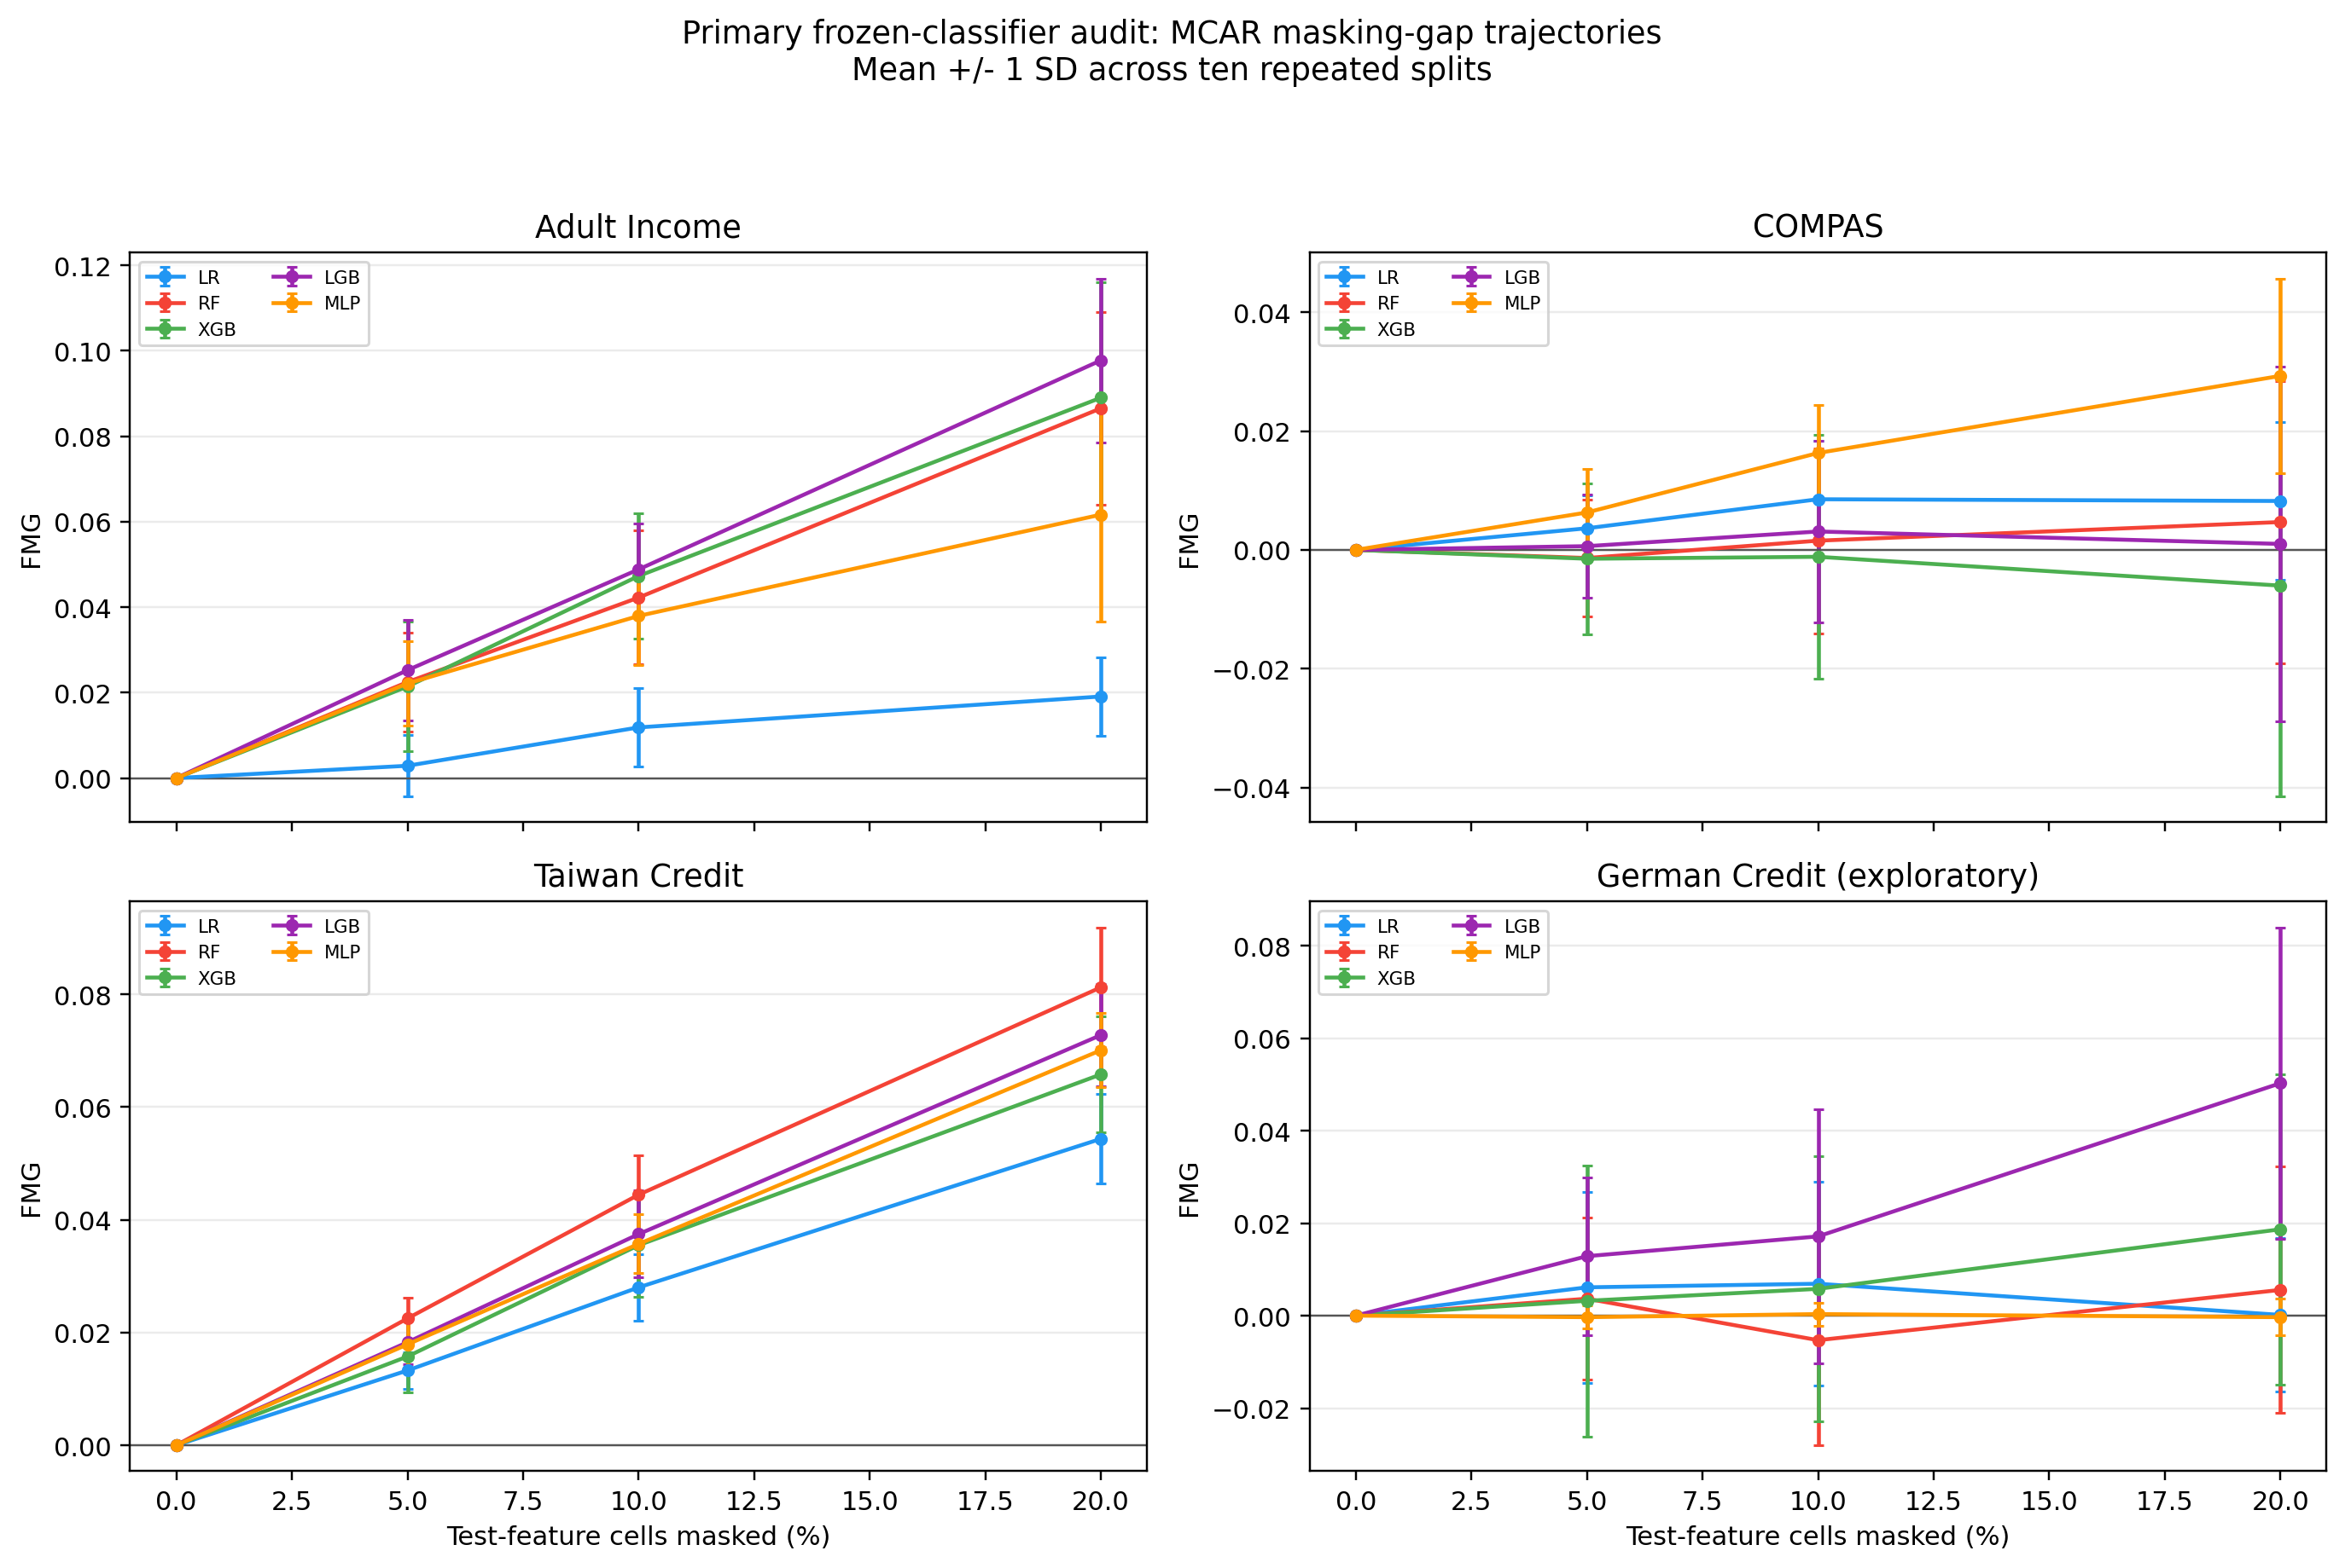
Fig. 3. Mean FMG across MCAR rates for five classifiers on Adult Income, COMPAS, Taiwan Credit, and exploratory German Credit; error bars show ±1 SD across ten repeated splits. Adult values use the corrected complete-case sample.
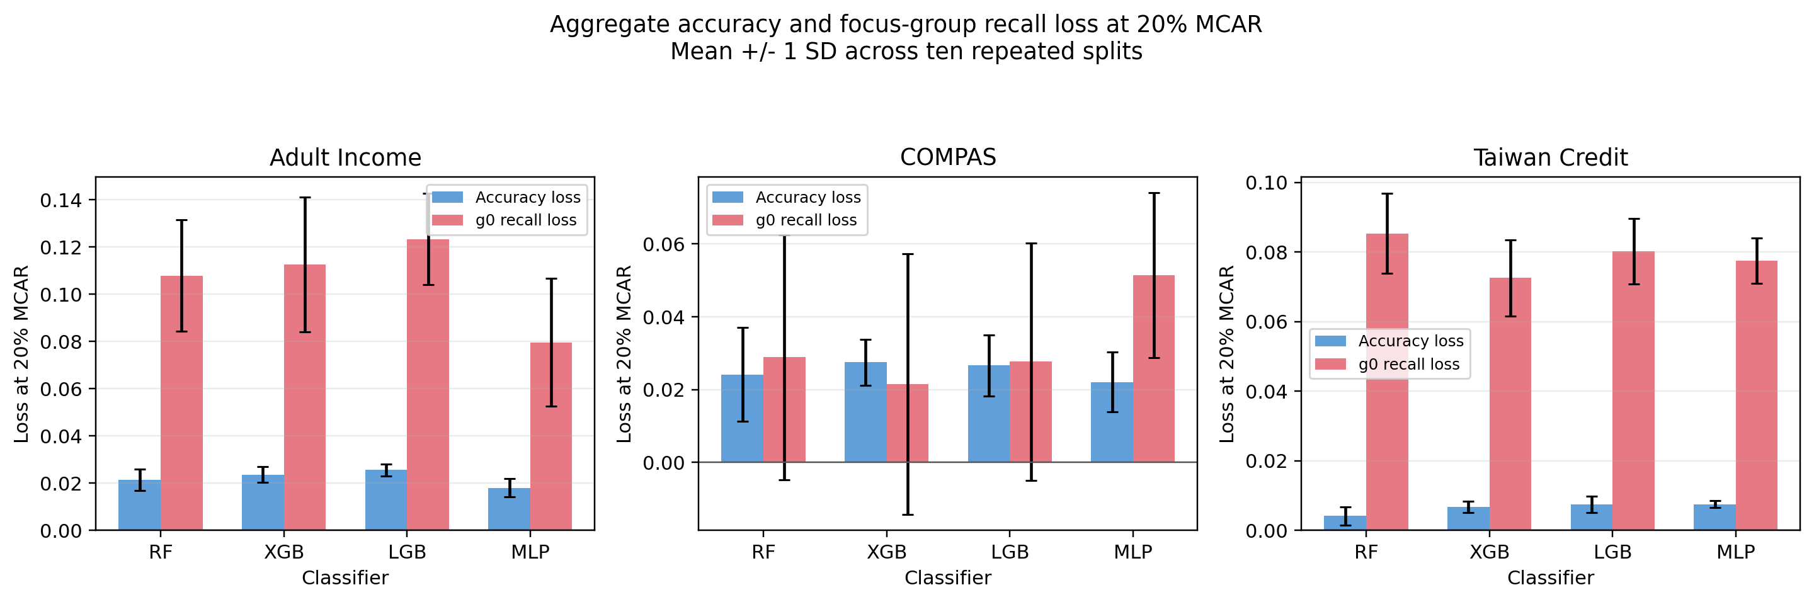
Fig. 4. Aggregate-accuracy and g0 positive-class recall loss at 20% MCAR for four classifiers on three primary datasets; bars show means and error bars ±1 SD across ten repeated splits. g1 losses are reported in Table 3.

4.2 Relationship to Equal Opportunity
Relationship to Equal Opportunity (EOG) compares recall between groups within the same condition. FMG, in contrast, compares the loss in focus-group recall with the loss in aggregate accuracy across conditions. EOG changes vary by dataset and are included only as descriptive context; they should not be interpreted as a causal explanation for any FMG pattern.

4.3 Group-conditional MAR sensitivity
We extended the missingness analysis to one constructed group-conditional MAR mechanism across the three primary datasets (Adult Income, COMPAS, and Taiwan Credit), four primary models (RF, XGB, LGB, and MLP), ten repeated splits, and nominal rates of 10% and 20%. The probability of masking a test-feature cell in the encoded and scaled matrix depends on the observed focus-group attribute; group-specific probabilities are calibrated so the weighted overall expected rate equals the nominal rate. The sensitive attribute is retained for audit grouping but excluded from model features, and the classifier is trained on clean data and frozen for test evaluation. Each dataset-model-split-rate case is paired with its MCAR counterpart. Mean FMG was higher under group-conditional missingness in 12/12 dataset-model comparisons at 10% and 11/12 at 20%. These are descriptive comparisons over the specified repeated splits; no seed-based significance claims are made. Fig. 5 summarizes paired differences. This sensitivity concerns only the specified group-conditional MAR mechanism; it does not establish results for every MAR mechanism or for MNAR missingness.
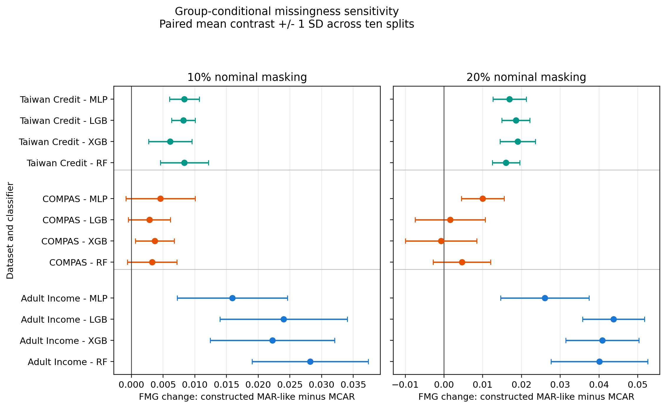
Fig. 5. Paired FMG difference under one constructed group-conditional MAR mechanism versus MCAR across three primary datasets, four classifiers, and 10%/20% nominal masking; points and error bars show the mean and ±1 SD across ten repeated splits.

4.4 Age-conditioned MAR sensitivity
Across 72 descriptive dataset-model-rate-strength contrasts, mean FMG differences (age-conditioned MAR minus matched-eligible-feature MCAR) ranged from -0.0092 to 0.0318; positive paired split-level differences ranged from 3/10 to 10/10. The largest positive mean difference occurred for COMPAS/XGB at 20% expected missingness and an age odds ratio of 4 per standard deviation (mean difference = 0.0318; 10/10 split-level differences positive). These are descriptive repeated-split summaries, not significance tests. Effects varied across datasets, models, rates, and propensity strengths; this exploratory sensitivity does not establish a general MAR effect. Per-split values, realized masking rates, subgroup denominators, and comparison summaries are included in the supplementary analysis package.

4.5 Class-rate adjustment
For corrected Adult Income RF, mean FMG is 0.0865 in the original sample and 0.0933 in the matched-subsample analysis; FMG values were positive in all ten repeated splits in both conditions. This one matched-subsample comparison does not causally separate class imbalance, reduced sample size, and missingness effects. Fig. 6 shows the per-split comparison and the descriptive association with class-rate differential.
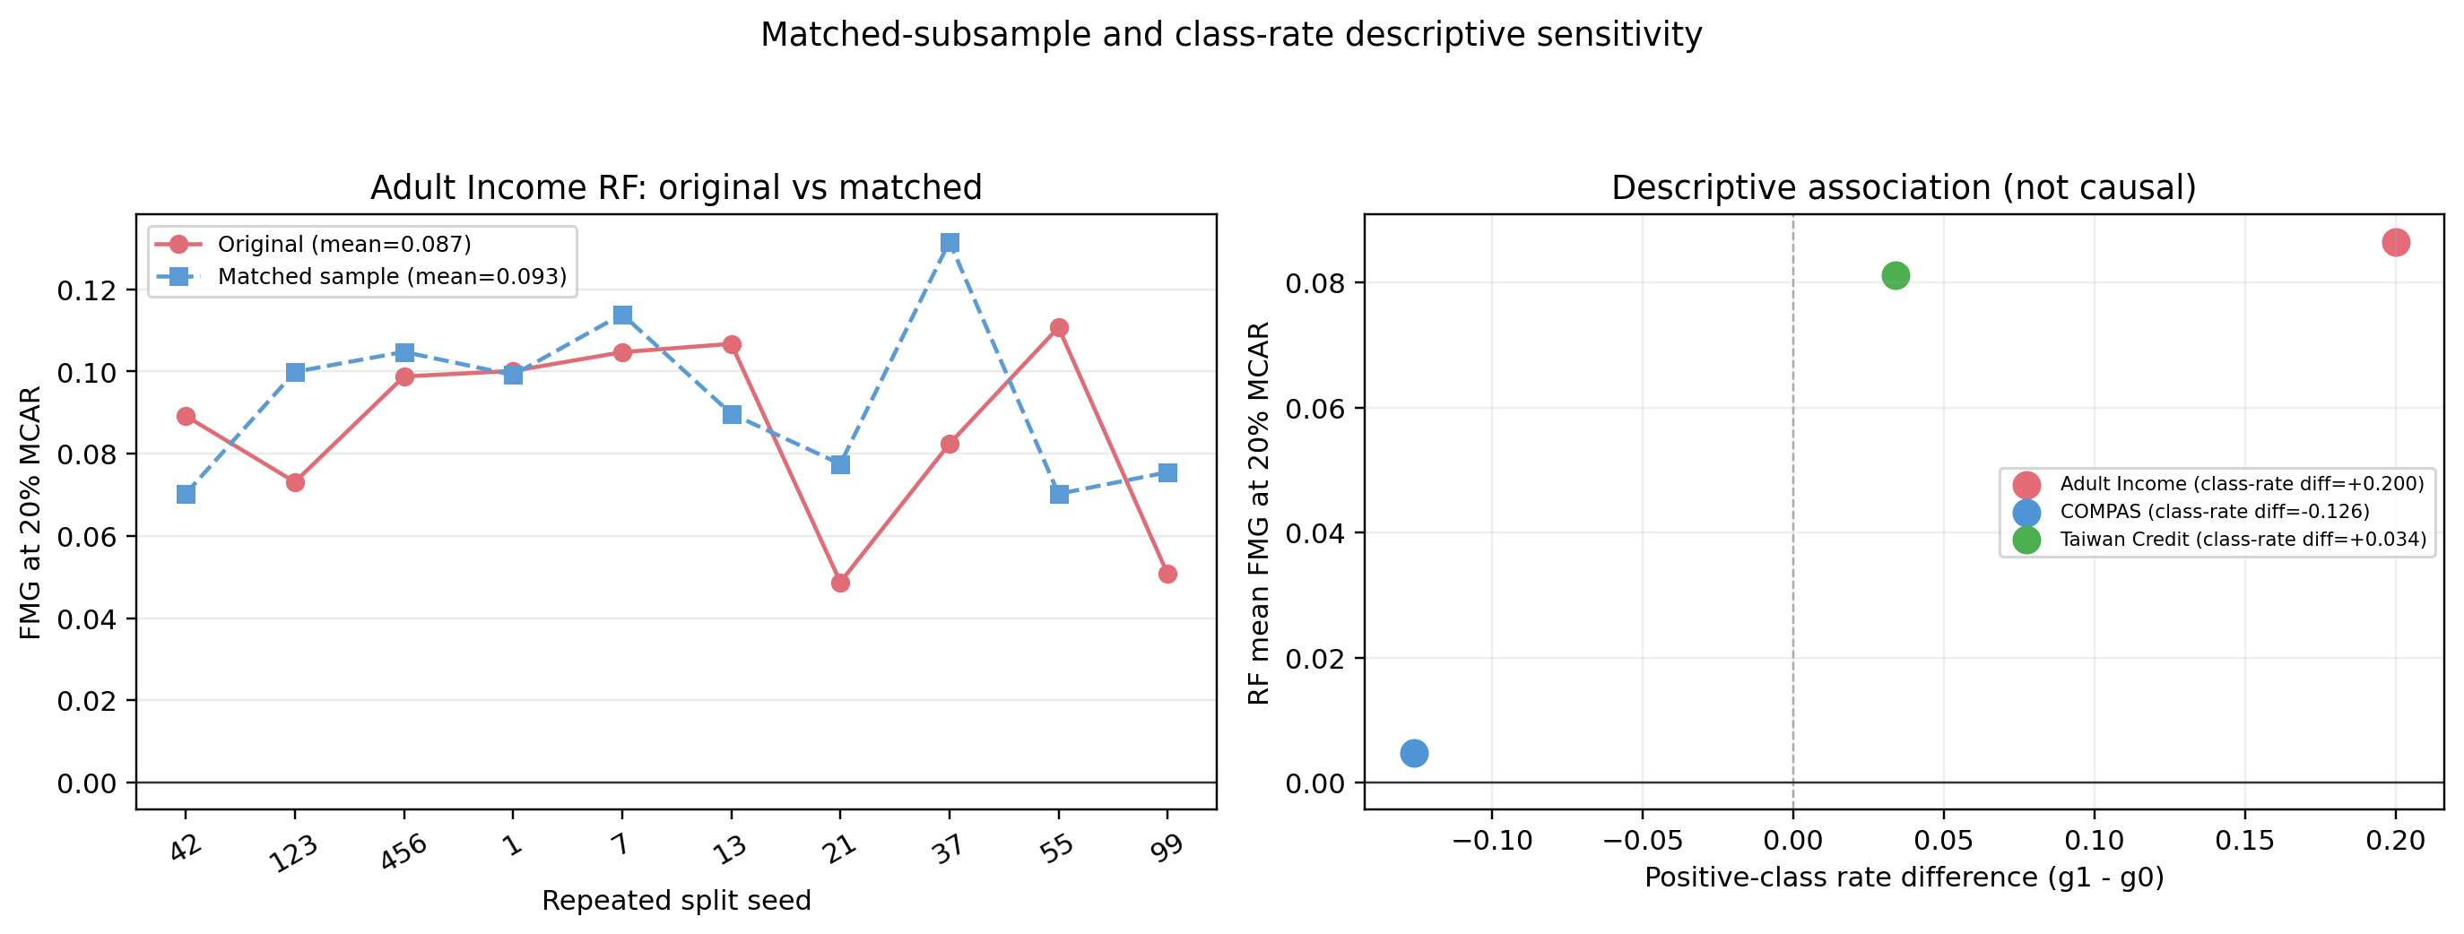
Fig. 6. Corrected Adult Income matched-subsample and class-rate descriptive sensitivities at 20% MCAR. The subsample analysis does not isolate a causal class-imbalance effect.

4.6 Extended-seed COMPAS analysis
The post-hoc n = 30 COMPAS extension reproduces the first ten split-level values exactly. Across 30 repeated splits, RF has mean FMG = 0.0036 with 14/30 positive values; MLP has mean FMG = 0.0281 with 27/30 positive values. This descriptive extension indicates model-dependent results within this COMPAS benchmark, not a dataset-wide conclusion. Fig. 7 displays the extended-split distributions.
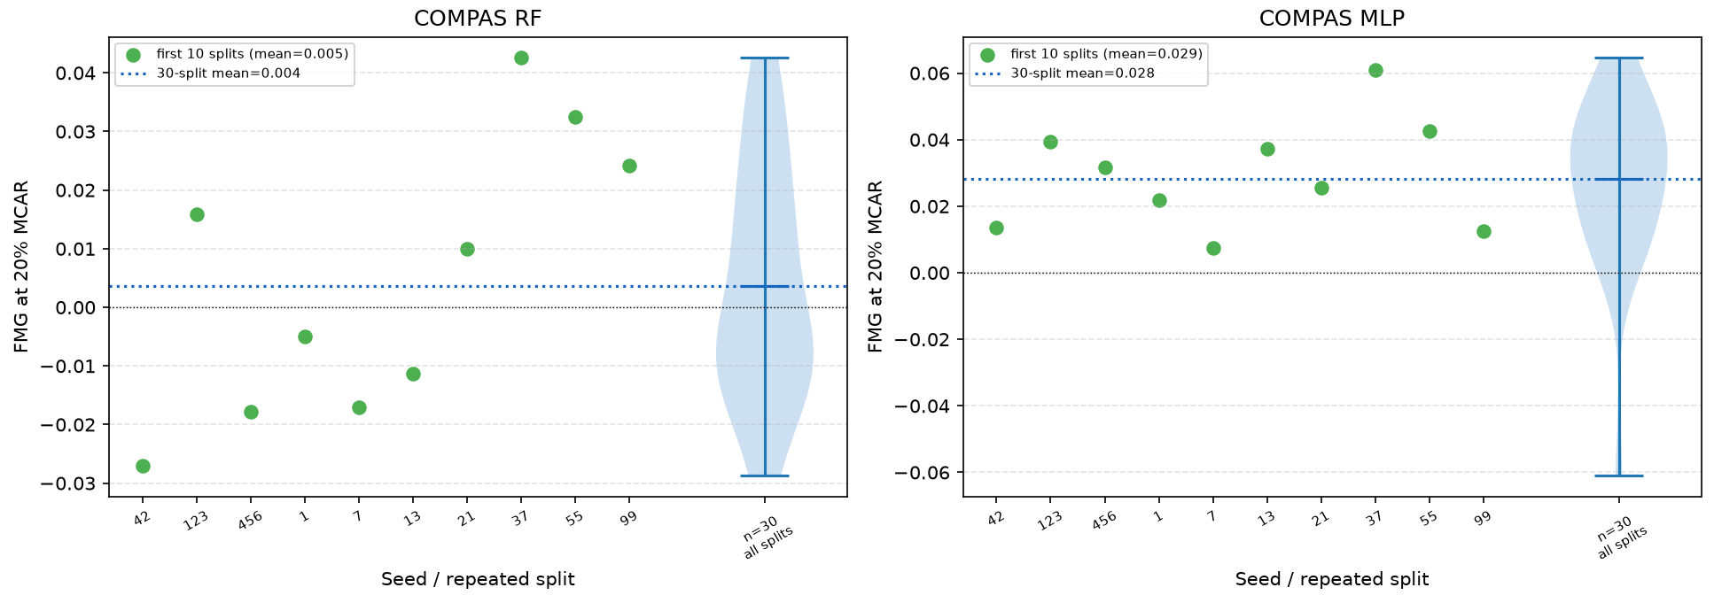
Fig. 7. Descriptive COMPAS RF and MLP sensitivity across ten and thirty repeated splits at 20% MCAR; the first ten splits are included in the n=30 distribution and are not independent replications.

4.7 SHAP diagnostic
The exploratory SHAP analysis introduced by Lundberg and Lee [35] is restricted here to COMPAS RF at seed 42 and reports subgroup-specific changes in mean absolute SHAP values after 20% MCAR masking and imputation. The largest displayed between-group differences involve priors_count, age, and c_days_from_compas; race is not a model feature. Adult SHAP values from the earlier run are not carried forward because they were computed on the Adult sample before the missing-marker correction. Fig. 8 is therefore COMPAS-only. These attribution shifts are descriptive, do not identify a causal mechanism for FMG, and should be interpreted in light of the known sensitivity of SHAP explanations to small input perturbations (Ghorbani et al. [36]).
A separate multi-model/multi-seed sensitivity re-fit RF, XGBoost, and LightGBM on the two public-health datasets for three seeds, using up to 20 matched test observations per group. The top-ranked mean absolute attribution shifts were the BRFSS age-group feature across all model/group combinations and number_inpatient across the UCI Diabetes combinations (Table S10). For these top features, signed direction agreed with the three-seed mean in two or three seeds, depending on the model and group. These are exploratory attribution shifts, not causal drivers of FMG; raw magnitudes are not compared across models because model output scales and explanation modes differ. The re-fit also used locally recorded software versions that differ from the earlier Colab extension, so it is a separate sensitivity rather than an explanation of the exact earlier fitted objects. A larger attribution shift for AGEG5YR or number_inpatient reflects a change in the model's attribution to that feature in this sampled comparison; it does not diagnose FMG or explain its value.
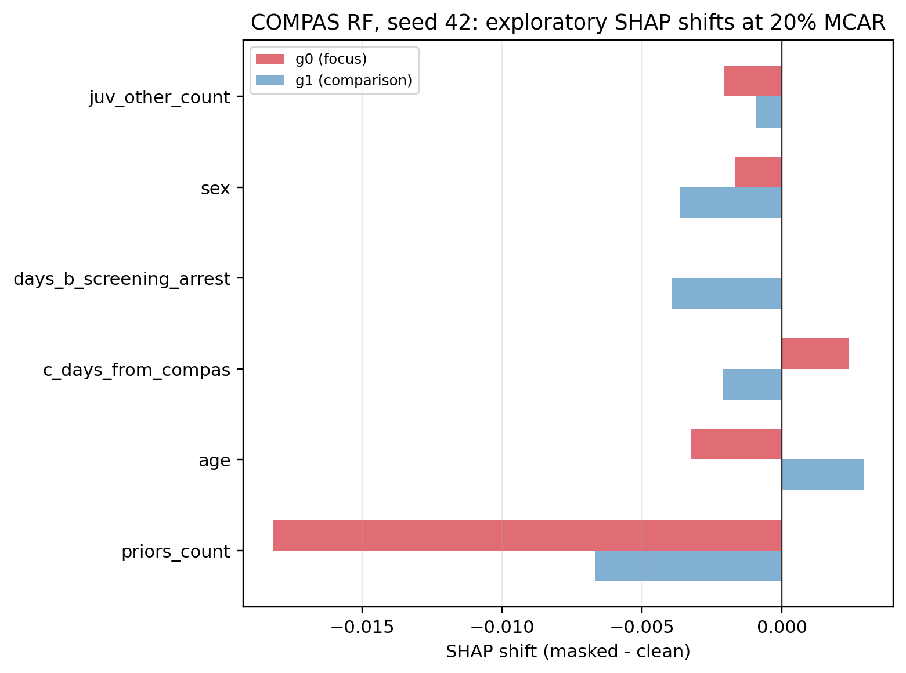
Fig. 8. COMPAS-only exploratory RF seed-42 change in mean absolute SHAP attribution under 20% MCAR for six features with the largest between-group asymmetry. This is a single-split descriptive illustration, not a causal explanation.

4.8 Imputation ablation
The expanded type-aware sensitivity analysis covers RF, three datasets, ten fixed seeds, and one 20% MCAR condition, with the same raw test-cell mask shared across imputation strategies within each dataset and seed. Imputation/encoding pipelines are fitted on clean training data; each strategy's classifier is trained on clean transformed training data and then held fixed for clean and masked test evaluation. The strategies are median imputation for numeric features plus most-frequent categorical imputation, five-neighbour KNN numeric imputation plus most-frequent categorical imputation, and iterative numeric imputation plus most-frequent categorical imputation. The in-notebook cell 35 reports only the median/mode pipeline; KNN/mode and iterative/mode results were generated separately by the type-aware sensitivity script. Table 4 and Fig. 9 report descriptive focus-group results without significance tests. Corrected Adult Income mean FMG ranges from 0.026972 to 0.032747, with 7/10 to 9/10 positive splits; COMPAS ranges from −0.0131 to 0.0049 (3–5/10 positive splits); Taiwan Credit ranges from 0.0689 to 0.0856 (10/10 positive splits). In the corrected Adult rerun, KNN/mode mean FMG was 0.032747 under scikit-learn 1.9.1, compared with 0.031762 in the earlier scikit-learn 1.6.1 output; median/mode was 0.031763 in both. The earlier KNN and median/mode values were close but distinct, and the KNN estimate shows modest version sensitivity. These type-aware means are below the primary encoded-space RF mean FMG of 0.0865, but the pipelines differ in representation and imputation; this is not an isolated causal effect or general ranking. These dataset-dependent results do not establish broad preprocessing robustness.
Table 4. Multi-seed, type-aware imputation sensitivity at 20% MCAR (RF; ten seeds). Adult rows were rerun with scikit-learn 1.9.1; COMPAS and Taiwan Credit retain the earlier recorded scikit-learn 1.6.1 run. Cross-dataset differences may therefore reflect both dataset and software-version differences.
Dataset | Strategy | FMG mean ± SD | + seeds | Acc./g0 recall loss
Adult Income | Iterative/mode | 0.026972 ± 0.029278 | 7/10 | 0.0194; 0.0464
Adult Income | KNN/mode | 0.032747 ± 0.024813 | 9/10 | 0.0226; 0.0553
Adult Income | Median/mode | 0.031763 ± 0.027052 | 9/10 | 0.0205; 0.0523
COMPAS | Iterative/mode | -0.013119 ± 0.026977 | 3/10 | 0.0187; 0.0056
COMPAS | KNN/mode | -0.004284 ± 0.017726 | 4/10 | 0.0245; 0.0202
COMPAS | Median/mode | 0.004873 ± 0.026213 | 5/10 | 0.0249; 0.0297
Taiwan Credit | Iterative/mode | 0.085624 ± 0.014840 | 10/10 | 0.0049; 0.0906
Taiwan Credit | KNN/mode | 0.068865 ± 0.014564 | 10/10 | 0.0055; 0.0744
Taiwan Credit | Median/mode | 0.083100 ± 0.014349 | 10/10 | 0.0044; 0.0875

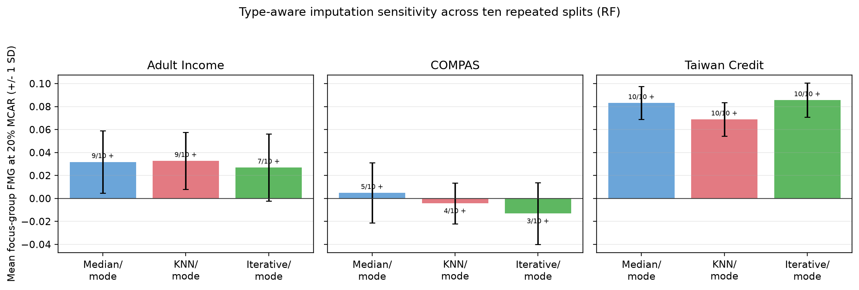
Fig. 9. Multi-seed, type-aware FMG sensitivity at 20% MCAR for RF across three datasets and ten repeated splits; bars show means, error bars ±1 SD, and labels give positive-split counts.

4.9 Complementary-group and baseline-recall sensitivity
At 20% MCAR, corrected Adult complementary-group (g1) mean FMG ranged from 0.0928 to 0.1189 across models, with positive g1 FMG in all ten splits for every Adult model. The g1 mean was also positive for all four models in Taiwan Credit, again with positive values in all ten splits. In COMPAS, g1 mean FMG was negative for all four models, and positive values occurred in only one to three splits. These group-level patterns vary across datasets and do not support a general claim that the prespecified focus group is always more affected. Corrected model-level summaries are reported in Supplementary Table S1.
Across the twelve dataset-model pairs, the descriptive Spearman association between clean baseline focus-group recall and 20% MCAR FMG ranged from −0.394 to 0.806 (ten paired seeds per pair) after correction of the Adult input. The direction was not consistent across models and datasets. These small-sample correlations are descriptive only and do not establish that baseline recall explains FMG. Corrected Adult-dependent per-seed and summary values are included in the Adult correction package; prior supplementary Adult values should not be reused.

4.10 Descriptive Diagnostic Discordance
This benchmark-only comparison contains 120 paired primary evaluations at each masking rate (three datasets × four models × ten seeds). At δ = 1 percentage point, 107 evaluations met the recall-loss threshold, 77 met the accuracy-loss threshold, and 41 recall flags were not accompanied by an accuracy flag; at δ = 2.5 percentage points, 100 evaluations met the recall-loss threshold, 31 met the accuracy-loss threshold, and 78 recall flags were not accompanied by an accuracy flag; at δ = 5 percentage points, 91 evaluations met the recall-loss threshold, 0 met the accuracy-loss threshold, and 91 recall flags were not accompanied by an accuracy flag; at δ = 10 percentage points, 26 evaluations met the recall-loss threshold, 0 met the accuracy-loss threshold, and 26 recall flags were not accompanied by an accuracy flag. At the 1-percentage-point threshold, the share of recall-loss flags not accompanied by an accuracy-loss flag was 85/94 (90.4%) at 5% MCAR, 58/103 (56.3%) at 10% MCAR, and 41/107 (38.3%) at 20% MCAR. Thus, in these benchmark rows, aggregate accuracy sometimes remained below the same illustrative threshold when subgroup recall loss exceeded it. Corrected dataset-model-seed threshold files are saved in adult_corrected_rerun/. This analysis demonstrates descriptive benchmark discordance only: the thresholds are uncalibrated, the same two component losses determine the flags and FMG, and we did not test whether FMG improves analyst decisions, monitoring, or outcomes in an operational setting.

4.11 Public-Health Benchmark Extension
The separate extension used 80/20 and 70/30 split settings, three seeds (42, 123, 456), five classifiers, MCAR, one constructed group-conditional MAR mechanism, and one constructed value-conditional MNAR mechanism at 5%, 10%, and 20% masking, with five mask repetitions per condition. Table S7 reports the 80/20, 20% MCAR condition; means and standard deviations summarize 15 seed-by-mask-repetition records per dataset-model and are descriptive. BRFSS mean FMG ranged from 0.0272 to 0.0455; comparison-group (g1) recall loss exceeded focus-group (g0) recall loss for all five models. This can coexist with positive FMG because FMG compares g0 recall loss with aggregate-accuracy loss, not with g1 recall loss. In UCI Diabetes, mean clean focus-group recall ranged from 0.000 to 0.020 across models, and RF clean recall was zero in both groups. The near-zero UCI FMG values therefore reflect a recall-floor limitation in this condition, not evidence of robustness. The extension broadens retrospective benchmark coverage but does not establish clinical benefit, causal effects, or deployment utility, and is not independent external validation of an operational system.
Secondary outcomes and intersectional groups were also available in the completed public-health extension (Supplementary Tables S8–S9). Under 80/20, 20% MCAR, mean masked focus-group precision across the five models ranged from 0.6038 to 0.6696 in BRFSS and 0.0000 to 0.5085 in UCI; corresponding F1 ranges were 0.0994–0.1330 and 0.0000–0.0305, balanced-accuracy ranges were 0.5234–0.5320 and 0.5000–0.5068, and AUROC ranges were 0.7815–0.7906 and 0.6376–0.6456. These are descriptive values averaged over 15 seed-by-mask records per model and provide complementary context; they do not replace or redefine the primary FMG estimand. The contrast between tasks cannot isolate the effects of prevalence, outcome definition, cohort composition, model operating point, or evaluation design. In the prespecified intersectional analysis (Black women versus White women in BRFSS; African-American versus other reported-race women in UCI), each model had 15 eligible seed-by-mask records at this condition. For this sensitivity, the contrast uses intersection-specific recall loss and accuracy loss within that intersection, so its accuracy comparator differs from the primary global-accuracy comparator. Mean intersectional FMG ranged from 0.0309 to 0.0461 in BRFSS and 0.0000 to 0.0038 in UCI. The observed positive-record counts varied by model in UCI (0–14 of 15), while all 15 records were positive for every BRFSS model. All included intersectional evaluations met the minimum outcome-cell count rule, but these summaries remain conditional on these two group definitions and three seeds.
FMG is currently evaluated for a binary positive outcome and one prespecified focus group per comparison. For a multiclass extension, a class-specific one-versus-rest recall loss could be paired with aggregate accuracy loss for each prespecified class; macro- or prevalence-weighted summaries would answer different questions and should be reported separately. No multiclass experiment was conducted here, so this is a proposed extension rather than a validated generalization.
5. Discussion
Within the specified benchmark, aggregate accuracy alone did not describe the full change in focus-group recall. The primary results were consistent across the four tested models in Adult Income and Taiwan Credit, whereas only the COMPAS MLP met both primary criteria. This model variation argues against generalizing a single dataset-wide pattern to all classifiers. The expanded group-conditional analysis also showed mostly positive paired FMG differences relative to MCAR for the one constructed mechanism tested, but it does not characterize all forms of non-random missingness.
Relation to prior work and model variation. The setting overlaps with prior studies of fairness effects under missingness [1], structured inference-time missingness [3], and test-time tabular feature-missingness robustness [2], but this is not a direct replication: the datasets, protocols, and estimands differ. The present analysis reports a paired, descriptive contrast between focus-group recall loss and aggregate-accuracy loss for the same frozen classifier and masking condition. Within COMPAS, only the MLP met both primary criteria. In the separate 30-split descriptive sensitivity, mean FMG was 0.0281 (27/30 positive splits) for MLP and 0.0036 (14/30) for RF. This model-dependent contrast is not evidence of a causal mechanism. Different model responses to encoded and imputed inputs are one possible explanation, but architecture and other mechanisms were not isolated; the result should not be generalized to all tree-based models.
The corrected age-conditioned sensitivity spans -0.0092 to 0.0318 across 72 tested dataset-model-rate-strength contrasts, with positive split-level differences ranging from 3/10 to 10/10. The largest positive mean difference was COMPAS/XGB at 20% missingness and an age odds ratio of 4 per standard deviation (0.0318; 10/10 positive splits). This is bounded descriptive evidence for the specified mechanism and benchmark configuration, not a general MAR effect or robustness property.
FMG contrasts focus-group recall loss with aggregate-accuracy loss. A positive value is not, by itself, an equal-opportunity violation, a causal effect of the sensitive attribute, or a comprehensive fairness evaluation. It should be used alongside established fairness measures, calibration and error-rate analyses, and context-specific missingness assessment. The present experiments evaluate the diagnostic under controlled benchmark conditions; they do not show improved decisions, operational utility, or production monitoring performance.
The primary MCAR design is a controlled stress test, not a model of the frequency or causes of missing features in production. The constructed MAR and MNAR extension mechanisms improve coverage of selected alternatives but do not exhaust realistic missingness processes. Likewise, the binary tasks permit a single positive-class recall contrast; they cannot establish how class selection or aggregation should work for multiclass settings. The supplementary health extension reports precision, F1, balanced accuracy, and AUROC as complementary outcomes, but the primary benchmark does not provide a full alternative-metric comparison.
The descriptive value of FMG is that it expresses the direction and size of the difference between two losses as one signed contrast; it does not contain information beyond subgroup-recall and aggregate-accuracy losses reported separately. The threshold-discordance analysis shows that, within this benchmark and the tested illustrative thresholds, accuracy-only flags do not always coincide with focus-group recall flags. This is a comparison of component-loss thresholds, not evidence that FMG changes decisions or improves monitoring. A potential use is to help an analyst scan and prioritize benchmark cases for further examination, but that benefit was not compared with component-only reporting. Establishing decision or monitoring value requires an operational study with a defined decision context, prespecified actions, and appropriate outcome data.
In a future operational study, a model owner could supply a frozen classifier, labelled evaluation data, group labels, training-fitted preprocessing, and a realistic missingness scenario. An audit result might then motivate investigation of the data pipeline or further evaluation. These are potential uses, not outcomes tested here: the benchmark does not assess a live medical, financial, agricultural, or public-service deployment, nor does it validate operational thresholds or human-review interventions.
The public-health extension provides a specific contrast. In BRFSS, comparison-group (g1) recall loss exceeded focus-group (g0) recall loss in all five models, even though the FMG means were positive; FMG compares g0 recall loss with aggregate-accuracy loss, not g1 loss. In UCI Diabetes, clean focus-group recall averaged 0.000–0.020 across models, and RF had zero clean recall in both groups, so its near-zero FMG is a floor-effect observation, not evidence of robust predictions. The datasets differ in task, cohort, group definitions, and evaluation design, and the extension uses only three seeds; these results do not identify which difference accounts for the contrast or establish that one dataset is intrinsically more vulnerable. BRFSS model fitting was unweighted although held-out metrics used survey weights.
6. Limitations and Threats to Validity
Internal and statistical validity. The primary experiment applies independent MCAR masking at test time. The age-conditioned sensitivity varies one logistic observed-age propensity (odds ratios 1.5, 2, and 4 per standard deviation) across three primary datasets, four models, ten repeated splits, and 10%/20% rates. These analyses cover only one observed covariate and one propensity form; they do not represent all MAR mechanisms and do not test MNAR. Because repeated splits reuse observations, seed-level p-values and confidence intervals are not used to support population claims; reported results are descriptive summaries of this benchmark procedure. The n = 30 COMPAS extension is post-hoc descriptive evidence. The matched-subsample result is one adjustment and does not causally decompose class imbalance, sample size, and missingness. The public-health extension adds only three repeated seeds and five mask replicates per condition, and it examines two task-specific public datasets rather than prospective clinical data. BRFSS is a cross-sectional self-report outcome; UCI rows are hospital encounters from 1999-2008. The extension uses unweighted fitting with weighted BRFSS evaluation, and tests only the specified group-conditional MAR and value-conditional synthetic MNAR mechanisms. Its results therefore do not generalize to all health populations, missingness processes, or clinical decisions.
7. Future Scope
Future work should test type-aware preprocessing across additional classifier families, datasets, and masking rates; evaluate broader observed-covariate MAR mechanisms and empirically grounded MNAR scenarios beyond the single constructed mechanism in the public-health extension; examine additional intersectional subgroups; and conduct independently specified replications. It should also determine whether the audit changes decisions or improves monitoring in real operational settings, using an identified decision context, operational data, and prespecified actions; the present benchmark did not evaluate those outcomes or deployment safety. The added SHAP sensitivity is limited to three tree models, three seeds, two public-health datasets, up to 20 test observations per group, and mixed exact/approximate attribution modes. Future research should extend SHAP to additional model families, datasets, and seeds using harmonized exact attribution methods where feasible, compare additional subgroup metrics and multiclass estimands, assess computational scaling on larger datasets, and study adaptations for federated, online, and continual-learning systems. These topics require additional design and evidence and are not claimed as completed here.

8. Conclusion
This study presents a reproducible frozen-classifier audit for controlled test-time feature masking, with FMG defined as the signed difference between focus-group recall loss and aggregate-accuracy loss under the same stressor. In the specified benchmark, nine of twelve primary comparisons had a mean FMG above the study-specific descriptive reference of 0.01. Direct comparison of the two subgroup recall losses showed greater g0 loss in four of twelve dataset-model pairs, confirming that positive FMG alone is not a between-group disparity. Group-conditional MAR, age-propensity, complementary-group, baseline-recall, and imputation analyses provide additional bounded summaries of variation across tested conditions. Because seed splits reuse records, these are descriptive benchmark findings rather than inferential claims about a broader population. FMG is a conditional diagnostic for further investigation; it does not certify fairness, establish causality, or validate deployment safety. The threshold-discordance analysis identifies benchmark cases in which subgroup-recall loss crosses an illustrative threshold while aggregate-accuracy loss does not; this does not demonstrate added information beyond the component losses or operational benefit. Real-world decision and monitoring utility remains future work. A separate public-health extension produced a contrasting result: BRFSS model means exceeded 0.01 at 20% MCAR, whereas UCI Diabetes model means did not. This dataset- and task-dependent contrast broadens the benchmark evidence but does not validate clinical or operational use.

Declarations
Funding: No external funding was reported.
Competing interests: The authors declare no competing interests.
Ethics: The study uses public benchmark datasets. COMPAS is included solely as a standard fairness benchmark; the study does not endorse algorithmic recidivism prediction.
Declaration of Generative AI and AI-Assisted Technologies: During the preparation of this manuscript, generative AI tools, including OpenAI’s Prism, were used to assist with language refinement, structural editing, and improvement of clarity and presentation. The authors reviewed and verified the manuscript content, citations, interpretations, and final text and take full responsibility for the accuracy and integrity of the submitted work.
Author contributions: M. Vamsi Krishna: conceptualisation, methodology, software, data curation, formal analysis, experiments, and original draft preparation. S. Sri Harsha: validation, investigation, review and editing, and visualisation.
Data Availability: The benchmark datasets are publicly available from the cited providers. The project repository release at https://github.com/MVamsiKrishna2501050195/FMG-research/tree/fmg-submission-release-v2-2026-10-25 provides the canonical corrected analysis notebook (FMG_research_final_REVIEWER_FIXED.ipynb), run manifest (run_manifest_20261025.json), and full corrected-run output archive (reproducibility/FMG_full_run_outputs_2026-10-25.zip). The release also contains experiments/public_health/ with the extension protocol and code, full-run output archive and manifest, and separate exploratory multi-seed SHAP outputs. Raw BRFSS and UCI source data are not redistributed and should be obtained from their providers. The corrected Adult analysis uses only the adult.data training member; adult.test was not appended.

References
[1] Min, S., Asif, H., and Vaidya, J. Exploring the inequitable impact of data missingness on fairness in machine learning. IEEE Intelligent Systems, 40(3), 28-38, 2025. https://doi.org/10.1109/MIS.2025.3549484.
[2] Jang, S., Eun, J., Yi, H., and Choi, C. When does train-time masking help? A leakage-controlled robustness audit of tabular classifiers under feature missingness. IEEE Access, 14, 84378-84398, 2026. https://doi.org/10.1109/ACCESS.2026.3695538.
[3] T. Kochs, A. Castellani, F. Lanfermann, and B. Hammer, “Evaluating and mitigating fairness risks in machine learning under structured missing data,” in Proceedings of the 3rd Workshop on Fairness and Bias in AI (AEQUITAS@ECAI 2025), CEUR Workshop Proceedings, vol. 4147, published 2026. https://ceur-ws.org/Vol-4147/paper12.pdf
[4] Y. Zhang and Q. Long, “Assessing fairness in the presence of missing data,” Advances in Neural Information Processing Systems, vol. 34, 2021. https://proceedings.neurips.cc/paper/2021/hash/85dca1d270f7f9aef00c9d372f114482-Abstract.html
[5] J. J. Cherian and E. J. Candès, “Statistical inference for fairness auditing,” Journal of Machine Learning Research, vol. 25, no. 149, pp. 1–49, 2024. https://jmlr.org/papers/v25/23-0739.html
[6] Bhatti, A., Sandrock, T., and Nienkemper-Swanepoel, J. The influence of missing data mechanisms and simple missing data handling techniques on fairness. International Journal of Data Science and Analytics, 22, Article 172, 2026. https://doi.org/10.1007/s41060-026-01139-0.
[7] Caton, S., Malisetty, S., and Haas, C. Impact of imputation strategies on fairness in machine learning. Journal of Artificial Intelligence Research, 74, 1011-1035, 2022. https://doi.org/10.1613/jair.1.13197.
[8] Emmanuel, T., Maupong, T., Mpoeleng, D., Semong, T., Mphago, B., and Tabona, O. A survey on missing data in machine learning. Journal of Big Data, 8, Article 140, 2021. https://doi.org/10.1186/s40537-021-00516-9.
[9] Jeanselme, V., De-Arteaga, M., Zhang, Z., Barrett, J., and Tom, B. Imputation strategies under clinical presence: Impact on algorithmic fairness. arXiv:2208.06648, 2022.
[10] Jeong, H., Wang, H., and Calmon, F. P. Fairness without imputation: A decision tree approach for fair prediction with missing values. Proceedings of AAAI, 36(9), 9558-9566, 2022. https://doi.org/10.1609/aaai.v36i9.21189.
[11] Martinez-Plumed, F., Ferri, C., Nieves, D., and Hernández-Orallo, J. Missing the missing values: The ugly duckling of fairness in machine learning. International Journal of Intelligent Systems, 36(7), 3217-3258, 2021. https://doi.org/10.1002/int.22415.
[12] Miao, X., Qiang, L., Huang, G., Wu, Y., and Yin, J. Fairness-aware classification over incomplete data. Proceedings of the 48th International ACM SIGIR Conference on Research and Development in Information Retrieval, 549-558, 2025. https://doi.org/10.1145/3726302.3729975.
[13] Pessach, D., and Shmueli, E. A review on fairness in machine learning. ACM Computing Surveys, 55(3), Article 51, 1-44, 2022. https://doi.org/10.1145/3494672.
[14] Barrainkua, A., Gordaliza, P., Lozano, J. A., and Quadrianto, N. Preserving the fairness guarantees of classifiers in changing environments: A survey. ACM Computing Surveys, 57(6), Article 137, 1–32, 2025. https://doi.org/10.1145/3637438.
[15] Buolamwini, J., and Gebru, T. Gender Shades: Intersectional accuracy disparities in commercial gender classification. Proceedings of FAT*, 2018, 77-91.
[16] Caton, S., and Haas, C. Fairness in machine learning: A survey. ACM Computing Surveys, 56(7), Article 166, 1-38, 2024. https://doi.org/10.1145/3616865.
[17] Chouldechova, A. Fair prediction with disparate impact: A study of bias in recidivism prediction instruments. Big Data, 5(2), 153-163, 2017. https://doi.org/10.1089/big.2016.0047.
[18] D'Amour, A., et al. Underspecification presents challenges for credibility in modern machine learning. Journal of Machine Learning Research, 23(226), 1-61, 2022.
[19] Hardt, M., Price, E., and Srebro, N. Equality of opportunity in supervised learning. Advances in Neural Information Processing Systems, 29, 3315-3323, 2016.
[20] Mehrabi, N., Morstatter, F., Saxena, N., Lerman, K., and Galstyan, A. A survey on bias and fairness in machine learning. ACM Computing Surveys, 54(6), Article 115, 1-35, 2021. https://doi.org/10.1145/3457607.
[21] Wang, H., He, L., Gao, R., and Calmon, F. Aleatoric and epistemic discrimination: Fundamental limits of fairness interventions. Advances in Neural Information Processing Systems, 36, 2023.
[22] Wang, Y., and Singh, L. Analyzing the impact of missing values and selection bias on fairness. International Journal of Data Science and Analytics, 12, 101-119, 2021. https://doi.org/10.1007/s41060-021-00259-z.
[23] Kamiran, F., and Calders, T. Data preprocessing techniques for classification without discrimination. Knowledge and Information Systems, 33(1), 1-33, 2012. https://doi.org/10.1007/s10115-011-0463-8.
[24] Hendrycks, D., and Dietterich, T. Benchmarking neural network robustness to common corruptions and perturbations. International Conference on Learning Representations, 2019.
[25] Koh, P. W., et al. WILDS: A benchmark of in-the-wild distribution shifts. Proceedings of the 38th International Conference on Machine Learning, 139, 5637-5664, 2021.
[26] Moreno-Torres, J. G., Raeder, T., Alaiz-Rodríguez, R., Chawla, N. V., and Herrera, F. A unifying view on dataset shift in classification. Pattern Recognition, 45(1), 521-530, 2012. https://doi.org/10.1016/j.patcog.2011.06.019.
[27] Shao, M., Li, D., Zhao, C., Wu, X., Lin, Y., and Tian, Q. Supervised algorithmic fairness in distribution shifts: A survey. Proceedings of the 33rd International Joint Conference on Artificial Intelligence, 8225–8233, 2024. https://doi.org/10.24963/ijcai.2024/909.
[28] Singh, H., Xia, F., Gossmann, A., Chuang, A., Hong, J. C., and Feng, J. "Who experiences large model decay and why?" A hierarchical framework for diagnosing heterogeneous performance drift. Proceedings of the 42nd International Conference on Machine Learning, Proceedings of Machine Learning Research, 267, 55757-55787, 2025. https://proceedings.mlr.press/v267/singh25e.html.
[29] Shadbahr, T., Roberts, M., Stanczuk, J., et al. The impact of imputation quality on machine learning classifiers for datasets with missing values. Communications Medicine, 3, Article 139, 2023. https://doi.org/10.1038/s43856-023-00356-z.
[30] Dua, D., and Graff, C. UCI Machine Learning Repository. University of California, Irvine, 2019. https://archive.ics.uci.edu/dataset/2/adult.
[31] Angwin, J., Larson, J., Mattu, S., and Kirchner, L. Machine Bias. ProPublica, 2016. https://www.propublica.org/article/machine-bias-risk-assessments-in-criminal-sentencing.
[32] Yeh, I.-C., and Lien, C.-H. The comparisons of data mining techniques for the predictive accuracy of probability of default of credit card clients. Expert Systems with Applications, 36(2), 2473-2480, 2009. https://doi.org/10.1016/j.eswa.2007.12.020.
[33] Grömping, U. South German Credit Data: Correcting a Widely Used Data Set. Report 4/2019, Department II, Beuth University of Applied Sciences Berlin, 2019. https://www1.bht-berlin.de/FB_II/reports/Report-2019-004.pdf
[34] Rubin, D. B. Inference and missing data. Biometrika, 63(3), 581-592, 1976. https://doi.org/10.1093/biomet/63.3.581.
[35] Lundberg, S. M., and Lee, S.-I. A unified approach to interpreting model predictions. Advances in Neural Information Processing Systems, 30, 4765-4774, 2017.
[36] Ghorbani, A., Abid, A., and Zou, J. Interpretation of neural networks is fragile. Proceedings of AAAI, 33(1), 3681-3688, 2019. https://doi.org/10.1609/aaai.v33i01.33013681.
[37] Centers for Disease Control and Prevention, “2024 BRFSS Survey Data and Documentation,” Behavioral Risk Factor Surveillance System, 2025. https://www.cdc.gov/brfss/annual_data/annual_2024.html.
[38] J. Clore, K. Cios, J. DeShazo, and B. Strack, “Diabetes 130-US Hospitals for Years 1999-2008,” UCI Machine Learning Repository, dataset, 2014. https://doi.org/10.24432/C5230J.
[39] OpenML. credit-g, OpenML dataset 31, version 1; original Statlog German Credit data. https://www.openml.org/d/31.

