Controlled Test-Time Feature Masking and Focus-Group Recall Degradation in Tabular Classifiers
M. Vamsi Krishna; S. Sri Harsha
KL University
2501050195@kluniversity.in; sriharsha@kluniversity.in

Abstract
Machine-learning classifiers are often evaluated on complete test data, although deployed systems may receive inputs with missing features. This study examines whether controlled test-time missing-completely-at-random (MCAR) feature masking, applied after training, causes a greater recall decline for a selected demographic focus group than for overall accuracy. We define the Focus-Group Masking Gap (FMG, abbreviated as MG in the tables and figures) as the drop in focus-group recall minus the drop in aggregate accuracy under the same masking condition. We evaluate five classifier families on four tabular datasets using ten random seeds. The primary analysis covers four non-linear families, RF, XGB, LGB, and MLP, on Adult Income, COMPAS, and Taiwan Credit; German Credit and logistic regression are exploratory. At 20% MCAR missingness, 9 of 12 primary comparisons have MG > 0.01 and meet the Bonferroni-adjusted threshold of alpha = 0.0042. All four Adult Income comparisons and all four Taiwan Credit comparisons are significant. COMPAS shows a model-dependent pattern: MLP is significant (MG = 0.0293, SD = 0.0164, p = 0.000977), whereas RF, XGB, and LGB are not. These results indicate that aggregate accuracy may conceal a larger recall loss for the focus group under the masking condition examined here. We present FMG as a diagnostic for subgroup-aware robustness auditing, rather than as a general fairness certificate or a causal explanation.
Keywords: missing data; MCAR; fairness; tabular classifiers; focus-group masking gap; robustness evaluation

1. Introduction
A classifier may perform well on complete data yet receive incomplete features at test time. Overall accuracy is usually the headline measure, but it can conceal a different degree of degradation for a particular demographic group. We therefore examine whether controlled feature masking at test time reduces focus-group recall more than aggregate accuracy when the trained model remains unchanged.
Our contribution is an empirical diagnostic called the Focus-Group Masking Gap, evaluated through controlled test-time MCAR feature masking. The claim is deliberately limited. We do not argue that missingness-related fairness, incomplete-data classification, robustness to missingness, or subgroup-specific deployment drift are new research topics. Instead, the study combines three specific elements: masking is introduced only after training, performance is assessed separately for a selected focus group, and the resulting statistic compares the group's recall loss with the loss in aggregate accuracy. The primary analysis uses Adult Income, COMPAS, and Taiwan Credit with four non-linear classifier families. German Credit and logistic regression are exploratory. Supplementary analyses include a limited MAR probe, a matched-subsample class-rate adjustment, an extended-seed COMPAS analysis, single-seed imputation ablations, and descriptive SHAP shifts.

2. Related Work and Scope
Recent work relevant to this study spans three areas: robustness to distribution shift (Hendrycks and Dietterich, 2019; Koh et al., 2021), missing-data handling, and fairness evaluation (Barrainkua et al., 2025; Caton and Haas, 2024; Caton et al., 2022; D'Amour et al., 2022; Emmanuel et al., 2021; Mehrabi et al., 2021; Moreno-Torres et al., 2012; Shao et al., 2024; Jang et al., 2026; Singh et al., 2025). Fairness criteria also require careful interpretation because error-rate requirements can conflict across groups (Buolamwini and Gebru, 2018; Chouldechova, 2017; Hardt et al., 2016; Kamiran and Calders, 2012). Research on missing values and fair prediction supports evaluating the entire preprocessing-and-prediction pipeline; imputation should not be assumed to be neutral (Caton et al., 2022; Emmanuel et al., 2021; Jeong et al., 2022; Martinez-Plumed et al., 2021; Jeanselme et al., 2022; Min et al., 2025; Bhatti et al., 2026; Shadbahr et al., 2023; Wang and Singh, 2021). Recent studies of incomplete data and missingness-related fairness examine imputation, complete-case analysis, explicit incomplete-data classifiers, missingness mechanisms, and mitigation through reweighting or resampling under fairness metrics (Pessach and Shmueli, 2022; Min et al., 2025; Wang et al., 2023; Bhatti et al., 2026; Miao et al., 2025; Wang and Singh, 2021). Against this background, our contribution is deliberately bounded. We do not claim to be the first study to connect missing data with fairness.
Several recent papers make this distinction clearer. Wang and Singh report that missing values and selection bias can alter fairness even when predictive accuracy remains relatively stable, but their analysis focuses on conventional fairness metrics and mitigation strategies rather than a deployment-time discrepancy between recall degradation and aggregate accuracy (Wang and Singh, 2021). Shadbahr et al. examine missingness and imputation quality through aggregate performance and imputation metrics, rather than subgroup recall degradation (Shadbahr et al., 2023). Jang et al. study deployment-time missingness overlays for tabular robustness and report aggregate AUROC degradation without stratification by a sensitive group (Jang et al., 2026). Bhatti et al. evaluate fairness under different missingness mechanisms, while Miao et al. propose a fairness-aware classifier for incomplete data; neither introduces an aggregate-versus-focus-group degradation metric (Bhatti et al., 2026; Miao et al., 2025). SHIFT examines heterogeneous subgroup model decay after deployment shift, but it remains a general distribution-shift diagnostic rather than a missingness-specific recall audit (Singh et al., 2025). Wang et al. provide theoretical grounding for limits on discrimination under missing data, but not a practical deployment-time audit statistic (Wang et al., 2023).
The distinction examined here is diagnostic rather than definitional. Earlier studies investigate how missing data, imputation, specialized classifiers, missingness mechanisms, or deployment shifts affect fairness measures and model performance. Our question is narrower: can an aggregate metric that appears acceptable conceal a larger recall loss for a focus group when a feature-masking overlay is applied to held-out test data? The Focus-Group Masking Gap is not intended to replace established fairness metrics. It is a targeted robustness signal that compares subgroup recall degradation with aggregate-accuracy degradation under the same stressor.

3. Methodology

3.1 Datasets and focus groups
Table 1. Datasets and analytical scope.
Dataset | Rows | Task | Sensitive attribute | Focus group
Adult Income | 32,561 | Income > $50K | Sex | Female (g0)
COMPAS | 5,278 | Two-year recidivism | Race | African-American (g0)
Taiwan Credit | 30,000 | Payment default | Sex | Female (g0)
German Credit | 1,000 | Credit outcome | Personal status | Female (g0); exploratory

The primary analysis uses Adult Income (Dua and Graff, 2019), COMPAS (Angwin et al., 2016), and Taiwan Credit (Yeh and Lien, 2009). We treat German Credit (Grömping, 2019) as exploratory because its sample is smaller and its historical release has known issues; the OpenML-corrected encoding described in (Grömping, 2019) is used. For every dataset, the sensitive attribute is excluded from the model features. In COMPAS, race is also excluded because it defines the focus-group comparison.
The reported focus groups are fixed dataset-level comparison groups rather than groups selected after inspecting the MG results: female for Adult Income and Taiwan Credit, African-American for COMPAS, and female for exploratory German Credit. The sensitive attribute is excluded from the model features and is used only for subgroup evaluation. The complementary group is retained for the descriptive comparison. These choices provide an observable subgroup for recall evaluation while keeping the sensitive attribute outside the model input; they are not outcome-selected claims about which group is most affected. For every dataset and seed, subgroup_denominators_per_seed.csv records the test-group total, positive- and negative-label counts, positive-label rate, recall denominator, and no-positive-label indicator.

3.2 Preprocessing and models
For each seed, we divide the data into 70% training and 30% test sets using target stratification. Categorical mappings are learned only from the training data, and any category that appears exclusively in the test set is assigned the reserved value -1. We then apply min-max scaling to all encoded features using parameters learned from the training set. Original row indices are retained so that sensitive labels can be recovered for the test rows before subgroup evaluation. The fixed seeds are {42, 123, 456, 1, 7, 13, 21, 37, 55, 99}.
Unless otherwise stated, parameters not listed below use the relevant library defaults. Logistic regression uses C=1.0, the lbfgs solver, and max_iter=1000. Random forest uses 100 trees with n_jobs=-1. XGBoost uses 100 trees with logloss evaluation and verbosity=0, while LightGBM uses 100 trees with verbosity=-1. The multilayer perceptron uses hidden_layer_sizes=(50, 30), max_iter=500, and early_stopping=True. For each experiment, model random_state is set to the current experiment seed. The single-seed imputation ablation uses KNNImputer(n_neighbors=5) and IterativeImputer(max_iter=10, random_state=42).
We train logistic regression, random forest (RF), XGBoost (XGB), LightGBM (LGB), and multilayer perceptron (MLP) using only clean training features. The primary model family consists of RF, XGB, LGB, and MLP; logistic regression is included for exploratory comparison.

3.3 Missingness, imputation, and metric
For each test feature, we independently impose missingness with probability epsilon in {0.05, 0.10, 0.20}, following the missing-completely-at-random (MCAR) mechanism (Rubin, 1976). Masking is applied only after model training. In the primary and MAR analyses, the mask-generation seed is the corresponding experiment seed; the SHAP and imputation-ablation analyses use seed 42. In the primary experiment, a SimpleImputer with the median strategy is fitted to the encoded and scaled training-feature matrix and then applied to the masked test matrix. Thus, the pipeline performs matrix-level median imputation after label encoding rather than using separate continuous-median and categorical-mode procedures. The MG values describe this specific preprocessing pipeline and should not be treated as properties independent of preprocessing choices.
For each model, dataset, and missingness rate epsilon, we calculate the Focus-Group Masking Gap as MG(epsilon) = [recall(g0, clean) - recall(g0, stressed)] - [accuracy(clean) - accuracy(stressed)]. In the prose, we refer to this statistic as FMG; the tables and figures use MG to keep the notation compact. A positive value means that focus-group recall declined more than aggregate accuracy under the same stressor.

3.4 Focus-Group Masking Gap Audit Algorithm (Algorithm 1)
Algorithm 1 (evaluation procedure). This is an evaluation algorithm, not a new classifier-training method; it evaluates an existing model under a specified test-time masking stressor.
- Inputs: a classifier; labelled training and test data; group labels; training-fitted preprocessing and imputation; missingness rates; and random seeds.
- For each seed, fit preprocessing and train the classifier using the clean training data.
- Evaluate the unchanged trained classifier on the clean test set; record aggregate accuracy and focus-group recall.
- Generate an MCAR mask on test features only at the specified missingness rate; do not retrain the classifier.
- Apply the mask and transform the masked test features using the preprocessing and imputation fitted on the training data.
- Evaluate the same trained classifier on the stressed test set; record aggregate accuracy and focus-group recall.
- Calculate MG = [focus-group recall(clean) − focus-group recall(stressed)] − [accuracy(clean) − accuracy(stressed)].
- Repeat the procedure for every seed and missingness rate, retaining the paired per-seed values.
- Report the mean MG, standard deviation, exact one-sided Wilcoxon signed-rank p-value, paired Cohen's dz, and subgroup denominators.
- Outputs: per-seed results, aggregate statistics, significance decisions, tables, and figures.
The procedure is applied to the same trained model before and after masking. The denominator record is part of the reproducibility output, so a reader can check the number of positive labels supporting each focus-group recall value.

3.5 Statistical analysis
For inference, we use an exact one-sided Wilcoxon signed-rank test on the ten per-seed MG values, testing against zero with the alternative MG > 0. The ten seeds represent repeated stratified train/test resampling units for the specified split, model-fitting, and masking procedure. No k-fold cross-validation is used, and the seeds do not represent independent deployments or independent populations. If a focus-group test subset contains no positive labels, recall is recorded as zero under the implementation's zero_division=0 rule. The corresponding subgroup totals and positive-label denominators are included with the per-seed results. We regard a primary comparison as substantive only when MG > 0.01 and p < 0.0042, the Bonferroni threshold for the 12 primary comparisons. The 0.01 value is a study-specific warning threshold representing a one-percentage-point discrepancy, not a universal fairness cutoff. We calculate paired Cohen's dz as mean(MG) divided by the sample standard deviation of MG. The n = 30 COMPAS analysis is treated as post-hoc supplementary evidence.
The 12 primary p-values correspond to the four primary models in each of the three primary datasets and form the prespecified multiplicity family. Each test concerns the paired seed-level MG values for one model-dataset pair; it does not estimate population-level uncertainty, independent-deployment uncertainty, or a causal effect.

4. Results

4.1 Primary analysis at 20% MCAR
Nine of the twelve primary comparisons satisfy both the practical and corrected statistical criteria. Adult Income and Taiwan Credit show positive MG values for all four primary models. For COMPAS, the result depends on the model: MLP is positive and significant, whereas RF, XGB, and LGB are not. The mean MG across all 12 primary comparisons is 0.0534; across the nine significant comparisons, it is 0.0712.
Table 2. Primary 20% MCAR results, n = 10. Significant means MG > 0.01 and p_MG < 0.0042.
Data | Model | MG | SD | Acc. drop | Recall drop | p_MG | dz | Sig.
Adult | RF | 0.0907 | 0.0229 | 0.0203 | 0.1110 | 0.000977 | 3.961 | Yes
Adult | XGB | 0.0971 | 0.0160 | 0.0236 | 0.1207 | 0.000977 | 6.052 | Yes
Adult | LGB | 0.0953 | 0.0141 | 0.0238 | 0.1191 | 0.000977 | 6.747 | Yes
Adult | MLP | 0.0383 | 0.0190 | 0.0190 | 0.0573 | 0.000977 | 2.017 | Yes
COMPAS | RF | 0.0047 | 0.0238 | 0.0242 | 0.0289 | 0.347656 | 0.197 | No
COMPAS | XGB | -0.0060 | 0.0355 | 0.0275 | 0.0215 | 0.784180 | -0.169 | No
COMPAS | LGB | 0.0010 | 0.0299 | 0.0266 | 0.0276 | 0.652344 | 0.034 | No
COMPAS | MLP | 0.0293 | 0.0164 | 0.0221 | 0.0514 | 0.000977 | 1.787 | Yes
Taiwan | RF | 0.0812 | 0.0106 | 0.0042 | 0.0854 | 0.000977 | 7.635 | Yes
Taiwan | XGB | 0.0658 | 0.0103 | 0.0068 | 0.0726 | 0.000977 | 6.411 | Yes
Taiwan | LGB | 0.0728 | 0.0091 | 0.0075 | 0.0803 | 0.000977 | 8.025 | Yes
Taiwan | MLP | 0.0701 | 0.0066 | 0.0075 | 0.0776 | 0.000977 | 10.606 | Yes

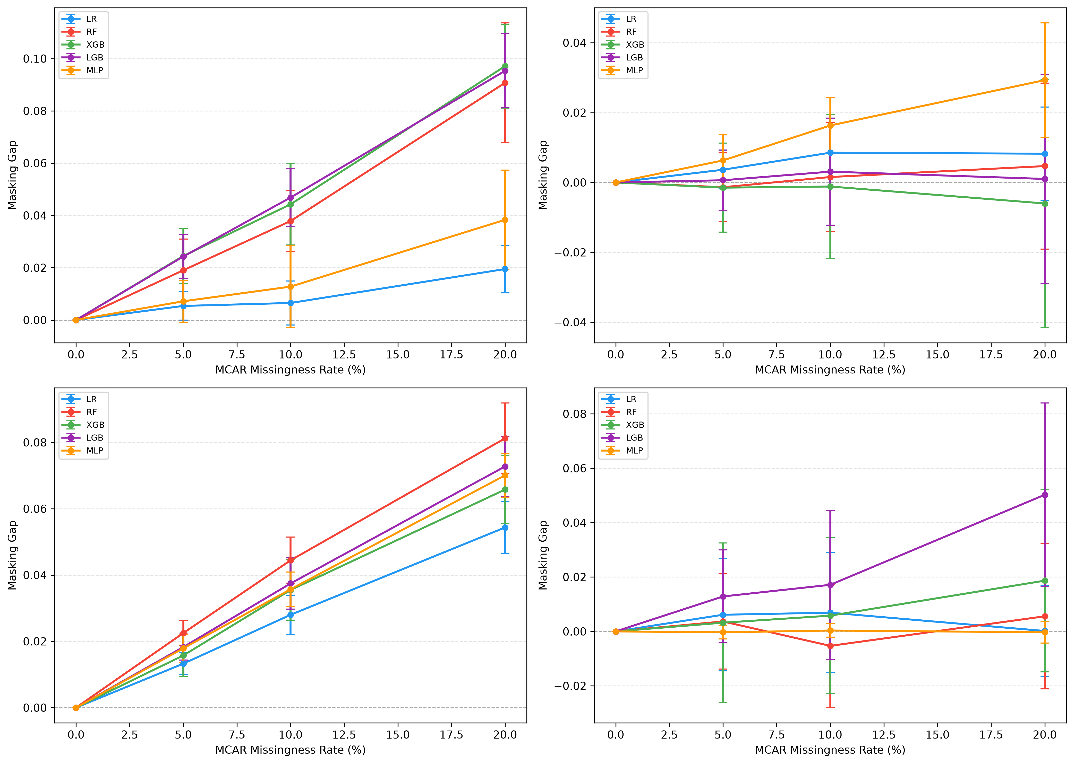
Fig. 1 Focus-Group Masking Gap versus MCAR missingness rate. Panels are ordered Adult Income, COMPAS, Taiwan Credit, and German Credit; error bars show ±1 SD over ten seeds, and German Credit is exploratory.
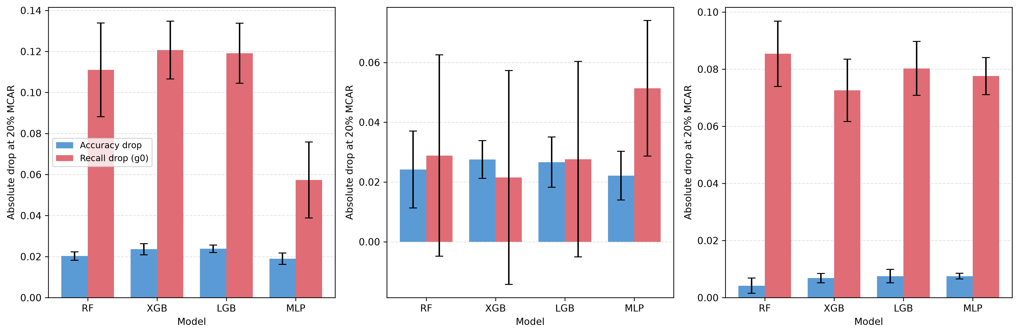
Fig. 2 Aggregate-accuracy and focus-group-recall degradation at 20% MCAR. Panels are ordered Adult Income, COMPAS, and Taiwan Credit; the bars contextualize the Focus-Group Masking Gap.

4.2 Equal Opportunity Gap
Equal Opportunity Gap (EOG) compares recall between groups within the same condition. MG, in contrast, compares the loss in focus-group recall with the loss in aggregate accuracy across conditions. EOG changes vary by dataset and are included only as descriptive context; they should not be interpreted as a causal explanation for any MG pattern.

4.3 MAR probe
The supplementary MAR probe is limited to RF on Adult Income and Taiwan Credit. In this analysis, feature-specific missingness is weighted by the Spearman association with the sensitive attribute. At 20% nominal missingness, Adult Income has MCAR mean MG = 0.0907 and MAR mean MG = 0.2219 (one-sided p = 0.000977). Taiwan Credit has MCAR mean MG = 0.0812 and MAR mean MG = 0.1156 (one-sided p = 0.001953). These results apply only to the stated probe; they do not show that MCAR provides a universal quantitative bound for MAR or MNAR.
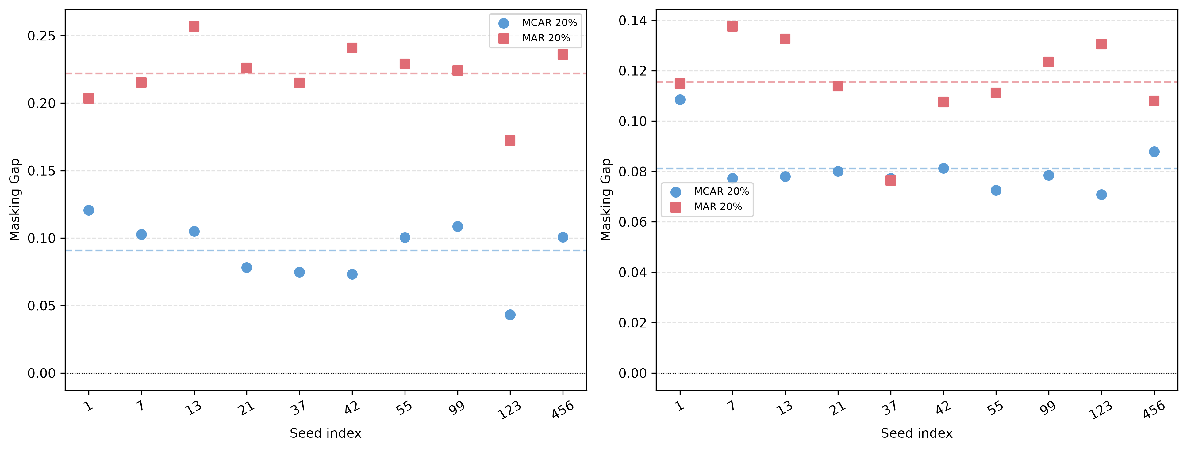
Fig. 3 Supplementary MAR versus MCAR masking gaps for RF at 20% nominal missingness. The left panel is Adult Income and the right panel is Taiwan Credit; points are paired seed-level values and dashed lines show condition means.

4.4 Class-rate adjustment
For Adult Income RF, the original mean MG is 0.0907 (p = 0.0010), compared with a matched-subsample mean MG of 0.1013 (p = 0.0010). The signal persists after this specific class-rate adjustment. This suggests that class-rate imbalance alone does not remove the observed Adult Income pattern, although the analysis does not causally decompose class imbalance, reduced sample size, and missingness effects.
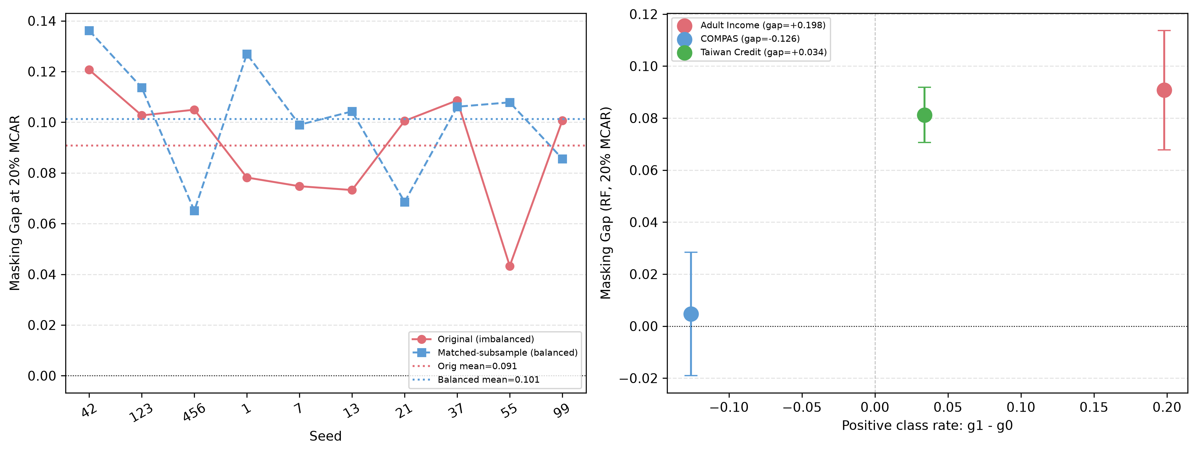
Fig. 4 Class-imbalance checks. The left panel compares original and matched-subsample Adult Income RF results; the right panel plots RF masking gap against the positive-class-rate differential for Adult Income, COMPAS, and Taiwan Credit.

4.5 Extended-seed COMPAS analysis
The post-hoc n = 30 COMPAS extension reproduces the first ten seed values exactly. RF remains unsupported (mean MG = 0.0036; 14 of 30 positive seeds; p = 0.232273), whereas MLP remains positive (mean MG = 0.0281; 27 of 30 positive seeds; p = 0.000003) and meets alpha = 0.0042. The extension therefore supports a model-dependent conclusion for COMPAS, rather than a single null conclusion for the dataset as a whole.
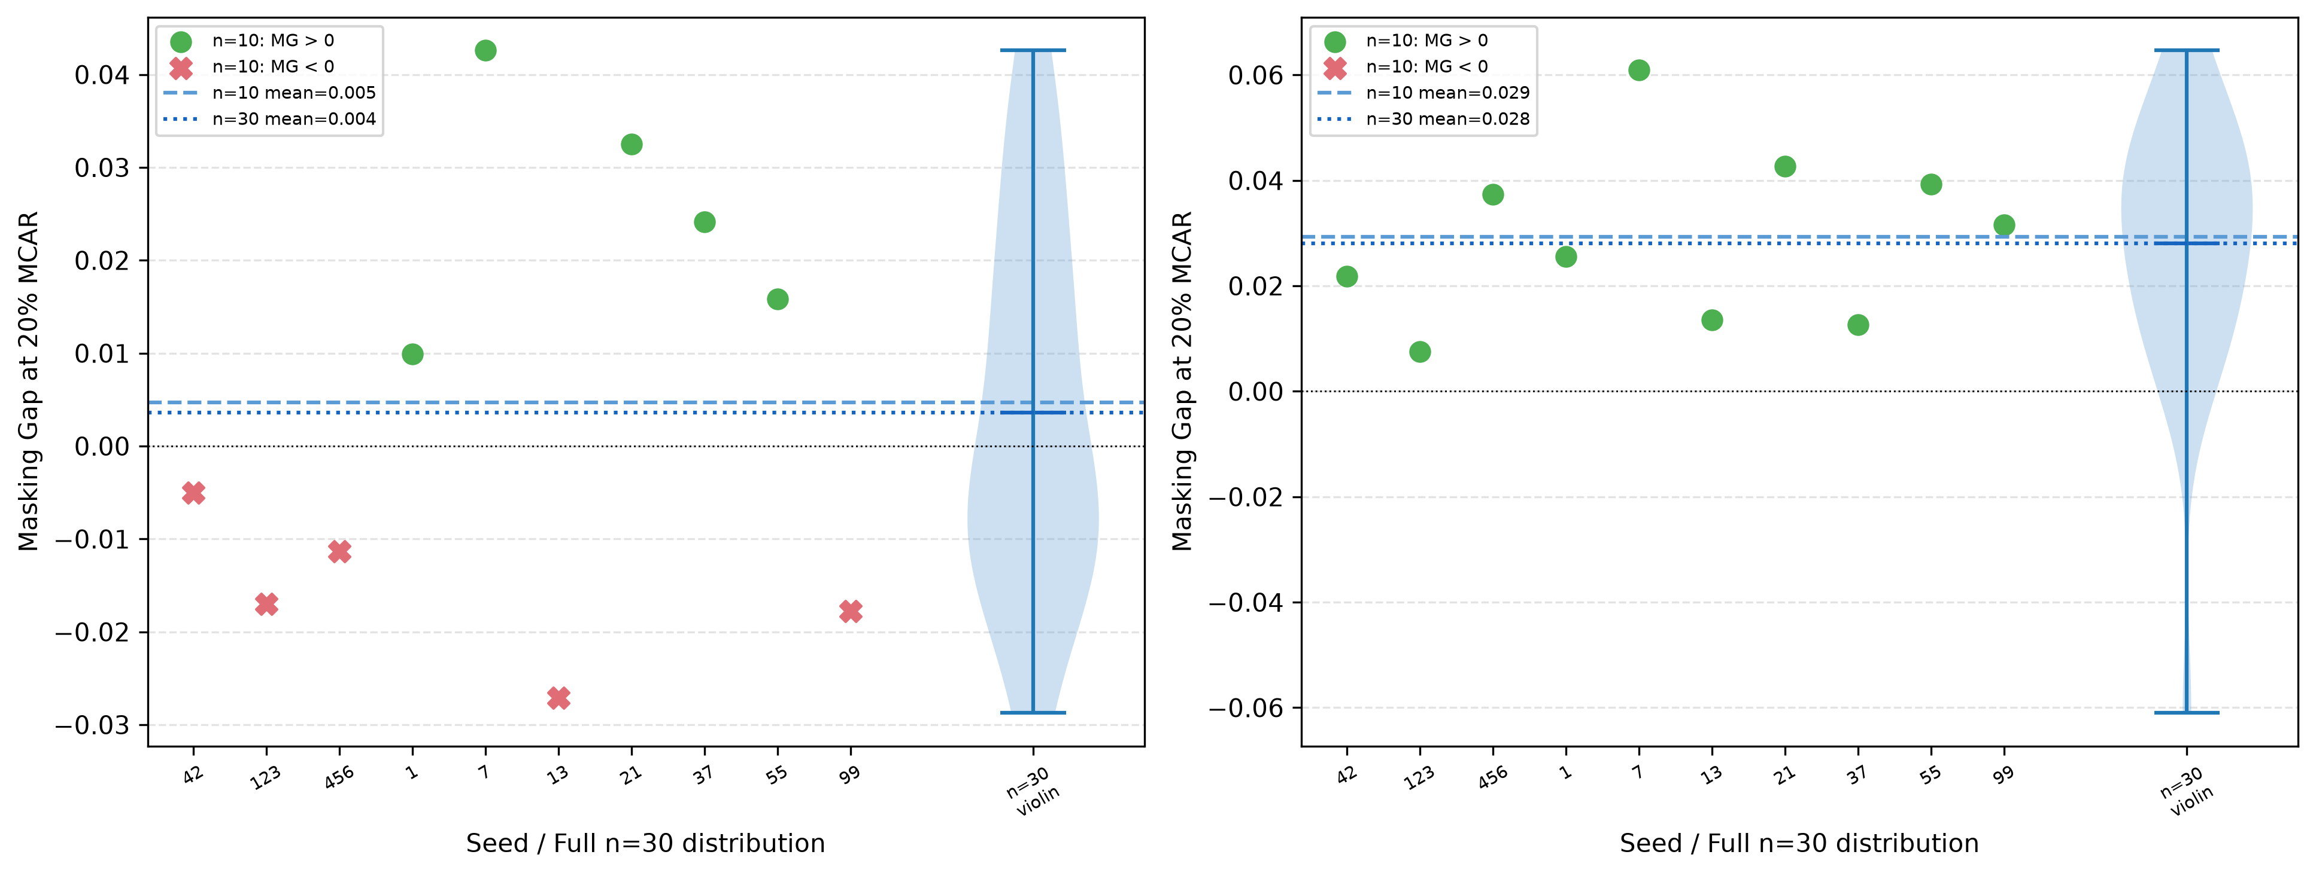
Fig. 5 Supplementary COMPAS extended-seed analysis. The left panel shows RF and the right panel MLP; the first ten points are the primary seed results and the violin summarizes all 30 seeds.

4.6 SHAP diagnostic
The exploratory SHAP (Lundberg and Lee, 2017) analysis evaluates RF at seed 42 on 500 test instances and reports subgroup-specific changes in mean absolute SHAP values after 20% MCAR masking and imputation. For Adult Income, the largest displayed between-subgroup differences involve age, education-num, and capital-gain. For COMPAS, the largest displayed differences involve priors_count, age, and c_days_from_compas. Race is not used as a COMPAS model feature. These shifts are descriptive; they do not identify a causal mechanism for MG, and SHAP attributions can be unstable after small input perturbations (Ghorbani et al., 2019).
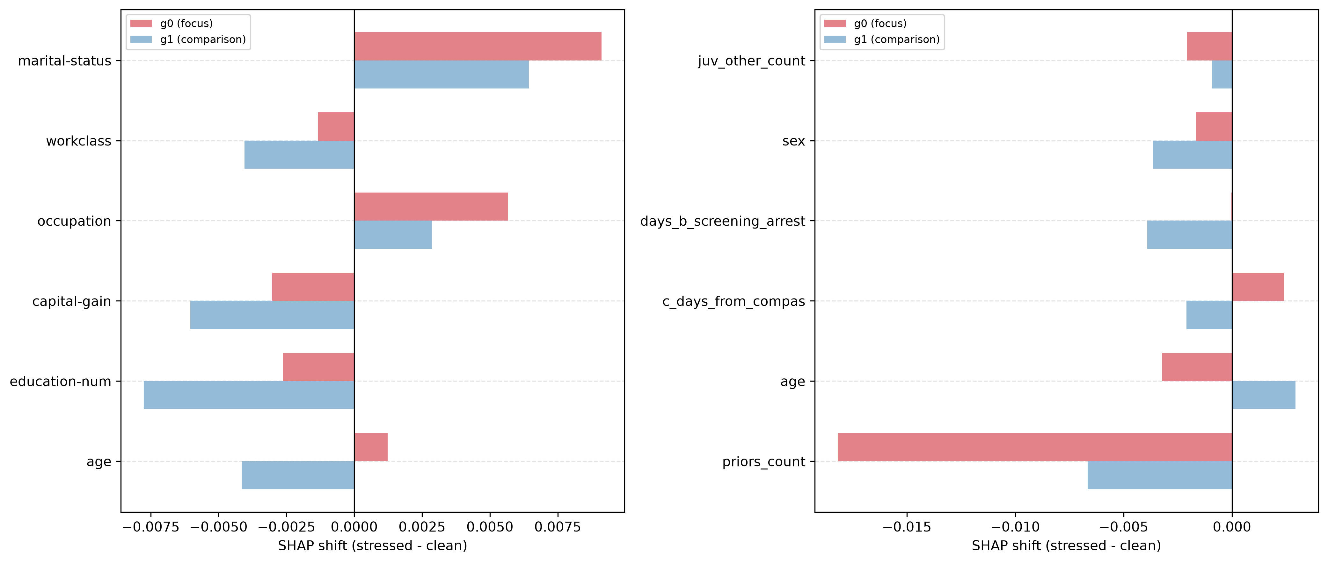
Fig. 6 Per-subgroup mean absolute-SHAP shifts at 20% MCAR for RF, seed 42. The left panel is Adult Income and the right panel is COMPAS; features are ranked by between-group asymmetry.

4.7 Imputation ablation
The imputation ablation is illustrative: it covers RF, seed 42, and only two datasets. Adult Income has positive MG for every tested strategy, with Simple imputation producing the smallest value at both missingness rates. COMPAS has negative MG for every strategy at both rates, with KNN closest to zero. Because these results come from one seed, they do not establish a general ranking of imputation methods.
Table 3. Illustrative imputation ablation: RF, seed 42 only.
Data | Imputer | Rate | MG | Accuracy | Recall g0
Adult | Simple | 10% | 0.0223 | 0.8497 | 0.5670
Adult | KNN | 10% | 0.0364 | 0.8526 | 0.5559
Adult | MICE | 10% | 0.0593 | 0.8503 | 0.5307
Adult | Simple | 20% | 0.0732 | 0.8392 | 0.5056
Adult | KNN | 20% | 0.0906 | 0.8426 | 0.4916
Adult | MICE | 20% | 0.1441 | 0.8374 | 0.4330
COMPAS | Simple | 10% | -0.0138 | 0.6414 | 0.6758
COMPAS | KNN | 10% | -0.0095 | 0.6420 | 0.6722
COMPAS | MICE | 10% | -0.0188 | 0.6383 | 0.6777
COMPAS | Simple | 20% | -0.0271 | 0.6263 | 0.6740
COMPAS | KNN | 20% | -0.0173 | 0.6269 | 0.6648
COMPAS | MICE | 20% | -0.0293 | 0.6332 | 0.6832

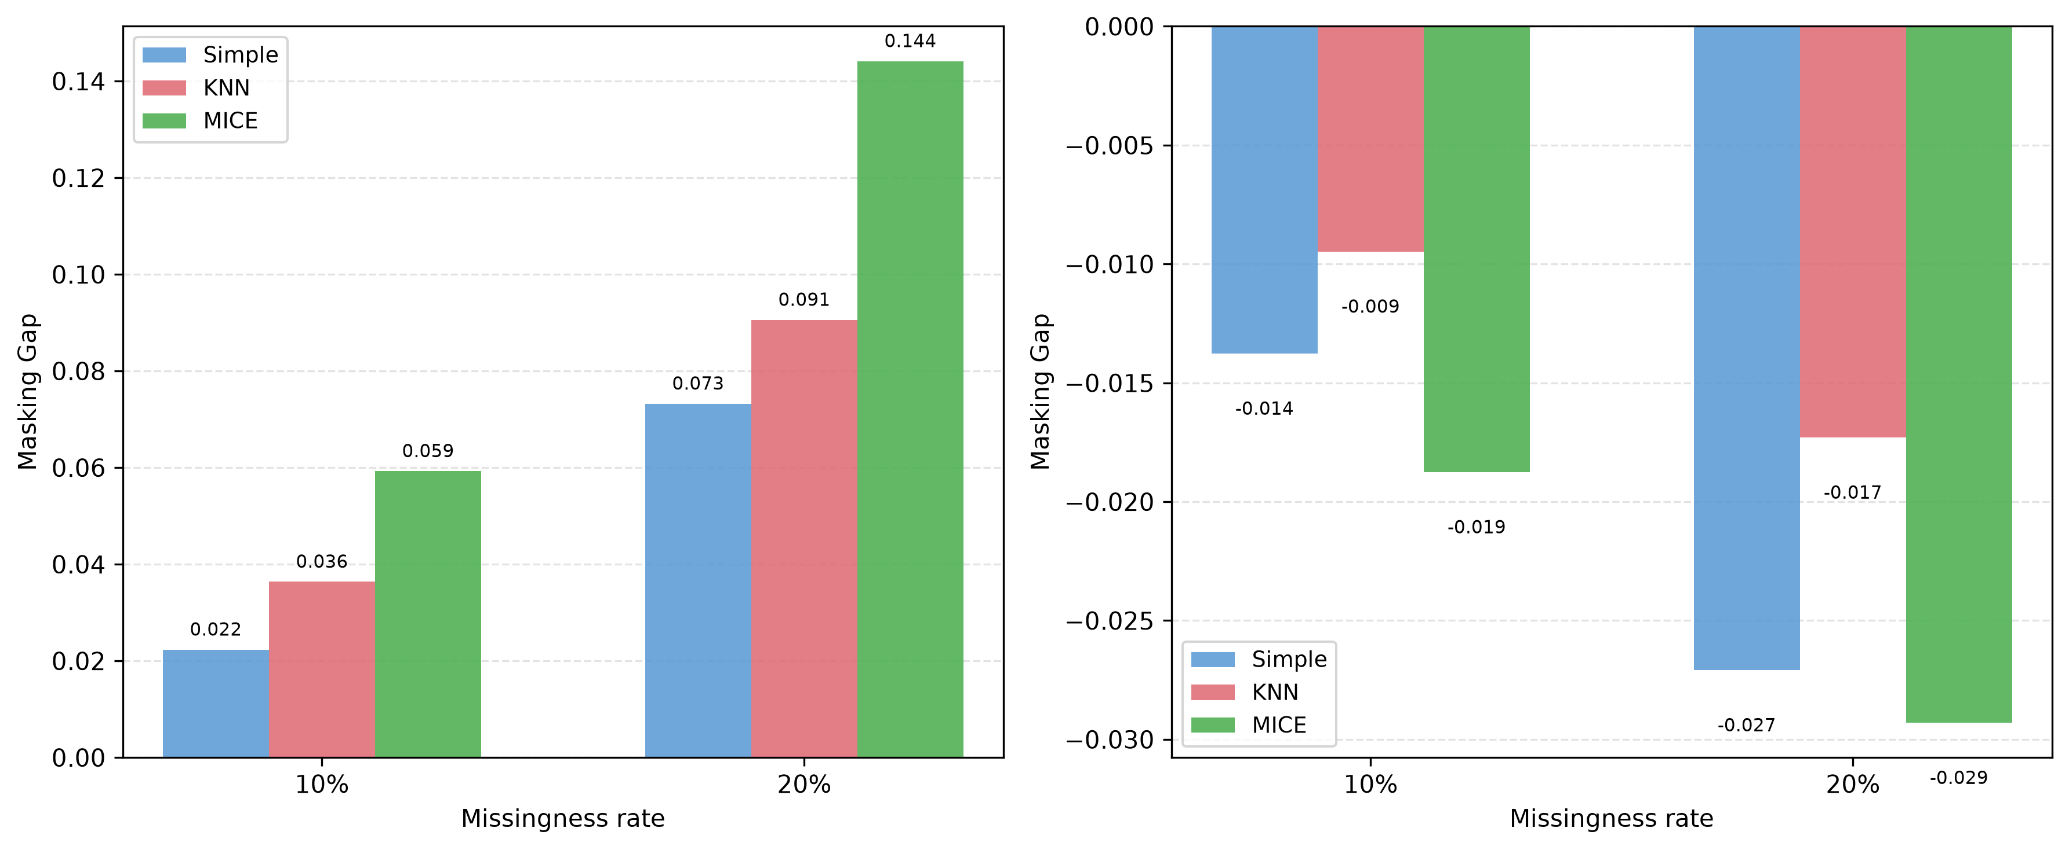
Fig. 7 Illustrative imputation ablation for RF at seed 42. The left panel is Adult Income and the right panel is COMPAS; results are not averaged across seeds and do not rank methods generally.

5. Discussion
In the settings examined here, aggregate accuracy did not always reveal how much recall a focus group lost after features were masked at test time. The clearest and most stable pattern appeared in Adult Income and Taiwan Credit. COMPAS was different: MLP showed a positive, significant MG, but RF, XGB, and LGB did not. That model-to-model spread matters. It argues against explaining the findings only through dataset-level class rates or by assuming that every classifier responds to missing features in the same way.
MG places two losses side by side: the change in focus-group recall and the change in aggregate accuracy. A positive value is not an equal-opportunity violation. It is not a causal effect of the sensitive attribute, either. Nor does it amount to a complete fairness assessment. We therefore treat MG as one diagnostic within a subgroup-stratified robustness audit, alongside conventional performance measures, calibration, error-rate checks, and monitoring of missingness in deployment.
In a practical audit, a model owner would supply a frozen classifier, labelled validation data, group labels, training-fitted preprocessing, and a plausible missingness scenario, then run the procedure on a batch of cases. A persistent positive gap could prompt investigation of the data pipeline, additional data collection, fallback processing, or human review. The present benchmark does not validate operational thresholds in a live medical, financial, agricultural, or public-service deployment.

6. Limitations and Threats to Validity
Internal and statistical validity. The main experiment uses independent MCAR masking at test time. The MAR check is smaller: it covers RF on two datasets and uses a constructed, correlation-weighted mechanism. The main evidence comes from ten seeds and 12 non-linear model-dataset comparisons; the n = 30 COMPAS analysis is post-hoc supplementary evidence, not part of the primary test set. The matched-subsample result shows that the signal persists after one adjustment, but it does not provide a causal decomposition of class imbalance.
Construct validity. Nominal variables are label-encoded and then median-imputed in the encoded, scaled feature matrix, which imposes an artificial order on categories and limits the pipeline, especially for KNN and iterative imputation. SHAP and imputation analyses are restricted to their stated models, datasets, and seed(s), so they do not support causal or general claims about imputation. A type-aware preprocessing sensitivity analysis remains future work.
Reproducibility. The derived result tables contain seed-level recall and masking-gap values, but not the per-seed number of positive labels in the focus group. A reproducibility release should include those denominators, the no-positive-case rule, the recall convention, the exact mask-generation seeds, and the software environment versions.
External validity and scope. The novelty claim is bounded by earlier work on incomplete-data classification, missing-data mechanisms, concurrent train-time masking, missing-values fairness, and heterogeneous deployment drift. The contribution is narrower: a controlled test-time Focus-Group Masking Gap diagnostic, not a general account of missingness and fairness.

7. Conclusion
These experiments show why aggregate accuracy should not be the only number monitored when controlled test-time MCAR masking may affect subgroups differently. In nine of the 12 primary non-linear model-dataset comparisons, MG exceeded 0.01 and met the Bonferroni-corrected threshold at alpha = 0.0042. Adult Income and Taiwan Credit provided the most consistent evidence; the COMPAS result varied by model. The matched-subsample adjustment preserved the Adult Income signal, while the limited MAR probe produced larger RF gaps in the tested settings. The n = 30 extension supported COMPAS MLP, but not RF. Further work should test type-aware imputation, broader MAR/MNAR mechanisms, intersectional groups, and independently specified replications.

Declarations
Funding. No external funding was reported.
Competing interests. The authors declare no competing interests.
Ethics. The study uses public benchmark datasets. COMPAS is included solely as a standard fairness benchmark; the study does not endorse algorithmic recidivism prediction.
Data and code availability. The accompanying reproducibility package contains the canonical notebook cc3_masking_gap_publication_ready.ipynb, the result CSV files, figures, and subgroup_denominators_per_seed.csv. The denominator file records subgroup totals, positive- and negative-label counts, positive-label rates, recall denominators, and no-positive-label indicators for each dataset, group, and seed. The package also records the recall convention and no-positive-case rule, exact mask-generation seeds, model hyperparameters, preprocessing and imputation rules, software and library versions, and instructions for regenerating every table and figure. The package is publicly available in the repository identified in the Data Availability statement below.
AI-use disclosure. Generative AI tools were used during manuscript preparation for language refinement, organizational support, and analytical cross-checking. The authors reviewed and verified all generated content, calculations, citations, and interpretations and remain fully responsible for the final manuscript.
Author contributions. M. Vamsi Krishna: conceptualisation, methodology, software, data curation, formal analysis, experiments, and original draft preparation. S. Sri Harsha: validation, investigation, review and editing, and visualisation.
Data Availability. The benchmark datasets are publicly available from their cited sources. Code, result files, and reproducibility materials are available at: https://github.com/MVamsiKrishna2501050195/FMG-research.

References
Angwin, J., Larson, J., Mattu, S., and Kirchner, L. Machine Bias. ProPublica, 2016. https://www.propublica.org/article/machine-bias-risk-assessments-in-criminal-sentencing.
Barrainkua, A., Gordaliza, P., Lozano, J. A., and Quadrianto, N. Preserving the fairness guarantees of classifiers in changing environments: A survey. ACM Computing Surveys, 57(6), Article 137, 1–32, 2025. https://doi.org/10.1145/3637438.
Bhatti, A., Sandrock, T., and Nienkemper-Swanepoel, J. The influence of missing data mechanisms and simple missing data handling techniques on fairness. International Journal of Data Science and Analytics, 22, Article 172, 2026. https://doi.org/10.1007/s41060-026-01139-0.
Buolamwini, J., and Gebru, T. Gender Shades: Intersectional accuracy disparities in commercial gender classification. Proceedings of FAT*, 2018, 77-91.
Caton, S., and Haas, C. Fairness in machine learning: A survey. ACM Computing Surveys, 56(7), Article 166, 1-38, 2024. https://doi.org/10.1145/3616865.
Caton, S., Malisetty, S., and Haas, C. Impact of imputation strategies on fairness in machine learning. Journal of Artificial Intelligence Research, 74, 1011-1035, 2022. https://doi.org/10.1613/jair.1.13197.
Chouldechova, A. Fair prediction with disparate impact: A study of bias in recidivism prediction instruments. Big Data, 5(2), 153-163, 2017. https://doi.org/10.1089/big.2016.0047.
D'Amour, A., et al. Underspecification presents challenges for credibility in modern machine learning. Journal of Machine Learning Research, 23(226), 1-61, 2022.
Dua, D., and Graff, C. UCI Machine Learning Repository. University of California, Irvine, 2019. https://archive.ics.uci.edu/dataset/2/adult.
Emmanuel, T., Maupong, T., Mpoeleng, D., Semong, T., Mphago, B., and Tabona, O. A survey on missing data in machine learning. Journal of Big Data, 8, Article 140, 2021. https://doi.org/10.1186/s40537-021-00516-9.
Ghorbani, A., Abid, A., and Zou, J. Interpretation of neural networks is fragile. Proceedings of AAAI, 33(1), 3681-3688, 2019. https://doi.org/10.1609/aaai.v33i01.33013681.
Grömping, U. South German Credit Data: Correcting a Widely Used Data Set. Report 4/2019, Department II, Beuth University of Applied Sciences Berlin, 2019. https://www1.bht-berlin.de/FB_II/reports/Report-2019-004.pdf
Hardt, M., Price, E., and Srebro, N. Equality of opportunity in supervised learning. Advances in Neural Information Processing Systems, 29, 3315-3323, 2016.
Hendrycks, D., and Dietterich, T. Benchmarking neural network robustness to common corruptions and perturbations. International Conference on Learning Representations, 2019.
Jang, S., Eun, J., Yi, H., and Choi, C. When does train-time masking help? A leakage-controlled robustness audit of tabular classifiers under feature missingness. IEEE Access, 14, 84378-84398, 2026. https://doi.org/10.1109/ACCESS.2026.3695538.
Jeanselme, V., De-Arteaga, M., Zhang, Z., Barrett, J., and Tom, B. Imputation strategies under clinical presence: Impact on algorithmic fairness. arXiv:2208.06648, 2022.
Jeong, H., Wang, H., and Calmon, F. P. Fairness without imputation: A decision tree approach for fair prediction with missing values. Proceedings of AAAI, 36(9), 9558-9566, 2022. https://doi.org/10.1609/aaai.v36i9.21189.
Kamiran, F., and Calders, T. Data preprocessing techniques for classification without discrimination. Knowledge and Information Systems, 33(1), 1-33, 2012. https://doi.org/10.1007/s10115-011-0463-8.
Koh, P. W., et al. WILDS: A benchmark of in-the-wild distribution shifts. Proceedings of the 38th International Conference on Machine Learning, 139, 5637-5664, 2021.
Lundberg, S. M., and Lee, S.-I. A unified approach to interpreting model predictions. Advances in Neural Information Processing Systems, 30, 4765-4774, 2017.
Martinez-Plumed, F., Ferri, C., Nieves, D., and Hernández-Orallo, J. Missing the missing values: The ugly duckling of fairness in machine learning. International Journal of Intelligent Systems, 36(7), 3217-3258, 2021. https://doi.org/10.1002/int.22415.
Mehrabi, N., Morstatter, F., Saxena, N., Lerman, K., and Galstyan, A. A survey on bias and fairness in machine learning. ACM Computing Surveys, 54(6), Article 115, 1-35, 2021. https://doi.org/10.1145/3457607.
Miao, X., Qiang, L., Huang, G., Wu, Y., and Yin, J. Fairness-aware classification over incomplete data. Proceedings of the 48th International ACM SIGIR Conference on Research and Development in Information Retrieval, 549-558, 2025. https://doi.org/10.1145/3726302.3729975.
Min, S., Asif, H., and Vaidya, J. Exploring the inequitable impact of data missingness on fairness in machine learning. IEEE Intelligent Systems, 40(3), 28-38, 2025. https://doi.org/10.1109/MIS.2025.3549484.
Moreno-Torres, J. G., Raeder, T., Alaiz-Rodríguez, R., Chawla, N. V., and Herrera, F. A unifying view on dataset shift in classification. Pattern Recognition, 45(1), 521-530, 2012. https://doi.org/10.1016/j.patcog.2011.06.019.
Pessach, D., and Shmueli, E. A review on fairness in machine learning. ACM Computing Surveys, 55(3), Article 51, 1-44, 2022. https://doi.org/10.1145/3494672.
Rubin, D. B. Inference and missing data. Biometrika, 63(3), 581-592, 1976. https://doi.org/10.1093/biomet/63.3.581.
Shadbahr, T., Roberts, M., Stanczuk, J., et al. The impact of imputation quality on machine learning classifiers for datasets with missing values. Communications Medicine, 3, Article 139, 2023. https://doi.org/10.1038/s43856-023-00356-z.
Shao, M., Li, D., Zhao, C., Wu, X., Lin, Y., and Tian, Q. Supervised algorithmic fairness in distribution shifts: A survey. Proceedings of the 33rd International Joint Conference on Artificial Intelligence, 8225–8233, 2024. https://doi.org/10.24963/ijcai.2024/909.
Singh, H., Xia, F., Gossmann, A., Chuang, A., Hong, J. C., and Feng, J. "Who experiences large model decay and why?" A hierarchical framework for diagnosing heterogeneous performance drift. Proceedings of the 42nd International Conference on Machine Learning, Proceedings of Machine Learning Research, 267, 55757-55787, 2025. https://proceedings.mlr.press/v267/singh25e.html.
Wang, H., He, L., Gao, R., and Calmon, F. Aleatoric and epistemic discrimination: Fundamental limits of fairness interventions. Advances in Neural Information Processing Systems, 36, 2023.
Wang, Y., and Singh, L. Analyzing the impact of missing values and selection bias on fairness. International Journal of Data Science and Analytics, 12, 101-119, 2021. https://doi.org/10.1007/s41060-021-00259-z.
Yeh, I.-C., and Lien, C.-H. The comparisons of data mining techniques for the predictive accuracy of probability of default of credit card clients. Expert Systems with Applications, 36(2), 2473-2480, 2009. https://doi.org/10.1016/j.eswa.2007.12.020.

