A Frozen-Classifier Audit for Subgroup Recall Loss Under Test-Time Feature Missingness
M. Vamsi Krishna; S. Sri Harsha
KL University | 2501050195@kluniversity.in; sriharsha@kluniversity.in
Abstract
Test-time feature missingness can reduce recall in a prespecified subgroup while leaving aggregate accuracy seemingly stable. In this paper, we define the Focus-Group Masking Gap (FMG)—the signed difference between focus-group recall loss and aggregate-accuracy loss for the same frozen classifier under test-only feature masking. Across our primary benchmark of ten repeated stratified splits spanning three datasets (Adult Income, COMPAS, and Taiwan Credit) and four model families (Random Forest, XGBoost, LightGBM, and Multilayer Perceptron), nine of twelve dataset-model pairs exceeded the descriptive reference of 0.01 at 20% missing completely at random (MCAR), with an overall mean FMG of 0.0545. A positive FMG is not a between-group disparity: focus-group (g0) recall loss exceeded comparison-group (g1) recall loss in only 4 of 12 primary pairs. To test domain sensitivity, a separate public-health extension evaluated the 2024 CDC Behavioral Risk Factor Surveillance System (BRFSS, 353,573 respondents) and UCI Diabetes 130-US Hospitals (99,493 encounters) across five models, three seeds, two split ratios, and three missingness mechanisms (MCAR, MAR, and MNAR). At an 80/20 split and 20% MCAR, BRFSS mean FMG ranged from 0.0272 to 0.0455 (with comparison-group loss exceeding focus-group loss in all five models), whereas UCI mean FMG ranged from 0.0000 to 0.0038 due to a baseline recall floor (0.000–0.020). Overall, FMG provides a reproducible, denominator-transparent diagnostic for comparing subgroup recall degradation against headline accuracy under controlled test-time missingness.
Keywords: missing data; MCAR; fairness auditing; tabular classifiers; focus-group masking gap; robustness evaluation
1. Introduction
Test-time feature loss can hide subgroup recall decline behind stable headline metrics. Deployed tabular classifiers frequently encounter incomplete inputs after training when intake forms omit optional fields, clinical sensors drop readings, or upstream data services return partial records. Because aggregate accuracy averages errors across majority and minority classes as well as across demographic subpopulations, it can remain nearly unchanged even when positive-class recall drops sharply for a prespecified group. We therefore ask a focused diagnostic question: does test-time feature masking reduce focus-group recall more than aggregate accuracy for the same frozen classifier?
Prior work links data missingness with both algorithmic fairness and inference-time robustness. Researchers have examined how missingness mechanisms and imputation choices alter group fairness outcomes (Min et al. [1]; Bhatti et al. [6]; Caton et al. [7]), how tabular classifiers degrade under test-time feature-missingness overlays (Jang et al. [2]; Kochs et al. [3]), and how statistical inference supports subgroup auditing (Zhang and Long [4]; Cherian and Candès [5]). Rather than claiming that inference-time missingness is unstudied, we isolate a specific paired contrast—focus-group recall loss minus aggregate-accuracy loss under identical test-time masking—and pair every estimate with explicit per-split subgroup positive-label denominators.
Positive FMG must be distinguished from a between-group fairness disparity. Because FMG compares focus-group (g0) recall loss against overall accuracy loss rather than against comparison-group (g1) recall loss, a positive FMG can occur even when both subgroups lose substantial recall. Indeed, in our primary benchmark at 20% MCAR, g0 recall loss exceeded g1 recall loss in only 4 of 12 dataset-model pairs, demonstrating why reporting both component losses and subgroup denominators is essential.
Here, we present a reproducible frozen-classifier audit for test-time feature missingness. We contribute (i) a formal definition of the signed Focus-Group Masking Gap (FMG) and its algebraic relation to overall sensitivity and specificity losses, (ii) the finding that comparison-group recall loss was equal to or greater than focus-group recall loss in 8 of 12 primary pairs, (iii) a leakage-free test-only masking protocol that tracks per-split subgroup denominators, and (iv) a descriptive evaluation across socio-economic and public-health benchmarks under MCAR, observed-covariate MAR, and synthetic MNAR mechanisms. Section 2 reviews related work; Section 3 details the datasets, models, masking mechanisms, and audit algorithm; Section 4 reports the empirical findings and sensitivity analyses; and Sections 5–8 discuss implications, limitations, future directions, and conclusions.
2. Literature Review and Research Gap
Missing-data handling and imputation directly shape downstream subgroup performance. Foundational and recent studies examine how missingness mechanisms, imputation strategies, and incomplete-data classification interact with group fairness (Min et al. [1]; Bhatti et al. [6]; Caton et al. [7]; Emmanuel et al. [8]; Jeanselme et al. [9]; Jeong et al. [10]; Martinez-Plumed et al. [11]; Miao et al. [12]; Pessach and Shmueli [13]). In particular, Caton et al. [7] and Bhatti et al. [6] demonstrate that standard imputation choices can shift fairness metrics across demographic groups. Whereas fairness-aware incomplete-data methods modify training or prediction procedures to mitigate discrimination (Kamiran and Calders [23]; Jeong et al. [10]; Miao et al. [12]), our audit evaluates an already-trained, frozen classifier without retraining. Feng et al. [40] adapt fairness interventions for classifiers trained with missing data; our study instead audits a clean-trained frozen classifier under test-only masking.
Subgroup fairness definitions capture distinct error-rate trade-offs within a fixed evaluation condition. As established by Chouldechova [17], Hardt et al. [19], Buolamwini and Gebru [15], and subsequent surveys (Mehrabi et al. [20]; D'Amour et al. [18]; Wang et al. [21]; Caton and Haas [16]; Barrainkua et al. [14]), group fairness criteria such as Equal Opportunity compare true-positive rates across groups under the same deployment distribution, while missing values and selection bias can distort those comparisons (Wang and Singh [22]). In contrast, our audit evaluates how a single prespecified subgroup's recall degrades across two test conditions—clean versus masked—relative to the headline accuracy degradation of the same model.
Test-time distribution shift and missingness overlays degrade tabular classifiers unevenly. Broader robustness literature characterizes model decay under corruptions and distribution shift (Moreno-Torres et al. [26]; Hendrycks and Dietterich [24]; Koh et al. [25]; Shadbahr et al. [29]; Shao et al. [27]; Singh et al. [28]). Closely related to our setup, Jang et al. [2] audit tabular classifiers under feature-missingness overlays at train and test time, and Kochs et al. [3] show that structured missingness introduced solely during inference can degrade fairness and propose a mitigation strategy. Similarly, Zhang and Long [4] and Cherian and Candès [5] establish statistical inference frameworks for fairness estimation and subgroup auditing.
The FMG audit complements prior work by isolating a paired diagnostic contrast. Rather than proposing a new missing-data estimator, fairness guarantee, or retraining algorithm, we formalize the signed difference between focus-group recall loss and aggregate-accuracy loss for a frozen classifier, accompanied by per-split positive-label denominators and threshold-discordance counts. Table 1 summarizes how this bounded diagnostic scope relates to existing research streams.
Table 1. Comparison of related research streams and the bounded scope of the FMG audit.
Research Stream | Overlap with Present Study | Specific Distinction in This Paper | Boundary of Claim
Fairness under missing data [1], [3], [6], [7] | Studies group-related missingness, imputation impacts, and inference-time fairness degradation. | Reports the paired signed difference between focus-group recall loss and aggregate-accuracy loss for a frozen model. | Does not claim that fairness degradation under test-time missingness is newly discovered.
Test-time missingness robustness [2], [29] | Evaluates tabular classifier degradation under controlled feature-missingness overlays at inference time. | Pairs subgroup recall loss directly against headline accuracy loss with explicit per-split subgroup denominators. | Does not claim test-time feature masking itself as a novel stress-testing method.
Statistical fairness auditing [4], [5] | Audits subgroup performance under missing data, sampling variability, or distribution shift. | Provides a deterministic, fixed-group descriptive contrast across clean and masked test evaluations. | Does not provide simultaneous subgroup inference, certification, or a new statistical estimator.
Fairness-aware incomplete-data learning [10], [12], [40] | Develops training or tree-splitting algorithms to improve fairness on incomplete tabular data. | Audits an unchanged, clean-trained classifier to diagnose vulnerability prior to retraining. | Serves as a pre-deployment or post-hoc diagnostic rather than a mitigation algorithm.

3. Methodology
3.1 Datasets and Focus Groups
Four tabular benchmarks define our primary and exploratory socioeconomic evaluation. The primary benchmark comprises Adult Income (Dua and Graff [30]), ProPublica COMPAS (Angwin et al. [31]), and Taiwan Credit Default (Yeh and Lien [32]). For Adult Income, the official adult.data training file (32,561 raw records) was parsed with '?' treated as missing; excluding 2,399 incomplete records under our complete-case baseline rule yielded 30,162 analyzed rows. We also include the OpenML credit-g version of Statlog German Credit (1,000 rows; data ID 31 [39]) strictly as an exploratory benchmark due to its small sample size and legacy status-code encodings (distinct from the corrected South German Credit dataset of Grömping [33]). Table 2 summarizes the tasks, sample sizes, and prespecified focus groups.
Table 2. Summary of primary, exploratory, and public-health extension datasets and prespecified focus groups.
Dataset | Analyzed Rows | Prediction Task | Sensitive Attribute | Focus Group (g0) & Role
Adult Income [30] | 30,162 (32,561 raw) | Annual income > $50K | Sex | Female (g0); Primary benchmark
COMPAS [31] | 5,278 | Two-year recidivism | Race | African-American (g0); Primary benchmark
Taiwan Credit [32] | 30,000 | Credit card default | Sex | Female (g0); Primary benchmark
German Credit [39] | 1,000 | Credit risk outcome | Personal status | Female A92/A95 (g0); Exploratory
CDC BRFSS 2024 [37] | 353,573 | Self-reported diabetes | Race/ethnicity | Non-Hispanic Black (g0); Health extension
UCI Diabetes [38] | 99,493 encounters | 30-day hospital readmission | Race | African-American (g0); Health extension

Two large-scale clinical and surveillance cohorts form a separate public-health extension. We evaluated a cross-sectional self-reported diabetes task in the 2024 CDC Behavioral Risk Factor Surveillance System (BRFSS, 353,573 eligible respondents [37]) and an early hospital readmission task in the UCI Diabetes 130-US Hospitals dataset (99,493 eligible encounters from 1999–2008 [38]). In BRFSS, the focus group (g0) comprises non-Hispanic Black respondents compared against non-Hispanic White respondents (g1); models were trained unweighted, while held-out metrics incorporated CDC final person weights and primary-sampling-unit (PSU) stratified bootstrap resampling. In UCI Diabetes, g0 comprises African-American patients compared against other records with reported race (g1), using patient-disjoint train/test splits partitioned by patient_nbr.
Focus-group definitions are locked a priori and excluded from predictor matrices. Across all datasets, the sensitive attribute is removed before model training and used solely to partition test-set evaluation into the focus group (coded g0 = 0) and its complement (coded g1 = 1). To ensure audit transparency, per-seed subgroup sample sizes, positive- and negative-label counts, base rates, and recall denominators are logged automatically for every split.
The end-to-end frozen-classifier audit architecture and data flow are illustrated in Figs. 1 and 2.
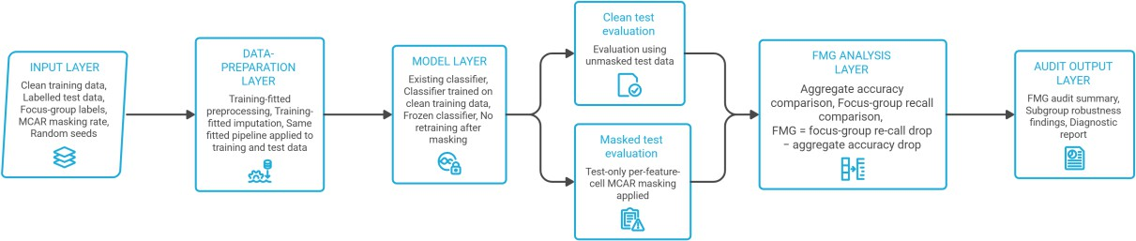
Fig. 1. Frozen-classifier audit architecture across five sequential stages: (1) the Input Layer ingests clean training data, labeled test data, focus-group indicators, MCAR masking rates, and random seeds; (2) the Data-Preparation Layer fits encoding, scaling, and imputation parameters strictly on clean training data; (3) the Model Layer trains the classifier on clean features and freezes its parameters; (4) parallel Clean and Masked Test Evaluation branches score unmasked and test-masked inputs without retraining; and (5) the FMG Analysis and Output Layers compute the signed difference between focus-group recall loss and aggregate-accuracy loss.
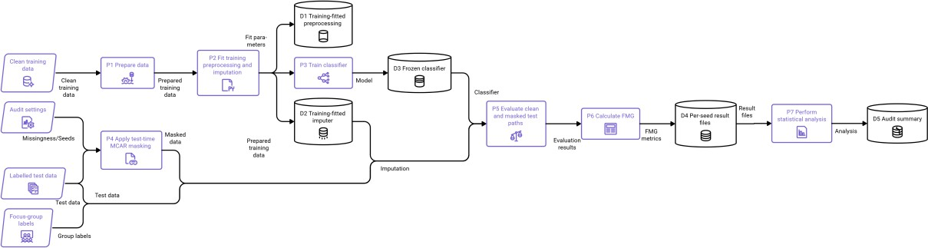
Fig. 2. Detailed audit data-flow diagram (P1–P7 and data stores D1–D5). Training data pass through preparation (P1) to fit and store preprocessing parameters (D1) and the training imputer (D2), which feed classifier training (P3) to produce the frozen model (D3). Held-out test data undergo parallel clean evaluation and test-time MCAR masking (P4) followed by training-fitted imputation; both paths are scored by the frozen classifier (P5) to compute per-seed FMG metrics (P6, D4) and descriptive summary statistics (P7, D5).
3.2 Preprocessing Pipeline and Model Families
Each primary benchmark run uses ten fixed target-stratified 70:30 train/test splits. Using fixed random seeds {42, 123, 456, 1, 7, 13, 21, 37, 55, 99}, categorical predictors are integer-encoded via mappings learned strictly on the training split (assigning −1 to unseen test categories), and all features are min-max scaled to [0, 1] using training-set extrema. Hyperparameters remain fixed across all runs and are never tuned on masked test data.
Five distinct classifier architectures span ensemble, boosting, neural, and linear paradigms. Our four primary models are Random Forest (RF; 100 trees, n_jobs = −1), XGBoost (XGB; 100 trees, logloss objective), LightGBM (LGB; 100 trees), and a feed-forward Multilayer Perceptron (MLP; hidden layers (50, 30), max_iter = 500, internal training early_stopping = True), with Logistic Regression (LR; C = 1.0, lbfgs solver, max_iter = 1000) included as a linear reference. Evaluating these diverse model families tests whether the divergence between subgroup recall loss and aggregate accuracy loss persists across different decision-boundary geometries.
3.3 Masking Mechanisms, Imputation, and the FMG Estimand
Test-time MCAR masking perturbs eligible feature cells independently after training. In the primary protocol, each feature cell in the encoded and scaled test matrix is masked independently with probability ε ∈ {0.05, 0.10, 0.20} (Rubin [34]) using a mask seed matched to the split seed, and masked entries are replaced using a median SimpleImputer fitted on the clean training split. Because integer label encoding imposes an artificial ordinal scale on nominal categories, we also conduct a dedicated type-aware sensitivity analysis (Section 4.8) that masks raw feature cells prior to transformation and compares median/mode, five-neighbor KNN/mode (n_neighbors = 5), and iterative numeric/mode (max_iter = 10) imputation.
Two structured MAR sensitivities test non-uniform missingness propensities. First, a group-conditional MAR experiment calibrates subgroup-specific cell-masking probabilities so that the overall expected missingness matches nominal rates of 10% and 20%. Second, an observed-covariate logistic MAR experiment retains age as fully observed and assigns row-specific Bernoulli masking probabilities to all remaining features using standardized test age, testing conditional odds ratios of 1.5, 2.0, and 4.0 per standard deviation of age at 10% and 20% expected missingness.
Cell-level masking probability compounds across multi-feature records. Because ε denotes the independent per-cell masking probability across p eligible features, the probability that a test record experiences at least one masked feature cell is given by:
P(at least one masked feature) = 1 − (1 − ε)^p (1)
The Focus-Group Masking Gap (FMG) measures excess subgroup recall loss relative to headline accuracy loss. Let R(g0, clean) and R(g0, masked) denote positive-class recall for the focus group g0 on the clean and masked test sets, and let A(clean) and A(masked) denote aggregate test accuracy across the entire held-out cohort. We define the paired focus-group recall loss ΔR(ε), aggregate-accuracy loss ΔA(ε), and their signed contrast FMG(ε) as:
ΔR(ε) = R(g0, clean) − R(g0, masked), ΔA(ε) = A(clean) − A(masked) (2)
FMG(ε) = ΔR(ε) − ΔA(ε) (3)
That is, FMG(ε) > 0 indicates that test-time masking reduces focus-group recall by a larger margin than it reduces overall accuracy, FMG(ε) = 0 indicates equal degradation, and FMG(ε) < 0 indicates that overall accuracy drops more than focus-group recall. Because ΔR(ε) and ΔA(ε) each lie in [−1, 1], FMG(ε) is bounded in [−2, 2].
3.4 Focus-Group Masking Gap Audit Algorithm
Algorithm 1 formalizes the step-by-step evaluation protocol. For n test records, p eligible features, and r mask repetitions, generating masks and imputing matrices requires O(rnp) time and O(np) working memory per active mask, plus r forward-inference passes of the frozen classifier.
Algorithm 1: Focus-Group Masking Gap (FMG) Frozen-Classifier Audit
Inputs: Trained or configurable classifier; labeled training and test data; sensitive-group labels (g0, g1); training-fitted encoding, scaling, and imputation pipeline; masking rates ε ∈ {0.05, 0.10, 0.20}; fixed random seeds.
Step 1 (Train & Freeze): For each seed, fit the preprocessing and imputation pipeline on clean training data, train the classifier on clean features (excluding sensitive attributes), and freeze model weights.
Step 2 (Clean Baseline): Evaluate the frozen classifier on the unmasked test set; record aggregate accuracy A(clean), focus-group recall R(g0, clean), comparison-group recall R(g1, clean), and subgroup positive-label denominators.
Step 3 (Test-Time Masking): Generate an independent test-only feature mask at rate ε without retraining the classifier, and transform masked test features using the training-fitted imputer.
Step 4 (Stressed Evaluation): Evaluate the unchanged classifier on the masked test set; record A(masked), R(g0, masked), and R(g1, masked).
Step 5 (Contrast Calculation): Compute ΔR(ε) = R(g0, clean) − R(g0, masked), ΔA(ε) = A(clean) − A(masked), and FMG(ε) = ΔR(ε) − ΔA(ε).
Outputs: Paired per-seed clean and masked metrics, FMG mean and standard deviation, observed range, positive-split counts, and per-seed subgroup denominators.

3.5 Statistical Analysis and Reproducibility Protocol
Repeated stratified splits summarize benchmark stability on finite datasets. Across the ten fixed train/test splits, we report the mean, standard deviation (SD), observed range, count of splits with FMG > 0, and percentile-bootstrap 95% intervals for mean FMG alongside focus-group positive-label denominator ranges. Because repeated splits resample the same finite dataset, these summaries describe benchmark stability rather than independent population-level confidence intervals; we use 0.01 (1 percentage point) strictly as a descriptive reference grid point rather than an operational alert cutoff. All 800 primary evaluation rows (4 datasets × 5 classifiers × 10 seeds × 4 masking levels) and SHA-256 verified output tables are archived in the public reproducibility repository.
3.6 Descriptive Diagnostic-Discordance Analysis
Threshold-discordance indicators test when accuracy monitoring misses subgroup recall drops. To quantify how often focus-group recall loss crosses a sensitivity threshold δ ∈ {0.01, 0.025, 0.05, 0.10} while aggregate-accuracy loss remains below that same threshold δ, we define the binary threshold indicators and discordance indicator U(δ) for each dataset-model-seed evaluation:
I_R(δ) = 1[ΔR ≥ δ], I_A(δ) = 1[ΔA ≥ δ], U(δ) = I_R(δ) · (1 − I_A(δ)) (4)
Simply put, U(δ) = 1 identifies benchmark runs where an analyst monitoring only whether aggregate accuracy drops by at least δ would miss a focus-group recall drop of at least δ.
3.7 Exploratory Multi-Model SHAP Sensitivity
Tree-based feature attribution shifts are evaluated under clean and masked inputs. To examine how test-time masking perturbs feature attributions without claiming causal mechanism identification, we compute positive-class SHAP values (Lundberg and Lee [35]) on COMPAS RF (seed 42) and across RF, XGBoost, and LightGBM on the two public-health cohorts (80/20 split, seeds 42, 123, and 456, 20% MCAR) for up to 20 matched held-out observations per group.
3.8 Aggregate-Metric Decomposition
Aggregate accuracy loss decomposes algebraically into overall recall and specificity losses. Let π denote positive-class prevalence in the held-out test set, ΔTPR_all = TPR(clean) − TPR(masked) denote overall positive-class recall loss, and ΔTNR_all = TNR(clean) − TNR(masked) denote overall specificity loss. Because binary accuracy satisfies ΔA = π ΔTPR_all + (1 − π) ΔTNR_all, the population-wide recall-versus-accuracy contrast FMG_all simplifies to:
FMG_all = ΔTPR_all − ΔA = (1 − π)(ΔTPR_all − ΔTNR_all) (5)
Thus, at the full-cohort level, positive-class recall degrades more than overall accuracy whenever masking reduces sensitivity more than specificity, scaled by the negative-class prevalence (1 − π).
4. Results
4.1 Primary Benchmark Analysis at 20% MCAR
Nine of twelve primary dataset-model pairs exceed a mean FMG of 0.01 at 20% MCAR. Across all 12 primary comparisons (Table 3), mean FMG is 0.0545, and across the nine pairs exceeding the 0.01 reference, mean FMG reaches 0.0727. All four primary classifiers (LGB, MLP, RF, and XGB) exhibit positive FMG in 10 of 10 splits on both Adult Income (mean FMG 0.0616–0.0977) and Taiwan Credit (mean FMG 0.0658–0.0812), whereas on COMPAS only the MLP consistently exceeds 0.01 (mean FMG 0.0293; 10/10 positive splits). Logistic regression (archived as a linear reference) similarly yielded a mean FMG of 0.0191 on Adult Income at 20% MCAR.
Subgroup recall loss frequently exceeds headline accuracy loss even when both groups degrade. For example, on Adult Income with Random Forest (Table 3), 20% MCAR masking reduces aggregate accuracy by only 0.0214 (2.14 percentage points) but reduces female (g0) positive-class recall by 0.1079 (10.79 percentage points), producing a mean FMG of 0.0865. At the same time, male (g1) positive-class recall drops by 0.1403, resulting in a negative between-group recall-loss difference (g0 − g1 = −0.0324). Across the 12 primary pairs, g0 recall loss exceeds g1 recall loss in only 4 pairs (the four COMPAS models), confirming empirically that FMG diagnoses divergence from headline accuracy rather than between-group disparity. Figs. 3 and 4 illustrate these trajectories across masking rates and classifiers.
Table 3. Primary benchmark results at 20% MCAR across ten repeated 70:30 stratified splits, reporting mean FMG (SD), aggregate-accuracy loss, focus-group (g0) and comparison-group (g1) recall losses, signed between-group difference (g0 − g1), positive-split counts, percentile-bootstrap 95% intervals, and g0 positive-label denominator ranges (n+).
Dataset / Model | FMG Mean (SD); Acc. Loss | g0 / g1 Recall Loss; (g0 − g1) | Positive Splits; 95% CI; g0 n+ Range
Adult / LGB | 0.0977 (0.0192); acc 0.0256 | 0.1234 / 0.1443; −0.0209 | 10/10; [0.0862, 0.1086]; n+ 316–347
Adult / MLP | 0.0616 (0.0250); acc 0.0180 | 0.0797 / 0.1108; −0.0312 | 10/10; [0.0472, 0.0763]; n+ 316–347
Adult / RF | 0.0865 (0.0225); acc 0.0214 | 0.1079 / 0.1403; −0.0324 | 10/10; [0.0726, 0.0990]; n+ 316–347
Adult / XGB | 0.0890 (0.0269); acc 0.0237 | 0.1127 / 0.1359; −0.0232 | 10/10; [0.0727, 0.1048]; n+ 316–347
COMPAS / LGB | 0.0010 (0.0299); acc 0.0266 | 0.0276 / −0.0083; +0.0359 | 4/10; [−0.0154, 0.0192]; n+ 510–548
COMPAS / MLP | 0.0293 (0.0164); acc 0.0221 | 0.0514 / 0.0108; +0.0406 | 10/10; [0.0200, 0.0391]; n+ 510–548
COMPAS / RF | 0.0047 (0.0238); acc 0.0242 | 0.0289 / 0.0092; +0.0196 | 5/10; [−0.0090, 0.0189]; n+ 510–548
COMPAS / XGB | −0.0060 (0.0355); acc 0.0275 | 0.0215 / −0.0053; +0.0268 | 3/10; [−0.0251, 0.0158]; n+ 510–548
Taiwan Credit / LGB | 0.0728 (0.0091); acc 0.0075 | 0.0803 / 0.0878; −0.0075 | 10/10; [0.0687, 0.0788]; n+ 1092–1170
Taiwan Credit / MLP | 0.0701 (0.0066); acc 0.0075 | 0.0776 / 0.0896; −0.0120 | 10/10; [0.0662, 0.0740]; n+ 1092–1170
Taiwan Credit / RF | 0.0812 (0.0106); acc 0.0042 | 0.0854 / 0.0898; −0.0044 | 10/10; [0.0760, 0.0882]; n+ 1092–1170
Taiwan Credit / XGB | 0.0658 (0.0103); acc 0.0068 | 0.0726 / 0.0810; −0.0084 | 10/10; [0.0597, 0.0717]; n+ 1092–1170

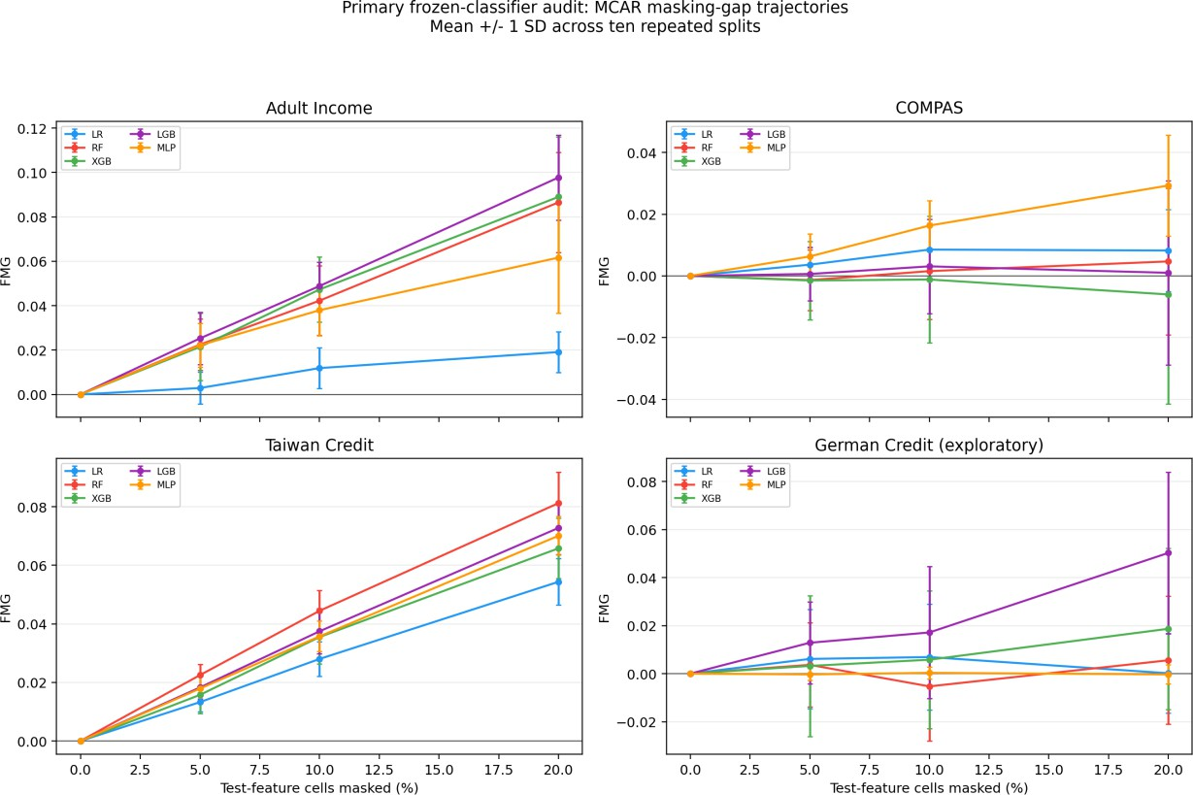
Fig. 3. Mean FMG trajectories across test-time MCAR masking rates (0%, 5%, 10%, and 20%) for five classifiers (LR, RF, XGB, LGB, and MLP) on Adult Income, COMPAS, Taiwan Credit, and exploratory German Credit. Error bars denote ±1 SD across ten repeated stratified splits.
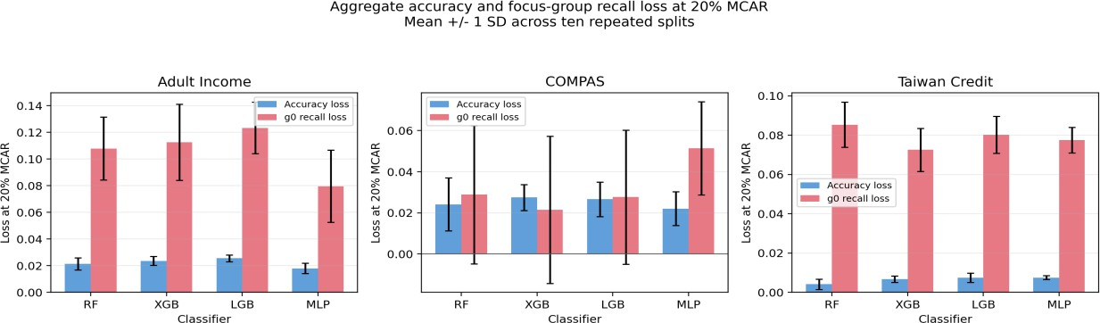
Fig. 4. Direct comparison of mean aggregate-accuracy loss (blue bars) and focus-group (g0) positive-class recall loss (red bars) at 20% MCAR across four primary classifiers on Adult Income, COMPAS, and Taiwan Credit (±1 SD across ten splits).
4.2 Relationship to Equal Opportunity Difference
Equal Opportunity Difference (EOG) and FMG measure different quantities. Whereas EOG evaluates between-group recall differences within a single test condition, FMG tracks within-group recall loss relative to aggregate accuracy loss across clean and stressed conditions; observed EOG shifts vary by dataset and do not explain FMG magnitude.
4.3 Group-Conditional MAR Sensitivity
Group-conditional missingness amplifies FMG relative to uniform MCAR masking. When test-cell masking probabilities depend on focus-group membership at calibrated nominal rates of 10% and 20% (Fig. 5), mean FMG exceeded its paired MCAR baseline in 12 of 12 dataset-model pairs at 10% masking and in 11 of 12 pairs at 20% masking, with the largest increases occurring on Adult Income (+0.025 to +0.044 at 20% masking).
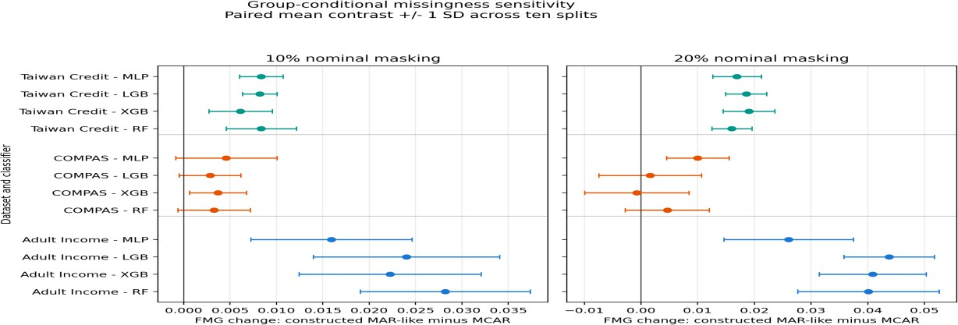
Fig. 5. Paired FMG change (constructed group-conditional MAR minus matched MCAR) across three primary datasets and four classifiers at 10% (left) and 20% (right) nominal masking rates. Points and horizontal bars denote the mean difference and ±1 SD across ten splits.
4.4 Age-Conditioned Logistic MAR Sensitivity
Covariate-dependent MAR produces dataset- and model-specific shifts relative to MCAR. Across 72 evaluated combinations (3 datasets × 4 models × 2 missingness rates × 3 age odds ratios of 1.5, 2.0, and 4.0), mean paired FMG differences between age-conditioned MAR and matched-feature MCAR ranged from −0.0092 to +0.0318 (with 3/10 to 10/10 positive splits), peaking for COMPAS XGBoost at 20% missingness and an odds ratio of 4.0 (+0.0318; 10/10 splits positive).
4.5 Class-Rate Adjustment Sensitivity
Matching subgroup positive-class base rates preserves positive FMG on Adult Income. In a matched-subsample sensitivity on Adult Income with Random Forest at 20% MCAR (Fig. 6), equalizing subgroup base rates increased mean FMG slightly from 0.0865 (original cohort) to 0.0933 (matched cohort), with 10 of 10 splits remaining positive in both settings.
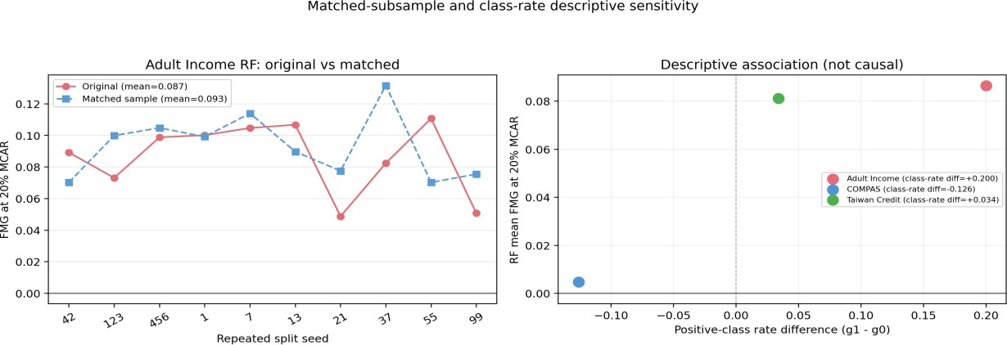
Fig. 6. Adult Income Random Forest sensitivity at 20% MCAR comparing original versus base-rate-matched subsamples across ten splits (left) and the descriptive association between inter-group positive-class base-rate differential (g1 − g0) and mean RF FMG across the three primary datasets (right).
4.6 Extended-Seed COMPAS Stability Analysis
Expanding COMPAS evaluation to 30 repeated splits confirms architecture-dependent behavior. Across 30 stratified splits at 20% MCAR (Fig. 7), COMPAS Random Forest maintained a near-zero mean FMG of 0.0036 (14/30 positive splits), whereas the Multilayer Perceptron maintained a consistently positive mean FMG of 0.0281 (27/30 positive splits).
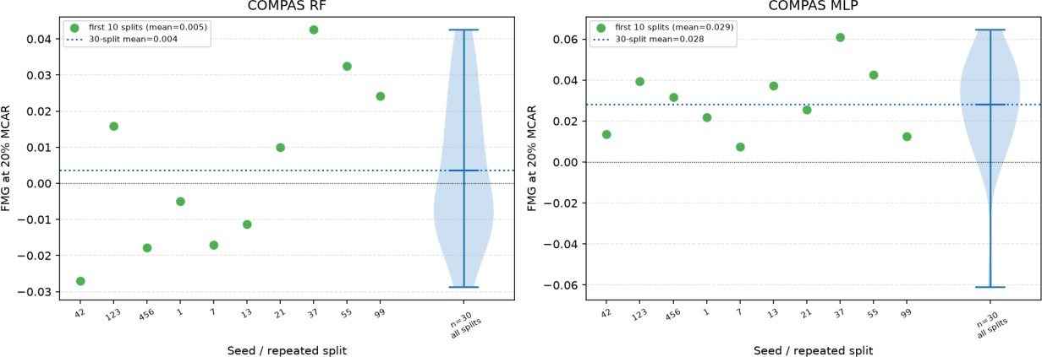
Fig. 7. Extended 30-split distribution and first-10-split trajectory of FMG at 20% MCAR on COMPAS for Random Forest (left, 30-split mean = 0.0036) and Multilayer Perceptron (right, 30-split mean = 0.0281).
4.7 Exploratory SHAP Attribution Sensitivity
Test-time masking shifts feature attributions toward demographic and utilization correlates. On COMPAS Random Forest (seed 42, 20% MCAR; Fig. 8), the largest between-group shifts in mean absolute SHAP values occurred on priors_count, age, and c_days_from_compas. In the multi-seed public-health sensitivity across RF, XGBoost, and LightGBM, the largest attribution shifts consistently centered on the 5-year age-group category (AGEG5YR) in BRFSS and prior inpatient visits (number_inpatient) in UCI Diabetes.
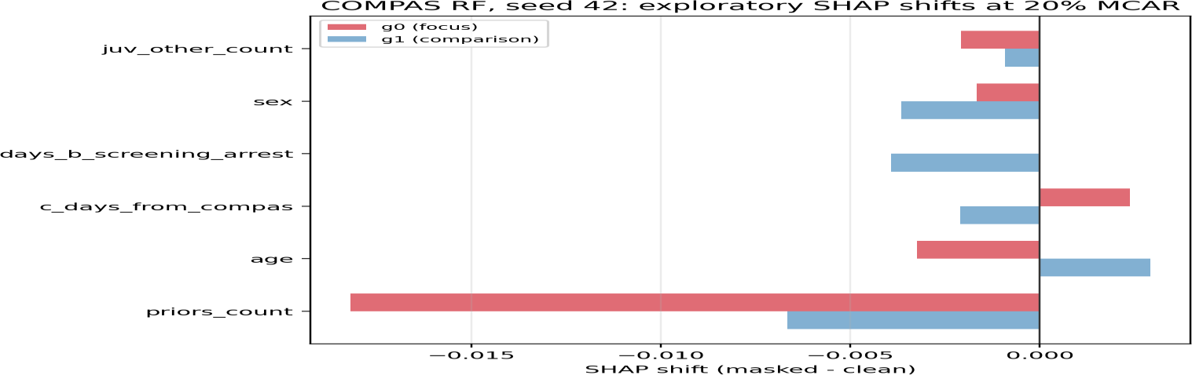
Fig. 8. Exploratory change in mean absolute SHAP attribution (masked minus clean at 20% MCAR) on COMPAS Random Forest (seed 42) for the six predictors exhibiting the largest asymmetry between the focus group (g0, red) and comparison group (g1, blue).
4.8 Type-Aware Preprocessing and Imputation Ablation
Type-aware raw-feature masking reduces Adult Income FMG by roughly two-thirds while preserving Taiwan Credit FMG. When 20% MCAR masking is applied to raw feature cells prior to encoding and paired with type-aware imputation (median/mode, 5-NN/mode, or iterative/mode for Random Forest across ten seeds; Table 4 and Fig. 9), Adult Income mean FMG drops from 0.0865 (encoded-space median imputation) to 0.0270–0.0327 (7/10 to 9/10 positive splits). Conversely, Taiwan Credit mean FMG remains high across all three type-aware pipelines (0.0689–0.0856; 10/10 positive splits), and COMPAS remains near zero (−0.0131 to +0.0049), demonstrating that preprocessing representation strongly modulates measured sensitivity on categorical-heavy datasets.
Table 4. Multi-seed, type-aware imputation sensitivity at 20% raw-feature MCAR for Random Forest across ten repeated splits (Adult Income rerun under scikit-learn 1.9.1; COMPAS and Taiwan Credit under scikit-learn 1.6.1).
Dataset | Imputation Strategy | FMG Mean ± SD | Positive Splits | Acc. Loss / g0 Recall Loss
Adult Income | Iterative / mode | 0.0270 ± 0.0293 | 7/10 | 0.0194 / 0.0464
Adult Income | KNN (5-NN) / mode | 0.0327 ± 0.0248 | 9/10 | 0.0226 / 0.0553
Adult Income | Median / mode | 0.0318 ± 0.0271 | 9/10 | 0.0205 / 0.0523
COMPAS | Iterative / mode | −0.0131 ± 0.0270 | 3/10 | 0.0187 / 0.0056
COMPAS | KNN (5-NN) / mode | −0.0043 ± 0.0177 | 4/10 | 0.0245 / 0.0202
COMPAS | Median / mode | 0.0049 ± 0.0262 | 5/10 | 0.0249 / 0.0297
Taiwan Credit | Iterative / mode | 0.0856 ± 0.0148 | 10/10 | 0.0049 / 0.0906
Taiwan Credit | KNN (5-NN) / mode | 0.0689 ± 0.0146 | 10/10 | 0.0055 / 0.0744
Taiwan Credit | Median / mode | 0.0831 ± 0.0143 | 10/10 | 0.0044 / 0.0875

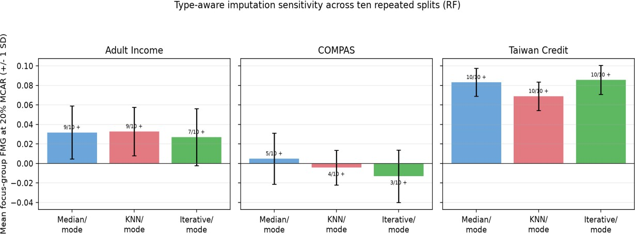
Fig. 9. Type-aware Random Forest FMG sensitivity at 20% raw-feature MCAR across Adult Income, COMPAS, and Taiwan Credit comparing median/mode (blue), KNN/mode (red), and iterative/mode (green) imputation pipelines (±1 SD and positive-split counts across ten splits).
4.9 Complementary-Group and Baseline-Recall Sensitivity
Comparison-group (g1) FMG is also positive on Adult Income and Taiwan Credit. When FMG is computed for the comparison group g1 at 20% MCAR, mean g1 FMG ranges from 0.0928 to 0.1189 on Adult Income (10/10 splits positive across all four models) and is positive in 10 of 10 splits for all four models on Taiwan Credit, whereas it is negative across all four models on COMPAS. Across the 12 primary pairs, the within-pair Spearman correlation between clean baseline focus-group recall and 20% MCAR FMG ranges widely from −0.394 to +0.806, indicating that baseline recall level alone does not determine FMG magnitude.
4.10 Descriptive Diagnostic Discordance
Headline accuracy thresholds frequently fail to flag substantial subgroup recall losses. Across the 120 primary dataset-model-seed evaluations at 20% MCAR, focus-group recall loss exceeded δ = 1.0, 2.5, 5.0, and 10.0 percentage points in 107, 100, 91, and 26 runs, respectively, whereas aggregate-accuracy loss crossed those same thresholds in only 77, 31, 0, and 0 runs. Consequently, an accuracy-only monitor using the same numeric cutoff δ missed 41/107 (38.3%) recall drops at δ = 1%, 78/100 (78.0%) at δ = 2.5%, 91/91 (100%) at δ = 5.0%, and 26/26 (100%) at δ = 10.0%.
4.11 Public-Health Benchmark Extension
Public-health benchmarks reveal contrasting positive-FMG and recall-floor regimes. In the 2024 CDC BRFSS diabetes evaluation (80/20 split, 20% MCAR, 15 seed-by-mask replicates per model), mean FMG ranged from 0.0272 to 0.0455 across the five classifiers (and 0.0309 to 0.0461 in the Black-women versus White-women intersectional audit), while comparison-group (g1) recall loss exceeded focus-group (g0) recall loss for every model. In contrast, on UCI Diabetes 30-day readmission, mean FMG ranged from 0.0000 to 0.0038 because clean baseline focus-group recall was near zero (0.000–0.020 across models, with RF at 0.000), illustrating how severe class imbalance and low operating-point sensitivity create a recall floor that bounds subsequent recall loss near zero.
4.12 Aggregate-Metric Decomposition Outcomes
Positive FMG on imbalanced primary tasks coincides with a sensitivity-specificity contrast in the aggregate decomposition. Pooling across the four primary models and ten splits at 20% MCAR (Eq. 5), Adult Income exhibited overall sensitivity loss ΔTPR_all = 0.1288, specificity change ΔTNR_all = −0.0132, accuracy loss ΔA = 0.0222, and FMG_all = 0.1067; Taiwan Credit showed ΔTPR_all = 0.0825, ΔTNR_all = −0.0151, ΔA = 0.0065, and FMG_all = 0.0760. These changes are consistent with a shift toward negative-class predictions for Adult and Taiwan, but the decomposition covers only the three primary datasets and does not isolate imputation as the cause. In COMPAS, sensitivity (ΔTPR_all = 0.0222) and specificity (ΔTNR_all = 0.0280) both declined by similar amounts (FMG_all = −0.0029). These pooled values describe the tested model-split combinations and are not inferential estimates. Additional decomposition results are provided in Supplementary Table S10.
5. Discussion
Aggregate accuracy can obscure substantial recall changes when positive-class prevalence is low. In the pooled primary results, Adult Income showed an overall recall loss of 12.9 percentage points with a 2.2-point accuracy loss; Taiwan Credit showed an 8.3-point overall recall loss with a 0.7-point accuracy loss. For the three primary datasets included in the decomposition, the Adult and Taiwan patterns are consistent with a shift toward negative-class predictions, but the analysis does not establish imputation as the cause.
FMG must be interpreted alongside both component losses and comparison-group recall. Because FMG contrasts focus-group recall loss against aggregate accuracy loss rather than against comparison-group recall loss, a positive FMG does not imply that the focus group suffered greater harm than the comparison group. In fact, comparison-group (g1) recall loss exceeded focus-group (g0) recall loss in all four models on Adult Income, all four models on Taiwan Credit, and all five models on BRFSS. Reporting ΔR(g0), ΔR(g1), ΔA, and per-split positive denominators together prevents analysts from mistaking an overall sensitivity collapse for a group-specific disparity—or, conversely, from overlooking a subgroup recall collapse that is masked by high overall accuracy.
Representation and operating-point calibration strongly influence measured missingness sensitivity. First, our imputation ablation (Table 4) shows that replacing integer-encoded median imputation with type-aware raw-feature imputation reduces Adult Income RF FMG from 0.0865 to 0.0270–0.0327, confirming that FMG audits the entire preprocessing-and-model pipeline rather than the classifier in isolation. Second, the UCI Diabetes readmission benchmark highlights a critical diagnostic boundary: when a classifier's clean baseline recall is already near zero (0.000–0.020), ΔR(g0) cannot exceed that baseline, producing a near-zero FMG that reflects poor baseline sensitivity rather than robustness to missing data.
6. Limitations and Threats to Validity
This study is subject to four principal methodological boundaries: (i) Controlled missingness scope: The primary benchmark uses uniform cell-level MCAR masking, and while our extensions test one group-conditional MAR mechanism, one age-conditioned logistic MAR mechanism (odds ratios 1.5, 2.0, and 4.0), and one synthetic value-conditional MNAR mechanism, these do not exhaust complex real-world missingness processes. (ii) Finite-sample resampling: Repeated stratified splits (10 splits in the primary benchmark, 30 post-hoc splits on COMPAS, and 3 seeds × 5 mask replicates in the public-health extension) reuse observations from finite datasets; reported bootstrap intervals and standard deviations therefore quantify split-to-split benchmark stability rather than independent population-level inference. (iii) Pipeline and weight conditioning: Primary results reflect integer categorical encoding with median imputation, while the BRFSS extension fits unweighted estimators before evaluating survey-weighted test metrics. (iv) Diagnostic versus operational scope: FMG is a descriptive paired contrast that contains no mathematical information beyond ΔR(g0) and ΔA reported separately; validating whether FMG improves human monitoring decisions or clinical/financial outcomes requires a prospective operational study.
7. Future Scope
Future research should extend this audit framework along four concrete directions. First, type-aware preprocessing and multiple-imputation pipelines should be benchmarked across broader neural and tabular foundation-model families under empirically learned missingness graphs. Second, multiclass extensions should evaluate class-specific one-versus-rest recall contrasts alongside calibration and precision-recall trade-offs under threshold adjustment. Third, exact feature-attribution methods should be scaled to larger cohorts to isolate how imputation distorts decision boundaries. Finally, prospective human-in-the-loop monitoring studies are needed to test whether pairing subgroup recall-loss alerts with headline accuracy metrics improves deployment governance in clinical and financial workflows.
8. Conclusion
We have presented a reproducible frozen-classifier audit for evaluating subgroup recall degradation under test-time feature missingness. By pairing focus-group recall loss directly against aggregate-accuracy loss (FMG) and logging per-split positive-label denominators, our evaluation across four socioeconomic benchmarks and two public-health cohorts shows that headline accuracy remained within 0.4–2.6 percentage points of its clean baseline in 9 of 12 primary dataset-model pairs even as focus-group recall dropped by 5.1–12.3 percentage points. At the same time, direct comparison with complementary subgroups (where g1 recall loss exceeded g0 recall loss in 8 of 12 primary pairs and all 5 BRFSS models) and the UCI Diabetes baseline-recall floor (0.000–0.020) demonstrate why FMG must be reported alongside both component losses, comparison-group recall, and baseline denominators. The audit can support controlled pre-deployment investigation; whether it improves operational monitoring or decisions remains future work.
Declarations
Funding: No external funding was received for this study.
Competing Interests: The authors declare no competing financial or non-financial interests.
Ethics Approval: This study analyzes publicly available benchmark and surveillance datasets. ProPublica COMPAS is included strictly as a standard algorithmic fairness benchmark; this work does not endorse criminal-justice risk scoring.
Declaration of Generative AI and AI-Assisted Technologies: During manuscript preparation, OpenAI Codex and ChatGPT were used to assist with language refinement and structural editing. The authors reviewed, verified, and take full responsibility for all code, empirical results, citations, and final text.
Author Contributions: M. Vamsi Krishna: Conceptualization, methodology, software, data curation, formal analysis, experiments, and original draft preparation. S. Sri Harsha: Validation, investigation, manuscript review and editing, and visualization.
Data and Code Availability: All benchmark datasets are publicly available from their original repositories (UCI Machine Learning Repository, ProPublica, OpenML, and CDC BRFSS). The versioned code and reproducibility release is available at https://github.com/MVamsiKrishna2501050195/FMG-research/tree/fmg-submission-release-v3-2026-10-28. It includes the canonical notebook, SHA-256 manifests, per-seed result CSVs, subgroup-denominator logs, decomposition outputs, and public-health extension archive.
References
[1] Min, S., Asif, H., and Vaidya, J. (2025). Exploring the inequitable impact of data missingness on fairness in machine learning. IEEE Intelligent Systems, 40(3), 28–38. https://doi.org/10.1109/MIS.2025.3549484
[2] Jang, S., Eun, J., Yi, H., and Choi, C. (2026). When does train-time masking help? A leakage-controlled robustness audit of tabular classifiers under feature missingness. IEEE Access, 14, 84378–84398. https://doi.org/10.1109/ACCESS.2026.3695538
[3] Kochs, T., Castellani, A., Lanfermann, F., and Hammer, B. (2026). Evaluating and mitigating fairness risks in machine learning under structured missing data. In Proceedings of the 3rd Workshop on Fairness and Bias in AI (AEQUITAS@ECAI 2025), CEUR Workshop Proceedings, Vol. 4147. https://ceur-ws.org/Vol-4147/paper12.pdf
[4] Zhang, Y., and Long, Q. (2021). Assessing fairness in the presence of missing data. Advances in Neural Information Processing Systems (NeurIPS), 34, 16007–16019. https://proceedings.neurips.cc/paper/2021/hash/85dca1d270f7f9aef00c9d372f114482-Abstract.html
[5] Cherian, J. J., and Candès, E. J. (2024). Statistical inference for fairness auditing. Journal of Machine Learning Research, 25(149), 1–49. https://jmlr.org/papers/v25/23-0739.html
[6] Bhatti, A., Sandrock, T., and Nienkemper-Swanepoel, J. (2026). The influence of missing data mechanisms and simple missing data handling techniques on fairness. International Journal of Data Science and Analytics, 22, Article 172. https://doi.org/10.1007/s41060-026-01139-0
[7] Caton, S., Malisetty, S., and Haas, C. (2022). Impact of imputation strategies on fairness in machine learning. Journal of Artificial Intelligence Research, 74, 1011–1035. https://doi.org/10.1613/jair.1.13197
[8] Emmanuel, T., Maupong, T., Mpoeleng, D., Semong, T., Mphago, B., and Tabona, O. (2021). A survey on missing data in machine learning. Journal of Big Data, 8, Article 140. https://doi.org/10.1186/s40537-021-00516-9
[9] Jeanselme, V., De-Arteaga, M., Zhang, Z., Barrett, J., and Tom, B. (2022). Imputation strategies under clinical presence: Impact on algorithmic fairness. arXiv preprint arXiv:2208.06648.
[10] Jeong, H., Wang, H., and Calmon, F. P. (2022). Fairness without imputation: A decision tree approach for fair prediction with missing values. Proceedings of the AAAI Conference on Artificial Intelligence, 36(9), 9558–9566. https://doi.org/10.1609/aaai.v36i9.21189
[11] Martinez-Plumed, F., Ferri, C., Nieves, D., and Hernández-Orallo, J. (2021). Missing the missing values: The ugly duckling of fairness in machine learning. International Journal of Intelligent Systems, 36(7), 3217–3258. https://doi.org/10.1002/int.22415
[12] Miao, X., Qiang, L., Huang, G., Wu, Y., and Yin, J. (2025). Fairness-aware classification over incomplete data. Proceedings of the 48th International ACM SIGIR Conference on Research and Development in Information Retrieval, 549–558. https://doi.org/10.1145/3726302.3729975
[13] Pessach, D., and Shmueli, E. (2022). A review on fairness in machine learning. ACM Computing Surveys, 55(3), Article 51, 1–44. https://doi.org/10.1145/3494672
[14] Barrainkua, A., Gordaliza, P., Lozano, J. A., and Quadrianto, N. (2025). Preserving the fairness guarantees of classifiers in changing environments: A survey. ACM Computing Surveys, 57(6), Article 137, 1–32. https://doi.org/10.1145/3637438
[15] Buolamwini, J., and Gebru, T. (2018). Gender Shades: Intersectional accuracy disparities in commercial gender classification. Proceedings of the Conference on Fairness, Accountability, and Transparency (FAT*), 81, 77–91.
[16] Caton, S., and Haas, C. (2024). Fairness in machine learning: A survey. ACM Computing Surveys, 56(7), Article 166, 1–38. https://doi.org/10.1145/3616865
[17] Chouldechova, A. (2017). Fair prediction with disparate impact: A study of bias in recidivism prediction instruments. Big Data, 5(2), 153–163. https://doi.org/10.1089/big.2016.0047
[18] D'Amour, A., Heller, K., Moldovan, D., Adlam, B., Alipanahi, B., Beutel, A., et al. (2022). Underspecification presents challenges for credibility in modern machine learning. Journal of Machine Learning Research, 23(226), 1–61.
[19] Hardt, M., Price, E., and Srebro, N. (2016). Equality of opportunity in supervised learning. Advances in Neural Information Processing Systems (NeurIPS), 29, 3315–3323.
[20] Mehrabi, N., Morstatter, F., Saxena, N., Lerman, K., and Galstyan, A. (2021). A survey on bias and fairness in machine learning. ACM Computing Surveys, 54(6), Article 115, 1–35. https://doi.org/10.1145/3457607
[21] Wang, H., He, L., Gao, R., and Calmon, F. P. (2023). Aleatoric and epistemic discrimination: Fundamental limits of fairness interventions. Advances in Neural Information Processing Systems (NeurIPS), 36.
[22] Wang, Y., and Singh, L. (2021). Analyzing the impact of missing values and selection bias on fairness. International Journal of Data Science and Analytics, 12, 101–119. https://doi.org/10.1007/s41060-021-00259-z
[23] Kamiran, F., and Calders, T. (2012). Data preprocessing techniques for classification without discrimination. Knowledge and Information Systems, 33(1), 1–33. https://doi.org/10.1007/s10115-011-0463-8
[24] Hendrycks, D., and Dietterich, T. (2019). Benchmarking neural network robustness to common corruptions and perturbations. International Conference on Learning Representations (ICLR).
[25] Koh, P. W., Sagawa, S., Marklund, H., Xie, S. M., Zhang, M., Balsubramani, A., et al. (2021). WILDS: A benchmark of in-the-wild distribution shifts. Proceedings of the 38th International Conference on Machine Learning (ICML), PMLR 139, 5637–5664.
[26] Moreno-Torres, J. G., Raeder, T., Alaiz-Rodríguez, R., Chawla, N. V., and Herrera, F. (2012). A unifying view on dataset shift in classification. Pattern Recognition, 45(1), 521–530. https://doi.org/10.1016/j.patcog.2011.06.019
[27] Shao, M., Li, D., Zhao, C., Wu, X., Lin, Y., and Tian, Q. (2024). Supervised algorithmic fairness in distribution shifts: A survey. Proceedings of the 33rd International Joint Conference on Artificial Intelligence (IJCAI), 8225–8233. https://doi.org/10.24963/ijcai.2024/909
[28] Singh, H., Xia, F., Gossmann, A., Chuang, A., Hong, J. C., and Feng, J. (2025). 'Who experiences large model decay and why?' A hierarchical framework for diagnosing heterogeneous performance drift. Proceedings of the 42nd International Conference on Machine Learning (ICML), PMLR 267, 55757–55787. https://proceedings.mlr.press/v267/singh25e.html
[29] Shadbahr, T., Roberts, M., Stanczuk, J., Gilbey, J., Teare, P., Dittmer, S., et al. (2023). The impact of imputation quality on machine learning classifiers for datasets with missing values. Communications Medicine, 3, Article 139. https://doi.org/10.1038/s43856-023-00356-z
[30] Dua, D., and Graff, C. (2019). Adult Income Dataset, UCI Machine Learning Repository. University of California, Irvine. https://archive.ics.uci.edu/dataset/2/adult
[31] Angwin, J., Larson, J., Mattu, S., and Kirchner, L. (2016). Machine Bias: There's software used across the country to predict future criminals. And it's biased against blacks. ProPublica. https://www.propublica.org/article/machine-bias-risk-assessments-in-criminal-sentencing
[32] Yeh, I.-C., and Lien, C.-H. (2009). The comparisons of data mining techniques for the predictive accuracy of probability of default of credit card clients. Expert Systems with Applications, 36(2), 2473–2480. https://doi.org/10.1016/j.eswa.2007.12.020
[33] Grömping, U. (2019). South German Credit Data: Correcting a Widely Used Data Set. Report 4/2019, Department II, Beuth University of Applied Sciences Berlin. https://www1.bht-berlin.de/FB_II/reports/Report-2019-004.pdf
[34] Rubin, D. B. (1976). Inference and missing data. Biometrika, 63(3), 581–592. https://doi.org/10.1093/biomet/63.3.581
[35] Lundberg, S. M., and Lee, S.-I. (2017). A unified approach to interpreting model predictions. Advances in Neural Information Processing Systems (NeurIPS), 30, 4765–4774.
[36] Ghorbani, A., Abid, A., and Zou, J. (2019). Interpretation of neural networks is fragile. Proceedings of the AAAI Conference on Artificial Intelligence, 33(01), 3681–3688. https://doi.org/10.1609/aaai.v33i01.33013681
[37] Centers for Disease Control and Prevention (CDC). (2025). 2024 BRFSS Survey Data and Documentation. Behavioral Risk Factor Surveillance System. https://www.cdc.gov/brfss/annual_data/annual_2024.html
[38] Clore, J., Cios, K., DeShazo, J., and Strack, B. (2014). Diabetes 130-US Hospitals for Years 1999–2008. UCI Machine Learning Repository. https://doi.org/10.24432/C5230J
[39] OpenML. (2014). credit-g (Statlog German Credit Data, Data ID 31, Version 1). https://www.openml.org/d/31
[40] Feng, R., Calmon, F. P., and Wang, H. (2023). Adapting fairness interventions to missing values. Advances in Neural Information Processing Systems, 36 (NeurIPS 2023). https://doi.org/10.52202/075280-2595

