Test-Time Feature Missingness Can Hide Recall Loss Behind Stable Accuracy
M. Vamsi Krishna; S. Sri Harsha
Department of Computer Science and Engineering, Koneru Lakshmaiah Education Foundation, Vaddeswaram, Guntur District, Andhra Pradesh 522302, India
Corresponding author: 2501050195@kluniversity.in | sharsha@kluniversity.in
ORCID: 0009-0001-8313-4762

Abstract
Missing test features can leave headline accuracy nearly unchanged while positive-class recall falls for a selected subgroup. We define the signed Focus-Group Masking Gap (FMG) as focus-group recall loss minus aggregate-accuracy loss under identical test-only masking. FMG is presented as a prespecified paired monitoring convention: it does not add mathematical information beyond its two component losses, but it packages their divergence into an auditable alert rule. Across ten repeated splits on 12 primary dataset-model pairs from Adult Income, COMPAS, and Taiwan Credit, mean FMG at 20% MCAR was 0.0545; 9 of 12 pairs exceeded the descriptive 0.01 reference. Focus-group recall loss exceeded comparison-group loss in only 4 of 12 pairs, so FMG is not a between-group disparity. A BRFSS extension showed mean FMG of 0.0272--0.0455, while UCI Diabetes showed 0.0000--0.0038 with near-zero clean focus-group recall. The study provides a leakage-controlled audit framework and retrospective benchmark threshold-discordance and alert-coverage analysis, but does not establish fairness, causality, deployment benefit, or superiority over all missingness-aware adaptation methods.
Keywords: missing data; MCAR; fairness auditing; tabular classifiers; focus-group masking gap; robustness evaluation

Introduction
An incomplete record can make a classifier miss positive cases while its headline accuracy barely changes. This can happen when intake forms omit fields, sensors fail, or upstream systems return partial records. Because accuracy averages errors across classes and groups, it can conceal recall loss for a prespecified subgroup. We ask whether the same frozen classifier loses more focus-group recall than aggregate accuracy under test-time feature masking.
Prior work links data missingness with both algorithmic fairness and inference-time robustness. Researchers have examined how missingness mechanisms and imputation choices alter group fairness outcomes (Min et al. [1]; Bhatti et al. [6]; Caton et al. [7]), how tabular classifiers degrade under test-time feature-missingness overlays (Jang et al. [2]; Kochs et al. [3]), and how statistical inference supports subgroup auditing (Zhang and Long [4]; Cherian and Candès [5]). Recent feature-decrement research also develops test-time imputation and adaptation strategies for open tabular environments (Cheng et al. [41]). Rather than claiming that inference-time missingness is unstudied, we isolate a specific paired contrast---focus-group recall loss minus aggregate-accuracy loss under identical test-time masking---and pair every estimate with explicit per-split subgroup positive-label denominators.
Positive FMG must be distinguished from a between-group fairness disparity. Because FMG compares focus-group (g0) recall loss against overall accuracy loss rather than against comparison-group (g1) recall loss, a positive FMG can occur even when both subgroups lose substantial recall. Indeed, in our primary benchmark at 20% MCAR, g0 recall loss exceeded g1 recall loss in only 4 of 12 dataset-model pairs, demonstrating why reporting both component losses and subgroup denominators is essential.
Here, we present a reproducible frozen-classifier audit for test-time feature missingness. We contribute (i) a formal definition and prespecified reporting convention for the signed Focus-Group Masking Gap (FMG), together with its algebraic relation to overall sensitivity and specificity losses, (ii) the finding that comparison-group recall loss was greater than focus-group recall loss in 8 of 12 primary pairs, (iii) a leakage-free test-only masking protocol that tracks per-split subgroup denominators, (iv) a descriptive evaluation across socio-economic and public-health benchmarks under MCAR, constructed group-conditioned and observed-age-conditioned MAR sensitivities, and a value-conditional MNAR sensitivity, and (v) a benchmark threshold-discordance analysis showing when accuracy-only monitoring misses subgroup recall loss. FMG is not claimed to add information beyond reporting its component losses; its contribution is the reproducible pairing of those quantities with explicit thresholds, denominator reporting, and audit outputs. The study does not claim a new imputation, adaptation, fairness, causal, or decision-utility method. Section 2 reviews related work; Section 3 details the datasets, models, masking mechanisms, and audit algorithm; Section 4 reports the empirical findings and sensitivity analyses; and Sections 5--8 discuss implications, limitations, future directions, and conclusions.

Literature Review and Research Gap
Missing values and imputation can change measured group-fairness outcomes. Reviews and empirical studies examine how missingness mechanisms, imputation strategies, and incomplete-data classification interact with fairness (Min et al. [1]; Bhatti et al. [6]; Caton et al. [7]; Emmanuel et al. [8]; Jeanselme et al. [9]; Jeong et al. [10]; Martinez-Plumed et al. [11]; Miao et al. [12]; Pessach and Shmueli [13]). Caton et al. [7] and Bhatti et al. [6] report that imputation choices can shift group-fairness metrics. Recent work on fully test-time feature decrement studies imputation and adaptation as remedies for missing features (Cheng et al. [41]). Our audit differs from these approaches: we freeze a classifier trained on clean data and mask only test inputs, then ask whether subgroup recall loss is hidden by aggregate accuracy. The contribution is therefore an audit and measurement framework, not a mitigation, adaptation, or calibration method. Feng et al. [40] adapt fairness interventions for classifiers trained with missing data; we evaluate inference-time sensitivity without retraining.
Fairness metrics compare groups within one condition; FMG compares one group's change across conditions. Equal Opportunity compares group true-positive rates under the same evaluation distribution (Chouldechova [17]; Hardt et al. [19]), while broader work studies group disparities, selection, and measurement (Buolamwini and Gebru [15]; D'Amour et al. [18]; Mehrabi et al. [20]; Wang et al. [21]; Caton and Haas [16]; Barrainkua et al. [14]; Wang and Singh [22]). Our audit instead compares a prespecified subgroup's recall on clean and masked test inputs with the change in overall accuracy. It complements, rather than replaces, between-group fairness metrics.
Robustness studies measure performance changes under corruptions and distribution shifts. Prior work includes general shift benchmarks and corruption tests (Moreno-Torres et al. [26]; Hendrycks and Dietterich [24]; Koh et al. [25]; Shadbahr et al. [29]; Shao et al. [27]; Singh et al. [28]). Jang et al. [2] study tabular classifiers under feature-missingness overlays at training and test time, while Kochs et al. [3] examine structured test-time missingness and mitigation. Cheng et al. [41] study fully test-time feature decrement and propose imputation/adaptation strategies across tabular tasks. Zhang and Long [4] and Cherian and Candès [5] develop statistical methods for fairness estimation and subgroup audits. Our paired comparison adds a focused way to describe subgroup recall change relative to aggregate accuracy under the same masked inputs, while leaving recovery and mitigation to future work.
The practical concern is a mismatch between aggregate accuracy and subgroup recall after test inputs are masked. The FMG audit makes this paired contrast explicit and reports per-split positive-label denominators and threshold-discordance counts. It is not a missing-data estimator, a fairness guarantee, a causal effect, or a retraining method. Table 1 places this diagnostic alongside related research streams and makes the distinction from feature-recovery methods explicit.
Table 1. Comparison of related research streams and the bounded scope of the FMG audit.
Research Stream | Overlap with Present Study | Specific Distinction in This Paper | Boundary of Claim
Fairness under missing data [1], [3], [6], [7] | Studies group-related missingness, imputation impacts, and inference-time fairness degradation. | Reports the paired signed difference between focus-group recall loss and aggregate-accuracy loss for a frozen model. | Does not claim that fairness degradation under test-time missingness is newly discovered.
Test-time missingness robustness [2], [29] | Evaluates tabular classifier degradation under controlled feature-missingness overlays at inference time. | Pairs subgroup recall loss directly against headline accuracy loss with explicit per-split subgroup denominators. | Does not claim test-time feature masking itself as a novel stress-testing method.
Statistical fairness auditing [4], [5] | Audits subgroup performance under missing data, sampling variability, or distribution shift. | Provides a deterministic, fixed-group descriptive contrast across clean and masked test evaluations. | Does not provide simultaneous subgroup inference, certification, or a new statistical estimator.
Fairness-aware incomplete-data learning [10], [12], [40] | Develops training or tree-splitting algorithms to improve fairness on incomplete tabular data. | Audits an unchanged, clean-trained classifier to diagnose vulnerability prior to retraining. | Serves as a pre-deployment or post-hoc diagnostic rather than a mitigation algorithm.
Test-time feature decrement and adaptation [41] | Studies missing features in open tabular environments and develops imputation/adaptation responses. | Keeps the clean-trained classifier frozen and asks whether focus-group recall loss is hidden by aggregate accuracy. | Does not claim an imputation, adaptation, or recovery algorithm.

Methodology

Datasets and Focus Groups
Four tabular benchmarks define our primary and exploratory socioeconomic evaluation. The primary benchmark comprises Adult Income (Dua and Graff [30]), ProPublica COMPAS (Angwin et al. [31]), and Taiwan Credit Default (Yeh and Lien [32]). For Adult Income, the official adult.data training file (32,561 raw records) was parsed with '?' treated as missing; excluding 2,399 incomplete records under our complete-case baseline rule yielded 30,162 analyzed rows. We also include the OpenML credit-g version of Statlog German Credit (1,000 rows; data ID 31 [39]) strictly as an exploratory benchmark due to its small sample size and legacy status-code encodings (distinct from the corrected South German Credit dataset of Grömping [33]). Table 2 summarizes the tasks, sample sizes, and prespecified focus groups.
Table 2. Summary of primary, exploratory, and public-health extension datasets and prespecified focus groups.
Dataset | Analyzed Rows | Prediction Task | Sensitive Attribute | Focus Group (g0) & Role
Adult Income [30] | 30,162 (32,561 raw) | Annual income > $50K | Sex | Female (g0); Primary benchmark
COMPAS [31] | 5,278 | Two-year recidivism | Race | African-American (g0); Primary benchmark
Taiwan Credit [32] | 30,000 | Credit card default | Sex | Female (g0); Primary benchmark
German Credit [39] | 1,000 | Credit risk outcome | Personal status | Female A92/A95 (g0); Exploratory
CDC BRFSS 2024 [37] | 353,573 | Self-reported diabetes | Race/ethnicity | Non-Hispanic Black (g0); Health extension
UCI Diabetes [38] | 99,493 encounters | 30-day hospital readmission | Race | African-American (g0); Health extension

Two large-scale clinical and surveillance cohorts form a separate public-health extension. We evaluated a cross-sectional self-reported diabetes task in the 2024 CDC Behavioral Risk Factor Surveillance System (BRFSS, 353,573 eligible respondents [37]) and an early hospital readmission task in the UCI Diabetes 130-US Hospitals dataset (99,493 eligible encounters from 1999--2008 [38]). In BRFSS, the focus group (g0) comprises non-Hispanic Black respondents compared against non-Hispanic White respondents (g1); models were trained unweighted, while held-out metrics incorporated CDC final person weights and primary-sampling-unit (PSU) stratified bootstrap resampling. In UCI Diabetes, g0 comprises African-American patients compared against other records with reported race (g1), using patient-disjoint train/test splits partitioned by patient_nbr.
Focus-group definitions are locked a priori and excluded from predictor matrices. Across all datasets, the sensitive attribute is removed before model training and used solely to partition test-set evaluation into the focus group (coded g0 = 0) and its complement (coded g1 = 1). To ensure audit transparency, per-seed subgroup sample sizes, positive- and negative-label counts, base rates, and recall denominators are logged automatically for every split.
The end-to-end frozen-classifier audit architecture and data flow are illustrated in Figs. 1 and 2.

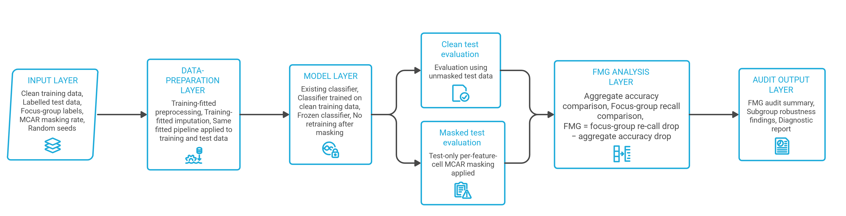
Figure 1. Frozen-classifier audit architecture across five sequential stages: (1) the Input Layer ingests clean training data, labeled test data, focus-group indicators, MCAR masking rates, and random seeds; (2) the Data-Preparation Layer fits encoding, scaling, and imputation parameters strictly on clean training data; (3) the Model Layer trains the classifier on clean features and freezes its parameters; (4) parallel Clean and Masked Test Evaluation branches score unmasked and test-masked inputs without retraining; and (5) the FMG Analysis and Output Layers compute the signed difference between focus-group recall loss and aggregate-accuracy loss.

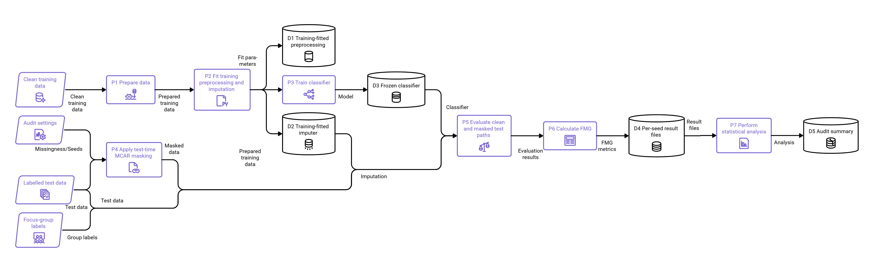
Figure 2. Detailed audit data-flow diagram (P1--P7 and data stores D1--D5). Training data pass through preparation (P1) to fit and store preprocessing parameters (D1) and the training imputer (D2), which feed classifier training (P3) to produce the frozen model (D3). Held-out test data undergo parallel clean evaluation and test-time MCAR masking (P4) followed by training-fitted imputation; both paths are scored by the frozen classifier (P5) to compute per-seed FMG metrics (P6, D4) and descriptive summary statistics (P7, D5).

Preprocessing Pipeline and Model Families
Each primary benchmark run uses ten fixed target-stratified 70:30 train/test splits. Using fixed random seeds 42, 123, 456, 1, 7, 13, 21, 37, 55, 99, categorical predictors are integer-encoded via mappings learned strictly on the training split (assigning -1 to unseen test categories), and all features are min-max scaled to [0, 1] using training-set extrema. Hyperparameters remain fixed across all runs and are never tuned on masked test data.
Five distinct classifier architectures span ensemble, boosting, neural, and linear paradigms. Our four primary models are Random Forest (RF; 100 trees, n_jobs = -1), XGBoost (XGB; 100 trees, logloss objective), LightGBM (LGB; 100 trees), and a feed-forward Multilayer Perceptron (MLP; hidden layers (50, 30), max_iter = 500, internal training early_stopping = True), with Logistic Regression (LR; C = 1.0, lbfgs solver, max_iter = 1000) included as a linear reference. Evaluating these diverse model families tests whether the divergence between subgroup recall loss and aggregate accuracy loss persists across different decision-boundary geometries.

Masking Mechanisms, Imputation, and the FMG Estimand
Test-time MCAR masking perturbs eligible feature cells independently after training. In the primary protocol, each feature cell in the encoded and scaled test matrix is masked independently with probability ε ∈ (0.05, 0.10, 0.20) (Rubin [34]) using a mask seed matched to the split seed, and masked entries are replaced using a median SimpleImputer fitted on the clean training split. Because integer label encoding imposes an artificial ordinal scale on nominal categories, we also conduct a dedicated type-aware sensitivity analysis (Section 4.8) that masks raw feature cells prior to transformation and compares median/mode, five-neighbor KNN/mode (n_neighbors = 5), and iterative numeric/mode (max_iter = 10) imputation.
Two structured MAR sensitivities test non-uniform missingness propensities. First, a group-conditional MAR experiment calibrates subgroup-specific cell-masking probabilities so that the overall expected missingness matches nominal rates of 10% and 20%. Second, an observed-covariate logistic MAR experiment retains age as fully observed and assigns row-specific Bernoulli masking probabilities to all remaining features using standardized test age, testing conditional odds ratios of 1.5, 2.0, and 4.0 per standard deviation of age at 10% and 20% expected missingness.
Cell-level masking probability compounds across multi-feature records. Because ε denotes the independent per-cell masking probability across p eligible features, the probability that a test record experiences at least one masked feature cell is given by:
(1) Pr(at least one masked feature) = 1 - (1 - ε)^p.
The Focus-Group Masking Gap (FMG) measures excess subgroup recall loss relative to headline accuracy loss. Let R(g0, clean) and R(g0, masked) denote positive-class recall for the focus group g0 on the clean and masked test sets, and let A(clean) and A(masked) denote aggregate test accuracy across the entire held-out cohort. We define the paired focus-group recall loss ΔR(ε), aggregate-accuracy loss ΔA(ε), and their signed contrast FMG(ε) as:
(2) ΔR(ε) = R(g_0,clean) - R(g_0,masked),
ΔA(ε) = A(clean) - A(masked).
(3) FMG(ε) = ΔR(ε) - ΔA(ε).
That is, FMG(ε) > 0 indicates that test-time masking reduces focus-group recall by a larger margin than it reduces overall accuracy, FMG(ε) = 0 indicates equal degradation, and FMG(ε) < 0 indicates that overall accuracy drops more than focus-group recall. Because ΔR(ε) and ΔA(ε) each lie in [-1, 1], FMG(ε) is bounded in [-2, 2].

Focus-Group Masking Gap Audit Algorithm
Algorithm 1 formalizes the step-by-step evaluation protocol. For n test records, p eligible features, and r mask repetitions, generating masks and imputing matrices requires O(rnp) time and O(np) working memory per active mask, plus r forward-inference passes of the frozen classifier.

Algorithm 1. Focus-Group Masking Gap (FMG) Frozen-Classifier Audit
- Train and freeze. For each seed, fit the preprocessing and imputation pipeline on clean training data, train the classifier on clean features (excluding sensitive attributes), and freeze model weights.
- Evaluate the clean baseline. Evaluate the frozen classifier on the unmasked test set; record aggregate accuracy A_clean, focus-group recall R(g_0,clean), comparison-group recall R(g_1,clean), and subgroup positive-label denominators.
- Mask test features. Generate an independent test-only feature mask at rate ε without retraining the classifier, and transform masked test features using the training-fitted imputer.
- Evaluate masked inputs. Evaluate the unchanged classifier on the masked test set; record A_masked, R(g_0,masked), and R(g_1,masked).
- Calculate the contrast. Compute ΔR(ε)=R(g_0,clean)-R(g_0,masked), ΔA(ε)=A_clean-A_masked, and FMG(ε)=ΔR(ε)-ΔA(ε).

Statistical Analysis and Reproducibility
Repeated stratified splits summarize benchmark stability on finite datasets. Across the ten fixed train/test splits, we report the arithmetic mean, standard deviation (SD), observed range, count of splits with FMG > 0, and descriptive percentile-bootstrap intervals for mean FMG alongside focus-group positive-label denominator ranges. The headline 12-pair mean is the unweighted arithmetic mean of the 12 dataset-model cell means; pooled decomposition values are descriptive averages over the reported model-split combinations, not population-weighted estimates. Comparisons of focus-group and comparison-group losses are paired within the same split and masking condition. Because repeated splits resample the same finite dataset, these summaries describe benchmark stability rather than independent population-level confidence intervals; we make no multiplicity-adjusted confirmatory significance claim. We use 0.01 (1 percentage point) strictly as a descriptive reference grid point rather than an operational alert cutoff. All 800 archived benchmark evaluation rows (4 datasets × 5 classifiers × 10 seeds × 4 masking levels, including the exploratory German Credit benchmark) and SHA-256 verified output tables are archived in the public reproducibility repository.
Mechanism specification. The group-conditioned sensitivity retains the sensitive-group label as fully observed audit metadata, excludes it from the model feature matrix, assigns the focus group a higher cell-selection probability, and calibrates the two group-specific probabilities so their weighted expected average equals the requested overall rate. This is one constructed group-conditioned stressor, not a claim about all MAR processes. In the observed-age-conditioned sensitivity, age remains observed and all other test-feature cells are eligible; for standardized observed age z_i, the per-cell propensity is logit(p_i)=alpha + log(OR) z_i, where OR is 1.5, 2, or 4 per standard deviation and alpha is calibrated separately for each split, rate, and strength to attain the nominal expected cell-missingness rate. For the public-health value-conditional sensitivity, cells are sampled without replacement with weights proportional to exp(clip(0.65 |z_ij|, 0, 5)), where z_ij uses the training median and training standard deviation for feature j; the number selected is round(rate × n × p). This value-dependent construction is a stressor based on clean feature values and is not an identified natural-MNAR process. The achieved rates and generator code are archived with the mechanism-specific manifests.

Diagnostic Discordance Analysis
Threshold-discordance indicators test when accuracy monitoring misses subgroup recall drops. To quantify how often focus-group recall loss crosses a sensitivity threshold delta in {0.01, 0.025, 0.05, 0.10} while aggregate-accuracy loss remains below that same threshold delta, we define the binary threshold indicators and discordance indicator U(delta) for each dataset-model-seed evaluation:
(4) I_R(δ) = 1[Δ R ≥ δ], I_A(δ) = 1[ΔA ≥ δ], U(δ) = I_R(δ)(1-I_A(δ)).
Simply put, U(δ)=1 identifies benchmark runs where an analyst monitoring only whether aggregate accuracy drops by at least δ would miss a focus-group recall drop of at least δ.

Exploratory UCI Operating-Point Sensitivity
We evaluated whether the UCI Diabetes recall-floor result was specific to the default classifier operating point. Using the same ten fixed split seeds as the primary schedule, we evaluated 80/20 splits and a 70/30 split-ratio sensitivity, five model families (LR, RF, XGBoost, LightGBM, and MLP), and two alternatives: class-weighted refits where supported, and a probability cutpoint set to the positive-class prevalence in the training partition. The latter cutpoint used no test labels; the class-weighted condition refit the model, so it is a sensitivity to the model-and-operating-point pipeline rather than a threshold-only change. Each resulting model was held fixed between its clean and masked test evaluations under MCAR and the constructed group-conditional MAR and value-conditional MNAR mechanisms at 5%, 10%, and 20% nominal feature masking. The UCI patient identifier was used only for patient-disjoint splitting and excluded from model inputs; the focus group is African American. The two MLP labels in the raw output correspond to the same threshold-calibrated model because this implementation has no class-weight option; they are counted once in descriptive summaries. We report repeated-split summaries descriptively and do not treat these seeds as independent populations.

Exploratory Multi-Model SHAP Sensitivity
Tree-based feature attribution shifts are evaluated under clean and masked inputs. To examine how test-time masking perturbs feature attributions without claiming causal mechanism identification, we compute positive-class SHAP values (Lundberg and Lee [35]) on COMPAS RF (seed 42) and across RF, XGBoost, and LightGBM on the two public-health cohorts (80/20 split, seeds 42, 123, and 456, 20% MCAR) for up to 20 matched held-out observations per group.

Aggregate-Metric Decomposition
Aggregate accuracy loss decomposes algebraically into overall recall and specificity losses. Let π denote positive-class prevalence in the held-out test set, ΔTPR_all = TPR(clean) - TPR(masked) denote overall positive-class recall loss, and ΔTNR_all = TNR(clean) - TNR(masked) denote overall specificity loss. Because binary accuracy satisfies ΔA = π ΔTPR_all + (1 - π) ΔTNR_all, the population-wide recall-versus-accuracy contrast FMG_all simplifies to:
(5) FMG_all = ΔTPR_all - ΔA
= (1-π)(ΔTPR_all - ΔTNR_all).
Thus, at the full-cohort level, positive-class recall degrades more than overall accuracy whenever masking reduces sensitivity more than specificity, scaled by the negative-class prevalence (1 - π).

Results

Primary Benchmark Analysis at 20% MCAR
Nine of twelve primary dataset-model pairs exceed a mean FMG of 0.01 at 20% MCAR. Across all 12 primary comparisons (Table 3), mean FMG is 0.0545, and across the nine pairs exceeding the 0.01 reference, mean FMG reaches 0.0727. All four primary classifiers (LGB, MLP, RF, and XGB) exhibit positive FMG in 10 of 10 splits on both Adult Income (mean FMG 0.0616--0.0977) and Taiwan Credit (mean FMG 0.0658--0.0812), whereas on COMPAS only the MLP consistently exceeds 0.01 (mean FMG 0.0293; 10/10 positive splits). Logistic regression (archived as a linear reference) similarly yielded a mean FMG of 0.0191 on Adult Income at 20% MCAR.
Subgroup recall loss frequently exceeds headline accuracy loss even when both groups degrade. For example, on Adult Income with Random Forest (Table 3), 20% MCAR masking reduces aggregate accuracy by only 0.0214 (2.14 percentage points) but reduces female (g0) positive-class recall by 0.1079 (10.79 percentage points), producing a mean FMG of 0.0865. At the same time, male (g1) positive-class recall drops by 0.1403, resulting in a negative between-group recall-loss difference (g0 - g1 = -0.0324). Across the 12 primary pairs, g0 recall loss exceeds g1 recall loss in only 4 pairs (the four COMPAS models), confirming empirically that FMG diagnoses divergence from headline accuracy rather than between-group disparity. Figs. 3 and 4 illustrate these trajectories across masking rates and classifiers.
Table 3. Primary benchmark results at 20% MCAR across ten repeated 70:30 stratified splits, reporting mean FMG (SD), aggregate-accuracy loss, focus-group (g0) and comparison-group (g1) recall losses, signed between-group difference (g0 - g1), positive-split counts, descriptive 95% percentile-bootstrap intervals, and g0 positive-label denominator ranges (n+).
Dataset / Model | FMG Mean (SD); Acc. Loss | g0 / g1 Recall Loss; (g0 - g1) | Positive Splits; descriptive 95% bootstrap interval; g0 n+ range
Adult / LGB | 0.0977 (0.0192); acc 0.0256 | 0.1234 / 0.1443; -0.0209 | 10/10; [0.0862, 0.1086]; n+ 316 to 347
Adult / MLP | 0.0616 (0.0250); acc 0.0180 | 0.0797 / 0.1108; -0.0312 | 10/10; [0.0472, 0.0763]; n+ 316 to 347
Adult / RF | 0.0865 (0.0225); acc 0.0214 | 0.1079 / 0.1403; -0.0324 | 10/10; [0.0726, 0.0990]; n+ 316 to 347
Adult / XGB | 0.0890 (0.0269); acc 0.0237 | 0.1127 / 0.1359; -0.0232 | 10/10; [0.0727, 0.1048]; n+ 316 to 347
COMPAS / LGB | 0.0010 (0.0299); acc 0.0266 | 0.0276 / -0.0083; +0.0359 | 4/10; [-0.0154, 0.0192]; n+ 510 to 548
COMPAS / MLP | 0.0293 (0.0164); acc 0.0221 | 0.0514 / 0.0108; +0.0406 | 10/10; [0.0200, 0.0391]; n+ 510 to 548
COMPAS / RF | 0.0047 (0.0238); acc 0.0242 | 0.0289 / 0.0092; +0.0196 | 5/10; [-0.0090, 0.0189]; n+ 510 to 548
COMPAS / XGB | -0.0060 (0.0355); acc 0.0275 | 0.0215 / -0.0053; +0.0268 | 3/10; [-0.0251, 0.0158]; n+ 510 to 548
Taiwan Credit / LGB | 0.0728 (0.0091); acc 0.0075 | 0.0803 / 0.0878; -0.0075 | 10/10; [0.0687, 0.0788]; n+ 1092 to 1170
Taiwan Credit / MLP | 0.0701 (0.0066); acc 0.0075 | 0.0776 / 0.0896; -0.0120 | 10/10; [0.0662, 0.0740]; n+ 1092 to 1170
Taiwan Credit / RF | 0.0812 (0.0106); acc 0.0042 | 0.0854 / 0.0898; -0.0044 | 10/10; [0.0760, 0.0882]; n+ 1092 to 1170
Taiwan Credit / XGB | 0.0658 (0.0103); acc 0.0068 | 0.0726 / 0.0810; -0.0084 | 10/10; [0.0597, 0.0717]; n+ 1092 to 1170

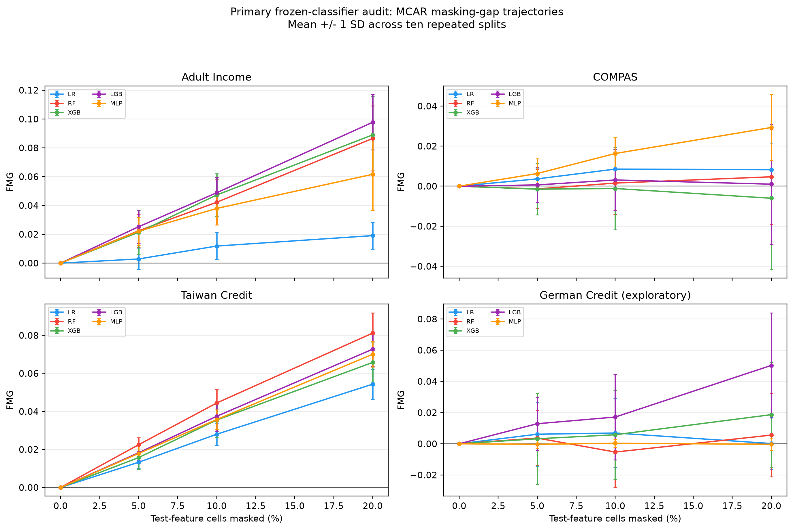
Figure 3. Mean FMG trajectories across test-time MCAR masking rates (0%, 5%, 10%, and 20%) for five classifiers (LR, RF, XGB, LGB, and MLP) on Adult Income, COMPAS, Taiwan Credit, and exploratory German Credit. Error bars denote 1 SD across ten repeated stratified splits.

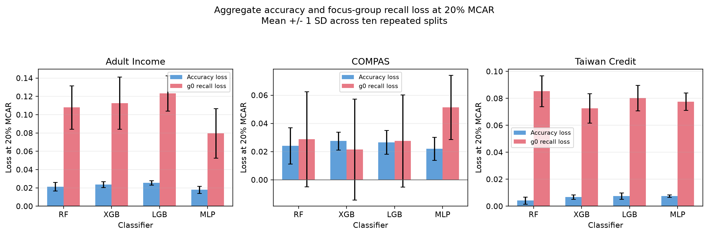
Figure 4. Direct comparison of mean aggregate-accuracy loss (blue bars) and focus-group (g0) positive-class recall loss (red bars) at 20% MCAR across four primary classifiers on Adult Income, COMPAS, and Taiwan Credit (1 SD across ten splits).

Relationship to Equal Opportunity Difference
Equal Opportunity Difference (EOG) and FMG measure different quantities. Whereas EOG evaluates between-group recall differences within a single test condition, FMG tracks within-group recall loss relative to aggregate accuracy loss across clean and stressed conditions; observed EOG shifts vary by dataset and do not explain FMG magnitude.

Group-Conditional MAR Sensitivity
Group-conditional missingness amplifies FMG relative to uniform MCAR masking. When test-cell masking probabilities depend on focus-group membership at calibrated nominal rates of 10% and 20% (Fig. 5), mean FMG exceeded its paired MCAR baseline in 12 of 12 dataset-model pairs at 10% masking and in 11 of 12 pairs at 20% masking, with the largest increases occurring on Adult Income (+0.025 to +0.044 at 20% masking).

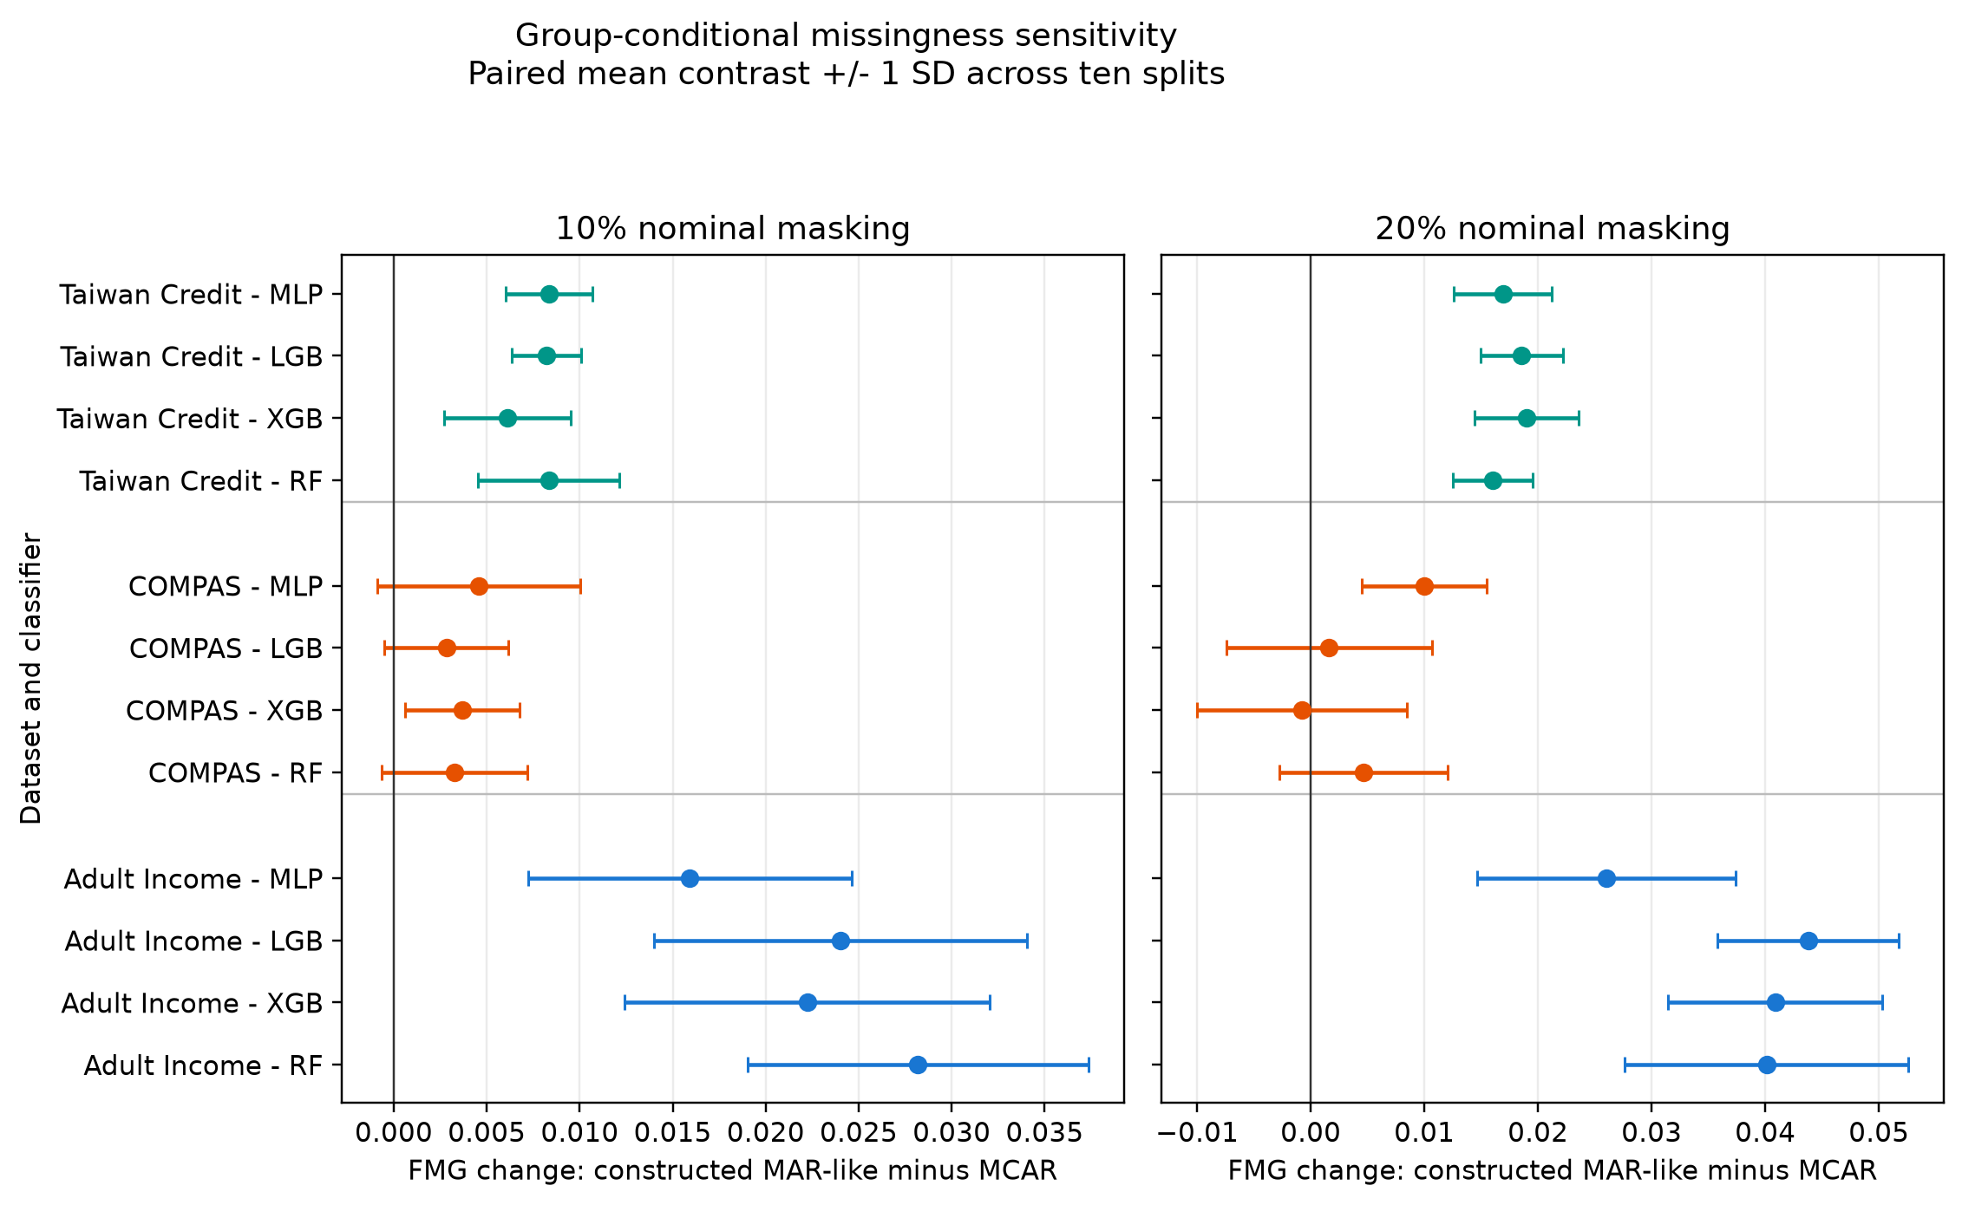
Figure 5. Paired FMG change (constructed group-conditional MAR minus matched MCAR) across three primary datasets and four classifiers at 10% (left) and 20% (right) nominal masking rates. Points and horizontal bars denote the mean difference and 1 SD across ten splits.

Age-Conditioned Logistic MAR Sensitivity
Covariate-dependent MAR produces dataset- and model-specific shifts relative to MCAR. Across 72 evaluated combinations (3 datasets × 4 models × 2 missingness rates × 3 age odds ratios of 1.5, 2.0, and 4.0), mean paired FMG differences between age-conditioned MAR and matched-feature MCAR ranged from -0.0092 to +0.0318 (with 3/10 to 10/10 positive splits), peaking for COMPAS XGBoost at 20% missingness and an odds ratio of 4.0 (+0.0318; 10/10 splits positive).

Class-Rate Adjustment Sensitivity
Matching subgroup positive-class base rates preserves positive FMG on Adult Income. In a matched-subsample sensitivity on Adult Income with Random Forest at 20% MCAR (Fig. 6), equalizing subgroup base rates increased mean FMG slightly from 0.0865 (original cohort) to 0.0933 (matched cohort), with 10 of 10 splits remaining positive in both settings.

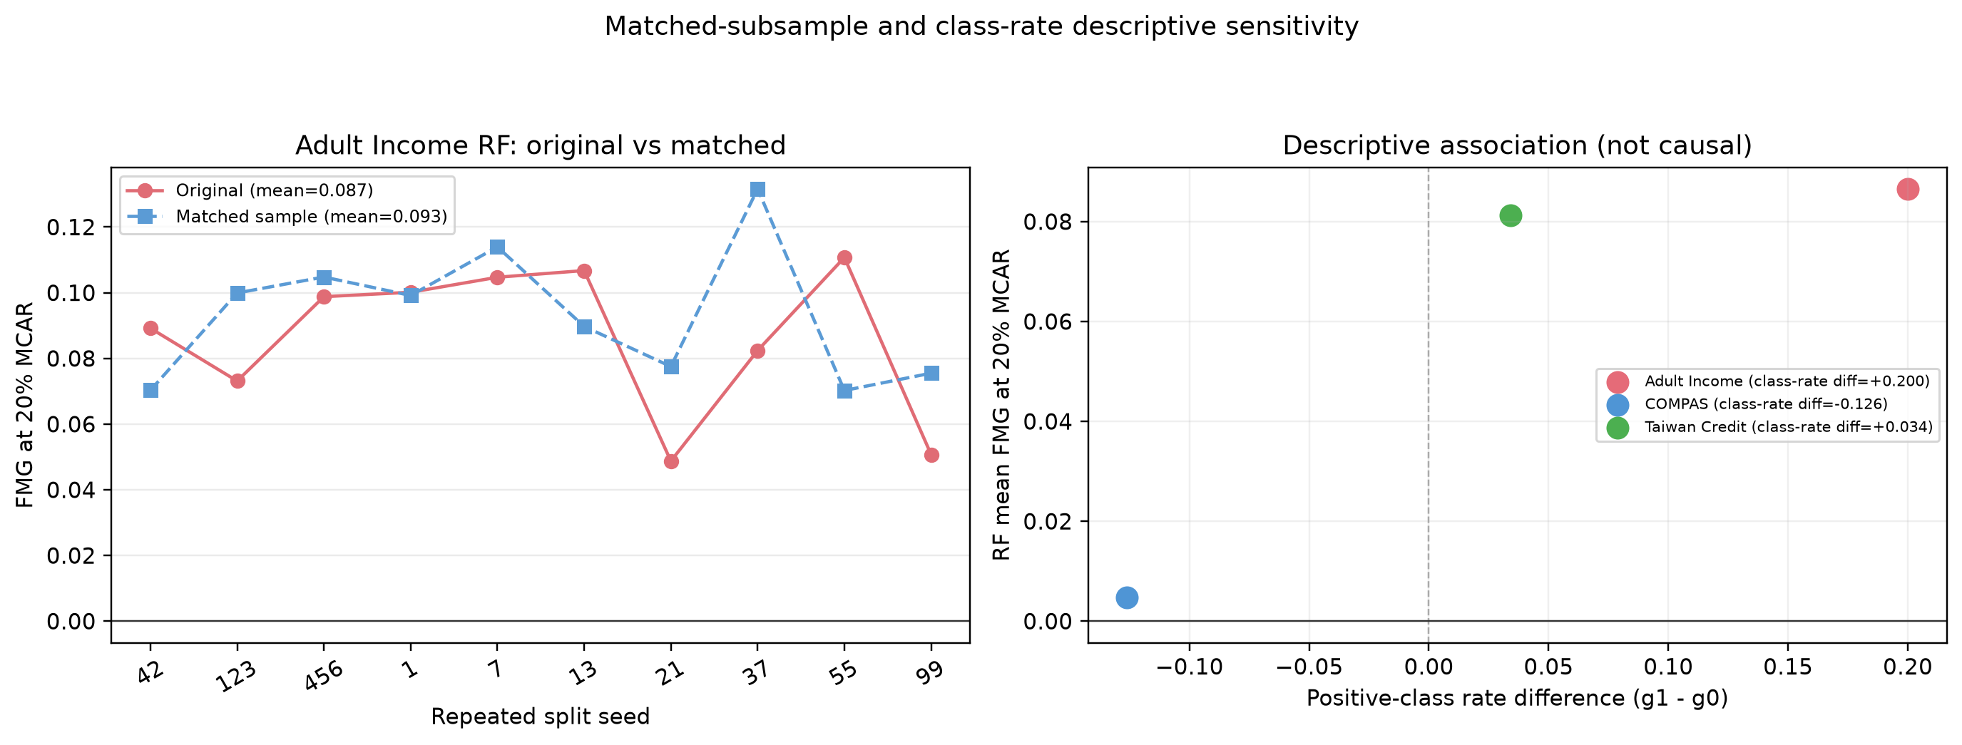
Figure 6. Adult Income Random Forest sensitivity at 20% MCAR comparing original versus base-rate-matched subsamples across ten splits (left) and the descriptive association between inter-group positive-class base-rate differential (g1 - g0) and mean RF FMG across the three primary datasets (right).

Extended-Seed COMPAS Stability Analysis
Expanding COMPAS evaluation to 30 repeated splits confirms architecture-dependent behavior. Across 30 stratified splits at 20% MCAR (Fig. 7), COMPAS Random Forest maintained a near-zero mean FMG of 0.0036 (14/30 positive splits), whereas the Multilayer Perceptron maintained a consistently positive mean FMG of 0.0281 (27/30 positive splits).

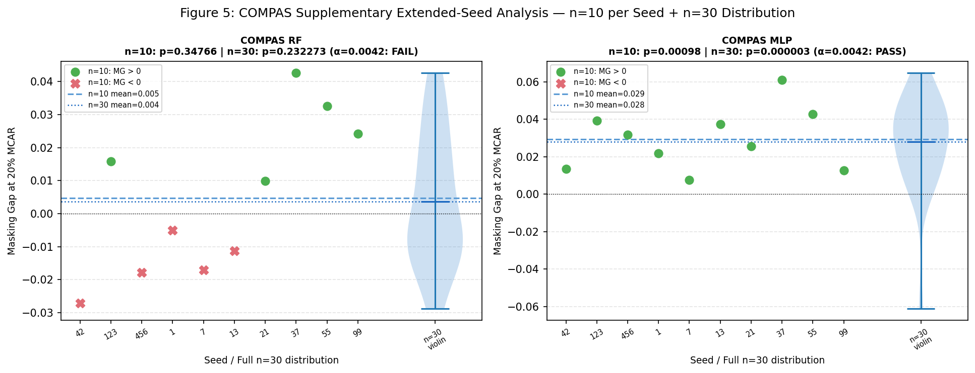
Figure 7. Extended 30-split distribution and first-10-split trajectory of FMG at 20% MCAR on COMPAS for Random Forest (left, 30-split mean = 0.0036) and Multilayer Perceptron (right, 30-split mean = 0.0281).

Exploratory SHAP Attribution Sensitivity
Test-time masking shifts feature attributions toward demographic and utilization correlates. On COMPAS Random Forest (seed 42, 20% MCAR; Fig. 8), the largest between-group shifts in mean absolute SHAP values occurred on priors_count, age, and c_days_from_compas. In the multi-seed public-health sensitivity across RF, XGBoost, and LightGBM, the largest attribution shifts consistently centered on the 5-year age-group category (AGEG5YR) in BRFSS and prior inpatient visits (number_inpatient) in UCI Diabetes.

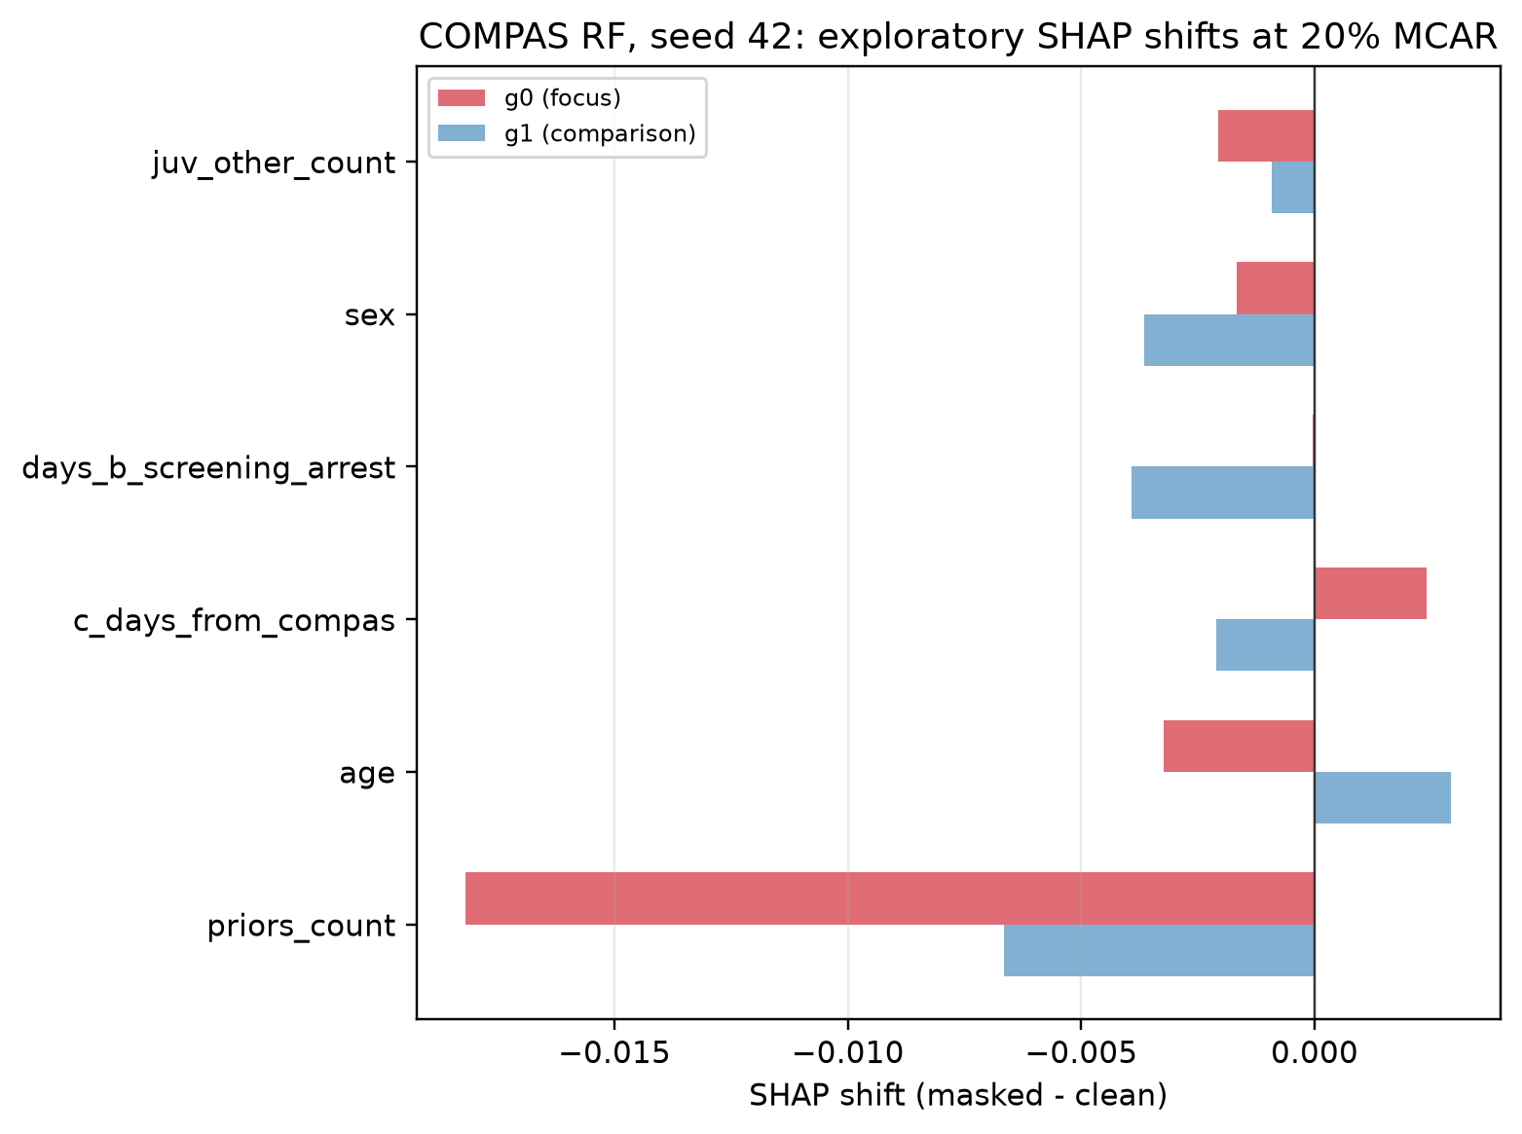
Figure 8. Exploratory change in mean absolute SHAP attribution (masked minus clean at 20% MCAR) on COMPAS Random Forest (seed 42) for the six predictors exhibiting the largest asymmetry between the focus group (g0, red) and comparison group (g1, blue).

Type-Aware Preprocessing and Imputation Ablation
Type-aware preprocessing across all primary model cells. We extended the raw-feature type-aware sensitivity to all three primary datasets, all four primary classifier families, ten fixed seeds, and one 20% MCAR condition, using median/mode, five-neighbour KNN/mode, and iterative numeric/mode pipelines. The completed run contains 360 unique evaluations with no missing outputs. Across the 36 dataset-model-pipeline means, 24 exceeded the descriptive 0.01 reference: 10/12 Adult Income, 2/12 COMPAS, and 12/12 Taiwan Credit. At the dataset-model level, at least one type-aware pipeline exceeded 0.01 in 10/12 cells, while all three pipelines exceeded it in 7/12 cells. Adult Income means ranged from -0.0121 to 0.0984, COMPAS from -0.0574 to 0.0272, and Taiwan Credit from 0.0332 to 0.0802. The detailed Random Forest comparison is shown in Table 4; the complete all-model per-seed output and manifest are supplied as supplementary reproducibility files. These descriptive results show that preprocessing sensitivity is not confined to Random Forest, while also confirming that the direction and magnitude remain dataset- and model-dependent.
Table 4. Multi-seed, type-aware imputation sensitivity at 20% raw-feature MCAR for Random Forest across ten repeated splits (Adult Income rerun under scikit-learn 1.9.1; COMPAS and Taiwan Credit under scikit-learn 1.6.1).
Dataset | Imputation Strategy | FMG Mean SD | Positive Splits | Acc. Loss / g0 Recall Loss
Adult Income | Iterative / mode | 0.0270 0.0293 | 7/10 | 0.0194 / 0.0464
Adult Income | KNN (5-NN) / mode | 0.0327 0.0248 | 9/10 | 0.0226 / 0.0553
Adult Income | Median / mode | 0.0318 0.0271 | 9/10 | 0.0205 / 0.0523
COMPAS | Iterative / mode | -0.0131 0.0270 | 3/10 | 0.0187 / 0.0056
COMPAS | KNN (5-NN) / mode | -0.0043 0.0177 | 4/10 | 0.0245 / 0.0202
COMPAS | Median / mode | 0.0049 0.0262 | 5/10 | 0.0249 / 0.0297
Taiwan Credit | Iterative / mode | 0.0856 0.0148 | 10/10 | 0.0049 / 0.0906
Taiwan Credit | KNN (5-NN) / mode | 0.0689 0.0146 | 10/10 | 0.0055 / 0.0744
Taiwan Credit | Median / mode | 0.0831 0.0143 | 10/10 | 0.0044 / 0.0875

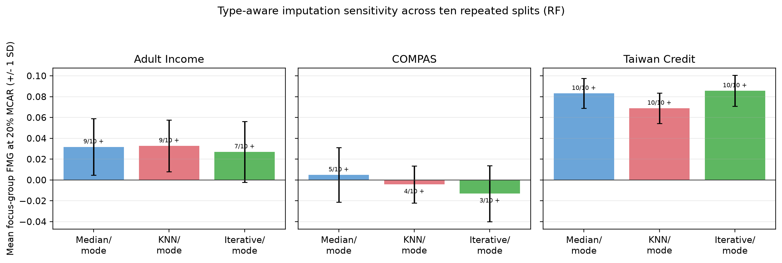
Figure 9. Type-aware Random Forest FMG sensitivity at 20% raw-feature MCAR across Adult Income, COMPAS, and Taiwan Credit comparing median/mode (blue), KNN/mode (red), and iterative/mode (green) imputation pipelines (1 SD and positive-split counts across ten splits).

Complementary-Group and Baseline-Recall Sensitivity
Comparison-group (g1) FMG is also positive on Adult Income and Taiwan Credit. When FMG is computed for the comparison group g1 at 20% MCAR, mean g1 FMG ranges from 0.0928 to 0.1189 on Adult Income (10/10 splits positive across all four models) and is positive in 10 of 10 splits for all four models on Taiwan Credit, whereas it is negative across all four models on COMPAS. Across the 12 primary pairs, the within-pair Spearman correlation between clean baseline focus-group recall and 20% MCAR FMG ranges widely from -0.394 to +0.806, indicating that baseline recall level alone does not determine FMG magnitude.

Descriptive Diagnostic Discordance
Headline accuracy thresholds frequently fail to flag substantial subgroup recall losses. Across the 120 primary dataset-model-seed evaluations at 20% MCAR, focus-group recall loss exceeded δ=1.0, 2.5, 5.0, and 10.0 percentage points in 107, 100, 91, and 26 runs, respectively, whereas aggregate-accuracy loss crossed those same thresholds in only 77, 31, 0, and 0 runs. Consequently, an accuracy-only monitor using the same numeric cutoff δ missed 41/107 (38.3%) recall drops at δ=1%, 78/100 (78.0%) at δ=2.5%, 91/91 (100%) at δ=5.0%, and 26/26 (100%) at δ=10.0%. For example, at δ=5%, accuracy-only monitoring would issue no alerts, while the subgroup-recall rule would issue alerts in 91 of 91 runs. FMG therefore changes the monitoring decision by making this divergence explicit, while remaining a compact summary rather than a replacement for either component.
Retrospective alert coverage. Let N_R(delta) denote the number of benchmark runs with I_R(delta)=1 and let C_A(delta) = [N_R(delta)-sum U(delta)]/N_R(delta) denote the fraction of those subgroup-recall alerts also captured by the accuracy-only rule. The accuracy-only rule captured 66/107 = 61.7% of subgroup-recall alerts at delta=1%, 22/100 = 22.0% at delta=2.5%, and 0/91 and 0/26 = 0% at delta=5% and 10%, respectively. This calculation makes the monitoring contrast explicit and reproducible, but it is retrospective detection coverage over benchmark runs: it is not a human-factors study, a calibrated production utility estimate, or evidence that FMG improves outcomes. The coverage calculation can be reconstructed directly from the two component losses; FMG supplies a compact scalar label for the same discrepancy.

Public-Health Benchmark Extension
Public-health benchmarks reveal contrasting positive-FMG and recall-floor regimes. In the 2024 CDC BRFSS diabetes evaluation (80/20 split, 20% MCAR, 15 seed-by-mask replicates per model), mean FMG ranged from 0.0272 to 0.0455 across the five classifiers (and 0.0309 to 0.0461 in the Black-women versus White-women intersectional audit), while comparison-group (g1) recall loss exceeded focus-group (g0) recall loss for every model. In contrast, on UCI Diabetes 30-day readmission, mean FMG ranged from 0.0000 to 0.0038 because clean baseline focus-group recall was near zero (0.000--0.020 across models, with RF at 0.000), illustrating how a recall floor bounds subsequent recall loss near zero. Taken together with Adult, COMPAS, and Taiwan, the results indicate that FMG is most positive when masking disproportionately changes subgroup positive-class detection relative to aggregate accuracy, often under imbalanced or sensitivity-dominated pipelines; it is near zero when subgroup and aggregate degradation are similar or when baseline subgroup recall is already at a floor. This is a conditional diagnostic pattern, not a universal effect.
The UCI Diabetes 130-US Hospitals cohort also supplies an independent observed-missingness check, rather than only a synthetic mask overlay. In the raw 101,766-row file, 47 predictor fields have a cell-missingness rate of 7.82%; every record has at least one missing predictor, with the highest rates for weight (96.86%), max_glu_serum (94.75%), A1Cresult (83.28%), medical_specialty (49.08%), and payer_code (39.56%). The public-health audit therefore tests the frozen-classifier diagnostic after training-fitted imputation on a naturally incomplete healthcare table. These rates describe the observed data only and do not identify an MCAR, MAR, or MNAR mechanism. Because clean focus-group recall is near a floor in this extension, low subsequent FMG must not be interpreted as evidence of robustness or absence of risk.

UCI Sensitivity to Alternative Operating Points
Alternative operating points removed the near-zero clean-recall condition, but did not make FMG a between-group disparity. At 20% MCAR across the two split ratios, the ten-seed UCI sensitivity contained 18 distinct model--split--variant settings after counting the duplicated MLP implementation once. Mean clean focus-group recall ranged from 0.157 to 0.583 and mean FMG from 0.0438 to 0.1210; mean FMG was positive in all 18 settings, with positive FMG in 9 or 10 of 10 splits in each setting. However, focus-group recall loss exceeded comparison-group recall loss in only 12 of 18 settings. These summaries describe repeated splits of the same benchmark, not independent-population evidence. Because class weighting refits the classifier and the prevalence cutpoint changes the prediction rule, this sensitivity does not isolate a causal effect of threshold adjustment or establish an operationally optimal cutpoint.

Aggregate-Metric Decomposition Outcomes
Positive FMG on imbalanced primary tasks coincides with a sensitivity-specificity contrast in the aggregate decomposition. Pooling across the four primary models and ten splits at 20% MCAR (Eq. 5), Adult Income exhibited overall sensitivity loss ΔTPR_all = 0.1288, specificity change ΔTNR_all = -0.0132, accuracy loss ΔA = 0.0222, and FMG_all = 0.1067; Taiwan Credit showed ΔTPR_all = 0.0825, ΔTNR_all = -0.0151, ΔA = 0.0065, and FMG_all = 0.0760. These changes are consistent with a shift toward negative-class predictions for Adult and Taiwan, but the decomposition covers only the three primary datasets and does not isolate imputation as the cause. In COMPAS, sensitivity (ΔTPR_all = 0.0222) and specificity (ΔTNR_all = 0.0280) both declined by similar amounts (FMG_all = -0.0029). These pooled values describe the tested model-split combinations and are not inferential estimates. Additional decomposition results are provided in Supplementary Table S10.
Theory Extension: Causal Masking Sensitivity
We supplement FMG with a theory-facing intervention formulation. Let G denote group membership, Y the binary label, X the clean feature vector, and h a frozen score with decision threshold t. Define the hard prediction function as phi_h(x)=1[h(x) >= t]. Let T_M(X) denote the feature vector after applying a prespecified test-time mask M and the training-fitted imputation pipeline. For a fixed masking policy q(m|x,g), define the subgroup masking intervention effect tau_g(q) as the clean positive-class recall minus the expected masked positive-class recall within G=g, equivalently the difference between the expectations of phi_h(X) and phi_h(T_M(X)) conditional on G=g,Y=1.
Proposition 1 (subgroup masking bound). Define total variation by TV(P,Q)=sup_B |P(B)-Q(B)| = 1/2 ||P-Q||_1. Let P_g^(0) be the distribution of X conditional on G=g and Y=1, and let P_g^(1) be the distribution of T_M(X) under q with the same conditioning. If phi_h is the hard prediction function defined above, then |tau_g(q)| <= TV(P_g^(0), P_g^(1)). Proof. tau_g(q) is the difference of the expectations of the bounded function phi_h under these two distributions. Since 0 <= phi_h <= 1, the dual characterization of total variation bounds the difference of expectations by total variation. The result is a bound on the hard-recall intervention contrast; it is not a claim about probability calibration, ranking, or causal identification under natural missingness.
Proposition 2 (aggregate-accuracy visibility). For an exhaustive, mutually exclusive partition of the evaluated population, let pi_g1 = Pr(G=g,Y=1) and pi_g0 = Pr(G=g,Y=0) denote joint population masses. Then aggregate accuracy loss equals the sum over groups of pi_g1 times subgroup recall loss plus pi_g0 times subgroup true-negative-rate loss. Therefore, if masking changes only the positive-class recall of group g, aggregate accuracy loss is pi_g1 times tau_g(q), while FMG_g(q) is (1-pi_g1) times tau_g(q). This gives an exact explanation for why a large subgroup recall loss can coexist with a small aggregate-accuracy loss for a rare subgroup.
Identification scope. The intervention effect is identified for the experimentally imposed MCAR and randomized MAR policies under consistency, a fixed masking policy, positivity of evaluated mask patterns, and a frozen classifier and preprocessing pipeline. The experiment does not identify the effect of naturally occurring MNAR missingness without additional assumptions; such results are reported as sensitivity analyses rather than causal estimates.
Uncertainty and validation. The primary uncertainty intervals are percentile bootstrap intervals obtained by resampling the ten repeated-split FMG values within each dataset-model cell. They summarize benchmark variability across the fixed repeated splits and are not patient-level confidence intervals or population-level uncertainty guarantees. The formal propositions are evaluated algebraically under the stated common-input-space and frozen-classifier assumptions, while the empirical threshold-discordance analysis is computed from the saved primary per-seed outputs. No patient-level nested bootstrap, natural-MNAR identification, or deployment-level interval validity is claimed.
Operational Threshold Discordance
To assess the practical monitoring distinction using the reproducible primary outputs, we compare focus-group recall-loss flags with aggregate-accuracy-loss flags at the same illustrative thresholds. Across the 120 primary dataset-model-seed evaluations at 20% MCAR, focus-group recall loss exceeded delta=1.0, 2.5, 5.0, and 10.0 percentage points in 107, 100, 91, and 26 runs, respectively, while aggregate-accuracy loss crossed those thresholds in 77, 31, 0, and 0 runs. At delta=5%, an accuracy-only rule generated no alerts while the subgroup-recall rule generated 91 alerts. This is benchmark-level threshold discordance, not evidence that FMG adds information beyond its components or improves production monitoring.
The threshold analysis therefore supports a narrow contribution: FMG provides a compact, prespecified way to report the divergence between two already observable losses. Direct subgroup recall remains the primary alert quantity, and between-group recall loss remains necessary for fairness-disparity claims. The analysis does not establish an optimal threshold, human decision benefit, or deployment utility.
This result calibrates the contribution. FMG should be presented as a paired monitoring diagnostic for identifying cases in which subgroup recall change is not reflected by headline accuracy; it should not be presented as a superior fairness metric, a causal estimator, or a replacement for direct subgroup recall and between-group disparity.

Discussion
Aggregate accuracy can obscure substantial recall changes when positive-class prevalence is low. In the pooled primary results, Adult Income showed an overall recall loss of 12.9 percentage points with a 2.2-point accuracy loss; Taiwan Credit showed an 8.3-point overall recall loss with a 0.7-point accuracy loss. For the three primary datasets included in the decomposition, the Adult and Taiwan patterns are consistent with a shift toward negative-class predictions, but the analysis does not establish imputation as the cause.
FMG must be interpreted alongside both component losses and comparison-group recall. Because FMG contrasts focus-group recall loss against aggregate accuracy loss rather than against comparison-group recall loss, a positive FMG does not imply that the focus group suffered greater harm than the comparison group. In fact, comparison-group (g1) recall loss exceeded focus-group (g0) recall loss in all four models on Adult Income, all four models on Taiwan Credit, and all five models on BRFSS. Reporting ΔR(g0), ΔR(g1), ΔA, and per-split positive denominators together prevents analysts from mistaking an overall sensitivity collapse for a group-specific disparity---or, conversely, from overlooking a subgroup recall collapse that is masked by high overall accuracy.
Preprocessing choices and baseline recall shape how FMG should be read. The completed type-aware analysis now covers all 12 primary dataset-model cells, three raw-feature imputation pipelines, and ten seeds at 20% MCAR. Across the 36 pipeline means, 24 exceeded the descriptive 0.01 reference; this occurred in 10/12 Adult Income, 2/12 COMPAS, and 12/12 Taiwan Credit pipeline conditions. The range across pipelines was -0.0121--0.0984 for Adult Income, -0.0574--0.0272 for COMPAS, and 0.0332--0.0802 for Taiwan Credit. Thus, the original 9/12 primary result is conditional on the primary encoded-space pipeline, while the expanded sensitivity shows that the qualitative pattern is stable for Taiwan, mixed for Adult Income, and generally near zero or negative for COMPAS under some type-aware pipelines. The UCI default-operating-point result had a recall floor: clean focus-group recall was 0.000--0.020 and mean FMG was 0.0000--0.0038. Neither sensitivity establishes a universally better imputation strategy, threshold, deployment benefit, or between-group fairness effect.

Matched feature-decrement augmentation baseline and cost audit
Matched feature-decrement augmentation baseline. To test whether the diagnostic is altered by a missingness-aware training regime, we implemented a matched feature-decrement augmentation (FDA) baseline that instantiates the augmented-training principle described by Cheng et al. [41]. This is not an exact reproduction of their LLM-based ATLLM system; it isolates the training-time augmentation principle under the present frozen-classifier protocol. For each of the three primary datasets, four primary models, and ten fixed seeds, FDA concatenated the clean training rows with one independently generated 20% MCAR-masked, training-median-imputed copy. Both the clean-trained and FDA models were then evaluated on the same clean and masked test sets; no test-time adaptation or label information was used. Across the 120 paired runs, FDA reduced mean FMG on Adult Income from 0.120 to 0.083, on COMPAS from 0.013 to 0.011, and on Taiwan Credit from 0.084 to 0.058. This comparator result shows that the magnitude of the audit signal depends on the training regime, while the proposed audit remains applicable to either regime. It does not establish that FDA or ATLLM is universally superior. The comparison is matched to the primary audit on datasets, 70:30 splits, ten seeds, 20% MCAR masks, classifier families, and frozen clean-versus-masked evaluation; it is therefore a direct family-level feature-decrement baseline under this protocol, but not an exact reproduction of Cheng et al.'s ATLLM or LLM-IMPUTE implementation.
For the 120 paired FDA comparator runs, we additionally applied an exact two-sided sign-flip test to the 10 seed-level differences in FMG within each dataset--model cell, with Holm adjustment across the 12 cells. The analysis is deliberately descriptive: the repeated splits reuse finite observations and are not treated as independent population samples. Mean FMG reduction (clean-trained minus FDA) was 0.0367 on Adult Income, 0.0022 on COMPAS, and 0.0257 on Taiwan Credit. Seven of the 12 cells had Holm-adjusted descriptive sign-flip p<0.05 (three Adult cells and all four Taiwan cells); no COMPAS cell did. The complete cell-level estimates, bootstrap intervals, exact p-values, and analysis script are supplied as supplementary reproducibility artifacts. These tests support stability of the paired benchmark differences, not a universal claim about missingness-aware training.
Table 5. Descriptive exact paired sign-flip analysis of the feature-decrement augmentation comparator; p-values are adjusted across the 12 dataset--model cells.
Dataset | Mean FMG reduction | Holm-adjusted descriptive p<0.05 cells
Adult Income | 0.0367 | 3/4
COMPAS | 0.0022 | 0/4
Taiwan Credit | 0.0257 | 4/4
The same run recorded fit and prediction time using the local execution environment. Mask augmentation approximately doubled the training rows and increased mean fit time by about 1.9 times across model-dataset cells (the largest overhead was model-dependent); prediction-time cost was essentially unchanged because both models used the same imputation and inference protocol. These timings are hardware-specific and are reported for transparency rather than as a systems benchmark. The ReMasker validation was run for 50 epochs on CPU, with ten fixed seeds across three datasets and four classifier families; this resource-bounded configuration is reported explicitly so that the comparison is reproducible and not presented as exhaustive training-budget parity.
Direct recent imputation comparator. To test whether the audit result depends on the recovery front-end, the same frozen Random Forest protocol was evaluated with the official ReMasker masked-autoencoding imputer [47]. ReMasker was fitted only on clean training features and then applied to the identically masked test set; test labels were never used. In the 50-epoch CPU validation, the mean FMG was 0.1052 for ReMasker versus 0.1248 for the training-fitted median baseline on Adult Income, 0.0037 versus 0.0173 on COMPAS, and 0.0592 versus 0.0873 on Taiwan Credit. Exact paired sign-flip tests of median FMG minus ReMasker FMG gave descriptive p-values of 0.002, 0.305, and 0.014, respectively. ReMasker therefore did not uniformly reduce FMG at the individual-model level: its effect was dataset-dependent and should be interpreted as a recovery-pipeline sensitivity, not a universal mitigation.
Table 6. Ten-seed RF comparison of median imputation and official ReMasker imputation at 20% MCAR using a 50-epoch CPU validation; paired p-values are descriptive exact sign-flip tests.
Dataset | Median FMG | ReMasker FMG | Median−ReMasker | Paired p
Adult Income | 0.1248 | 0.1052 | 0.0197 | 0.002
COMPAS | 0.0173 | 0.0037 | 0.0137 | 0.305
Taiwan Credit | 0.0873 | 0.0592 | 0.0281 | 0.014
Dataset | Clean-trained FMG | Mask-augmented FMG | Aug./clean fit time
Adult Income | 0.120 | 0.083 | 2.1x
COMPAS | 0.013 | 0.011 | 1.4x
Taiwan Credit | 0.084 | 0.058 | 1.9x
Native missing-value baseline. We additionally evaluated XGBoost and LightGBM with the same clean training splits and identical 20% test-only MCAR masks, but passed masked NaN values directly to the classifiers without test-time imputation. This uses the models' native missing-value routing and provides a direct recovery-front-end sensitivity check. The completed run contains 60 unique evaluations across three datasets, two models, and ten seeds. Mean FMG was 0.1853 for LightGBM and -0.2233 for XGBoost on Adult Income, 0.0186 and -0.0664 on COMPAS, and 0.0987 and -0.0460 on Taiwan Credit, respectively. Native routing therefore changed both the magnitude and, for XGBoost, the direction of the audit signal relative to imputation-based pipelines. These results do not establish that native routing is superior; they demonstrate that FMG must be reported together with the missing-value handling policy and classifier family. The per-seed output and manifest are supplied as supplementary reproducibility files.
All-model extension. We reused each fitted ReMasker imputer for XGB, LightGBM, and MLP in addition to RF, without changing the clean training data or masked test inputs. In the 50-epoch CPU validation, the mean paired difference (median FMG minus ReMasker FMG) was -0.0601 on Adult Income, 0.0259 on COMPAS, and 0.0362 on Taiwan Credit. Direct paired tests identified differences in 3/4 Adult cells, 1/4 COMPAS cells, and 4/4 Taiwan cells after Holm adjustment. Adult results were mixed by classifier: ReMasker reduced FMG for RF and MLP but increased it for LGB and XGB. The direction is therefore not universal: recovery choice and classifier family jointly affect the audit signal. These results support reporting FMG with the recovery pipeline, not treating ReMasker or native missing-value routing as a universal mitigation.
Table 7. Aggregate all-model extension of the ten-seed ReMasker comparison using the 50-epoch CPU validation; paired tests are descriptive and adjusted across the twelve cells.
Dataset | Mean median−ReMasker FMG | Holm-adjusted descriptive p<0.05 cells
Adult Income | −0.0601 | 3/4
COMPAS | 0.0259 | 1/4
Taiwan Credit | 0.0362 | 4/4

Limitations and Threats to Validity
This study is subject to five principal methodological boundaries: (i) Controlled missingness scope: The primary benchmark uses uniform cell-level MCAR masking, and while our extensions test one group-conditional MAR mechanism, one age-conditioned logistic MAR mechanism (odds ratios 1.5, 2.0, and 4.0), and one synthetic value-conditional MNAR mechanism, these do not exhaust complex real-world missingness processes. (ii) Finite-sample resampling: Repeated stratified splits (10 splits in the primary benchmark, 30 post-hoc splits on COMPAS, 10 repeated UCI operating-point splits, and 3 seeds × 5 mask replicates in the public-health extension) reuse observations from finite datasets; reported bootstrap intervals and standard deviations therefore quantify split-to-split benchmark stability rather than independent population-level inference. The UCI sensitivity also covers only the tested class-weight and training-prevalence cutpoint rules. (iii) Pipeline and weight conditioning: The primary results reflect integer categorical encoding with median imputation, while the expanded type-aware analysis covers three raw-feature imputation pipelines and the native XGBoost/LightGBM routing sensitivity, each at one fixed masking rate. The BRFSS extension fits unweighted estimators before evaluating survey-weighted test metrics. (iv) Comparator scope: The study includes imputation, preprocessing, mask-augmented training, ReMasker, and native missing-value routing sensitivities but does not claim a head-to-head comparison with every missingness-aware training or test-time adaptation method. (v) Diagnostic versus operational scope: FMG is a descriptive paired contrast with no mathematical information beyond ΔR(g0) and ΔA reported separately; its practical value is a standardized, thresholded audit rule. Validating whether that rule improves human monitoring decisions or clinical/financial outcomes requires a prospective operational study.
External-method boundary. Lacuna identified ReMasker [47], DiffPuter [48], and the IJCAI-2025 feature-decrement adaptation work of Cheng et al. [41] as recent missingness-aware recovery or adaptation research. ReMasker and DiffPuter are imputation front-ends that alter the inputs supplied to a classifier, whereas FMG audits a fixed classifier under a specified masking policy; they are not interchangeable estimands. Cheng et al. study fully test-time feature decrement and propose LLM-based imputation and augmented training. We therefore added three transparent sensitivity families under the present protocol: the matched feature-decrement augmentation baseline, the 50-epoch ReMasker recovery comparator, and a native NaN-routing baseline for XGBoost and LightGBM. These are principled family-level comparisons, not exact reproductions of ATLLM or LLM-IMPUTE. The direction-changing native-routing result further shows why recovery policy must be reported with FMG. Full LLM-based adaptation methods remain outside the current compute budget and require separate matched-cost experiments. The paper does not claim to benchmark every missingness-aware training or test-time adaptation method.

Future Work
Future research should extend this audit framework along four concrete directions. First, the completed all-model type-aware sensitivity should be extended to additional masking rates, multiple-imputation uncertainty, broader neural and tabular foundation-model families, and empirically learned missingness graphs. Representative missingness-aware training or test-time adaptation methods should be benchmarked with matched training budgets, wall-clock and memory reporting, and the same frozen-classifier audit protocol where appropriate. Second, multiclass extensions should evaluate class-specific one-versus-rest recall contrasts alongside calibration and precision-recall trade-offs. Third, exact feature-attribution methods should be scaled to larger cohorts to isolate how imputation distorts decision boundaries. Finally, prospective human-in-the-loop monitoring studies are needed to test whether pairing subgroup recall-loss alerts with headline accuracy metrics improves deployment governance in clinical and financial workflows.

Conclusion
Under controlled test-time masking, subgroup recall can fall more than aggregate accuracy suggests. Across 12 primary dataset--model pairs at 20% MCAR, mean FMG was 0.0545 and 9 pairs exceeded the descriptive 0.01 reference under the primary preprocessing pipeline. The completed type-aware sensitivity extended this check to all 12 cells and three raw-feature imputation pipelines: 24 of 36 pipeline means exceeded 0.01, with the strongest consistency on Taiwan Credit, mixed behavior on Adult Income, and near-zero or negative behavior for some COMPAS pipelines. The native missing-value baseline further showed that routing policy can change FMG magnitude and direction, especially between XGBoost and LightGBM. Focus-group recall loss exceeded comparison-group loss in only 4 of 12 primary pairs, so FMG is not a between-group disparity. The public-health extension showed two different regimes: all five BRFSS models had larger comparison-group recall loss, while UCI Diabetes FMG remained 0.0000--0.0038 against clean focus-group recall of 0.000--0.020. FMG is therefore a descriptive paired comparison and a standardized monitoring convention. It contains no information beyond its two component losses, is not a between-group fairness disparity, and is not a fairness certificate or deployment-safety guarantee. Whether it improves monitoring or decisions requires prospective evaluation.

Declarations
Funding:
No external funding was received for this study.
Competing Interests:
The authors declare no competing financial or non-financial interests.
Ethics Approval:
This study analyzes publicly available benchmark and surveillance datasets. ProPublica COMPAS is included strictly as a standard algorithmic fairness benchmark; this work does not endorse criminal-justice risk scoring.
Declaration of Generative AI and AI-Assisted Technologies:
During manuscript preparation and revision, generative AI-assisted tools were used for language refinement, structural editing, code and numerical-consistency review, and manuscript-edit suggestions. The authors reviewed, verified, and take full responsibility for all code, empirical results, citations, and final text.
Author Contributions:
M. Vamsi Krishna: Conceptualization, methodology, software, data curation, formal analysis, experiments, and original draft preparation. S. Sri Harsha: Validation, investigation, manuscript review and editing, and visualization.
Data and Code Availability:
All benchmark datasets are publicly available from their original repositories (UCI Machine Learning Repository, ProPublica, OpenML, and CDC BRFSS). The rectified submission package is publicly available at https://github.com/MVamsiKrishna2501050195/FMG-research/tree/fmg-submission-v4-final-2026-11-08 and contains the completed all-model type-aware analysis, native XGBoost/LightGBM missing-value baseline, feature-decrement augmentation outputs, ReMasker outputs, updated notebooks, per-seed CSV files, manifests, and this manuscript. This immutable tagged URL identifies the reproducibility release used for submission. The raw UCI data are not redistributed and should be obtained from the cited UCI repository.

References
[1] Min, S., Asif, H., and Vaidya, J. (2025). Exploring the inequitable impact of data missingness on fairness in machine learning. IEEE Intelligent Systems, 40(3), 28--38. https://doi.org/10.1109/MIS.2025.3549484
[2] Jang, S., Eun, J., Yi, H., and Choi, C. (2026). When does train-time masking help? A leakage-controlled robustness audit of tabular classifiers under feature missingness. IEEE Access, 14, 84378--84398. https://doi.org/10.1109/ACCESS.2026.3695538
[3] Kochs, T., Castellani, A., Lanfermann, F., and Hammer, B. (2026). Evaluating and mitigating fairness risks in machine learning under structured missing data. In Proceedings of the 3rd Workshop on Fairness and Bias in AI (AEQUITAS@ECAI 2025), CEUR Workshop Proceedings, Vol. 4147. https://ceur-ws.org/Vol-4147/paper12.pdf
[4] Zhang, Y., and Long, Q. (2021). Assessing fairness in the presence of missing data. Advances in Neural Information Processing Systems (NeurIPS), 34, 16007--16019. https://proceedings.neurips.cc/paper/2021/hash/85dca1d270f7f9aef00c9d372f114482-Abstract.html
[5] Cherian, J. J., and Candès, E. J. (2024). Statistical inference for fairness auditing. Journal of Machine Learning Research, 25(149), 1--49. https://jmlr.org/papers/v25/23-0739.html
[6] Bhatti, A., Sandrock, T., and Nienkemper-Swanepoel, J. (2026). The influence of missing data mechanisms and simple missing data handling techniques on fairness. International Journal of Data Science and Analytics, 22, Article 172. https://doi.org/10.1007/s41060-026-01139-0
[7] Caton, S., Malisetty, S., and Haas, C. (2022). Impact of imputation strategies on fairness in machine learning. Journal of Artificial Intelligence Research, 74, 1011--1035. https://doi.org/10.1613/jair.1.13197
[8] Emmanuel, T., Maupong, T., Mpoeleng, D., Semong, T., Mphago, B., and Tabona, O. (2021). A survey on missing data in machine learning. Journal of Big Data, 8, Article 140. https://doi.org/10.1186/s40537-021-00516-9
[9] Jeanselme, V., De-Arteaga, M., Zhang, Z., Barrett, J., and Tom, B. (2022). Imputation strategies under clinical presence: Impact on algorithmic fairness. arXiv preprint arXiv:2208.06648.
[10] Jeong, H., Wang, H., and Calmon, F. P. (2022). Fairness without imputation: A decision tree approach for fair prediction with missing values. Proceedings of the AAAI Conference on Artificial Intelligence, 36(9), 9558--9566. https://doi.org/10.1609/aaai.v36i9.21189
[11] Martinez-Plumed, F., Ferri, C., Nieves, D., and Hernández-Orallo, J. (2021). Missing the missing values: The ugly duckling of fairness in machine learning. International Journal of Intelligent Systems, 36(7), 3217--3258. https://doi.org/10.1002/int.22415
[12] Miao, X., Qiang, L., Huang, G., Wu, Y., and Yin, J. (2025). Fairness-aware classification over incomplete data. Proceedings of the 48th International ACM SIGIR Conference on Research and Development in Information Retrieval, 549--558. https://doi.org/10.1145/3726302.3729975
[13] Pessach, D., and Shmueli, E. (2022). A review on fairness in machine learning. ACM Computing Surveys, 55(3), Article 51, 1--44. https://doi.org/10.1145/3494672
[14] Barrainkua, A., Gordaliza, P., Lozano, J. A., and Quadrianto, N. (2025). Preserving the fairness guarantees of classifiers in changing environments: A survey. ACM Computing Surveys, 57(6), Article 137, 1--32. https://doi.org/10.1145/3637438
[15] Buolamwini, J., and Gebru, T. (2018). Gender Shades: Intersectional accuracy disparities in commercial gender classification. Proceedings of the Conference on Fairness, Accountability, and Transparency (FAT*), 81, 77--91.
[16] Caton, S., and Haas, C. (2024). Fairness in machine learning: A survey. ACM Computing Surveys, 56(7), Article 166, 1--38. https://doi.org/10.1145/3616865
[17] Chouldechova, A. (2017). Fair prediction with disparate impact: A study of bias in recidivism prediction instruments. Big Data, 5(2), 153--163. https://doi.org/10.1089/big.2016.0047
[18] D'Amour, A., Heller, K., Moldovan, D., Adlam, B., Alipanahi, B., Beutel, A., et al. (2022). Underspecification presents challenges for credibility in modern machine learning. Journal of Machine Learning Research, 23(226), 1--61.
[19] Hardt, M., Price, E., and Srebro, N. (2016). Equality of opportunity in supervised learning. Advances in Neural Information Processing Systems (NeurIPS), 29, 3315--3323.
[20] Mehrabi, N., Morstatter, F., Saxena, N., Lerman, K., and Galstyan, A. (2021). A survey on bias and fairness in machine learning. ACM Computing Surveys, 54(6), Article 115, 1--35. https://doi.org/10.1145/3457607
[21] Wang, H., He, L., Gao, R., and Calmon, F. P. (2023). Aleatoric and epistemic discrimination: Fundamental limits of fairness interventions. Advances in Neural Information Processing Systems (NeurIPS), 36.
[22] Wang, Y., and Singh, L. (2021). Analyzing the impact of missing values and selection bias on fairness. International Journal of Data Science and Analytics, 12, 101--119. https://doi.org/10.1007/s41060-021-00259-z
[23] Kamiran, F., and Calders, T. (2012). Data preprocessing techniques for classification without discrimination. Knowledge and Information Systems, 33(1), 1--33. https://doi.org/10.1007/s10115-011-0463-8
[24] Hendrycks, D., and Dietterich, T. (2019). Benchmarking neural network robustness to common corruptions and perturbations. International Conference on Learning Representations (ICLR).
[25] Koh, P. W., Sagawa, S., Marklund, H., Xie, S. M., Zhang, M., Balsubramani, A., et al. (2021). WILDS: A benchmark of in-the-wild distribution shifts. Proceedings of the 38th International Conference on Machine Learning (ICML), PMLR 139, 5637--5664.
[26] Moreno-Torres, J. G., Raeder, T., Alaiz-Rodríguez, R., Chawla, N. V., and Herrera, F. (2012). A unifying view on dataset shift in classification. Pattern Recognition, 45(1), 521--530. https://doi.org/10.1016/j.patcog.2011.06.019
[27] Shao, M., Li, D., Zhao, C., Wu, X., Lin, Y., and Tian, Q. (2024). Supervised algorithmic fairness in distribution shifts: A survey. Proceedings of the 33rd International Joint Conference on Artificial Intelligence (IJCAI), 8225--8233. https://doi.org/10.24963/ijcai.2024/909
[28] Singh, H., Xia, F., Gossmann, A., Chuang, A., Hong, J. C., and Feng, J. (2025). 'Who experiences large model decay and why?' A hierarchical framework for diagnosing heterogeneous performance drift. Proceedings of the 42nd International Conference on Machine Learning (ICML), PMLR 267, 55757--55787. https://proceedings.mlr.press/v267/singh25e.html
[29] Shadbahr, T., Roberts, M., Stanczuk, J., Gilbey, J., Teare, P., Dittmer, S., et al. (2023). The impact of imputation quality on machine learning classifiers for datasets with missing values. Communications Medicine, 3, Article 139. https://doi.org/10.1038/s43856-023-00356-z
[30] Dua, D., and Graff, C. (2019). Adult Income Dataset, UCI Machine Learning Repository. University of California, Irvine. https://archive.ics.uci.edu/dataset/2/adult
[31] Angwin, J., Larson, J., Mattu, S., and Kirchner, L. (2016). Machine Bias: There's software used across the country to predict future criminals. And it's biased against blacks. ProPublica. https://www.propublica.org/article/machine-bias-risk-assessments-in-criminal-sentencing
[32] Yeh, I.-C., and Lien, C.-H. (2009). The comparisons of data mining techniques for the predictive accuracy of probability of default of credit card clients. Expert Systems with Applications, 36(2), 2473--2480. https://doi.org/10.1016/j.eswa.2007.12.020
[33] Grömping, U. (2019). South German Credit Data: Correcting a Widely Used Data Set. Report 4/2019, Department II, Beuth University of Applied Sciences Berlin. https://www1.bht-berlin.de/FB_II/reports/Report-2019-004.pdf
[34] Rubin, D. B. (1976). Inference and missing data. Biometrika, 63(3), 581--592. https://doi.org/10.1093/biomet/63.3.581
[35] Lundberg, S. M., and Lee, S.-I. (2017). A unified approach to interpreting model predictions. Advances in Neural Information Processing Systems (NeurIPS), 30, 4765--4774.
[36] Ghorbani, A., Abid, A., and Zou, J. (2019). Interpretation of neural networks is fragile. Proceedings of the AAAI Conference on Artificial Intelligence, 33(01), 3681--3688. https://doi.org/10.1609/aaai.v33i01.33013681
[37] Centers for Disease Control and Prevention (CDC). (2025). 2024 BRFSS Survey Data and Documentation. Behavioral Risk Factor Surveillance System. https://www.cdc.gov/brfss/annual_data/annual_2024.html
[38] Clore, J., Cios, K., DeShazo, J., and Strack, B. (2014). Diabetes 130-US Hospitals for Years 1999--2008. UCI Machine Learning Repository. https://doi.org/10.24432/C5230J
[39] OpenML. (2014). credit-g (Statlog German Credit Data, Data ID 31, Version 1). https://www.openml.org/d/31
[40] Feng, R., Calmon, F. P., and Wang, H. (2023). Adapting fairness interventions to missing values. Advances in Neural Information Processing Systems, 36, pp. 59388--59409 (NeurIPS 2023). https://proceedings.neurips.cc/paper_files/paper/2023/hash/ba0ad9d1e0c737800b2340b9cd68c208-Abstract-Conference.html

[41] Cheng, Z.-J., Jia, Z.-Y., Yu, K.-Y., Zhou, Z., and Guo, L.-Z. (2025). Fully Test-Time Adaptation for Feature Decrement in Tabular Data. Proceedings of the International Joint Conference on Artificial Intelligence (IJCAI 2025), paper 0550. https://www.ijcai.org/proceedings/2025/0550.pdf
[42] Martínez-Plumed, F., Ferri, C., Nieves, D., and Hernández-Orallo, J. (2019). Fairness and Missing Values: Why Deleting Missing Data Amplifies Bias. arXiv:1905.12728. https://arxiv.org/abs/1905.12728
[43] Zhu, Y., Yuan, J., Jiang, B., Lin, T., Jin, H., Wang, X., and Zhou, C. (2023). Prediction with Incomplete Data under Agnostic Mask Distribution Shift. arXiv:2305.11197. https://doi.org/10.48550/arXiv.2305.11197
[44] Miller, A. C., Gatys, L. A., Futoma, J., and Fox, E. B. (2021). Model-based metrics: Sample-efficient estimates of predictive model subpopulation performance. Proceedings of Machine Learning Research, 149. https://proceedings.mlr.press/v149/miller21a.html
[45] Alloula, A., Jones, C., Glocker, B., and Papiez, B. (2025). Subgroups Matter for Robust Bias Mitigation. Proceedings of the International Conference on Machine Learning. https://openreview.net/forum?id=P0RkH1RT5z
[46] Akpinar, N.-J., Lipton, Z. C., and Chouldechova, A. (2024). The Impact of Differential Feature Under-reporting on Algorithmic Fairness. arXiv:2401.08788. https://doi.org/10.48550/arXiv.2401.08788
[47] Du, T., Melis, L., and Wang, T. (2024). ReMasker: Imputing Tabular Data with Masked Autoencoding. International Conference on Learning Representations (ICLR 2024). https://doi.org/10.48550/arXiv.2309.13793; https://openreview.net/forum?id=KI9NqjLVDT
[48] Zhang, H., Fang, L., Wu, Q., and Yu, P. (2024). DiffPuter: Empowering Diffusion Models for Missing Data Imputation. International Conference on Learning Representations (ICLR 2024). https://doi.org/10.48550/arXiv.2405.20690; https://proceedings.iclr.cc/paper_files/paper/2025/hash/9e2ad37b8899366767df9319efc6f4de-Abstract-Conference.html

Author Biographies
M. Vamsi Krishna is pursuing an M.Tech in Computer Science and Engineering at Koneru Lakshmaiah Education Foundation, India. His research interests include machine learning and deep learning

S. Sri Harsha is affiliated with the Department of Computer Science and Engineering at Koneru Lakshmaiah Education Foundation, India. His research interests include machine learning, mobile ad hoc network security, and image recognition

