Freight Analysis at a Major Steel Distributor

**Problem Addressed**

The problem being addressed is an increasing cost of freight at a major North American Steel Distributor. External Freight costs in particular tend to be the most problematic, and thus the focus of this project.

Internal Freight is delivered on company owned or leased trucks with scheduled routes to specific regions, so costs are more controllable. External Freight is delivered to customers using hired transportation services, so costs fluctuate more and are less manageable. If a customer is not assigned to an internal ship route, an external transportation service is used to make the delivery. Employees often have to decide on transportation providers based on best guesses or past experiences.

In general, it is more cost effective to set up an internal route for frequent deliveries to the same region. However, in many cases, such as infrequent deliveries to a location or an insignificant amount of weight being shipped, it makes more sense to use a transportation service to make the delivery.

The problem of rising transportation cost stems from a lack of available tools to help make data-driven decisions. Management is unable to confidently determine what new internal routes to set up and decide when it will be cost effective to do so. Employees lack the means to decide on the most cost effective transportation service to select when no internal route is available. With these problems identified, this analysis focuses on three main objectives:

* Enhancing visibility of external freight operations
* Improving freight planning through pattern and outlier identification
* Reducing the need for costly external transportation services

**Assumption Made**

When deciding to create a new internal route, the new route cost/shipment and cost/pound shipped metrics will be at least comparable to the average cost figures for that Branch’s current internal routes. This assumption will be used in estimating potential cost savings when creating a new route.

Although there are often more factors involved, this project simplifies transportation costs down to cost/shipment and cost/pound shipped. These are effective metrics to compare Internal Freight and External Freight costs to one another.

Shipping a full truckload, around 40,000 pounds, is more cost effective than shipping two less than full truck loads. Although schedules often require multiple truck runs to meet delivery requirements, it makes most financial sense to load trucks with as much weight and as many shipments as possible.

**Data Sources**

*Primary Data Source – External Freight*

The data source of focus is an exported Excel spreadsheet from the Steel Distributor’s production system. The spreadsheet contains external shipment data for all branches of the company over a four month period (June-September 2017). The data has been scrubbed of sensitive information and modified to obscure confidential operations of the business.

Structure – 1,291 Records and 11 Columns:

* FromBranch: Where the shipment came from
* PayeeNbr: Transportation Service Provider Number (Internal naming structure)
* PayeeName: Transportation Service Provider Name
* ShipDate: When the shipment was sent out
* ShipToCity: City shipment delivered to
* ShipToState: State abbreviation
* State Region: Region of state shipped to (based on Zip code)
* Zip: Zipcode delivered to
* Items: Number of Items shipped
* Weight: Total Weight shipped
* Ship Cost: Total Cost of shipment

*Data Source 2 – Internal Freight Metrics*

This data source contains average cost figures for all internal routes for five branches of the Steel Distributor. This data shows the cumulative average cost/stop and average cost/pound shipped for all Internal Routes for each Branch. This data has also been altered to obscure confidential operations of the business.

Structure -- 6 Records and 3 Columns:

* Branch: Where the internal shipments originated
* Avg Cost/Stop: Total cost of all internal routes divided by total number of stops made
* Avg Cost/Pound: Total cost of all internal routes divided by total number of pounds shipped

*Data Source 3 – Lat_Long*

This data source contains all U.S Zip Codes with corresponding latitude and longitudes.

Structure – 42,523 Records and 5 Columns:

* ZIP: Zip Code
* City: City of associated Zip Code
* State: State of associated Zip Code
* Lat: Latitude value
* Long: Longitude value

**Addressing Data Issues**

The original data was broken out by specific invoice number. Multiple invoices can be associated with a single customer order and a single shipment, causing 1 shipment to appear as multiple. So, prior to exporting from the production system, weight and cost fields were summed and the data was grouped by distinct shipments. This allows for accurate cost/shipment and cost/pounds shipped metrics to be calculated.

Since this project’s focus is on External Freight shipped to customers, all Purchase Orders (shipments from vendors to the Steel Distributor’s Branches) were removed from the data set. Only Sales Orders (shipments from branches to customers) remained.

Data Source 2 only includes cumulative average cost data for internal routes for five of the Steel Distributor’s Branches. Therefore, in order to compare external to internal freight costs, the other branch data was removed from the Primary Data Source.

The Primary Data Source as well as Data Source 2 contained sensitive data. Customer information was removed and any confidential information was transformed to obscure the data. The nature of the transformation is unknown.

Any records containing Null Values were removed to avoid skewing the results.

The logic for the ‘State Region’ field was re-used from another application. This logic uses the first three digits of the Zip code to assign a Region. In order to do so, the Zip codes cannot contain Null values and must match the 5 digit format. The logic is not perfect, but it does a fairly accurate job in describing the location of the zip code in relation to the State.

**Application of Methodology**

After the above data modifications were applied, the primary data source and both supporting data sources were combined into one excel spreadsheet. The Zip5 field was calculated based on the left(ZIP,5) function to bring in latitude and longitude fields (joined on the 5 digit Zip) from the Zip data source. This step was to prepare the data for ingestion into the visualization tool.

The use of Tableau, a data visualization tool, was initially used to explore the data set and get a better understanding of what the data showed. The creation of new worksheets to analyze the data in different ways progressively grew into multiple dashboards of information and a story to express one noteworthy finding. Tableau transformed from an exploratory tool into a story board and solution to the problem being addressed.

The Dashboards are a culmination of each worksheet; they combine the individual pieces of information into a central location to show a more compelling story. Keep in mind that each sheet, dashboard, and story is interactive to provide users the ability to explore the data in different ways to gather insights.

Figure 1 in Appendix A shows the DB_RegionDetail Dashboard. This displays a map of all the external shipments over the four month time period. The colors represent the Branch in which each shipment originated, the size of the circle relates to the total cost, and the location is the center of the city shipped to. The three tables organize total cost and weight shipped metrics by branch, state, and specific region. The Ship Date section counts the number of days in each month a shipment was sent. The DB_RegionDetail Dashboard is the first tool for transportation management. It allows for easy recognition of clustering and unique shipments. Managers can visually identify patterns and can spot outlier shipments to investigate. The tool is interactive and allows for selections to be made to see specific shipment details, filtering shipments by Branch or specific state regions.

Figure 2 in Appendix A shows the DB_ShipDetail Dashboard. This is similar in that it shows the map of shipments; however, it also contains detailed information on specific transportation services (Payee). The Payee Table on top breaks the cost and weight metrics down to give details about specific Payee cost metrics. The ShipDates Table on the right organizes the data by day. The DB_ShipDetail Dashboard is the second tool for transportation management. It allows users to dive deeper into the selections made on the first dashboard, and view detailed cost information about specific Payee Services. Managers can identify which service providers are being used most frequently, how many days per month shipments are being sent to selected locations, and provides cost/shipment and cost/pound metrics to compare to Internal Route Costs.

Figure 3 in Appendix A shows the DB_PayeeAnalysis Dashboard. This is another breakdown of the Payee shipment details, but more simplified. In the top Table, the cumulative average cost/pound calculation is displayed for each Payee associated with the selections made in previous tabs. This table is color coded; green represents Payee’s with the lowest average cost/pound shipped, while red represents Payee’s with the highest average cost/pound shipped. The Total Cost & Weight Table shows the shipment detail. The DB_PayeeAnalysis Dashboard is the tool for transportation employees. It allows the user to easily identify the most cost effective transportation service provider to use when selecting a payee to make a delivery. The Payee’s highlighted in green generally offer the lowest prices, while the payee’s highlighted in red are typically the most expensive. If detailed information is needed, that is also displayed on the bottom of the Dashboard.

The Story is a way to capture the dashboards at certain moments in time to explain specific scenarios.

The Michigan Route Story in Appendix B shows one example of the progression of selections of the previous dashboards. The first scene shows all shipments from Branch 1. Scene two filters those data points by only shipments to Michigan. Scene three filters the shipments again, but this time only showing those sent to Southwestern Michigan. And finally, Scene 4 shows Payee detailed information regarding only those shipments sent from Branch 1 to the specific region in Michigan. The Story functionality allows managers to dive into the data and track their progression through the tool.

**Results and Recommendations**

The project team has provided a Freight Analysis tool built in Tableau that addresses all of the problems and objectives laid out in the beginning of the project.

The Freight Analysis Tool provides:

* A dynamic and interactive visualization of external shipments. Users can quickly see the details of each shipment, and can effectively visualize regional clustering and outliers.
* The means for management to analyze external freight patterns, investigate specific shipments, and more confidently identify new internal routes to reduce the need for transportation services.
* The necessary tools for Employees to make data-driven decisions when selecting a transportation service; reducing total freight cost.

The purpose of this tool is to provide ongoing support for freight planning decision makers. As the Freight Analysis Tool is connected to live data and time moves forward, new patterns and new insights will emerge.

That said, with the currently ingested data, the most noteworthy initial results and recommendations are expressed in the Story – Michigan Route Example:

* The tight clustering of cities shipped to in the Southwestern Michigan region is ideal for creating a single Internal Route for Branch 1 (Romeo).
* There is a substantial amount of weight (261 shipments - 586,593 pounds) and freight cost ($55,192) associated with external shipments to this region over the four month period.
* 586,593 pounds of weight divided by the max truck load weight (40,000 pounds) is enough weight to fill roughly 15 full truckloads.
* The number of days in each month product was shipped to the region averages to about 15.5
* The cost per pound difference between the Branch 1 Internal Route average cost ($.0484) and the external cost of shipments to Southwestern Michigan ($.0941) result in a savings potential of over $26,000

***Initial Recommendation*** – Create a new Internal Route for Branch 1 (Romeo) that is scheduled to run to Southwestern Michigan four days per week. This will average out to 16 truck runs per month containing about 36,000 pounds with room for varying shipment weight. The cost savings will be roughly $26,000 every 4 months at the current rate.

**Possibilities for Further Study**

It would be beneficial to do an analysis of Internal Freight as well. Although the Steel Distributor generally has a better grasp on internal truck route costs, there is surely room for improvement and opportunities to use data in the decision making process. Perhaps for optimizing weight per delivery, customers shipped to per truck run, or frequency of truck runs per month.

Another area of potential further study is incoming freight from mills and vendors. This project focused solely on shipments to customers, so it could definitely be beneficial to analyze incoming freight as well. Potential for a truck run to serve a dual purpose; both deliver shipments to customers on the way out and pick-up purchase orders from vendors on the way back in. This would definitely be an opportunity to reduce total transportation cost, and one worth investigating.

Appendix A

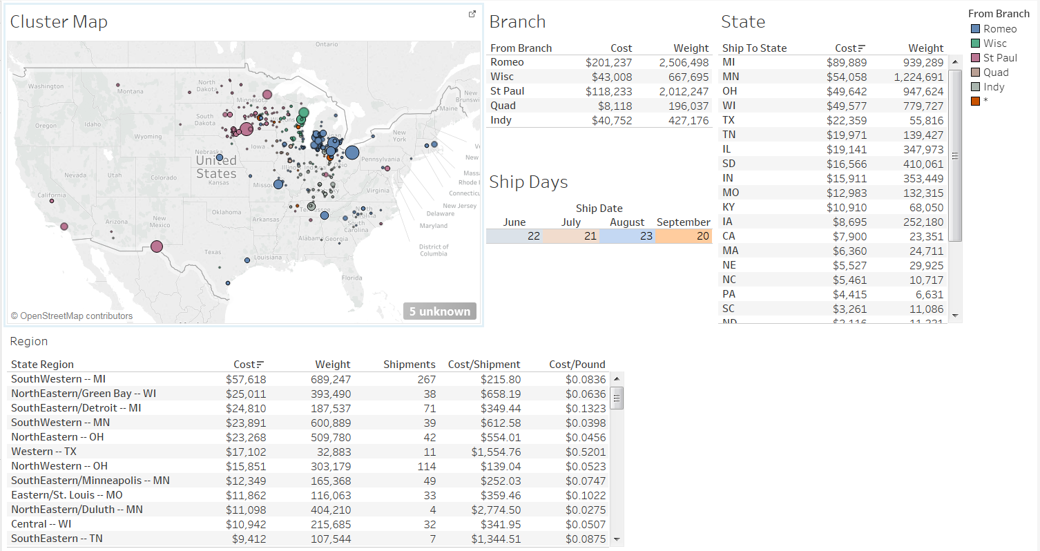

Figure 1. DB_RegionDetail

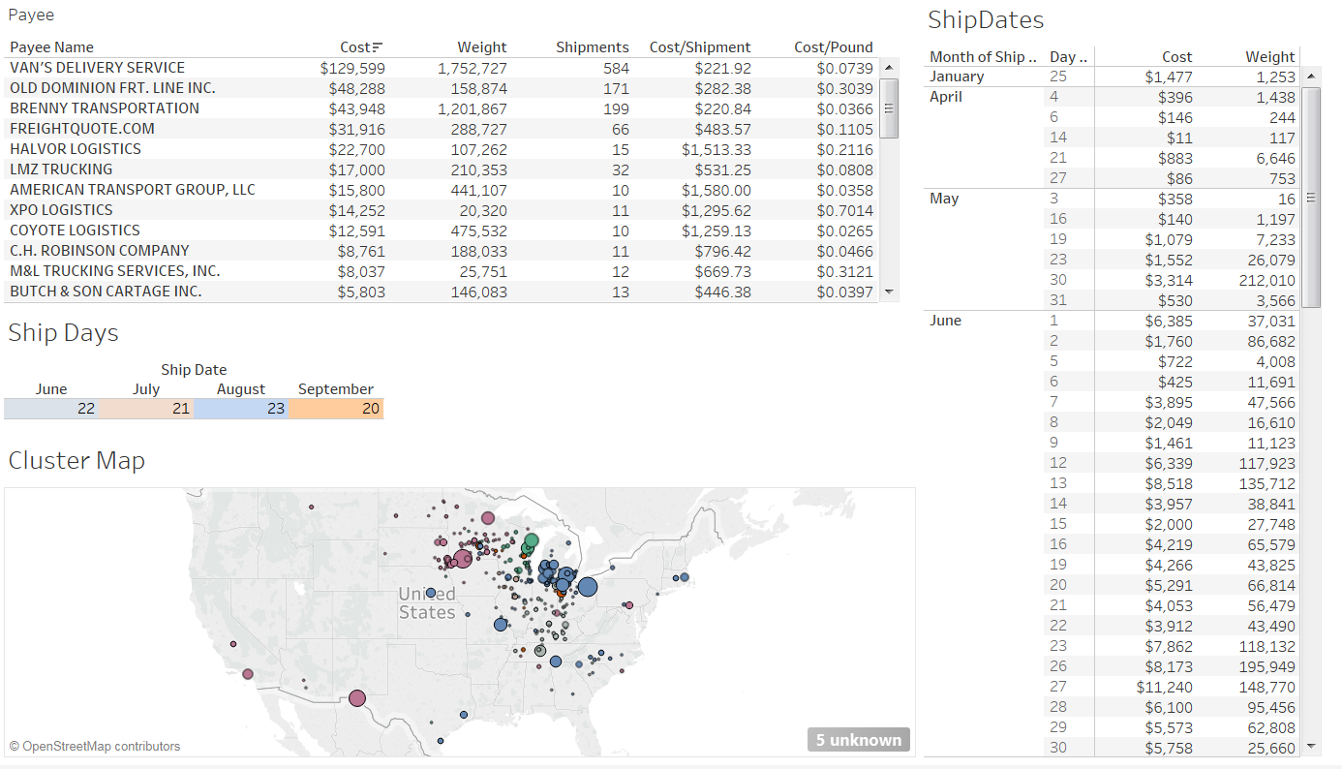

Figure 2. DB_ShipDetail

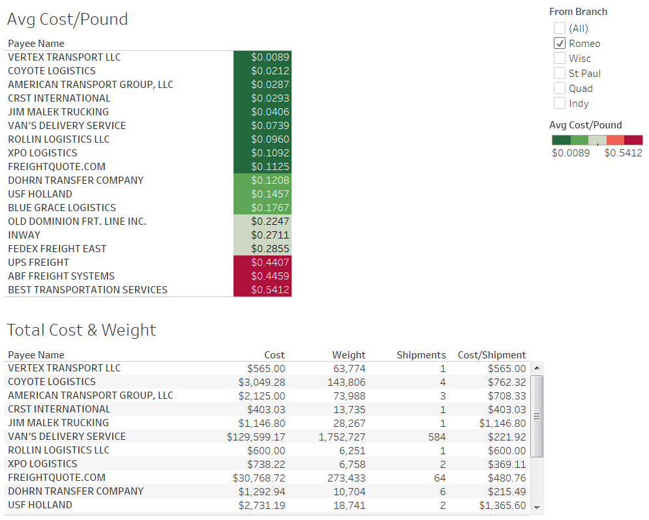

Figure 3. DB_PayeeAnalysis

Appendix B

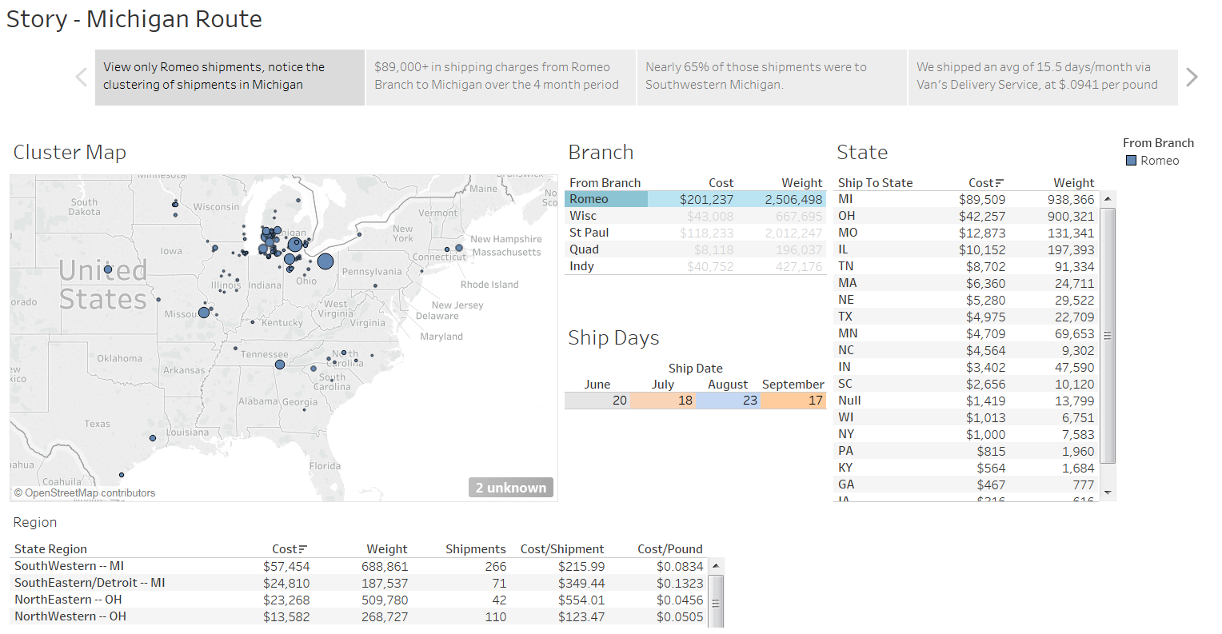

Figure 4. Story Scene 1

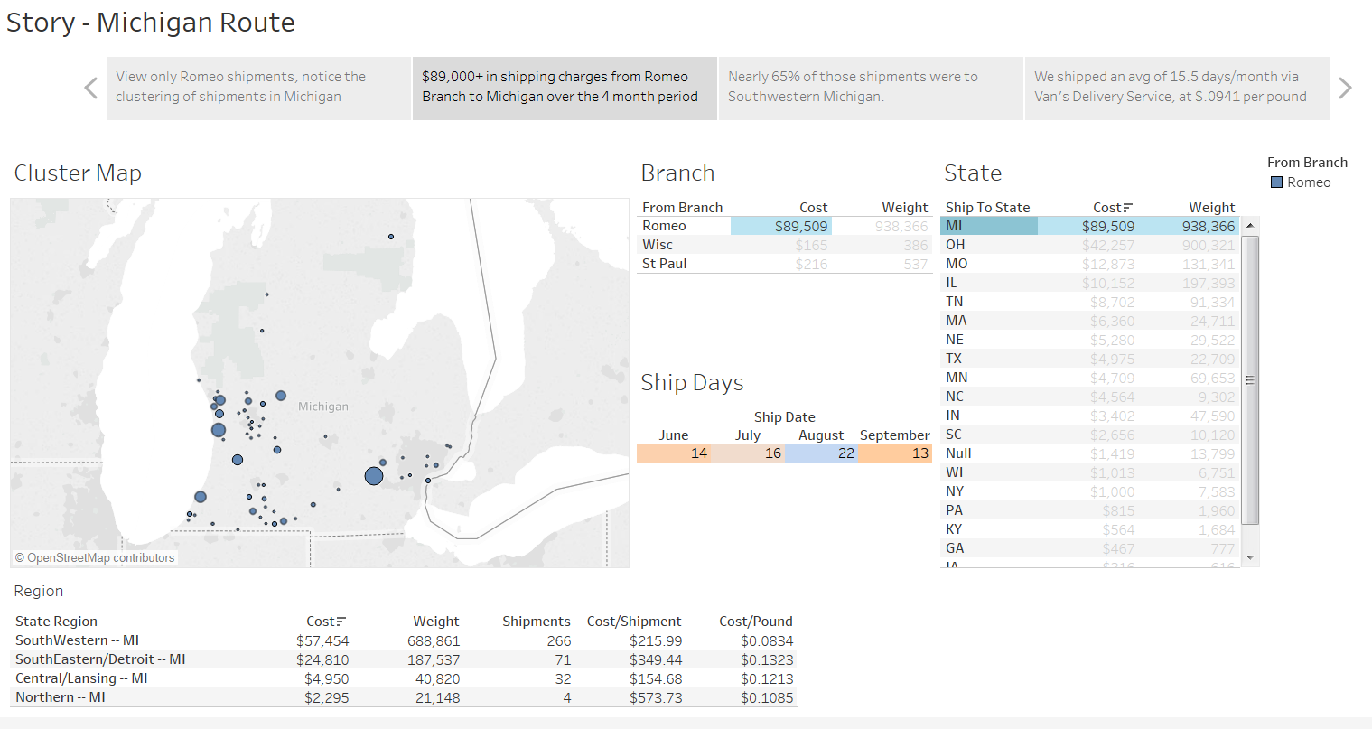Figure 5. Story Scene 2

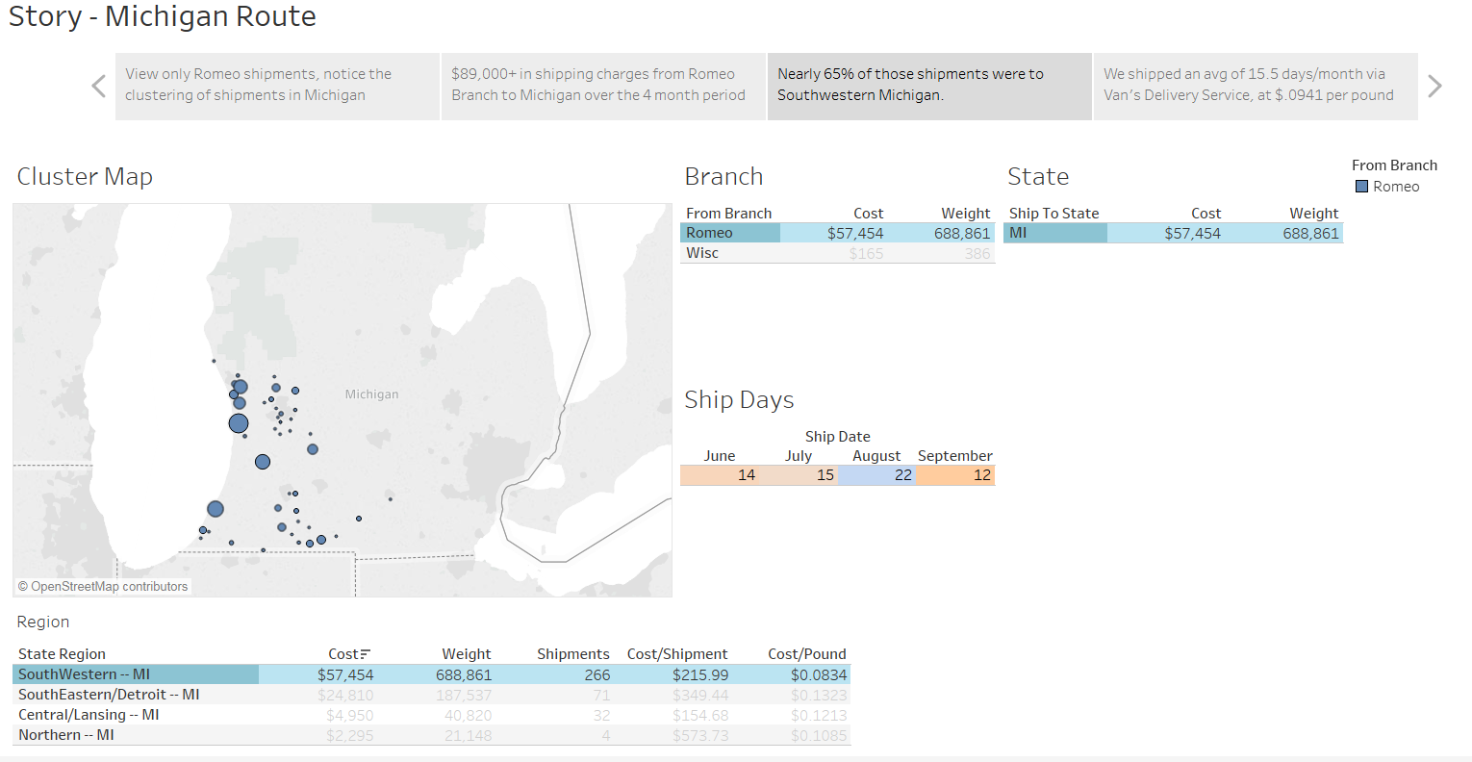Figure 6. Story Scene 3

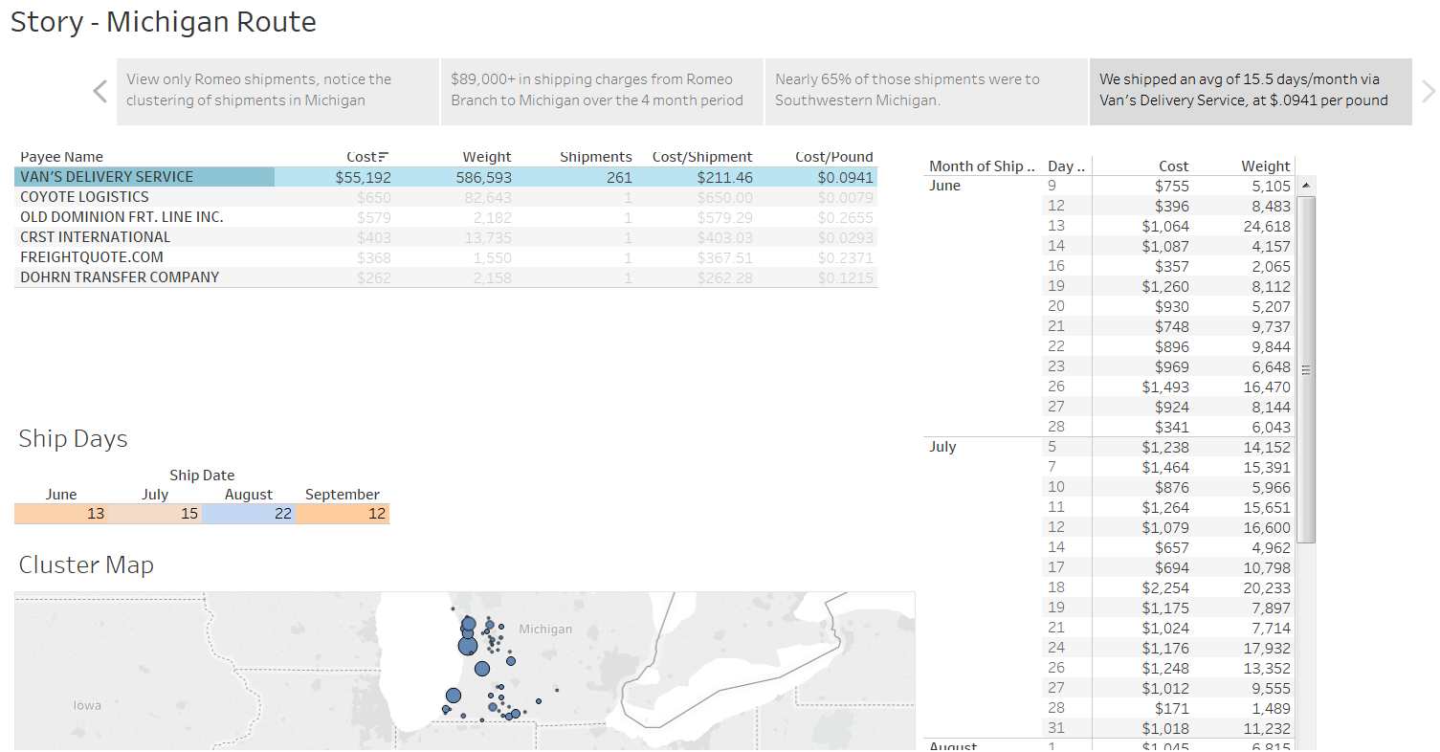Figure 7. Story Scene 4