During this lab the BerryIMU functionality was explored as well as speech recognition and various TCP/IP protocols. Throughout this lab I gained very valuable insight into highly practical tools we can use during our project. Further, our group discussed to a great extent the project scope and started narrowing down our project specifications. We are currently thinking of building a robot (four wheels) that is going to act either as a security or food delivery or rescue system. By using image processing, gesture recognition, and speech recognition we hope to build a semi-autonomous interactive system that is wirelessly connected.

* BerryIMU installation were done successfully, pip had to be used instead of conda for some libraries. To achieve functionality, we had to use python3.9 instead of just the python command to run the berryIMU.py script.
* The below image depicts the running of the script. The second image illustrates the motion when we filter the movement of the acceleration values using a simple threshold method.

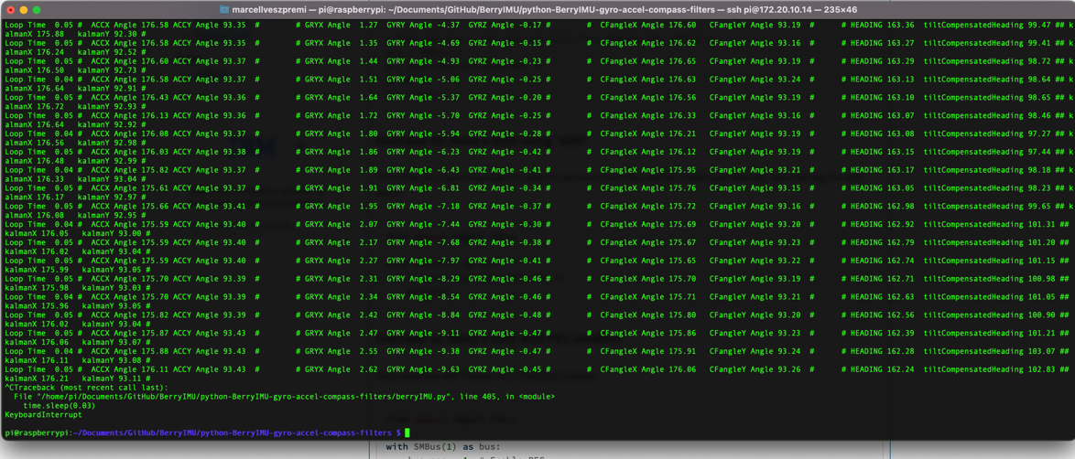

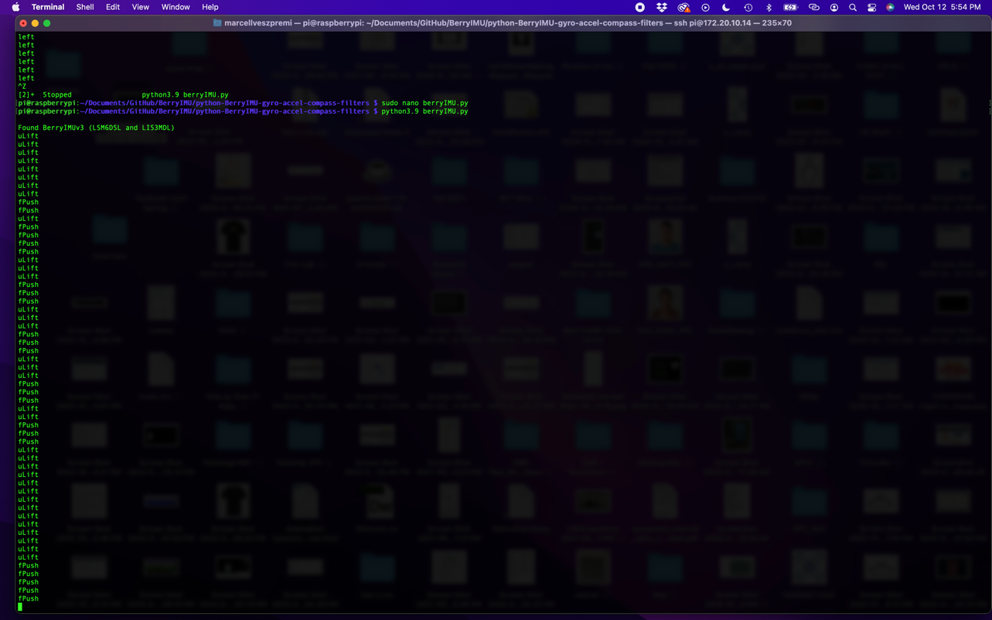

I tried sphinx speech recognition as we were hoping to achieve it running purely on the pi. I conclude using google cloud is much more effective. The results can be seen below.

The correct phrases were ‘hi’ ‘right’ and ‘left’ some of which were recognized.

**from** **pocketsphinx** **import** LiveSpeech

**for** phrase **in** LiveSpeech():

print(phrase)

