**Green Taxi:**

**Loading data into Hive Tables for Green:**

Creating tables for taxi data:

create table green (VendorID int, lpep_pickup_datetime timestamp,

lpep_dropoff_datetime timestamp, store_and_fwd_flag string, ratecodeid

int, pulocationid int, dolocationid int, passenger_count int,

trip_distance float, fare_amount float, extra float, mta_tax float,

tip_amount float, tolls_amount float, ehail_fee string ,

improve_surcharge float, total_amount float, payment_type int,

trip_type int, congestion_surcharge string)

row format delimited

fields terminated by ',';

Loading data from csv for all months of 2019:

load data local inpath '/home/cloudera/Desktop/Taxi-data-2019/Green/' into table green;

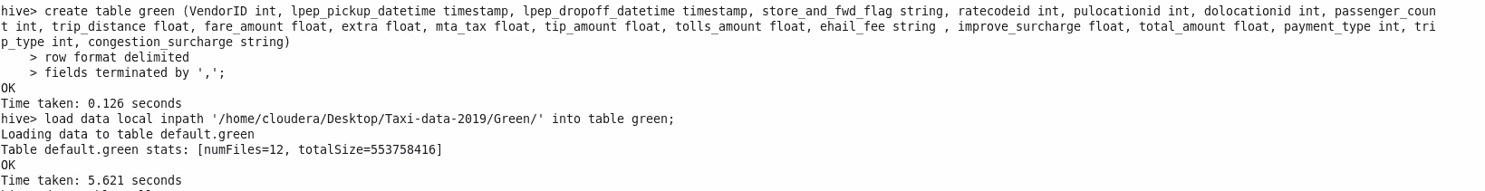

Total records provided by each vendor:

select count(*) as Vendor_Records, vendorid as Provider_Green from green group by vendorid;

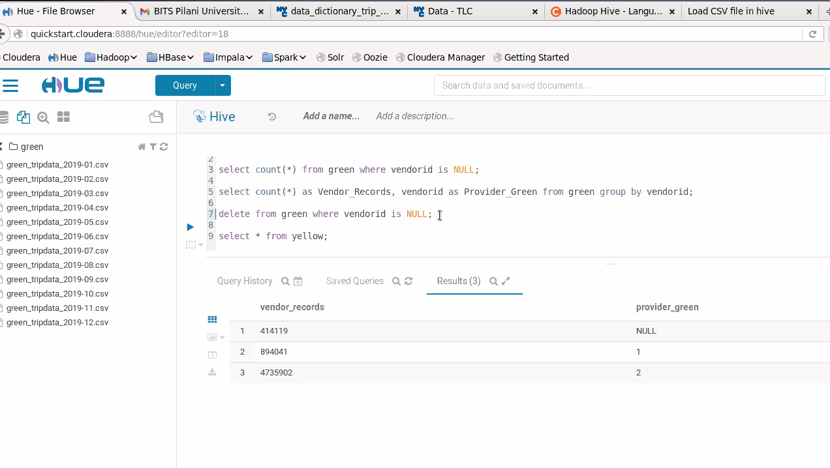

From above result, We see there are some null records for Vendor

**1) Which vendor provides the most useful data?**

Below query is for getting the vendor who is giving more inappropriate data(i.e nulls or negative values in CSV ):

select vendorid, count(*) from green

where vendorid is null or passenger_count is null or passenger_count<=0 or trip_distance <= 0

or RateCodeID is null or fare_amount <= 0 or extra < 0

or mta_tax not in (0,0.5) or tip_amount < 0

or tolls_amount < 0

or total_amount < 0 or year(lpep_pickup_datetime) <> 2019 group by vendorid;

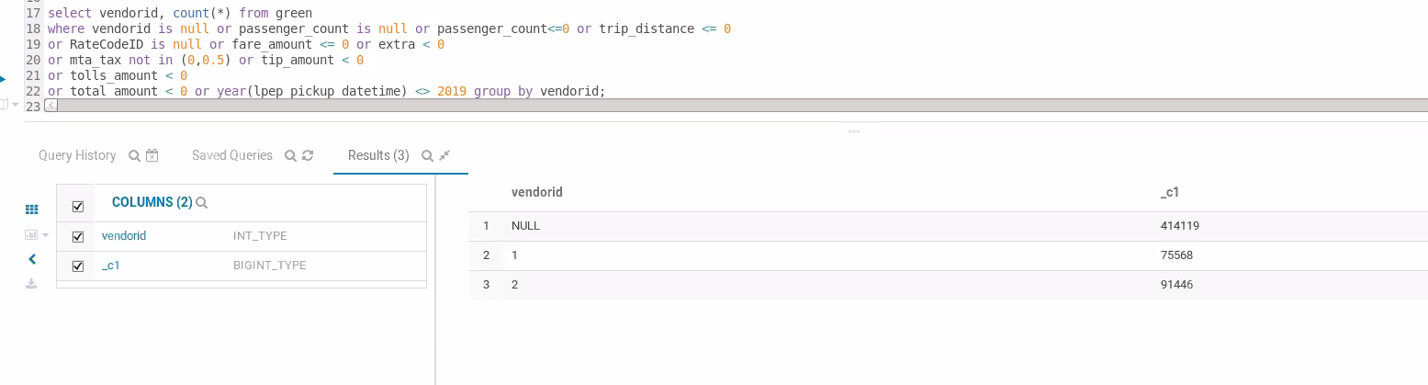

From above we can see there is no much difference but vendor 2= VeriFone Inc. is providing more useful data

**Cleaning the data for further processing:**

Now creating another table to load valid and appropriate data by removing nulls and negatives:

Creating table with partition by month:

create table if not exists green_partition (

vendorid int,

lpep_pickup_datetime string,

lpep_dropoff_datetime string,

store_and_fwd_flag string,

ratecodeid int,

pulocationid int,

dolocationid int,

passenger_count int,

trip_distance double,

fare_amount double,

extra double,

mta_tax double,

tip_amount double,

tolls_amount double,

improvement_surcharge double,

total_amount double,

payment_type int

) partitioned by (mnth int);

SET hive.exec.max.dynamic.partitions=100000;

SET hive.exec.max.dynamic.partitions.pernode=100000;

SET hive.exec.dynamic.partition=true;

SET hive.exec.dynamic.partition.mode=nonstrict;

Loading data to Green_partition table:

insert overwrite table green_partition partition(mnth)

select vendorid, lpep_pickup_datetime, lpep_dropoff_datetime, store_and_fwd_flag, ratecodeid, pulocationid, dolocationid, passenger_count,

trip_distance,

fare_amount, extra, mta_tax,

tip_amount, tolls_amount, improve_surcharge, total_amount, payment_type, month(lpep_pickup_datetime) as mnth

from green

where passenger_count>0 and trip_distance > 0

and RateCodeID is not null and fare_amount > 0 and extra >= 0

and mta_tax in (0,0.5) and tip_amount >= 0

and tolls_amount >= 0 and improve_surcharge = 0.30

and total_amount >= 0 and year(lpep_pickup_datetime) = 2019;

Counting the number of rows in which any column has NULL values

select count(*) as Total_NULL_records from green_partition

where vendorid is null

or tpep_pickup_datetime is null

or tpep_pickup_datetime is null

or passenger_count is null

or trip_distance is null

or ratecodeid is null

or store_and_fwd_flag is null

or pulocationid is null

or dolocationid is null

or payment_type is null

or fare_amount is null

or extra is null

or mta_tax is null

or tip_amount is null

or tolls_amount is null

or improvement_surcharge is null

or total_amount is null

or mnth is null;

There are no nulls in the data

**2) Find the month wise trip count, average distance and average passenger count**

**from the trips completed by yellow and green taxis in 2019. Summary**

**visualizations will be preferred for better analysis.**

- Compare the overall trip count monthwise: Based on the results we can see most number of trips are done in early months of the year and are getting reduced by the end o the year

select mnth as Month, count(*) as TripCoun from green_partition

group by mnth order by mnth;

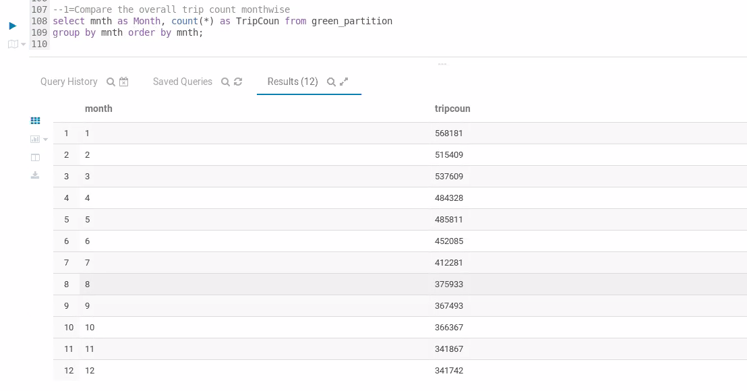

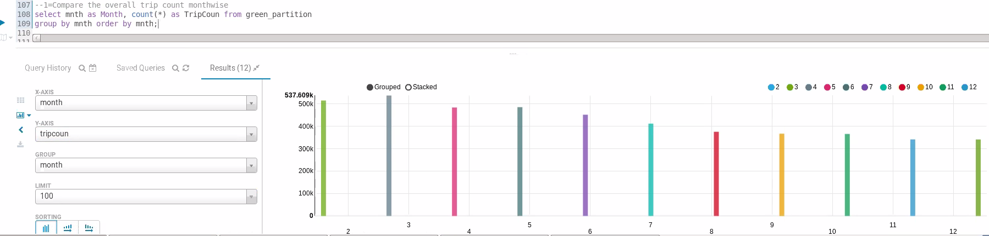

- Compare the overall average trip_distance monthwise: Based on the results, we can see it is almost similar 2 - 3 miles

select mnth as Month, avg(trip_distance) as Avg_TripDistance from green_partition

group by mnth order by mnth;

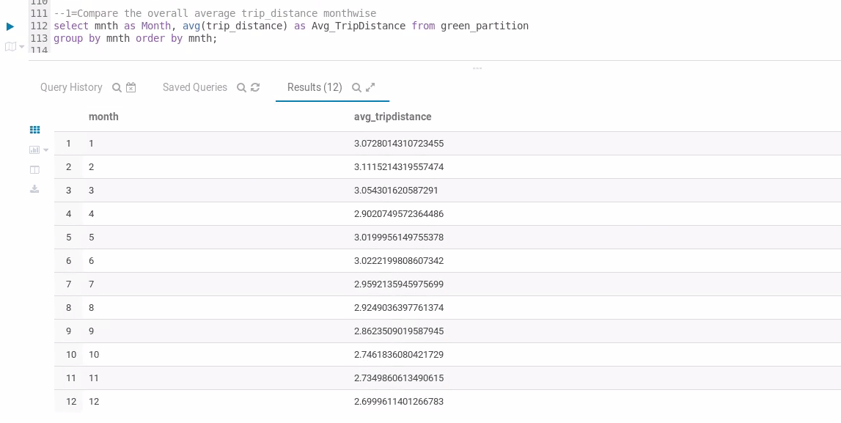

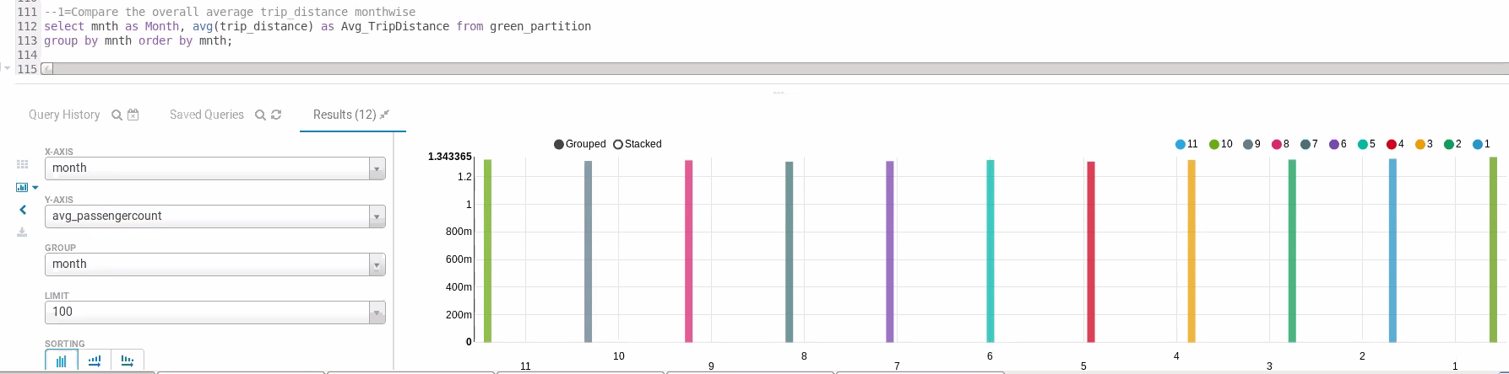

- Compare the overall average passenger count monthwise: From below we can see it is almost similar for all months

select mnth as Month, avg(passenger_count) as Avg_PassengerCount from green_partition

group by mnth order by mnth desc;

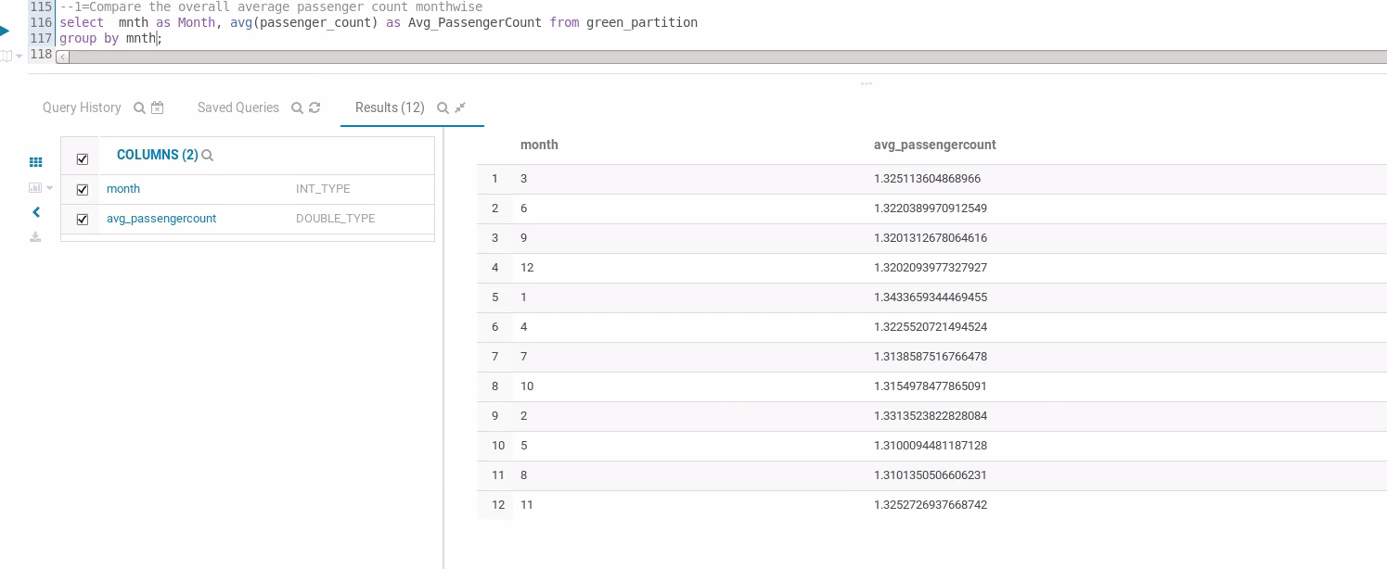

Visual bar graph for average passenger count. It is almost same across months

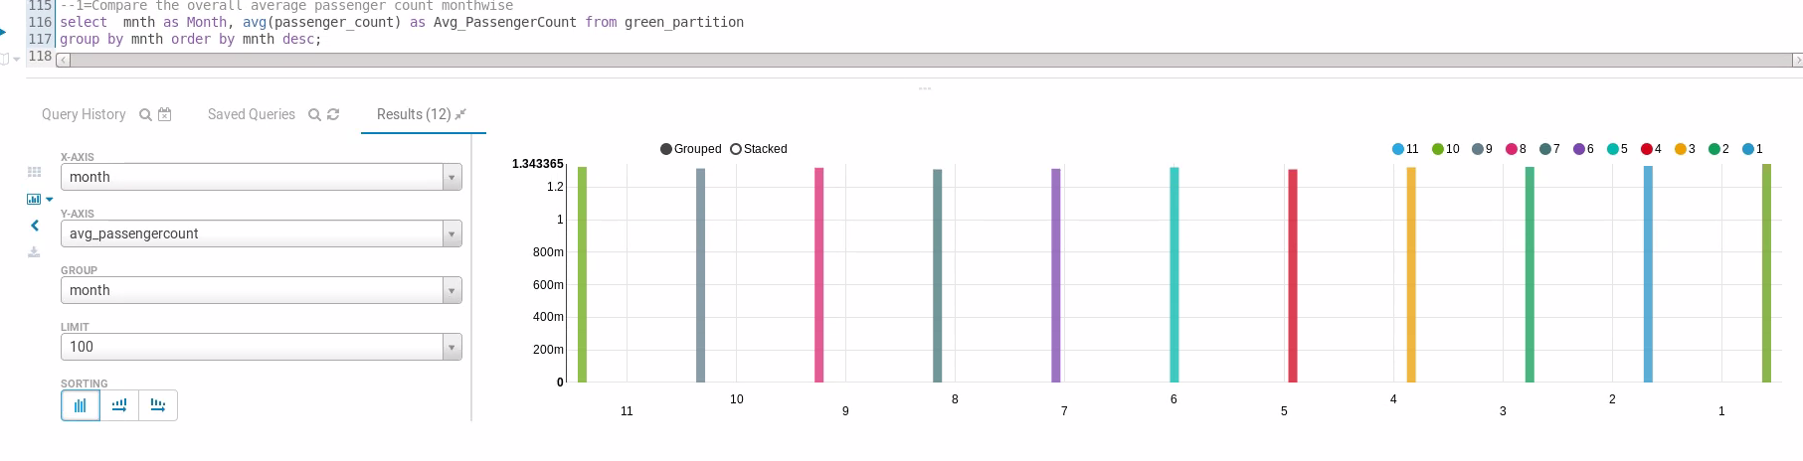

**Loading Location Name data:**

create table taxi_loc_data (LocationID int,Borough string,Zone string,service_zone string)

row format delimited

fields terminated by ',';

load data local inpath '/home/cloudera/Desktop/Taxi-data-2019/taxi+_zone_lookup.csv' into table taxi_loc_data;

**3) Find out the five busiest routes served by the yellow and green taxis during 2019.**

**The name of start and drop points to be provided.**

select pulocationid, dolocationid, count(*) as cnt from

green_partition group by pulocationid, dolocationid order by cnt desc limit 5;

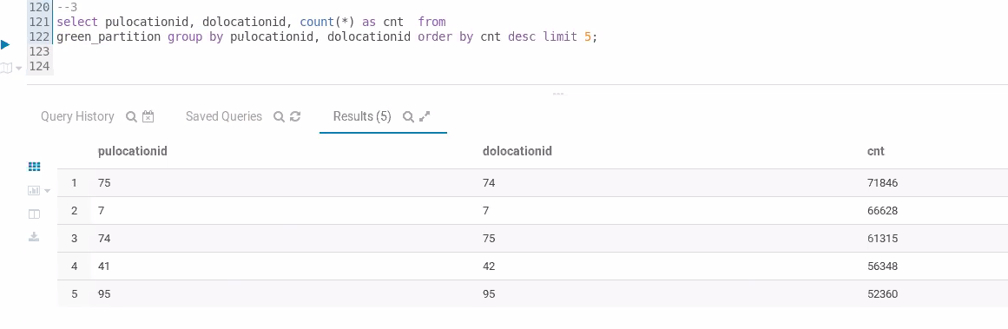

Populating Location names:

select gp.pulocationid, concat(tlp.borough, ',', tlp.zone, ',', tlp.service_zone) as pickuplocation, gp.dolocationid, concat(tld.borough, ',', tld.zone, ',', tld.service_zone) as droplocation, count(*) as cnt

from green_partition gp, taxi_loc_data tlp, taxi_loc_data tld where tlp.locationid = gp.pulocationid and tld.locationid = gp.dolocationid

group by gp.pulocationid, concat(tlp.borough, ',', tlp.zone, ',', tlp.service_zone), gp.dolocationid, concat(tld.borough, ',', tld.zone, ',', tld.service_zone) order by cnt desc limit 5;

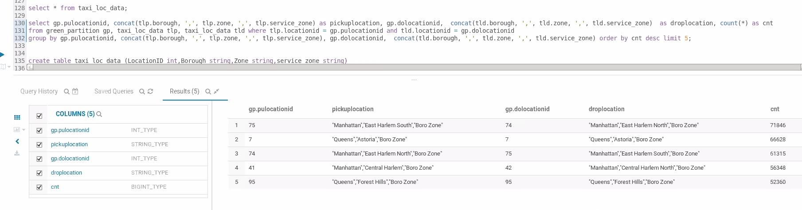

**4) What are the top 3 busiest hours of the day for the taxis?**

From Below we can see evening 4, 5, 6 PM are the busiest hours

select hour(lpep_pickup_datetime) as buisiest_hour, count(*) as cnt from

green_partition group by hour(lpep_pickup_datetime) order by cnt desc limit 3;

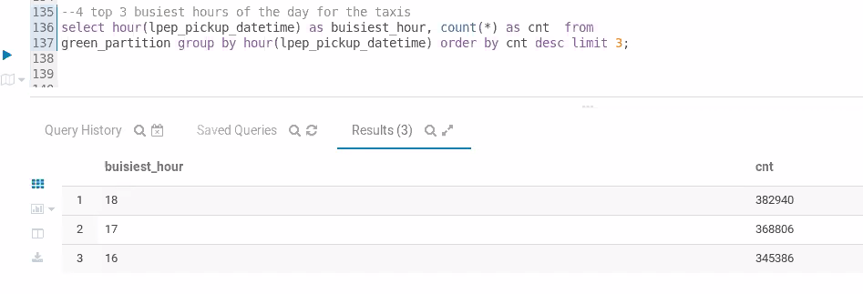

**5) What is the most preferred way of payment used by the passengers? What are**

**the weekly trends observed for the methods of payments?**

Mostly used payment mode is credit cards with 56%

select payment_type,(count(*)*100/5249106) cnt

from green_partition group by payment_type

order by cnt desc;

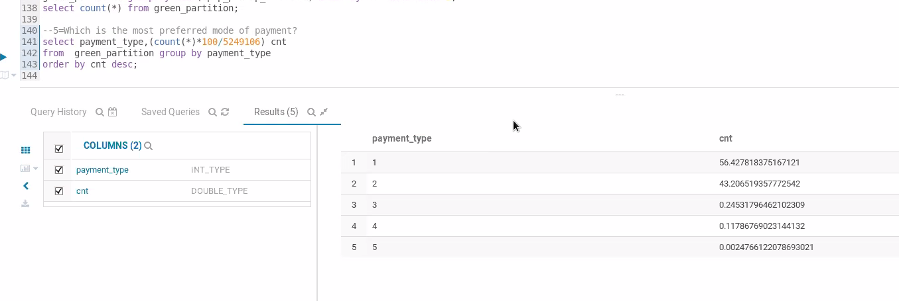

Below is the Weekly trends followed by customers for payments:

select weekofyear(lpep_pickup_datetime) as weeknumber, payment_type, count(*) as cnt

from green_partition

group by weekofyear(lpep_pickup_datetime), payment_type

order by weeknumber, cnt;

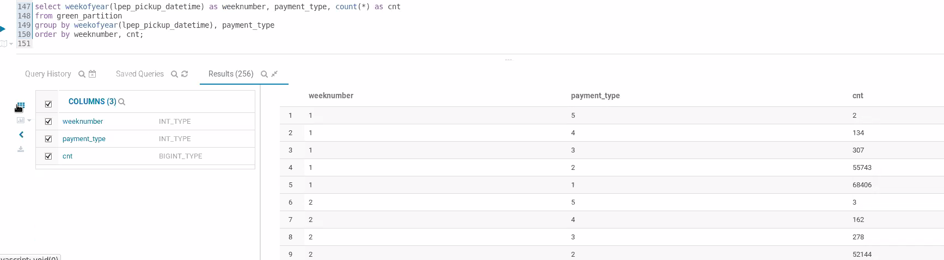

View

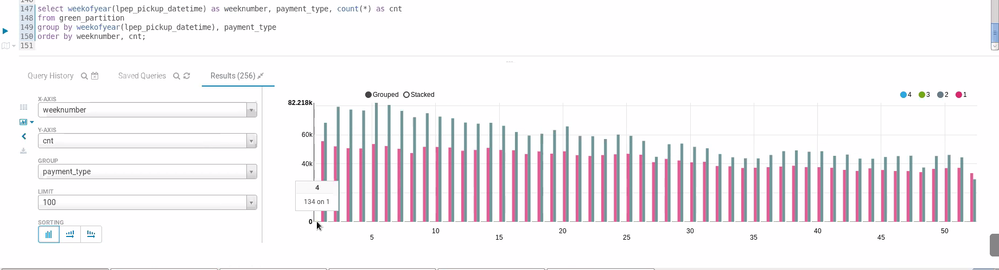

**Yellow Taxi:**

Creating table for yellow taxi data:

create table yellow (VendorID int, tpep_pickup_datetime timestamp,

tpep_dropoff_datetime timestamp, passenger_count int, trip_distance

float, ratecodeid int, store_and_fwd_flag string, pulocationid int,

dolocationid int, payment_type int, fare_amount float, extra float,

mta_tax float, tip_amount float, tolls_amount float, improve_surcharge

float, total_amount float, congestion_surcharge float)

row format delimited

fields terminated by ',';

Loading Data from csv for all months of 2019:

load data local inpath '/home/cloudera/Desktop/Taxi-data-2019/Yellow' into table yellow;

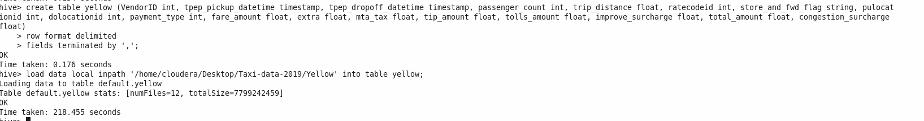

Total records provided by each vendor:

select count(*) as vendor_records, vendorid as provider_yellow from yellow group by vendorid;

We see there are some null records and VendorId 4 for Vendor which are invalid

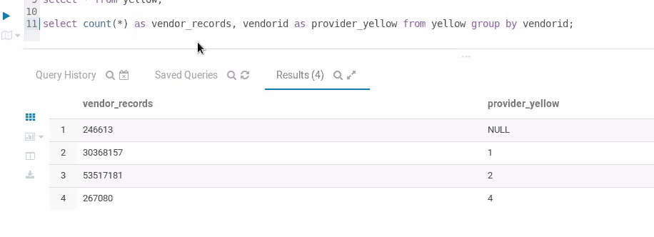

**1) Which vendor provides the most useful data?**

Below query is for getting the vendor who is giving more inappropriate data(i.e nulls or negative values in CSV ):

select vendorid, count(*) from yellow

where vendorid is null or passenger_count is null or passenger_count<=0 or trip_distance <= 0

or RateCodeID is null or fare_amount <= 0 or extra < 0

or mta_tax not in (0,0.5) or tip_amount < 0

or tolls_amount < 0

or total_amount < 0 or year(lpep_pickup_datetime) <> 2019 group by vendorid;

From above we can see there is no much difference but vendor 2= VeriFone Inc. is providing more useful data

**Cleaning the data for further processing:**

Now creating another table to load valid and appropriate data by removing nulls and negatives:

Creating table with partition by month:

create table if not exists yellow_partition (

vendorid int,

tpep_pickup_datetime string,

tpep_dropoff_datetime string,

passenger_count int,

trip_distance double,

ratecodeid int,

store_and_fwd_flag string,

pulocationid int,

dolocationid int,

payment_type int

fare_amount double,

extra double,

mta_tax double,

tip_amount double,

tolls_amount double,

improvement_surcharge double,

total_amount double,

) partitioned by (mnth int);

SET hive.exec.max.dynamic.partitions=100000;

SET hive.exec.max.dynamic.partitions.pernode=100000;

SET hive.exec.dynamic.partition=true;

SET hive.exec.dynamic.partition.mode=nonstrict;

Loading data to Yellow_partition table:

Not able to run the yellow partition insertion and queries. It is taking too much time and System is crashing. All Yellow taxi queries are updated above. Results will be similar to Green taxi details

insert overwrite table yellow_partition partition(mnth)

select vendorid, tpep_pickup_datetime, tpep_dropoff_datetime, passenger_count,

trip_distance, ratecodeid

store_and_fwd_flag, pulocationid, dolocationid, payment_type,fare_amount, extra, mta_tax,

tip_amount, tolls_amount, improve_surcharge, total_amount, month(tpep_pickup_datetime) as mnth

from yellow

where vendorid is not null and vendorid <> 4 and

passenger_count>0 and trip_distance > 0

and RateCodeID is not null and fare_amount > 0 and extra >= 0

and mta_tax in (0,0.5) and tip_amount >= 0

and tolls_amount >= 0 and improve_surcharge = 0.30

and total_amount >= 0 and year(tpep_pickup_datetime) = 2019;

Counting the number of rows in which any column has NULL values

select count(*) as Total_NULL_records from yellow_partition

where vendorid is null

or tpep_pickup_datetime is null

or tpep_pickup_datetime is null

or passenger_count is null

or trip_distance is null

or ratecodeid is null

or store_and_fwd_flag is null

or pulocationid is null

or dolocationid is null

or payment_type is null

or fare_amount is null

or extra is null

or mta_tax is null

or tip_amount is null

or tolls_amount is null

or improvement_surcharge is null

or total_amount is null

or mnth is null;

There are no nulls in the data

**2) Find the month wise trip count, average distance and average passenger count**

**from the trips completed by yellow and green taxis in 2019. Summary**

**visualizations will be preferred for better analysis.**

- Compare the overall trip count monthwise: Based on the results we can see most number of trips are done in early months of the year and are getting reduced by the end of the year

select mnth as Month, count(*) as TripCoun from yellow_partition

group by mnth order by mnth;

- Compare the overall average trip_distance monthwise: Based on the results, we can see it is almost similar 2 - 3 miles

select mnth as Month, avg(trip_distance) as Avg_TripDistance from yellow_partition

group by mnth order by mnth;

- Compare the overall average passenger count monthwise: From below we can see it is almost similar for all months

select mnth as Month, avg(passenger_count) as Avg_PassengerCount from yellow_partition

group by mnth order by mnth desc;

Visual bar graph for average passenger count. It is almost same across months

**3) Find out the five busiest routes served by the yellow and green taxis during 2019.**

**The name of start and drop points to be provided.**

select pulocationid, dolocationid, count(*) as cnt from

yellow_partition group by pulocationid, dolocationid order by cnt desc limit 5;

Populating Location names:

select gp.pulocationid, concat(tlp.borough, ',', tlp.zone, ',', tlp.service_zone) as pickuplocation, gp.dolocationid, concat(tld.borough, ',', tld.zone, ',', tld.service_zone) as droplocation, count(*) as cnt

from green_partition gp, taxi_loc_data tlp, taxi_loc_data tld where tlp.locationid = gp.pulocationid and tld.locationid = gp.dolocationid

group by gp.pulocationid, concat(tlp.borough, ',', tlp.zone, ',', tlp.service_zone), gp.dolocationid, concat(tld.borough, ',', tld.zone, ',', tld.service_zone) order by cnt desc limit 5;

**4) What are the top 3 busiest hours of the day for the taxis?**

From Below we can see evening 4, 5, 6 PM are the busiest hours

select hour(tpep_pickup_datetime) as buisiest_hour, count(*) as cnt from

yellow_partition group by hour(tpep_pickup_datetime) order by cnt desc limit 3;

**5) What is the most preferred way of payment used by the passengers? What are**

**the weekly trends observed for the methods of payments?**

Mostly used payment mode is credit cards with 56%

select payment_type,(count(*)*100/5249106) cnt

from yellow_partition group by payment_type

order by cnt desc;

Below is the Weekly trends followed by customers for payments:

select weekofyear(tpep_pickup_datetime) as weeknumber, payment_type, count(*) as cnt

from yellow_partition

group by weekofyear(tpep_pickup_datetime), payment_type

order by weeknumber, cnt;

Not able to run the yellow partition insertion and queries. It is taking too much time and System is crashing. All Yellow taxi queries are updated above. Results will bi similar to Green taxi details