10/04/2026

Re: Dear Sir/ Madame

My name is Sthandwa Hillary Ndlovu. I write this later asking for donations and help me to open my business so that I can do something better in life and have something meaningful to do and to help at home

Business Name: Lock'xion Chips Conner
Business details: Chips Russian and Kota

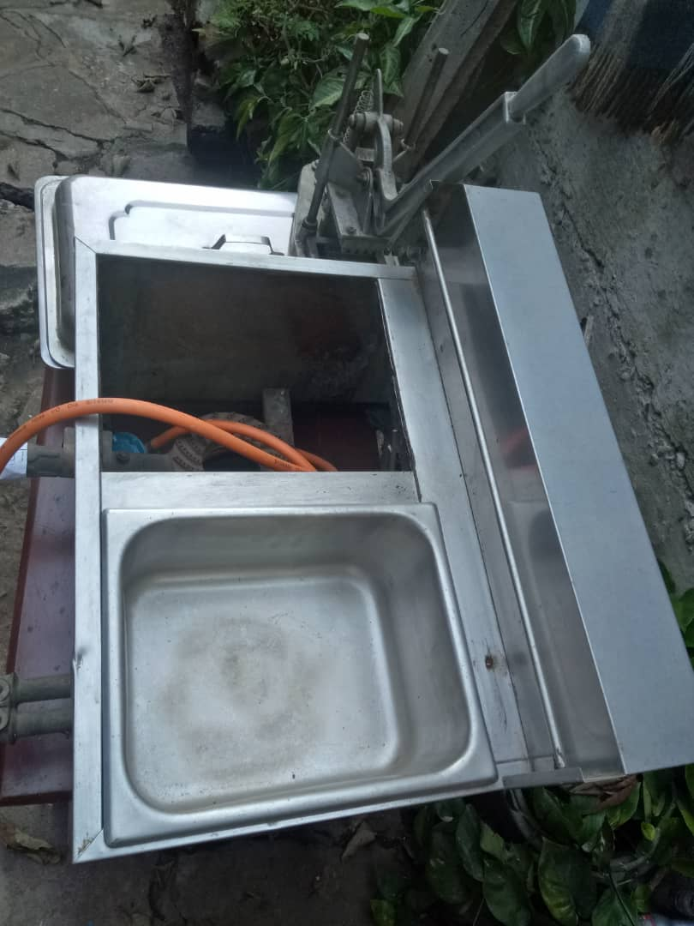

Your help will make a big difference

Thank you in advance.
Hoping to get reply from you.

Your's faithfully.
Sthandwa Hillary Ndlovu.

