Firebird Array Support
Firebird allows you to create arrays of datatypes. Using an array enables multiple data items to be stored in a single column. Firebird can perform operations on an entire array, effectively treating it as a single element, or it can operate on an array slice, a subset of array elements. An array slice can consist of a single element, or a set of many contiguous elements.
Starting with IBX2, IBX now offers full support for Firebird Arrays:
- The Firebird Language Bindings in the fbintf package provide both IArray and IArrayMetaData interfaces. The former is used to access and manage an array or array slice, while the latter can be queried to find out information about the array such as its type, number of dimensions, etc.
- IBX itself now includes TIBArrayField. This is a TField descendent and, like any other TField descendent (e.g. TStringField) provides the means to access an array element when it is returned by a TDataSet descendent as a field of the current row. TIBArrayField provides the IArray interface as one of its properties enabling direct access to the array.
- The IBControls Package now includes a TIBArrayGrid visual control. This is a TCustomStringGrid descendent and may be used to display and edit an array element. Examples are provided for both one and two dimensional arrays.
The IArray interface is documented as part of the fbintf package.

Defining an Array Element
This is fully described in the Firebird Document. For example:
Alter Table MyData (
...
MyArray VarChar(16) [0:16, -1:7] Character Set UTF8
);
An array may have a different set of values for each row. In the above example, a two dimensional array of strings is defined. The first index may vary from 0 to 16 and the second from -1 to 7.

TIBArrayField
TIBArrayField is used and behaves much the same as any other TField Descendent. It can be created in the IDE using the Fields Editor and saved as part of a form (and then accessed as a property of the form) or dynamically, when a TIBCustomDataSet descendent (e.g. TIBTable, TIBQuery, etc.) is opened (it can then be accessed (e.g.) using the “FieldByName” method).
TIBArrayField defines the following additional properties:
ArrayID: TISC_QUAD | This provides access to the Firebird internal array identifier stored in the row itself. This is not normally of direct interest to users.
ArrayIntf: IArray | This provides access to the array interface used to access and update the array element. When the field is null, this returns an empty array and setting an element of this array to any non-empty value will make the field non-null after the record has been posted.  Assigning an empty array to this property provides an alternative means to setting the field to null. (Setting the field IsNull property to true is the recommended method).
ArrayDimensions: integer | Returns the number of dimensions in the array.
ArrayBounds: TArrayBounds | This is a (pascal) dynamic array and returns an element for each dimension in the array, providing the upper and lower bound for that dimension.

TIBArrayField also provides an additional method:
function CreateArray: IArray;
This may be used to obtain an interface to a new empty array and which is compatible with the field. Once populated, it can be assigned to the ArrayIntf property and its contents will be saved as the value of the array field once the dataset has been “posted”.
Note: it is possible to retain a copy of the ArrayIntf and access it after the dataset has been scrolled. However, an exception is raised if an attempt is made to alter the contents of an array that is not linked to the current row of its TDataSet.

TIBArrayGrid
TIBArrayGrid is a visual control that can be linked to a TIBArrayField and used to display/edit the contents of a one or two dimensional Firebird array. It may be found in the “Firebird Data Controls” palette.
To use a TIBArrayGrid, simply drop it onto a form and set the DataSource property to the source dataset and the DataField property to the name of an array field. The grid should then be automatically sized to match the dimensions of the array.
Note that the array bounds can be refreshed at any time in the IDE, by right clicking on the control and selecting "Update Layout" from the pop up menu.
At runtime, the TIBArrayGrid will always display/edit the value of the array element in the current row. If this element is null then the array is empty. However, data can be inserted into an empty array. When the row is posted, the field will be set to the new/updated array.

Properties
Most TIBArrayGrid properties are the same as for TStringGrid. The following are specific to TIBArrayGrid. Note that you cannot set the Row or column counts directly as these are always set to match the array field.
Public Properties
ArrayIntf | Provides direct access to the array itself.
DataSet | The DataSet provided by the DataSource (read only).
Field | The source field

Published:
DataField | The name of the array column.
DataSource | The data source providing the source table.
ReadOnly | Set to true to prevent editing
ColumnLabels | A string list that provides the labels for each column in the grid. Provide one line per column. If non empty then a column label row is created as a fixed row at the top of the grid.
ColumnLabelAlignment | Sets the text alignment for column Labels
ColumnLabelFont | Sets the font used for column labels
RowLabels | A string list that provides the labels for each row in the grid. Provide one line per row. If non empty then a row label column is created as a fixed column to the left of the grid.
RowLabelAlignment | Sets the text alignment for row Labels
RowLabelFont | Sets the font used for row labels
RowLabelColumnWidth | Width of the Fixed Column used for row labels.
TextAlignment | Alignment of all cells other that those containing labels.

Examples
Example applications are provided for both one and two dimensional arrays. In each case, the example applications create their own database and populate it with test data when first run. Note that you will typically need to run the application before accessing database properties in the IDE. This is in order to create the database referenced by the IDE.

Database Creation
The IBDatabase property “CreateIfNotExists” is set to true in both examples. This means that if the database does not exist when an attempt is made to connect to it then the database is created. After it is created, the “OnCreateDatabase” event handler is used to add a table to the newly created database and to populate it with test data. The application then continues as if the database already existed.
By default, the database is created in the defined temporary directory. This behaviour can be overridden by editing the example's “unit1” unit to remove the “{$DEFINE LOCALDATABASE}” directive and setting the const “sDatabaseName” to the required path e.g.
const
sDatabaseName = 'myserver:/databases/test.fdb';

1D Array Example
A screenshot from this example program is illustrated below.
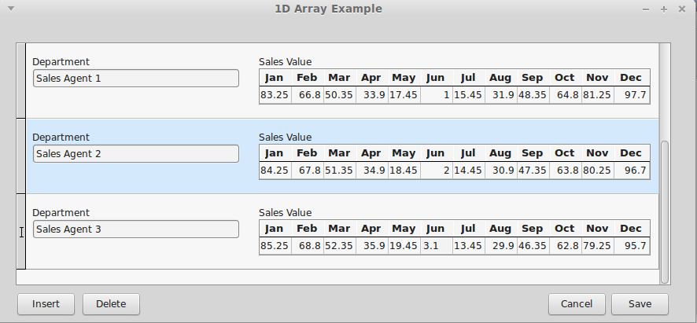
In this case, the test data table is defined as
Create Table TestData (
RowID Integer not null,
Title VarChar(32) Character Set UTF8,
MyArray Double Precision [1:12],
Primary Key(RowID)
);
Each row includes a floating point array with twelve elements. In the example application, the table is displayed and edited using a DBControlGrid. The title field is interpreted as a “Department” and displayed using a TDBEdit control. The array field is interpreted as sales by month and displayed as a one dimensional TIBArrayGrid with column labels. The example allows both the Departname Name and monthly sales values to be updated and changes saved. New rows can be inserted and existing rows deleted.

2D Array Example
A screenshot from this example program is illustrated below.
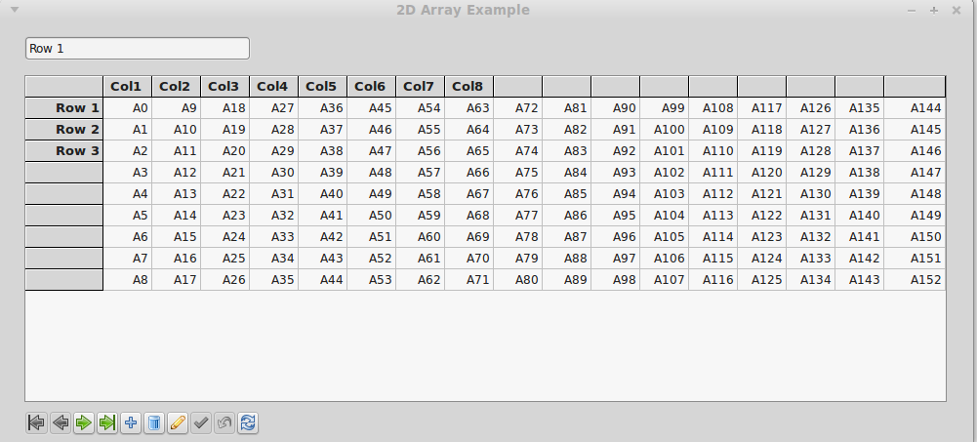
In this case, the test data table is defined as
Create Table TestData (
RowID Integer not null,
Title VarChar(32) Character Set UTF8,
MyArray VarChar(16) [0:16, -1:7] Character Set UTF8,
Primary Key(RowID)
);
Each row includes a two dimensional string array with indices 0..16 and -1 to 7. The grid interprets the first index as a column index and the second as a row index (i.e. x,y Cartesian co-ordinates).
The example program displays a row at a time with a navigation bar providing the means to scroll through the dataset, as well as saving or cancelling changes, inserting and deleting rows.
This example illustrates the use of both column and row labels.

