TIBTreeView
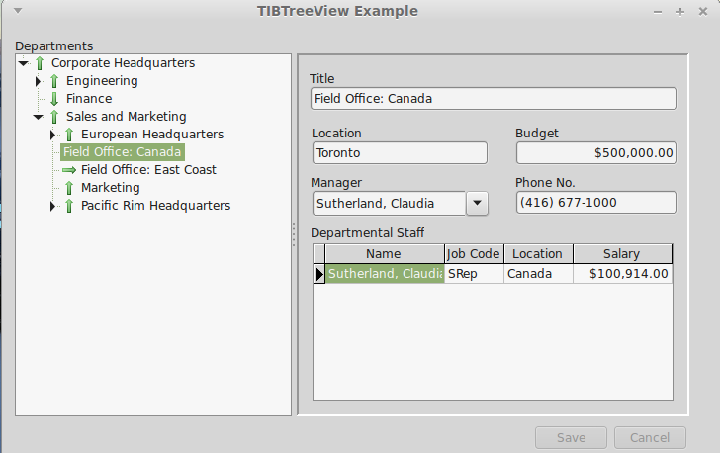Illustration 1: TIBTreeView Example
TIBTreeView is a data aware descendent of a TCustomTreeView and is used to present a hierarchically organised data set in a tree view. This dataset can be edited. Insertion, Deletion and Modification are supported, as are moving (e.g. using drag and drop) nodes from one part of the tree to another. The underlying dataset cursor is always positioned to reflect the currently selected tree node. It can thus be used to select a row for detailed editing. SQL Manipulation is used to load the tree as a series of separate queries.
Illustration 1 Is taken from ibx/examples/ibtreeview and uses the Firebird example “employee” database. This database contains a hierarchically organised table “DEPARTMENT” and which is used for the example.
To use a TIBTreeView, simply drop it on to a form, set the DataSource propert, and, as a minimum, the TextField, ParentField and KeyField properties as defined below.
The DataSet must have a single primary key field.

TIBTreeView Properties
DataSource | TDataSource | Identifies the source of the data to present using the tree view
TextField | string | The field name of the column used to source each node's display text
KeyField | string | The field name of the column used to source each node's key.
ParentField | string | The field name of the column used to identify the primary key of the parent row. This field is null for a root element.
HasChildField | string | Optional. The field name of the column used to indicate whether or not the row has child nodes. When present, this should return an integer value with non-zero values implying that child nodes exist.
RelationName | string | Optional. The Child Field is typically the result of joining the table to itself and is a count of child rows. However, this can result in ambiguous column names when the SQL is manipluated. This property should contain the Table Alias used to select the Key, Text and Parent Fields (see example).

