TIBDynamicGrid
The TIBDynamicGrid is illustrated above using Firebird's example “employee” databases.
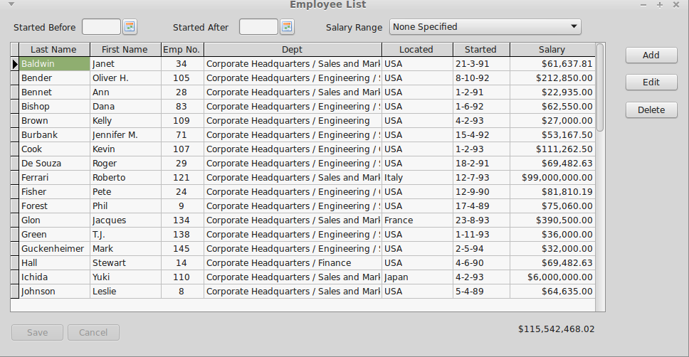Illustration 1: The TIBDynamicGrid
In use, it looks just like a TDBGrid and is a TDBGrid descendent. Any project that uses IBX and TDBGrid can thus be quickly converted to using TIBDynamicGrid. The control uses SQL Manipulation to manage column sorting.
This above example can be found in “ibx/examples/employee” and illustrates most of the benefits of TIBDynamicGrid.
- Resize the form and you will see how the “Dept” column automatically grows/shrinks to ensure that the grid always fills the available space and how the Salary “Total” column moves so that it is always aligned with the grid.
- Click on the “Started” column header (or any other column header) and the table will be resorted by that column. A second click on the same header reverses the sort order.
- Select a row and press “F2”, click on “Edit” or the left hand indicator column and the Editor Panel is revealed (See Illustration 2). This allows the row to be edited free of the contrainsts imposed by a simple column editor.
- After reopening the dataset (e.g. after a re-sort or change of filters) the previously selected row is automatically reselected.
- The filters, such a “salary range” also illustrate how the new IB SQL Parser works with the TIBDynamicGrid.
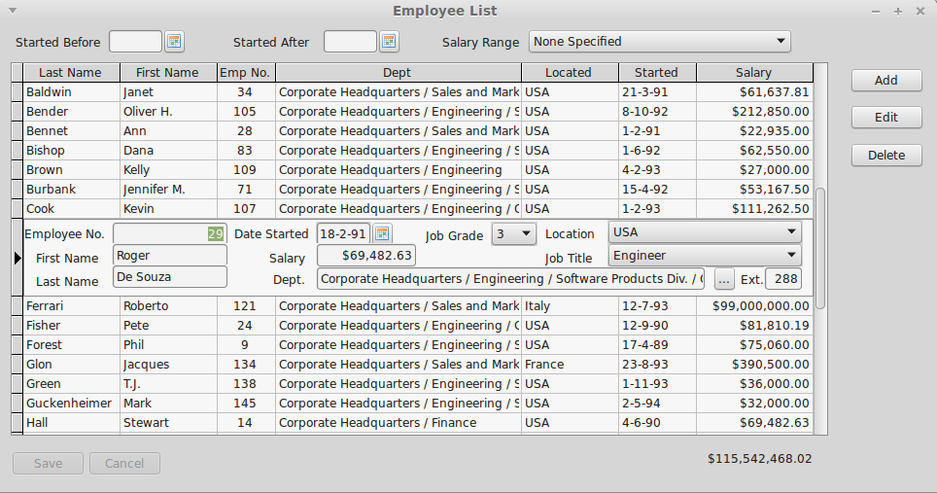Illustration 2: TIBDynamicGrid with an Edit Panel Visible

Column Properties
Most of TIBDynamicGrid's new features are accessed via the column editor and are properties of each column in the grid. The new column properties are given below.
AutoSizeColumn | Boolean | If true then the column is automatically resized to fill the grid. More than one column can have this property set to true.
ColumnTotalsControl | TControl | Optional. Used to identity a control (typically a TDBEdit or TDBText) to be kept in vertical alignment with the column, and to have the same width. Note that the horizontal positioning is unaffected by grid resize, and hence the total can be placed either above or below the grid.
InitialSortColumn | Boolean | Identifies the column used to sort the grid when the dataset is first opened.
DBLookupProperties | TDBLookupProperties | These are copied to a TIBLookupComboBox when it is used as a column editor. Setting TDBLookupProperties.ListSource implictly requests this as the column editor instead of a normal pick list.

TIBDynamicGrid New Properties
EditorPanel | TControl | When set, this control (typically a TPanel or Tframe) is used as the Editor Panel (see below).
ExpandEditorPanelBelowRow | Boolean | When set and an editor panel displayed, the row height is set to the current row height plus the panel height and the Editor Panel placed under the row. That is, the original row is still displayed with the editor panel beneath it. The default is that the editor panel appears to replace the row.
AllowColumnSort | Boolean | Enables column sorting by column header click (default true).
Descending | Boolean | Determines the initial sort order. Default is false i.e. ascending sort order.
DefaultPositionAtEnd | Boolean | Determines the initial focus row when the dataset is first opened. If true then the last row has focus, otherwise the first row. Default: false.
IndexFieldNames | String | This is a list or one or more dataset fieldnames. Typically this is the primary key for the dataset. Used for automatic reselection of rows after the dataset is reopened.

TIBDynamicGrid new Events
OnBeforeEditorHide | This event is called before the Editor Panel is hidden. Can be used to validate changes.
OnEditorPanelShow | This event is called after the Editor Panel is made visible
OnEditorPanelHide | This event is called after the Editor Panel is hidden. Can be used to do any additional tidying up needed.
OnKeyDownHander | The TIBDynamicGrid uses a KeyDown handler to intercept edit keys while the Editor Panel is active. For example, to process an “escape” key as a cancel edit. You can write your own keydown handler to modify this behaviour.
OnColumnHeaderClick | Called when a column header is clicked and before the dataset is re-sorted. Can be used to modify the column index for the sort.
OnUpdateSortOrder | Called when the dataset select SQL is being modified prior to resorting the dataset. Can be used to modified the SQL “Order by” clause. For example, to add a subsort column. For example, useful when one column has a “year” and the next column is the “month”. Clicking on “year” can then made to subsort on “month”.

