**Introduction To Engineering Design**

ENGINEERING DESIGN DEFINITION

In the study of science we seek to develop theories that explain natural phenomena. Scientific theories consist of a statement or set of statements that define some kind of ideal or theoretical system. These scientific principles, which are self-evident in the natural sciences, are also employed in the engineering sciences. Engineering science subjects such as thermodynamics, mechanics and materials science are generally based on established scientific principles like the first and second laws of thermodynamics, Newton's laws, and atomic and molecular theories of matter respectively.

Engineering design is quite different since theories and hypotheses cannot be developed or tested by laboratory experiments. Engineering design involves much broader issues including the consideration of people and organizations. It must therefore be regarded as a technology. This is particularly so since no single absolute answer can be found for any problem which involves both design decisions and compromise, since almost inevitably design parameters are contradictory.

Having established that engineering design is a technology it is necessary to present a definition. Many attempts at a definition have been made, particularly in the search for a snappy, short definition, but all attempts to date have been defeated. The dictionary definition of design is often *to fashion after a plan', which tells us very little about the way of working that we call engineering design. What follows is an amalgam of definitions for both the process and practitioners taken from the UK based Institution of Engineering Designers and the engineering design lecturer organization, SEED Ltd (Sharing Experience in Engineering Design).

*Engineering design is the total activity necessary to establish and define solutions to problems not solved before, or new solutions to problems which have previously been solved in a different way. The engineering designer uses intellectual ability to apply scientific knowledge and ensures the product satisfies an agreed market need and product design specification whilst permitting manufacture by the optimum method. The design activity is not complete until the resulting product is in use providing an acceptable level of performance and with clearly identified methods of disposal.*

In order to increase our understanding of design it is helpful to extend this definition and to identify and highlight the main characteristics of engineering design:

* Trans-disciplinary
* Highly complex
* Iterative.

Most engineering design is now a trans-disciplinary team effort and the distinctions between the traditional disciplines, mechanical, electrical, electronic, civil and even chemical engineers are becoming blurred. Relatively new areas of engineering specialization, such as control and software engineering should be added to this list.

Consider for example automobiles, which not so very long ago were the sole province of mechanical engineers. Complex engine management systems, anti-lock braking systems, active suspension systems, four-wheel steering, air bags, and automatic seat belt tensioning are just some of the new developments. These systems are highly complex and require input from many different kinds of engineers for their optimum design. Also, the selection of the appropriate technology for each part of a truly integrated design has become critical to the success of the product. Only engineers with a broad understanding of all potentially useful technologies and all the issues involved can make optimal decisions.

As an illustrative example we can usefully consider anti-lock braking systems (ABS). Perhaps because traditionally automobile design was the province of the mechanical engineer, the first anti-lock braking systems introduced were purely mechanical in nature. Although the performance of mechanical units was considered to be adequate in the early stages, their performance has since been surpassed by integrated systems which include software, electronic and mechanical technologies. Purely mechanical systems cannot match the performance levels which can be achieved by integrated designs.

An ABS, as the name suggests, improves braking performance by preventing wheel lock. A modem system can be seen in Fig. 1.3 with (a) being the general layout and (b) being the electronic circuit diagram. In the complete description of the system a hydraulic circuit diagram would also be required along with component details. Such systems allow braking to occur without impairing directional control and shorten braking distances considerably. This is accomplished by sensing the speed of each wheel along with wheel acceleration, comparing this to forward speed and modulating brake pressure accordingly.

The complexity of the complete system shown in Fig. 1.3 (a) and (b) serves to illustrate the need for inter-disciplinary engineering design teams. The main components in the general layout are:

1. Front wheel sensor
2. Front pulse wheel
3. Hydraulic modulator
4. Control unit
5. Rear wheel sensor
6. Rear pulse wheel
7. Indicator lamp
8. Brake tubes.

The induction sensors are used to signal wheel speed information to the control unit (computer). Signals are received by the control unit as sinusoid voltages and converted to digital signals for processing in the logic circuits. The main components in the electrical layout are:

1. Battery
2. Ignition switch
3. Alternator

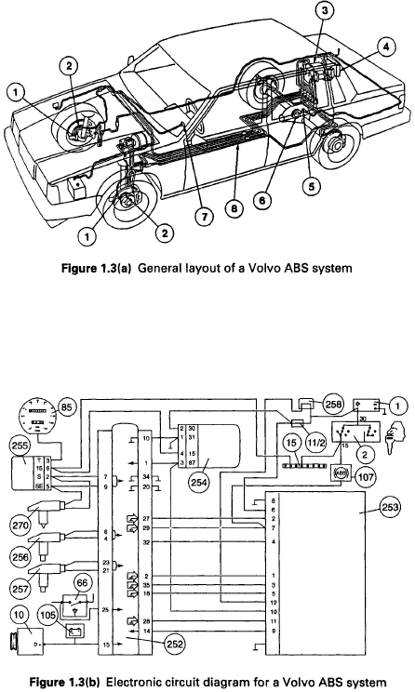

(11/2) Fuse

(15) Distribution coil

(66) Brake switch

(85) Speedometer

(105) Charging lamp

(107) Indicator lamp

(252) Control unit

(253) Hydraulic modification

(254) Surge protection unit

(255) Speedometer converter unit

(256) Sensor - left front

(257) Sensor - right front

(258) ABS Fuse box

(270) Sensor - rear wheels.

It is not possible to give a complete and detailed account of the design of anti-lock braking systems in this text, nor is it desirable. However, it is important to note that a design such as this is very soon superseded. The detailed information presented regarding ABS is reproduced with the kind permission of Volvo Car Corporation, whose designs have become more sophisticated. For example, the S80 is available with the active chassis system DSTC (Dynamic Stability and Traction Control). This system uses a number of sensors, including a yaw angle sensor, to compare the way the car is handling with the way

it ought to be behaving. DSTC then retards the appropriate wheel or wheels in order to stabilize the car. Volvo describe DSTC as an invisible hand which keeps the car on the road, even in extremely slippery conditions!

The purpose in using ABS as an example is purely to reinforce the stated definition of engineering design and to illustrate the technical and human interface complexities which are encountered in modem systems design. Along with this definition of the design process it is illuminating to consider the job description of an engineering designer. Although this can vary in detail, in general an engineering designer must be capable of dealing with the following:

* The production of practical design solutions starting from a limited definition of requirements
* taking into account many factors.
* The production of design schemes, analysis, manufacturing drawings and related documentation within defined timescales.
* The assessment of the design requirements of a particular component, system, assembly or installation in consultation with other departments.
* The production of designs which will favourably influence the cost and functional quality of the product and improve profitability and/or the company's reputation with customers.
* The undertaking of feasibility studies for future projects.
* Negotiations with vendors on aspects of bought out components and equipment, and with subcontractors or partner firms on interfaces.
* The assessment of the work of others.

The personal characteristics, derived from these responsibilities, which a design engineer

must possess are:

* ability to identify problems
* ability to simplify problems
* creative skills
* sound technical knowledge
* sense of urgency
* analytical skills
* sound judgement
* decisiveness
* open mindedness
* ability to communicate
* negotiating skills
* supervisory skills.

These abilities and skills are possessed by everyone to a greater or lesser extent. They are developed in engineering designers over a period of time, mainly by the practice of engineering design and by exposure to the design process.

THE ENGINEERING DESIGN PROCESS

The cost of a product, particularly in international markets, is only one factor which has a bearing on success. Reliability, fitness for purpose, delivery, ease of maintenance and many other factors have a significant influence and many of these are determined by design. Good design is therefore critical for success both in national and export markets and can only be ensured by adherence to a formal design process.

The engineering design process in its simplest form is a general problem solving process which can be applied to any number of classes of problem, not just engineering design. It must be remembered that the design process as outlined will not produce any design solutions. The aim in recommending a design process to adopt is to support the designer by providing a framework or methodology. Without such a process there is the very real danger that when faced with a design problem and a blank sheet of paper the young engineer will not know how to begin. The rigorous adherence to the process as outlined later will free the mind, which can become extremely cluttered during a project, so that more inventive and better reasoned solutions emerge.

A systematic approach permits a clear and logical record of the development of a design. This is useful if the product undergoes development and redesign. Also, the disturbing trend of law suits against companies and individuals often means that the designer must be able to prove that best practices were employed. This can best be established by reference to comprehensive supporting documentation, such as records of the decisions made and reasons why they were made.

If we accept the need for a systematic approach, how and in what order should we consider the influencing factors? There are several suggested systems which vary in detail but are basically similar. Figure 1.4 illustrates the design process as presented by Pahl and Beitz (G. Pahl and W. Beitz (1984) *Engineering Design,* London, Design Council) and Fig. 1.5 is that recommended by SEED. Study of the two figures reveals an underlying similarity with the basic process being to identify the problem, generate potential solutions, select from the solutions, refine and analyse the selected concept, carry out detail design and produce product descriptions which will enable manufacture. Quite obviously for

both models to be complete they must be extended to include use and recycling or disposal.

The SEED (Pugh) model is the one we will be following throughout the text. As indicated by the return lines, design is an iterative process involving much back tracking and parallel activity. This is normal. The principle of iteration is the fundamental principle of the design process. Designing something new is like a voyage of discovery. As the design progresses, more and more information is discovered and more knowledge gained. If the designer does not iterate the new information, concepts emerging would not be acted upon. The systematic approach is not a series of instructions to be followed blindly. There is never a unique solution.

Some words of caution. Engineering design is not always a sequential process, nor can it be neatly divided into discrete activities each of which must be fully completed before the next is begun. This is why feedback loops are always included on any diagram of the design process. However, the reader should be aware that even this does not do justice to the necessary continual iteration and that all steps in the design process are often going on simultaneously. Also, an engineering designer is rarely completely satisfied with the solution arrived at. This is partly due to the principle of time. If a company is to maximize its profits from the labours of a design team then the shortest possible time must be taken in getting the product launched. It is inevitable therefore that with a second look the product could be improved. This lack of perfection often causes dissatisfaction and must be accepted as a consequence of working as an engineering designer.

The first and most important stage in the design process as outlined in Fig. 1.5 is the formulation of a Product Design Specification (PDS). This is especially important as international trade becomes simpler and competitiveness becomes harder to achieve. Companies must use a logical and comprehensive approach to design if they are to profit from their labours. Therefore an all encompassing problem definition which is used to audit and guide the remainder of the design process is essential.

The process of design is always the same and is not dependent on the size or complexity

of the problem. However, it is almost always subject to unforeseen complications and a

flexible design management approach is essential.

GENERAL EXAMPLE

As a simplified illustration of the design process consider the problem of building an extension to a court house. The brief stated that the whole of the works must be carried out with the existing court in full operation and, due to national terrorist activity, that bomb blast protection be provided. The requirement was:

* A new courtroom
* Offices, stores and amenities for ushers and clerks
* A new boiler room.

**Specification**In order to develop a full and detailed specification of the problem many initial investigations were carried out. Drawings of the existing building were obtained but, as is normal, no original strength calculations were available and depth of foundation piles was not known. A site survey was undertaken and a geotechnical investigation revealed that the ground was poor down to depth of 21 m. Samples extracted from bore holes were laboratory tested enabling moisture content, chemical composition and particle sizes to be obtained.

**Concept generation**Having defined the specification, including the relevant British Standards for foundations (BS 8004), structural use of concrete (BS 8110) and notes on blast resilient designs, the next stage was to consider alternative concepts. After initial brainstorming and the consideration of many concepts only three were considered worthy of investigation. These were:

(1) add an additional storey;

(2) infill at ground floor level and extend at ground floor level;

(3) an additional two storey building linked with corridors.

**Concept selection**Concept 1 was ruled out since on investigation the existing piles were found to be fully loaded and the cost of strengthening the structure would be prohibitive. Concept 3 was ruled out because it was impossible to allow for sufficient daylight reaching existing windows. Concept 2 was selected because it presented the optimum solution, when compared with the specification, including customer requirements.

**Detail design**Having made this overall decision, further detailed investigation was necessary, with much engineering science and materials knowledge being employed. Decisions such as whether to use driven or angered piles and use ground beams or slabs had to be made. Above foundation level masonry stability, vertical, shear and bending loading capacities needed to be calculated.

**Manufacture**Once this detail design stage had been completed the construction phase could begin. This phase can be likened to prototype manufacture prior to mass production of products.

The project reported was very complex and was completed slightly ahead of schedule within the customer's budget. Many engineering projects do not go so well which, in most cases, can be traced back to a lack of adherence to the iterative step-by-step approach being advocated. In this case the design process was followed rigidly. Effective lines of communication established at the outset of the project were just as instrumental in the success of this project as the engineering expertise employed.

ENGINEERING DESIGN INTERFACES

As outlined earlier it is essential that a design engineer has good communication skills. This can be further reinforced by study of Fig. 1.6 which gives an indication of the most frequently used lines of communication, both within the design department and outside. As explained earlier the design process begins with a design brief or Product Design Specification. This then is the major trigger which causes the design department to act.

Two broad types of communication can be identified, internal and external. Those internal communications with the design department may include defining input parameters for computation, discussion and information transfer with other relevant design groups, informing the drawing office by such means as scheme drawings and materials specifications, gaining approval for proposals from the originator and answering the questions of reviewers at design audit meetings.

External communications both with other departments and outside the company are easier to define than internal communications and are probably of greater importance. Those identified in Fig. 1.6 are the main lines of communication although many others exist. In detail the types of communication with other departments and outside are:

**Sales**There is continuous two way communication between the design and sales departments. The sales department supply customer requirements and the design department supplies technical descriptions, performance data and predictions.

**Purchasing**This is generally one way communication with the design department supplying the technical information essential for the purchasing department to buy in components.

**Analysis/Specialists**Within companies there are many specialists who are often consulted by the design team. These may include standards, materials and stress analysis experts, amongst many others.

**Manufacturing**Although this is indicated as a one way communication process in Figs 1.4 and 1.5, with design supplying working drawings to manufacturing, many other links exist. During all design review meetings at least one representative of the manufacturing department will be present to ensure optimum manufacturing methods are being specified by the design team. This is part of what has become known as concurrent engineering, which serves to shorten the time taken from initial concept to the production of the first products for sale. Also, manufacturing departments provide feedback to

design and request design changes which ease manufacture.

**Commissioning and Maintenance**This is generally a one way process with information being fed back to the design department when problems are encountered.

**Development**In smaller companies design and development form one department which is an indication of how closely linked the two departments are. In the development department tests are carried out on particular aspects of design concepts generally by manufacturing the design and performing accelerated tests or by simulations. The results of these tests are fed back to the design team.

**Subcontract**There are very few companies which have the facilities to manufacture fully everything they sell. Also, it is often cheaper, due mainly to economies of scale, for components to be bought in. It is necessary for the design team, in conjunction with the purchasing department, to communicate with potential subcontractors and to use their expertise.

As already discussed, not only do design engineers need to communicate with many different people in many different departments they also require inter-disciplinary skills encompassing the many different fields of engineering. However, the required breadth of knowledge cannot be gained in the classical academic way. As illustrated in Fig. 1.7 industry requires engineers who have complete knowledge in all disciplines. By contrast traditional academic courses tend towards producing people who know everything about very narrow subject areas. There is also a very real danger that engineering designers

will not develop the required level of detailed knowledge to complement the required breadth. Thus, in the final illustration in Fig. 1.7 the design engineer is shown as having broad knowledge complemented by 'ears' of detailed knowledge.

PRINCIPLES

Throughout the book engineering design principles which are identified are presented at the end of each chapter.

Introductory principles

**Iteration**Progress towards a solution should involve all the stages identified in order, but much backtracking is essential. This is the nature of engineering design.

**Compromise***A* perfect or single solution rarely emerges and the best that can be achieved is an optimum solution. That is a design which best satisfies the customer.

**Complexity**Engineering is a technology, not a science, so along with the engineering science knowledge used the importance of communication, teamwork, project management and ergonomics cannot be underestimated.

**Responsibility**There is the potential for many failures to occur due to negligence or oversight and the ultimate responsibility for safe and correct 'products' rests squarely on the shoulders of the professional engineering designer.

**Simplification**In general the simplest solution is the best and all professional engineers seek elegant and simple solutions.

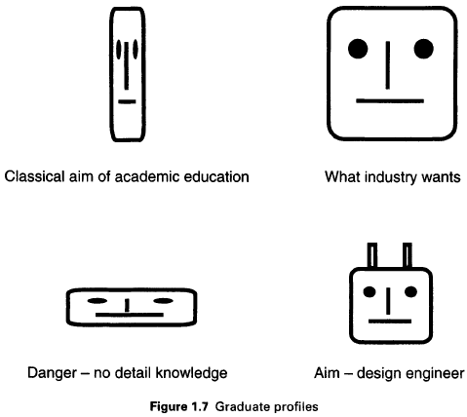

As a final thought consider the alternative, humorous though cynical, design process suggested by Dr Glockenspiel:

(1) Euphoria

(2) Disenchantment

(3) Search for the guilty

(4) Punishment of the innocent

(5) Distinction for the uninvolved.