**Logic**

A complete programming language includes facilities to implement sequential constructs, in which one statement follows another and the statements are executed in order, and two other constructs, which represent modifications of sequential constructs.  Selection constructs represent different paths through the set of instructions.  Iteration constructs represent repetition of the same set of instructions until a specified condition has been met.  The three classes of constructs required to complete a programming language are illustrated in the figure below.

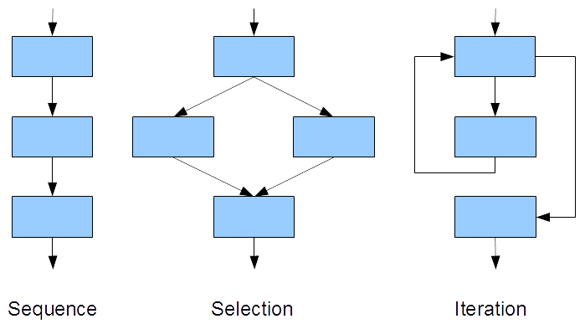

Since programmers who maintain application software are typically not those who develop that software originally and the maintenance programmers may change throughout the lifetime of a software application, it is critical that the software is not only readable but also easy to upgrade and maintain.  The principles of structured programming, which were developed in the 1960s, provide important coding guidelines that respect this objective.

This chapter introduces the selection and iteration constructs supported by the C language and describes how to implement structured programming principles in coding iterations.

Structured Programming

A structured program consists of sets of simple constructs, each of which has one entry point and one exit point.  Any programmer may replace one construct with an upgraded construct without affecting the other constructs in the program or introducing errors ("bugs").

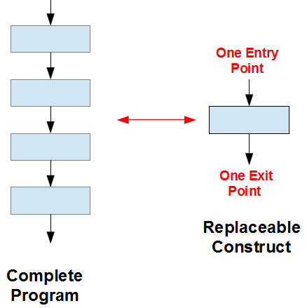

The simplest example of a structured construct is a *sequence*.  A sequence is either a simple statement or a code block.  A *code block* is a set of statements enclosed in a pair of curly braces to be executed sequentially.

For example (more practical examples below)

|  |  |
| --- | --- |
| // single statement (original)  printf("I like pizza\n"); | // code block (upgrade)  {  printf("I like pizza\n");  printf("I want more pizza\n");  } |

Unlike a single statement, a C code block does not require a terminating semi-colon of its own (after the closing brace).

Preliminary Design

During the design stage of a programming solution, it is helpful to outline the steps involved.  Well-established techniques include:

* pseudo-coding
* flow charting

Clear and concise pseudo-code or flow charts improve chances are that our coding will also be clear and concise.

Pseudo-Code

*Pseudo-code* is a set of shorthand notes in a human (non-programming) language that itemizes the key steps in the sequence of instructions that produce a programming solution.  For example, the pseudo code for calculating the change in a vending machine might look something like

|  |
| --- |
| 1) declare variables for quarters and nickels  2) calculate the number of quarters in the change  3) calculate the remainder to be returned in nickels  4) output the change in quarters and nickels |

Flow Charts

A *flow chart* is a set of conventional symbols connected by arrows that illustrate the flow of control through a programming solution.  Popular sets of symbols for sequences, selections and iterations are shown below

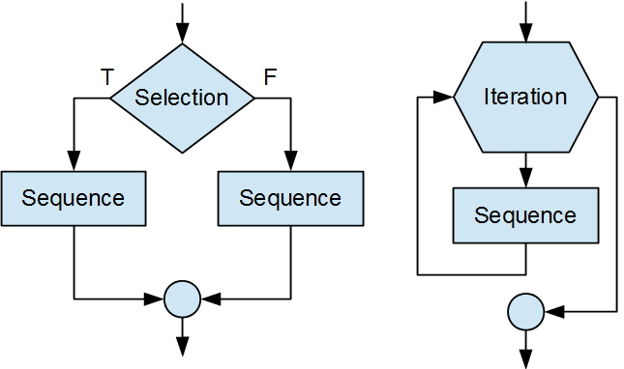

Usage of these sets with the C language is illustrated below.

Selection Constructs

The C language supports three selection constructs:

* optional path
* alternative paths
* conditional expression

The flow charts for these three constructs are shown below.

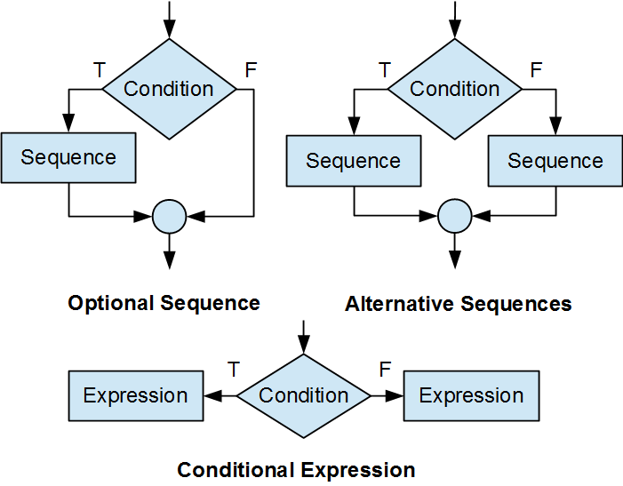

Optional Path

The simplest selection construct executes a sequence only if a certain condition is satisfied; that is, only if the condition is true.  This optional selection takes the form

if (*condition*)

*sequence*

Parentheses enclose the condition, which may be a relational expression or a logical expression.  The sequence may be a single statement or a code block.

For example,

|  |  |
| --- | --- |
| if (likePizza == 1)  printf("I like pizza\n"); | if (likePizza == 1) {  printf("I like pizza\n");  printf("I want more pizza\n");  } |

The program executes the sequence only if likePizza is equal to 1.  Otherwise, the program bypasses the sequence altogether.

Alternative Paths

The C language supports two ways of describing alternative paths: an binary select construct and a multiple selection construct.

Binary Selection

The binary selection construct executes one of a set of alternative sequences.  This construct takes the form

if (*condition*)

*sequence*

else

*sequence*

Parentheses enclose the condition, which may be a relational expression or a logical expression.  The sequences may be single statements or code blocks.  The program executes the sequence following the if only if the condition is true.  The program executes the sequence following the else only if the condition is false.

For example,

|  |  |
| --- | --- |
| if (likePizza == 1)  printf("I like pizza\n");  else  printf("I hate pizza\n"); | if (likePizza == 1) {  printf("I like pizza\n");  } else {  printf("I hate pizza\n");  printf("I don't want pizza\n");  } |

Multiple Selection

For three alternative paths, we append an if else construct to the else keyword.

For example,

if (*condition*)

*sequence*

else if (*condition*)

*sequence*

else

*sequence*

If the first condition is true, the program skips the second and third sequences.  If the first condition is false, the program skips the first sequence and evaluates the second condition.  The program executes the second sequence only if the first condition is false and the second condition is true.  The program executes the third sequence and skips the first two only if both conditions are false.

Compound Conditions

The condition in a selection construct may be a compound condition.  A compound condition takes the form of a logical expression.

For example,

|  |
| --- |
| if (age > 12 && age < 16)  printf("Student Fare - no id required\n");  else if (age > 15 && age < 20)  printf("Student Fare - id is required\n");  else if (age < 13)  printf("Child ride for free!\n");  else if (age >= 65)  printf("Senior Fare - id is required\n");  else  printf("Adult Fare\n"); |

Case-by-Case

The case-by-case selection construct compares a condition - simple or compound - against a set of constant values or constant expressions.  This construct takes the form

switch (*condition*) {

case *constant*:

*sequence*

break;

case *constant*:

*sequence*

break;

default:

*sequence*

}

If the condition matches a constant, the program executes the sequence associated with the case for that constant.  The break; statement transfers control to the closing brace of the switch construct.  Braces around the statements between case labels are unnecessary.

If a break statement is missing for a particular case, control flows through to the subsequent case and the program executes the sequence under that case as well.

The program executes the sequence following default only if the condition does not match any of the case constants.  The default case is optional and this keyword may be omitted.

For example, the following code snippet compares the value of choice to 'A' or 'a', 'B' or 'b', and 'C' or 'c' until successful.  If unsuccessful, the code snippet executes the statements under default.

|  |
| --- |
| char choice;  double cost;  printf("Enter your selection (a, b or c) ? ");  scanf("%c", &choice);  switch (choice) {  case 'A' :  case 'a' :  cost = 1.50;  break;  case 'B' :  case 'b' :  cost = 1.10;  break;  case 'C' :  case 'c' :  cost = 0.75;  break;  default:  choice = '?';  cost = 0.0;  }  printf("%c costs %.2lf\n", choice, cost); |

Conditional Expression

The conditional selection construct is shorthand for the alternative path construct.  This ternary expression combines a condition and two sub-expressions using the ? : operator

*condition* ? *operand* : *operand*

If the condition is true, the expression evaluates to the operand between ? and :.  If the condition is false, the expression evaluates to the operand following :.

For example,

|  |
| --- |
| int main()  {  int minutes;  char s;  printf("How many minutes left ? ");  scanf("%d", &minutes);  s = minutes > 1 ? 's' : ' ';  printf("%d minute%c left\n", minutes, s);  return 0;  } |

If the operands in a conditional expression are themselves expressions, the conditional expression only evaluates the operand identified by the condition.