**MobaXTerm Installation**

1. Download and install MobaXTerm (Home Edition, Installer) from: <https://mobaxterm.mobatek.net/>
2. Get the IP address of the Ubuntu machine in your virtual machine: ifconfig

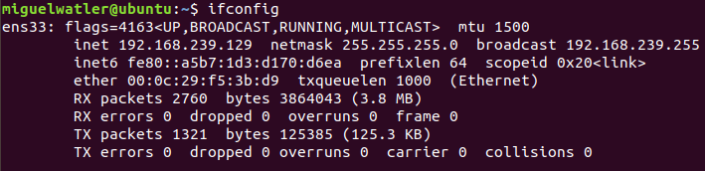

1. Create an SSH session in MobaXTerm by providing the IP address of your virtual machine and your username. Make sure you have the ssh server installed on your virtual machine. If you do not, then install it: **$ sudo apt install openssh-server**

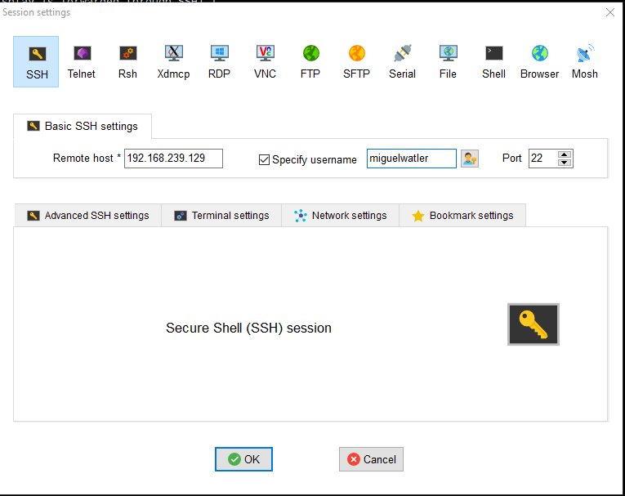

1. You will now be able to log into your Ubuntu machine from your desktop as if it were a separate machine. MobaXterm makes it much easier to write code than the console on VM Ware. It is widely used in industry.

