PROPOSAL FOR AN MWA-PUBLICATION

[Date circulated: 2014-10-02]

Publication title: | The low-frequency Murchison radio environment: interference analysis and mitigation
Principal contact:  The Principal Contact must be an Individual Member of the MWA collaboration (as defined  in the MWA Membership Policy) and cannot be  a student. This does not have to be the same  person as the primary author. Please provide  institution affiliation and email address. | André Offringa  Astron (Netherlands Institute for Radio Astronomy)  offringa@astron.nl
Author List:  Please specify all authors of the paper. It is sufficient to reference the Builders List without writing the names on that list, but all additional authors must be explicitly stated. | A. R. Offringa, R. B. Wayth, N. Hurley-Walker, D. Kaplan, the EoR, GLEAM and builders lists.
Anticipated date of draft submission for Collaboration review: | 1 december 2014
Intended journal: | PASA
Paper Summary:

We describe the cotter preprocessing pipeline, specifically the mitigation of radio-frequency interference (RFI) in MWA data, and analyze results from the RFI detection.

cotter is a preprocessing pipeline for MWA data, that takes the data from the GPU correlator boxes and converts it into a standardized format (CASA measurement sets or uvfits files). It implements RFI detection using the aoflagger library. Implementing RFI detection efficiently is a challenging issue, due to the large data volumes of MWA observations and the data reordering which is necessary for flagging. To minimize IO overhead, cotter simultaneously performs various other tasks on the data: it applies bandpass gain corrections; corrects the phases for varying cable lengths; calculates the uvw-coordinates; applies phase tracking to the desired sky coordinates; flags samples from the correlator that are missing or incorrect; and allows averaging the observation in frequency or time direction to reduce the data volume. It also collects various statistics.

We will show results of 10 observation nights (4 EoR and 6 GLEAM nights) and a few specific RFI testing observations. These are all processed with cotter, and the RFI environment is analyzed with the help of the outputted statistics. We will show a few examples of common RFI types, describe the amount of data lost due to RFI, and show its dependency on frequency (see Fig. 1). Additionally, the residual data will be analyzed for false negatives (RFI leakage). These results will be compared to the LOFAR results (Offringa et al. 2013a, http://arxiv.org/abs/1210.0393 ) at the same frequency, including the RFI brightness distributions as in Offringa et al. (2013b, http://arxiv.org/abs/1307.5580 ).

[page 1/2]

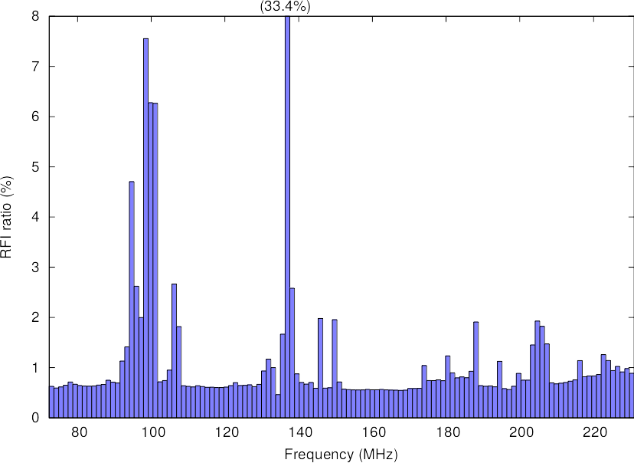

Fig. 1: Average detected RFI per sub-band (preliminary)

