数据库实例：

S2L1M00LC\SIPLACE_2008R2EX

S2L2M00LC\SIPLACE_2008R2EX

S2L3M00LC\SIPLACE_2008R2EX

S2L4M00LC\SIPLACE_2008R2EX

S2L5M00LC\SIPLACE_2008R2EX

账号：sa

密码均为：Siplace.1

第一步：每条线搜索对应的贴片机名字和站点，如下

select strStation, lId from SiplaceOIS..V_Station3 where strLine = 'SEWC-Lines\Line1'；

select strStation, lId from SiplaceOIS..V_Station3 where strLine = 'SEWC-Lines\Line2'；

select strStation, lId from SiplaceOIS..V_Station3 where strLine = 'SEWC-Lines\Line3'；

select strStation, lId from SiplaceOIS..V_Station3 where strLine = 'SEWC-Lines\Line4'；

select strStation, lId from SiplaceOIS..V_Station3 where strLine = 'SEWC-Lines\Line5'；

得到结果：

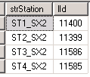

第二步：by station name搜索抛料的track

select recipe.lIdTrack, min(dtStart) as dtStart, max(dtEnd) as dtEnd from SiplaceSIS..V_Recipe as recipe where strStation = 'ST1_SX2' AND strLine = 'SEWC-Lines\Line4' group by recipe.lIdTrack order by dtStart

倒叙排列，查询时间段：‘2017-10-17 00:00:00’~‘2017-10-18 00:00:00’即找到记录：

（**红色部分**）

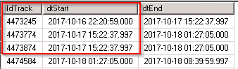

第三步：依次带入第二步的lIdTrack找到对应位置的component

select

Track.ucTable as [Table],

Track.sTrack as [Track],

Track.ucTower as [Tower],

Track.sLevel as [Level],

Track.sReceptacle as [Division],

Track.strPartNumber as [Component]

from

SiplaceSIS..V_TRACK as Track

where

Track.lIdTrack = '4473245'

group by

Track.ucTable,

Track.sTrack,

Track.ucTower,

Track.sLevel,

Track.sReceptacle,

Track.strPartnumber；

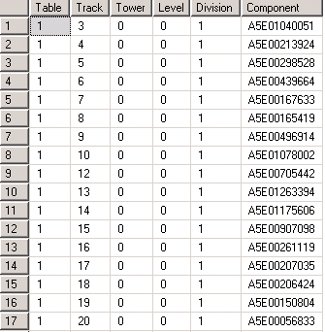

第四步：带入第一步搜索到的站点编号11400，第二步搜索到的starttime，此处需注意开始时间需从'2017-10-17 00:00:00.000开始，获取抛料数据

select

sum(sAccessTotal) as [Total],

sum(sRejectIdent) as [CameraReject],

sum(sRejectVacuum) as [VacuumReject],

usedcomponents.ucTable as [Table],

usedcomponents.sTrack as [Track],

usedcomponents.ucTower as [Tower],

usedcomponents.sLevel as [Level],

usedcomponents.sReceptacle as [Division]

from

SiplaceOIS..V_UsedComponents3 as usedcomponents

where

usedcomponents.lId = '11400'

AND dtTime between '2017-10-17 00:00:00.000' and '2017-10-17 15:22:37.997'

group by

usedcomponents.ucTable,

usedcomponents.sTrack,

usedcomponents.ucTower,

usedcomponents.sLevel,

usedcomponents.sReceptacle

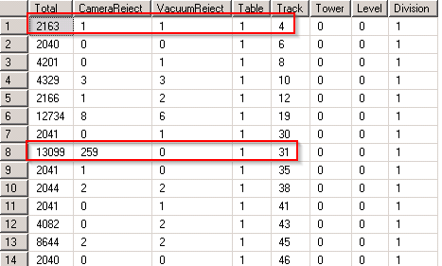

第五步：by 第四步的table和Track，去第三步找到对应的component

SELECT * FROM (

select

Track.ucTable as [Table],

Track.sTrack as [Track],

Track.ucTower as [Tower],

Track.sLevel as [Level],

Track.sReceptacle as [Division],

Track.strPartNumber as [Component]

from

SiplaceSIS..V_TRACK as Track

where

Track.lIdTrack = '4473774'

group by

Track.ucTable,

Track.sTrack,

Track.ucTower,

Track.sLevel,

Track.sReceptacle,

Track.strPartnumber) T1 JOIN (select

sum(sAccessTotal) as [Total],

sum(sRejectIdent) as [CameraReject],

sum(sRejectVacuum) as [VacuumReject],

usedcomponents.ucTable as [Table],

usedcomponents.sTrack as [Track],

usedcomponents.ucTower as [Tower],

usedcomponents.sLevel as [Level],

usedcomponents.sReceptacle as [Division]

from

SiplaceOIS..V_UsedComponents3 as usedcomponents

where

usedcomponents.lId = '11400'

AND dtTime between '2017-10-17 00:00:00' and '2017-10-17 15:22:37.997'

group by

usedcomponents.ucTable,

usedcomponents.sTrack,

usedcomponents.ucTower,

usedcomponents.sLevel,

usedcomponents.sReceptacle) T2 ON

T1.[Table] = T2.[Table] AND T1.Track = T2.Track

第六步：change Track，change starttime重复三四五

第七步：change station重复二三四五

最后得到

|  |  |  |  |  |  |  |
| --- | --- | --- | --- | --- | --- | --- |
| Component | Waste type | Reject qty | Placed qty | Price | Time | Line |
| A5E00213924 | Camera | 1 | 3243 | 5 | 2017-10-17 | 'SEWC-Lines\Line4 |
| A5E00213924 | Vacuum | 1 | 3243 | 5 | 2017-10-17 | 'SEWC-Lines\Line4 |