**Create a web service + java + Eclipse + tomcat   
By: Rahul Akula**  
https://www.youtube.com/watch?v=zn8vLBOEhic  
  
@0:15: Creating new dynamic web project.  
Axis2: Apache Axis2™ is a Web Services / SOAP / WSDL engine, the successor to the widely used [Apache Axis](http://ws.apache.org/axis/) SOAP stack. <http://axis.apache.org/axis2/java/core/>  
  
@0:19: Project Name: AddServiceServer  
@0:19: Target Runtime: Apache Tomcat v6.0

Name: AddServiceServer  
@0:27: Configuration: MODIFY -->  
@0:29: Check “Axis2 Web Services” in “Project Faces” panel on the left.  
Of the menu titled “Project Facets”

|  |
| --- |
| Trouble Shoot: <http://stackoverflow.com/questions/12434305/how-can-i-use-axis2-as-runtime-in-eclipse> When I try to enable Axis2 Web Services facets, I am getting this error "Axis2 Web services core1.1 requires Dynamic Web Module with version matching expression "2.2,2.3,2.4,2.5"." what does it mean? ANSWER: This means that when you create a new web project, in the first step of the wizard you have a combobox allowing you to select the Dynamic web module version. You should select one of the versions it suggests you to.  NOTE: Looks like your configurations may be out of date... Might create problems. But lets not be perfect. Let’s get something running. Swap out projects later. |

**If using Tomcat v7.0 or greater:  
BE CAREFUL!: If you screw this new-project setup up, you will not be able to edit it later:**

|  |
| --- |
| I just had the same issue. It turns out that Axis2 doesn't like the 3.0 dynamic web projects of Eclipse. Just create a new dynamic web project and choose "Dynamic Web Module Version" to be below 3.0, i.e. 2.5, 2.4. I used the 2.5 version and now everything works like a charm.  **Trying to change the version from the "Project Facets" in Preferences does not work :( so a new project must be made.** |

@0:32: Hit OK.  
@0:33: Hit Next.  
@0:35: Hit Finish.  
@0:35... WAITING FOR PROJECT TO BUILD.  
  
**TROUBLE SHOOT: Failed while installing Axis2 Web Services Core 1.1:**  
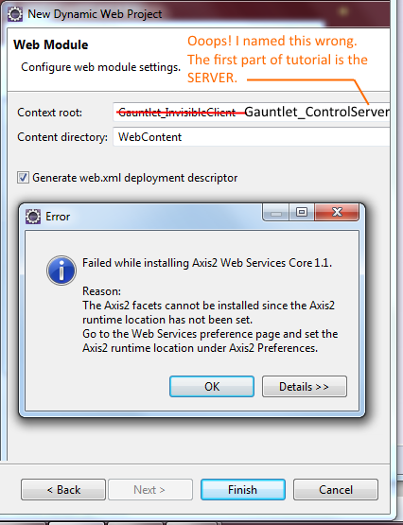

|  |
| --- |
| **Downloading and installing Axis2:** Get the binary: https://axis.apache.org/axis2/java/core/download.cgi  This link clues me to think: The binary distribution is the correct choice. (I am deciding if I need the .War distribution or the binary distribution to get this working) <http://www.eclipse.org/webtools/community/tutorials/TopDownAxis2WebService/td_tutorial.html>  Create environment variable on machine: AXIS2_HOME == somethingSomethingpath/axis2-1.6.3 Or whatever. |

**Below is my hack for another problem that will happen if your build crashes:**

|  |
| --- |
| Trouble Shoot: “A project with that name already exists” 1. Delete the project. 2. Delete data in your .metaData folder. |

Did you just install Axis2? HOLD ON!   
You are not done with your detour from the original tutorial just yet:  
**“Go to the web services preferences and set the Axis2 runtime location under Axis2 preference.”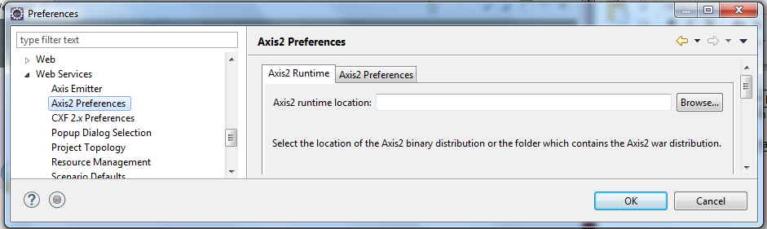 Trouble Shoot: Compiler Warning:**

|  |
| --- |
| No grammar constraints (DTD or XML Schema) referenced in the document.  Resource: axis2.xml  Path: /Gauntlet_InvisibleClient/WebContent/WEB-INF/conf  Location:line 1  Type:XML Problem  Solution: http://stackoverflow.com/questions/4551783/no-grammar-constraints-dtd-or-xml-schema-detected-for-the-document Add Doc Type: <?xml version='1.0' encoding='UTF-8'?>  <!DOCTYPE rootElement>  By looking at Axis2.xml, looks like the root element is**:  < axisconfig > So your doc-type wrapper should look like this: <!DOCTYPE axisconfig >** Note: This is a hack. Its the minimum you can get away with. But a better solution that “turn off compiler warnings for doc type.” Also: This w3 schools stuff was useful:  <http://www.w3schools.com/xml/xml_dtd_intro.asp>  File is also missing the XML declaration...SO... <?xml version="1.0"?> **<!DOCTYPE axisconfig >** |

@0:52: Expand “Java Resources” folder of project.  
@0:54: RIGHT CLICK on “Java Resources” folder.  
@0:54-0:56: New >Class  
@1:00: Source Folder: AddServicesServer/src  
@1:05: Let us write an operator class.  
Name: OperatorClass  
@1:11: (Either Next or Ok or something, can’t see screen)  
@1:13: Things are thinking. So it must have been “FINISH” button.  
@1:16: Inside OperatorClass.java  
@1:23: Let us write a method which implement addition.  
@1:45: Done writing function. Now going to convert it into a web service.  
@1:48: Right clicks <prjRoot> in project explorer. (AKA: AddServicesServer)  
@1:48-1:54: New --> Other;  
@1:52: Type: “Web Services” into Wizards search bar.  
@1:55: Select: “Web Service” inside “Web Services” folder.  
@1:56: Hit NEXT.  
@2:00- : Put function of class name in “Services Implimentation” text box.  
Hits “Browse” button to find.  
@2:06: Types “OperatorClass” into Class name search of “Browse Classes” dialog.  
@2:15: WAIT! SOMETHING IS WRONG! (Search is not working)  
@2:15: Backs out/cancels.  
@2:18: Under “Configuration” to the RIGHT of the first picture on the  
@2:18: Web Services dialog, he selects “Server Runtime Tomcat v6.0 Server”  
@2:19: Looks like he is double clicking.  
@2:19: DIALOG: “Service Deployment Configuration”  
@2:21: Under white-boxed area labeled: “Server runtime”  
Selects “Tomcat v6.0 Server at localhost under “Existing Servers”  
@2:22: Hits OK.  
@2:23: Back at “Web Services” Dialog Box.  
@2:23: Clicks BLUE TEXT: “Web Service Runtime: Apache Axis2”  
(It is the middle url looking text under the lable “Configuration”)  
(To the RIGHT of the first picture on this dialog.)  
  
@2:24-2:25: DIALOG: “Service Deployment Configuration”  
Selects:  
(*) Choose Web service runtime first. <--this radio option is selected on this menu.  
Inside Server runtime box: Existing Servers -> Tomcat v6.0 at localHost  
Inside “Web services runtime” box: Selects: Apache Axis2  
  
@2:26: Hits “OK”. Now in: DIALOG: Web Services. Again.  
@2:38: After all that work... hand types:  
“Operator Class” into “Service Implementation” text box.  
I thought the steps we were just doing were to solve the search problem???  
@2:40: (Hits next or finish. Can’t see bottom of screen.)  
@2:42: The wait time suggests it was “FINISH”  
@2:45: It was actually: NEXT --> FINISH. Because I see:  
“(*)Generate a default services.xml file” option checked on a menu now.  
And the computer is thinking.

|  |
| --- |
| Trouble Shooting: Eclipse is HANGING in the wizard:  https://bugs.eclipse.org/bugs/show_bug.cgi?id=225852  Please take a look at this problem. There are other users reporting hanging problem related to adding facet to projects in recent WTP drivers. Trung is trying to get a dump to see where the hang is occurring. He did noticed that it does not hang when "generate JUnit" is not checked.  After i clicked next on the first page of the wizard, I got to the page where I saw the check box for Junit. I noticed that there were still background jobs running (look at bottom right), but I still clicked Finish right away. Nevertheless, this is a legitimate usage scenario though.  **JMIM COMMENT: I recall it targeting that weird JRE folder that from all I know is NOT a JDK. We should go back to the JDK7 I downloaded that I know is an actual JDK.** Story: I download the JDK8 from oracle, and it gives me JRE8. I swear I am not making this up. I found it was odd that it was in a JRE8 folder instead ofa JDK folder.  I tried to make the problem happen to me as you have described, failed to reproduse. Can you tell us that you have any JAVA_VM options set in. Also assume you are using sun JDK.  The JUnit test case generation is in the WebServices preferences. Noted here: <https://wiki.eclipse.org/Creating_a_bottom-up_Axis2_Web_service> |

@2:49: “Currenty the server is stopped.” [ Start Server] <--button.  
@2:29: *CLICKS [Start Server] button. *  
@2:52-3:18: WAIT FOR SERVER TO START UP.  
@3:18: We are done! Hit [Finish]  
@3:18-3:39: Explores all the new stuff in projec t explorer.  
@3:39: And now we are done with the creation of a service.  
///////////////////////////////////////////////////////////////////////////////////////////

@3:47: MAKING ANOTHER DYNAMIC PROJECT!  
@3:54: Project name: “AddServicesClient”  
@3:56: Project Location: Use default location.  
@3:57: Configuration Section ---> [Modify]   
(Click the modify button on New Dynamic Web Project Dialog)  
@3:58: PROJECT FACETS DIALOG:  
@3:58: Check: “Axis2 Web Services”  
@4:00: Hit [ Ok ] button.  
@4:01: [Next] , [Finish]  
@4:02: PROJECT IS BUILDING....  
@4:15: Expands “AddServiceClient” in Project Explorer  
(Expands <PrjRoot> in Project Explorer)  
@4:16: Expands “Java Resources”  
@4:19: Right Clicks on <prjRoot> --> New --> Other  
@4:20-4:23: Search For “Web Services”  
@4:25: Select “Web Services **Client**”,   
@4:26: [NEXT]  
@4:27: DIALOG: “Web Services”  
@4:28: Service Definition Drop-Down... JUST KIDDING!  
@4:33: CANCELS??  
@4:40: RIGHT-CLICKS on “AddService**Server**” project. THE SERVER PROJECT!  
@4:46: JUST KIDDING!..  
@4:46: In Project Explorer:  
AddService**Server** / Java Resources / src / default package /....  
@4:50: RightClick “OperatorClass.java” and --> Run --> Run On Server

|  |
| --- |
| public class OperatorClass{  public int add(int a, int b){  return (a+b);  }//func  }//class |

@4:53: DIALOG: “Run On Server”  
@4:54: Select your tomcat installation.  
@4:54: Hit [ Next ].  
@4:54-5:12: Loading.... Please Wait.  
@5:12: DIALOG: “Run On Server : **Add and Remove**”  
@5:14: Configured Resources:  
1. AddServiceServer  
2. WERSC <--Is this important. Or just another thing he has running from an unrelated project?  
@5:15: Click [Finish].  
@5:24: 404!  
@5:37: Right Click on “AddServiceServer” project root in Project Explorer.  
@5:38: Run As -->Run On Server.  
@5:40: [ Finish] <click it.  
@5:47: <http://localhost11112/AddServiceServer>  
@5:47: Click “Services” hyperlink on Apache Software Foundation Axis home Page.  
@5:52: SWEET! Our operator class shows up!  
@5:53: Click on it!  
@5:55: Holy Hell... Look at all that XML...  
@5:56: Copying the current URL:  
<http://localhost:11112/AddServicesServer/services/OperatorClass.wsdl>  
@6:03: Going into the CLIENT project now. (AddServicesClient)  
(Within the Project Explorer)  
@6:03: Lol. I just realized “Add Services” is a funny pun. Wonder if that was intentional?  
@6:05: Right Click --> New --> Other -->  
@6:09: DIALOG: “New: Select a wizard.” Search for “Web Services”  
@6:10: Select: Web Service Client  
@6:11: Hit [ Next ]  
@6:12: DIALOG: “ Web Service Client: Web Services”  
@6:12: PASTE the URL into the “Service Definition”  
This URL: <http://localhost:11112/AddServicesServer/services/OperatorClass.wsdl>  
@6:15: Hit [ Next ]... I am joking. Don’t do that.  
@6:15: DIALOG: “ Web Service Client: Web Services”  
Under “Configuration”, hit the hyperlink looking thingy:  
“Server runtime: Tomcat v6.0 Server”  
@6:16: DIALOG: “Client Environment Configuration”  
@6:17: Everything looks good here.  
(*) Choose a server first, is selected radio button.  
Server Runtime: Tomcat Server at localHost  
Web Service Runtime: Apache Axis2  
@6:16-6:17: Hit [ Ok ]  
@6:17:  
Under “Configuration”, hit the OTHER hyperlink looking thingy:  
“Web service runtime Apache Axis2” (it is in the middle of the 3)  
@6:18: DIALOG: “Client Environment Configuration”  
(*) Choose a Web service runtime first, is selected radio button.  
Web Service Runtime: Apache Axis2  
Server runtime: Tomcat v6.0 Server at localhost.  
Hit [ Ok ]  
@6:19: Hit [Next ]  
@6:20: DIALOG: “Web Service Client: Axis2 Client Web Service Configuration”  
Service name: OperatorClass  
Port Name: OperatorClassHttpSoap11Endpoint  
Databinding: ADB  
Custom package name: org.apache.ws.axis2  
Client Mode: (*) Generate a client which supports both synchronous and asychronous invocation.  
@6:22: Hit [ Finish ]  
@6:22-6:26: Thinking.... (connecting to server?)  
@6:28: Woah... Where did “TestClient.java” come from?  
Auto generated? I wasn’t paying attention? Made before the tutorial started??  
@6:31: In Project Explorer:  
Goto: AddServicesClient / Java Resources / src / org.apache.ws.axis2

@6:32: Two auto-generated classes here:  
1.OperatorClassCallbackHandler.java  
2.OperatorClassStub.java  
  
@6:33: Right Click on “src” folder. New --> Class  
@6:35: DIALOG: “New Java Class : Java Class”  
Source Folder: AddServiceClient/src  
@6:49: Name: TestOperatorClassServ**ee**r **<--Typo of Serveer != Server is in video.**  
@6:56: Click [Finish].  
@7:03: Inside auto-generated method stub of:  
public static void main(String[] args){}  
@7:12: OperatorClassStub  
@7:12 – 8:39: CREATING CLASS BODY of OperatorClassStub.java

|  |
| --- |
| public class TestOperatorClassServeer{  public static void main(String[] args){  OperatorClassStub classStub = new OperatorClassStub();  Add add0 = new Add();  add0.setA(8);  add0.setB(9);  classStub.add(add0);    int finalvalue = classStub.add(add0).get_return();  System.out.println(finalvalue);  }//func  }//class |

@8:39: Right click in code window --> Run As --> Run On Server  
**@9:03: We get “17” to print in the console!**