**MySQL DataBase Tutorial #1:**  
<https://www.youtube.com/watch?v=iP1wOSsKjW8>  
By: ProgrammingKnowledge on youtube.  
@0:00- 10:17 : Installing.   
@10:17- Opening MySQL Work Bench.   
@??--10:04: **CTRL+U** for Connect to DataBase (AKA: Query Database)   
Will be leaving everything default. And storing your password in vault.   
Then hit ok.

|  |  |
| --- | --- |
| **OBJECT BROWSER** 🡪🡪🡪🡪🡪🡪🡪🡪🡪🡪🡪  Also known as: **NAVIGATOR** 🡪🡪🡪🡪🡪🡪🡪🡪🡪🡪🡪🡪🡪🡪  @11:45 Object Browser is now called "Navigator"  @11:55 Edit Table Data is now 1 of 3 invisible icons that show up when you mouse over the table entry within the Schemas window. Thought it was the "Alter Table" But that seems to let you change around the structure of the table, not edit the entries. |  |

**Beginners MYSQL Database Tutorial 2 #   
CREATE NEW DATABASE SCHEMA and TABLE**[**https://www.youtube.com/watch?v=JyRWDQSQYNw**](https://www.youtube.com/watch?v=JyRWDQSQYNw)  
By: ProgrammingKnowledge on youtube.  
Note: **[Brackets / Braces]** [Denote / Mark] **[Synonamous / Equivalent]** [Words / Terms ]  
@0:30 : Database tab > [ Query Database / Connect To Database ]  
ShortCut: CTRL + U  
@0:38: Store password in vault.  
@0:47: Click OK.  
@1:12: A new schema is a new database.  
@1:36: Clicks Icon with ToolTip: “Create a new schema in the connected server”.  
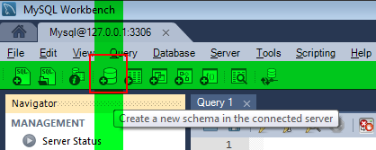  
@1:59: Name “Database” and hit “Apply”.  
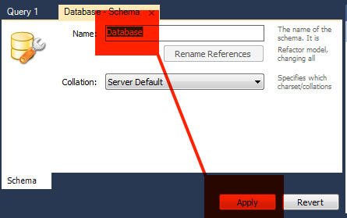  
@2:01: Review the SQL Script to be applied on the Database:  
CREATE SCHEMA `database` ;  
@3:14: Hits Apply. Hits Finish.  
@3:22: Database can now be seen in [Object Browser / Navigator]  
(Vertical docked ui on left)

|  |  |
| --- | --- |
| You can create a new Database by opening up a new query tab. @3:42: >>>>>>>>>>>>>>>>>>>>>>>>>>>  @4:37: Then you can execute it: CREATE SCHEMA `database123`; C:\DEV\REPO\GIT\PetFinderAPIPractice\JohnMark\Tutorials\SQL\MySqlWorkBenchTut\ExecuteSelectedPortionOfTheScript.png | C:\DEV\REPO\GIT\PetFinderAPIPractice\JohnMark\Tutorials\SQL\MySqlWorkBenchTut\CreateANewSQLTabForExecutingQueries.png |

@4:56: You might need to use the “Refresh All” button before you see the new database that has been created as a result of your script:  
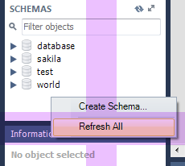  
@5:15: This is a database that contains some tables…  
@5:31: Right click on “table” under your database name, and select “Create Table…”  
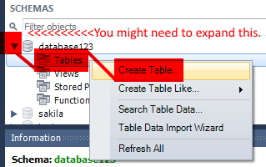

|  |
| --- |
| **@5:46:** Naming table: “employeeinfo”  **@6:22:** **Chevron** Gives you more vertical space.  **@6:27:** DOUBLE CLICKING inside the table will automatically give you a first column name. |
| C:\DEV\REPO\GIT\PetFinderAPIPractice\JohnMark\Tutorials\SQL\MySqlWorkBenchTut\TableNameChevronColumnName.png |

@6:45: First column is generally “Primary Key”  
@6:52: What is a primary key?  
@6:55: A primary key is a unique identifier for every row.  
@7:20: There must be something presented in the table which is unique for that employee only.  
@7:27: For that, we need a primary key.  
@7:35: A primary key is a key which is unique for every row in the table.  
@7:47: Double clicks and creates a “name” field under the “employeeinfo” field.  
@7:59: Creates “surname” field.  
@8:04: Creates “age” field.  
@8:29: My columns are ready.  
@8:30: Hits “Apply”

|  |
| --- |
| Table we made in the editor, and here is the SQL review that just popped up after hitting apply: |
| C:\DEV\REPO\GIT\PetFinderAPIPractice\JohnMark\Tutorials\SQL\MySqlWorkBenchTut\SQLTableEditorColumns.png |
| |  |  | | --- | --- | | C:\DEV\REPO\GIT\PetFinderAPIPractice\JohnMark\Tutorials\SQL\MySqlWorkBenchTut\ReviewTheSQLScriptToBeAppliedOnTheDatabase.png | CREATE TABLE `database123`.`employeeinfo` (  `idemployeeinfo` INT NOT NULL COMMENT '',  `name` VARCHAR(45) NULL COMMENT '',  `surname` VARCHAR(45) NULL COMMENT '',  `age` INT NULL COMMENT '',  PRIMARY KEY (`idemployeeinfo`) COMMENT ''); | |

@8:35: Copy the SQL Statement to clipboard.  
@8:46: Hit “Apply”  
@8:48: Hit “Finish”.  
@8:58: Expand your employeeinfo table in the [Object Browser / Navigator ]  
@9:02: Right Click on employeeinfo table.  
@9:03: Select “Edit Table Data”

|  |  |
| --- | --- |
| NEW WAY to access “Edit Table Data” | Old Way with context menu: |
| C:\DEV\REPO\GIT\PetFinderAPIPractice\JohnMark\Tutorials\SQL\MySqlWorkBenchTut\EditTableData_NEW.png | C:\DEV\REPO\GIT\PetFinderAPIPractice\JohnMark\Tutorials\SQL\MySqlWorkBenchTut\EditTableData_OLD.png |

@9:06: I see: SELECT \* FROM database123.employeeinfo;  
But… Not what is on presenter’s screen…  
AH. I see now. It is in my MIDDLE window rather than the top window.  
@9:24: Clear out the script from your query tab.  
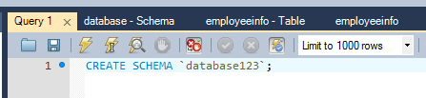  
@9:42: Remember that SQL script we reviewed to create database123?  
After you delete “CREATE SCHEMA `database123`, paste the CREATE TABLE script below:

|  |
| --- |
| CREATE TABLE `database123`.`employeeinfo` (  `idemployeeinfo` INT NOT NULL COMMENT '',  `name` VARCHAR(45) NULL COMMENT '',  `surname` VARCHAR(45) NULL COMMENT '',  `age` INT NULL COMMENT '',  PRIMARY KEY (`idemployeeinfo`) COMMENT ''); |

@9:53: Renaming table name to `oopsTable`  
NOTE: I personally started with a database called `database123` so I can’t experiment by using that name.  
@10:25: If it is “NOT NULL” that means it is “not nullable” meaning null values are NOT ALLOWED.  
Use this on required fields. Like your primary key, and whatever else you think is a must-have.  
@11:10: Hitting the “execute script” button.  
@11:30: DONE! Created a table and created a new Schema.  
  
Tomorrow: https://www.youtube.com/watch?v=Iaj3jm2pC0Q