|  |
| --- |
|  |
| Computer Programming |
| GPA Calculator |
|  |
|  |
| **Instructor: Miss. Shumaila** |

**Group Members:**

|  |
| --- |
|  |

**Muhammad Nauman: (2015-MC-163)**

**Muhammad Furqan: (2015-MC-145)**

**Usama Tariq: (2015-MC-161)**

**Arslan Ahmed: (2015-MC-151)**

**Usama Khan: (2015-MC-169)**

**Waqar Nawaz: (2015-MC-167)**

**CODE…**

#include <iostream>.h>

#include <conio.h>

using namespace std;

int main()

{

clrscr();

int ns=0;

cout<<"Enter Number of subjects:";

cin>>ns;

int ch[50],tch=0;

char p1,p2;

float res[50],gpa,rest=0;

for (int i=0 ;i<=(ns-1);i++)

{

cout<<"Enter the grade of subject"<<i<<":";

cin>>p1>>p2;

cout<<"Enter the CH of subject"<<i<<":";

cin>>ch[i];

if (p1=='A'&&p2=='+')

res[i]=4*ch[i];

else if (p1=='A'&&p2=='*')

res[i]=3.7*ch[i];

else if (p1=='B'&&p2=='+')

res[i]=3.3*ch[i];

else if (p1=='B'&&p2=='*')

res[i]=3*ch[i];

else if (p1=='B'&&p2=='-')

res[i]=2.7*ch[i];

else if (p1=='C'&&p2=='+')

res[i]=2.3*ch[i];

else if (p1=='C'&&p2=='*')

res[i]=2*ch[i];

else if (p1=='C'&&p2=='-')

res[i]=1.7*ch[i];

else if (p1=='D'&&p2=='*')

res[i]=1*ch[i];

else if (p1=='F'&&p2=='*')

res[i]=0*ch[i];

}

for (int j =0 ; j<=(ns-1);j++)

{

rest=rest+res[j];

tch=tch+ch[j];

}

gpa=rest/tch;

cout<<"Your gpa:"<<gpa;

getch();

}

**Output is….**

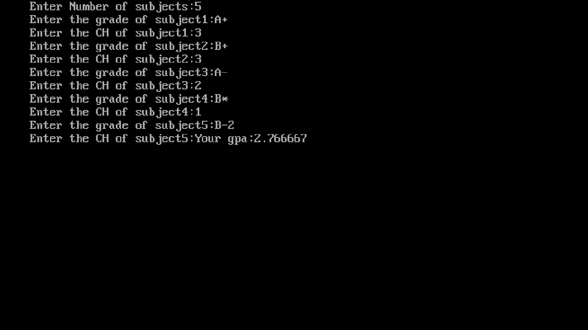

**Applications**

* With the help of this program we can easily calculate the GPA of the desired subject.
* We can easily calculate the GPA of MULTIPLE subject by using this single program.
* It is less time consuming and calculate the GPA quickly