**Architecture rules**

1. Introduction システム

ET Robocon Architecture competition started in 2013. Participants compete on “architect” ability. This includes idea, design, implementation and presentation. The intent is to develop people who are able to create something innovative/creative.

It is left open in order to not get in the way of your imagination. There aren’t many rules. The participants should understand this intent while they are participating. If there is anything that isn’t written here, if there is something questionable or if there are other questions, the judges will decide.

* 1. Purpose

This document explains the rules of the ET robocon 2013 competition.

* 1. How documents are laid out

2013 ET Robocon Contest Rules

Top document

2013 developers sector competition Terms ET Robocon

To reference

ET Robocon 2013 architect sector competition Terms

ET Robocon 2013 architect department review Terms

2013 Competition Terms ET Robocon (Bluetooth communication)

Traveling body assembly instructions

To reference

To reference

To reference

Platforms List

A sample program

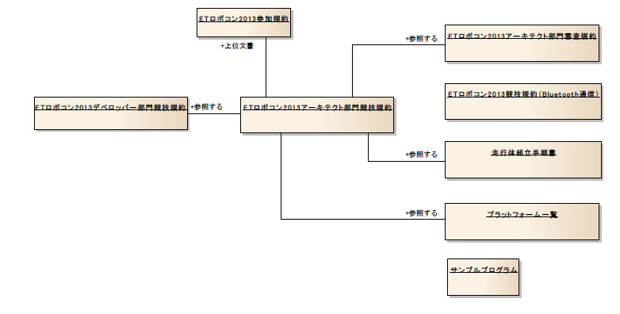

* + 1. Participation rules
  1. Reference Documents

1. Terminology

Describes with terms appearing in this document

|  |  |
| --- | --- |
| Performance stage | In the architecture, there is a course. |
| Gadget | Some hardware. The robot itself or some other gadget that we used. |
| System | Any tangible object (including participants, robots, gadgets, presentation video, anything that is created by participants for this competitions) |
| Plan documentation | The documentation that explains about the system, the problems solved, and the solutions |
| Competition Field | The part of the facility/location where we’re being judged |
| Give up | When the competitor cannot finish the competition, and stops in the middle. |

1. Judging Method

is shown in Figure 3-1 of the examination system architect department.

Planning is taking place before competition Judgment document (link5 below)

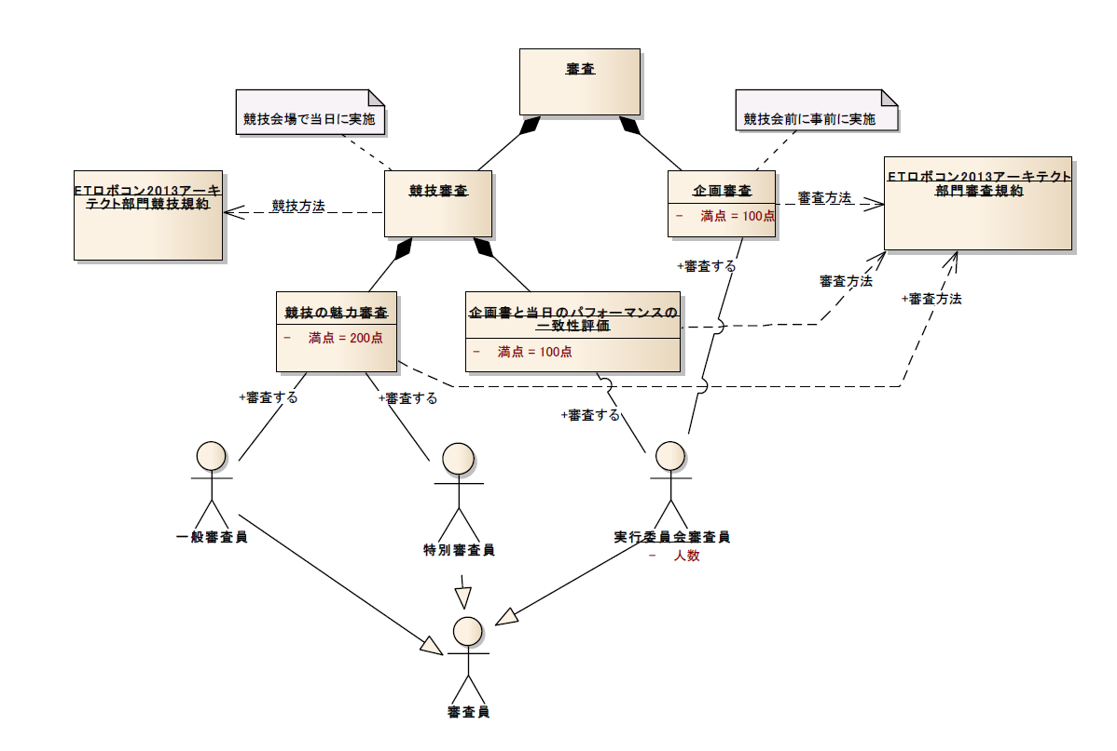

Screening method

Screening method

Evaluate

Match the assessment of performance of the day and proposal

Charm examination of the competition

Screening method

Perfect Score

ET Robocon 2013 architect department review Terms

ET Robocon 2013 architect sector competition Terms

Conducted in advance to competition before

Planning review

Competition Method

REVIEW

GAME REVIEW

Conducted on the day in competition venues

* 1. Review

The judgment is based on planning/competition. All competitors will go through both evaluations. If in case somebody doesn’t get a part of the judgment (something on our end), you’ll be treated as an exhibition.

Upon reviewing the plan and competition, the best competitor will win.

* 1. Planning Judgment

Prior to competition, submit the plan document to organizers. The organizers evaluate the documents prior. The evaluation is done by the organizer judge. Out of 100. For reference, the PPT slide (link below)

* 1. Competition Judgment

Happens At the actual arena. There are 2 parts to this. One is the combination of the performance and planning together. Second is the attractiveness. Refer to PPT again.

* 1. Match the assessment of planning and performance of the day

At the arena, the competitors, we show the system. The judge will check if the features in the planning doc is in the performance. Done by the “organizer” judge out of 100 points.

* 1. Charm examination of the competition

At the arena, show off. They are going to judge the attractiveness of the performance of the system. Special/Ordinary out of 200 points.

* 1. Judge

All 3 above, are the jury. Sometimes there is no special judge.

* 1. Executive Committee judge

Organizer

* 1. Special jury

Elected by exec committee. Person from industry or academia.

* 1. General jury

Observer, ANYONE!!

1. Competition field

I is shown in Figure 4-1 for the competition field is carried out.

* 1. Course

Figure 4-2 shows the structure of the course. The course depiction is comprised of the “basic stage” defined by the developer group and the performance stage. The performance stage contains a slope and gates for use.

* 1. Basic Stage

The basic stage conforms to reference document 1. The architecture group does not use anything after the 4th gate. It is OK to not pass through gates 1 through 3. Teams must pass through gate 4.

* 1. Performance Stage

The performance stage is the domain of the architecture group. Table 4-1 has the characteristics. Competitors can interact via their “gadget” in the performance stage and in the area above it. The performance stage is going to be installed on top of the course. Please refer to figure 4-2 for the installation position.

Table 4-1: Characteristics of the performance stage

|  |  |  |
| --- | --- | --- |
| Number | Item | Description |
| 1 | Outline | Long edge 2790mm, Shorter edge 2740mm thickness 1mm (Numerical values subject to change) |
| 2 | Material | Rigid vinyl (Similar to the table cloth) |
| 3 | Color | White |

# 4.4 What the competitor can bring in:

The competitor is allowed to bring in the items listed in table 4-2.

Table 4-2

|  |  |  |
| --- | --- | --- |
| Number | Item | Description |
| 1 | The robot | A robot that runs in the basic stage is allowed in the performance stage. The specifications are referenced in document 4. |
| 2 | “Gadget” | It is OK if the robot and “gadget” are one combined entity. You can connect the “gadget” to the power supply control panel, and it can be something like a” projector speaker amp, auxiliary power, mobile router in the “gadget”. |

# 4.5 Facilities that the executive committee provides:

The executive committee provides the items listed in table 4-3

|  |  |  |
| --- | --- | --- |
| Number | Item | Description |
| 1 | Control panel | This is freely available to the competitor. It is placed near the starting position. It provides AC power. It is roughly the size of two PC laptops |
| 2 | AC power supply | Up to 200 Watt 100V AC power is available to the competitor. |
| 3 | Microphone | The microphone that the competitor can use during the presentation. |

# 4.6 Other facilities

Other facilities that make up the competition field are listed in table 4-4

Table 4-4

|  |  |  |
| --- | --- | --- |
| Number | Item | Description |
| 1 | Presentation video | While the calibrator is calibrating, this video can played instead of the competitor presenting. If you wish to screen a video, please submit it to the executive committee in advance. The video is specified as follows:  Media format: YouTube  Duration: 2 minutes  Recommended screen size: horizontal 720 x vertical 480 |
| 2 | Measurement system | Shows the progress of the competition. |
| 3 | Video projector | Shows the presentation and measurement system. You are not allowed to bring any items that connect with this projector. |

Items the contestants bring

Facilities Executive Committee to provide

Other facilities

1. Competition sequence
   1. Competition examination order decision
   2. Rehearsal
   3. Vehicle Inspection
   4. Game
      1. Contestant Admission
      2. System Installation start signal
      3. System Installation
      4. Presentation video screening
      5. Description of the contestant
      6. Start Signal
      7. Running body start
      8. Basic Suteji Competition
      9. Performance Tae-ji competition
      10. Performance end signal
      11. System Withdrawal
      12. System withdrawal completion signal

5. Competition Sequence

5.1

Day before you will be informed on the order of competition.

5.2. Rehearsal

On the day of the competition, with the purpose of confirming the competition field, you will be given the opportunity to test the system. It might be that there will be several participants rehearsing at the same time.

5.3. Inspection

It will be inspected if the robot that will be running the basic stage was built according to the rules. The content of inspection will be in accordance with Developer competition. If the robot does not pass the inspection, it will not able to participate in the competition. The gadget (You can bring extra piece of equipment) will not be inspected.

5.4 Competition

The competition will be only one time. – No re-trial. The order of the competition is in the diagram.

5.4.1 Competitors Entering the Arena

The competitors will be called in the field when it’s their turn.

5.4.2. Signal to start setting the System

The referees will signal when to start to set the system. From this point, they will start measuring the system setup time.

5.4.3. System Initialization

The competitors can install the system in the competition. The maximum time is 2 mins.

5.4.4. Presentation Video Showing

The competitors can show a presentation video during the system installation. If it was decided to show a video presentation, the judging committee will show it.

5.4.5. Competitor Explanation

The competitor can present the content of competition/exhibition.

5.4.6 Start Signal

Once the two minutes have passed from the signal for starting the setup or the participated have indicated that they have finished setup, the referee will signal the start of basic stage competition. The signal is going to be ‘3,2,1 GO!’ Go! Represents the start.

5.4.7. Starting the Robot

The methodology to start the robot should be in accordance to document [1]. The starting point can be selected either IN course or OUT course. It can be chosen freely.

5.4.8. Basic Stage Competition

The robot will run the basic stage. The running should be accordance to document [1]. However, the robot has to run from the starting of the basic stage to the middle of the gate number 4. Once the robot has passed through the middle of gate number 4, the basic stage is finished <fix grammar>.

If the robot has no possibility to finish the basic stage, the competitor should say give up. With that, the competition will be finished.

The competitor will not be move on to the performance stage.

5.4.9. Performance Stage Competition

Once the basic stage is finished, the performance stage competition will begin. The performance stage competition has to be finished within 2 mins. The time will be measure moment that the beginning signal is given.

The performance stage will be finished once 2 mins has passed or the competitor indicates that competition/performance has finished.

Those robot that finish basic competition during the performance stage competition, have to be on top of the performance stage. <??>

If the robot moves out of the performance stage territory, there is possibly of points being deducted.

Once the performance system is finished or the competitor says give up, the referee will give a signal. From this point, the time to remove system will be measured.

5.4.11 System Removal

The competitor has to remove every item brought into the competition field [robot, gadget, etc] to restore it to original condition.

The removal has to be finished within one minute from the signal of end of competition.

If it takes you more than defined time, there is a possibility of getting points deducted.

5.4.12 Signal for finishing the system removal

Once the system removal is finished, the referee will indicate. The time for system removal is measured from the end of performance to the end of removal of the system.

Competition Rules

I is shown in a different field rules for competition.

* 1. Prohibitions

The materials listed here are banned.

|  |  |
| --- | --- |
| Prohibited acts: | Description |
| Use of fire and liquid |  |
| Damage/ Defile the course |  |
| Physical harm to people, goods |  |
| Interference in competition operation |  |
| Violation of law |  |
| Not good representation of the system |  |

* 1. Rules of Hardware

|  |  |
| --- | --- |
| Type | Description |
| Running body | Refer to document 4 |
| Gadgets | None |

* 1. Software

|  |  |
| --- | --- |
| Type | Description |
| Running body | Refer to document 1 |
| Gadgets | None |

* 1. Disqualification

If a competitor has violated the provisions of this Agreement, deduction of points, you may or disqualified.

The athlete who disqualified, score of the competition review is scored as 0 points. However, disqualification does not affect the score of plan review planning examination.

* 1. Fall of running bode
  2. Intervention in the system