Initial Setup of the Communication System with the Raspberry pi as the central hub

1. Power on the Router
2. Power on the Raspberry Pi . As soon as the Raspberry pi boots up, the initialization scripts will start up the VNC server on the pi, setup the bluetooth dongle on the pi and setup the connection between the Raspberry pi and the Router through the WIFI dongle.
3. Connect your laptop to the “belkin.3237” Wifi network.

In order to remote access the Pi (via ssh or VNC), it is important to know the IP address of the Pi. This step is to find the IP address of the Pi

1. Open a web browser on the laptop and navigate to ‘**http://192.168.2.1/**’ to open the Router page as shown below:

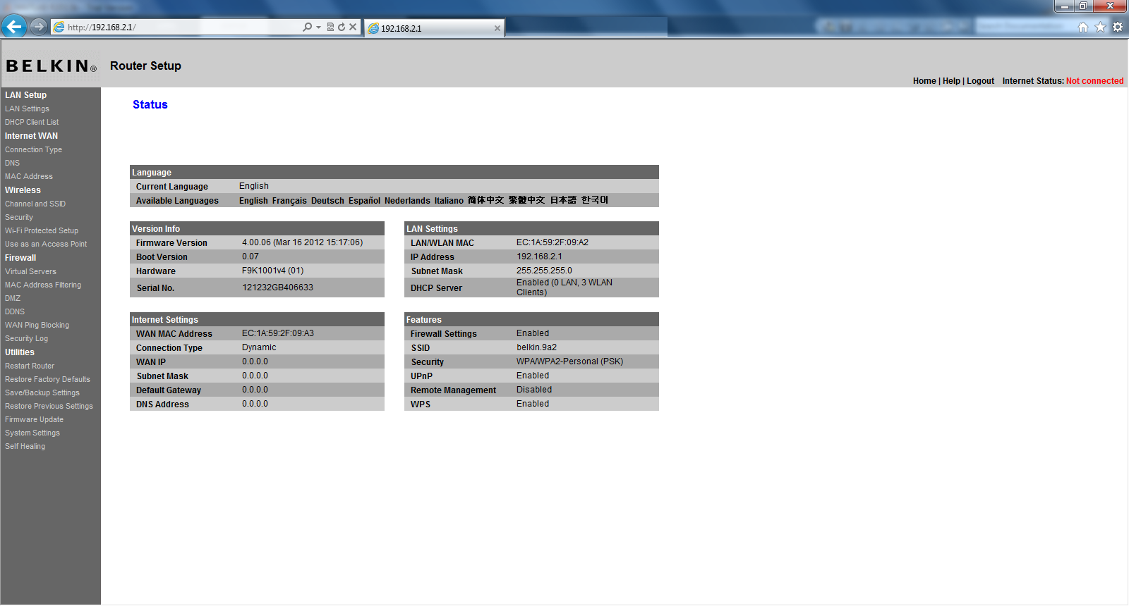

1. Click on DHCP Client List under LAN Setup on the left. It will open up a screen which will ask for password. **Click on Submit without entering any password**. The following screen will open up listing the IP addresses of each computer connected to the network.

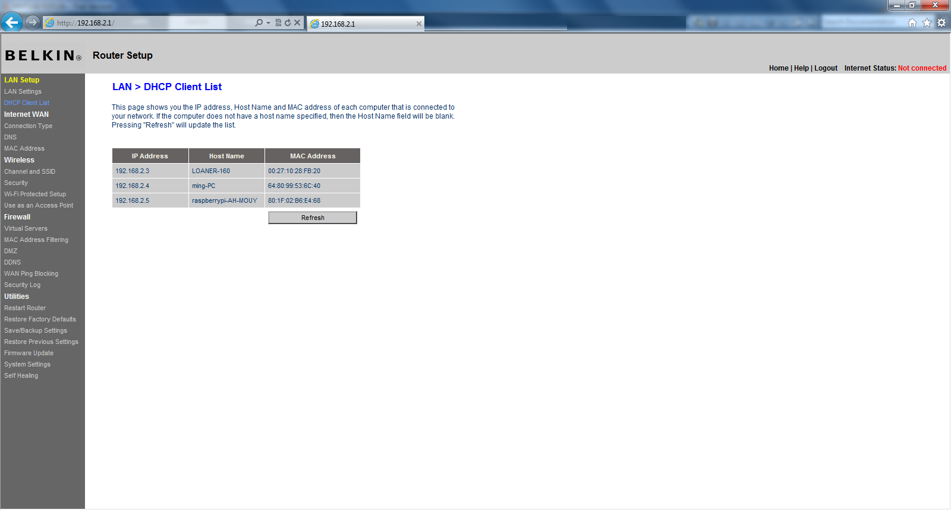

As you can see from the image above, the Raspberry pi has a host name of ‘raspberrypi-AH-MOUY’ and an IP Address of 192.168.2.5.

Once the above setup is complete, there are 2 additional steps

1. Pair all the devices with the Pi using the Bluetooth manager.

We have the VNC server running on the Raspberry pi when it boots up. To access the Bluetooth Manager on the Raspberry Pi, you will have to open the UltraVNC Viewer on the laptop – enter the IP address of the Pi followed by the port on which the VNC Server is setup (<Pi’s IP>:1) for example ‘192.168.2.2:1’. This will open up the Desktop on the Raspberry Pi – then pair the devices.

On desktop, choose start menu, choose Preference -> Bluetooth Manager

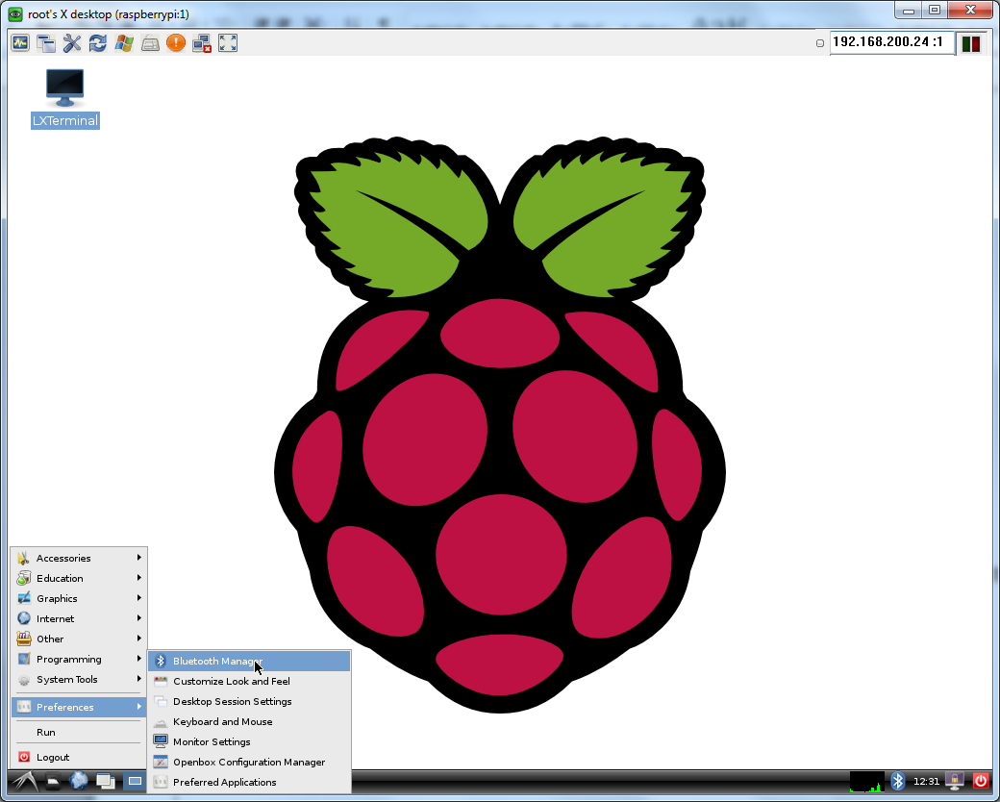

In the pop-up window, click search to find the device

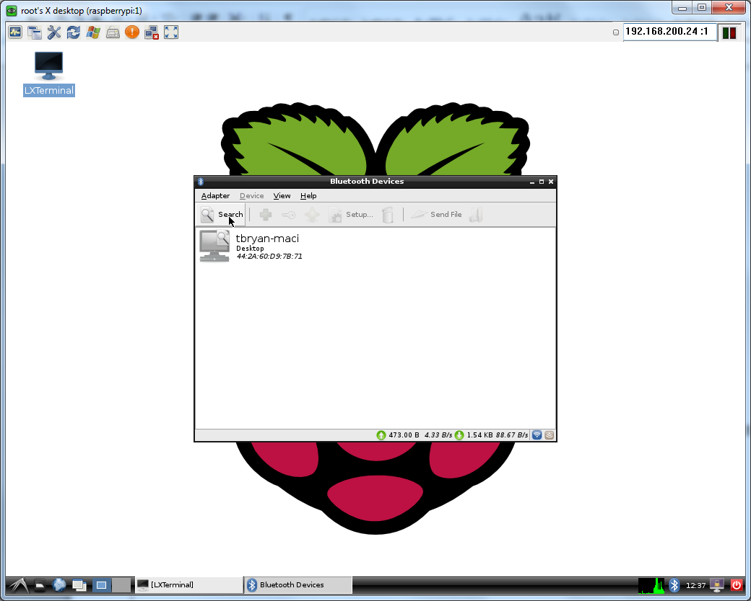

Find the device, right click the device, click Pair to pair the device

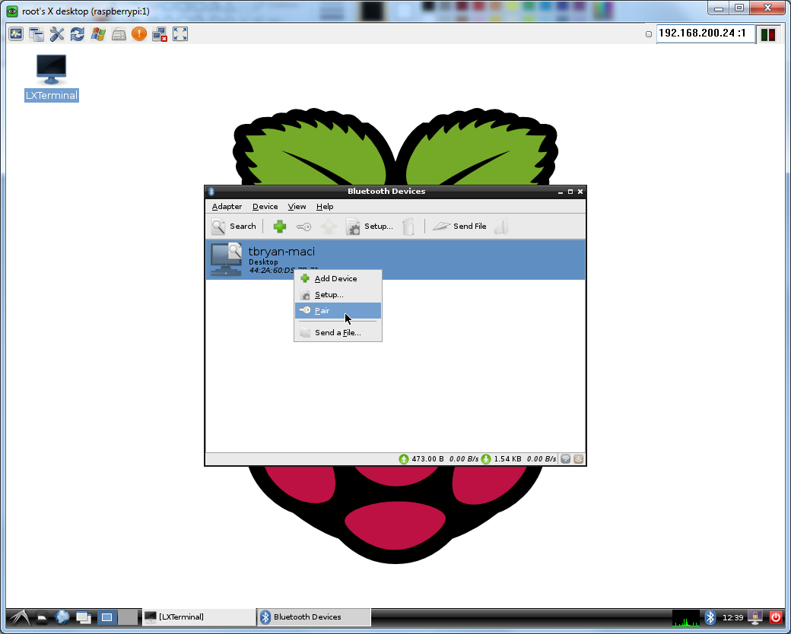

In the pop-up window, input the passcode to pair the device.

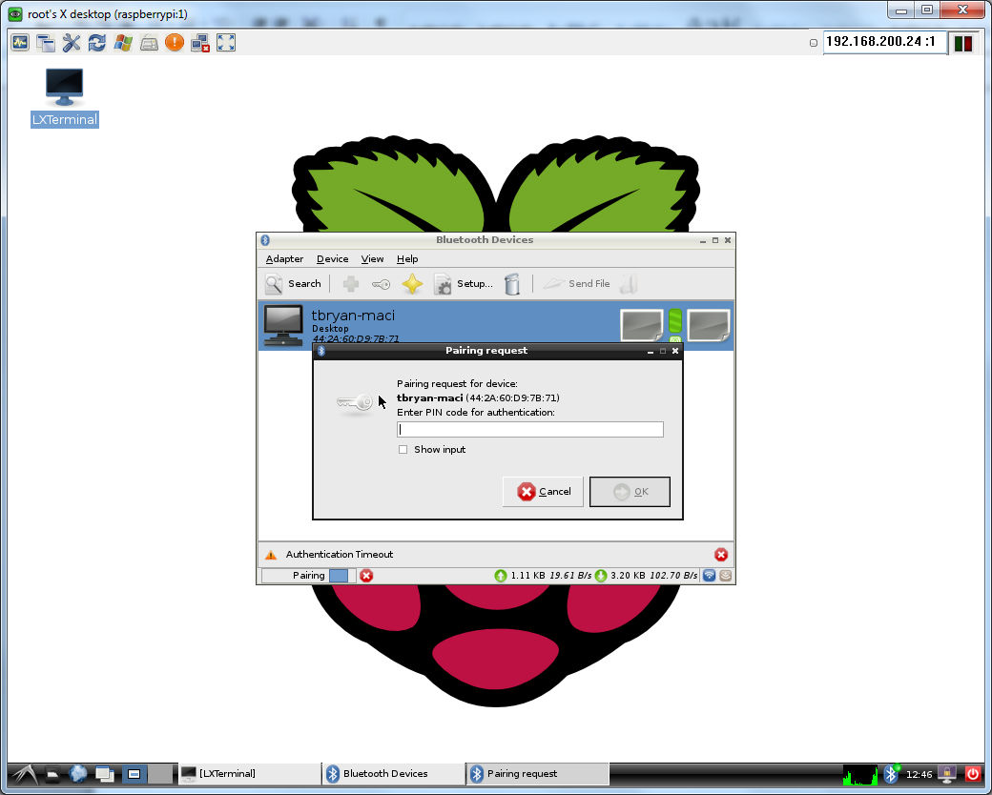

1. Change the RFCOMM.CONF file on the Pi to reflect the MAC addresses of your devices (if you are trying new NXT/Arduino on Pi).

The RFCOMM is the Bluetooth protocol we are using. It stands for Radio frequency communication protocol and provides an emulation of serial ports to enable Bluetooth communication between devices. In order to use this protocol, we need to map each device to a separate RFCOMM socket. We use the ‘rfcomm.conf’ file to specify this mapping between the MAC address of the device and the RFCOMM socket that it uses. Mario, Princess, Yoshi and the LED Cube – all have to be mapped to separate RFCOMM sockets to enable them to communicate with the Pi via Bluetooth.

We have created a MATLAB function “UpdateMAC” that will help you update on Raspberry Pi.

The input arguments to this function are the IP address of the Pi and the name and MAC addresses of the entity you want to update (Mario, Princess, Yoshi or Cube).

Example:

Assume we are testing the double see saw with the communication system.

Assuming the IP address of the Raspberry Pi is 192.168.2.2 and MAC addresses of the Mario and Princess are ’00:16:53:45:23:12:10’ and ’00:16:53:45:23:13:15’, then you need to execute the following to setup the devices for Bluetooth communication using the RFCOMM protocol:

>>UpdateMAC(‘192.168.2.2’,’Mario’, ’00:16:53:45:23:12:10’,’Princess’, ’00:16:53:45:23:13:15’);

This function creates the ‘rfcomm.conf’ file and then used the RASPBERRYPI System object to write this file into the required location on the Raspberry Pi.

|  |  |  |
| --- | --- | --- |
| Device | Software | Hardware |
| Raspberry Pi | Raspberry Pi Support package, Bluez, blueman, tightvncserver, Simulink model running on Raspberry Pi | Bluetooth dongle,WIFI dongle |
| NXT | NXT Support package, Simulink model running on NXT |  |
| Arduino | Arduino support package, Simulink model running on Arduino | SilverMate |
| Laptop | MATLAB, Raspberry Pi support package, UltraVNC Viewer, Putty |  |

**Troubleshooting (FAQ)**

**What are the usernames and passwords to access all these things**

Linux account

Username: Pi

Password: raspberry

Username: root

Password: raspberry

VNC password: raspberry

**Why I cannot remote desktop to Pi**

Unplug Pi and plug the power back. Sit back and relax for 2 minutes. If it works, enjoy it!

If it doesn’t work, check the following things

1. On your web browser, go to 192.168.2.1 (assuming you are connecting with the Belkin router), see if you can find the device in the device list. If not, try to switch the USB port of wifi dongle and Bluetooth dongle, and reboot Pi.
   1. When rebooting, take a look at the ACT light on board, if it never blinks, the file system might be corrupt. You might need to contact comm team for solution.
   2. If switching the USB prt does not solve your problem, you might want to connect the two dongles with a powered USB Hub and reboot the system again, if it still does not work, contact comm team
2. If you can find the device on the web page. Try to ping Pi’s IP address. If there’s no response, contact comm team
3. If you can ping Pi’s IP address, try ssh to Pi using tools like putty.
   1. If you cannot ssh to Pi, contact comm team
   2. If you can ssh to Pi, run the following command on terminal.

sudo /etc/init.d/vncboot restart

* 1. Reboot Pi and try again
  2. If it still not solve the problem, contact comm team

**Why I cannot see my Device for pairing**

1. For NXT, check
   1. It’s turned on
   2. Bluetooth is turned on on NXT
   3. No model is running on NXT
2. For Arduino
   1. Check it’s turned on
   2. The wires are properly connected (You are not assuming to have acces to the wires though)
   3. Try reboot Arduino borad to see if it can detect from Pi. If not, Contact comm team

**Why I cannot send/receive to NXT/Arduino in my Pi model**

At first, **you have to reach BYE state each time at the end of your Pi model** because the background daemon is expecting the BYE signal to close the UDP/Bluetooth connection and reset the system state. The most common pitfall is you stop your model before it reaches BYE state, you you forgot to add the BYE state in your model.

If that’s the case, ssh to Pi, and run the following command to restart the background service.

sudo /etc/init.d/NXT_SPP_boot restart

If restart the service does not working for you, check the following things

**Notice: ALL the devices are supposed to be turned on and in “waiting” state before running the Raspberry Pi model**

1. If NXT/Arduino is turned on
2. If NXT/Arduino is paired, go to Bluetooth manager, find the device, right click on it, choose “Refresh service”, ther’s should be no warnings or errors
3. If your NXT is built in slave mode (you can check that in “Model Configuration”->”Run on Target Hardware”)
4. If everything looks OK. Reboot the Pi to see if it works. If it still not works, contact comm team