**A.R.M. Loxahatchee National Wildlife Refuge**

**Refuge 39-Box Model**

**User’s Manual**

by

Hamid Bazgirhoob

Ehab A. Meselhe

Michael G. Waldon

Prepared for the U.S. Fish and Wildlife Service under a cooperative-agreement with the University of Louisiana-Lafayette

July 2011

Revised May 2015

TABLE OF CONTENTS

1. Introduction

2. Data Preparation

3. Code

4. Model Execution and Post Processing

Appendix

Literature Cited

1. **Introduction**

As restoration of the Arthur R. Marshall Loxahatchee National Wildlife Refuge (Refuge) continues, there is a need for a quantitative methodology for predicting impacts of proposed management changes on Refuge water quantity and quality. A series of compartment-based models have been developed for the hydrologic and water quality modeling of the Refuge ([http://LoxModel.MWaldon.com](http://loxmodel.mwaldon.com)). The first of these models, termed the Simple Refuge Screening Model (SRSM), simulates the water budget, regulation schedule implementation, and constituent dynamics for chloride (Cl), sulfate (SO4), and total phosphorus (TP). The SRSM uses two compartments to describe water volume and stage, and four compartments to simulate constituent mass and concentration. SRSM version 1.0 (Arceneaux *et al*, 2007; Meselhe *et al*., 2007a, 2007b) was implemented as a daily water budget using a Microsoft Excel workbook for water volume modeling, and the EPA WASP model (<http://www.epa.gov/athens/wwqtsc/html/wasp.html>) simulating TP. Versions 2 and 3 of the SRSM were transitional and are no longer available. SRSM version 4.0 (Meselhe *et al*, 2009) was developed using the commercial numerical differential equation solver package of Berkeley-Madonna (Macey, *et al*, 2000). It allows greater clarity in coding, supports shorter time steps obviating the need for the ad-hoc procedures of Version 1.0, and provides a well-documented user interface.

Wang *et al* (2008) applied cluster analysis of concentrations of chloride, total phosphorus, sulfate, and calcium measured at sites distributed throughout the Refuge to objectively determine the number of compartments and to spatially delineate these compartments with similar features within the refuge. That delineation led to a 9-Box (compartment) model structure (Wang, et al, 2012).

Consideration of management objectives and compatibility with possible future model scenarios then led to further disaggregation of the 9-Box model into the 39-Box model. The 39-Box Model defines twenty (28) marsh compartments and eleven (11) canal segments (Figure 1).

As with the SRSM and 9-Box model, the 39 Box model is based on a link-node conceptualization. Each node in a link-node conceptualization has the state variables of water volume, and mass for each constituent. Stage, depth, and constituent concentration are calculated from these state variables. Flow of water, and transport of constituent mass (mass flux) occurs between nodes through links. Each link has an upstream and downstream end which defines the direction of positive flow and mass transport. Links have properties of length and cross-sectional area, nodes have the property of surface area. In addition to advective or flow-related mass transport through links, mass transport is also modeled as dispersion at links which moves mass from the node with higher to the node with lower concentration.

Each of these models (the SRSM Version 1, SRSM version 4, 9-Box Model, and 39-Box Model) has specific advantages and limitations. The models were designed to be a complimentary suite. As such, the 39-Box Model is not intended to replace the other models, but instead to provide additional options for Refuge modeling applications.

This manual describes the 39-Box (compartment) model which was developed from the 9-Box model and the SRSM. It aims to provide users with an understanding of both the theory and implementation of the model. The objective is to give users the ability to accurately simulate various water management scenarios for the Refuge in order to gain a better understanding of this wetland system and its dynamics. This manual assumes that the reader is generally familiar with the Refuge location, hydrologic features, and water quality. For more information, users are directed to the Refuge Comprehensive Conservation Plan (USFWS 2000).

* 1. **General Description of Model Structure**

The refuge is compartmentalized into 39 compartments (also termed boxes, nodes, or cells), and each is classified as canal or marsh. Surface areas are assumed constant (Table 1), with marsh area totaling 4.03 million m2 and canal area totaling 560.02 million m2. The link-node diagram of the refuge is shown in Figure 2. As shown in Table 1 and Figure 2, compartments 1-11 represent the canal cells and compartments 12-39 represent the marsh cells.

The model simulates the mass and concentration of chloride (Cl), total phosphorus (TP), and sulfate (SO4). Note that Cl mass is measured as chlorine, and TP mass is measured as phosphorus, and not as phosphate. However, SO4 mass is measured as sulfate, and not as sulfur. This convention for SO4 maintains consistency with South Florida Water Management District laboratory reporting.

Compartments 1-11 represents the canal cells and compartments 12-39 represents the marsh cells. Exchange flow is calculated in the marsh based on compartment surface area ratios. For this purpose there is a Node factor defined for each exchange node between a canal and marsh cell.

There are water quality, meteorological, stage, and discharge monitoring stations in the refuge which measure the inflow and outflow, water level, precipitation, evapotranspiration and the simulated three constituent concentrations. Sites are located in both canal cells and marsh cells. However, some cells do not have any associated water quality monitoring sites, and most cells do not have an associated stage monitoring site. Figures 3, 4, 5 and 6 map the location of monitoring sites in the Loxahatchee Refuge.

**Figure 1: This map delineates the model 39 Compartments. Also shown are stage gauges and inflow/outflow structures.**

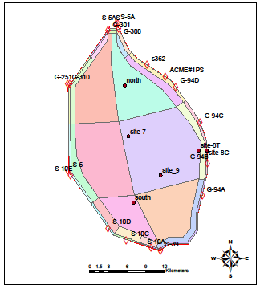

**Figure 2: Link-node diagram of the 39-Compartment design**

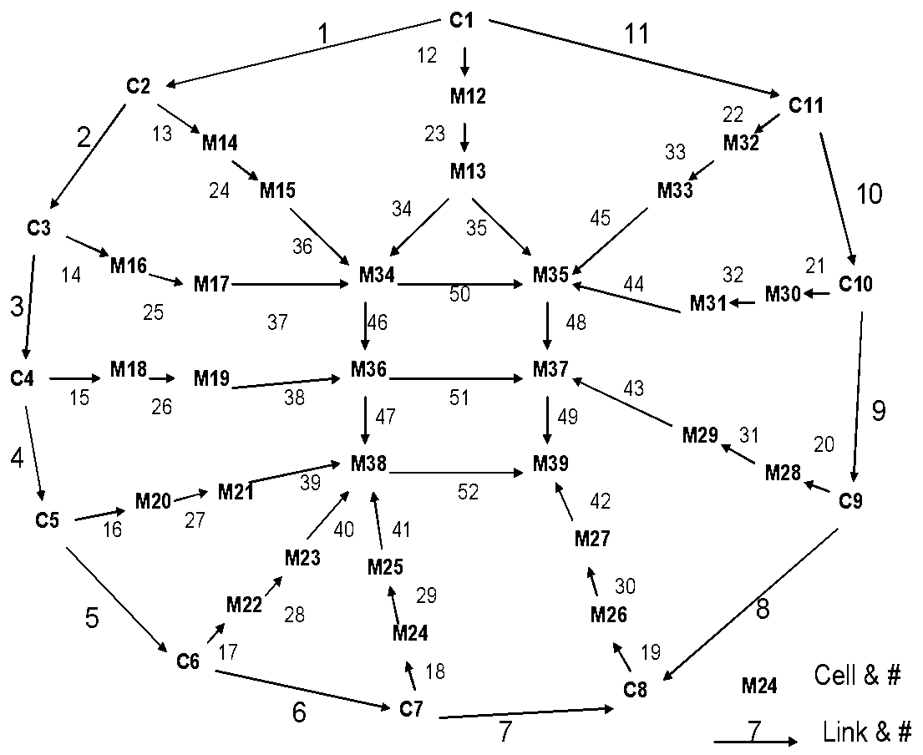

**Figure 3: Location of rain gages used in model daily rainfall estimation.**

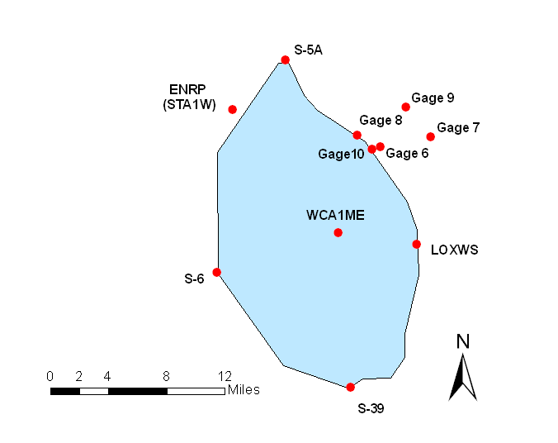

**Figure 4: Hydraulic structures located in the Loxahatchee Refuge. Discharge at each structure is monitored. This figure is adapted from Meselhe *et al* (2005).**

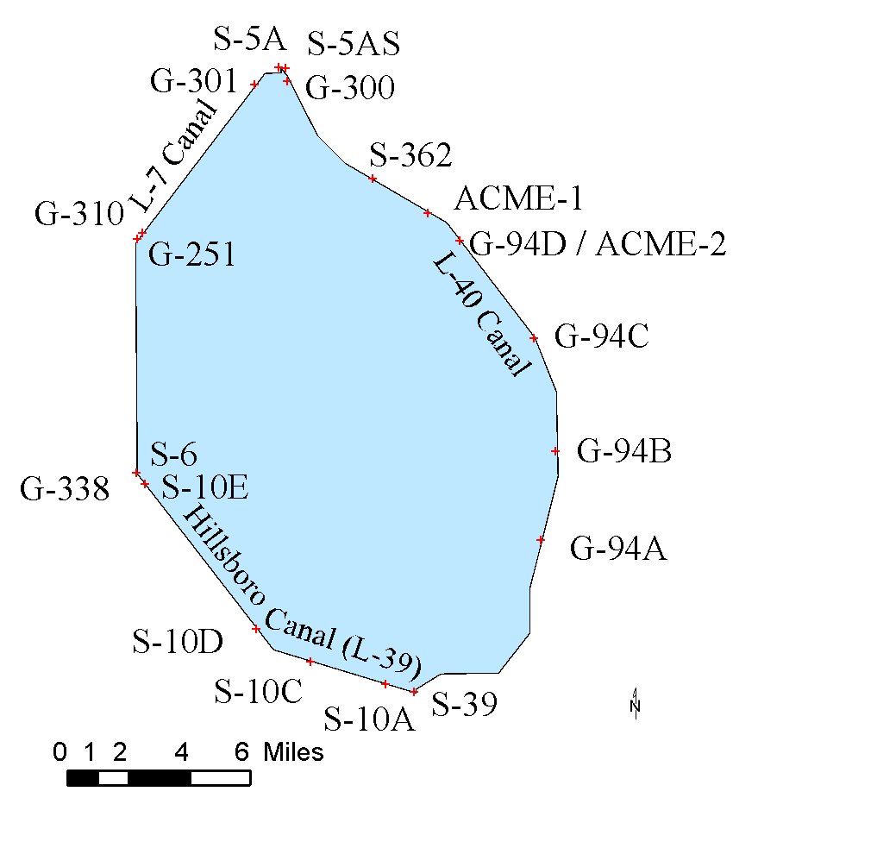

**Figure 5: Water level gages located in the Loxahatchee Refuge**

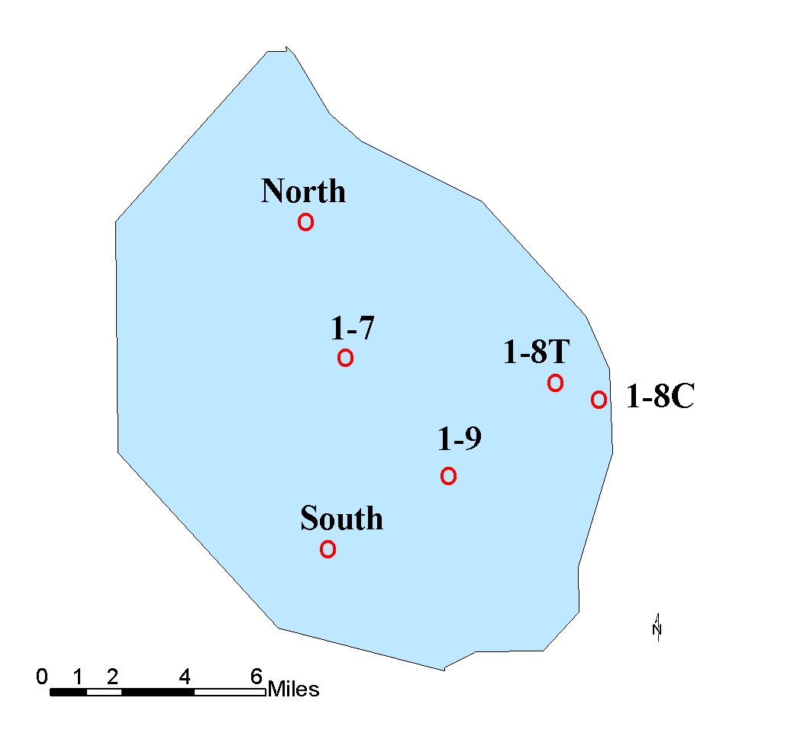**Figure 6: XYZ and EVPA water quality monitoring sites located inside the Loxahatchee Refuge.**

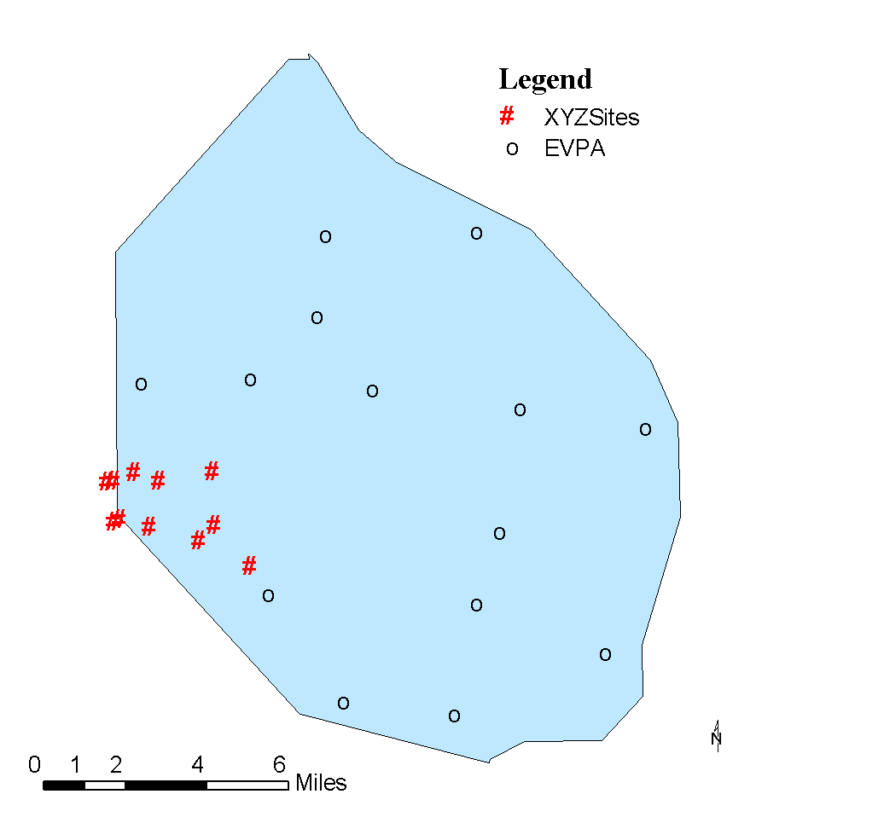

**Table 1: Classification of each compartment and compartmental area.**

| **Compartment Number** | **Description** | **Area (m2)** |
| --- | --- | --- |
| 1 | Canal | 67451.135821 |
| 2 | Canal | 432580.505184 |
| 3 | Canal | 1321081.928510 |
| 4 | Canal | 1070766.748980 |
| 5 | Canal | 343866.846945 |
| 6 | Canal | 242568.499782 |
| 7 | Canal | 290820.545859 |
| 8 | Canal | 1172416.460760 |
| 9 | Canal | 745969.419186 |
| 10 | Canal | 770845.383037 |
| 11 | Canal | 325422.412436 |
| 12 | Marsh | 1181402.531870 |
| 13 | Marsh | 2501726.141840 |
| 14 | Marsh | 293003.038514 |
| 15 | Marsh | 543785.352232 |
| 16 | Marsh | 3485961.830800 |
| 17 | Marsh | 4045182.150470 |
| 18 | Marsh | 3195752.157130 |
| 19 | Marsh | 7636805.725330 |
| 20 | Marsh | 7200836.398630 |
| 21 | Marsh | 13400480.995600 |
| 22 | Marsh | 4195293.495740 |
| 23 | Marsh | 14539203.085100 |
| 24 | Marsh | 1890978.078230 |
| 25 | Marsh | 7512971.274630 |
| 26 | Marsh | 988502.221609 |
| 27 | Marsh | 5248955.803790 |
| 28 | Marsh | 522323.800231 |
| 29 | Marsh | 2903428.104900 |
| 30 | Marsh | 4434932.932820 |
| 31 | Marsh | 12224954.711100 |
| 32 | Marsh | 4740640.266060 |
| 33 | Marsh | 12213974.991300 |
| 34 | Marsh | 61064630.228800 |
| 35 | Marsh | 62998466.731800 |
| 36 | Marsh | 87163883.382300 |
| 37 | Marsh | 135435126.208000 |
| 38 | Marsh | 31888461.517200 |
| 39 | Marsh | 63423036.384400 |

**Table 2: Parameters**

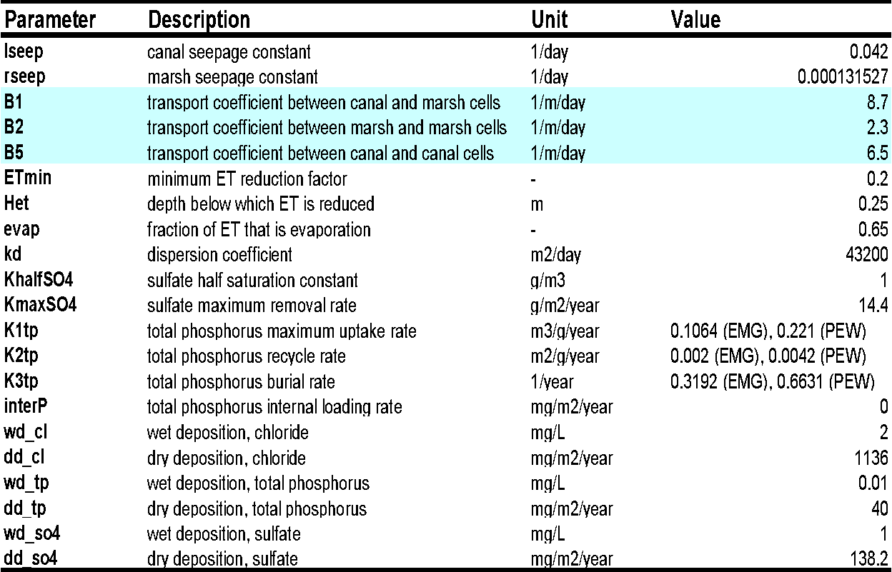

1.1.2 **Equations & Simulations**

The 39-Box model simulates the mass and concentration of chloride (Cl), total phosphorus (TP), and sulfate (SO4). Note that TP mass is measured as phosphorus, not phosphate, and SO4 mass is measured as sulfate, not sulfur. Compartments 1-11 represents the canal cells and compartments 12-39 represents the marsh cells. Exchange flow is calculated in the marsh based on compartment surface area ratios. For this purpose there is a Node factor defined for each exchanging node between a canal and marsh cell.

Simulation of each constituent is based on a mass balance equation. The loading terms of the mass budget (*qnet*, *gload*, sload and *aload*) are similar for all three constituents. However, the reactive load term (*rload*) is uniquely structured for each constituent. Chloride is modeled as a conservative constituent with zero reactive load. Its mass is lost or gained solely through the transport of water into or out of the system. Total Phosphorus (TP) dynamics are approximated with equations adapted from those presented in the Dynamic Model for Stormwater Treatment Areas (DMSTA) developed by Walker and Kadlec (2011; see also <http://wwwalker.net/dmsta/index.htm>). Finally, sulfate (SO4) is simulated using a Monod relationship (SRSM v. 4.0 User’s Manual by Meselhe, *et al*, 2009).

The following samples of model code illustrate the volume and mass balance differential equations defined in the model. The rate of canal volume increase (m3/day) in compartment 1 is calculated as

d/dt(vol[1])=(P - ET - Gc[1])*area[1] + (Qin[1] -Q[1]-Q[11] -Q[12] -QoutHistoric[1])

This equation illustrates the use of Berkeley Madonna subscript syntax. In Berkeley-Madonna, subscripts are enclosed in square brackets. Constituent differential equations are more complex. Constituent mass rate of change depends on loads from flow and dispersion between cells (qload and dload), loads associated with structure flow (sload), load from aerial deposition (aload), load from groundwater recharge (gload), and reactive load (rload) which can include both uptake and return to the water column. The following sample of code defines this mass balance. This code also illustrates the use of comments for program self-documentation. In Berkeley-Madonna, comments may be inserted using two alternatives. Any text on a line following a semicolon (;) is ignored by the compiler, and all text falling between braces (aka curly or squiggly brackets, {}) is ignored.

{Canal cells}  
; Canals --- structure load + flow (advective) load + dispersive load + aerial load - groundwater load + reactive loads  
d/dt(mass[1..nconstit, 1..nc]) = sload[i,j] + qdload[i, j] + aload[i, j] - gload[i, j] + rload[i, j]  
  
{marsh cells --- flow (advective) load + dispersive load + aerial load - groundwater load for each constituent + reactive loads}  
d/dt(mass[1..nconstit, (nc+1)..ncell]) = qdload[i, j] + aload[i, j] - gload[i, j] + rload[i, j]  
  
The following code sample defines loads and also illustrates Berkeley-Madonna implied loops which use the variables i, j, and k for the first second, and third implied subscripts.

;Dispersion loads:

dload[1..nconstit, 1..nc] = kd1*(exarea[j]/Radius[j])*(conc[i,up[j]]-conc[i,dn[j]])

dload[1..nconstit, (nc+1)..22] = kd2*(exarea[j]/Radius[j])*(conc[i,up[j]]-conc[i,dn[j]])

dload[1..nconstit, 23..nlinks] = kd3*(exarea[j]/Radius[j])*(conc[i,up[j]]-conc[i,dn[j]])

;Aerial deposition

aload[1..nconstit, 1..ncell] = area[ j]*((DD[i]/1000) + (precip[i]*P))

;Groundwater seepage + transpiration

gload[1..nconstit, (nc+1)..ncell] = conc[i, j]*(Gm[j]+(transp*ET))*area[ j] ; marsh seepage + transp load

gload[1..nconstit, 1..nc] = conc[i, j]*Gc[j]*area[j] ; canal seepage load, no transpiration in canal

;Net canal structure inflow - outflow loads

sload[1..nconstit,1..4] = LOAD[i,j] - QoutHistoric[j]*conc[i, j]

sload[1..nconstit,5] = LOAD[i,5] - Qout[5]*conc[i, 5]

sload[1..nconstit,6] = LOAD[i,6] - Qout[6]*conc[i, 6]

sload[1..nconstit,7] = LOAD[i,7] - Qout[7]*conc[i, 7]

sload[1..nconstit,8] = LOAD[i,8] - Qout[8]*conc[i, 8]

sload[1..nconstit,9..nc] = LOAD[i,j] - QoutHistoric[j]*conc[i, j]

;Reactive loads (losses)

rload[cl, 1..ncell] = 0 ; conservative

rload[so4, (nc+1)..ncell] = -(kso4[j]/depth[j])*max(mass[i, j],0)

rload[so4, 1..nc] = 0

rload[so4eco, (nc+1)..ncell] = -(MaxSO4Removal*area[j]) * conc[i, j]/(khalfSO4+conc[i, j]) ;g/day

rload[so4eco, 1..nc] = 0

rload[dmsta_tp, (nc+1)..ncell] = Release[i, j] - Uptake[i, j]

interP = 0.0

rload[dmsta_tp, 1..nc] = interP*area[j]

Where:

*i* = constituent,

*j* = compartment number (1-4),

*k* = DMSTA calibration set (Phosphorus only),

*M* = mass (g),

*t* = time (days),

*qnet* = net mass flow in surface water (g/day),

*gload* = loss to groundwater seepage and evapotranspiration (g/day),

*aload* = gain from wet and dry deposition (g/day), and

*rload* = loss to storage uptake/release (TP) or reaction (SO4) (g/day).

sload = Net canal structure inflow - outflow loads

* 1. **Model Platform – Berkeley Madonna**

The model is implemented using the differential equations solver Berkeley Madonna version 8.3.9, which is a proprietary software developed by Robert I. Macey and George F. Oster. Berkeley-Madonna has several advantages. Compared with the STELLA program which was first applied in transition from Version 1 of the SRSM, Berkeley-Madonna is less expensive, faster, and accommodates much larger models. Both platforms are user-friendly and employ graphical user interfaces.

The Berkeley-Madonna program which is the backdrop for the code of the SRSM, 9-Box, and 39-Box models, has a number of useful built-in functions and operations. The Berkeley-Madonna user interface consists of a number of windows which may be opened, moved, resized, minimized, or closed by the user at any time. Model components and processes are user-defined in the **Equations** window; the optional Berkeley-Madonna Flowchart window was not used in the 39-Box model development. That is in Berkeley-Madonna terminology, the model is a “plain-text” rather than a “visual” model (Macey, *et al*, 2000;Meselhe, *et al*, 2009). Figure 7 shows the general format of the Berkeley-Madonna desktop.

Berkeley-Madonna has many features which improve ease of use and allow rapid coding and testing of alternatives. However, Berkeley-Madonna also has several disadvantages. At all times, users have full access to the model equations and parameter values. This is often convenient, but there is no executable module which shields the inner workings of the model, and this makes the model susceptible to inadvertent revision of the model and to subsequent errors. Users must be vigilant and take care not to corrupt the model code or parameterization. The requirement that the model always run within the Berkeley-Madonna system also makes application of alternative optimization codes or automated simulation outside of the Berkeley-Madonna interface impossible. Berkeley-Madonna also has no run-time capability to read or write data in external files. Berkeley-Madonna also lacks the capability of dealing with date or time formats, and as a consequence, all time in the 39-Box model is simply measured in days after January 1, 1995. Finally, the Berkeley-Madonna editor and compiler do not support macros or subroutines. Because of this deficiency, code in the equation window may be highly repetitive, prone to inadvertent error, and makes the code less readable.

No practical workarounds for these system deficiencies were identified by the model team. One alternative which was rejected as impractical is to copy/paste text between the equation window and a more advanced editor that supports macros. However, this alternative was rejected because it would be awkward and be a potential source of error. Implementing the model code in the Modelica simulation language (https://www.modelica.org/) was also considered, but this too was rejected because constraints of time and effort.

**Figure 7: The general format of the Berkeley-Madonna desktop**

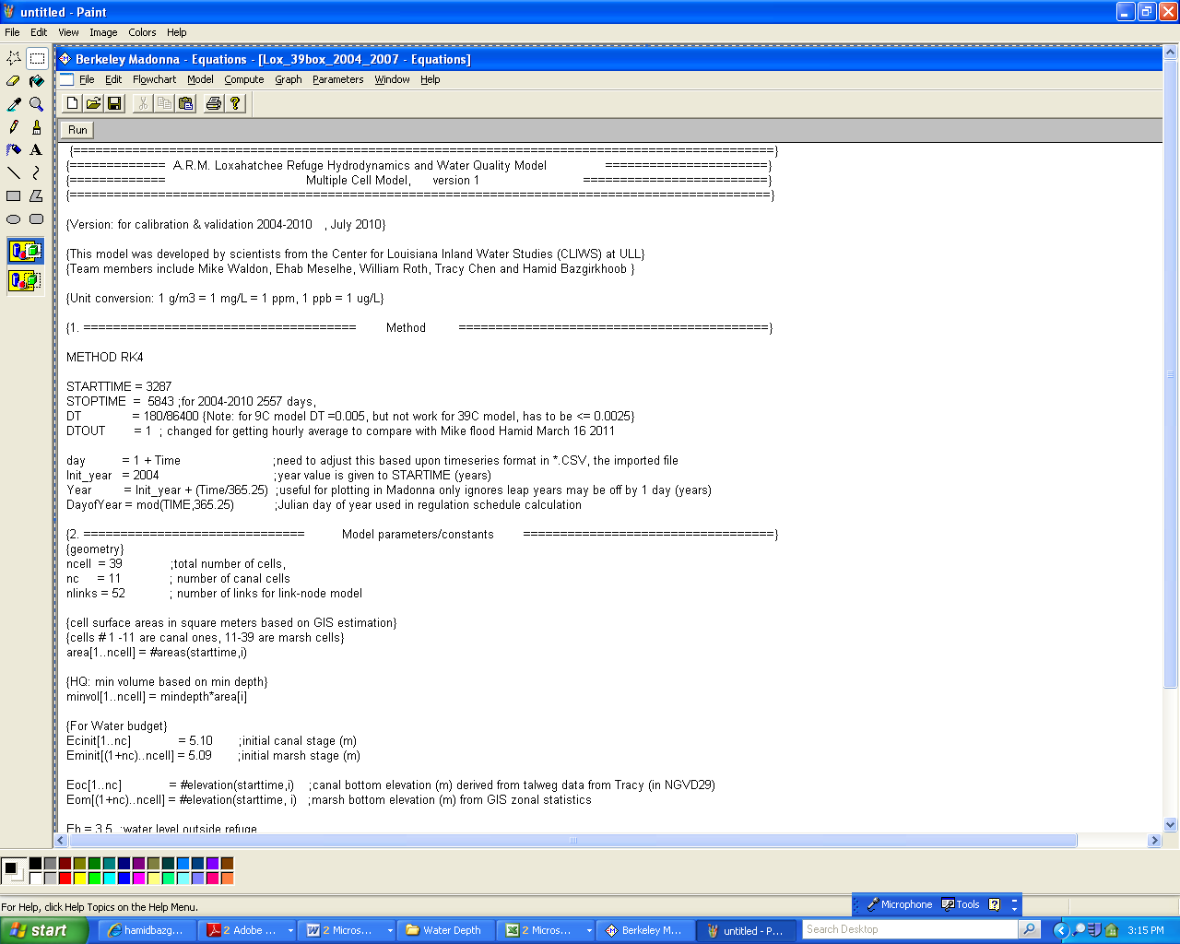

Berkeley-Madonna also has the capability to perform optimizations, curve-fitting, and sensitivity analyses. For a comprehensive description of all pre-programmed functions, users of the model are encouraged to download the Berkeley-Madonna user’s guide from [www.berkeleymadonna.com](http://www.berkeleymadonna.com). Additionally, users may download a demo version of this software from the Berkeley-Madonna web site and run models. However, while the demo version of the Berkeley-Madonna program allows users to modify and run models, the demo version does not allow the user to save model files or output of any kind.

* 1. **User’s Manual Objectives**

This manual presents the pertinent information required for users to understand the components of the model (i.e., imported data, model equation format, and post-processing methods). Ultimately, users should use this document as a companion for the model to assure accurate execution and interpretation.

* 1. **Caveats**
     1. If unfamiliar with Berkeley-Madonna, model users are strongly urged to consult the user’s guide before attempting to run or manipulate any of the model components.
     2. All parameter values represent those used to accurately validate and calibrate this model; discretion should be used when altering these values.
     3. This model is set up to simulate a 16-year (1995-2010) period. All time series data needed to successfully run the model are stored within the model file. This manual provides the user with the background and understanding needed to revise this model simulation for other user-selected time periods or scenarios. Should the user want to simulate another time period or alternative conditions, the proper data must be obtained, properly formatted, and imported into the model.
     4. Because of the level of spatial aggregation in the model, the model is not appropriate for applications that involve site-specific events. All results should be considered as spatial average values for the area of study.
     5. This document offers a brief summary of model theory and equations. Users should consult the referenced documentation, the model code, and the companion manuscript for more in-depth descriptions of equations and calibration parameter values.

1. **Data Preparation**

This section describes how to import the necessary time series text files. The 7 separate data input files are outlined in Table 1.

The user need to prepare the Chloride, Inflow, Outflow, PET ( precipitation and evapotranspiration), Regulation ( hurricanes and hydraulic- hydrologic events), SO4 and TP observed data in files, in the text format for the time period of run; with the day as the first column.

**Table 3: Model input files**

| **Filename** (alphabetical) | **Data Vectors** | **Summary** |
| --- | --- | --- |
| *CL.txt* | 14 | Chloride concentration values (mg/L) |
| *INFLOW.txt* | 20 | Historic inflow values (m3/d) |
| *OUTFLOW.txt* | 20 | Historic outflow values (m3/d) |
| *PET.txt* | 3 | Precipitation and Evapotranspiration (m/d) |
| *Regulation.txt* | 5 | Water supply release from S-39 and hurricane releases from S-10 structures (m3/d) |
| *SO4.txt* | 14 | Sulfate concentration values (mg/L) |
| *TP.txt* | 14 | TP concentration values (mg/L) |

Users may create data files for importing in any spreadsheet editing program. Berkeley-Madonna imports data files in either tab-delimited text format or comma-separated values (CSV) format. The preloaded input files in the model are primarily derived from data downloaded from the South Florida Water Management District’s database (DBHYDRO[1]). Although these data are readily available, it is strongly suggested that the user first run model simulations with the preloaded datasets.

**2.1 Spreadsheet Formatting**

Berkeley-Madonna supports definition of one and two dimensional piecewise linear arbitrary functions through importing text files of defining the function vertices. These functions are termed datasets, and are displayed and imported through the dataset window. Text files used in development of the 39-Box model were formatted as comma delimited values (*.csv). One dimensional datasets are defined by data in two columns which may be considered x-values and corresponding y-values on each row. The x-values must be monotonically increasing. A two-dimensional dataset also has x-values in the first column which are monotonically increasing, but begin in row 2. The first row defines a y-value for each column beginning in column 2. The value in (row 1, column 1) is not used and may be set at zero. One dimensional datasets are often used to define time series functions. In the 39-Box model, two dimensional datasets are used to define multiple related time series such as precipitation and evapotranspiration in a single dataset with the y-value designating the column of the desired variable, and the x-value designating time in days. See Appendix 1 for an example of a dataset spreadsheet, and Appendix 2 for a list of datasets and variables.

The 39-Box Model imports time series from 2-dimensional array dataset. The first column of the array is typically the time value in days increasing monotonically from the simulation initial time set at zero, to the final simulation day (in this case, 3287 to 4747). Berkeley-Madonna applies linear interpolation between data values. In order to avoid interpolation in the time series data, the user is encouraged to format the time series such that there are two values (the same value) for each time period (e.g., t1.000 = 5.656 and t1.999 = 5.656); thus, the imported data become similar to a stepwise constant function. To minimize the effort, a data organization subroutine may be written into a Visual Basic for Applications (VBA) module in Microsoft Excel. Additionally, the user must note that text and other non-numerical symbols will not be imported into Berkeley-Madonna; in fact, the importing process will cease if Berkeley-Madonna encounters such a symbol. As a reference, an abbreviated example spreadsheet, along with its VBA data organization subroutine, is provided in the Appendix of this document.

**2.2 Importing Data**

Once a time series spreadsheet has been created, it may be imported into Berkeley-Madonna by choosing **Import Dataset** from the **File** menu, or by choosing the **Dataset** from the **Model** menu. The user is then prompted to specify the dataset type and filename; in this case all datasets are entered as **1D** and given a specified filename per Table 1 (the file extension should not be included). Berkeley-Madonna syntax requires that the name of the input file be preceded by a pound sign (#). Typically, for 2-dimensional datasets a timing variable must be given; this variable tells Berkeley-Madonna at which times to read imported data. A simple solution is to use the build in function named **TIME**. In Berkeley-Madonna the syntax **TIME** represents a linear function that counts from the specified start time (**STARTTIME**) value to the specified stop time (**STOPTIME**) value based upon the time step (**DT**). The following equations set variables for precipitation (P) and evapotranspiration (ET) to the appropriate imported time series data values:

P = #PET (day, 1); (m/day)

ET = #PET (day, 2); (m/day)

where **#PET** indicates the file of imported data being used, **day** is the integer day of the simulation, and the numerical value indicates a column in the imported dataset. Once data are successfully imported, the file name will appear in the Datasets window on the Berkeley-Madonna desktop. Additionally, it is important to note that imported data are saved directly in the Berkeley-Madonna model file (*.mmd). There is no dynamic link between these data and the parent spreadsheet; therefore, any changes to the time series data must be made in the parent *.csv or *.txt file and then re-imported into the Berkeley-Madonna model.

**2.3 Comments, Constant Values, Arrays, & Equations**

Comments within the equation window provide model self-documentation, and are an important part of the model documentation. There are two alternative syntaxes for comments in Berkeley-Madonna a. Any text between left and right curly brackets, { }, is treated as a comment and not processed. This form of comment can span multiple lines of text. On a single line, all text following a semicolon is also treated as a comment.

Additionally, in imported text data files, all characters on a line beginning with the first non-numeric character are ignored. This allows comments identifying source or column names to be included within these text files.

Equation syntax in Berkeley-Madonna is similar to that in other programming languages such as Basic or FORTRAN. The value calculated on the right-hand-side of an equals sign is assigned to the variable on the left-hand-side. Unlike common programming languages, but similar to spreadsheets, Berkeley-Madonna is non-procedural; meaning the ordering of the equations is not significant. Berkeley-Madonna effectively sorts the equations in order to calculate the value of variables before they are used in subsequent calculations; the program recognizes circular references if such a sorting cannot be accomplished (Macey *et al*, 2000).

Many of the model equations have been consolidated by using arrays. Such equations are set up by using the square brackets ([]) for the values to be arrayed. There are 3 sets of arrayed variables: constituents, compartment, and DMSTA calibration sets. For all equations displayed in sections labeled **3.4.** The user can see examples of arrayed initial conditions and differential equations. Labels for each of the arrayed variables are given below.

Arrays are used extensively in the model to express equations that are repeated for a range of cells or constituents. Many of the array index values have been programmed as constants to enhance clarity of the code. For example, the equation “tp=3” defines a constant named tp that can be used as an array index (subscript) in place of simply the more obscure number 3. Berkeley-Madonna does identify constants during compilation, and there is apparently no runtime cost associated with this programming style.

; DEFINE ARRAYS

; REFUGE GEOMETRY

Ncell=11; total number of cells, canal is cell ncell

Nm=ncell-11; number of marsh cells

Canal=ncell; cell number for canal (there are 11 canal cells)

; CONSTITUENTS

nconstit= 3

cl= 1; chloride; conservative

so4=2; sulfate; monod relationship;

tp= 3; tp modeled with DMSTA equations

; DMSTA CALIBRATION SETS

emerg = 1; Emergent marsh

pew = 2; Pre-existing wetland

Berkeley-Madonna has a unique notation for array operations (Macey *et al*, 2000). Equations imply looping through a range of subscripts through ranges specified on the left-hand-side of the equation (see for examples sections 3.4.5 and 3.4.6 below). The variables i, j, and k are reserved in Berkeley-Madonna to refer on the right-hand-side of the equation to the first, second, and third array index, respectively, of the variable on the left. This notation replaces loops that are more commonly used in other programming languages.

**2.4 Runtime Options**

Berkeley-Madonna offers several numerical methods to solve ODEs, Euler’s Method, Runge Kutta-2, Runge Kutta-4, Auto stepsize and Rosenbrock (Stiff). The model may be executed accurately and expeditiously using the **RK4** (fourth order Runge-Kutta) method.

The current model is set up to simulate the 7 year period from 2004 to 2010 The user may specify the simulation period with the **STARTTIME** and **STOPTIME** functions. Model coding for the runtime parameters is given below.

1. **Code**

METHOD RK4

STARTTIME = 3287 {JAN04}; 4748 {JAN08};

STOPTIME=5843 {DEC10}; 4747 {DEC07};

DT = 0.00208333(3 minutes in the form of 180/86400, for the 39-Box DT has to be

<= 0.0025

DTOUT = 1

By default, Berkeley-Madonna saves model output every calculation time step, which can become costly as model size and complexity increases. The built-in variable **DTOUT** defines the time period that elapses between data storage for a simulation run. Setting **DTOUT** can reduce memory requirements. Here, model output is stored every one time unit (i.e., one day). If the user desires to store all output data, then **DTOUT** should be set equal to zero or, alternatively, the **DTOUT** statement can be removed.

**3.1 Parameters**

These values fall into two categories for the model code – simulation option parameters, and model parameters. The simulation option parameters are given at the beginning of the code (found in the **Equations** window). These allow some flexibility with model calculations, input data, and initial conditions. The user can choose outflow type, scale flow and constituent load, choose time series or constant values for boundary concentration, and choose different initial condition sets. The remaining parameters are calibrated and calculated values needed for an accurate base simulation of the model.

All model parameters (constant values) that are not arrayed can also be viewed in the **Parameters** window, which allows the user to change values and reset them without directly changing the code. Parameters with values modified from those set in the **Equations** window are flagged by an asterisk in the **Parameters** window. Users are cautioned that if parameter values are changed using the **Parameter** window, the altered values may persist in future model runs until they are reset. Additionally, the **Overlay Plots** (Figure 3) button can be used to display multiple model runs on the same graph; this feature is very helpful when visually assessing parameter alterations. Lists of all parameters are given in the appendix of this document.

**3.2 Processes**

Model processes are those equations that contribute to state variable calculation (e.g. groundwater seepage, corrected evapotranspiration, and reaction losses). Such equations represent values that can change with each time step. The user should consult the referenced material for more in depth discussions and explanations of model processes.

**3.3 State Variables**

Berkeley-Madonna has several ways to code state variables. The model uses the **d/dt()** option to define differential equations. All model differential equations are given below. It is necessary to specify an initial value for all state variables using the **INIT** initializer syntax.

The model directly calculates the change in volume of the Canal and Marsh compartments as per the 2-compartment structure described by Arceneaux *et al* (2007). The stage is then calculated from the volume. It must be noted that the area of the compartments is constant (i.e., it does not change with stage). The calculated value for the exchange flow,B2 (canal to marsh flow) is used to drive the volume differential equations for the 39-compartment constituent model.

**3.4.1 Initial Volume Values: 39-Compartment Model**

Init vol[1..nc] = D_CO[i]*area[i];

Init vol[(nc+1)..ncell] = D_MO[i]*area[i];

In which:

D_CO [1...nc] = Ecinit[i] - Eoc[i] initial depth in Canal

D_MO [(nc+1)...ncell] = Eminit[i] – Eom[i] initial depth in marsh

**3.4.2 Volume Differential Equations**

ETm[(nc+1)..ncell] = cor_ET[i] ;ETm = corrected ET in marsh (m/day)

cor_ET[(nc+1)..ncell] = Fet[i] *ET ;cor_ET = corrected ET (m/day)

Fet[(nc+1)..ncell] = MAX(ETmin, MIN(1, (Hm[i]/Het))) ;Fet = reduction factor for marsh ET (dimensionless)

Hm[(nc+1)..ncell] = MAX(0, (Em[i] - Eom[i])) ;Hm = marsh water depth (m)

transp = 1-evap ;fraction of ET that is transpired

dn[1..nlinks] = #linkdn(starttime, i)

up[1..nlinks] = #linkup(starttime, i)

{For Qmc estimation}

Q[1..nlinks] = (10^7)*B[i]*W[i]*(depth[dn[i]]^3)*(E[up[i]]-E[dn[i]])/Radius[i]

{For seepage}

Gc[1..nc] = lseep*(Ec[i] - Eb) ;Gc = canal seepage loss (m/day)

Gm[(nc+1)..ncell] = rseep*(Em[i] - Eb) ;Gm = marsh seepage loss (m/day)

canal seepage loss, m3/day

SpC[1..nc] = Gc[i]*area[i]

SpCanal = ARRAYSUM (SpC[*])

marsh seepage loss, m3/day

SpM[(nc+1)..ncell] = Gm[i]*area[i]

SpMarsh = ARRAYSUM (SpM[*])

totalSeepage = SpCanal + SpMarsh

{Stage}

Ec[1..nc] = depth[i] + Eoc[i]

Em[(nc+1)..ncell] = depth[i] + Eom[i]

d/dt(vol[canal])= ( P-ET-Gc[i])*area[i]+(Qin[i]-Qout[i]-QoutHistoric[i])

d/dt(vol[marsh])= (P-ETm[i]-Gm[i])*area[i] + Qin[i]-Q[out]

**3.4.3 Mass Calculations**

Calculate advective loads for each flow connection, + load is with positive flow

qload[1..nconstit, 1..nlinks]=(max(q[j],0)*conc[i,up[j]])-(max(-q[j],0)*conc[I,dn[j]])

exarea[1..nlinks]=W[i]*min(depth[dn[i]],depth[i]])

Dispersion coefficients: kd1, kd2, kd3

Dispersion loads:

dload[1..nconstit, 1..nc] = kd1*(exarea[j]/Radius[j])*(conc[i,up[j]]-conc[i,dn[j]])

dload[1..nconstit, (nc+1)..22] = kd2*(exarea[j]/Radius[j])*(conc[i,up[j]]-conc[i,dn[j]])

dload[1..nconstit, 23..nlinks] = kd3*(exarea[j]/Radius[j])*(conc[i,up[j]]-conc[i,dn[j]])

Aerial deposition

aload[1..nconstit, 1..ncell] = area[ j]*((DD[i]/1000) + (precip[i]*P))

Groundwater seepage + transpiration

gload[1..nconstit, (nc+1)..ncell] = conc[i, j]*(Gm[j]+(transp*ET))*area[ j] ; marsh seepage + transp load

gload[1..nconstit, 1..nc] = conc[i, j]*Gc[j]*area[j] ; canal seepage load, no transpiration in canal

Net canal structure inflow - outflow loads

sload[1..nconstit,1..4] = LOAD[i,j] - QoutHistoric[j]*conc[i, j]

sload[1..nconstit,5] = LOAD[i,5] - Qout[5]*conc[i, 5]

sload[1..nconstit,6] = LOAD[i,6] - Qout[6]*conc[i, 6]

sload[1..nconstit,7] = LOAD[i,7] - Qout[7]*conc[i, 7]

sload[1..nconstit,8] = LOAD[i,8] - Qout[8]*conc[i, 8]

sload[1..nconstit,9..nc] = LOAD[i,j] - QoutHistoric[j]*conc[i, j]

Reactive loads (losses)

rload[cl, 1..ncell] = 0 ; conservative

rload[so4, (nc+1)..ncell] = -(kso4[j]/depth[j])*max(mass[i, j],0)

rload[so4, 1..nc] = 0

rload[so4eco, (nc+1)..ncell] = -(MaxSO4Removal*area[j]) * conc[i, j]/(khalfSO4+conc[i, j]) ;g/day

rload[so4eco, 1..nc] = 0

rload[dmsta_tp, (nc+1)..ncell] = Release[i, j] - Uptake[i, j]

interP = 0.0

rload[dmsta_tp, 1..nc] = interP*area[j]

Where:

*i* = constituent,

*j* = compartment number (1-4),

*k* = DMSTA calibration set (Phosphorus only),

*M* = mass (g),

*t* = time (days),

*qnet* = net mass flow in surface water (g/day),

*gload* = loss to groundwater seepage and evapotranspiration (g/day),

*aload* = gain from wet and dry deposition (g/day), and

*rload* = loss to storage uptake/release (TP) or reaction (SO4) (g/day).

sload = Net canal structure inflow - outflow loads

**4.1. SRSM Regulatory Release**

A regulatory release is a discharge of water out of the Refuge that occurs as a result of the Refuge stage in relation to the Regulation Schedule (USFWS, 2000). The Regulation Schedule mandates a release of water from the Refuge when a date-dependent stage is exceeded. Magnitude of outflow during a regulatory release is not specified within the Regulation Schedule. It is therefore necessary to assume a water management rule in order to model regulatory releases. Version 4 of the SRSM (Meselhe *et al*, 2009) modeled regulatory releases based on historic discharges, and the same management rule for regulatory release is applied in the 39-Box model.

* 1. **Regulatory Release Calculations**

A regulatory release is a discharge of water out of the Refuge that occurs as a result of the Refuge stage in relation to the Regulation Schedule. Magnitude of outflow during a regulatory release is not specified within the Regulation Schedule. It is therefore necessary to make assumptions related to water management in order to model regulatory releases. The prior version of the SRSM modeled regulatory releases based on historic discharges.

1. **Model Execution & Post-processing**

Berkeley-Madonna’s user interface for model execution and post-processing is simple and straightforward. All operations needed for a general simulation run can be performed in the **Graph** window. The provided image designates the pertinent buttons with which the user should be familiar; however, for explicit explanations on each button, the Berkeley-Madonna user’s guide (Macey *et al*, 2000) should be consulted. The model may be executed from the **Graph** window by pressing the **Run** button; otherwise, the user may select **Run** from the **Compute** menu.

**Figure 8: Graphical Output**

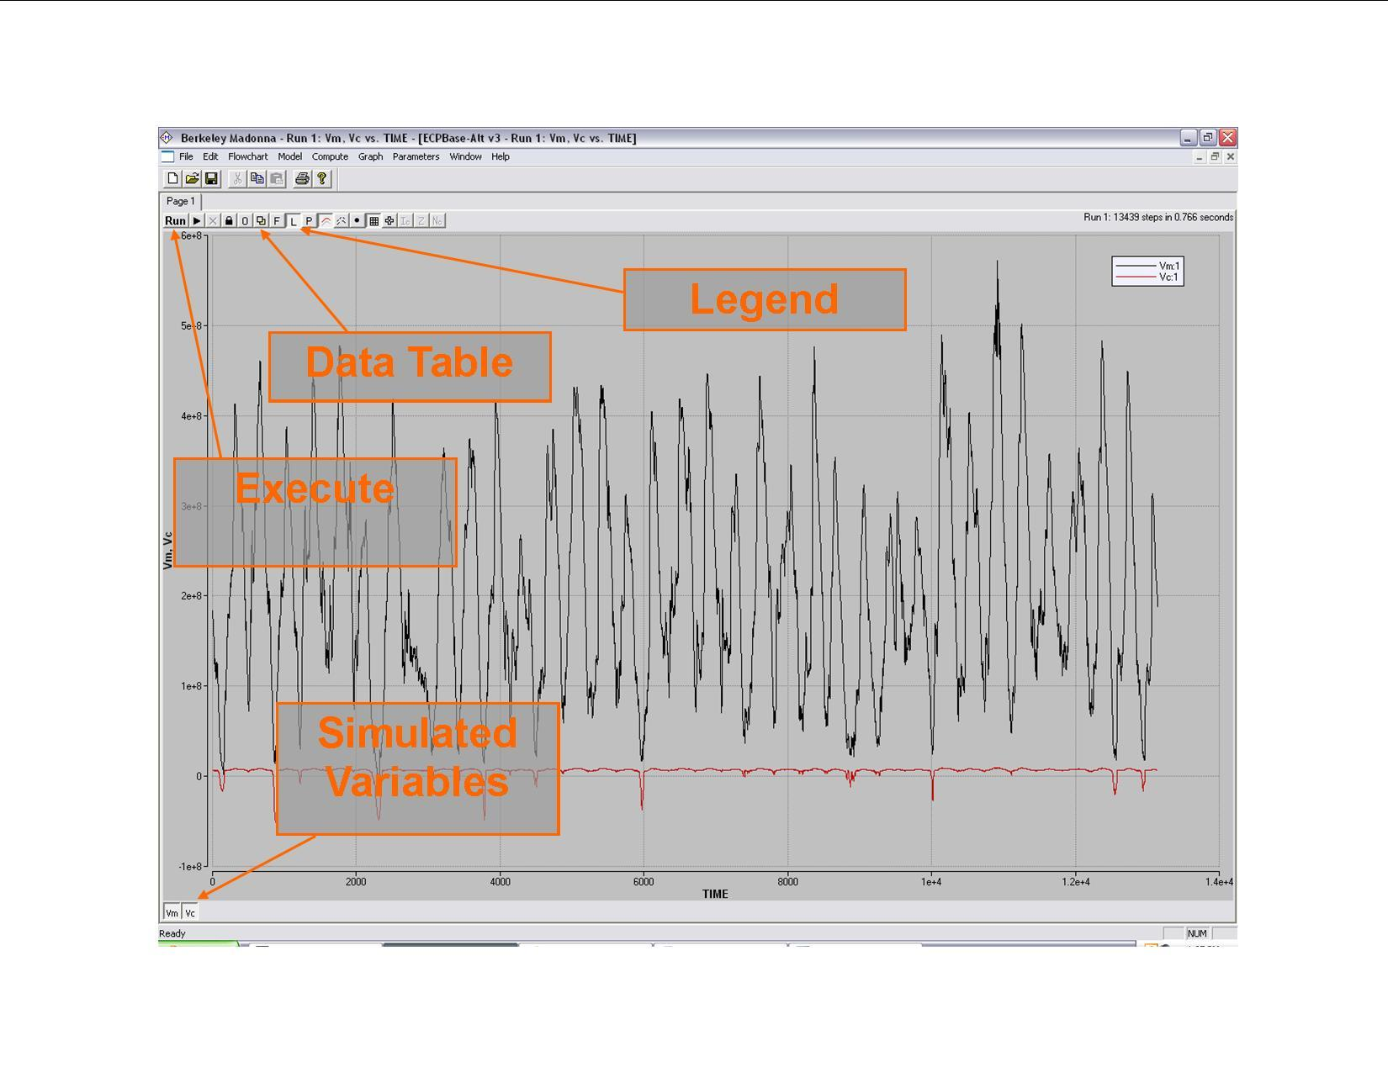

**Figure9: Graph Toolbar**

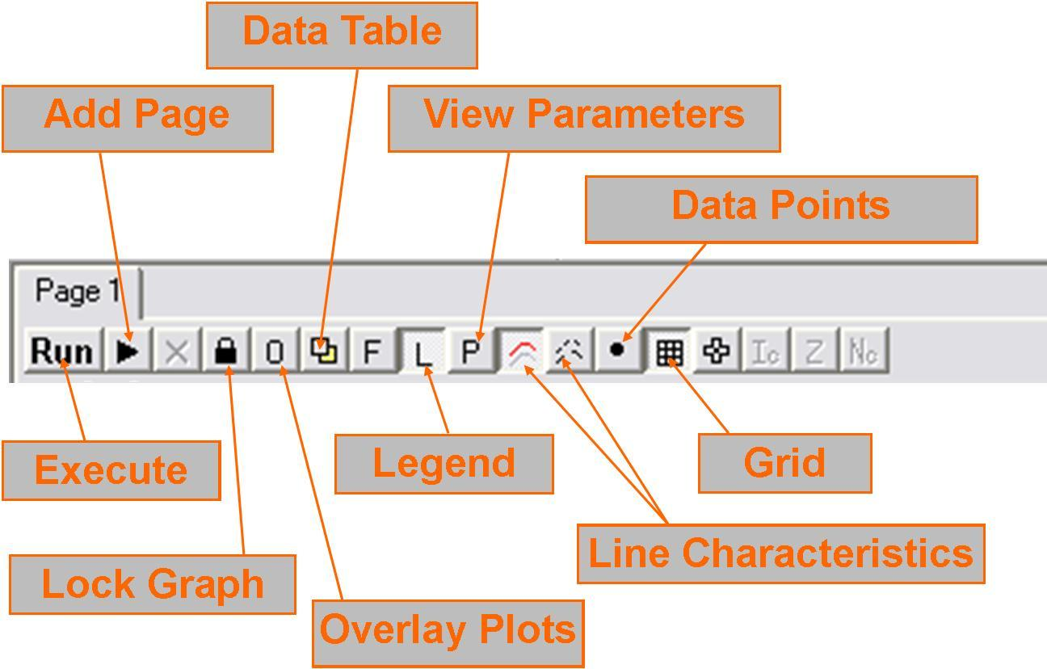

After pressing the **Run** button, Berkeley-Madonna will automatically output several variables from the model in the **Graph** window. To specify which variables to output, the user can double-click in the window and choose them from a list or select **Choose Variables** from the **Graph** menu. Once the desired variables are chosen and a model run is complete, the user may print the graph directly from Berkeley-Madonna or export the data as *.csv or *.txt. To export data the table must be displayed in the **Graph** window by clicking the **Data Table** button (see Figure 3). Then the user can select **Export Table** from the **File** menu, or use the **Copy Table** selection under the edit drop down menu.

* 1. **Optimization**

Berkeley-Madonna Equation solver has the ability to find an optimum value for the parameters in the equation window, to have the least error or divergence from the observed values for different period of times for different input files.

**4.1.1 One Parameter Optimization**

The one parameter optimization can be done by following these steps:

1. Importing the observed data set for the parameter for the length of time of optimization. This step can be done for one or multiple stations.
2. Write the optimization formula in the equation window, which the user finds more suitable to calculate the optimized factor. For instance, the user may want the optimized factor has the least error with the observed data for that parameter. Here the user can use the error formula like this:

AbsError_3cl = ABS (cl3-Obs_3cl)

d/dt (IAE3cl) = AbsError_3cl

INIT IAE3cl = 0

Here, the user has defined the absolute error for chloride for compartment 3, equal to the absolute value of the difference between the observed and simulation. And also, he has defined the initial value of this error to be zero. So, for the period of optimization there will be an accumulative error for the compartment 3 for chloride. Now, the summation of all the available observed data for the compartments will reach us to the minimum error. Here it may the compartment 4. So we have:

AbsError_4cl=ABS (cl4-Obs_4cl)

d/dt (IAE4cl) = AbsError_4cl

INIT IAE4cl = 0

And at the end, the user needs to define a summation for all the absolute errors for the observed stations, for which he wants the value to minimum. This part will be discussed in part 4.c.

1. Select optimization part from the parameter window. The code will ask for the parameter you want to optimize. As Berkeley-Madonna will do calculations for 7 digits after the point, it will assume each gained answer to be different from with the other one, though the difference is so small as 10 -7. At the same time, we know that the Berkeley-Madonna are doing the calculations in numerical equations, which means there may be multiple answers for different ranges which all of them will have the least error with our observed data set. So, here in order to prevent wasting a lot of time to find the optimal value, we can define a minimum and a maximum value for the optimized factor, which actually will be the range for the software to find the optimal value in; and two initial guesses with a tolerance for the answer, to start the calculation around them and also can move to the next guess with a predefined accuracy. The user can predict the optimized value to be in a especial domain, and so can easily define the maximum and minimum and the two initial guesses.

d) At the end, the user need to define what parameter he needs to be minimum; which in the example above will be the summation of the errors for the chloride for different compartments.

* + 1. **4.1.2 Optimization for multiple parameters**

The optimization for two or more parameters can be done the same way as for one parameter, except that the parameters may have different units. For instance, the user may want the optimal value of a parameter in such a way that the simulation has the least error with the observed data for a constituent and water level at the same time. The constituent simulation unit in the code has the unit of mg/l and the water level has the unit of meters. Consequently, the user needs to deactivate the role of units in the optimization formula. He needs to divide the result of the absolute error for each individual parameter with the observation by the average of the observed for that period. By this way, the units will be affectless in the formula and at the same time each set of observed data will have its own strength. At the end the user can add up all the absolute errors for different data sets and ask the model to find the optimal value in case the summation of the absolute errors be minimum. Figure 10, shows this calculation for optimization of sulfate and water level for especial compartments at the same time.

**Figure 10: Optimization for two factors at the same time in the Berkeley-Madonna 39-Box Model**

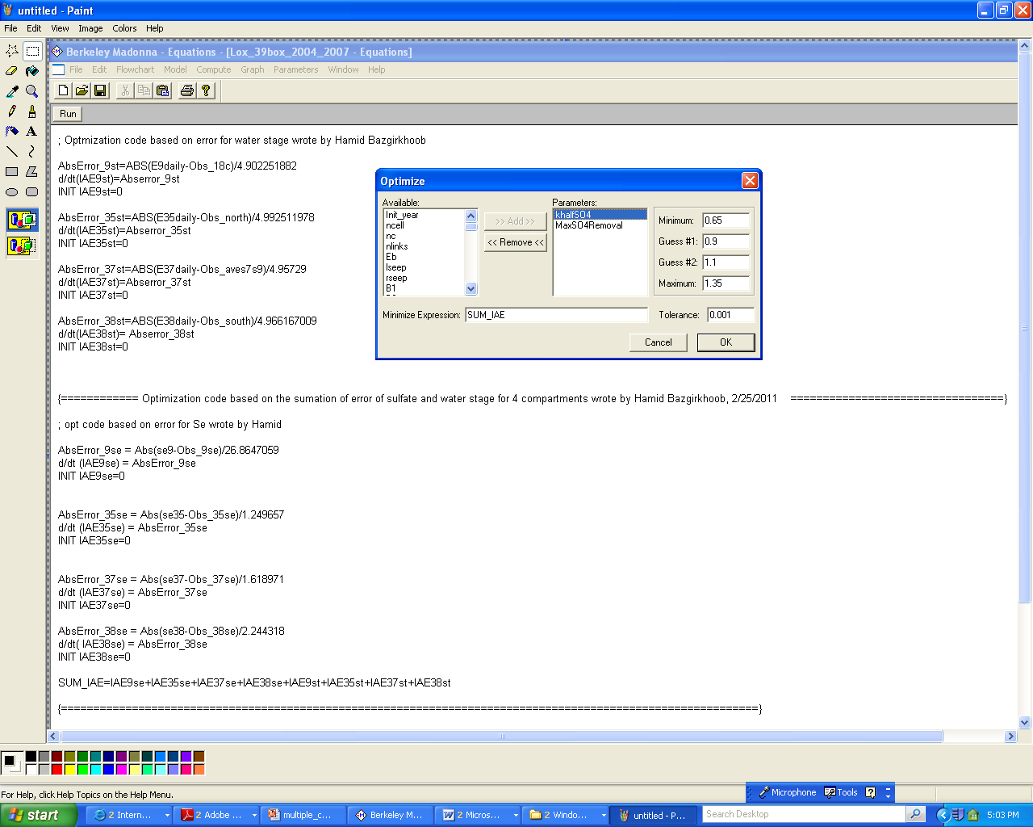

**Appendix**

1. **Example Spreadsheet Format**

**Figure 11: Sample Excel Spreadsheet**

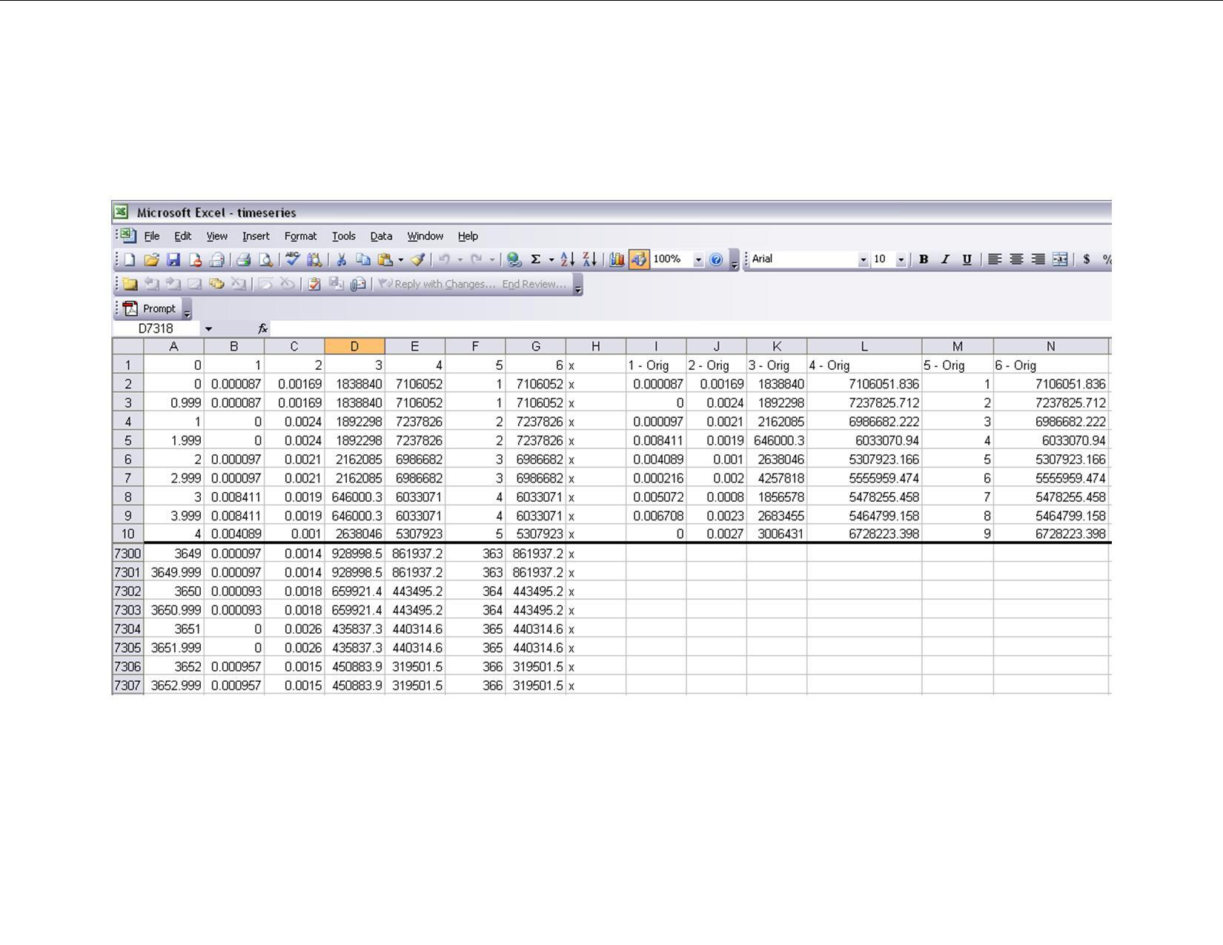

1. **Imported Datasets**

| **Variable name** | **File** | **Column** | **Description** |
| --- | --- | --- | --- |
| **P** | PET | 1 | Area Average Precipitation(m/day) |
| **ET** | PET | 2 | Observed Evapotranspiration(m/day) |
| **S39_Out** | Outflow | 1 | Obseved Structure Outflow (m3/day) |
| **G94A_Out** | Outflow | 2 | Obseved Structure Outflow (m3/day) |
| **G94B_Out** | Outflow | 3 | Obseved Structure Outflow (m3/day) |
| **G94C_Out** | Outflow | 4 | Obseved Structure Outflow (m3/day) |
| **G300_Out** | Outflow | 5 | Obseved Structure Outflow (m3/day) |
| **S5AS_Out** | Outflow | 6 | Obseved Structure Outflow (m3/day) |
| **G301_Out** | Outflow | 7 | Obseved Structure Outflow (m3/day) |
| **G338_Out** | Outflow | 8 | Obseved Structure Outflow (m3/day) |
| **S10E_Out** | Outflow | 9 | Obseved Structure Outflow (m3/day) |
| **S10D_Out** | Outflow | 10 | Obseved Structure Outflow (m3/day) |
| **S10C_Out** | Outflow | 11 | Obseved Structure Outflow (m3/day) |
| **S10A_Out** | Outflow | 12 | Obseved Structure Outflow (m3/day) |
| **G94A_in** | Inflow | 1 | Obseved Structure Inflow (m3/day) |
| **G94C_in** | Inflow | 2 | Obseved Structure Inflow (m3/day) |
| **G94D_in** | Inflow | 3 | Obseved Structure Inflow (m3/day) |
| **ACME1_in** | Inflow | 4 | Obseved Structure Inflow (m3/day) |
| **S362_in** | Inflow | 5 | Obseved Structure Inflow (m3/day) |
| **G300_in** | Inflow | 6 | Obseved Structure Inflow (m3/day) |
| **S5AS_in** | Inflow | 7 | Obseved Structure Inflow (m3/day) |
| **S5A_in** | Inflow | 8 | Obseved Structure Inflow (m3/day) |
| **G301_in** | Inflow | 9 | Obseved Structure Inflow (m3/day) |
| **G310_in** | Inflow | 10 | Obseved Structure Inflow (m3/day) |
| **G251_in** | Inflow | 11 | Obseved Structure Inflow (m3/day) |
| **S6_in** | Inflow | 12 | Obseved Structure Inflow (m3/day) |
| **G338_in** | Inflow | 13 | Obseved Structure Inflow (m3/day) |
| **S10A_hurricane** | Regulation | 1 | Supplementary emergency water release (m3/day) |
| **S10C_hurricane** | Regulation | 2 | Supplementary emergency water release (m3/day) |
| **S10D_hurricane** | Regulation | 3 | Supplementary emergency water release (m3/day) |
| **S39_WS** | Regulation | 4 | Supplementary emergency water release (m3/day) |
| **G94A_TP** | TP | 1 | Observed total phosphorus concentration (mg/L) |
| **G94C_TP** | TP | 2 | Observed total phosphorus concentration (mg/L) |
| **G94D_TP** | TP | 3 | Observed total phosphorus concentration (mg/L) |
| **ACME1_TP** | TP | 4 | Observed total phosphorus concentration (mg/L) |
| **S362_TP** | TP | 5 | Observed total phosphorus concentration (mg/L) |
| **G300_TP** | TP | 6 | Observed total phosphorus concentration (mg/L) |
| **S5AS_TP** | TP | 7 | Observed total phosphorus concentration (mg/L) |
| **S5A_TP** | TP | 8 | Observed total phosphorus concentration (mg/L) |
| **G301_TP** | TP | 9 | Observed total phosphorus concentration (mg/L) |
| **G310_TP** | TP | 10 | Observed total phosphorus concentration (mg/L) |
| **G251_TP** | TP | 11 | Observed total phosphorus concentration (mg/L) |
| **S6_TP** | TP | 12 | Observed total phosphorus concentration (mg/L) |
| **G338_TP** | TP | 13 | Observed total phosphorus concentration (mg/L) |
| **G94A_Cl** | CL | 1 | Observed chloride concentration (mg/L) |
| **G94C_Cl** | CL | 2 | Observed chloride concentration (mg/L) |
| **G94D_Cl** | CL | 3 | Observed chloride concentration (mg/L) |
| **ACME1_Cl** | CL | 4 | Observed chloride concentration (mg/L) |
| **S362_Cl** | CL | 5 | Observed chloride concentration (mg/L) |
| **G300_Cl** | CL | 6 | Observed chloride concentration (mg/L) |
| **S5AS_Cl** | CL | 7 | Observed chloride concentration (mg/L) |
| **S5A_Cl** | CL | 8 | Observed chloride concentration (mg/L) |
| **G301_Cl** | CL | 9 | Observed chloride concentration (mg/L) |
| **G310_Cl** | CL | 10 | Observed chloride concentration (mg/L) |
| **G251_Cl** | CL | 11 | Observed chloride concentration (mg/L) |
| **S6_Cl** | CL | 12 | Observed chloride concentration (mg/L) |
| **G338_Cl** | CL | 13 | Observed chloride concentration (mg/L) |
| **G94A_SO4** | SO4 | 1 | Observed sulfate concentration (mg/L) |
| **G94C_SO4** | SO5 | 2 | Observed sulfate concentration (mg/L) |
| **G94D_SO4** | SO6 | 3 | Observed sulfate concentration (mg/L) |
| **ACME1_SO4** | SO7 | 4 | Observed sulfate concentration (mg/L) |
| **S362_SO4** | SO8 | 5 | Observed sulfate concentration (mg/L) |
| **G300_SO4** | SO9 | 6 | Observed sulfate concentration (mg/L) |
| **S5AS_SO4** | SO10 | 7 | Observed sulfate concentration (mg/L) |
| **S5A_SO4** | SO11 | 8 | Observed sulfate concentration (mg/L) |
| **G301_SO4** | SO12 | 9 | Observed sulfate concentration (mg/L) |
| **G310_SO4** | SO13 | 10 | Observed sulfate concentration (mg/L) |
| **G251_SO4** | SO14 | 11 | Observed sulfate concentration (mg/L) |
| **S6_SO4** | SO15 | 12 | Observed sulfate concentration (mg/L) |
| **G338_SO4** | SO16 | 13 | Observed sulfate concentration (mg/L) |

1. **Simulation Option Parameters**

| **Variable Name** | **Default Value** | **Explanation** |
| --- | --- | --- |
| **CalcQRo** | 1 | Distinguishes between calculated (1) or historic outflow (0) |
| **RSQfact** | 1 | Scaling factor for regulatory release |

1. **Model Parameters**

| **Variable Name** | **Value** | **Description** |
| --- | --- | --- |
| **ncell** | 39 | Total number of cells |
| **nc** | 11 | Number of canal cells |
| **nlinks** | 52 | Number of links for link-node model |
| **C1_area** | 67451.13582 | Canal Surface Area (m2) |
| **C2_area** | 432580.5052 | Canal Surface Area (m2) |
| **C3_area** | 1321081.929 | Canal Surface Area (m2) |
| **C4_area** | 1070766.749 | Canal Surface Area (m2) |
| **C5_area** | 343866.8469 | Canal Surface Area (m2) |
| **C6_area** | 242568.4998 | Canal Surface Area (m2) |
| **C7_area** | 290820.5459 | Canal Surface Area (m2) |
| **C8_area** | 1172416.461 | Canal Surface Area (m2) |
| **C9_area** | 745969.4192 | Canal Surface Area (m2) |
| **C10_area** | 770845.383 | Canal Surface Area (m2) |
| **C11_area** | 325422.4124 | Canal Surface Area (m2) |
| **M12_area** | 1181402.532 | Marsh Surface Area (m2) |
| **M13_area** | 2501726.142 | Marsh Surface Area (m2) |
| **M14_area** | 293003.0385 | Marsh Surface Area (m2) |
| **M15_area** | 543785.3522 | Marsh Surface Area (m2) |
| **M16_area** | 3485961.831 | Marsh Surface Area (m2) |
| **M17_area** | 4045182.15 | Marsh Surface Area (m2) |
| **M18_area** | 3195752.157 | Marsh Surface Area (m2) |
| **M19_area** | 7636805.725 | Marsh Surface Area (m2) |
| **M20_area** | 7200836.399 | Marsh Surface Area (m2) |
| **M21_area** | 13400481 | Marsh Surface Area (m2) |
| **M22_area** | 4195293.496 | Marsh Surface Area (m2) |
| **M23_area** | 14539203.09 | Marsh Surface Area (m2) |
| **M24_area** | 1890978.078 | Marsh Surface Area (m2) |
| **M25_area** | 7512971.275 | Marsh Surface Area (m2) |
| **M26_area** | 988502.2216 | Marsh Surface Area (m2) |
| **M27_area** | 5248955.804 | Marsh Surface Area (m2) |
| **M28_area** | 522323.8002 | Marsh Surface Area (m2) |
| **M29_area** | 2903428.105 | Marsh Surface Area (m2) |
| **M30_area** | 4434932.933 | Marsh Surface Area (m2) |
| **M31_area** | 12224954.71 | Marsh Surface Area (m2) |
| **M32_area** | 4740640.266 | Marsh Surface Area (m2) |
| **M33_area** | 12213974.99 | Marsh Surface Area (m2) |
| **M34_area** | 61064630.23 | Marsh Surface Area (m2) |
| **M35_area** | 62998466.73 | Marsh Surface Area (m2) |
| **M36_area** | 87163883.38 | Marsh Surface Area (m2) |
| **M37_area** | 135435126.2 | Marsh Surface Area (m2) |
| **M38_area** | 31888461.52 | Marsh Surface Area (m2) |
| **M39_area** | 63423036.38 | Marsh Surface Area (m2) |
| **Ecinit** | 5.10 | Initial Canal Stage (m) |
| **Eminit** | 5.09 | Initial Marsh Stage (m) |
| **Eoc_C1** | 2.44289 | Canal bottom elevation (m) |
| **Eoc_C2** | 0.98225 | Canal bottom elevation (m) |
| **Eoc_C3** | 0.941286 | Canal bottom elevation (m) |
| **Eoc_C4** | 0.498 | Canal bottom elevation (m) |
| **Eoc_C5** | 0.58 | Canal bottom elevation (m) |
| **Eoc_C6** | 0.716 | Canal bottom elevation (m) |
| **Eoc_C7** | 0.6905 | Canal bottom elevation (m) |
| **Eoc_C8** | -0.106778 | Canal bottom elevation (m) |
| **Eoc_C9** | 1.42233 | Canal bottom elevation (m) |
| **Eoc_C10** | 1.64929 | Canal bottom elevation (m) |
| **Eoc_C11** | 1.24433 | Canal bottom elevation (m) |
| **Eom_M12** | 4.645 | marsh bottom elevation (m) |
| **Eom_M13** | 4.645 | marsh bottom elevation (m) |
| **Eom_M14** | 4.55 | marsh bottom elevation (m) |
| **Eom_M15** | 4.55 | marsh bottom elevation (m) |
| **Eom_M16** | 4.55 | marsh bottom elevation (m) |
| **Eom_M17** | 4.55 | marsh bottom elevation (m) |
| **Eom_M18** | 4.13 | marsh bottom elevation (m) |
| **Eom_M19** | 4.42 | marsh bottom elevation (m) |
| **Eom_M20** | 4.42 | marsh bottom elevation (m) |
| **Eom_M21** | 4.33 | marsh bottom elevation (m) |
| **Eom_M22** | 4.04 | marsh bottom elevation (m) |
| **Eom_M23** | 4.04 | marsh bottom elevation (m) |
| **Eom_M24** | 4.04 | marsh bottom elevation (m) |
| **Eom_M25** | 4.04 | marsh bottom elevation (m) |
| **Eom_M26** | 4.29 | marsh bottom elevation (m) |
| **Eom_M27** | 4.29 | marsh bottom elevation (m) |
| **Eom_M28** | 4.58 | marsh bottom elevation (m) |
| **Eom_M29** | 4.56 | marsh bottom elevation (m) |
| **Eom_M30** | 4.6 | marsh bottom elevation (m) |
| **Eom_M31** | 4.63 | marsh bottom elevation (m) |
| **Eom_M32** | 4.74 | marsh bottom elevation (m) |
| **Eom_M33** | 4.74 | marsh bottom elevation (m) |
| **Eom_M34** | 4.75 | marsh bottom elevation (m) |
| **Eom_M35** | 4.83 | marsh bottom elevation (m) |
| **Eom_M36** | 4.62 | marsh bottom elevation (m) |
| **Eom_M37** | 4.55 | marsh bottom elevation (m) |
| **Eom_M38** | 4.19 | marsh bottom elevation (m) |
| **Eom_M39** | 4.43 | marsh bottom elevation (m) |
| **Eb** | 3.5 | Water Stage outside Refuge (m) |
| **Iseep** | 0.0484046 | Canal Seepage Constant (1/day) |
| **rseep** | 8.16E-10 | Marsh Seepage Constant (1/day) |
| **B1** | 6.97621 | Transport Coefficient Between Canal and Canal(1/m-day) |
| **B2** | 1.13863 | Transport Coefficient Between Canal and Marsh(1/m-day) |
| **B3** | 4.55002 | Transport Coefficient Between Marsh and Marsh(1/m-day) |
| **Radius_link 1** | 3345 | Radius of link 1 |
| **Radius_link 2** | 8059 | Radius of link 2 |
| **Radius_link 3** | 12408 | Radius of link 3 |
| **Radius_link 4** | 9781 | Radius of link 4 |
| **Radius_link 5** | 5366 | Radius of link 5 |
| **Radius_link 6** | 3279 | Radius of link 6 |
| **Radius_link 7** | 7120 | Radius of link 7 |
| **Radius_link 8** | 14101 | Radius of link 8 |
| **Radius_link 9** | 12465 | Radius of link 9 |
| **Radius_link 10** | 7607 | Radius of link 10 |
| **Radius_link 11** | 2730 | Radius of link 11 |
| **Radius_link 12** | 108 | Radius of link 12 |
| **Radius_link 13** | 182 | Radius of link 13 |
| **Radius_link 14** | 671 | Radius of link 14 |
| **Radius_link 15** | 429 | Radius of link 15 |
| **Radius_link 16** | 248 | Radius of link 16 |
| **Radius_link 17** | 477 | Radius of link 17 |
| **Radius_link 18** | 183 | Radius of link 18 |
| **Radius_link 19** | 472 | Radius of link 19 |
| **Radius_link 20** | 1314 | Radius of link 20 |
| **Radius_link 21** | 338 | Radius of link 21 |
| **Radius_link 22** | 327 | Radius of link 22 |
| **Radius_link 23** | 375 | Radius of link 23 |
| **Radius_link 24** | 495 | Radius of link 24 |
| **Radius_link 25** | 541 | Radius of link 25 |
| **Radius_link 26** | 805 | Radius of link 26 |
| **Radius_link 27** | 778 | Radius of link 27 |
| **Radius_link 28** | 798 | Radius of link 28 |
| **Radius_link 29** | 592 | Radius of link 29 |
| **Radius_link 30** | 843 | Radius of link 30 |
| **Radius_link 31** | 1103 | Radius of link 31 |
| **Radius_link 32** | 1022 | Radius of link 32 |
| **Radius_link 33** | 850 | Radius of link 33 |
| **Radius_link 34** | 9990 | Radius of link 34 |
| **Radius_link 35** | 9892 | Radius of link 35 |
| **Radius_link 36** | 7476 | Radius of link 36 |
| **Radius_link 37** | 3222 | Radius of link 37 |
| **Radius_link 38** | 4213 | Radius of link 38 |
| **Radius_link 39** | 3551 | Radius of link 39 |
| **Radius_link 40** | 3028 | Radius of link 40 |
| **Radius_link 41** | 5420 | Radius of link 41 |
| **Radius_link 42** | 3427 | Radius of link 42 |
| **Radius_link 43** | 5946 | Radius of link 43 |
| **Radius_link 44** | 3631 | Radius of link 44 |
| **Radius_link 45** | 7994 | Radius of link 45 |
| **Radius_link 46** | 10674 | Radius of link 46 |
| **Radius_link 47** | 10051 | Radius of link 47 |
| **Radius_link 48** | 10497 | Radius of link 48 |
| **Radius_link 49** | 9684 | Radius of link 49 |
| **Radius_link 50** | 6275 | Radius of link 50 |
| **Radius_link 51** | 9330 | Radius of link 51 |
| **Radius_link 52** | 6390 | Radius of link 52 |
| **Width_link 1** | 37.5 | Width of link 1 |
| **Width_link 2** | 55 | Width of link 2 |
| **Width_link 3** | 55 | Width of link 3 |
| **Width_link 4** | 55 | Width of link 4 |
| **Width_link 5** | 55 | Width of link 5 |
| **Width_link 6** | 55 | Width of link 6 |
| **Width_link 7** | 47.5 | Width of link 7 |
| **Width_link 8** | 40 | Width of link 8 |
| **Width_link 9** | 40 | Width of link 9 |
| **Width_link 10** | 40 | Width of link 10 |
| **Width_link 11** | 35 | Width of link 11 |
| **Width_link 12** | 896 | Width of link 12 |
| **Width_link 13** | 5148 | Width of link 13 |
| **Width_link 14** | 11683 | Width of link 14 |
| **Width_link 15** | 13712 | Width of link 15 |
| **Width_link 16** | 6128 | Width of link 16 |
| **Width_link 17** | 4163 | Width of link 17 |
| **Width_link 18** | 2872 | Width of link 18 |
| **Width_link 19** | 15871 | Width of link 19 |
| **Width_link 20** | 13305 | Width of link 20 |
| **Width_link 21** | 11729 | Width of link 21 |
| **Width_link 22** | 4798 | Width of link 22 |
| **Width_link 23** | 1130 | Width of link 23 |
| **Width_link 24** | 4659 | Width of link 24 |
| **Width_link 25** | 11671 | Width of link 25 |
| **Width_link 26** | 13680 | Width of link 26 |
| **Width_link 27** | 6152 | Width of link 27 |
| **Width_link 28** | 4155 | Width of link 28 |
| **Width_link 29** | 2869 | Width of link 29 |
| **Width_link 30** | 15967 | Width of link 30 |
| **Width_link 31** | 13315 | Width of link 31 |
| **Width_link 32** | 11687 | Width of link 32 |
| **Width_link 33** | 3932 | Width of link 33 |
| **Width_link 34** | 867 | Width of link 34 |
| **Width_link 35** | 788 | Width of link 35 |
| **Width_link 36** | 4779 | Width of link 36 |
| **Width_link 37** | 11212 | Width of link 37 |
| **Width_link 38** | 12928 | Width of link 38 |
| **Width_link 39** | 5496 | Width of link 39 |
| **Width_link 40** | 3907 | Width of link 40 |
| **Width_link 41** | 2960 | Width of link 41 |
| **Width_link 42** | 14143 | Width of link 42 |
| **Width_link 43** | 12725 | Width of link 43 |
| **Width_link 44** | 11618 | Width of link 44 |
| **Width_link 45** | 4219 | Width of link 45 |
| **Width_link 46** | 7107 | Width of link 46 |
| **Width_link 47** | 5582 | Width of link 47 |
| **Width_link 48** | 9358 | Width of link 48 |
| **Width_link 49** | 10656 | Width of link 49 |
| **Width_link 50** | 14161 | Width of link 50 |
| **Width_link 51** | 12202 | Width of link 51 |
| **Width_link 52** | 8643 | Width of link 52 |
| **ETmin** | 0.2 | minimum ET reduction factor for marsh |
| **HET** | 0.25 | ET depth reduction boundary(m) |
| **evap** | 0.65 | Fraction of ET that is evaporation |
| **transp** | 0.35 | Fraction of ET that is transpiration |
| **mindepth** | 0.05 | Minimum water depth (m) |
| **minvol_C1** | 1986.7 | Minimum volume of Canal1 |
| **minvol_C2** | 14618 | Minimum volume of Canal2 |
| **minvol_C3** | 32939.1 | Minimum volume of Canal3 |
| **minvol_C4** | 38640.1 | Minimum volume of Canal4 |
| **minvol_C5** | 17292.4 | Minimum volume of Canal5 |
| **minvol_C6** | 11932 | Minimum volume of Canal6 |
| **minvol_C7** | 8164.05 | Minimum volume of Canal7 |
| **minvol_C8** | 33192.9 | Minimum volume of Canal8 |
| **minvol_C9** | 27266.9 | Minimum volume of Canal9 |
| **minvol_C10** | 23701.2 | Minimum volume of Canal10 |
| **minvol_C11** | 11028 | Minimum volume of Canal11 |
| **minvol_M12** | 14650.2 | Minimum volume of Marsh12 |
| **minvol_M13** | 27189.3 | Minimum volume of Marsh13 |
| **minvol_M14** | 59070.1 | Minimum volume of Marsh14 |
| **minvol_M15** | 174298 | Minimum volume of Marsh15 |
| **minvol_M16** | 159788 | Minimum volume of Marsh16 |
| **minvol_M17** | 381840 | Minimum volume of Marsh17 |
| **minvol_M18** | 209765 | Minimum volume of Marsh18 |
| **minvol_M19** | 726960 | Minimum volume of Marsh19 |
| **minvol_M20** | 94548.9 | Minimum volume of Marsh20 |
| **minvol_M21** | 375649 | Minimum volume of Marsh21 |
| **minvol_M22** | 49425.1 | Minimum volume of Marsh22 |
| **minvol_M23** | 262448 | Minimum volume of Marsh23 |
| **minvol_M24** | 26116.2 | Minimum volume of Marsh24 |
| **minvol_M25** | 145171 | Minimum volume of Marsh25 |
| **minvol_M26** | 221747 | Minimum volume of Marsh26 |
| **minvol_M27** | 611248 | Minimum volume of Marsh27 |
| **minvol_M28** | 237032 | Minimum volume of Marsh28 |
| **minvol_M29** | 610699 | Minimum volume of Marsh29 |
| **minvol_M30** | 360042 | Minimum volume of Marsh30 |
| **minvol_M31** | 670024 | Minimum volume of Marsh31 |
| **minvol_M32** | 125086 | Minimum volume of Marsh32 |
| **minvol_M33** | 202259 | Minimum volume of Marsh33 |
| **minvol_M34** | 3.05323E+06 | Minimum volume of Marsh34 |
| **minvol_M35** | 3.14992E+06 | Minimum volume of Marsh35 |
| **minvol_M36** | 4.35819E+06 | Minimum volume of Marsh36 |
| **minvol_M37** | 6.77179E+06 | Minimum volume of Marsh37 |
| **minvol_M38** | 1.59442E+06 | Minimum volume of Marsh38 |
| **minvol_M39** | 3.17115E+06 | Minimum volume of Marsh39 |
| **nconstit** | 5 | Number of calculated constituents in the model |
| **Cl** | 1 | Chloride, conservative |
| **SO4** | 2 | Sulfate, apparent settling |
| **tp** | 3 | Total Phosphorus, k-c*model |
| **SO4eco** | 4 | Sulfate, monod relationship, ecolab |
| **dmsta_tp** | 5 | TP modeled with DMSTA equations |
| **Precip_Cl** | 2.00 | Chloride Concentration from Rainfall ( mg/L) |
| **DD[cl]** | 3.110198 | Dry deposition of chloride (mg/m2-day) |
| **Precip_SO4** | 1.00 | Sulfate Concentration from Rainfall ( mg/L) |
| **DD[SO4]** | 0.378371 | Dry deposition of SO4 (mg/m2-day) |
| **Precip[SO4eco]** | 1.00 | SO4eco Concentration from rainfall (mg/L) |
| **DD[SO4eco]** | 0.378371 | Dry deposition of SO4eco (mg/m2-day) |
| **Precip_TP** | 0.010 | TP Concentration from Rainfall ( mg/L) |
| **DD[tp]** | 0.110 | Dry deposition of Phosphorus (mg/m2-day) |
| **Precip[dmsta_tp]** | 0.010 | wet deposition of TP(mg/L) |
| **DD[dmsta_tp]** | 0.110 | dry deposition of TP (mg/m2.day) |
| **KhalfSO4** | 0.650927 | Sulfate half saturation constant (g/m3) |
| **MaxSO4removal** | 0.074991 | Maximum sulfate removal (g/m2-yr) |
| **Ktp** | 0.045995 | settling rate (m/day) |
| **cstarm** | 0.008 | C* in marsh cells |
| **cstarc** | 0.080 | C* in canal cells |
| **K1[emerg]** | 0.291307 | Phosphorus (emergent wetland) maximum uptake rate( m3/g/day) |
| **K1[Pew]** | 0.605065 | Phosphorus (Pre-existing wetland) maximum uptake rate( m3/g/day) |
| **K2[emerg]** | 0.005476 | Phosphorus (Emergent wetland) recycle rate( m2/g/day) |
| **K2[Pew]** | 0.011499 | Phosphorus (Pre-existing wetland) recycle rate( m2/g/day) |
| **K3[emerg]** | 0.000874 | Phosphorus (Emergent wetland) burial rate( 1/day) |
| **K3[Pew]** | 0.001815 | Phosphorus (Pre-existing wetland) burial rate( 1/day) |
| **kd1** | 0 | Dispersion Coefficient between canal and canal (m2/day) |
| **kd2** | 0 | Dispersion Coefficient between canal and marsh (m2/day) |
| **kd3** | 43200 | Dispersion Coefficient between marsh and marsh (m2/day) |

**LITERATURE CITED**

Arceneaux, J., Meselhe, E. A., Griborio, A., and Waldon, M. G. (2007). "The Arthur R. Marshall Loxahatchee National Wildlife Refuge Water Budget and Water Quality Models." *Report No. LOXA-07-004, currently available at < http://mwaldon.com/LoxModel/reports/LOXA07-004--2007-06.pdf >*, University of Louisiana at Lafayette in cooperation with the US Fish and Wildlife Service, Lafayette, Louisiana.

Macey, R., Oster, G., and Zahnley, T. (2000). "Berkeley Madonna User’s Guide Version 8.0." University of California, Department of Molecular and Cellular Biology, Berkeley, CA.

Meselhe, E. A., Griborio, A. G., and Gautam, S. (2005). "Hydrodynamic And Water Quality Modeling For The A.R.M. Loxahatchee National Wildlife Refuge, Phase 1: Preparation Of Data, Task 1: Data Acquisition and Processing." *Report #LOXA05-014 available at < http://sofia.usgs.gov/lox_monitor_model/advisorypanel/data_acq_report.html >*, University of Louisiana-Lafayette in cooperation with the US Fish and Wildlife Service, Lafayette, LA.

Meselhe, E., Arceneaux, J., and Waldon, M. G. (2007a). "Mass Balance Model Version 1.01." *LOXA-07-002, currently available at < http://loxmodel.mwaldon.com >*, University of Louisiana - Lafayette in cooperation with the US Fish and Wildlife Service, Lafayette, LA.

Meselhe, E., Arceneaux, J., Waldon, M. G., and Wang, H. (2007b). "Water Quality Model Version 1.00." *LOXA-07-003, currently available at < http://loxmodel.mwaldon.com >*, University of Louisiana - Lafayette in cooperation with the US Fish and Wildlife Service, Lafayette, LA.

Meselhe, E. A., Waldon, M. G., and Roth, W. (2009). "A.R.M. Loxahatchee National Wildlife Refuge Simple Refuge Screening Model Version 4.00 User’s Manual." University of Louisiana - Lafayette, Lafayette, Louisiana.

Meselhe, E., Chen, C., Bazgirhoob, H., Wang, H., Roth, B., Arceneaux, J., and Waldon, M. G. (2011). "Near Zeroth Order Sulfate Disappearance Rate Estimated using Models of the Arthur R. Marshall Loxahatchee National Wildlife Refuge " Annual Greater Everglades Mercury/Sulfur Workshop, June 21-22, 2011, West Palm Beach, FL.

USFWS. (2000). "Arthur R. Marshall Loxahatchee National Wildlife Refuge Comprehensive Conservation Plan." *available at < http://loxahatchee.fws.gov >*, US Fish and Wildlife Service, Boynton Beach, Florida.

Walker, W. W., Jr., and Kadlec, R. H. (2011). "Modeling Phosphorus Dynamics in Everglades Wetlands and Stormwater Treatment Areas." Critical Reviews in Environmental Science and Technology, 41(6), 430-446.

Wang, H., Meselhe, E. A., Waldon, M. G., Surratt, D., Abdou, S., Chen, C., and Harwell, M. C. (2008). "Compartment delineation for a wetland water quality model in the Northern Everglades, Florida, USA." *Journal of Environmental Hydrology*, 16, Paper 36.

Wang, H., Meselhe, E. A., Waldon, M. G., Harwell, M. C., and Chen, C. (2012). "Compartment-based hydrodynamics and water quality modeling of a Northern Everglades Wetland, Florida, USA." Ecological Modelling, 247, 273-285.

1. http://www.sfwmd.gov/portal/page?_pageid=2894,19708232&_dad=portal&_schema=PORTAL