Title: Stage Model Flow Chart

Read time series and parameter input

Set initial condition for first day

Loop through days from start to end

Integrate forward to determine volume one day forward

Calculate depth and stage from volume

reset initial condition to newly calculated value

Daily Stage Model Iteration

Reset initial condition, increment day  
Integrate forward to determine volume one day forward  
Calculate depth and stage from volume

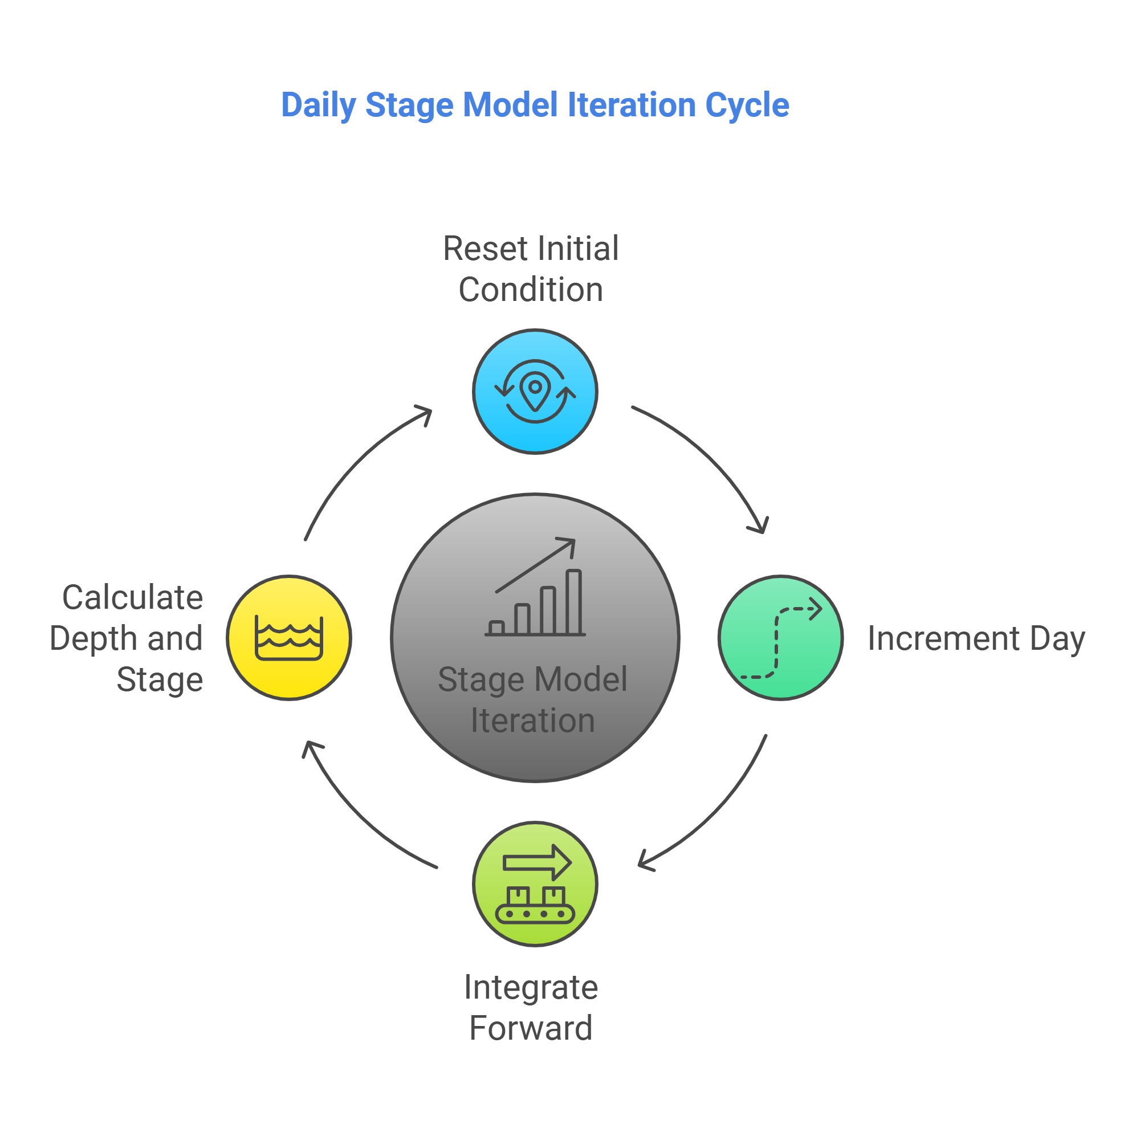

Figure credit: napkin.ai

Function derivs: For each cell calculate derivative of cell volume, dV/dt

Calculate dV/dt from net structure inflow-outflow (m3/day)

Set structure outflow for each cell to historic value

Optionally set S10s and S39 outflow to calculated regulatory releases

Add structure inflow to each cell

Calculate and add/subtract link flows between cells (m3/day)

Add precipitation (m3/day)

Subtract evapotranspiration (m3/day)

Subtract seepage loss to groundwater (m3/day)

Calculate dV/dt from net structure inflow-outflow (m3/day)

Calculate and add/subtract link flows between cells (m3/day)

Add precipitation (m3/day)

Subtract evapotranspiration (m3/day)

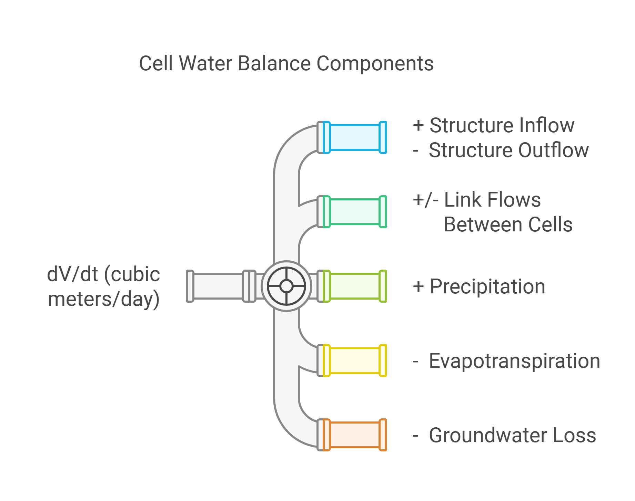

Figure credit: napkin.ai