Project Work

* Visualization order of analysis
  + histograms
  + Box Plots
* Do a correlation before a regression plot

Does correlation correspond to causations?

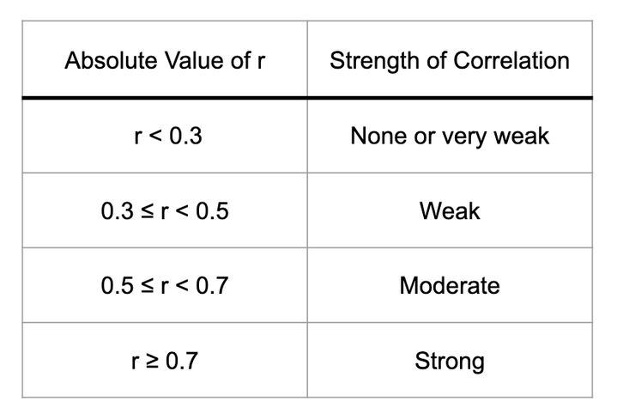

*# Dependencies*

import pandas as pd

import matplotlib.pyplot as plt

import scipy.stats as st

income = wdi_data.*iloc*[:,*1*]

measles = wdi_data.*iloc*[:,*12*]

correlation = st.*pearsonr*(income,measles)

plt.*scatter*(income,measles)

plt.*xlabel*('Income Per Capita')

plt.*ylabel*('% Measles Immunization')

*print*(*f*"The correlation between both factors is {*round*(*correlation*[*0*],2)}")

plt.*show*()