Mark White

CSD325

Assignment9.2-APIs

Status Code: 200-Everything went okay, and the result has been returned (if any).



Viewing astronaut data without formatting

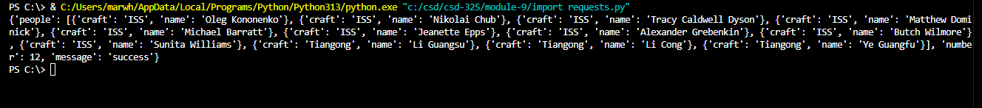

Status Code (200) and Data without formatting

