Mark White

CSD325

Assignment9.2-APIs

Status Code: 200-Everything went okay, and the result has been returned (if any).



Viewing astronaut data in JSON

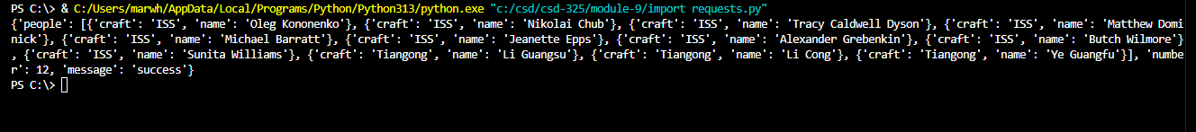

Status Code and JSON data

Data returned in JSON

API status code 200 and pokeAPI data in JSON