Mark White
CSD380
Mod5.2
Value Stream Mapping (VSM)
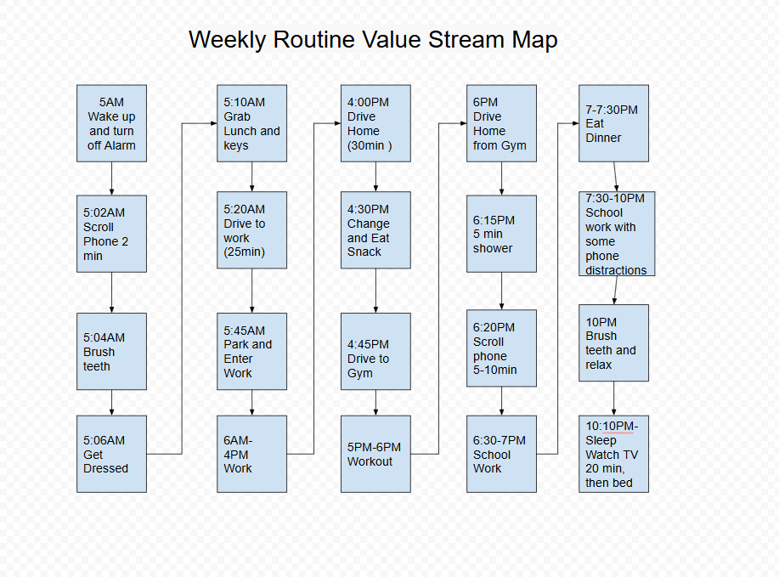

Lean Analysis:
Value-Added Activities:
- Brushing teeth, dressing, grabbing lunch (essential prep)
- Driving to work (required commute)
- Work (core productivity)
- Workout (health & well-being)
- School work (goal-oriented)
- Dinner (basic need)
Non-Value-Added Activities:
- Phone scroll after waking up and before schoolwork
- Distractions during schoolwork
- Watching TV before bed
Possible Improvements:
Opportunity | Suggestion
Reduce phone scroll time | Limit morning and evening phone use to <2 min. Save ~10 to 30 min/day.
Minimize distractions during study | Use focus timers or app blockers. Setting “Do Not Disturb” mode on could improve study efficiency and reduce total time needed.
Batch snack/dinner prep | Prep snacks/dinners in advance to shorten transitions.
TV time before bed | Consider replacing with reading or winding down without tech devices to improve sleep quality.

