Project: Todo list application
Course: CSD 380 Module 4
Description: Test Cases for Todo list
Date: 2025/06/18
To complete the test case plan, fill out the information for Project, Course, Description and Date in the header below.
.
TABLE OF CONTENTS
Test Case 1: verify Add items to list
Test Case 2: Verify items added from top to bottom
Test Case 3: Verify editing todo list
Test Case 4: Verify delete from todo list
Test Case 5: Verify page loads all items

For each test, the developer should: provide a test description, a test objective, the developer name and date tested. For each step, fill out the actions to be taken and describe the expected results, and indicate yes or no for each step depending upon the result. The peer tester should provide their name, date tested, indicate yes or no for each step depending upon the result, and a screenshot (thumbnail) of the result.

Test 1 | Test 1 will go over the “add task” functionality
 | Test Objective: Users can add new items to their to-do list. | Developer:  Date tested: 2025/06/19 | Peer tester: Mark White  Date tested: 2025/6/22
Step | Action | Expected results: | Developer pass/fail | Tester pass/fail  + Screenshot
1 | Navigate to site | Todo list app loads | YES | YES  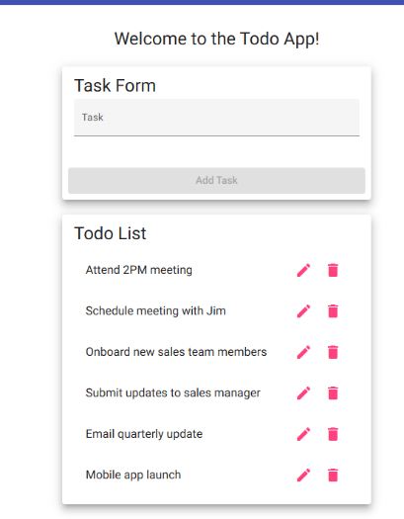
2 | Click in text field under task form | Field becomes fillable via keyboard typing | YES | YES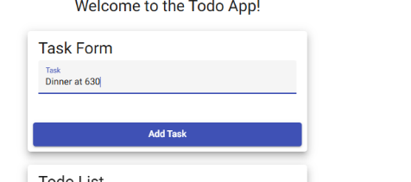
3 | Type more than 3 letters or numbers | Task form button becomes usable | YES | YES Visible in step 2 screenshot
4 | Click Add Task | Task is added to the Todo list below it | YES | YES 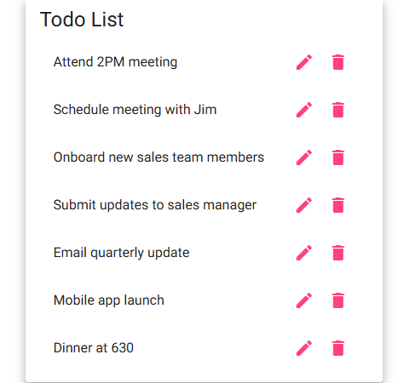
5 | Clear task form | Task form field is cleared and add task button becomes unclickable | YES | YES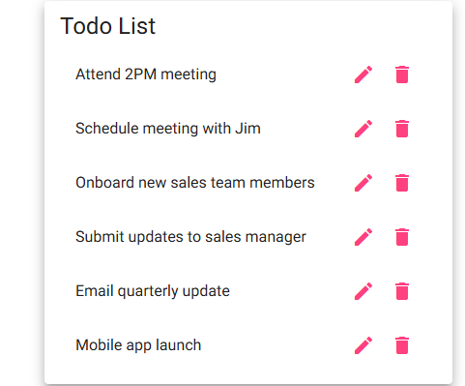
Comments | All actions required in steps work as they are intended to with no errors.

Test 2 | Test 2 will check if added items go to the bottom of list
 | Test Objective: Tasks added by user will be added to the bottom of list after completion | Developer:  Date tested: 2025/06/19 | Peer tester: Mark White  Date tested: 2025/6/22
Step | Action | Expected results: | Developer pass/fail | Tester pass/fail
1 | Navigate to site | Site loads | YES | YES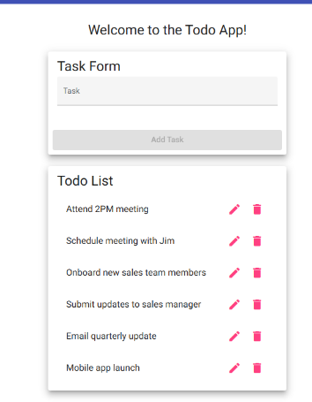
2 | Click in add task form field | Field becomes fillable via keyboard typing | YES | YES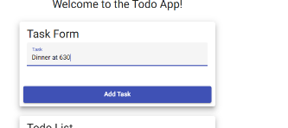
3 | Type more than 3 letters or numbers | Task form button becomes usable | YES | YES Visible in step 2 screenshot
4 | Click add task | Task is added to bottom of list | YES | YES
Comments | All actions required in steps work as they are intended to with no errors.

Test 3 | Test 3 Edit task functionality
 | Test Objective: Items in todo list should be editable via pen icon click | Developer:  Date tested: 2025/06/19 | Peer tester: Mark White  Date tested: 2025/6/22
Step | Action | Expected results: | Developer pass/fail | Tester pass/fail
1 | Navigate to site | Site loads w/list of items in todo list | YES | YES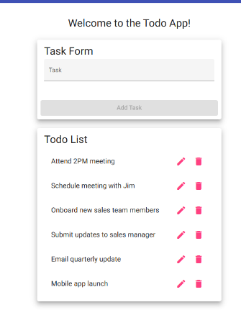
2 | Click pen icon | Edit form window opens | YES | YES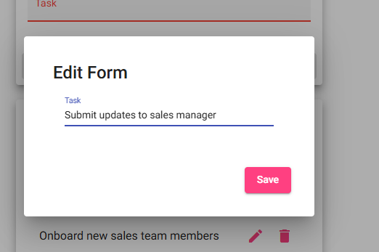
3 | Change text in form field | Text can be changed/deleted | YES | YES 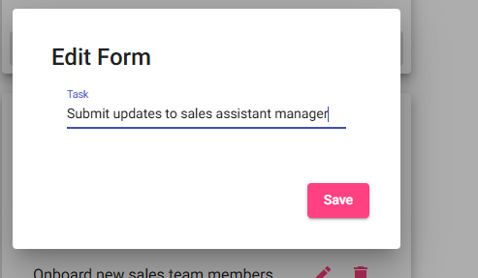
4 | Click save | Altered list item is changed in list | YES | YES 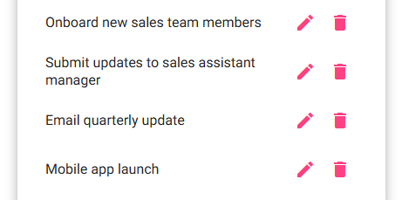
Comments | All actions required in steps work as they are intended to with no errors.

Test 4 | Delete task functionality
 | Test Objective: Checking item deletion from task list functionality | Developer:  Date tested: 2025/06/19 | Peer tester: Mark White  Date tested: 2025/6/22
Step | Action | Expected results: | Developer pass/fail | Tester pass/fail
1 | Navigate to site | Site loads w/list of items in todo list | YES | YES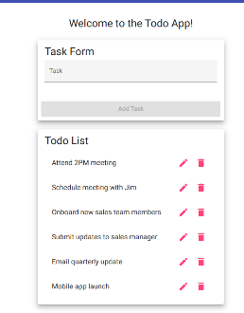
2 | Click trash icon next to item | Item is removed from list | YES | YES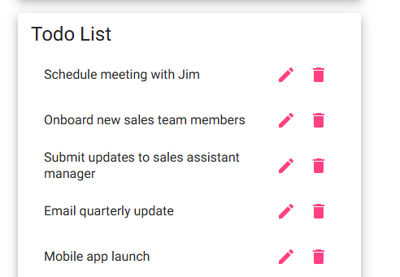
Comments | All actions required in steps work as they are intended to with no errors.

Test 5 | Site load functionality
 | Test Objective: Check to see if the app loads completely to display all items. | Developer:  Date tested: 2025/06/19 | Peer tester: Mark White  Date tested: 2025/6/22
Step | Action | Expected results: | Developer pass/fail | Tester pass/fail
1 | Verify internet connection | Wifi or ethernet connection is confirmed | YES | YES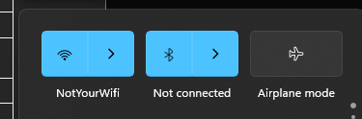
2 | Go to a suitable web browser | Browser loads completely | YES | YES 
3 | Navigate to site | Site loads w/list of items in todo list w/o issue | YES | YES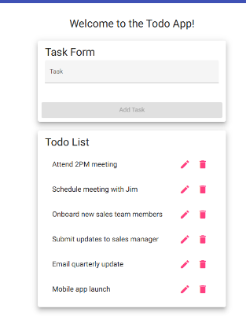
Comments | All actions required in steps work as they are intended to with no errors.

