Project: To DO business Requirements
Course: CSD-380
Description: Test Plan
Date: 6/17/25
To complete the test case plan, fill out the information for Project, Course, Description and Date in the header below.
.
TABLE OF CONTENTS
<DESCRIPTION> 2
<DESCRIPTION> 2
<DESCRIPTION> 3

For each test, the developer should: provide a test description, a test objective, the developer name and date tested. For each step, fill out the actions to be taken and describe the expected results, and indicate yes or no for each step depending upon the result. The peer tester should provide their name, date tested, indicate yes or no for each step depending upon the result, and a screenshot (thumbnail) of the result.

Test 1 | Access Website Through URL
 | Test Objective:  Ensures that users can access the application | Developer: Jason Schriner  Date tested: 2025/06/17 | Peer tester: Mark White  Date tested: 2025/6/22
Step | Action | Expected results: | Developer pass/fail | Tester pass/fail  + Screenshot
1 | Open a browser | Browser opens successfully | <yes/no> | YES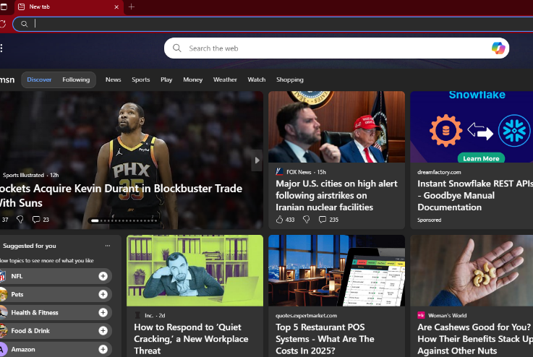
2 | Navigate to https://buwebdev.github.io/todo/ | Page loads without errors | <yes/no> | YES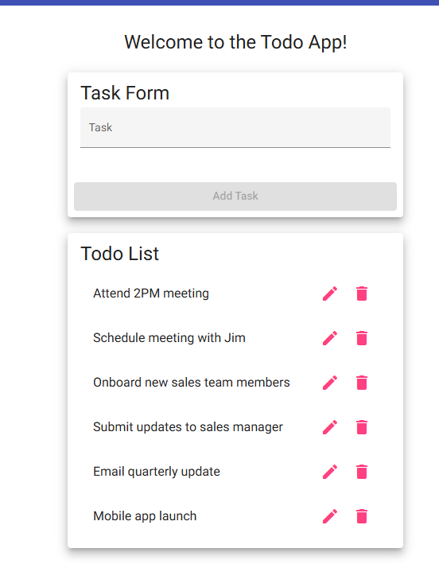
3 | Refresh the page | The browser refreshes the page, the application attempts to load | <yes/no> | YES
4 | Confirm browser loads correctly | The application loads without errors | <yes/no> | YES
Comments | All actions required in steps work as they are intended to with no errors.

Test 2 | Create a new to do task item
 | Test Objective:  Item appears on list | Developer: Jason Schriner  Date tested: 2025/06/17 | Peer tester: Mark White  Date tested: 2025/6/22
Step | Action | Expected results: | Developer pass/fail | Tester pass/fail
1 | Enter a task into the input field | The task appears in the input field, The submit button becomes active | <yes/no> | YES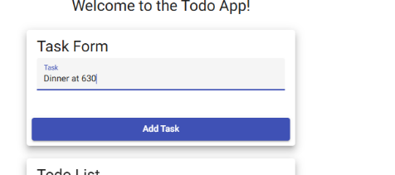
2 | Click the Submit button | The task is added to the list | <yes/no> | YES 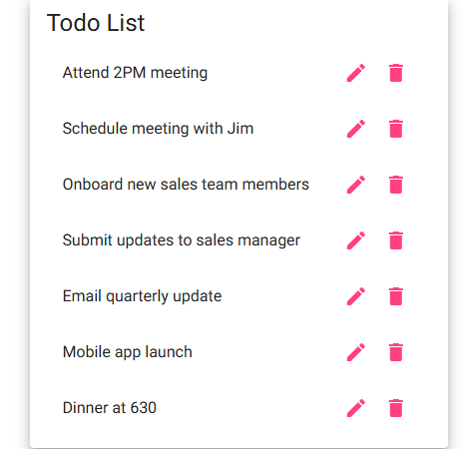
3 | Confirm the task appears on the page | The task is displayed as a new item on  The list | <yes/no> | YES
4 | Add another task with different task | The new task should display below the previous task | <yes/no> | YES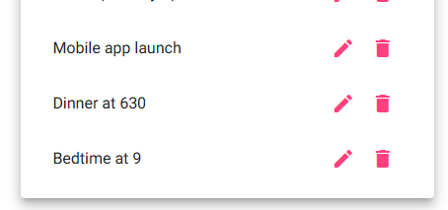
5 | Leave the input field blank and try to submit | Button remains unclickable | <yes/no> | YES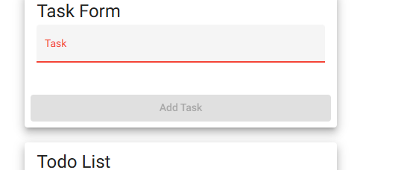
Comments | All actions required in steps work as they are intended to with no errors.

Test 3 | View a list of To DO task items
 | Test Objective: | Developer: Jason Schriner  Date tested: 2025/06/17 | Peer tester: Mark White  Date tested: 2025/6/22
Step | Action | Expected results: | Developer pass/fail | Tester pass/fail
1 | Open browser | Browser opens successfully | <yes/no> | YES
2 | Navigate to https://buwebdev.github.io/todo/ | Page loads without errors | <yes/no> | YES
3 | Observe the task list area | A section is present for tasks | <yes/no> | YES
4 | Add a new task using the input | The new tasks appear in the task list | <yes/no> | YES
5 | Refresh the page | The tasks reappear in the task list | <yes/no> | NO
Comments | All actions required in the steps work as intended except step 5. When refreshing the page after adding task, it will remove the task(s) and return to the original to-do list.

Test 4 | Delete a To Do task
 | Test Objective:  To delete a task | Developer: Jason Schriner  Date tested: 2025/06/17 | Peer tester: Mark White  Date tested: 2025/6/22
Step | Action | Expected results: | Developer pass/fail | Tester pass/fail
1 | Open browser | Browser opens successfully | <yes/no> | YES
2 | Navigate to https://buwebdev.github.io/todo/ | Page loads without errors | <yes/no> | YES
3 | Add a new task to the list | Task appears on the list | <yes/no> | YES
4 | Click the delete (trash can) icon next to the task | The task is removed from the list | <yes/no> | YES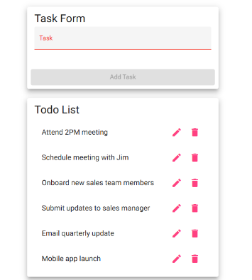
5 | Confirm the task is no longer in the list | The task is no longer present | <yes/no> | YES verified in step 4 screenshot
Comments | All actions required in steps work as they are intended to with no errors.

Test 5 | Edit a To Do item on the task list
 | Test Objective:  To successfully edit a task | Developer: Jason Schriner  Date tested: 2025/06/17 | Peer tester: Mark White  Date tested: 2025/6/22
Step | Action | Expected results: | Developer pass/fail | Tester pass/fail
1 | Navigate to https://buwebdev.github.io/todo/ | Page loads without errors | <yes/no> | YES 
2 | Click the pen (edit) icon next to the task | Task form appears | <yes/no> | YES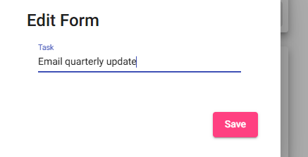
3 | Clear form and replace task | Text clears and new input appears | <yes/no> | YES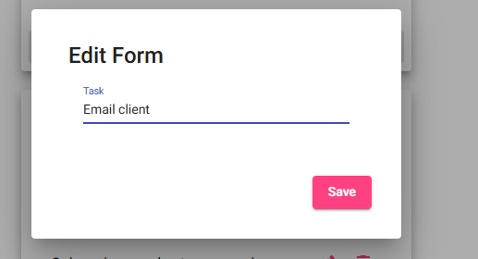
4 | Click save button | Task appears correctly in list | <yes/no> | YES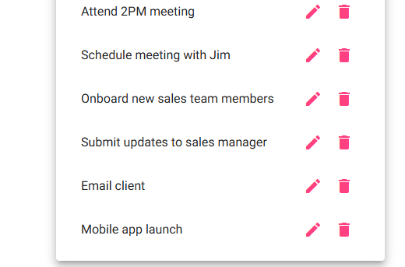
Comments | All actions required in steps work as they are intended to with no errors.

