# 1. Home Screen

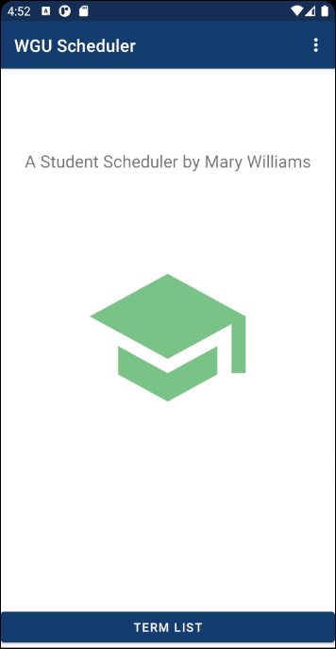

Menu Options

Populate Database: This option will fully clear and input data into the database for testing purposes.

Clear Database: This option will clear the database of all data for testing purposes.

Buttons

Term List: This button will navigate the user to the term list, where they can view a list of all terms. See 2. List of Terms.

# 2. List of Terms

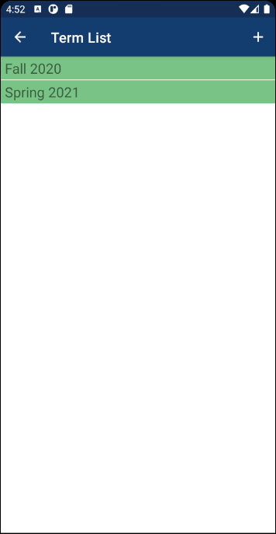

Menu Options

Add Button: This option will navigate the user to a variation of the term details where they can input a new term. See 3. Detailed Term View – ‘Add’ version.

Other

Term in the list: Clicking on this will navigate the user to a variation of the term details where they can view and update current data for the selected term. See 3. Detailed Term View – ‘Edit’ version.

# 3. Detailed Term View

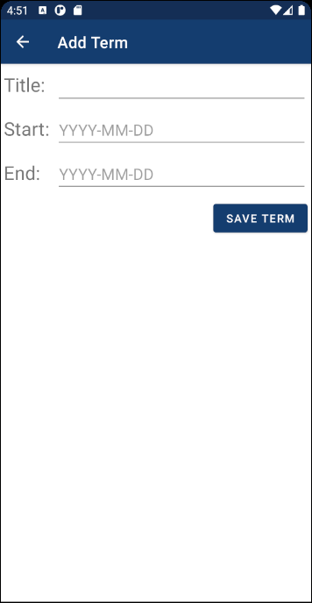

## ‘Add’ version of Term Details:

The add version of term details is a simplified screen that does not allow the user to navigate to options that are unavailable because the term does not yet exist.

Buttons

Save Term: This button will create a new term in the database with the information the user input, followed by returning to the previous screen. The new term will now appear in the term list. See 2. List of Terms.

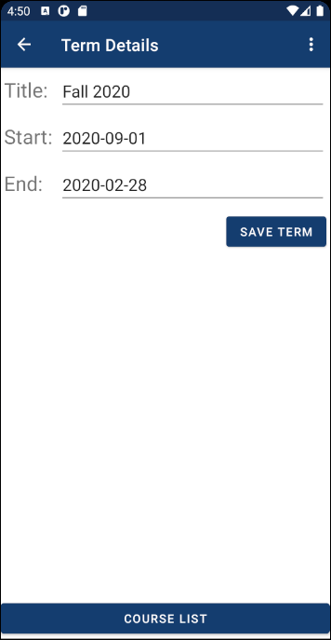

## ‘Edit’ Version of Term details:

The edit version of term details populates with current data on the selected term, as well as allowing the user to navigate to associated courses or to delete the term.

Menu Options

Delete Term: This option will give the user the choice to delete the selected term. The user will not be able to complete this action if there are any courses associated with the term.

Buttons

Save Term: This button will update the term in the database with the information the user input.

Course List: This button will navigate the user to the course list, where they can view a list of associated courses. See 4. List of Courses.

# 4. List of Courses

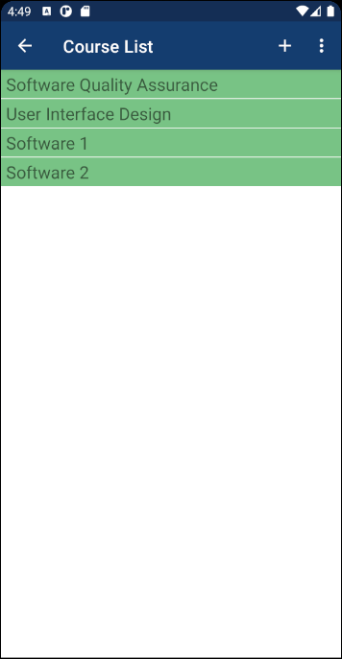

Menu Options

Add Button: This option will navigate the user to a variation of the course details where they can input a new course. See 5. Detailed Course View – ‘Add’ version.

Delete All: This option will give the user the choice to delete all courses in the list. This will include deleting any associated assessments the courses may have.

Other

Course in the list: Clicking on this will navigate the user to a variation of the course details where they can view and update current data for the selected course. See 5. Detailed Course View – ‘Edit’ version.

# 5. Detailed Course View

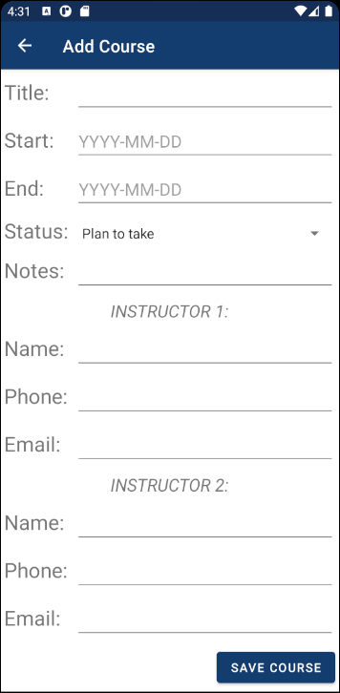

## ‘Add’ Version of Course Details

The add version of course details is a simplified screen that does not allow the user to navigate to options that are unavailable because the course does not yet exist.

Buttons

Save Course: This button will create a new course in the database with the information the user input, followed by returning to the previous screen. The new course will now appear in the course list. See 4. List of Courses.

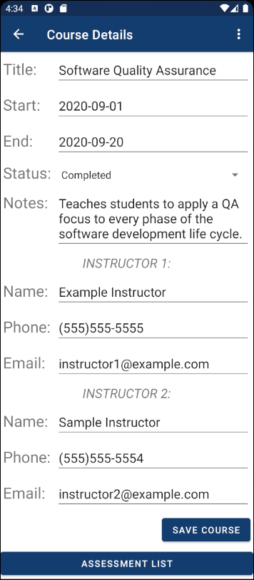

## ‘Edit’ Version of Course Details

The edit version of course details populates with current data on the selected course, as well as allowing the user to navigate to associated assessments or to perform actions such as delete, share notes, and set alerts for the course.

Menu Options

Delete Course: This option will give the user the choice to delete the selected course.

Share Notes: This option will allow the user to share the course notes via email or SMS.

Set Start Alert: This option will allow the user to set a notification for the course start date.

Set End Alert: This option will allow the user to set a notification for the course end date.

Buttons

Save Course: This button will update the course in the database with the information the user input.

Assessment List: This button will navigate the user to the assessment list, where they can view a list of associated assessments. See 6. List of Assessments.

# 6. List of Assessments

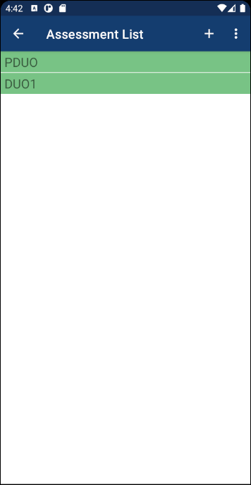

Menu Options

Add Button: This option will navigate the user to a variation of the assessment details where they can input a new assessment. See 7. Detailed Assessment View – ‘Add’ version.

Delete All: This option will give the user the choice to delete all assessments in the list.

Other

Assessment in the list: Clicking on this will navigate the user to a variation of the assessment details where they can view and update current data for the selected assessment. See 7. Detailed Assessment View – ‘Edit’ version.

# 7. Detailed Assessment View

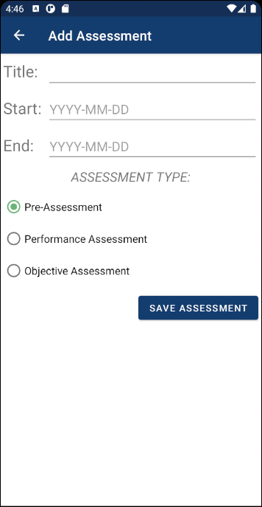

## ‘Add’ Version of Assessment Details

The add version of assessment details is a simplified screen that does not allow the user to navigate to options that are unavailable because the assessment does not yet exist.

Buttons

Save Assessment: This button will create a new assessment in the database with the information the user input, followed by returning to the previous screen. The new assessment will now appear in the assessment list. See 6. List of Assessments.

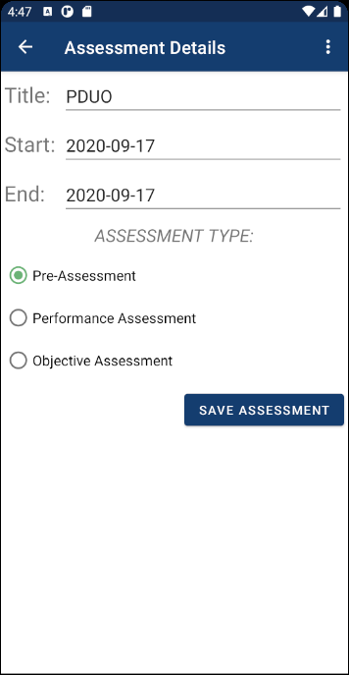

## ‘Edit’ Version of Assessment Details

The edit version of assessment details populates with current data on the selected assessment, as well as allowing the user to perform actions such as delete and set alerts for the assessment.

Menu Options

Delete Assessment: This option will give the user the choice to delete the selected assessment.

Set Start Alert: This option will allow the user to set a notification for the assessment start date.

Set End Alert: This option will allow the user to set a notification for the assessment end/goal date.

Buttons

Save Assessment: This button will update the assessment in the database with the information the user input.