5 Software Management

5.1 Introduction

5.1.1 Methods
MX Linux offers two complementary GUI methods of software management for CLI see 5.5.4):
- MX Package Installer (MXPI) for one-click installation / removal of popular applications. This includes applications in the Debian Stable, MX Test, Debian Backports, and the Flatpaks repositories (Section 3.2.11).
- Synaptic Package Manager, a full-featured graphical tool for a whole range of actions with Debian packages. (Note: Flatpaks are not available via Synaptic at this time)
MXPI is recommended and has the following advantages over Synaptic:
- It's a lot faster!
- The Popular Applications tab is restricted to the packages most often used, so everything is easy to find.
- It correctly installs some complicated packages that are difficult for new users (e x. Wine).
- It is a single source including the repositories mentioned above and has newer packages than what Synaptic has by default.
Synaptic has its own advantages:
- It has a large number of advanced filters set up such as Sections (categories), Status, etc.
- It offers detailed information about particular packages.
- It makes it very easy to add new software repositories.

This Section 5 concentrates on Synaptic, which is the recommended method for beginners to manage software packages beyond the capabilities of MX Package Installer. It will also look at other methods that are available and may be required for certain situations.

5.1.2 Packages
Software operations in MX are accomplished behind the scenes through the Advanced Package Tool (APT) system. Software is provided in the form of a package: a discrete, non-executable bundle of data that includes instructions for your package manager about installation. Packages are stored on servers called repositories (repos), and can be browsed, downloaded, and installed through special client software called a package manager.
The majority of packages have one or more dependencies, meaning that they have one or more packages that must also be installed in order for them to work. The APT system is designed to automatically handle dependencies for you; in other words, when you try to install a package whose dependencies are not already installed, your APT package manager will automatically mark those dependencies for installation as well. It can happen that these dependencies can not be met, preventing the installation of a package. If help is needed with dependencies, please post a request for help in the MX Linux Forum.

5.2 Repositories
APT repositories are much more than just web sites with downloadable software. The packages on repository sites are specially organized and indexed to be accessed through a package manager, rather than browsed directly.
WARNING: Be extremely cautious when adding other repositories to MX Linux! This is especially true for: Debian Sid or non official PPAs, it is very possible to break your installation beyond repair.

5.2.1 Standard repositories
MX Linux comes with a set of enabled repositories that offer you both security and choice. If you are new to MX Linux (and especially if you are new to Linux), it is recommended that in general you stick with the default repos at first. For security reasons, these repos are digitally signed, meaning that packages are authenticated with an encryption key to make sure they are authentic. If you install packages from non-Debian repos without the key, you will get a warning that they could not be authenticated. To get rid of this warning and make sure your installations are secure, you need to install missing keys using MX Fix GPG keys.
Repos are most easily added, enabled/disabled, removed, or edited through Synaptic, though they can also be altered by hand by editing the files in /etc/apt/ in a root terminal. In Synaptic, click Settings > repos, then click the button New and add the information. Repo information is often given as a single line, like this:
deb http://mxrepo.com/mx/testrepo/ bookworm test
Be careful to note the location of the spaces, which separate the information into four chunks that are then entered into separate lines in Synaptic.
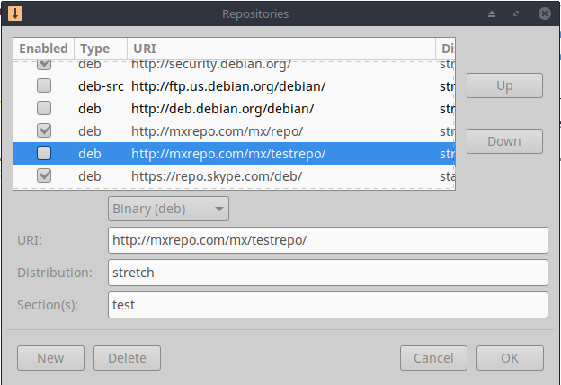
Figure 5-1: Repos, with the MX test repo highlighted.

Some repos carry special labels:
- contrib, which depend on or are accessory to non-free packages.
- non-free, which do not meet the Debian free software guidelines (DFSG).
- security, which contain security-related updates only.
- backports, which contain packages from newer versions of Debian that have been made backwards compatible to keep your OS up-to-date.
- MX, which contain the special packages that make MX Linux what it is.
The current list of standard MX repos is kept in the MX/antiX Wiki.

5.2.2 Community repos
MX Linux has its own Community Repos with packages that our Packagers build and maintain. These packages are distinct from official MX packages coming from Debian Stable, and contain packages from other sources:
- Debian Backports, from testing or even experimental.
- Our sister distro antiX.
- Independent projects.
- Open-source hosts such as GitHub.
The Community Repos are critical to MX Linux, since they permit an OS based on Debian Stable to stay abreast of important software developments, security patches and critical bug fixes.
In addition to the MX Main repo, the MX Test repo aims to get feedback from users before new packages are moved to Main. The easiest way to install from MX Test is with the Package Installer (Section 3.2), as it handles many steps automatically.
To find out more about what is available, who the packagers are, and even how to get involved, see MX Community Packaging Project.

5.2.3 Dedicated repos
In addition to the general repos such as Debian, MX, and Community, there also exist a certain number of dedicated repos associated with a single application. When you add one of them, either directly or through Synaptic, then you will receive updates. Some are preloaded but not enabled, others you will add yourself.
Here is a common example (Vivaldi browser):
deb http://repo.vivaldi.com/stable/deb/ stable main

New users coming from Ubuntu or one of its derivatives often ask about PPA repos; Ubuntu deviates from standard Debian, so such repos need to be treated with caution. Consult the MX/antiX Wiki.

5.2.4 Development repos
One final category of repository exists for acquiring the most recent (and thus least stable) build of an application. This is done through a version control system such as Git that can be consulted by the end user to stay current with development. A copy of the application source code can be downloaded into a directory on a local machine. The software repositories are a convenient method of managing projects using Git, and MX Linux keeps most of its code in its own GitHub repo.
More: Wikipedia: Software repository

5.2.5 Mirrors
- MX Linux repos for both packages and ISOs (Image files) are “mirrored” on servers at different sites around the world; the same is true for Debian repos. These mirror sites provide multiple sources of the same information, and function to reduce download time, improve reliability, and provide a certain resiliency in case of server failure. During installation, the most likely mirror will be automatically selected for you based on location and language. But the user may have reasons to prefer another:
- The automatic assignment at installation may be wrong in some cases.
- The user may change residency.
- A new mirror may become available that is much closer, faster or more reliable.
- An existing mirror may change its URL.
- The mirror being used may become unreliable or go offline.
MX Repo Manager (Section 3.2) makes it easy to switch mirrors, enabling you to choose the one that works best for you. Note: Pay attention to the button that selects the fastest mirror for your location.

5.3 SynapticPackage Manager
The following section seeks to provide an up-to-date overview of Synaptic use. Note that your root password is required and, naturally, you will need to be connected to the Internet.

5.3.1 Installing and removing packages

Installing
- Here are the basic steps for installing software in Synaptic:
- Click Start menu > System > Synaptic Package Manager, supplying the root password if asked.
- Hit the Reload button. This button tells Synaptic to contact the online repository servers and download a new index file with information on:
  - What packages are available.
  - What versions they are.
  - What other packages are required for them to be installed.
- If you get a message that some of the repos failed to be contacted, wait a minute and then try again.
- If you already know the name of the package you are looking for, just click in the pane on the right and start typing; Synaptic will incrementally search as you type.
- If you don’t know the package’s name, use the Search box in the upper right corner to locate software based on name or keywords. This is one of Synaptic’s greatest advantages over other methods.
- Alternatively, use one of the filter buttons in the bottom left corner:
  - Sections provides subareas such as Editors, Games and Amusement, Utilities, etc. You will see a description of each package in the bottom pane, and can use the tabs to discover more information about it.
  - Status groups packages by their installation situation.
  - Origin will show packages from a specific repository.
  - Custom Filters provides various filter options.
  - Search Results will show a list of previous searches for the Synaptic session you are in.
- Click the empty box at the left end of the package you want and select Mark for Installation on the pop-up screen. If the package has dependencies, you will be notified and they will automatically be marked for installation as well. You can also just double-click the package if it is the only one you are installing.
- Some packages also have “Recommended” and “Suggested” packages that can be viewed via right-clicking the package name. These are additional packages that add functionality to the selected package, and it is a good idea to look them over.
- Click Apply to begin the installation. You can safely ignore any warning message: “You are about to install software that can’t be authenticated!”
- There may be additional steps: just follow the prompts as you receive them until the installation completes.
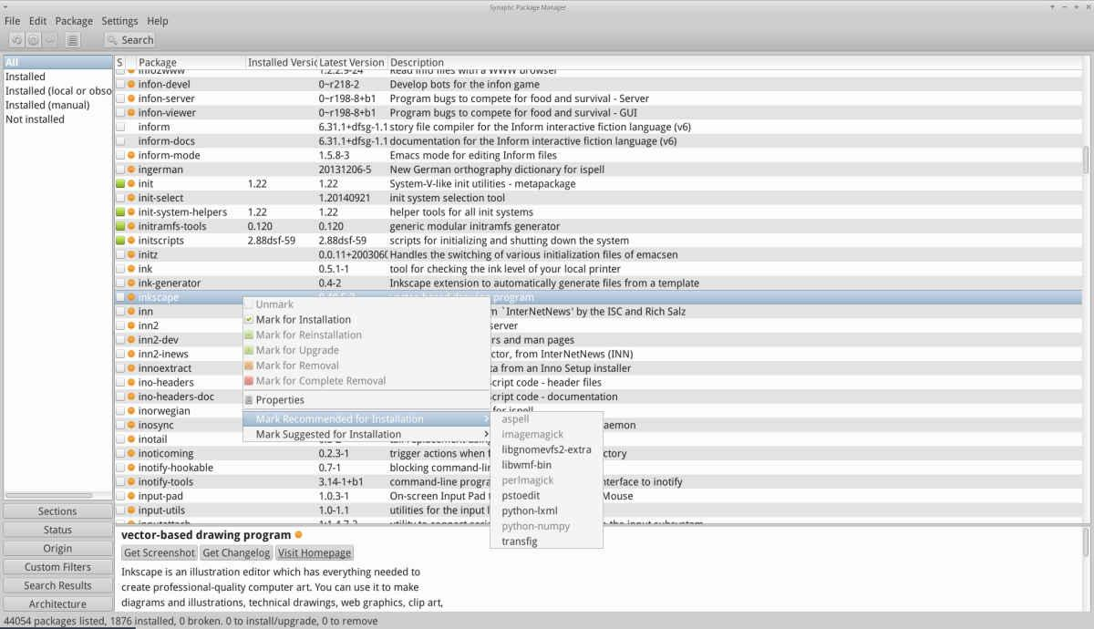
Figure 5-2: Checking recommended packages during package installation.

Removing software
Removing software from your system with Synaptic seems as straightforward as installing, but there is more to it than meets the eye:
- To remove a package, simply click the same box as for installation and select Mark for Removal or Mark for Complete Removal.
  - Removal uninstalls the software, but leaves system configuration files in case you want to keep your settings.
  - Complete Removal removes the software and the system configuration files as well (purging). Your personal configuration files related to the package will not be removed. Check also for other configuration file remnants in Synaptic’s category Not installed (residual config).
- When you have other programs that depend on the package being removed, those packages will have to be removed as well. This usually happens when you remove software libraries, services, or command-line applications that serve as back-ends to other applications. Make sure you read carefully the summary Synaptic gives you before clicking OK.
- Removing large applications that are composed of many packages can bring complications. Many times these packages are installed using a meta-package, which is an empty package that simply depends on all the packages you need for the application. The best way to remove a complicated package like this is to inspect the dependency list for the meta-package, and remove the packages listed there. Take care, however, that you don’t uninstall a dependency of another application you want to keep!
- You may find that the status category Auto-removable begins to accumulate packages. These were installed by other packages and are no longer needed, so you can click on that status category, highlight all the packages in the right pane, and then right-click them to remove. Be sure to examine the list carefully when the verification box appears, because sometimes you may find that the dependencies listed for removal include packages you actually want to keep. Use apt -s autoremove to do a simulated (= the -s switch) dry run if you’re unsure.
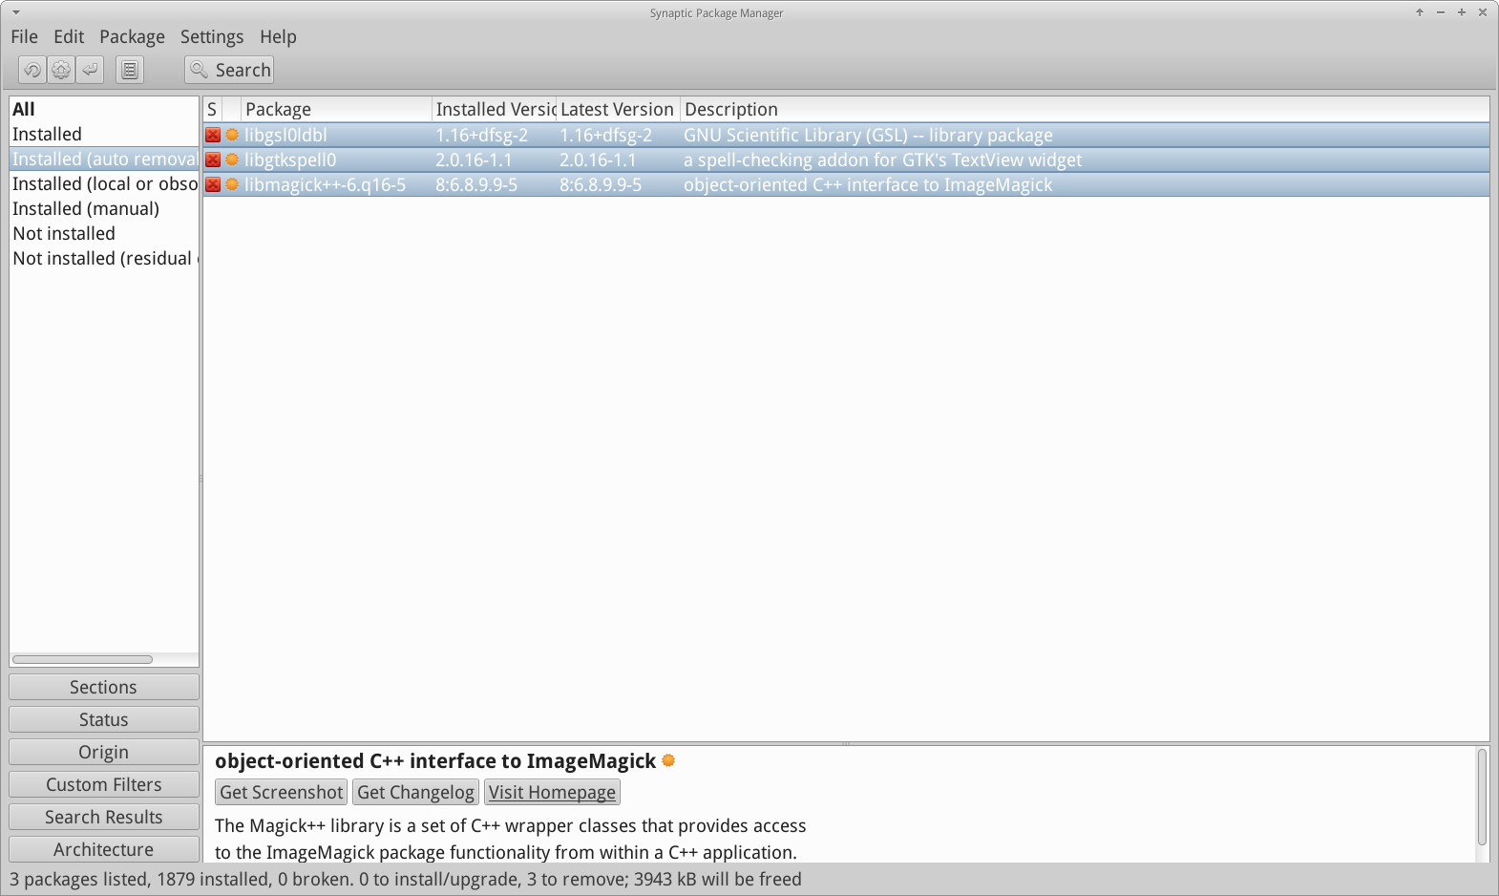
Figure 5-3: Getting ready to clear out the auto-removable packages.

5.3.2 Upgrading and downgrading software
Synaptic enables you to quickly and conveniently keep your system up-to-date.

Upgrading software
- Unless you are using a manual method in Synaptic or a terminal, upgrading is typically triggered by the a change in the MX Updater icon in the Notification Area (default: empty box turns green). There are two ways to proceed when this happens.
- Left-click the icon. This is the faster method because there is no wait for software to load, run, etc. A terminal window appears with the packages to upgrade; examine them carefully, then click OK to complete the process.
- Right-click the icon to use Synaptic instead.
- Click the Mark All Upgrades icon below the menu bar to select all available packages for upgrade, or click on the Installed (up-gradable) link in the left panel to review the packages or to select upgrades individually.
- Click Apply to begin the upgrade, ignoring the warning message. As the installation process begins, you have the option of watching the details in a terminal within Synaptic.
- With some package upgrades, you may be asked to confirm a dialog, enter configuration information, or decide whether or not to overwrite a configuration file you have altered. Pay attention here, and follow the prompts until the upgrade completes.

Downgrading software
Sometimes you may want to downgrade an application to an older version, for instance because of problems that arose with the new one. This is easy to do in Synaptic:
- Open Synaptic, supply the root password, and click Reload.
- Click on Installed in the panel on the left, then find and highlight the package you want to downgrade in the panel on the right.
- On the menu bar, click Package > Force version...
- Select from the available versions on the pull-down list. There may not be options available.
- Click Force Version, then install in the usual manner.
- To keep that lower version from immediately being upgraded again, you need to pin it.

Figure 5-4: Using Force version to downgrade a package.

Pinning a version
Sometimes you may want to pin an application to a specific version to keep it from being upgraded in order to avoid problems with more recent ones. This is easy to do:
- Open Synaptic, supply the root password, and click Reload.
- Click on Installed in the panel on the left, then find and highlight the package you want to pin in the panel on the right.
- On the menu bar, click Package > Lock version...
- Synaptic will highlight the package in red and add a lock icon to the first column.
- To unlock, highlight the package again and click Package > Lock version (which will have a check mark).
- Note that pinning via Synaptic does not prevent the package from being upgraded when using the command line.

5.4 Troubleshooting Synaptic issues
Synaptic is very reliable, but sometimes you may get an error message. A full discussion of such messages may be found in the MX/antiX Wiki, so here we will only mention a couple of the most common.
- You get a message that some repos failed to download repository information. This is usually a transient event and you simply need to wait and reload; or you can use MX Repo Manger to switch repos.
- If the installation of a package shows that software you want to keep will be removed, click Cancel to back out of the operation.
- It may happen with a new repository that you see an error message after reloading that says something like: W: GPG error: [some repository URL] Release: The following signatures couldn’t be verified . This message appears because apt includes package authentication in order to improve security, and the key is not present. To fix this, click Start menu > System > MX Fix GPG keys and follow the prompts. If no key is found, ask on the Forum.
- Occasionally, packages will not install because their install scripts fail one or more safety checks; for instance, a package might try to overwrite a file that is part of another package, or require downgrading another package due to dependencies. If you have an install or upgrade that is stuck on one of these errors, it is called a "broken" package. To fix this, click on the Broken packages entry in the left panel. Highlight the package and try first to fix the problem by clicking Edit > Fix Broken Packages. If that is not successful, then right-click the package to unmark or uninstall it.
- During installation or uninstallation, important messages sometimes appear about the process:
- Uninstall? Occasionally, conflicts in package dependencies can cause the APT system to uninstall a large number of important packages in order to install some other package. This is rare with the default configuration, but becomes increasingly likely as you add unsupported repos. BE VERY ATTENTIVE whenever installing a package would require that others be removed! If a large number of packages are going to be removed, you may want to investigate another method of installing this application.
- Keep? When upgrading, you may sometimes be informed that a new configuration file is available for a certain package, and be asked whether you want to install the new version or keep your current version.
- If the package in question is from an MX repository, it is recommended that you “install the maintainers version”.
- Otherwise, answer “keep the current version” (N), which is also the default choice.

5.5 Other methods

5.5.1 Aptitude
Aptitude is a package manager that can be used instead of apt or Synaptic. It is available from the repos, and is particularly helpful when dependency problems arise. Can be run as a straight CLI or as a primitive GUI.

Figure 5-5: Aptitude’s home screen (GUI), showing dependency resolver.
For details on this option, see the MX/antiX Wiki.

5.5.2 Deb packages
The software packages installed through Synaptic (and APT behind it) are in a format called Deb (short for Debian, the Linux distribution that devised APT). You can manually install downloaded deb packages using the graphical tool Deb Installer (section 3.2.28) or the command-line tool dpkg. These are simple tools to install local deb packages.
NOTE: if dependencies can not be satisfied, you will receive a notice and the program will stop.

Installing *.deb files with dpkg
- Navigate to the folder containing the deb package you want to install.
- Right-click an empty space to open a terminal and become root. Alternatively, click the arrow to move up one level and right-click the folder with the deb package > Open Root Thunar here.
- Install the package with the command (substituting the real package name, of course):
dpkg -i packagename.deb
- If you are installing multiple packages in the same directory at the same time (for instance if manually installing Libreoffice), you can do it all at once using:
dpkg -i *.deb
NOTE: In a shell command, the asterisk is a wild card in the argument. In this case it will cause the program to apply the command to any file whose name ends with .deb.
- If required dependencies are not installed on your system already, you will get unmet dependencies errors as dpkg does not automatically take care of them. To correct these errors and finish the installation, run this code to force the installation:
apt -f install
- apt will attempt to rectify the situation by either installing the needed dependencies (if they are available from the repos) or removing your .deb files (if the dependencies can not be installed).
NOTE: the command used in Step 5 above reflects the change from the legacy name apt-get.

5.5.3 Self-contained packages

 VIDEO: Launchers and Appimages
Appimages, Flatpaks and Snaps are self-contained packages that do not need to be installed in the usual sense. Be aware that these packages are not tested by Debian or MX Linux, so they may not function as expected.
- Appimages: simply download, move to /opt (recommended) and make executable by right-click > Permissions.
- Flatpaks: use Package Installer to get apps from Flathub.
- Snaps. Unreliable on MX Linux unless the user has booted into systemd. Workaround and details in the Wiki reference below.
One of the big advantages of self-contained packages is that any extra software they need is included, and so won't impact adversely on software already installed. This also makes them much bigger than the traditional installed packages.
HELP: the MX/antiX Wiki

5.5.4 CLI methods
It is equally possible to use the command line to install, remove, update, switch repos and generally to manage packages. Instead of launching Synaptic to carry out common tasks.
Table 5: Common commands to manage packages.
Command | Action
apt install packagename | Install a certain package
apt remove packagename | Remove a certain package
apt purge packagename | Completely remove a package (but not configuration/data in /home)
apt autoremove | Clear out leftover packages after a removal
apt update | Refresh the package list from the repos
apt upgrade | Install all available upgrades
apt dist-upgrade | Intelligently handle changing dependencies with new versions of packages

Apt processes and results are displayed in a terminal using the default display that many users find unattractive and hard to read. There exists an alternate display format called nala that is installed by default, though it is not used by default due to rare bugs that have arisen during testing. But the colors and organization make for a very user-friendly alternative that many prefer. To enable it, open the file ~/.config/MX-Linux/apt-notifier.conf, search for “nala” and remove the hash sign at the beginning of the line so that the result reads:
use_nala = true

5.5.5 More install methods
- Sooner or later some software that you want to install will not be available in the repos and you may need to use other installation methods. These methods include:
- Blobs. Sometimes what you want is not actually an installable package but a “blob” or pre-compiled collection of binary data stored as a single entity, especially closed-source. Such blobs are typically located in the directory /opt. Common examples include Firefox, Thunderbird and LibreOffice. RPM packages: Some distributions of Linux use the RPM packaging system. RPM packages are similar to deb packages in many ways, and there is a command-line program available from MX Linux to convert RPM packages to debs called alien. It does not come installed with MX Linux, but is available from the default repos. After you have installed it on your system, you can use it to install an rpm package with this command (as root): alien -i packagename.rpm. That will place a deb file with the same name in the location of the rpm file that you can then install as described above. For more detailed information on alien, see the internet version of its man page in the Links section at the bottom of this page.
- Source code: Any open-source program can be compiled from the programmer’s original source code if there is no other option. In ideal circumstances, this is actually a pretty simple operation, but sometimes you can run into errors that require more skill to sort through. Source is usually distributed as a tarball (tar.gz or tar.bz2 file). Your best option is usually to make a package request on the Forum, but see the Links for a tutorial on compiling programs.
- Miscellaneous: Many software developers package software in their own custom ways, usually distributed as tarballs or zip files. They may contain setup scripts, ready-to-run binaries, or binary installer programs similar to Windows setup.exe programs. In Linux, the installer often ends in .bin. Google Earth, for example, is often distributed this way. When in doubt, consult the installation instructions provided with the software.

5.5.6 Links
MX/antiX Wiki: Synaptic errors
MX/antiX Wiki: Installing Software
MX/antiX Wiki: Compiling
Debian package management tools
Debian APT Guide
Wikipedia: Alien

