6 Advanced use

6.1 Windows programs under MX Linux
There are a certain number of applications, both open-source and commercial, that will allow Windows applications to run under MX Linux. They are referred to as emulators, meaning that they replicate the functions of Windows on a Linux platform. Many MS Office applications, games and other programs can be run using an emulator with varying degrees of success ranging from near-native speed and functionality to only basic performance.

6.1.1 Open-source
Wine is the primary open-source Windows emulator for MX Linux. It is a kind of compatibility layer for running Windows programs, but does not require Microsoft Windows to run the applications. Best installed through MX Package Installer (under Misc); if installing with Synaptic, select "winehq-staging" to get all wine-staging packages. Wine versions are rapidly packaged by the Community Repository members and made available to users, with the latest version coming from the MX Test Repo.
NOTE: In order to run Wine in a Live session, you need to use home persistence (Section 6.6.3).
- Wine Home Page
- MX/antiX Wiki: Wine
DOSBox creates a DOS-like environment intended for running MS-DOS-based programs, especially computer games.
- DOSBox homepage
- DOSBox Wiki
DOSEMU is software available from the repos that allows DOS to be booted in a virtual machine, making it possible to run Windows 3.1, Word Perfect for DOS, DOOM, etc.
- DOSEMU Home Page
- MX/antiX Wiki: DOSEMU

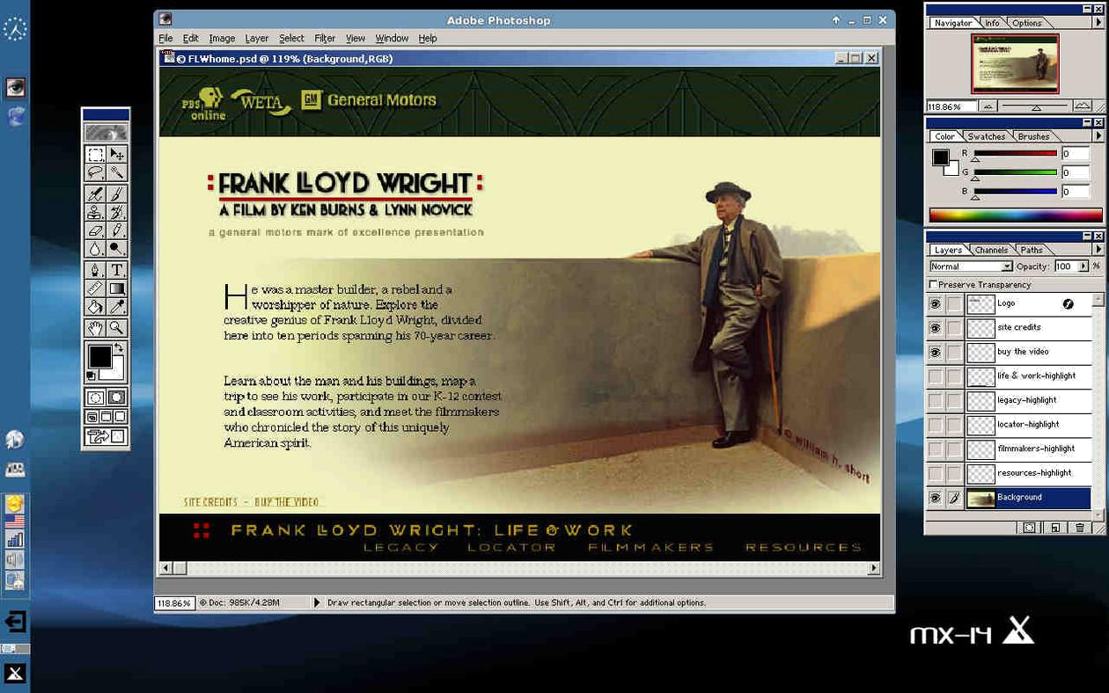
Figure 6-1: Photoshop 5.5 running under Wine.

6.1.2 Commercial
CrossOver Office allows you to install many popular Windows productivity applications, plugins and games in Linux, without needing a Microsoft Operating System license. Supports Microsoft Word, Excel and PowerPoint (up to 2003) particularly well.
- CrossOver Linux Home Page
- Wikipedia: Crossover
- Application Compatibility

Links
- Wikipedia: Emulator
- DOS Emulators

6.2 Virtual machines
Virtual machine applications are a class of programs that simulate a virtual computer in memory, allowing you to run any operating system on the machine. It is useful for testing, running non-native applications, and providing users the feeling of having a machine of their own. Many MX Linux users make use of virtual machine software to run Microsoft Windows “in a window” to seamlessly provide access to software written for Windows on their desktop. It is also used for testing to avoid installation.

6.2.1 VirtualBox Setup
 VIDEO: Virtual Box: set up a shared folder (14.4)
A number of virtual machine software applications for Linux exist, both open-source and proprietary. MX makes it particularly easy to use VirtualBox (VB) so we will focus on that here. For details and the most recent developments, see the Links section below. Here is an overview of the basic steps to set up and run VirtualBox:
- Installation. This is best done via the MX Package Installer, where VB appears in the Misc section. This will enable the VB repository, download and install the latest version of VB. The repository will be left enabled, allowing automatic updates via MX Updater.
- 64bit. VB requires Hardware Virtualization support to run a 64bit guest, the settings for which (if they exist) are located in the UEFI Firmware/BIOS. Details in the VB Manual.
- Reboot. It is a good idea to let VB set itself up completely by rebooting after installation.
- Post-installation. Check that your user belongs to the vboxusers group. Open MX User Manager > Group Membership tab. Select your username and make sure that ’vboxusers’ in the Groups list is ticked. Confirm and exit.
- Extension Pack. If you install VB from the MX Package Installer, the Extension Pack will be included automatically. Otherwise, you should download and install it from the Oracle web site (see Links). After the file is downloaded, navigate to it with Thunar and click on the file’s icon. The Extension Pack will open VB and install automatically.
- Location. Virtual machine files are stored by default in your /home/VirtualBox VMs folder. They can be fairly large and if you have a separate data partition you may consider making the default folder there. Go to File > Preferences > General tab and edit the folder location.

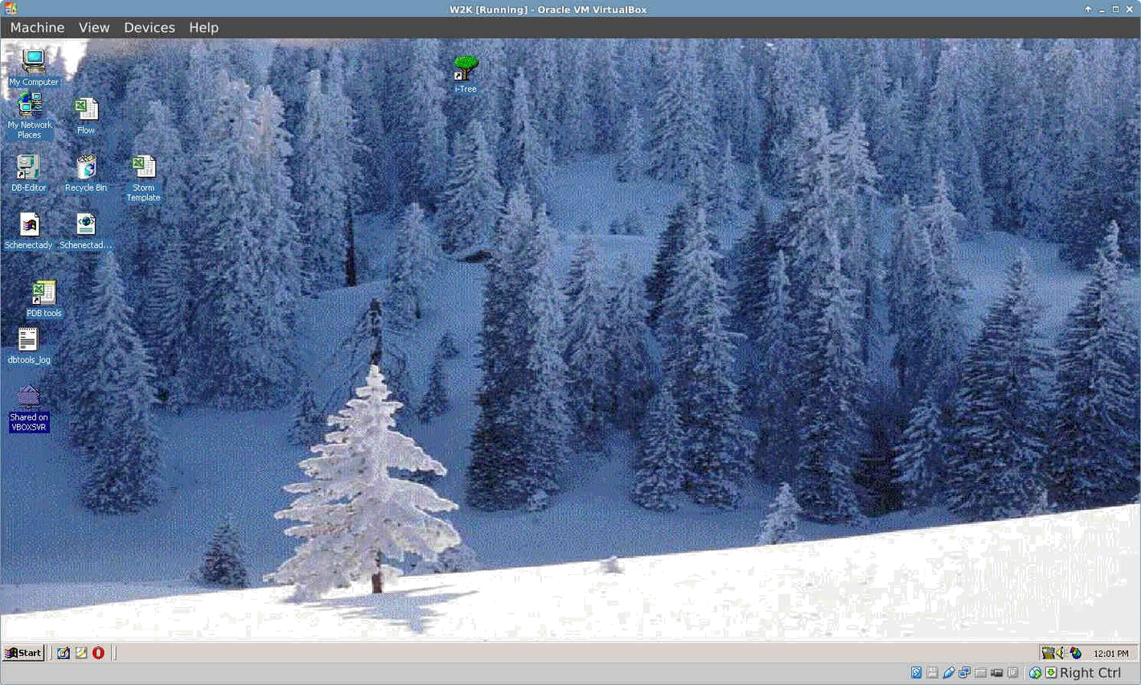
Figure 6-2: Windows 2000 running in VirtualBox.

6.2.2 VirtualBox Use
- Create a Virtual Machine. To create a virtual machine start VB, click the New icon on the toolbar. You will need a Windows CD or a Linux ISO (32bit only). Follow the wizard, accepting all suggested settings unless you know better — you can always change them later. If your ISO has PAE, click on System > Options tab and enable it. You may need to increase the memory allocated to the Guest above the minimum default figure, still leaving sufficient memory for your Host OS. For Windows Guests, consider creating a larger virtual HD than the 10GB default – while it is possible to increase the size later, it is not a straightforward process. For Windows 10 or 11 60 Gb is required. Select a Host Drive or Virtual CD/DVD Disk File
- Select a mount point. Once the machine is set up, then you can select the mount point to be either the Host Drive or a Virtual CD/DVD Disk File (ISO). Click Settings > Storage, and a dialog box will pop up where you will see in the middle a Storage Tree with an IDE Controller and a SATA Controller below it. By clicking on the CD/DVD Drive icon in the Storage Tree, you will see the CD/DVD Drive icon appear in the Attributes section in the right side of the window. Click on the CD/DVD Drive icon in the Attributes section to open a drop-down menu where you can assign the Host Drive or a Virtual CD/DVD disc file (ISO) to be mounted on the CD/DVD Drive. (You can select a different ISO file by clicking on Choose a Virtual CD/DVD disk file and navigating to the file.) Run the machine. The device you selected (ISO or CD/DVD) will be mounted when you start the virtual machine and your OS can be installed.
- GuestAdditions. Once your Guest OS is installed, be sure to install VB GuestAdditions by booting into the Guest OS, then clicking Devices > Insert GuestAdditions and pointing toward the ISO that it will automatically locate. This will allow you to enable sharing files between Guest and Host and to adjust your display in various ways so that it suits your environment and habits. If the app is unable to locate it, you may need to install the package virtualbox-guest-additions (done automatically if you used Package Installer).
- Moving. The safest way to move or change the settings of an existing Virtual Machine is to clone it: right-click the name of an existing machine > Clone, and fill in the information. To use the new clone, create a new Virtual Machine and in the wizard when you select the Hard Disk, choose "Use existing hard disk" and select the new clone’s *.vdi file.
- Documentation. Detailed documentation for VB is available through Help on the menu bar or as a PDF from the website.
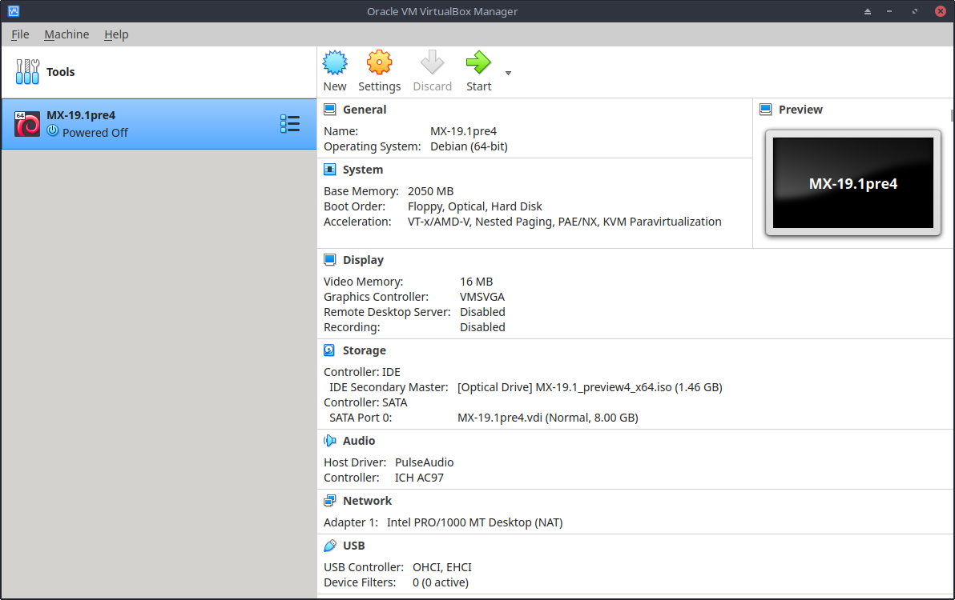
Figure 6-3: Settings screen in VirtualBox (MX-19.1).

Links
- Wikipedia: Virtual Machine
- Wikipedia: Comparison of virtual machine software
- VirtualBox home page
- VirtualBox Extension Pack

6.3 Alternate Window Managers
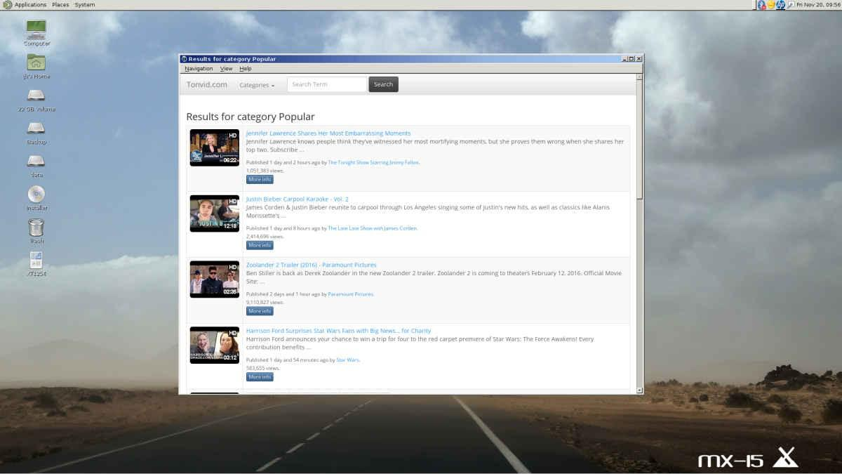
Figure 6-4: MATE running on top of MX-15 Linux, with YouTube Browser open.
A window manager (originally WIMP: Window, Icon, Menu, and Pointing device) in Linux is essentially the component which controls the appearance of Graphical user interfaces (GUI) and provides the means by which the user can interact with them.
The three MX Linux versions use Xfce, KDE or Fluxbox by definition. But other possibilities exist for users. MX Linux makes it easy to install many popular alternatives through the MX Package Installer, as described below.
- Budgie Desktop, a simple and elegant desktop using GTK+
    - Budgie Desktop
- Compiz, an OpenGL WM with compositing.
  - Compix Window Manager
- Gnome Base, a GTK+ based display manager and desktop that provides an ultra-light desktop environment.
  - Gnome Ultra (GOULD), an ultra-light desktop environment
- LXDE is a fast and light desktop environment whose components can be installed separately.
  - LXDE home page
- MATE is the continuation of GNOME 2 providing an intuitive and attractive desktop environment.
  - MATE home page
- IceWM is a very light-weight all-in-one desktop environment and stacking window manager.
  - IceWM home page
Once installed, you can choose the window manager you want from the Session Button in the center of the top bar on the default login screen; log in to as you normally would. If you replace the login manager with another from the repos, make sure you always have at least one available upon reboot.
MORE: Wikipedia: X Window Managers

6.4 Command Line
Although MX offers a complete set of graphical tools for installing, configuring, and using your system, the command line (also called the console, terminal, BASH, or shell) is still a useful and at times indispensable tool. Here are some common uses:
- Launch a GUI application to see its error output.
- Speed up system administration tasks.
- Configure or install advanced software applications.
- Execute multiple tasks quickly and easily.
- Troubleshoot hardware devices.
The default program to run a terminal in an MX desktop window is XFCE Terminal; KDE’s default is Konsole. Some commands are only recognized for super user (root), while others may vary the output depending on user.
To obtain temporary root permissions, use one of the methods described in Section 4.7.1. You will recognize when Terminal is running with root privileges by looking at the prompt line right before the space where you type. Instead of a $, you will see a #; in addition, the user name changes to root and may be written in red.
NOTE: If you try to run as a regular user a command that requires root privileges such as iwconfig, you may receive an error message that the command was not found, see a message box that the program must be run as root, or simply find yourself at the prompt again with no message at all.
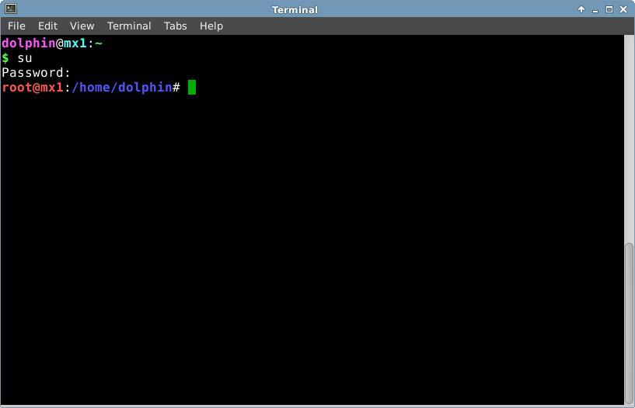
Figure 6-5: User now has administrative (root) privileges.

6.4.1 First steps
- For more information on running a terminal for solving system problems, please refer to the topic Troubleshooting at the end of this section. Also, it is advisable to make backups of the files you are working on as a root user with the commands cp and mv (see below).
- Though terminal commands can be fairly complex, understanding the command line is just a matter of putting together simple things. To see how easy it can be, open a terminal and try a few basic commands. This will all make more sense if you do it as a tutorial exercise rather than just reading it. Let’s start with a simple command: ls, which lists the contents of a directory. The basic command lists the contents of whatever directory you are currently in:
ls
- That’s a useful command, but it’s just a few short columns of names printed across the screen. Suppose we want more information on the files in this directory. We can add a switch to the command to make it print out more information. A switch is a modifier we append to a command to change its behavior. In this case, the switch we want is:
ls -l
- As you can see on your own screen if you are following along, this switch provides more detailed information (especially about permissions) on the files in any directory.
- Of course, we might want to see the contents of another directory (without going there first). To do this, we add an argument to the command, specifying which file we want to look at. An argument is a value or reference we add to a command to target its operation. By giving an argument of /usr/bin/, for instance, we can list the contents of that directory rather than the one where we currently are.
ls -l /usr/bin
- There are a lot of files in /usr/bin/! It would be nice if we could filter this output so that only entries that contained, say, the word “fire”would be listed. We can do this by piping the output of the ls command into another command, grep. The pipe, or │ character, is used to send the output of one command to the input of another. The command grep searches for the pattern you give it and returns all matches, so piping the output of the previous command to it filters the output.
ls -l /usr/bin | grep fire
- Finally, suppose we want these results saved in a text file for use at a later time. When we issue commands, the output is usually directed to the console display; but we can redirect this output somewhere else, such as to a file, using the > (redirect) symbol to instruct your computer to make a detailed list of all the files that contain the word “fire” in a particular directory (by default your Home directory, and to create a text file containing that list, in this case named “FilesOfFire”
ls -l /usr/bin | grep fire > FilesOfFire.txt
- As you can see, the command line can be used to perform complex tasks very easily by combining simple commands in different ways.

6.4.2 Common commands

Filesystem navigation
Table 6: Filesystem navigation commands.
Command | Comment
cd /usr/share | Changes current directory to the given path: “/usr/share”. With no argument, cd takes you to your home directory.
pwd | Prints the current working directory path
ls | Lists the contents of the current directory. Use the -a switch to show hidden files as well, and the -l switch to show details on all files. Often combined with other terms. lsusb lists all the usb devices, lsmod all the modules, etc.

File management
Table 7: File management commands.
Command | Comment
cp <sourcefile> <destinationfile> | Copy a file to another filename or location. Use the -R switch (“recursive”) to copy entire directories.
mv <sourcefile> <destinationfile> | Move a file or directory from one location to another. Also used to rename files or directories and to make a backup: for example before changing a critical file such as xorg.conf you might use this command to move it to something like xorg.conf_bak.
rm <somefile> | Delete a file. Use the -R switch to delete a directory, and the -f switch (“force”) if you don’t want to be prompted to confirm each deletion.
cat somefile.txt | Prints the contents of a file on the screen. Only use on text files.
grep | Find a given string of characters in a given piece of text, and print the entire line it was on. Usually used with a pipe, e.g. cat somefile.txt Ⅰ grep /somestring/ will display the line from somefile.txt that contains somestring. To find a network usb card, for instance, you could type: lsusb | grep -i Network. The grep command is case sensitive by default, so using the -i switch makes it case-insensitive.
dd | Copies anything bit by bit, so can be used for directories, partitions, and whole drives. Basic syntax is dd if=<somefile> of=<some other file>

Symbols
Table 8: Symbols.
Command | Comment
| | The pipe symbol used to send the output of one command to the input of another. Some keyboards show two short vertical bars instead
> | The redirect symbol, used to send the output of a command into a file of device. Doubling the redirect symbol will cause the output of a command to be added to an existing file rather than replacing it.
& | Adding the ampersand to the end of a command (with a space before it) causes it to run in the background so that you don’t have to wait for it to complete to issue the next command. Double ampersand indicates that the second command should only be run if the first has been successful.

Troubleshooting
For most new Linux users, the command line is mainly used as a troubleshooting tool. Terminal commands give quick, detailed information that can be easily pasted into a forum post, search box, or email when seeking help on the web. It is strongly recommended that you keep this information at hand when asking for help. Being able to refer to your specific hardware configuration will not only speed up your process of obtaining help, but also it will let others offer you more accurate solutions. Here are some common troubleshooting commands (see also Section 3.4.4). Some of them may not output information, or not as much information unless you are logged in as root.
Table 9: Troubleshooting commands.
Command | Comment
lspci | Shows a quick summary of detected internal hardware devices. If a device shows as /unknown/, you usually have a driver issue. The -v switch causes more detailed information to be displayed.
lsusb | Lists attached usb devices.
dmesg | Shows the system log for the current session (i.e. since you last booted). The output is quite long, and usually this is piped through grep, less (similar to most) or tail (to see what happened most recently). For example, to find potential errors related to your network hardware, try dmesg | grep -i net.
top | Provides a real-time list of running processes and various statistics about them. Also available as Htop along with a nice graphical version Task Manager.
Accessing documentation for commands.
- Many commands will print out a simple “usage information” message when you use the --help or -h switch. This can be helpful for quickly recalling the syntax of a command. For example: cp --help
- For more detailed information on how to use a command, consult the command’s man page. By default, man pages are displayed in the terminal’s less pager, meaning that only one screenful of the file is displayed at a time. Keep these tricks in mind to navigate the resulting screen:
  - The space bar (or PageDown key) advances the screen.
  - The letter b (or PageUp key) moves the screen backward.
  - The letter q exits the help document.

Alias
You can create an alias (personal command name) for any command, short or long, that you want; most easily done with the tool MX Bash Config. Details in the MX/antiX Wiki.

6.4.3 Links
- BASH Beginners Guide
- Command Line Basics

6.5 Scripts
A script is a simple text file that can be written directly from a keyboard, and consists of a logically sequenced series of operating system commands. The commands are handled one at a time by a command interpreter which in turn requests services from the operating system. The default command interpreter in MX Linux is Bash. The commands must be understandable to Bash, and command lists have been established for programming use. A shell script is the Linux counterpart of batch programs in the Windows world.
Scripts are used throughout the Linux OS and applications that run on it as an economical method of executing multiple commands in an easily created and modified manner. During boot, for instance, many scripts are invoked to start up specific processes such as printing, networking, etc. Scripts are also used for automated processes, system administration, application extensions, user controls, etc. Finally, users of all kinds can employ scripts for their own purposes.

6.5.1 A simple script
Let’s do a very simple (and famous) script to get the basic idea.
- Open your text editor (Start Menu > Accessories), and type:
#!/bin/bash
clear
echo Good morning, world!
- Save that file in your home directory with the name SimpleScript.sh
- Right-click the file name, select Properties, and check “Allow this file to run as a program” on the Permissions tab.
- Open a terminal and type:
sh /home/<username>/SimpleScript.sh
- The line “Good morning, world!” will appear on your screen. This simple script doesn’t do very much, but it does establish the principle that a simple text file can be used to send commands to control your system’s behavior.
NOTE: All scripts open with a shebang as in the beginning of the first line: it is a combination of a hash sign (#), an exclamation point, and the path to the command interpreter. Here, Bash is the interpreter and it is found in the standard location for user applications.

6.5.2 A useful script
Let’s look at a useful script for the ordinary user that reduces all the moves involved in backing up multiple sets of files into a single keystroke. The script below relies itself on a system script called rdiff-backup that would need to be installed from the repos for the script to work. It copies one directory to another, keeping a record of the differences in a special subdirectory so you can still recover files lost some time ago. (Incidentally, rdiff-backup relies in turn on a script called diff.)
In this example, a user named “newbie” wants to set up a script to back up documents, music, mail and pictures from the /home directory to an external drive.
1 #!/bin/bash
2 #
3 # This Rdiff-Backup script backs up to a second hard drive
4 # It must be run as root in order to mount the second hard drive
5
6 # To restore files, issue the command: cp -a /mnt/sda1/username /home
7 # To restore, but not overwrite:
8 # cp -a -i \SpecialChar nobreakdash\SpecialChar nobreakdash”reply=no /mnt/sda1/username /home
9
10 # Mount the external devices
11
12 mount /dev/sdb1
13 mount /dev/sdb2
14 mount /dev/sdb3
15
16 # Execute the backup
17
18 rdiff-backup /home/newbie/Documents /mnt/sdb2/Documents
19 rdiff-backup /home/newbie/Music /mnt/sdb1/Music
20 rdiff-backup /home/newbie/Mail /mnt/sdb2/Mail
21 rdiff-backup /home/newbie/Pictures /mnt/sdb3/Pictures
22
23 # Unmount the external devices
24
25 umount /dev/sdb1
26 umount /dev/sdb2
27 umount /dev/sdb3
Now let’s look at this script’s components:
- Lines 2-8: a hash or number sign has been placed in front of these lines (called “commenting them out”) to indicate to Bash that they are not part of the sequence of commands to be executed. Their purpose here is to provide anyone who looks at this script with information about such things as the script’s origin, creator, purpose, and license (metadata).
- Line 10: good scripts separate the commands into clearly labeled procedural sections, also in lines 16 and 22.
- Lines 12-14: the three devices to be used for the backup have to first be mounted so they are available to the system.
- Lines 18-21: here bash is told to use the system script rdiff-backup to compare the original directories (sources) with the backup directories (targets), copy over the differences it finds, and keep a record of the changes.
- Lines 25-27: once the backup work is done, the external drives are unmounted from the system.
Anyone who wanted to use such a script would have to carry out a few execution steps:
- Copy the whole script.
- Right-click the desktop and select Create New > Text file...
- Give the file a name that makes sense (no spaces, though), and add the “sh” extension so you will recognize it is a script. For this example, you might select Backup_DocsMusicMailPictures.sh
- Open the new text file and paste in the script.
- Change any names, locations, etc. to what they are on your particular system. In the example above, you may well have different names and/or locations for the directories to be backed up, and different devices where they are supposed to go.
- Save that script in a place you can easily find it when you need it; let’s say you make a new directory in your home called “scripts” for it.
- Right-click the script, select Properties, click on the Permissions tab, and check the box Is executable or Allow this file to run as a program and click OK.
- When you are ready to backup, open a terminal and type:
sh /home/scripts/Backup_DocsMusicMailPictures.sh
HINT: use the tab key to autocomplete the file name after you type the first few letters.
Links
- Bash Beguinners Guide
- Linux Shell Scripting Tutorial
- Linux Commands

6.5.3 Special script types
Some scripts require special software (scripting language) to run, rather than just launching them in Bash. The most common for regular users are Python scripts, which take the form *.py.
To run them, you need to call python to carry out the execution providing the correct path. If you downloaded “<somefile>.py” to your Desktop, for instance, you could do one of three things:
  - Just click on it. MX Linux has a small program called Py-Loader that will launch it using python.
  - Open a terminal and type:
python ~/Desktop/<somefile.py
  - Alternatively, you could open a terminal inside the folder itself, in which case you would type:
python ./<somefile>.py
Scripting languages are very advanced, and lie outside the scope of this Manual.

6.5.4 Pre-installed user scripts

inxi
, Inxi is a convenient command-line system information script written by a programmer known as “h2”. Enter inxi -h in a terminal to see all the options available, which include an entire range from sensor output to the weather. This is the command running behind MX Quick System Info.
MORE: MX/antiX Wiki

6.5.5 Tips and tricks
- Double-clicking a shell script opens it in the Featherpad editor by default instead of running the script. This is by design as a security measure to prevent accidentally running scripts when you didn't intend to. To change that behavior, click Settings > Mime Type Editor. Locate x-application/x-shellscript and change the default application to bash.
- A more advanced editor for programming scripts is geany, installed by default. It is a flexible and powerful IDE/editor that is lightweight and cross-platform.

6.6 Advanced MX Tools
In addition to the configuration MX Apps discussed in Section 3.2, MX Linux includes utilities for the advanced user available from MX Tools.

6.6.1 Chroot rescue scan (CLI)
A set of commands that allow you to get into a system even if its initrd.img is broken. It also lets you get into multiple systems without rebooting. Details and images in the HELP file.
HELP: here.

6.6.2 Live-usb kernel updater (CLI)
VIDEO: Change your kernel on an antiX or MX live-USB
WARNING: for use in a Live session only!
This command line application can update the kernel on an MX LiveUSB with any kernel that has been installed. This application will only show in MX Tools when running a Live session.

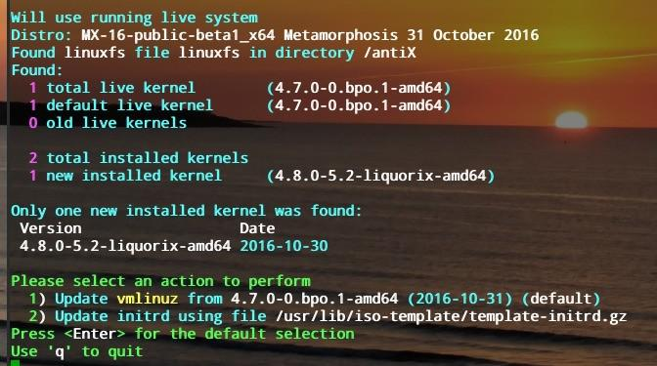
Figure 6-6: The live-usb kernel updater tool ready to switch to a new kernel.
HELP: here.

6.6.3 MX Live Usb maker
Use to create a Live-USB starting from an ISO file, a live -CD/DVD or an existing live-USB or even a running live system. Although UNetbootin is also available by default (see Section 2.2.3), Live-USB Maker has a number of advantages:
- It is faster.
- Saves state files across reboots.
- LiveUSB-Storage for saving files directly on the live-usb.
- Persistence.
- Remastering.
- Now offers dd option.
- Live kernel updating.
NOTE: the CLI form (live-usb-maker, run as root) offers many advanced options.
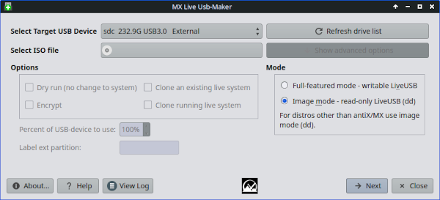
Figure 6-7: The live-usb maker tool ready to select the ISO to use.
HELP: here.

6.6.4 Live remaster (MX Snapshot and RemasterCC)
VIDEO: Make a snapshot of an installed system
VIDEO: MX-17: make a live-USB with persistence
VIDEO: MX-17: install apps on a live-USB with persistence
NOTE: this application will only show in MX Tools and be executable when running a Live session.
The primary purpose of live remastering is to make it as safe, easy, and convenient as possible for users to make their own customized version of MX Linux that can be distributed to other computers. The idea is that you use a LiveUSB (or a LiveHD, a "frugal install;" see the MX/antiX Wiki) to a hard drive partition as the development and testing environment. Add or subtract packages and then when you are ready to remaster, use the GUI or script and reboot. If something goes horribly wrong, simply reboot again with the rollback option and you will boot into the previous environment.
Many users will already be familiar with the tool MX Snapshot for remastering(see also an older but still useful app RemasterCC) The remastered ISO (a “respin”) can be put on a LiveMedium in the usual manner (see Section 2.2) and then installed, if desired, by opening a root terminal and entering the command: minstall-launcher.

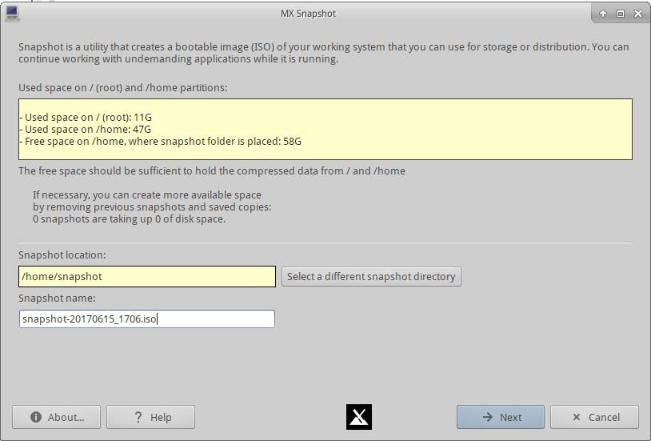
Figure 6-9: Opening screen of Snapshot.
MX Community members use Live remastering with Snapshot to produce unofficial spins of MX Linux that can be tracked on the Forum.

VIDEO: MX 16 - Remaster your Live-USB
VIDEO: MX Spins: Workbench!
VIDEO: MX Spins: Stevo's KDE!

The Live ISO may be run with what is called “persistence.” Persistence is a hybrid between a LiveMedium and a full install; it allows you to retain any files you install or add during a live session. Programs installed or removed from, and customizations to, the "demo" user files during live persistence will be carried over to the installed system.
VIDEO: Live USB with persistence (legacy mode)
VIDEO: Live USB with persistence (UEFI mode)

6.7 SSH (Secure Shell)
SSH (Secure Shell) is a protocol used to securely log onto remote systems. It is the most common way to access remote Linux and Unix-like computers. MX Linux comes with the main packages necessary to run SSH in active mode, the main one being OpenSSH, a free implementation of the Secure Shell that consists of a whole suite of applications.
- Start or restart the ssh daemon as root with the command:
/etc/init.d/ssh start
- To start the ssh daemon automatically when the computer starts, click All Settings > Session and Startup > Application Autostart. Click the Add button, then in the dialog box insert a name such as StartSSH, a short description if you want, and the command
/etc/init.d/ssh start
Press OK and you are done. The next time you restart, the SSH daemon will be active.
- KDE users on MX Linux can do the same using Preferences > Settings > Start & Stop > Automatic Start.

6.7.1 SSH Troubleshooting
Occasionally, SSH does not work in passive mode, sending a message of denied connection. Then you can try the following:
- Edit as root the file ’/etc/ssh/sshd-config’. About line 16 you will find the parameter ’UsePrivilegeSeparation yes’. Change that to
UsePrivilegeSeparation no
- Add yourself (or the intended users) to the group ’ssh’ using MX User Manager or editing as root the file /etc/group.
- Sometimes the certificates can be missing or outdated; an easy way to rebuild them is to run (as root) the command
ssh-keygen -A
- Check if sshd is running by typing
/etc/init.d/ssh status
The system should answer ’[ ok ] sshd is running.’
- If you are using a firewall, check that port 22 is not blocked. It must allow IN and OUT traffic.
MORE: Openssh manual

6.8 Synchronization

File synchronization (or syncing) allows files in different locations to remain identical. It takes one of two forms:
- one-way (“mirroring”), where one source computer is copied to others but not the reverse.
- two-way, where multiple computers are kept identical.
For instance, MX Linux users find it handy when managing multiple installations for themselves, family members or other groups, thus eliminating the need to update more than once. There is a large amount of syncing software available, but the following two have tested and proved useful to MX Linux users:
- unison-gtk (in the repos)
- FreeFileSync

