


MX-23 Fluxbox Manual

Table of Contents
1. Introduction 1
2. MX-Fluxbox Default Setup 2
2.1 Desktop icons 3
2.2 Docks 4
2.3 Conky 4
2.4 The tint2 panel 5
2.5 The rootMenu 6
3. Fluxbox 8
3.1 Styles 8
3.2 Themes 8
3.3 Wallpaper 9
3.4 Key Shortcuts 9
3.5 Managing menus 9
3.6 Text files 10
3.7 Overlay File 10
3.7 Window Settings and Controls 11
3.8 Remove Desktop items 12
3.9 Terminals 12
3.10 Screen Options 12
4. Traditional Fluxbox 12
5. FAQ-Finder 14
6. Links 16

1. Introduction
This Help document supplements the User’s Manual (Shift+F1), which covers general MX Linux topics including installation, configuration and software management.

MX Fluxbox (=MXFB) constitutes a minimal or “base” version of MX Linux that can be used out-of-the-box. By design it does not contain all the software automatically included with the other MX-Linux versions. But additional software can be easily installed using the MX Package Installer by clicking on the desktop icon “Software”. Here you can find and install a multitude of other applications such as an office suite (LibreOffice) or sophisticated graphics editor (Gimp).
As the name suggests, MXFB employs Fluxbox as a Window Manager to control the placement and appearance of windows. Its small memory footprint and quick loading time are very effective on low-resource systems—and very fast on higher-level machines.

MXFB can be run in two basic configurations, with many possible variations in between:
- Default, that includes the basic Fluxbox components but follows the MX Linux preference for the use of convenient graphical apps.
- Fluxbox, to which various components from the default configuration may be added with a simple click or two.

2. MX-Fluxbox Default Setup
5
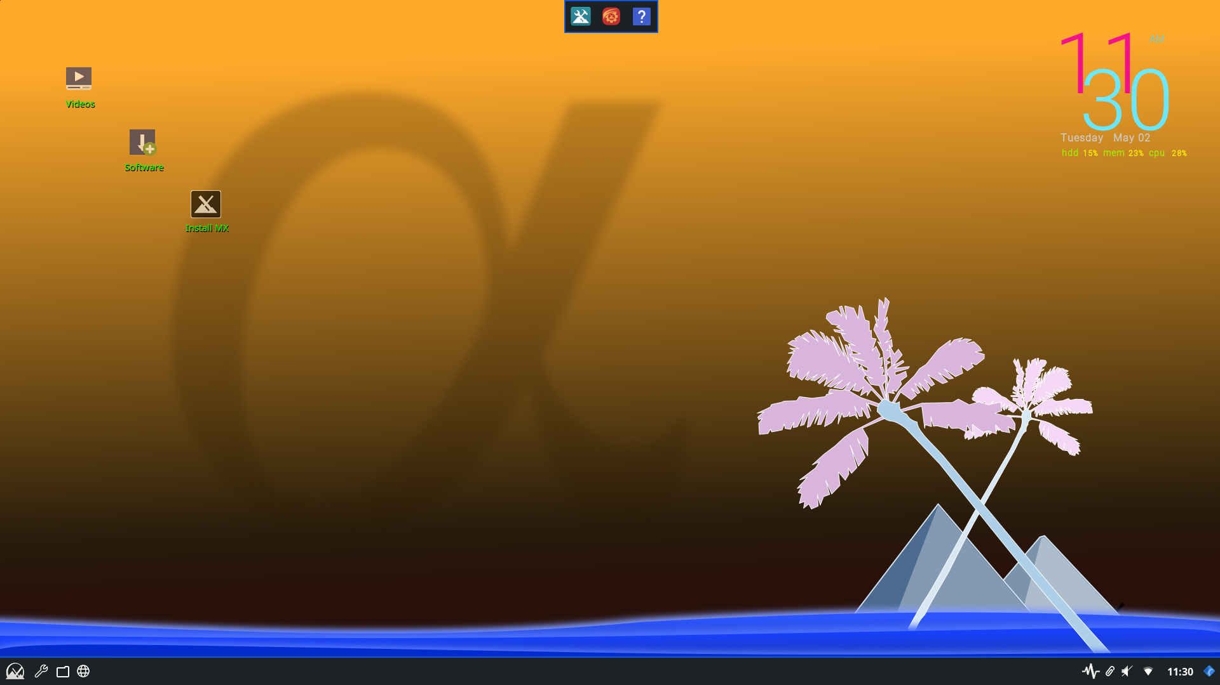
The default setup of MX_Fluxbox looks like this.
4
3
2
5
1

Going clockwise from the upper left corner, here are the principle components:

- Desktop icons (Section 2.1)
- A native dock (Section 2.2)
- System information display, called a “conky” (Section 2.3)
- The creative tint2 panel (Section 2.4)
- The hidden Fluxbox “rootMenu” (Section 2.5)

The first stop for new users might well be the Settings manager, available from the dock (red icon in the middle), the panel (wrench icon) or the root Menu.

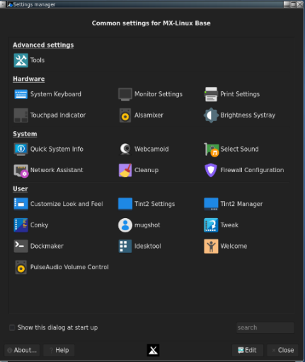

In addition to desktop icons and dock items, applications can be launched with any of the following tools:

- click the traditional panel’s Start (MX logo) button to open Xfce Appfinder
- right-click the desktop: Menu > All Apps for a Debian-like categorical menu
- click the keyboard’s logo key (Windows or Apple icon) to bring up a very fast tool called “rofi” for an alphabetical, searchable menu with handy properties (details in the Wiki)
- click Ctrl+F2 to bring up a small run window (fbrun) for the actual program name

The following sections aim to give users a basic understanding of how to use and manage each of the principle components.

Note: the word “Menu” in the following sections refers to the rootMenu that appears with a right-click on the desktop.

2.1 Desktop icons
Hide: Menu > Out of sight > Toggle icons
Remove (icon): middle-click icon to launch iDesktool
Stop: Menu > Out of sight > Toggle iDesk
Manage: Menu > Appearance > Desktop icons
Help: in the Wiki

Desktop icons are enabled in MXFB by iDesk, an older tool no longer maintained. MX Linux Devs and users adapted, modernized and expanded it to produce iDesktool: Menu > Appearance > Desktop icons.

This tool greatly facilitates the use of desktop icons on MX-Fluxbox. It is very straightforward and should raise few questions about its use.
Here are the basic mouse actions for a desktop icon (config in ~/.ideskrc), using the default “Videos” icon as an example:
Action | Mouse | Example
Execute | Left single click | Opens to the MXFB YouTube channel
Execute alt | Right single click | Opens an action menu
Manage | Middle (scroll button) single click | Opens iDesktool focused on the icon
Drag | Left click hold, release to stop

2.2 Docks

Hide: Menu > Out of sight > Toggle autohide dock
Remove/Add (a Dock item): Menu > Appearance > Dockmaker
Stop (Default dock): Menu > Out of sight > Disable Default dock
Manage: Menu > Appearance > Dockmaker
Help: in the Wiki
MXFB has a native app called Dockmaker which makes it easy for the user to create, modify and manage docks. A small dock appears at the top of the desktop when the user logs in for the first time whosse configuration is set in ~/fluxbox/scripts/DefaultDock.mxdk.
This default Dock contains the following items (from left to right):
- MX Tools
- Settings Manager
- Help (this Manual)
NOTE: you can also use tint2 as a dock, and a few examples can be found using Tint2 manager.

2.3 Conky

Hide: Menu > Out of sight > Toggle conky
Remove (conky): Menu > Appearance > Conky
Stop: Menu > Out of sight > Toggle conky
Manage: Menu > Appearance > Conky
Help: in the Wiki: MX Conky, Conky Manager

MX-Fluxbox users can make use of the default conky set for MX Linux by clicking Menu > Appearance > Conky to bring up MX Conky; Conky Manager can be launched from it, or using any of the menus. Conky Manager is a handy method of basic management, while MX Conky supplies advanced features unique to MX Linux such as color manipulation.
In Conky Manager follow these simple steps to edit, view and display a conky:
- Highlight each conky and hit Preview to see what it looks like. Be sure to close each preview before going to another.
- Click on the Settings icon (gears) to change basic properties such as location.
- Check the box to select any conky you want to use. It will be auto-installed.
- The configuration files are stored in the folder ~/.conky/ in individual theme files. They can be edited, though it is not easy, by highlighting the conky in the list and clicking on the edit icon (pencil).
For more complicated conkies, you may need to make use of a compositor. Click Menu > Settings > Config > Startup, and uncomment the line about a compositor so it looks like this: compton &

2.4 The tint2 panel
Hide: Menu > Out of sight > Toggle autohide panel
Remove: Manual: delete the config file from ~/.config/tint2/
Stop: Manual: put a comment (#) in front of line in the “startup” file
Manage: Settings manager > Tint2 manager
Help: in the Wiki

The original Fluxbox toolbar is very different from what today’s users expect in function and design. That’s the reason an alternative “traditional” toolbar was added starting with MX-Fluxbox 2.2 using a highly configurable app known as “tint2.”
(You can toggle back and forth between the two: Menu > Appearance > Toolbar > Fluxbox/Traditional)

To change the panel, click the wrench icon next to the Start button, the gear icon on the dock or the listing in the Menu. This launches the Settings manager, where you can click on “Tint2 manager.”
The screen opens showing all the tint2 configurations in the location ~/config/tint2/. MXFB supplies a set of very different configurations that you can try out.
In addition to selecting an existing configuration you can also change the elements of any panel—in fact, that is one of the great pleasures of using tint2. Click on either the “Config” button for a graphical editor or the “Edit” button to directly edit the configuration file.
The Graphical editor includes two applications:
- “Themes” displays all the tint2 configs in the user’s location as well as a few others brought in during installation.
- “Properties” displays the features of the running config. If the Properties window is not visible, click on the little gear icon in the upper left corner.
Here are a couple of common actions in the “Properties” window to get you started:
- Adding/Removing launchers. Click the “Launcher” entry on the left side. The right panel has two columns: on the left a list of application icons currently displayed on the toolbar, while on the right a list of all desktop applications installed. Use the arrows to move items up/down.
  - Add: select the application you want from the list in the right column, click the “left arrow” icon on the middle and then click the “Apply” button, to instantly add it to the toolbar.
  - Remove: reverse the procedure.
- Moving or resizing the panel. Click the “Panel” entry in the left panel and then choose its placement and size in the right panel. Click the “Apply” button. That is also where you can scroll down and check the “Autohide” box if desired.
- Changing to time/date format. Click the “Clock” entry in the left panel and then change the field “First line format” or “Second line format” to whatever you like. To get 24hr time, for instance, you would change “%I” to “%H”. Codes in the Wiki.

NOTE: Back up your current configuration before changing it: click on ~/.config/tint2/tint2rc and then save it under a new name such as “tint2rc_BAK.” You can then copy all your customized lines from your backup file to the correct place on your new tint2rc configuration.

2.5 The rootMenu
The rootMenu is hidden by default and offers a quick and easy way to access many functions and settings.
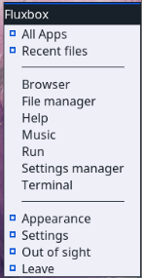
Show: right click on desktop
Remove/Add (a menu item): Menu > Settings > Configure > Menus
Stop: put a comment (#) in front of the line in the init file that starts with:
session.menuFile:
Manage: Menu > Settings > Configure > Menus
Help: Section 3.5 and Links
The short main menu (~/.fluxbox/menu-mx) incorporates three submenus (Appearance, Settings, Out of sight) that are located in ~/.fluxbox/submenus.
The root menu is divided into three sections:
- Top
  - All apps: a Debian-like categorical menu. It is updated automatically when using Package Installer; otherwise click Update if necessary
  - Recent files: displays the most recent files used (click Refresh if necessary)

- Middle Section: links to directly open some frequently used apps
- Bottom
  - Appearance
    - conky
    - docks
    - desktop icons
    - monitors: small system monitors
    - style: decoration of windows, toolbar and menu
    - theme: set GTK theme (windows, icons)
    - toolbar: select between toolbar and panel
    - wallpaper: rotate, separate by workspace, select
  - Settings
    - backup
    - configure: the Fluxbox files such as menus, startup, etc.
    - display: change display parameters, help on how to save
    - keyboard: quick change to one of 11 languages
  - Out of sight: a collection of handy commands to hide elements
  - Leave:
    - refresh: used to restart fluxbox after changing a configuration file if not logging out
    - suspend
    - log out
    - reboot
    - shutdown

The new user would do well to work through that menu in order to appreciate its contents, power, speed and flexibility. Particularly attractive is the fact that these menus are easy to read and completely under the user’s control.

3. Fluxbox details

3.1 Styles
Styles are simple text files that tell fluxbox how to generate the appearance of the window and toolbar components, as well as the menu.
Fluxbox ships with a large number of predefined styles that can be selected in Menu > Look > Style.
(The config files of these styles are located in /usr/share/fluxbox/styles/ )
Many more styles can be found online with a web search on "fluxbox styles."

The MX Comfort tool enables you to edit the colors of the default MX-comfort fluxbox style and save the changes as a new style. Open Appfinder (MX Logo in Panel) or Rofi (Windows/Apple key) and search for MX Comfort to open the tool.

If you want to manually edit an existing fluxbox style, copy the style to ~/.fluxbox/styles, rename it, and make your changes (consult Ubuntu style guide under Links, below). You will find a few fluxbox styles that have been modified for use in MX in that folder.

Styles can include a background image, but that is blocked in MX-Fluxbox by default with the top lines in Menu > Settings > Configure > Overlay. To allow the style to determine the background, place a hash mark in front to the line so that it looks like this:

! The following line will prevent styles from setting the background.
#background: none

If you like a style but want to change certain traits, copy it to ~/.fluxbox/styles, rename it, and make your changes (consult Ubuntu style guide under Links, below). You will find a few fluxbox styles that have been modified for use in MX in that folder.

3.2 Themes
A GTK theme controls items such as the panel color, the backgrounds for windows and tabs, icons, how an application will look when it is active vs. inactive, buttons, check-boxes, etc. They range from very dark to very light.
The default theme for MX-Fluxbox is called MX-Comfort. It can be changed by right-clicking on the desktop to bring up Menu > Appearance > Theme, bringing up a selector for themes, icons, fonts etc. which makes it very easy to see and choose the other possibilities.
App Settings Manager > Customize look and feel
A number of themes are installed by default in MX-Fluxbox and others can be found with a web search.

3.3 Wallpaper
First make sure the overlay file is blocking the style from determining the background. Then click Menu > Appearance > Wallpapers > Select to see the available choices. Wallpapers whose name begins with “mxfb-” carry the MX-Fluxbox logo. The list that pops up from the menu entry includes user backgrounds (~/.fluxbox/backgrounds) and system backgrounds (/usr/share/backgrounds), separated by a horizontal line. This setup allows you to add backgrounds in the user folder and then be able to select them from the menu.

3.4 Key Shortcuts
Fluxbox allows the user to set key combinations as shortcuts.
The settings are stored in the file ~/.fluxbox/keys, which can be accessed for editing via Menu > Settings > Configure > Keys.

The names used for of a couple of the keys are a bit obscure:
- Mod1 = Alt
- Mod4 = Logo key (Windows, Apple)
More: http://fluxbox.sourceforge.net/docbook/en/html/c296.html

There are dedicated function key combinations in MX-Fluxbox (see top of keys file to change):
- Ctrl+F1: MX-Fluxbox documentation
- Ctrl+F2: Run command using the quick app runner “rofi”
- Ctrl+F3: File manager
- Ctrl+F4: Drop-down terminal
- vF5: MX Tools
Function keys alone are not programmed to avoid conflict with usage by apps.

3.5 Managing menus

Main menu (MX icon on panel)

rootMenu
You can change, add and rearrange the elements in the root menu. Subsections of the root menu can be dragged away as separate active menus. (Left click and hold the titlebar)
Open the menu file you wish to edit with Menu > Settings > Configure > Menus.
(The main menu and submenus Appearance, Settings and Out of sight are all separate files)
The syntax is: [category] (name) {command} – be sure to use brackets, parentheses and braces correctly.
Example 1: change “Music” to open Clementine instead of DeaDBeeF
- Find the line with the word Music (use Ctrl+F if necessary)
[exec] (Music) {deadbeef}
- Double-click the word “deadbeef” in the command part so it is highlighted, then type “clementine” and save, producing this result:
[exec] (Music) {clementine}
- Click Menu > Leave > Refresh to use the new settings
Example 2: add Skype to the menu
- Decide where you want it to show up; for this example, let’s assume you want to add a new category “Communicate” in the Common apps section and enter it there
- Create the category using the submenu commands (see below), introduce a new line and follow the pattern: [exec] (menu entry) {command}
- The result will look something like this:
[submenu] (Communicate)
[exec] (Skype) {skypeforlinux}
[end]
- Menu > Leave > Refresh
NOTE: as the second example shows, the command to use may not always be obvious.

Categorical menu
–update
–removal

3.6 Text files

All basic settings are controlled by text files with straight-forward format. When editing these configuration files, you can prevent individual settings from being applied by simply commenting out the relevant line (adding a hashtag # at the beginning of the line)

For example: Setting A: This line will be read by Fluxbox
# Setting B: but this one won’t be
Setting C: And this one will be

Before you begin editing any configuration files, you should back up your current configuration. In the file manager Thunar (Folder icon in panel or dock) click on the config file and save it under a new name such as “filename-BAK.” Should things go wrong you can always restore the previous setup.

3.7 Overlay File

Fluxbox allows the user to globally override settings, eg. System fonts, xxx,xxx via the overlay file.
These override settings are stored in the file ~/.fluxbox/overlay, which can be accessed for editing via Menu > Settings > Configure > Overlay.

Element settings defined in the overlay file will override settings defined elsewhere in the fluxbox setup. For example, font settings in the overlay file will override the font settings defined in the current fluxbox style.

You can adjust the font being used by a theme or style using the theme selector; default for MX-Fluxbox is Sans 11. More detailed control is available by using the ~/.fluxbox/overlay file. For instance, this set of commands might be tried to make the text generally larger:
# fonts------------------------------------------
menu.frame.font: PT Sans-12:regular
menu.title.font: PT Sans-12:regular
toolbar.clock.font: PT Sans-11:regular
toolbar.workspace.font: PT Sans-11:regular
toolbar.iconbar.focused.font: PT Sans-11:regular
toolbar.iconbar.unfocused.font: PT Sans-11:regular
window.font: Lato-9

For other font options, consult the Links at the end of this document.

3.7 Window Settings and Controls

A variety of settings for how windows look and behave can be accessed with Menu > Settings > Configure > Window >

- Focus Model : Options for window focussing
- Maximize Options: how maximized windows are handled
- Tab Options: show/hide tabs on title bar, show/hide icons in title bar
- Transparency: settings for focused, unfocussed Windows and root menu (left click reduces value, right click increases value, 0= transparent, 255=opaque)
- Opaque Window Moving: toggle on/off
- Workspace Warping: toggle on/off
- Slit
- Toolbar

Moving and adjusting windows can be controlled with various key and mouse combinations
- Resize: Alt + right click near the corner you want to change and drag.
- Move: Alt + left click and drag.
- Stick: use the little square in the top left corner to limit the window to the current desktop.
- Options: right-click on the window’s toolbar at the top. Of special value is the ability to select to remember size and location (recorded in ~/.fluxbox/apps).
- Tabbing: combine multiple windows into one window with tabs across the top by simply Ctrl-Clicking and holding the titlebar of one window and dragging and dropping it on another window. Reverse the procedure to separate them again.
- Reduce window to title bar: Double click on title bar

3.8 Remove Desktop items

Menu > Out of sight > ...

This entry includes:
- Actual kill entries that stop the entire program. The next time you log in anything enabled in the startup file will re-appear except the default dock, which will be disabled.
- A disable entry to remove the default dock.
- Toggle entries, which can kill or re-launch a program.

3.9 Terminals
- Ctrl+F4 (or Menu > Terminal) = Drop-down Xfce4-terminal
- Menu or Ctrl+F2: roxterm

3.10 Screen Options
- Brightness: Settings Manager > Tools > Brightness systray
- Capture: a dedicated icon in the dock runs mxfb-quickshot; if you have a Print Screen (AKA Print, PrtSc, etc.) key, that should work as well.
- Tiling: {ADD]

4. Traditional Fluxbox
This section addresses the user who wants to run a traditional Fluxbox setup.

How do I start?
It is very easy to restore a traditional Fluxbox setup. Right-click anywhere on the desktop to see and use the desktop menu (rootMenu). The following changes are at your fingertips:
- Settings > Toolbar > Fluxbox: the traditional (tint2) panel will disappear and the Fluxbox toolbar will appear at the top of the screen.
- Out-of-sight > Kill dock*
- Out-of-sight > Kill conky*
- Out-of-sight > Toggle iDesk and Toggle icons*
*For persistent changes, comment out (#) the relevant lines in the file which opens with rootMenu Settings > Configure > Startup so they look like this:

#$HOME/.fluxbox/scripts/DefaultDock.mxdk
#$HOME/.fluxbox/scripts/conkystart
#idesktoggle idesk on 1>/dev/null 2>&1 &

Let’s go through how to understand and use the changed desktop:

What is the toolbar across the top?
This fluxbox toolbar offers MX users information about workspaces, open applications, a system tray, and the current time. Its width and placement can be set with the options available by middle-clicking (=scroll wheel) the clock or pager on the toolbar—if that doesn’t work for some reason, click Menu > Settings > Window, slit and toolbar > Toolbar. Height is set in ~/.fluxbox/init/ :

session.screen0.toolbar.height: 0

If a zero is there, it means that the selected style will set the height. Otherwise, a value of 20 to 25 is often comfortable.

The toolbar contains the following default components (L-R):

pager
- Allows you to switch workspace up (right click) or down (left click); same as Control + F1/F2/ etc., Ctrl-Alt + ←/→ or using the scroll wheel over an empty section of the desktop. Number and name are set in the ~/.fluxbox/init. “W” stands for “Workspace.” Not used by default.
iconbar
- Here open apps will show an icon, with various window options available by right-clicking the relevant icon (including the toolbar itself) > iconbar mode. Default for MX-Fluxbox is to show All Windows.

systemtray AKA systray
- Equivalent of Notification Area in Xfce. Default components set in ~/.fluxbox/init; apps that have a systemtray option will show there when launched.

clock
- To adjust the clock to 12h or 24h, right-click and click 12h or 24h, whichever shows. If that doesn’t work, select "Edit clock format."
- 24h: %H:%M, 12h: %I:%M.
- The default is 12h time and date in day/short month format: %I:%M %b %d. Many other time/date options can be found in the Wiki.

You can move or delete any of the toolbar components in ~/.fluxbox/init/ , which by default are set up in this way:

workspacename, iconbar, systemtray, clock

How can I make the toolbar look more like legacy systems such as Windows?
Click Menu > Appearance > Toolbar > Traditional (using tint2)

I have read about the slit: what is that?
The slit was originally conceived as a container for dockapps, but in MXFB it is primarily used for the dock. It can be located at various locations on the desktop:
- TopLeft, TopCenter, TopRight
- LeftCenter, RightCenter
- BottomLeft, BottomCenter, BottomRight
You can search the default repo for dockapps with this terminal command:
apt-cache search dockapp
Many available in the repos may not work well, but it’s worth taking a look.
One very interesting and useful dockapp not found with that apt-cache search is the monitor stack gkrellm, installed by default in MX-Fluxbox. It is available by clicking Menu > System > Monitors and has many configuration options (right-click on the top label or on one of the charts), many skins and many plugins. A few skins are installed by default, and can be reviewed and selected by clicking Shift-PageUp.

5. FAQ-Finder

How do I… | From Desktop | with App | Further information
Open the root Menu | Right click on Desktop
Open programme X | rootMenu > All apps |  | (Apps sorted by categories)
 | Click MX Logo (xfce-Appfinder) |  | Opens xfce-appfinder (Apps sorted by categories)
 | Press Windows/ Apple key |  | Opens Rofi (Apps listed alphabetically)
Install new apps | Desktop icon “Software” | MX Packet Installer | Chapter 1
Toggle desktops icons on/off | rootMenu > Out of sight > Toggle iDesk |  | Chapter 2.1
Change to a different Conky | Conky Manager |  | Chapter 2.2
 | rootMenu > Appearance > Conky
Toggle Conky on/off | rootMenu > Out of sight > Toggle Conky |  | Chapter 2.2
Select a different Panel |  | Settings manager > tint2manager | Chapter 2.3
Edit a Panel |  | tint2settings | Chapter 2.3
Edit the items in a Dock | rootMenu > Appearance > Dockmaker |  | Chapter 2.4
Change appearance of window Title bar and FB-Menu | rootMenu > Appearance > Style |  | Chapter 3.1
Change appearance of window contents, icons, font | rootMenu > Appearance > Theme | Settings manager > Customize look and feel | Chapter 3.2
Change the wallpaper | rootMenu > Appearance > Wallpapers | Nitrogen | Chapter 3.3
Edit key shortcuts | rootMenu > Settings > Configure > Keys |  | Chapter 3.4
Edit root Menu | rootMenu > Settings > Configure > Menu |  | Chapter 3.5
Edit the Overlay file | rootMenu > Settings > Configure > Overlay |  | Chapter 3.6
Remove desktop items | rootMenu > Out of sight > |  | Chapter 3.8
Open a Terminal | rootMenu > Terminal (opens Roxterm) | Xfce4-terminal | Chapter 3.10

6. Links

The man files (in terminal or https://linux.die.net/man/):
- fluxbox
- fluxbox-keys
- fbrun
- fluxstyle
- fluxbox-remote
http://fluxbox.sourceforge.net/docbook/en/pdf/fluxbook.pdf
Basic handbook, somewhat dated but still useful

https://bbs.archlinux.org/viewtopic.php?id=77729
Some good general explanations with examples

https://wiki.archlinux.org/index.php/Fluxbox
Some commands are Arch-specific

https://wiki.ubuntu.com/HowToFluxboxStyles

https://ubuntuforums.org/showthread.php?t=617812
Excellent thread on fluxbox keys

https://wiki.debian.org/FluxBox

https://wiki.debian.org/FluxboxIcon

http://fluxbox.sourceforge.net/docbook/en/html/chap-tabs.html
Window tabbing.

https://github.com/jerry3904/mx-fluxbox
The GitHub repo of MX-Fluxbox

https://mxlinux.org/wiki/help-files/help-mx-fluxbox/
The MX-Fluxbox Wiki entry

https://bit.ly/2Sm1PJl
YouTube: MX-Fluxbox

v. 202205xx

