


MX-25 Fluxbox Manual
A supplement to the MX User’s Manual

Translations created by DeepL

Table of Contents
1. Introduction 2
2. Configuration 3
2.1 Default 3
2.2 Traditional 8
3. Fluxbox details 10
3.1 Root Menu 10
3.2 Other menus 11
3.3 Styles (themes) 11
3.4 Wallpapers 12
3.5 Shortcuts 12
3.6 Config files 13
3.7 Slit 13
3.8 Overlay 14
3.9 Window Settings and Controls 14
3.10 Screen Options 14
4. FAQ-Finder 15
5. Links 17

1. Introduction
Welcome to MX-25 Fluxbox!

MX Fluxbox (=MXFB) constitutes a minimal or “base” version of MX Linux that can be used out-of-the-box. By design it does not contain all the software automatically included with the other MX Linux versions. But additional software can be easily installed , by clicking on the desktop icon “Software” to launch MX Package installer. There you can find a multitude of other applications such as an office suite (e.g., LibreOffice), a graphics editor (e.g., Gimp) or a video player (e.g., VLC).

As the name suggests, MXFB employs Fluxbox as a Window Manager to control the placement and appearance of windows. Its small memory footprint and quick loading time are very effective on low-resource systems—and very fast on higher-level machines.

MXFB can be run in two basic configurations, with many possible variations in between:

- Default, employing a sophisticated panel known as “tint2”along with multiple graphical apps and components.

- Fluxbox, using the native “toolbar” along with a minimal desktop appearance.

The first-time user might profit from an overview of the MX-23 version:


MX-Fluxbox: what’s new

2. Configuration

2.1 Default
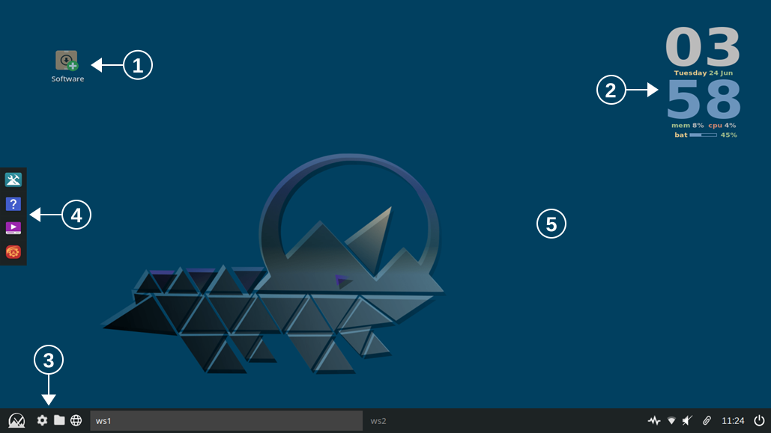
3
4
5
2
1
Fluxbox desktop (wallpaper not MX-25 default). Going clockwise from the upper left corner, here are the principal components:

- Desktop icons (Section 2.1.1)
- Desktop system information (Section 2.1.2)
- The tint2 panel (Section 2.1.3)
- A native dock (Section 2.1.4)
- The hidden (Root) Menu (Section 2.1.5)
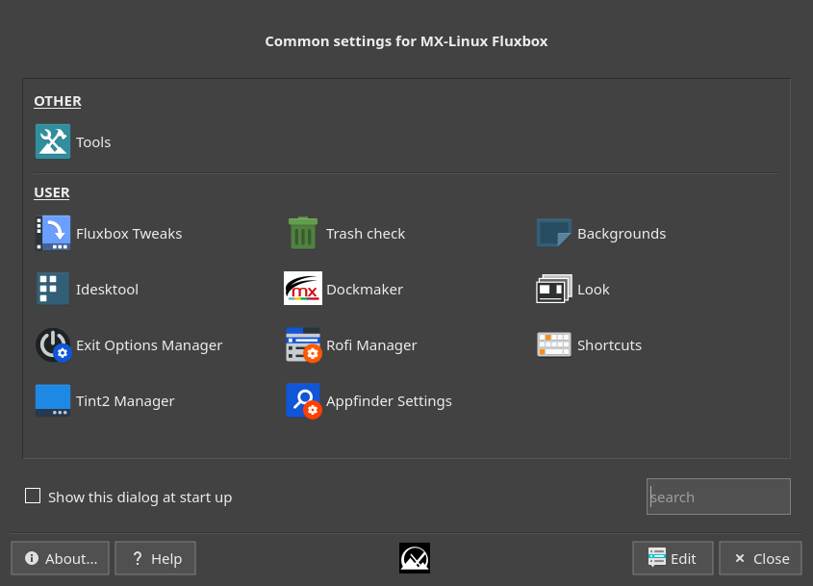
NOTE: the word “Menu” in this document refers to the Root Menu that appears with a right-click on the desktop.

The first stop for new users might well be the Settings manager, available from the dock (red icon), panel (gear icon) or Root Menu. The native apps listed there provide great ease and flexibility.

In addition to the visible panel, desktop and dock icons, applications can be launched in any of the following ways:

- click the panel’s Start (MX logo) button to open Appfinder
- right-click the desktop to see the Menu
- right-click the desktop: Menu > All Apps for a Debian-like categorical listing
- press the keyboard’s logo key (Windows or Apple icon) for a list of apps with handy properties
- press Ctrl+F2 to bring up a small run window for the actual program name. You can also enter a command (e.g., for a script) to launch in a terminal with Shift+Enter

This redundancy allows the user to select the most convenient method for a specific task or personal preference.

2.1.1 Desktop icons
Hide: Menu > Out of sight > Toggle icons
Remove (icon): middle-click icon to launch iDesktool
Stop: Menu > Out of sight > Toggle iDesk
Manage: Menu > Appearance > Desktop icons
Help: in the Wiki
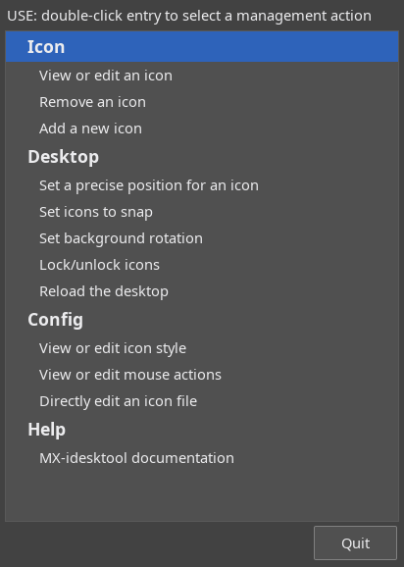
MX-Fluxbox: the Power tools

Desktop icons are enabled in MXFB by iDesk, an older app that MX Linux Devs and users adapted, modernized and expanded to produce iDesktool: Menu > Appearance > Desktop icons.

This tool greatly facilitates the use of desktop icons on MX Fluxbox. It is very straightforward and should raise few questions about its use.

Here are the basic mouse actions for a desktop icon (config in ~/.ideskrc),* using the default “Software” icon as an example:
Action | Mouse | Explanation
Execute | Left single click | Opens MX Package installer
Execute alt | Right single click | Opens an action menu
Manage | Middle (scroll button) single click | Opens iDesktool focused on the icon
Drag | Left click hold, release to stop

*the symbol “~” is a shortcut for the user’s home folder: ~/.ideskrc = /home/<username>/.ideskrc

2.1.2 Desktop system information

Conky
Hide: Menu > Out of sight > Toggle conky
Conky config: Menu > Appearance > Conky
Stop: Menu > Settings > Config files > Startup: comment out conkystart
Manage: Menu > Appearance > Conky
Help: in the Wiki: MX Conky, Conky Manager

Conky is a desktop system display with great customization potential. MX Fluxbox users can make use of a large set of configurations (configs) for MX Linux by clicking Menu > Appearance > Conky to bring up Conky Manager. Conky Manager is a handy method of basic management, while the tool MX Conky supplies advanced features unique to MX Linux such as color manipulation.
In Conky Manager follow these simple steps to edit, view and display a conky:
• Highlight each conky config and, if necessary, hit Preview to see what it looks like.
• Click on the Settings icon (gears) to change basic properties such as location.
• Check the box to select any config you want to use. It will be auto-installed.
• A config can be edited, though not always easy to understand, by highlighting it in the list and clicking on the edit icon (pencil). All configs are stored in the folder ~/.conky/ in individual theme files.
For a more complicated conky, you may need to make use of a compositor. Click Menu > Settings > Config > Startup, and uncomment the line about a compositor so it looks like this: picom &

Monitors (gkrellm)
Hide: Menu > Out of sight > Toggle monitors
Monitors config: Right-click top bar to see the menu
Stop: Settings > Config files > Startup: comment out gkrellm
Manage: Menu > Appearance > Monitors
Help: https://www.youtube.com/watch?v=G2F2YoZM63Y

GKrellM is a great desktop system information display that creates a single process stack of system monitors. Many options are available by right-clicking the top bar Configuration to see the index:
- General
- Builtins
- Plugins
- Themes
GKrellM configuration requires no editing of code. MX includes a few themes by default, and many others can be found online. Plugins can be installed by searching “gkrellm” in Synaptic.

2.1.3 The tint2 panel
Hide: Menu > Out of sight > Toggle autohide panel
Remove: Manual: delete the config file from ~/.config/tint2/
Stop: Manual: put a comment (#) in front of line in the “startup” file
Manage: Menu > MX Fluxbox tools > Tint2 Manager
Help: in the Wiki

The native (or traditional) Fluxbox toolbar is very different from what many of today’s users expect in function and design. For that reason an alternative toolbar was developed using a highly configurable app known as “tint2.” You can toggle back and forth between the two: Menu > Appearance > Toolbar > Fluxbox/tint2. The toggle will return you to the default configuration tint2rc; if you are using a different one, just log out and back in to restore your choice.

Icons L-R: Appfinder, MX Fluxbox tools, File Manager, Browser, [ws1 = workspace 1], Updater, Network Manager, Sound, Clipboard Manager, Clock, Exit Options. Note that the order inside the System Tray may change with a new session.

WARNING
When creating a brand new panel (not starting with one of the MX defaults), there may be an error with some Fluxbox versions. Setting the panel to 100% width causes the panel to be mislocated (e.g., floating above the screen bottom); in addition, space is reserved where the tint2 panel is supposed to be located, so it looks like maximized apps don't fill the screen when tint2 is mislocated.

There are two solutions:
- Set the width to 99% and the panel goes back to where it belongs.
- Set the panel to "100%" width and add a 1 pixel horizontal margin

To change the Panel being used, click the gear icon next to the Start button, the red gear icon on the dock or the listing in Menu > Settings > Config files > Tint2 panel. This launches the Settings manager, where you can click on “Tint2 manager.” The screen opens showing all the tint2 configurations in the location ~/config/tint2/. You can also use tint2 as a dock, see examples in Tint2 manager.
In addition to selecting an existing configuration you can also change the elements of any panel. Click on either the “Config” button for a graphical editor or the “Edit” button to directly edit the file.
The Graphical editor includes two applications:
- “Themes” displays all the tint2 configs in the user’s location as well as a few others brought in during installation.
- “Properties” displays the features of the running config. If the Properties window is not visible, click on the little gear icon in the upper left corner.
Here are a couple of common actions in the “Properties” window to get you started, using the Graphical editor:

- Adding/Removing launchers. Click the “Launcher” entry on the left side. The right panel has two columns: on the left a list of application icons currently displayed on the toolbar, while on the right a list of all desktop applications installed. Use the arrows to move items up/down.

  - Add: select the application you want from the list in the right column, click the “left arrow” icon on the middle and then click the “Apply” button, to instantly add it to the toolbar.
  - Remove: reverse the procedure.

- Moving or resizing the panel. Click the “Panel” entry in the left panel and then choose its placement and size in the right panel. Click the “Apply” button. That is also where you can scroll down and check the “Autohide” box if desired.

- Changing time/date format. To switch between 12h and 24hm use the dedicated button “12h/24h” on the Tint2 Manager main screen. For other changes, click the “Clock” entry in the left panel and then change the field “First line format” or “Second line format” to whatever you like. Codes in the Wiki.

NOTE: Back up your current configuration before changing it: for instance, click on ~/.config/tint2/tint2rc and then save it under a new name such as “tint2rc_BAK.” You can then copy all your customized lines from your backup file to the correct place on your new tint2rc configuration.

2.1.4 Docks

Hide: Menu > Out of sight > Toggle autohide dock
Remove/Add (a Dock item): Menu > Appearance > Dockmaker
Stop (Default dock): Menu > Out of sight > Disable Default dock
Manage: Menu > Appearance > Docks > Dockmaker
Help: in the Wiki
MX-Fluxbox: the Power tools
MXFB has a native app called Dockmaker (making use of wmalauncher) which makes it easy for the user to create, modify and manage docks.

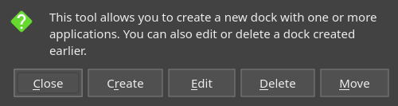

The default dock (~/fluxbox/scripts/DefaultDock.mxdk) contains the following items:
- MX Tools
- Help (this Manual)
- MX Videos
- Settings Manager

2.1.5 Root menu
The Menu is hidden by default, and revealed by right-clicking the desktop. It offers a quick and easy way to access many functions and settings. Details in Section 3.1.

2.2 Traditional
It is very easy for the user who prefers to run a traditional Fluxbox setup. Simply make the following changes for the running session as desired:

- Menu > Settings > Toolbar > Fluxbox

- Menu > Out-of-sight > Kill dock
- Menu > Out-of-sight > Kill conky
- Menu > Out-of-sight > Toggle iDesk and Toggle icons

To make changes permanent, comment out (#) the relevant lines in Menu > Settings > Config files > Startup so they look like this:

#$HOME/.fluxbox/scripts/DefaultDock.mxdk

#conkystart

#idesktoggle idesk on 1>/dev/null 2>&1 &

Toolbar

Traditional
The original toolbar can contain (setup in ~/.fluxbox/init) the following components (L-R):

- pager Allows you to switch workspace forward (right click) or backward (left click); same as Ctrl + F1/F2/ etc., Ctrl-Alt + ←/→ or using the scroll wheel over an empty section of the desktop. Number and name are set in the ~/.fluxbox/init where “ws” stands for “workspace.”
- workspace name Set in init by default at “ws1, ws2, etc” (ws=workspace).
- iconbar Here open apps will show an icon, with various window options available by right-clicking the relevant icon (including the toolbar itself) > iconbar mode. Default is to show All Windows.
- systemtray Equivalent of Notification Area in Xfce. Apps listed in ~/.fluxbox/startup that have a systemtray option will show here.
- clock For 12/24 hr change, use Menu > Settings > Config files > Quick config > Toolbar. For other changes, click Menu > Settings > Config files > init > Manual edit, press Ctrl + F to find “strftimeFormat” and change as desired. A short date can be added with %b %d. Many other time/date options can be found in the Wiki.

Enhanced MX Style
The enhanced MX toolbar can display the same information as the traditional one, but makes use of the more recent development of toolbar “buttons” to add launchers. In the image above they are at the left end (L/R):

- Appfinder
- Root Menu
- MX Fluxbox tools
- File manager
- Web browser
- Pager (triangle)
- Exit Options

Both toolbars follow settings in init; the enhanced toolbar adds additional toolbar settings to the Fluxbox default set and places font settings in overlay as well.

Resource
MX Fluxbox: Traditional mode

3. Fluxbox details

3.1 Root Menu
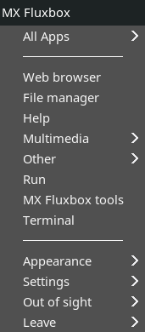
This short and static menu (~/.fluxbox/menu-mx) incorporates three submenus (Appearance, Settings, Out of sight) that are located in ~/.fluxbox/submenus. The root menu is divided into three sections:
- Top
  - All Apps: a Debian-like categorical menu. It is updated automatically after a package is installed or removed, and you can do that manually by clicking “Update.” Click on “Disable” to stop automatic updating.

- Middle Section: links to directly open commonly used apps,
- Bottom
  - Appearance

  - Settings

  - Out of sight: a collection of handy commands to hide elements

  - Leave

The new user would do well to work through that menu in order to appreciate its contents, power, speed and flexibility.

Editing
Particularly attractive is the fact that these menus are completely under the user’s control. You can change, add or rearrange the elements in the root menu. Open the menu file you wish to edit with Menu > Settings > Configure > Menus.
The typical syntax of a menu entry is: [exec] (name) {command} – be sure to use brackets, parentheses and braces correctly.
Example 1: change “Music player” to open Strawberry instead of DeaDBeeF
- Find the line with the word “DeaDBeeF” (use Ctrl+F if necessary)
[exec] (Music player) {deadbeef}
- Double-click the word “deadbeef” in the command part so it is highlighted, then type “strawberry” and save, producing this result:
[exec] (Music player) {strawberry}
- Save and exit – the change will be immediately available.
Example 2: add Zoom to the menu
- For this example, let’s assume you want to add a new category “Chat” in the common apps section and enter Zoom there
- Create the category using the submenu commands, introduce a new line and follow the pattern.
- The result will look something like this:
[submenu] (Chat)
[exec] (Zoom) {zoom}
[end]
NOTE: the actual launch command for some apps may not be identical to the name.

3.2 Other menus

Applications
- Appfinder (MX icon). The main menu for tint2 and the MX enhanced toolbar which uses a special Rofi theme. The contents are taken automatically from /usr/share/applications. You can change formatting by clicking the question mark on the left side of the menu to open up the Settings app.
- All Apps. This top entry in the Root Menu uses the desktop files (/usr/share/applications) to set up its structure. Its entries are refreshed by default every time the update program is run.
To stop this menu from updating automatically: open MX Tweak > Other tab and uncheck the entry “Generate Fluxbox All Apps menu…” You can then use the bottom menu entry “Update” whenever desired.
- Rofi. This app launcher is accessed by pressing the "Super" (Logo) key on your keyboard. It is structured alphabetically but includes frequently used apps at the top. More here.

Others
- Window menu. Right-click a window titlebar to see these important options, especially the ones in the submenu “Remember...” about location, dimension, etc.
- Workspaces menu. Middle-click on desktop to see listings.

3.3 Styles (themes)
Traditionally, the word “style” in Fluxbox refers to simple text files that tell it how to decorate the window, toolbar and menu. MXFB ships with a group of native styles along with a few select styles. All can be selected with Menu > Appearance > Theme.
In the wider sense, style can be thought of the combination of themes, decorations, icons and cursor. Many of the tools listed in the Settings Manager enable you to edit components of styles quickly and conveniently.

If you want to manually edit an existing traditional style, copy it to ~/.fluxbox/styles, rename it, and make your changes (consult style guide by tenr under Links, below). Traditional styles can include a wallpaper, but that is blocked in MX-Fluxbox by default with the top lines in Menu > Settings > Config files > Overlay. To allow the style to determine the background, place a hash mark in front to the line so that it looks like this:

! The following line will prevent styles from setting the background.
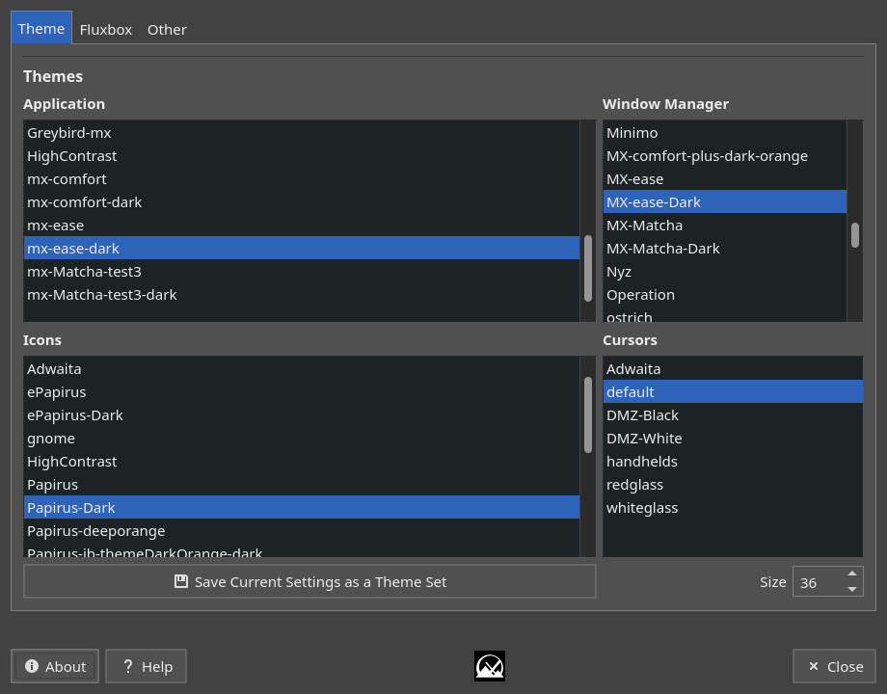
#background: none

Selection
MX Tweak (Theme tab) makes it easy to test and select elements as well as to combine them into your own particular theme. It links to MXFB Look to provide the option of designating your selections as specific collection of graphic features (a “look”) that you can save.

3.4 Wallpapers
First make sure the overlay file is blocking the style from determining the background. Then click Menu > Appearance > Wallpaper > Select to launch Nitrogen which displays the available choices. The selection includes by default any user backgrounds (~/.fluxbox/backgrounds) as well as system backgrounds (/usr/share/backgrounds). This setup allows you to add backgrounds in the user folder and then be able to select them from the menu. You can add other background sources by clicking “Preferences.”
A traditional method using fehbg can be enabled in Menu > Settings > Config files > Startup, search for “fehbg” to uncomment, and comment out “Nitrogen.” You may also want to modify Menu > Appearance > Wallpapers. Consult MX Fluxbox: Traditional mode for additional tips.

3.5 Shortcuts
Fluxbox allows the user to set key combinations as shortcuts. The settings are stored in the file ~/.fluxbox/keys, which can be accessed for editing via Menu > Settings > Config files > Keys. A handy ov,erview of the default keys is provided by the MXFB tool “Shortcuts;” a conky config “MX-FluxKeys” can be selected in Conky Manager.
The names used for of a couple of the keys are a bit obscure:
- Mod1 = Alt
- Mod4 = Logo key (Windows, Apple)
There are dedicated function key shortcuts in MX-Fluxbox:

- Ctrl+F1: MX-Fluxbox documentation
- Ctrl+F2: Run command; if you enter a command that needs terminal input, use Ctrl+Enter.
- Ctrl+F3: File manager
- F4: Drop-down terminal
- Ctrl+F5: MX Tools

3.6 Config files
All basic settings in Fluxbox are controlled by a set of text files in ~/.fluxbox/ that can be accessed easily by clicking Menu > Settings > Config files. Most settings need to be changed manually, though there is some help available for those in init.
- apps: actions based upon window properties
- init: main configuration file
- keys: shortcuts and key bindings
- menu: Fluxbox default ignored, replaced here with menu-mx
- overlay: style resources that override all styles
Before you begin editing any configuration files, you should back up your current configuration. Should things go wrong you can always restore the previous setup.

init
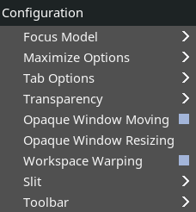
This file contains a long list of properties that determine much of the look and behavior of Fluxbox. It must be edited by hand, during which the detailed reference document would be very helpful.
Because init is both crucial and complicated, MX Fluxbox includes three user aids:
- a Fluxbox native configuration app: Menu > Settings > Config files > Quick config
- MX Tweak, “Fluxbox” tab with frequently changed properties
- an optional reorganization of init into categories triggered by clicking Menu > Settings > Config files > Init > Categorize. This is easier to make sense of and can be very helpful when editing a particular group.

3.7 Slit
The slit was originally conceived as a container for dockapps, but in MXFB it is primarily used for the dock by employing wmalauncher. It can be located at various locations on the desktop:
- TopLeft, TopCenter, TopRight
- LeftCenter, RightCenter
- BottomLeft, BottomCenter, BottomRight
You can search the default repo for dockapps with this terminal command: apt-cache search dockapp. Note that many available in the repos may not work well.

3.8 Overlay
Fluxbox allows the user to globally override all styles via the overlay file ~/.fluxbox/overlay, which can be accessed for editing via Menu > Settings > Configure > Overlay. The settings for the MXFB toolbar new to MX-25 (Section 4) are also located here. Element settings defined in the overlay file will override settings defined elsewhere in the Fluxbox setup.

3.9 Window Settings and Controls

Moving and adjusting windows can be controlled with various key and mouse combinations

- Resize: Alt + right click near the corner you want to change and drag.
- Move: Alt + left click and drag.
- Stick: use the little icon in the top left corner to show the window on all desktops.
- Options: right-click the window’s toolbar at the top. Of special value is the ability to select to remember size and location (recorded in ~/.fluxbox/apps).

- Tabbing: combine multiple windows into one window with tabs across the top by simply Ctrl-Clicking and holding the titlebar of one window and dragging and dropping it on another window. Reverse the procedure to separate them again.

- Reduce window to titlebar (“shade”): Double click the titlebar.

3.10 Screen Options
- Brightness: Menu > MX Fluxbox tools > Tools > Brightness systray
- Blanking: Menu > Settings > Display > Screensaver
- Capture: mxfb-quickshot. Triggered by the button “Print Screen” (AKA Print, PrtSc, etc.) or Alt+q key; interactive. Ctrl+Alt+q provides an 8s delay, whole screen capture only.

- Tiling: Alt+<number 1-9>, details are listed at the bottom of the keys file.

- Resolution: Menu > Settings > Display > Change (arandr). Be sure to read the “Help” file to see how to save any changes you wish to make.

4. FAQ-Finder
How do I… | From Desktop | With App
Open the Root Menu | Right click on Desktop
Open program X | Root Menu > All apps
 | Click MX Logo (Appfinder)
 | Press Windows/ Apple key (rofi)
Install new apps | Software icon | MX Package Installer
Toggle desktops icons on/off | Menu > Out of sight > Toggle iDesk
Change to a different Conky | Conky Manager
 | Menu > Appearance > Conky
Toggle Conky on/off | Menu > Out of sight > Toggle Conky
Select a different Panel |  | Settings manager > tint2manager
Edit a Panel |  | tint2settings
Edit the items in a Dock | Menu > Appearance > Dockmaker
 | For a rofi dock > Rofi Manager
Change appearance of window Title bar and FB-Menu | Menu > Appearance > Style
Change appearance of window contents, icons, font | Menu > Appearance > Theme | Settings manager > Customize look and feel
 | MX-Tweak
Change the wallpaper | Menu > Appearance > Wallpapers | Nitrogen
Edit key shortcuts | Menu > Settings > Config files > Keys
Edit root Menu | Menu > Settings > Config files > Menu
Remove desktop items | Menu > Out of sight >
Open a Terminal | Menu > Terminal | Xfce4-terminal or other preferred terminal

5. Links

The man files (in terminal or https://linux.die.net/man/):
- fluxbox
- fluxbox-keys
- fluxstyle
- fluxbox-remote

https://wiki.archlinux.org/index.php/Fluxbox
Some commands are Arch-specific

http://www.tenr.de/howto/style_fluxbox/style_fluxbox.html
The core document on Fluxbox styles

https://ubuntuforums.org/showthread.php?t=617812
Excellent thread on fluxbox keys, now unfortunately requiring registration

https://wiki.debian.org/FluxBox
Good orientation on basic features

https://github.com/MX-Linux/mx-fluxbox
The GitHub repo of MX-Fluxbox

https://mxlinux.org/wiki/help-files/help-mx-fluxbox/
The MX-Fluxbox Wiki entry

https://mxlinux.org/wiki/mx-fluxbox-traditional-mode/
Tips and tricks for running in traditional mode

https://bit.ly/2Sm1PJl
YouTube: MX-Fluxbox series

v. 20250708

