## 

MX-Fluxbox 3 Documentation

Table of Contents

1. Introduction 1

2. Default setup 1

2.1 Desktop icons 2

2.2 Conky 3

2.3 The tint2 panel 4

2.4 Docks 5

2.5 The rootMenu 5

3. Fluxbox setup 6

6. Links 12

# 1. **Introduction**

This Help document supplements the **Users Manual (F1)**, which covers general MX Linux topics.

1. Introduction

2. Installation

3. Configuration

4. Basic use

5. Software management

6. Advanced use

7. Under the hood

8. Glossary

MX Fluxbox (=MXFB) constitutes a minimal or “base” version of MX Linux that can be used out-of-the-box. Users will typically want additional common popular software for which it is recommended that they turn first to MX Package Installer.

As the name suggests, MXFB employs [Fluxbox](https://en.wikipedia.org/wiki/Fluxbox) as a [Window Manager](https://en.wikipedia.org/wiki/Stacking_window_manager) to control the placement and appearance of windows. Its small memory footprint and quick loading time are very effective on low-resource systems--and very fast on higher-level machines. All basic settings are controlled by [text files](https://en.wikipedia.org/wiki/Text_file) with straight-forward format.

MXFB can be run in two basic configurations, with possible many variations in between:

* **Default**, that includes the basic Fluxbox components but follows the MX Linux preference for the use of convenient graphical apps
* **Fluxbox**, to which various components from the default configuration may be added with a simple click or two

# 2. Default

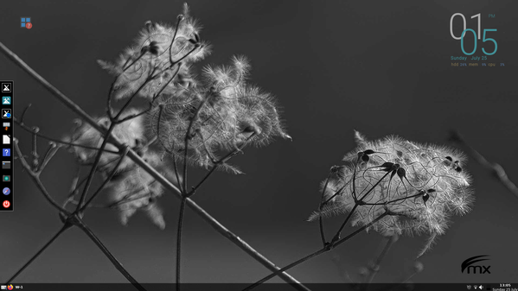

Going clockwise from the upper left corner here are the princi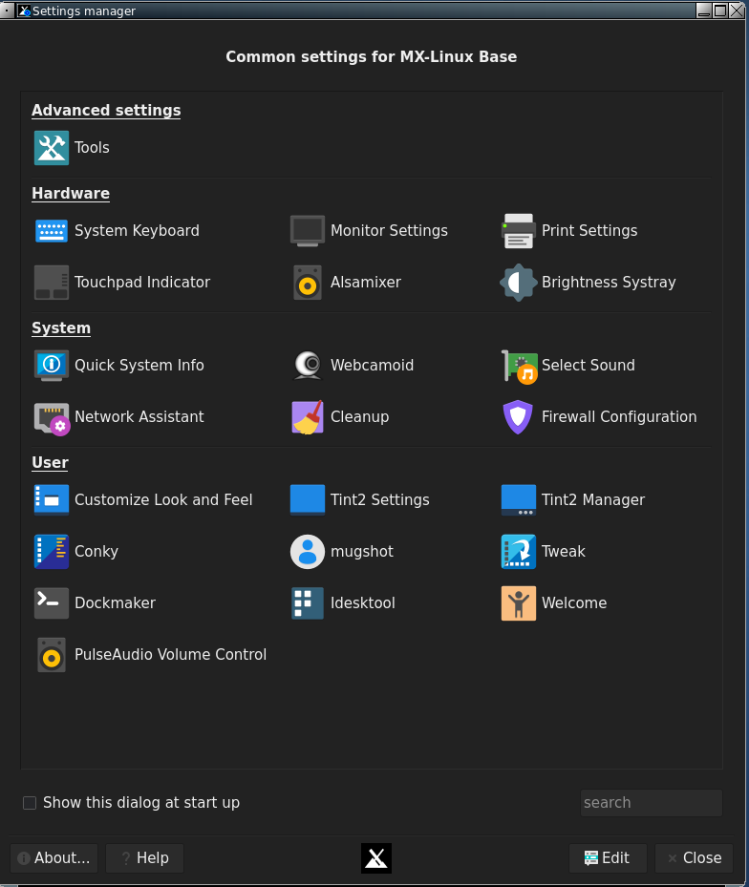ple components:

1. Desktop icons (Section 2.1)
2. System information display, called a “conky” (Section 2.2)
3. The creative tint2 panel (Section 2.3)
4. A native dock (Section 2.4)
5. The hidden Fluxbox “rootMenu” (Section 2.5)

The first stop for new users might well be the **Settings manager**, available from the dock, the panel or the rootMenu.

In addition to desktop icons and dock items, applications can be launched with any of the following tools:

* click the traditional panel’s Start (MX logo) button for Xfce’s Appfinder
* right-click the desktop: *Menu > All Apps* for a Debian-like categorical menu
* click the keyboard’s logo key (Windows or Apple icon) to bring up a very fast tool called “rofi” for an alphabetical menu with handy properties (details [in the Wiki](https://mxlinux.org/wiki/help-files/help-rofi/))
* click F2 to bring up a small run window (fbrun) for the actual program name

The following sections will give users a basic understanding of how to use and manage each of these components. Note: the word “Menu” in the following sections refers to the rootMenu that is shown with a right-click on the desktop.

## 2.1 Desktop icons

**Hide**: Menu > Out of sight > Toggle icons

**Remove (icon)**: middle-click icon to launch iDesktool

**Stop**: Menu > Out of sight > Toggle iDesk

**Manage**: Menu > Appearance > Desktop icons

**Help:** [in the Wiki](https://mxlinux.org/wiki/help-files/help-mx-idesktool/)

Desktop icons are enabled in MXFB by iDesk, a program first developed in 2005 and designed to draw desktop icons for users of minimal window managers such as fluxbox. Though icons can be set up manually, it is much easier with a graphical tool. MX Linux Devs and users adapted, modernized and expanded the existing tool to produce **iDesktool**: *Menu > Appearance > Desktop icons*.

This tool greatly facilitates the use of desktop icons on MX-Fluxbox. It is very straightforward and should raise few questions about its use.

Here are the basic mouse actions for a desktop icon (config in ~/.ideskrc), using the default “Video” icon as an example:

|  |  |  |
| --- | --- | --- |
| **Action** | **Mouse** | **Example** |
| Execute | Left single click | Opens to the MXFB YouTube channel |
| Execute alt | Right single click | Opens an action menu |
| Manage | Middle (scroll button) single click | Opens iDesktool focused on the icon |
| Drag | Left click hold, release to stop |  |

## 2.2 Conky

**Hide**: *Menu > Out of sight > Toggle conky*

**Remove (conky)**: *Menu > Appearance > Conky*

**Stop**: *Menu > Out of sight > Toggle conky*

**Manage**: *Menu > Appearance > Conky*

**Help**: in the Wiki: [MX Conky](https://mxlinux.org/wiki/help-files/help-mx-conky/), [Conky Manager](https://mxlinux.org/wiki/help-files/help-conky-manager/)

MX-Fluxbox users can make use of the default conky set for MX Linux by clicking *Menu > Appearance > Conky* to bring up MX Conky; Conky Manager can be launched from it, or using any of the menus. Conky Manager is a handy method of basic management, while MX Conky supplies advanced features such as the color manipulation unique to MX Linux.

In Conky Manager follow these simple steps to edit, view and display a conky:

* Highlight each conky and hit Preview to see what it looks like. Be sure to close each preview before going to another.
* Click on the Settings icon (gears) to change basic properties.
* Check the box to select any conky you want to use. It will be auto-installed.
* The configuration files are stored in the folder ~/.conky/ in individual theme files. They can be edited, though it is not intuitive, by highlighting the conky in the list and clicking on the edit icon (pencil).

For more complicated conkies, you may need to make use of a compositor. Click Menu > Settings > Config > Startup, and uncomment the line about a compositor so it lo oks like this: *compton &*

## 2.3 The tint2 panel

**Hide**: *Menu > Out of sight > Toggle autohide panel*

**Remove**: *Manual: delete the config from ~/.config/tint2/*

**Stop**: *Manual: put a comment (#) in front of line in the “startup” file*

**Manage**: *Settings manager > Tint2 manager (icons on dock and in panel)*

**Help**: [in the Wiki](https://mxlinux.org/wiki/applications/tint2-panel/)

The original Fluxbox toolbar is very different from what today’s users expect in function and design. (You can toggle back and forth between the two: *Menu > Appearance > Toolbar > Fluxbox* | Traditional) That’s the reason an alternative “traditional” toolbar was added starting with MX-Fluxbox 2.2 using an highly configurable app known as “**tint2**.”

To change the panel, click the wrench icon next to the Start button or the gear icon on the dock. This launches the Settings manager, where you can click on “Tint2 manager.”

The screen opens showing all the tint2 configurations in the location *~/config/tint2/*. MXFB supplies a small set of very different configurations that you can try out.

In addition to selecting an existing configuration you can also change the elements of any panel—in fact, that is one of the great pleasures of using tint2. Click on either the “Graphical editor” button at the top or the “Edit” button at the bottom for direct editing of the text file.

The Graphical editor includes two applications:

* “Themes” displays all the tint2 configs in the user’s location as well as a few others brought in during installation.
* “Properties” displays the features of the running config. If the Properties window is not visible, click on the little gear icon in the upper left corner.

Here are a couple of common actions to get you started:

* Adding/Removing launchers. In the “Properties” window click the “Launcher” entry on the left side. The right panel has two columns: on the left a list of application icons currently displayed on the toolbar, while on the right a list of all desktop applications installed.
  + **Add**: select the application you want from the list in the right column, click the “left arrow” icon on the middle and then click the “Apply” button, to instantly add it to the toolbar.
  + **Remove**: reverse the procedure.
* Moving or resizing the panel. In the “Properties” window click the “Panel” entry in the left panel and then choose its placement and size in the right panel. Click the “Apply” button.

**NOTE**: when you select a new theme you will lose any customization that you made to the previously used theme such as adding a quick launcher. It’s better to first back up your current configuration so you can then paste your customizations to the new theme: click on ~/.config/tint2/tint2rc to open it in featherpad and then save it under a new name such as “tint2rc_BAK.” You can then copy all your customized lines from your backup file to the correct place on your new tint2rc configuration.

## 2.4 Docks

**Hide**: *Menu > Out of sight > Toggle autohide dock*

**Remove/Add (a Dock item)**: *Menu > Appearance > Dockmaker*

**Stop (Default dock)**: *Menu > Out of sight > Disable Default dock*

**Manage**: *Menu > Appearance > Dockmaker*

**Help:** [in the Wiki](https://mxlinux.org/wiki/help-files/help-mx-dockmaker/)

External docks such as plank often do not work easily with Fluxbox. But MXFB has a native app called Dockmaker which makes it easy for the user to create, modify and manage docks. A vertical dock appears on the desktop when the user logs in for the first time whose configuration is set in *~/fluxbox/scripts/DefaultDock.mxdk*.

**NOTE**: you can also use tint2 as a dock

## 2.5 The rootMenu

**Hide**: *always hidden by default*

**Remove/Add (a menu item)**: *Menu > Settings > Configure > Menus*

**Stop**: *put a comment (#) in front of the line that starts:*

*session.menuFile:*

**Manage**: *Menu > Settings > Configure > Menus*

**Help:** Section 3 and Links

The rootMenu is composed of 4 separate units to facilitate reading, editing and function. The short main menu (~/.fluxbox/menu-mx) incorporates three submenus (Appearance, Settings, Out of sight) that are located in a folder “submenus.”

Details about this and the other Fluxbox components are treated in detail in the following Section 3, so here our goal is introduce the rootMenu’s elements from a very practical point of view. We will scan the three sections established by the separator lines.

* Top
  + All apps: a Debian-like categorical menu (update if necessary)
  + Recent files: displays the most recent files used (refresh if necessary)
* Middle: a few common apps
* Bottom
  + Appearance
    - conky
    - docks
    - desktop icons
    - monitors: small system monitors
    - style: decoration of windows, toolbar and menu
    - theme
    - toolbar: select between toolbar and panel
    - wallpaper: rotate, separate by workspace, select
  + Settings
    - backup
    - configure: the Fluxbox files such as menus, statup, etc.
    - display: change display parameters, help on how to adjust
    - keyboard: quick change to one of 11 language
  + Out of sight: a collection of handy commands to hide elements
  + Leave:
    - refresh: used after changing a configuration file if not logging out
    - suspend
    - log out
    - reboot
    - shutdown

The new user would do well to work through that menu in order to appreciate its contents, power and flexibility. Particularly attractive is the fact that the menus are completely under the user’s control.

# 3. Fluxbox

This section addresses the user who wants to run a traditional Fluxbox setup.

### How do I start?

It is very easy to restore a traditional Fluxbox setup. Right-click anywhere on the desktop to see and use the desktop menu (rootMenu). The following changes are at your fingertips:

* Settings > Toolbar > Fluxbox: the traditional panel will disappear and the Fluxbox toolbar will appear at the top of the screen.
* Out-of-sight > Kill dock*
* Out-of-sight > Kill conky*
* Out-of-sight > Toggle iDesk and Toggle icons*

*For persistent changes, comment out (#) the relevant lines in the file “startup”: Settings > Configure > Startup so they look like this:

#$HOME/.fluxbox/scripts/DefaultDock.mxdk

#$HOME/.fluxbox/scripts/conkystart

#idesktoggle idesk on 1>/dev/null 2>&1 &

Let’s go through how to understand and use the changed desktop:

### 

### What is the toolbar across the top?

This fluxbox toolbar offers MX users information about workspaces, open applications, a system tray, and the current time. Its width and placement can be set with the options available by middle-clicking (=scroll wheel) the clock or pager on the toolbar—if that doesn’t work for some reason, click Menu > Settings > Window, slit and toolbar > Toolbar. Height is set in ~/.fluxbox/init/ :

*session.screen0.toolbar.height: 0*

If a zero is there, it means that the selected style will set the height. Otherwise, a value of 20 to 25 is often comfortable.

The toolbar contains the following default components (L-R):

pager

* Allows you to switch workspace up (right click) or down (left click); same as Control + F1/F2/ etc., Ctrl-Alt + ←/→ or using the scroll wheel over an empty section of the desktop. Number and name are set in the *~/.fluxbox/init*. “W” stands for “Workspace.”

iconbar

* Here open apps will show an icon, with various window options available by right-clicking the relevant icon (including the toolbar itself) > iconbar mode. Default for MX-Fluxbox is All Windows.

systemtray AKA systray

* Equivalent of Notification Area in Xfce. Default components set in *~/.fluxbox/init*; apps that have a systemtray option will show there when launched.

clock

* To adjust the clock to 12h or 24h, right-click and click 12h or 24h, whichever shows. If that doesn’t work, select "Edit clock format."
* 24h: **%H:%M**, 12h: **%I:%M**.
* The default is 12h time and date in day/short month format: **%I:%M %b %d**. Many other time/date options are available: <https://mxlinux.org/wiki/other/time-formats-in-scripts/>

You can move or delete any of the toolbar components in ~/.fluxbox/init/ , which by default are set up in this way:

*workspacename, iconbar, systemtray, clock*

### **How can I make the toolbar look more like legacy systems such as Windows?**

Click Menu > Appearance > Toolbar > Traditional (using **tint2**)

### How can I get rid of desktop items I don’t want?

Menu > Out of sight > ...

This entry includes:

* Actual kill entries that stop the entire program. The next time you log in anything enabled in the startup file will re-appear except the default dock, which will be disabled.
* A disable entry to remove the default dock.
* Toggle entries, which can kill or re-launch a program.

### How can I change or add a menu entry?

Menu > Settings > Configure > Menus. The syntax is: [category] (name) {command} – be sure to use brackets, parentheses and braces correctly.

Example 1: change “Music” to open Clementine instead of DeaDBeeF

* Find the line with the word Music (use Ctrl+F if necessary)

[exec] (Music) {deadbeef}

* Double-click the word “deadbeef” in the command part so it is highlighted, then type “clementine” and save, producing this result:

[exec] (Music) {clementine}

* Click Menu > Leave > Refresh to use the new settings

Example 2: add Skype to the menu

* Decide where you want it to show up; for this example, let’s assume you want to add a new category “Communicate” in the Common apps section and enter it there
* Create the category using the submenu commands (see below), introduce a new line and follow the pattern: [exec] (menu entry) {command}
* The result will look something like this:

[submenu] (Communicate)

[exec] (Skype) {skypeforlinux}

[end]

* Menu > Leave > Refresh

NOTE: as the second example shows, the command to use may not always be obvious, so if necessary open the Application Finder (F6), right-click the entry you are interested in > Edit and copy the correct full command for the menu.

### What else should I know about the windows?

* Resize: Alt + right click near the corner you want to change and drag.
* Move: Alt + left click and drag.
* Stick: use the little square in the top left corner to limit the window to the current desktop.
* Options: right-click on the window’s toolbar at the top. Of special value is the ability to select to remember size and location (recorded in *~/.fluxbox/apps*).
* Tabbing: combine multiple windows into one window with tabs across the top by simply Ctrl-Clicking and holding the titlebar of one window and dragging and dropping it on another window. Reverse the procedure to separate them again.

### I see styles in the menu, what are those?

Styles are simple text files that tell fluxbox how to generate the appearance of the window and toolbar components. Fluxbox ships with a large number in */usr/share/fluxbox/styles/* that show in Menu > Look > Style, and many more can be found online with a web search on "fluxbox styles."

Styles can include a background image, but that is blocked in MX-Fluxbox by default with the top lines in Menu > Settings > Configure > Overlay. To allow the style to determine the background, place a hash mark in front to the line so that it looks like this:

*! The following line will prevent styles from setting the background.*

***#****background: none*

If you like a style but want to change certain traits, copy it to ~/.fluxbox/styles, rename it, and make your changes (consult Ubuntu style guide under Links, below). You will find a few fluxbox styles that have been modified for use in MX in that folder.

### What are themes and how do I manage them?

Themes in MX-Fluxbox are GTK 2.0 themes; a number are installed by default and others can be found with a web search. A GTK theme controls items such as the panel color, the backgrounds for windows and tabs, how an application will look when it is active vs. inactive, buttons, check-boxes, etc. They range from very dark to very light.

The default theme for MX-Fluxbox is [WHAT?]. It can be changed by right clicking on the desktop to bring up Menu > Appearance > Theme, bringing up a selector for themes, icons, fonts etc. which makes it very easy to see and choose the other possibilities.

### I can’t read some of the texts, can I do something about that?

You can adjust the font being used by a theme using the theme selector; default for MX-Fluxbox is Sans 11. More detailed control is available by using the ~/.fluxbox/overlay file. For instance, this set of commands might be tried to make the text generally larger:

# fonts------------------------------------------  
menu.frame.font: PT Sans-12:regular  
menu.title.font: PT Sans-12:regular  
toolbar.clock.font: PT Sans-11:regular  
toolbar.workspace.font: PT Sans-11:regular  
toolbar.iconbar.focused.font: PT Sans-11:regular  
toolbar.iconbar.unfocused.font: PT Sans-11:regular  
window.font: Lato-9

For other font options, consult the Links at the end of this document.

### Can I change the **wallpaper**?

First make sure the overlay file is blocking the style from determining the background. Then click Menu > Appearance > Wallpapers > Select to see the available choices. Wallpapers whose name begins with “mxfb-” carry the MX-Fluxbox logo. The list that pops up from the menu entry includes any user backgrounds (*~/.fluxbox/backgrounds*) and system backgrounds (*/usr/share/backgrounds*), separated by a horizontal line. This setup allows you to add backgrounds in the user folder and then be able to select them from the menu.

### What terminals are available?

* F4 (or Menu > Terminal) = Drop-down Xfce4-terminal
* Menu or F2: roxterm

### Can I use my own keystroke combinations?

Yes. Many are listed by default in Menu > Settings > Configure > Keys. The names of a couple of the keys are a bit obscure:

* Mod1 = Alt
* Mod4 = Logo key (Windows, Apple)

More: <http://fluxbox.sourceforge.net/docbook/en/html/c296.html>

There are 6 dedicated function keys in MX-Fluxbox (see top of *keys* file to change):

* F1: MX-Fluxbox documentation
* F2: Run command using the quick app runner “[rofi](https://mxlinux.org/wiki/help-files/help-rofi/)”
* F3: File manager
* F4: Drop-down terminal
* F5: MX Tools
* F6: All apps

### What screen options exist?

* Brightness: right-click the battery icon in the systray.
* Capture: a dedicated icon in the dock runs mxfb-quickshot; if you have a Print Screen (AKA Print, PrtSc, etc.) key, that should work as well.

### I have read about the slit: what is that?

The slit was originally conceived as a container for [dockapps](https://en.wikipedia.org/wiki/Dockapps), but which in MXFB is primarily used for the dock. It can be located at various locations on the desktop:

* TopLeft, TopCenter, TopRight
* LeftCenter, RightCenter
* BottomLeft, BottomCenter, BottomRight

You can search the default repo for dockapps with this terminal command:

*apt-cache search dockapp*

Many available in the repos may not work well, but it’s worth taking a look.

One very interesting and useful dockapp not found with that apt-cache search is the monitor stack [**gkrellm**](http://gkrellm.srcbox.net/), installed by default in MX-Fluxbox. It is available by clicking Menu > System > Monitors and has many configuration options (right-click on the top label or on one of the charts), [many skins](http://www.muhri.net/gkrellm/nav.php3?node=gkrellmall&sort=added&conf=DESC) and [many plugins](http://gkrellm.srcbox.net/Plugins.html). A few skins are installed by default, and can be reviewed and selected by clicking Shift-PageUp. A handy plugin can be installed from the repos **gkrellweather**, which works well when the version in the MX repos is installed.

# **6**. Links

The man files (in terminal or <https://linux.die.net/man/>):

* fluxbox
* fluxbox-keys
* fbrun
* fluxstyle
* fluxbox-remote

<http://fluxbox.sourceforge.net/docbook/en/pdf/fluxbook.pdf>

Basic handbook, somewhat dated but still useful

<https://bbs.archlinux.org/viewtopic.php?id=77729>

Some good general explanations with examples

<https://wiki.archlinux.org/index.php/Fluxbox>

Some commands are Arch-specific

<https://wiki.ubuntu.com/HowToFluxboxStyles>

<https://ubuntuforums.org/showthread.php?t=617812>

Excellent thread on fluxbox keys

<https://wiki.debian.org/FluxBox>

<https://wiki.debian.org/FluxboxIcon>

<http://fluxbox.sourceforge.net/docbook/en/html/chap-tabs.html>

Window tabbing.

<https://github.com/jerry3904/mx-fluxbox>

The GitHub repo of MX-Fluxbox

<https://mxlinux.org/wiki/help-files/help-mx-fluxbox/>

The MX-Fluxbox Wiki entry

<https://bit.ly/2Sm1PJl>

YouTube: MX-Fluxbox

**v. 20210805**